Lesson 3
Objective: Specify and partition a whole into equal parts, identifying and counting unit fractions by drawing pictorial area models.

Suggested Lesson Structure
 Fluency Practice (12 minutes)
 Application Problem (10 minutes)
 Concept Development (28 minutes)
 Student Debrief (10 minutes)
Total Time (60 minutes)
Fluency Practice (12 minutes)
- Sprint: Multiply with Six 3.OA.4 (10 minutes)
- Group Counting 3.OA.1 (2 minutes)
Sprint: Multiply with Six (10 minutes)

NOTE ON
PACING FLUENCY:
Consider counting by sevens, eights, or nines between Sprints A and B so that both Fluency activities can be completed within the 12 minutes allotted.

Materials: (S) Multiply with Six Sprint
Note: This Sprint supports fluency with multiplication using units of 6.
Group Counting (2 minutes)
Note: Group counting reviews interpreting multiplication as repeated addition.
Direct students to count forward and backward, occasionally changing the direction of the count.
- Sevens to 70
- Eights to 80
- Nines to 90

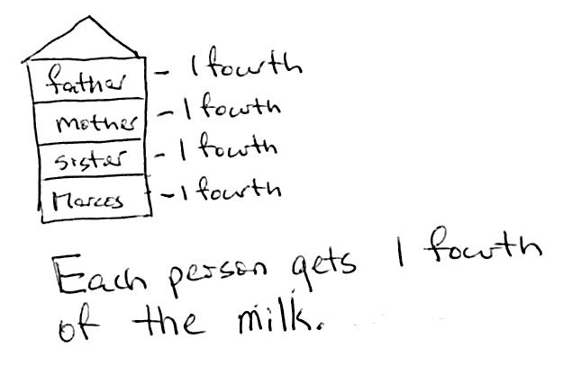
Application Problem (10 minutes)
Marcos has a 1-liter jar of milk to share with his mother, father, and sister. Draw a picture to show how Marcos must share the milk so that everyone gets the same amount. What fraction of the milk does each person get?
MP.2
Note: This problem reviews partitioning a whole into equal parts, as well as naming fractional parts of a whole.
Concept Development (28 minutes)
Materials: (T) Rectangular- and circular-shaped papers
(S) Personal white board

NOTES ON
MULTIPLE MEANS
OF ENGAGEMENT:
Increase the wait time for responses from English language learners and students with disabilities. Also, record student responses of the unit fraction and shaded amount on the board beside the model.

T: I have a rectangle. I want to split it into 4 equal parts.
Fold the paper so the parts are not the same size. Then, open it up to draw the lines where it was folded and show the class. Invite the students to notice the inequality of the parts.
T: Let me try again. (Fold it into 4 equal parts.)
T: How many equal parts did I split the whole into?
S: 4.
T: What is the fractional unit for 4 equal parts?
S: Fourths.
T: What is each part called?

NOTES ON
VOCABULARY:
Although the word copies may not be unfamiliar to students, its use in this context might be. The following excerpt from page 2 of the 3–5 Number and Operations—Fractions progression describes the concept associated with copies in Module 5: “If a whole is partitioned into 4 equal parts, then each part is $\frac{1}{4}$ of the whole, and 4 copies of that part make the whole.”

S: 1 fourth or 1 quarter.
T: I’m going to shade in 3 copies of 1 fourth. (Shade in 3 parts.) What fraction is shaded?
S: 3 fourths are shaded.
T: Let’s count them.
S: 1 fourth, 2 fourths, 3 fourths.
T: I have a circle. I want to split it into 2 equal parts.
Fold the paper so the parts are not the same size. Then, open it up to draw the lines where it was folded and show the class. Again, invite the students to notice and analyze the inequality of the parts.
T: Let me try again. (Fold it into 2 equal parts.)
T: How many equal parts did I split the whole into?
S: 2.
T: What is the fractional unit for 2 equal parts?
S: Halves.
T: What’s each part called?
S: 1 half.
T: I’m going to shade in 1 part. (Shade in 1 part.) What fraction is shaded?
S: 1 half is shaded.
Having established the meaning of equal parts, proceed to briskly analyze Shapes 1–4. Draw or project them, and then possibly use the brief sequence of questions elaborated for Shape 1:

NOTES ON
MULTIPLE MEANS
OF ACTION AND EXPRESSION:
Some students may benefit from manipulating concrete models simultaneously as they work on the pictorial level.

T: How many equal parts are there in all?
S: 3.
T: What is the fractional unit for 3 equal parts?
S: Thirds.
T: What’s each part called?
S: 1 third.
Shape 1
T: What fraction is shaded?
S: 2 thirds.
T: Count them.
S: 1 third, 2 thirds.

Shape 2
Shape 4

Shape 3

Repeat the steps and procedures with other shapes.

NOTES ON
MULTIPLE MEANS
OF ENGAGEMENT:
Open-ended activities, such as partitioning a whole into student-chosen fractional units, challenge students working above grade level.

T: Take out your personal white board. We’ll draw a few shapes and split them into smaller, equal parts.
T: Draw a rectangle and split it into thirds.
T: How many equal parts do we have altogether?
S: 3.
T: Shade in 1 part. What fraction is shaded?
S: 1 third.
Select a couple of student drawings to show the class.
Repeat the sequence to have students show 2 sixths of a square, 3 fourths of a line segment, and other examples as needed.
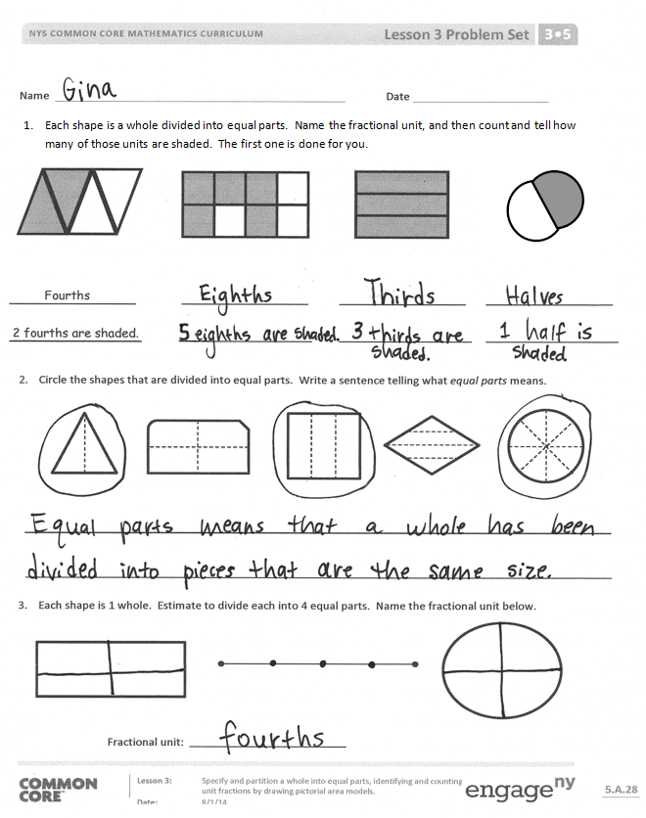
Problem Set (10 minutes)
Students should do their personal best to complete the Problem Set within the allotted 10 minutes. For some classes, it may be appropriate to modify the assignment by specifying which problems they work on first. Some problems do not specify a method for solving. Students should solve these problems using the RDW approach used for Application Problems.
Student Debrief (10 minutes)
Lesson Objective: Specify and partition a whole into equal parts, identifying and counting unit fractions by drawing pictorial area models.
The Student Debrief is intended to invite reflection and active processing of the total lesson experience.
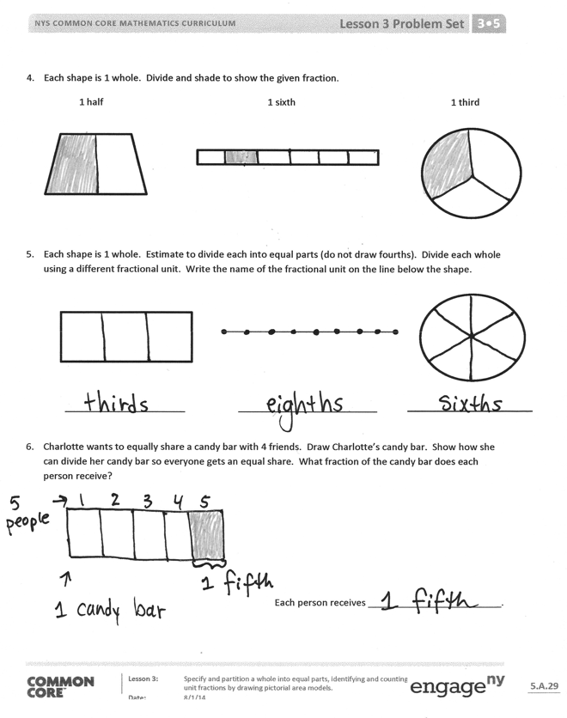
Invite students to review their solutions for the Problem Set. They should check work by comparing answers with a partner before going over answers as a class. Look for misconceptions or misunderstandings that can be addressed in the Debrief. Guide students in a conversation to debrief the Problem Set and process the lesson.
Any combination of the questions below may be used to lead the discussion.
- What is the same about fair shares of a jug of milk and fair shares of a candy bar? What is different? (Though a fraction of a jug of milk and a fraction of a candy bar is clearly different, each might be represented by drawing a rectangle.)
- In Problem 6, how does drawing fourths help you draw fifths well?
Exit Ticket (3 minutes)
After the Student Debrief, instruct students to complete the Exit Ticket. A review of their work will help with assessing students’ understanding of the concepts that were presented in today’s lesson and planning more effectively for future lessons. The questions may be read aloud to the students.
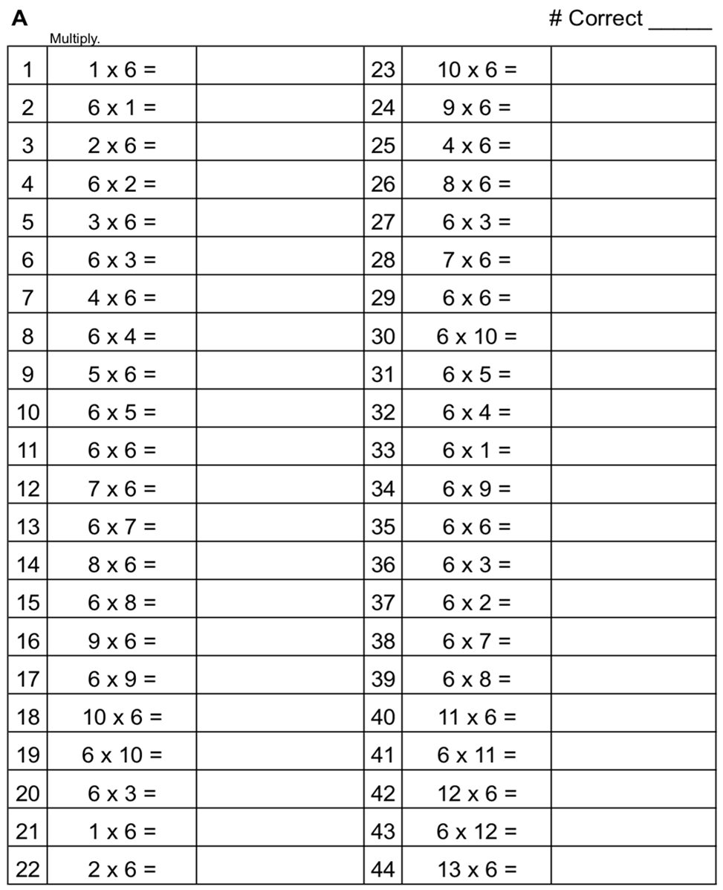
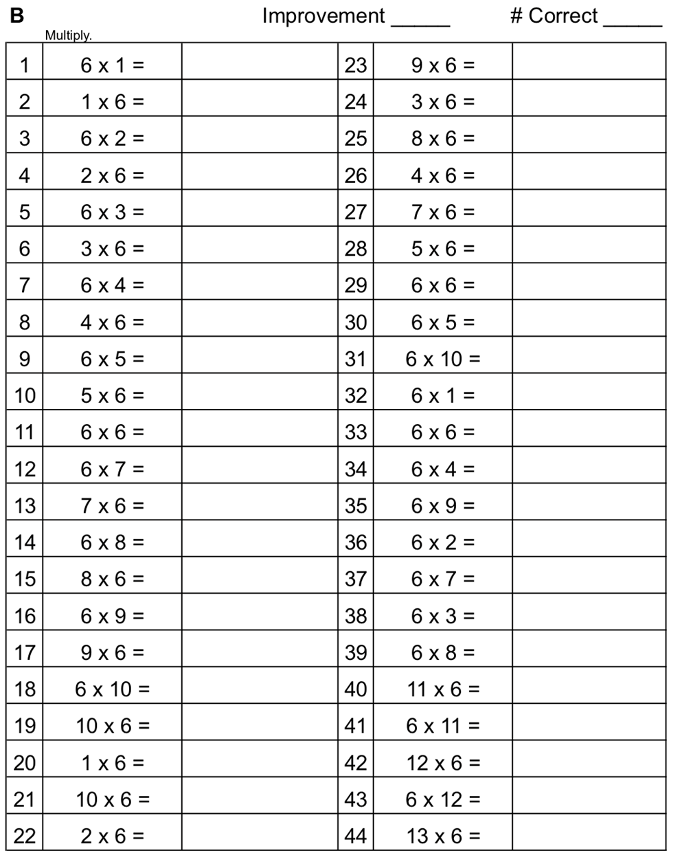
Name Date
1. Each shape is a whole divided into equal parts. Name the fractional unit, and then count and tell how many of those units are shaded. The first one is done for you.
2 fourths are shaded.
Fourths

- Circle the shapes that are divided into equal parts. Write a sentence telling what equal parts means.

- Each shape is 1 whole. Estimate to divide each into 4 equal parts. Name the fractional unit below.
Fractional unit:

- Each shape is 1 whole. Divide and shade to show the given fraction.
1 half 1 sixth 1 third

- Each shape is 1 whole. Estimate to divide each into equal parts (do not draw fourths). Divide each whole using a different fractional unit. Write the name of the fractional unit on the line below the shape.

- Charlotte wants to equally share a candy bar with 4 friends. Draw Charlotte’s candy bar. Show how she can divide her candy bar so everyone gets an equal share. What fraction of the candy bar does each person receive?

Each person receives _________________________.

Name Date

- ______________ sevenths are shaded.

- Circle the shapes that are divided into equal parts.

- Steven wants to equally share his pizza with his 3 sisters. What fraction of the pizza does he and each sister receive?

He and each sister receive _________________________.

Name Date
- Each shape is a whole divided into equal parts. Name the fractional unit, and then count and tell how many of those units are shaded. The first one is done for you.

Fourths
2 fourths are shaded.

- Each shape is 1 whole. Estimate to divide each into equal parts. Divide each whole using a different fractional unit. Write the name of the fractional unit on the line below the shape.

- Anita uses 1 sheet of paper to make a calendar showing each month of the year. Draw Anita’s calendar. Show how she can divide her calendar so that each month is given the same space. What fraction of the calendar does each month receive?

Each month receives _________________________.

