Lesson 2
Objective: Specify and partition a whole into equal parts, identifying and counting unit fractions by folding fraction strips.

Suggested Lesson Structure
 Fluency Practice (12 minutes)
 Application Problem (5 minutes)
 Concept Development (35 minutes)
 Student Debrief (8 minutes)
Total Time (60 minutes)
Fluency Practice (12 minutes)
- Group Counting 3.OA.1 (6 minutes)
- Multiplication by Three and Six 3.OA.4 (6 minutes)
Group Counting (6 minutes)
Materials: (S) Personal white board
Note: Group counting reviews interpreting multiplication as repeated addition.
Count forward and backward by threes twice. Pause between each counting sequence so that students see improvement on the second try. After doing the threes twice, have students underline the multiples of 6. (0, 3, 6, 9, 12, 15, 18, 21, 24, 27, 30, 27, 24, 21, 18, 15, 12, 9, 6, 3, 0.) Then, count forward and backward by sixes twice, pausing between each counting sequence to analyze weak points.
Multiplication by Three and Six (6 minutes)
Materials: (S) Personal white board (optional)
Note: Choose your mode of delivery, e.g., oral work, personal white boards. This activity reviews multiplication using units of three and six.
Guide students to write and pair facts of 3 and 6 and uncover the doubling:
2 × 3 = 6 2 × 6 = 12
3 × 3 = 9 3 × 6 = 18
4 × 3 = 12 4 × 6 = 24

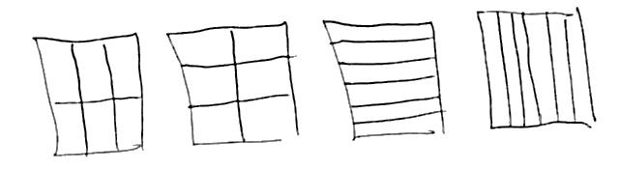
Application Problem (5 minutes)
Anu needs to cut a piece of paper into 6 equal parts. Draw at least 3 pictures to show how Anu can cut her paper so that all the parts are equal. (Early finishers can do the same thing with halves, fourths, or eighths.)
Note: This problem reviews the concept of equal parts from Lesson 1.
Concept Development (35 minutes)
Materials: (S) 8 paper strips sized 4 $\frac{1}{4}$” × 1” (vertically cut an 8 $\frac{1}{2}$” × 11” paper down the middle), pencil, crayon
Note: Students should save the fraction strips they create during this lesson for use in future Module 5 lessons.

NOTES ON
MULTIPLE MEANS
OF ACTION AND EXPRESSION:
For English language learners and others, sentence frames support English language acquisition. Students are able to form complete sentences while providing details about the fraction they are analyzing.
Ask students working above grade level for a possible method to partition the whole into ninths (e.g., after partitioning thirds).

Have students take one strip and fold it to make halves. (They might fold it one of two ways. This is correct, but for the purpose of this lesson, it is best to fold as pictured below.)
T: How many equal parts do you have in the whole?
S: Two.
T: What fraction of the whole is 1 part?
S: 1 half.
T: Draw a line to show where you folded your paper. Write the name of the fraction on each equal part.
Use the following sentence frames with the students chorally.
- There are ____________ equal parts in all.
- 1 equal part is called ____________________.
Students should fold and label strips showing fourths and eighths to start, followed by thirds and sixths and fifths and tenths. Some students may create more strips than others.

While circulating, watch for students who are not folding in equal parts. Encourage students to try specific strategies for folding equal parts. A word wall would be helpful to support the correct spelling of the fractional units, especially eighths.
When the students have created their fraction strips, ask a series of questions such as the following:
- Look at your set of fraction strips. Imagine they are pieces of delicious pasta. Raise the strip in the air that best shows how to cut 1 piece of pasta into equal parts with your fork.
- Look at your fraction strips. Imagine they are lengths of ribbon. Raise the strip in the air that best shows how to divide the ribbon into 3 equal parts.
- Look at your fraction strips. Imagine they are candy bars. Which best shows how to share your candy bar fairly with 1 person? Which shows how to share your half fairly with 3 people?
Problem Set (10 minutes)

NOTES ON
MULTIPLE MEANS
OF REPRESENTATION:
Acting out word problems on the Problem Set using concrete materials may increase student understanding.

Students should do their personal best to complete the Problem Set within the allotted 10 minutes. For some classes, it may be appropriate to modify the assignment by specifying which problems they work on first. Some problems do not specify a method for solving. Students should solve these problems using the RDW approach used for Application Problems.
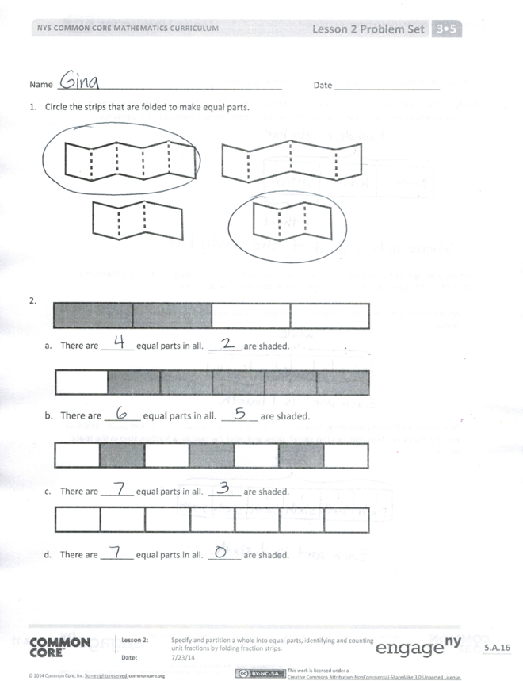
Student Debrief (8 minutes)
Lesson Objective: Specify and partition a whole into equal parts, identifying and counting unit fractions by folding fraction strips.
The Student Debrief is intended to invite reflection and active processing of the total lesson experience.
Invite students to review their solutions for the Problem Set. They should check work by comparing answers with a partner before going over answers as a class. Look for misconceptions or misunderstandings that can be addressed in the Debrief. Guide students in a conversation to debrief the Problem Set and process the lesson.
Any combination of the questions below may be used to lead the discussion.
- If the size of the whole stays the same, what happens as you partition it into more and more parts?
- What is the relationship between the number of equal parts and the name of the fraction?
- What strategies did you use for folding different fractional parts?
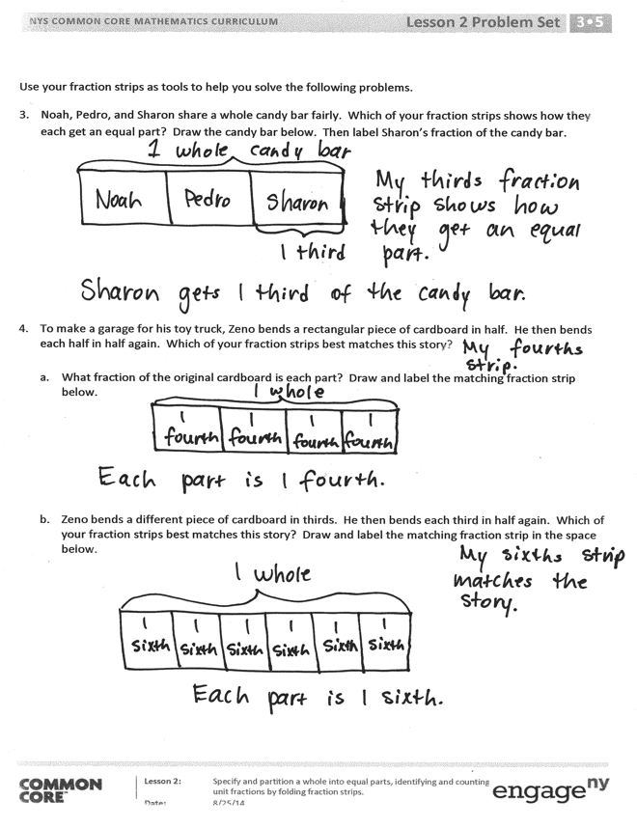
- What is the relationship of halves to fourths? Of halves to eighths?
- What is the relationship of thirds to sixths?
- What is the relationship of halves, fourths, and eighths to thirds and sixths?
- How does today’s Fluency Practice relate to the thirds and sixths we studied in the lesson?
Exit Ticket (3 minutes)
After the Student Debrief, instruct students to complete the Exit Ticket. A review of their work will help with assessing students’ understanding of the concepts that were presented in today’s lesson and planning more effectively for future lessons. The questions may be read aloud to the students.

Name Date
- Circle the strips that are folded to make equal parts.

  - There are _______ equal parts in all. _______ are shaded.

  - There are _______ equal parts in all. _______ are shaded.

  - There are _______ equal parts in all. _______ are shaded.

  - There are _______ equal parts in all. _______ are shaded.

Use your fraction strips as tools to help you solve the following problems.
- Noah, Pedro, and Sharon share a whole candy bar fairly. Which of your fraction strips shows how they each get an equal part? Draw the candy bar below. Then, label Sharon’s fraction of the candy bar.

- To make a garage for his toy truck, Zeno bends a rectangular piece of cardboard in half. He then bends each half in half again. Which of your fraction strips best matches this story?

- What fraction of the original cardboard is each part? Draw and label the matching fraction strip below.

- Zeno bends a different piece of cardboard in thirds. He then bends each third in half again. Which of your fraction strips best matches this story? Draw and label the matching fraction strip in the space below.

Name Date
- Circle the model that correctly shows 1 third shaded.

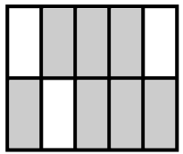
2.

There are _______ equal parts in all. _______ are shaded.

Michael bakes a piece of garlic bread for dinner. He shares it equally with his 3 sisters. Show how Michael and his 3 sisters can each get an equal share of the garlic bread.

Name Date
- Circle the strips that are cut into equal parts.

- There are _______ equal parts in all. _______ is shaded.

- There are _______ equal parts in all. _______ is shaded.

- There are _______ equal parts in all. _______ is shaded.

- There are _______ equal parts in all. _______ are shaded.

- Dylan plans to eat 1 fifth of his candy bar. His 4 friends want him to share the rest equally. Show how Dylan and his friends can each get an equal share of the candy bar.

- Nasir baked a pie and cut it in fourths. He then cut each piece in half.

- What fraction of the original pie does each piece represent?

- Nasir ate 1 piece of pie on Tuesday and 2 pieces on Wednesday. What fraction of the original pie was not eaten?

