Lesson 21

Objective: Solve two-step word problems involving multiplying single-digit factors and multiples of 10.

Suggested Lesson Structure

|  |  |
| --- | --- |
|  | A NOTE ON  STANDARDS ALIGNMENT: |
| This lesson incorporates the use of seconds in both the Concept Development and Problem Set. Although they are included in the Grade 4 standard (**4.MD.1**), students are familiar with seconds from G3–M2–Lesson 1. In this lesson, the conversion between minutes and seconds is always provided when needed. | |

 Fluency Practice (15 minutes)

 Concept Development (35 minutes)

 Student Debrief (10 minutes)

**Total Time (60 minutes)**

Fluency Practice (15 minutes)

* Sprint: Multiply by Multiples of 10 **3.NBT.3** (9 minutes)
* Group Counting  **3.OA.1** (3 minutes)
* Write in the Parentheses **3.OA.7** (3 minutes)

Sprint: Multiply by Multiples of 10 (9 minutes)

Materials: (S) Multiply by Multiples of 10 Sprint

Note: This Sprint reviews Lesson 19, which involved multiplying single-digit numbers by multiples of 10.

Group Counting (3 minutes)

Note: Group counting reviews interpreting multiplication as repeated addition. These counts review multiplication taught previously in the module. Direct students to count forward and backward, occasionally changing the direction of the count:

* Sixes to 60
* Sevens to 70
* Eights to 80
* Nines to 90

Write in the Parentheses (3 minutes)

Materials: (S) Personal white board

Note: This fluency activity reviews Lesson 20.

T: (Write 2 × 40 = 2 × 4 × 10.) What’s 2 × 40?

2 × 40 = 2 × 4 × 10

2 × 40 = (2 × 4) × 10

2 × 40 = 8 × 10

2 × 40 = 80

S: 80.

T: On your personal white board, copy the number sentence.   
Then, write in parentheses and solve.

S: (Write as shown in the box to the right.)

Continue with the following possible sequence:   
3 × 30 = 3 × 3 × 10 and 2 × 50 = 2 × 5 × 10.

Concept Development (35 minutes)

Materials: (T) Stopwatch, multiples of 10 multiplication cards (Template) (S) Personal white board

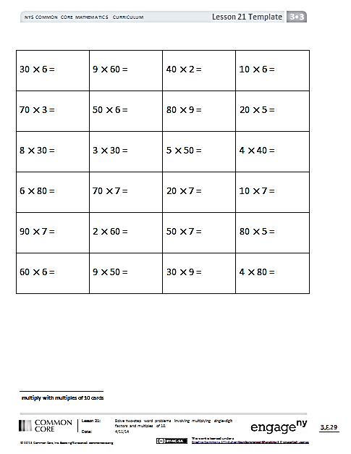

*Template*

Place one card face down on each student’s desk. At the prompt of "Go!," each student solves his or her problem. Students then line up as a class, ordering their products from least to greatest. Instruct students to complete these tasks silently and quickly. Let them know that you will time them and that extra time will be added as a penalty if they are too noisy.

T: It took you 4 minutes and 13 seconds to find the products and order them from least to greatest.   
How do we find the total number of seconds it took to complete this activity?

S: Add the total seconds in 4 minutes to 13 seconds.   
🡪 We need to know how many seconds are in   
1 minute first.

|  |  |
| --- | --- |
|  | A NOTE ON  STANDARDS ALIGNMENT: |
| The time used in this problem, 4 minutes and 13 seconds, is an arbitrary time used to demonstrate how to solve this problem. Be sure to use the actual time it takes the class to complete the activity. Seconds are part of the Grade 4 standard **4.MD.1.** | |

T: There are 60 seconds in 1 minute. Draw and label a tape diagram to show the total number of seconds in   
4 minutes. Label the unknown as *n.* Then, check with a partner.

S: (Draw and label. Then, check with a partner.)

T: Write an equation. Then, solve.

S: (Write 4 × 60 = *n*, *n* = 240.)

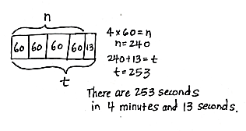T: Discuss with a partner the strategy you used to solve   
4 × 60.

T: (After discussion, call on some students to share.)

S: I thought of it as 4 × 6 tens, which equals 24 tens.   
And, 24 tens is 240. 🡪 I thought of it as (4 × 6) × 10, which is 24 × 10, which equals 240. 🡪 It’s like 24 tens is 10 tens + 10 tens + 4 tens or 100 + 100 + 40 = 240.

T: Four minutes is equal to how many seconds?

S: 240 seconds.

T: Whisper the next step to your partner.

S: Add 13 seconds to 240 seconds.

T: Add a unit of 13 to your diagram and label the total number of seconds using a letter for the unknown*.* Then, solve for *t*. How many seconds did it take you to complete the activity?

S: 253 seconds!

Project the following problems on the board and invite students to problem solve independently or in pairs using the RDW process:

|  |  |
| --- | --- |
|  | NOTES ON  MULTIPLE MEANS  OF ENGAGEMENT: |
| Give English language learners and others practice reading the word problems aloud on the Problem Set. Have students read the problems to their partners and paraphrase what the question asks them to find to improve understanding. | |

**MP.1**

* Each day Andrea does 25 squats to warm up for gymnastics practice and 15 squats to cool down after practice. How many squats does she do in all when she practices Monday through Friday?
* Benny gets $5 a week for allowance. After saving his money for 20 weeks, how much more does Benny need to buy a bike that costs $108?
* Genevieve makes 43 bracelets. She gives 13 bracelets away as gifts and sells the rest for $4 each. How much money does Genevieve make in all?

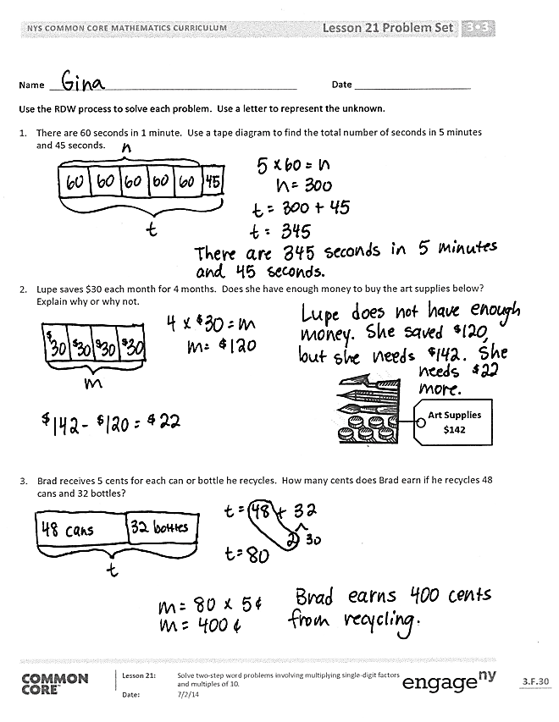The above problems represent a variety of two-step word problem types and provide varied practice for the students.

Problem Set (15 minutes)

Students should do their personal best to complete the Problem Set within the allotted 15 minutes. For some classes, it may be appropriate to modify the assignment by specifying which problems they work on first. Some problems do not specify a method for solving. Students should solve these problems using the RDW approach used for Application Problems.

Student Debrief (10 minutes)

**Lesson Objective:** Solve two-step word problems involving multiplying single-digit factors and multiples of 10.

The Student Debrief is intended to invite reflection and active processing of the total lesson experience.

Invite students to review their solutions for the Problem Set. They should check work by comparing answers with a partner before going over answers as a class. Look for misconceptions or misunderstandings that can be addressed in the Debrief. Guide students in a conversation to debrief the Problem Set and process the lesson.

You may choose to use any combination of the questions below to lead the discussion.

* 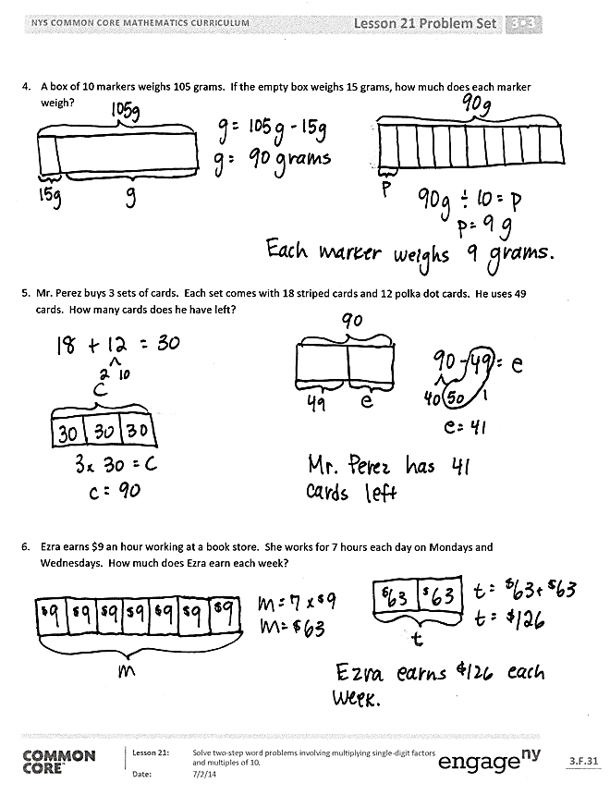In Problem 2, how many more months will Lupe need to save so she has enough to buy the art supplies? How do you know?
* In Problem 3, how many dollars does Brad earn? (You may want to prompt students by asking how many cents are in 1 dollar.)
* Discuss the second step of Problem 4 with a partner. How was this different than the other problems? Explain how you could solve it with multiplication.
* Explain the three unknowns you needed to find to solve Problem 5.
* Explain to a partner how you solved Problem 6. Explain how you could have used the multiplying by 10 strategy to help solve this problem.

Exit Ticket (3 minutes)

After the Student Debrief, instruct students to complete the Exit Ticket. A review of their work will help you assess the students’ understanding of the concepts that were presented in the lesson today and plan more effectively for future lessons. You may read the questions aloud to the students.

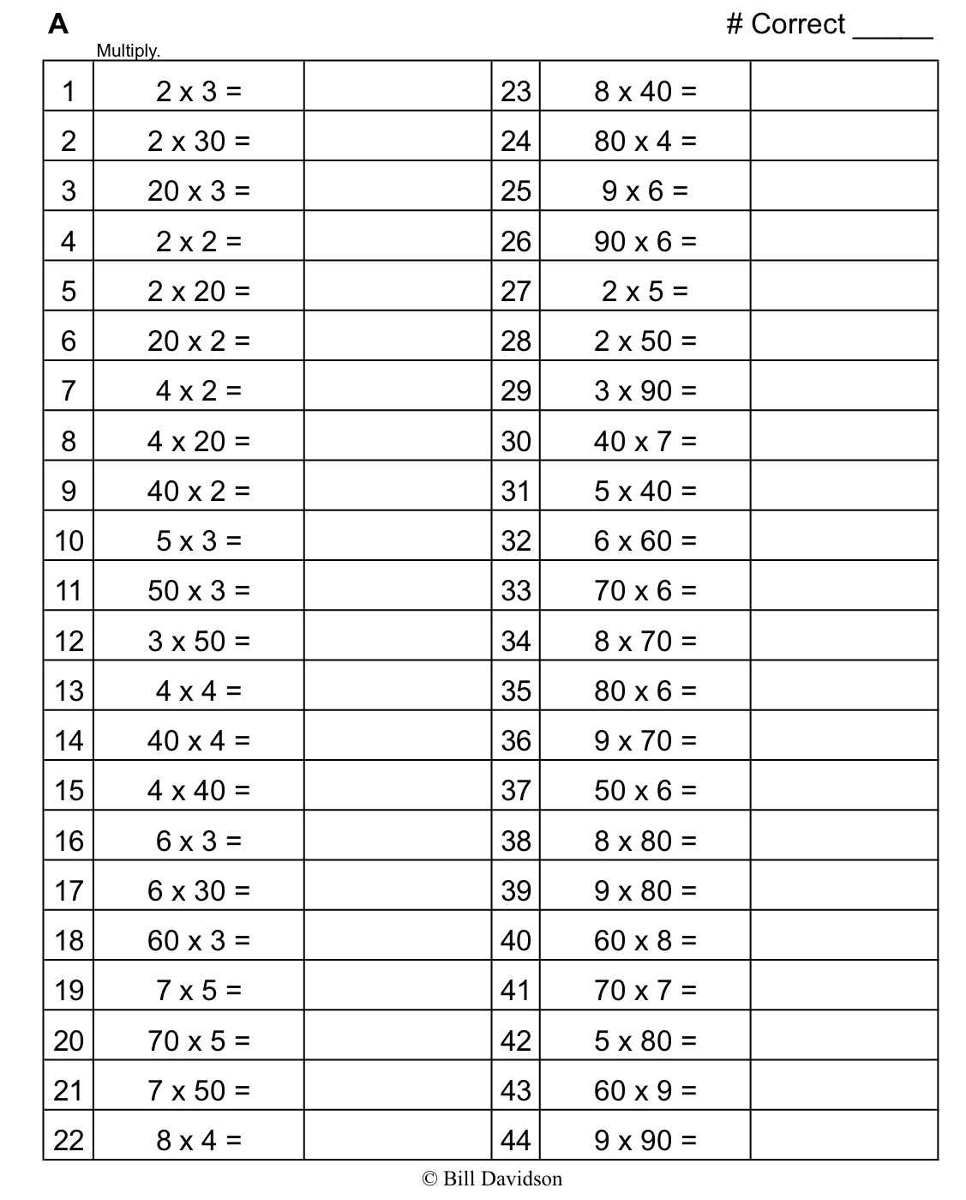

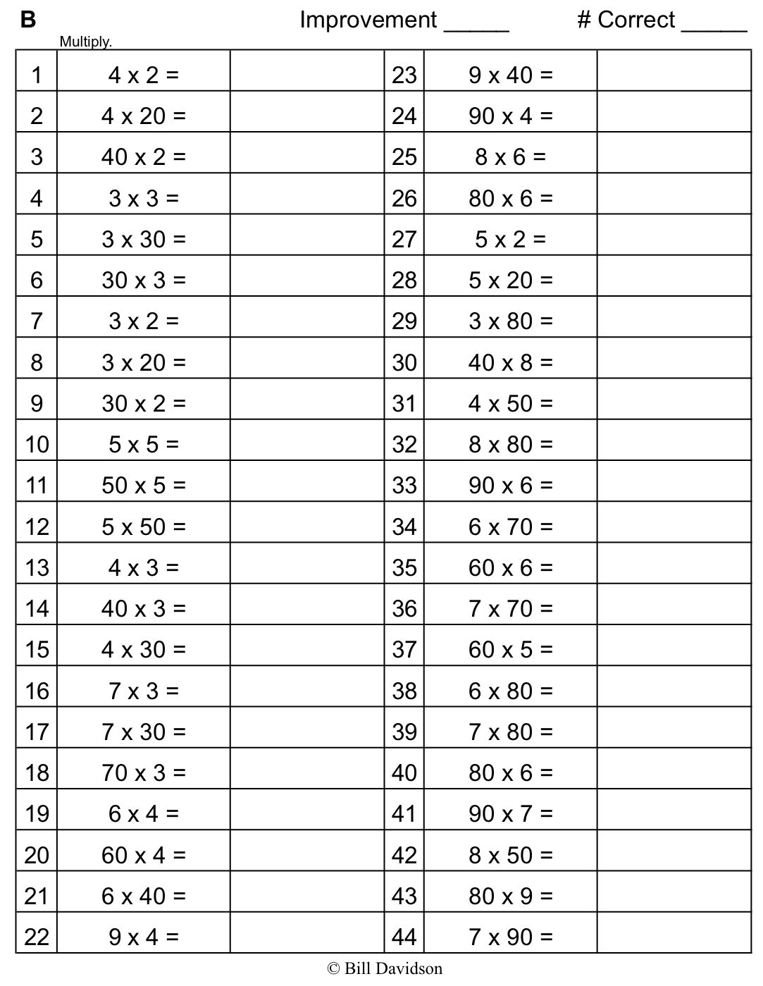

Name Date

Use the RDW process to solve each problem. Use a letter to represent the unknown.

1. There are 60 seconds in 1 minute. Use a tape diagram to find the total number of seconds in 5 minutes and 45 seconds.
2. Lupe saves $30 each month for 4 months. Does she have enough money to buy the art supplies below? Explain why or why not.



**Art Supplies $142**

1. Brad receives 5 cents for each can or bottle he recycles. How many cents does Brad earn if he recycles 48 cans and 32 bottles?
2. A box of 10 markers weighs 105 grams. If the empty box weighs 15 grams, how much does each marker weigh?
3. Mr. Perez buys 3 sets of cards. Each set comes with 18 striped cards and 12 polka dot cards. He uses 49 cards. How many cards does he have left?
4. Ezra earns $9 an hour working at a book store. She works for 7 hours each day on Mondays and Wednesdays. How much does Ezra earn each week?

Name Date

Use the RDW process to solve. Use a letter to represent the unknown.

Frederick buys a can of 3 tennis balls. The empty can weighs 20 grams, and each tennis ball weighs 60 grams. What is the total weight of the can with 3 tennis balls?

Name Date

Use the RDW process for each problem. Use a letter to represent the unknown.

1. There are 60 minutes in 1 hour. Use a tape diagram to find the total number of minutes in 6 hours and 15 minutes.
2. Ms. Lemus buys 7 boxes of snacks. Each box has 12 packets of fruit snacks and 18 packets of cashews. How many snack packets does she buy altogether?
3. Tamara wants to buy a tablet that costs $437. She saves $50 a month for 9 months. Does she have enough money to buy the tablet? Explain why or why not.
4. Mr. Ramirez receives 4 sets of books. Each set has 16 fiction books and 14 non-fiction books. He puts 97 books in his library and donates the rest. How many books does he donate?
5. Celia sells calendars for a fundraiser. Each calendar costs $9. She sells 16 calendars to her family members and 14 calendars to the people in her neighborhood. Her goal is to earn $300. Does Celia reach her goal? Explain your answer.
6. The video store sells science and history movies for $5 each. How much money does the video store make if it sells 33 science movies and 57 history movies?

|  |  |  |  |
| --- | --- | --- | --- |
| [1]  30 6 = | 9 60 = | 40 2 = | 10 6 = |
| 70 3 = | 50 6 = | 80 9 = | 20 5 = |
| 8 30 = | 3 30 = | 5 50 = | 4 40 = |
| 6 80 = | 70 7 = | 20 7 = | 10 7 = |
| 90 7 = | 2 60 = | 50 7 = | 80 5 = |
| 60 6 = | 9 50 = | 30 9 = | 4 80 = |

1. multiples of 10 multiplication cards