Lesson 20

Objective: Use place value strategies and the associative property *n* × (*m* × 10) = (*n* × *m*) × 10 (where *n* and *m* are less than 10)   
to multiply multiples of 10.

Suggested Lesson Structure

 Fluency Practice (15 minutes)

 Application Problem (5 minutes)

 Concept Development (30 minutes)

 Student Debrief (10 minutes)

**Total Time (60 minutes)**

Fluency Practice (15 minutes)

* Group Counting  **3.OA.1** (3 minutes)
* Multiply by Different Units **3.NBT.3** (6 minutes)
* Write in the Parentheses **3.OA.7** (6 minutes)

Group Counting (3 minutes)

Note: Group counting reviews interpreting multiplication as repeated addition. The counts in these lessons review the multiplication taught previously in the module. Direct students to count forward and backward, occasionally changing the direction of the count:

* Sixes to 60
* Sevens to 70
* Eights to 80
* Nines to 90

Multiply by Different Units (6 minutes)

Materials: (S) Personal white board

Note: This fluency activity reviews Lesson 19.

T: (Write 2 × 3 = ____.) Say the multiplication equation in unit form.

S: 2 ones × 3 = 6 ones.

T: Say it in standard form.

S: 2 × 3 = 6.

T: (Write 2 tens × 3 = ____.) On your personal white board, write the multiplication equation in unit form.

S: (Write 2 tens × 3 = 6 tens.)

T: Below your equation, write a second multiplication equation in standard form.

S: (Write 20 × 3 = 60.)

Continue with the following possible sequence: 4 × 2, 4 tens × 2, 5 × 3, 5 × 3 tens, 6 × 4, and 6 × 4 tens.

T: (Write 7 × 6 = ____.) Say the multiplication equation.

S: 7 × 6 = 42.

T: (Write 70 × 6 = ____.) Write the multiplication equation.

S: (Write 70 × 6 = 420.)

Continue with the following possible sequence: 8 × 8, 8 × 80; 9 × 8, 90 × 8; 6 × 6, 60 × 6; 8 × 7, 8 × 70; 4 × 9,   
40 × 9; and 9 × 6, 90 × 6.

Write in the Parentheses (6 minutes)

Materials: (S) Personal white board

Note: This fluency activity reviews the use of parentheses and prepares students for today’s lesson.

T: (Write 4 × 5 = 2 × 2 × 5.) What’s 4 × 5?

4 × 5 = 2 × 2 × 5

20 = (2 × 2) × 5

S: 20.

T: On your personal white board, copy the equation. Then, underneath the equation, write in parentheses and solve.

S: (Write 4 × 5 = 2 × 2 × 5. Beneath it, write 20 = (2 × 2) × 5.)

Continue with the following possible sequence: 6 × 4 = 6 × 2 × 2, 6 × 6 = 6 × 2 × 3, 4 × 7 = 2 × 2 × 7,   
7 × 8 = 7 × 4 × 2, 8 × 4 = 8 × 2 × 2, 8 × 6 = 8 × 3 × 2, 9 × 6 = 9 × 3 × 2, and 9 × 8 = 9 × 4 × 2.

Application Problem (5 minutes)

|  |  |
| --- | --- |
|  | NOTES ON  MULTIPLE MEANS  OF ACTION AND EXPRESSION: |
| Allow English language learners more time to compose their explanation, access to a math picture dictionary, an example of a well written response, and an opportunity to share their response (perhaps during the Debrief). | |

Model 3 × 4 on a place value chart. Then, explain how the array can help you solve 30 × 4.

**MP.3**

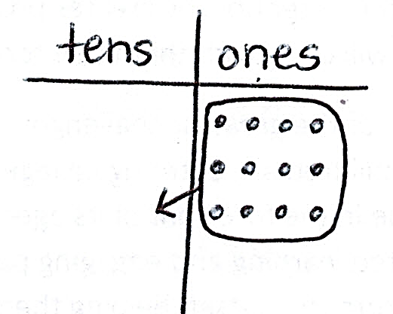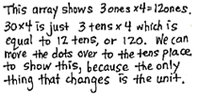

Note: This problem reviews multiplying by multiples of 10 from Lesson 19. In today’s Concept Development, students will build on their understanding from Lesson 19 to multiply by multiples of 10 using the associative property.

Concept Development (30 minutes)

|  |  |
| --- | --- |
|  | NOTES ON  MULTIPLE MEANS  OF ENGAGEMENT: |
| Allow students who are working above grade level more autonomy to experiment with the manner they use to solve, as well as with the numbers they choose. Example prompts are given below:   * Write a multiplication fact that you think is best solved using the associative property. * Write another three-factor multiplication equation with a product of 40. Compare the two equations. What do you notice? * In the equation 10 × (4 × 2), what would happen if you changed the factors inside the parentheses to numbers greater than 10? | |

Materials: (S) Personal white board

T: (Write 40 × 2.) Ten times what number gives us a product of 40?

S: 4.

T: Let’s rewrite our equation. (Write (10 × 4) × 2.)   
Why do you think I put 10 × 4 in parentheses?

S: The parentheses show that, when you group those numbers together and multiply, you get 40.   
🡪 The parentheses remind us that we put 10 × 4 where 40 used to be.

T: Let’s move the parentheses to change the way the numbers are grouped.

T: On your personal white board, use the parentheses to group the numbers differently.

S: (Write 10 × (4 × 2).)

T: Is this problem friendlier than 40 × 2?

S: Oh, it’s just 10 × 8! That’s the same as 80! That was a little easier than multiplying by 40.

Repeat the process with 20 × 3, 30 × 3, and 50 × 2.

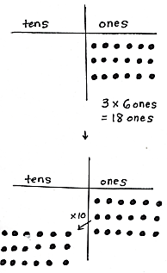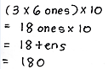

*Image A*

T: (Project or draw Image A shown.) Use the chart to write a multiplication equation in unit form.

S: (Write 3 × 6 ones = 18 ones.)

T: Now, I want to multiply 18 ones by ten. Watch as I show this on the chart. I redraw dots into the tens place and draw an arrow (draw arrow) to remind myself that they shift to the next unit. Let’s multiply our 3 groups of 6 ones by 10.

T: (Write (3 × 6 ones) × 10 = _____.) What is the answer to 18 ones × 10 in unit form?

S: 18 tens!

T: What is the value of 18 tens?

S: 180.

T: (Project or draw Image B shown next page.)   
This time, I already moved 6 ones to make them 6 tens. Use the chart to write a multiplication equation in unit form.

S: (Write 6 ones × 10 = 6 tens.)

T: Now, I want to multiply 6 tens by 3. How many rows do I need to add to show 3 rows of 6 tens?

S: 2 rows.

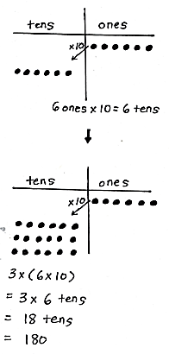

*Image B*

T: (Add 2 rows of 6 tens and write 3 × (6 × 10).) How does my array show this expression? Tell your partner.

S: There are 3 rows of 6 tens. 🡪 Six tens is the same as   
6 × 10. It has the parentheses around it because we did that first on the chart. 🡪 Then, we multiplied the   
6 × 10 by 3.

T: What is the answer to 3 × 6 tens in unit form?

S: 18 tens! 🡪 180.

T: Compare the equations (3 × 6 ones) × 10 and 3 × (6 × 10). What do you notice about the factors we used?

S: The factors are the same! 3, 6, and 10. The units are different and so is the order of what you multiply first.

T: In both charts, we saw how multiplying the ten, even at different times, made it easier to solve.

Repeat the process with (4 × 5) × 10 and 4 × (5 × 10).

Problem Set (10 minutes)

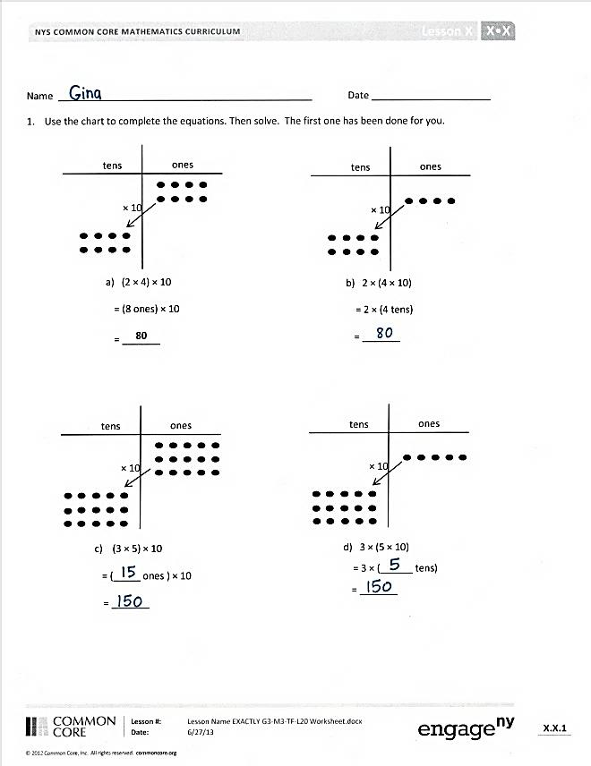

Students should do their personal best to complete the Problem Set within the allotted 10 minutes. For some classes, it may be appropriate to modify the assignment by specifying which problems they work on first. Some problems do not specify a method for solving. Students should solve these problems using the RDW approach used for Application Problems.

Student Debrief (10 minutes)

**Lesson Objective:** Use place value strategies and the associative property *n* × (*m* × 10) = (*n* × *m*) × 10 (where *n* and *m* are less than 10) to multiply by multiples of 10.

The Student Debrief is intended to invite reflection and active processing of the total lesson experience.

Invite students to review their solutions for the Problem Set. They should check work by comparing answers with a partner before going over answers as a class. Look for misconceptions or misunderstandings that can be addressed in the Debrief. Guide students in a conversation to debrief the Problem Set and process the lesson.

You may choose to use any combination of the questions below to lead the discussion.

* In Problem 1, which grouping is easier for you to solve? Why?
* How do you see the movement of the parentheses in the place value charts   
  in Problem 1?

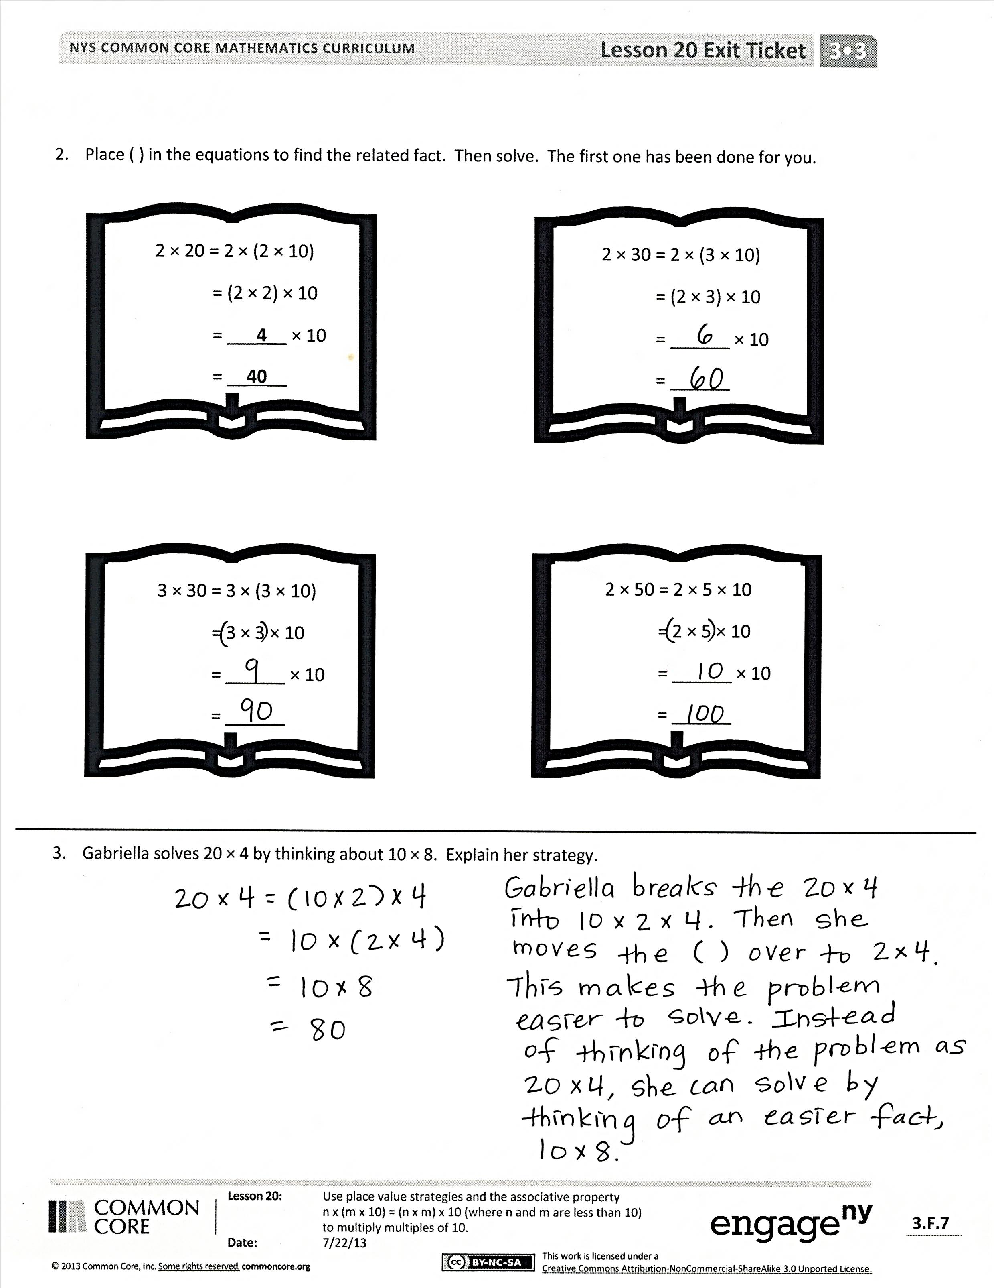

* Share with a partner how you knew where to draw parentheses for the equations in Problem 2.
* In Problem 3, how did Gabriella simplify the problem?
* Why didn’t we need to have a hundreds column in our place value charts?
* How is this new strategy helpful for finding unknown, larger facts?

Exit Ticket (3 minutes)

After the Student Debrief, instruct students to complete the Exit Ticket. A review of their work will help you assess the students’ understanding of the concepts that were presented in the lesson today and plan more effectively for future lessons. You may read the questions aloud to the students.

Name Date

1. Use the chart to complete the equations. Then, solve. The first one has been done for you.

× 10

tens

ones

b. 2 × (4 × 10)

= 2 × (4 tens)

= _______

× 10

tens

ones

a. (2 × 4) × 10

= (8 ones) × 10

= _______

**80**

× 10

tens

ones

1. (3 × 5) × 10

= ( _____ ones ) × 10

= _______

× 10

tens

ones

d. 3 × (5 × 10)

= 3 × ( ______ tens)

= _______

1. Place parentheses in the equations to find the related fact. Then, solve. The first one has been done for you.



2 × 30 = 2 × (3 × 10)

= (2 × 3) × 10

= ______ × 10

= ______



3 × 30 = 3 × (3 × 10)

= 3 × 3 × 10

= ______ × 10

= ______



2 × 50 = 2 × 5 × 10

= 2 × 5 × 10

= ______ × 10

= ______



2 × 20 = 2 × (2 × 10)

= (2 × 2) × 10

= 4 × 10

= 40

1. Gabriella solves 20 × 4 by thinking about 10 × 8. Explain her strategy.

Name Date

1. Place parentheses in the equations to find the related fact. Then, solve.

a. 4 × 20 = 4 × 2 × 10 b. 3 × 30 = 3 × 3 × 10

= 4 × 2 × 10 = 3 × 3 × 10

= ______ × 10 = _____ × 10

= ______ = _____

1. Jamila solves 20 × 5 by thinking about 10 tens. Explain her strategy.

Name Date

1. Use the chart to complete the equations. Then, solve.

× 10

tens

ones

1. (4 × 5) × 10

= (_____ ones) × 10

= _______

× 10

tens

ones

1. 4 × (5 × 10)

= 4 × (____ tens)

= _______

× 10

tens

ones

1. (2 × 5) × 10

= (10 ones) × 10

= _______

× 10

tens

ones

1. 2 × (5 × 10)

= 2 × (5 tens)

= _______

1. Solve. Place parentheses in (c) and (d) as needed to find the related fact.



3 × 20 = 3 × (2 × 10)

= (3 × 2) × 10

= 6 × 10

= ______

3 × 40 = 3 × (4 × 10)

= 3 × 4 × 10

= ______ × 10

= ______

3 × 30 = 3 × (3 × 10)

= (3 × 3) × 10

= ______ × 10

= ______

3 × 50 = 3 × 5 × 10

= 3 × 5 × 10

= ______ × 10

= ______

b.

b. )

a.

c.

d. )

1. Danny solves 5 × 20 by thinking about 10 × 10. Explain his strategy.