Lesson 19
Objective: Multiply by multiples of 10 using the place value chart.

Suggested Lesson Structure

NOTES ON
TIMING:
The Application Problem comes after the Concept Development in this lesson. The 15 minutes allotted for the Application Problem includes 5 minutes for the Application Problem and 10 minutes for the Problem Set.

 Fluency Practice (15 minutes)
 Concept Development (20 minutes)
 Application Problem (15 minutes)
 Student Debrief (10 minutes)
Total Time (60 minutes)
Fluency Practice (15 minutes)
- Group Counting 3.OA.1 (4 minutes)
- Multiply with 10 3.NBT.3 (3 minutes)
- Multiply by Different Units 3.NBT.3 (4 minutes)
- Exchange Place Value Disks 3.NBT.3 (4 minutes)
Group Counting (4 minutes)
Note: Group counting reviews interpreting multiplication as repeated addition. These counts review the multiplication taught previously in the module. Direct students to count forward and backward, occasionally changing the direction of the count:
- Sixes to 60
- Sevens to 70
- Eights to 80
- Nines to 90
Multiply with 10 (3 minutes)
Note: This fluency activity prepares students for this lesson.
T: I’ll say a multiplication problem. You say the answer. 10 × 1.
S: 10 × 1 = 10.
Continue with the following possible sequence: 10 × 2, 10 × 3, 10 × 8, and 10 × 6.
T: I’ll say a multiple of 10. You say the multiplication fact starting with 10. 20.
S: 10 × 2 = 20.
Continue with the following possible sequence: 30, 40, 90, 70, and 50.
Multiply by Different Units (4 minutes)
Materials: (S) Personal white board
Note: This fluency activity prepares students for this lesson.
T: (Write 2 × 3 = ___.) Say the multiplication equation in unit form.
S: 2 × 3 ones = 6 ones.
T: (Write 2 × 3 cats = ___.) On your personal white board, write the multiplication equation.
Continue with the following possible sequence: 3 × 4, 3 × 4 dogs; 4 × 5, 4 × 5 pencils; 5 × 6, 5 × 6 books; 6 × 7,
6 × 7 cars; 7 × 8, 7 × 8 turtles; 8 × 9, 8 × 9 chairs; and 9 × 7, 9 × 7 flowers.
Exchange Place Value Disks (4 minutes)
Materials: (S) Place value disks
Note: This fluency activity prepares students for this lesson.
T: Make an array showing 3 by 2 ones. As a multiplication equation, say how many ones you have.
S: 3 × 2 ones = 6 ones.
Continue with the following possible sequence: 3 by 3 ones, 4 by 2 ones, and 5 by 2 ones.
T: 10 ones can be exchanged for 1 of what unit?
S: 1 ten.
T: Exchange 10 ones for 1 ten.
T: Make an array showing 4 by 5 ones.
T: Say how many ones you have as a multiplication equation.
S: 4 × 5 ones = 20 ones.
T: Say the multiplication equation again; this time, say the answer in units of 10.
S: 4 × 5 ones = 2 tens.

NOTES ON
MULTIPLE MEANS
OF ACTION AND EXPRESSION:
During the Concept Development, check for understanding as students use concrete place value disks. Make sure students are distinguishing between ones disks and tens disks. Ask students to count out, “1 ten, 2 tens, 3 tens, etc.,” as they make their array. Alternatively, students may draw the disks.
T: Exchange 20 ones for 2 tens.
Concept Development (20 minutes)
Materials: (T/S) Place value disks (S) Personal white board
Problem 1: Multiply by multiples of 10 using place value disks.
T: Use your disks to show 2 rows of 3 ones.
S: (Model 2 × 3 ones array.)
T: (Write 2 × 3 ones = ______ ones.) Our array shows this equation, true?
S: True.
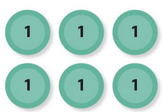
T: How many ones do we have in total?
2 × 3 ones = 6 ones
2 × 3 = 6

S: 6 ones.
T: Say the multiplication equation in standard form.
S: 2 × 3 = 6.
T: Use your disks to show 2 rows of 3 tens.
S: (Model 2 × 3 tens array.)
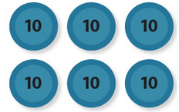
T: (Write 2 × 3 tens = ______ tens.) How many tens do we have in total?
2 × 3 tens = 6 tens
2 × 30 = 60

S: 6 tens.
T: What is the value of 6 tens?
S: 60.
T: Say the multiplication equation in standard form.
S: 2 × 30 = 60.
Repeat the process with 3 × 4 ones and 3 × 4 tens;2 × 6 ones and 2 × 6 tens.
Problem 2: Multiply by multiples of 10 using a place value chart.
tens
ones
2 × 5 ones = _______ ones
2 × 5 = _______
T: (Project or draw the place value chart shown at right.) Use the chart to write an equation in both unit form and standard form.
S: (Write 2 × 5 ones = 10 ones and 2 × 5 = 10.)
T: How many ones do I have in total?
S: 10 ones.
T: (Project or draw the place value chart shown at bottom right.) Compare the two charts. What do you notice about the number of dots?
S: The number of dots is exactly the same in both charts.
The only thing that changes is where they are placed. The dots moved over to the tens place.
tens
ones
2 × 5 tens = _______ tens
2 × 50 = _______
T: Because we still have a total of ten dots, what change do you think we will make in our equations?
S: The units will change from ones to tens.
T: Write your equations now.
S: (Write equations.)
T: Say the full equation in standard form.
S: 2 times 50 equals 100.
Repeat the process with 3 × 6 ones and 3 × 6 tens.
T: (Write 80 × 6 = _____.) How would you use this strategy to solve a more complicated problem like the one on the board?
MP.7
S: We can first think of the problem as 8 ones × 6, which is 48. We know that fact since we’ve been practicing our sixes. Then, all we have to do is move the answer over to the tens place, so it becomes 48 tens. So, the answer is 480!
Repeat the process with 7 × 90 and 60 × 4 to give the students an opportunity to discuss the unit form strategy with more complex problems.
Application Problem (15 minutes)
Mia has 152 beads. She uses some to make bracelets. Now there are 80 beads. If she uses 8 beads for each bracelet, how many bracelets does she make?

NOTES ON
TIMING:
The 15 minutes allotted for the Application Problem includes 5 minutes for the word problem to the left and 10 minutes for the Problem Set.

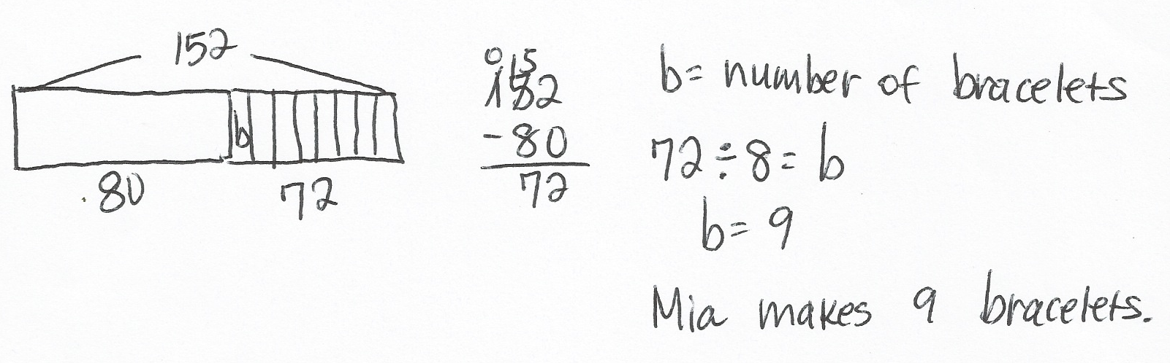

NOTES ON
MULTIPLE MEANS
OF ENGAGEMENT:
Instead of completing the Problem Set, give English language learners the option of writing a response to either of the first two Debrief questions. This chance to reflect and prepare their response in English may increase their confidence and participation in the Student Debrief.

Note: This problem reviews Lesson 18, which consisted of solving two-step word problems involving more than one operation.
Problem Set (10 minutes)
Students should do their personal best to complete the Problem Set within the allotted 10 minutes. For some classes, it may be appropriate to modify the assignment by specifying which problems they work on first. Some problems do not specify a method for solving. Students should solve these problems using the RDW approach used for Application Problems.
Student Debrief (10 minutes)
Lesson Objective: Multiply by multiples of 10 using the place value chart.
The Student Debrief is intended to invite reflection and active processing of the total lesson experience.
Invite students to review their solutions for the Problem Set. They should check work by comparing answers with a partner before going over answers as a class. Look for misconceptions or misunderstandings that can be addressed in the Debrief. Guide students in a conversation to debrief the Problem Set and process the lesson.
You may choose to use any combination of the ideas below to lead the discussion.
- How do the disks in Problem 1 show the strategy we learned today?

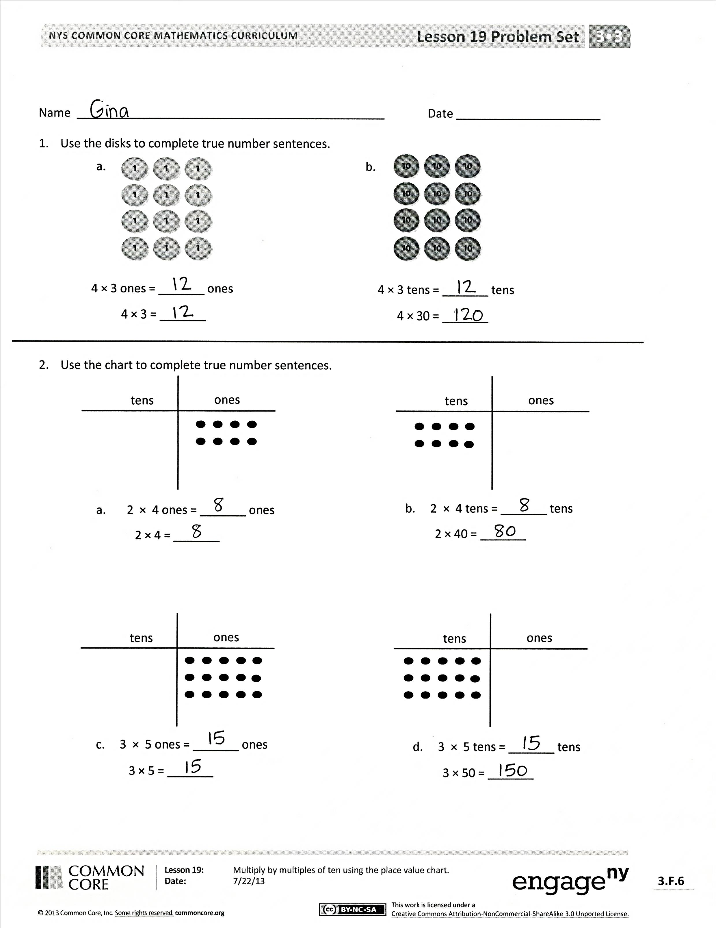
- What is the relationship between the charts in the left column and the charts in the right column in Problem 2? How did the left column help you solve the problems in the right column?
- How does knowing your multiplication facts help you easily multiply by multiples of 10?
- Now that we know a strategy for multiplying with multiples of 10, how would we use the same process for multiplying with multiples of 100? What would be the same? (The multiplication facts.) What would change? (The units.)
Exit Ticket (3 minutes)
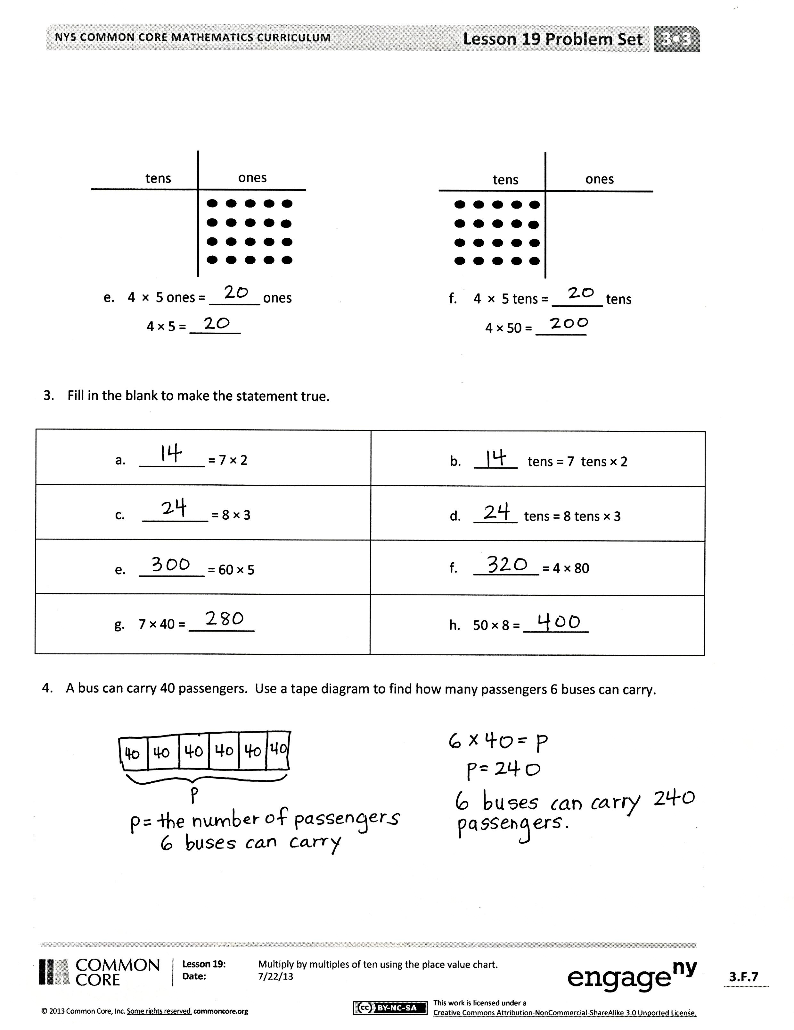
After the Student Debrief, instruct students to complete the Exit Ticket. A review of their work will help you assess the students’ understanding of the concepts that were presented in the lesson today and plan more effectively for future lessons. You may read the questions aloud to the students.

Name Date
- Use the disks to fill in the blanks in the equations.
4 × 3 ones = _______ ones
4 × 3 = _______
4 × 3 tens = _______ tens
4 × 30 = _______

b.

- Use the chart to complete the blanks in the equations.
tens
ones
b. 2 × 4 tens = _______ tens
2 × 40 = _______
tens
ones
- 2 × 4 ones = _______ ones
2 × 4 = _______
tens
ones
c. 3 × 5 ones = _______ ones
3 × 5 = _______
tens
ones
d. 3 × 5 tens = _______ tens
3 × 50 = _______

tens
ones
e. 4 × 5 ones = _______ ones
4 × 5 = _______
tens
ones
f. 4 × 5 tens = _______ tens
4 × 50 = _______

- _________ = 7 × 2 | - ______ tens = 7 tens × 2
- _________ = 8 × 3 | - ______ tens = 8 tens × 3
- _________ = 60 × 5 | - _________ = 4 × 80
- 7 × 40 = _________ | - 50 × 8 = _________
- Fill in the blank to make the equation true.

- A bus can carry 40 passengers. How many passengers can 6 buses carry? Model with a tape diagram.

Name Date
- Use the chart to complete the blanks in the equations.
tens
ones
tens
ones

6 × 5 ones = ______ ones 6 × 5 tens = ______ tens
6 × 5 = ______ 6 × 50 = ______

2. A small plane has 20 rows of seats. Each row has 4 seats.
- Find the total number of seats on the plane.

- How many seats are on 3 small planes?

Name Date
- Use the disks to complete the blanks in the equations.
a.
b.

3 × 3 ones = _______ ones
3 × 3 = _______
3 × 3 tens = _______ tens
30 × 3 = _______

- Use the chart to complete the blanks in the equations.
tens
ones
tens
ones
d. 5 × 5 tens = _______ tens
5 × 50 = _______
c. 5 × 5 ones = _______ ones
5 × 5 = _______
b. 2 × 5 tens = _______ tens
2 × 50 = _______
- 2 × 5 ones = _______ ones
2 × 5 = _______
tens
ones
tens
ones
- Match.
120
21
12
270
210
350
6 × 2
6 tens × 2
7 × 3
7 tens × 3
70 × 5
3 × 90

- Each classroom has 30 desks. What is the total number of desks in 8 classrooms? Model with a tape diagram.

