Lesson 18
Objective: Solve two-step word problems involving all four operations and assess the reasonableness of solutions.

Suggested Lesson Structure
 Fluency Practice (15 minutes)
 Concept Development (35 minutes)
 Student Debrief (10 minutes)
Total Time (60 minutes)
Fluency Practice (15 minutes)
- Sprint: Multiply and Divide with 1 and 0 3.OA.5 (8 minutes)
- Multiply with 10 3.NBT.3 (3 minutes)
- Group Counting 3.OA.1 (4 minutes)
Sprint: Multiply and Divide with 1 and 0 (8 minutes)
Materials: (S) Multiply and divide with 1 and 0 Sprint
Note: This Sprint reviews Lesson 16, which involves rules and properties when multiplying and dividing with
1 and 0.
Multiply with 10 (3 minutes)
Note: This fluency activity anticipates Lesson 19, which involves multiplying by multiples of 10 using the place value chart.
T: I’ll say a fact. You say the whole equation. 10 × 1.
S: 10 × 1 = 10.
Continue with the following possible sequence: 10 × 2, 10 × 3, 10 × 9, and 10 × 7.
T: I’ll say a product that is a multiple of 10. You say the multiplication fact starting with 10. 20.
S: 10 × 2 = 20.
Continue with the following possible sequence: 30, 40, 80, and 60.

Group Counting (4 minutes)
Note: Group counting reviews interpreting multiplication as repeated addition. These counts review multiplication taught previously in the module. Direct students to count forward and backward, occasionally changing the direction of the count.
- Sixes to 60
- Sevens to 70
- Eights to 80
- Nines to 90
Concept Development (35 minutes)
Materials: (S) Personal white board
Project the following word problem: Joe has $173 in the bank. He earns the same amount of money each week for 7 weeks and puts this money in the bank. Now, Joe has $208 in the bank. How much money does Joe earn each week?
T: Draw a model to show the total amount of money Joe has in the bank at the end of the 7 weeks.
At my signal, show me your personal white board. (Signal.)
T: Do we know the amount of money Joe puts in the bank?
S: No.
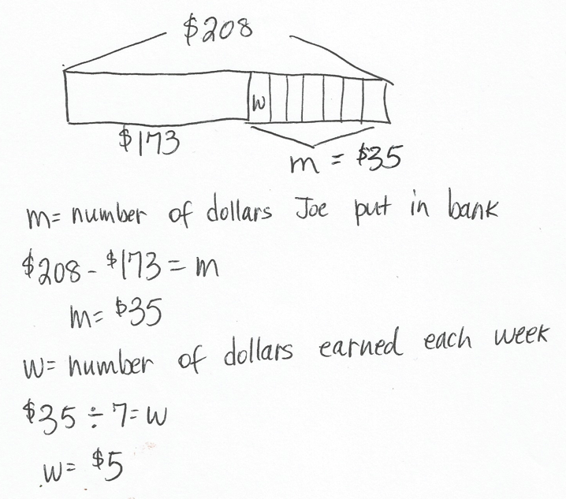
T: Label this unknown on your model using the letter m for money. Then, write what m represents. (Students write.) Write an equation to show how to solve for m.
S: (Write 208 $-$ 173 = m.)
T: Solve for m, and write its value on your model.
S: (Write m = $35.)
T: Is this answer reasonable?
S: Yes, because $173 + $35 equals $208, which is the total amount Joe has in the bank.
T: Did we answer the question in the problem?
S: No, we’re trying to figure out how much money he earns each week.
T: Adjust your model to show what you know about the amount of money Joe earns in 7 weeks.
S: (Split $35 into 7 equal pieces.)
T: Label the unknown with the letter w to represent how much money Joe earns each week. Then, write what w represents.
S: (Label. Then, write what w represents.)
T: Write an equation on your board and solve for w.
S: (Write 35 ÷ 7 = w; w = $5.)
T: Discuss with a partner. Is it reasonable that Joe earns $5 a week?
S: Yes, it makes sense because that’s how much I earn each week for my allowance! It’s reasonable because $5 a week for 7 weeks is $35 and that’s about $40. $173 is about $170 and $40 + $170 is $210, which is close to $208.
T: It’s important to make sure the answer makes sense for every part of the problem!
Problem Set (20 minutes)

NOTES ON
MULTIPLE MEANS
OF ENGAGEMENT:
When completing the Problem Set, students working above grade level may enjoy an open-ended extension. Offer students an option to choose one of the models and equations from the Problem Set to write their own word problem.
.

Students should do their personal best to complete the Problem Set within the allotted 20 minutes. For some classes, it may be appropriate to modify the assignment by specifying which problems they work on first. Some problems do not specify a method for solving. Students should solve these problems using the RDW approach used for Application Problems.
Student Debrief (10 minutes)
Lesson Objective: Solve two-step word problems involving all four operations and assess the reasonableness of solutions.

NOTES ON
MULTIPLE MEANS
OF ENGAGEMENT:
Take advantage of the opportunity in the Student Debrief to review personal and class goals regarding problem solving. Guide students to identify their strengths and weaknesses as problem solvers. Construct new goals for future work.
The Student Debrief is intended to invite reflection and active processing of the total lesson experience.
Invite students to review their solutions for the Problem Set. They should check work by comparing answers with a partner before going over answers as a class. Look for misconceptions or misunderstandings that can be addressed in the Debrief. Guide students in a conversation to debrief the Problem Set and process the lesson.
You may choose to use any combination of the questions below to lead the discussion.
- In Problem 1, you found that Sasha gives Rose a piece of yarn that is 27 centimeters long.
How many 9-centimeter pieces can Rose cut this piece into?
- In Problem 2, did Julio spend more time on his spelling homework or his math homework?
How do you know?
- How are Problems 3 and 4 similar? Discuss with a partner.
- In Problem 5, if Cora weighs 5 pencils, what is the total weight for the pencils and the ruler? How do you know?
- Discuss with a partner the importance of checking the reasonableness of your answer.
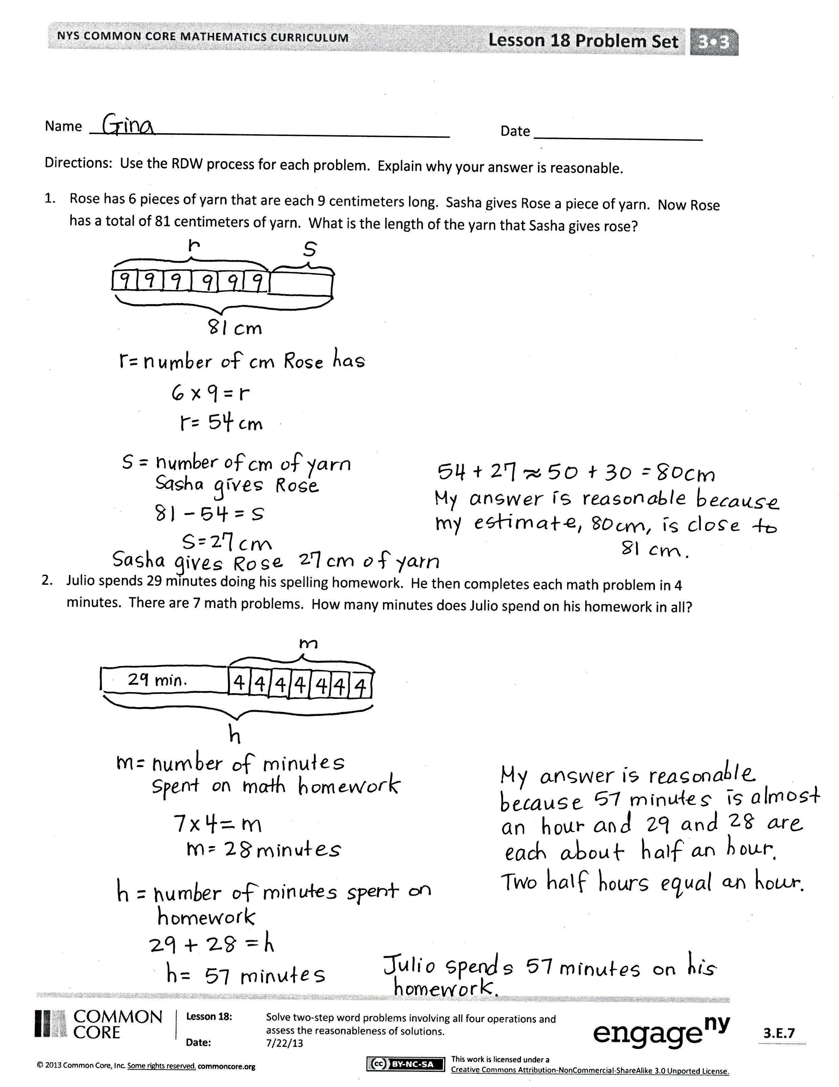
Exit Ticket (3 minutes)
After the Student Debrief, instruct students to complete the Exit Ticket. A review of their work will help you assess the students’ understanding of the concepts that were presented in the lesson today and plan more effectively for future lessons. You may read the questions aloud to the students.

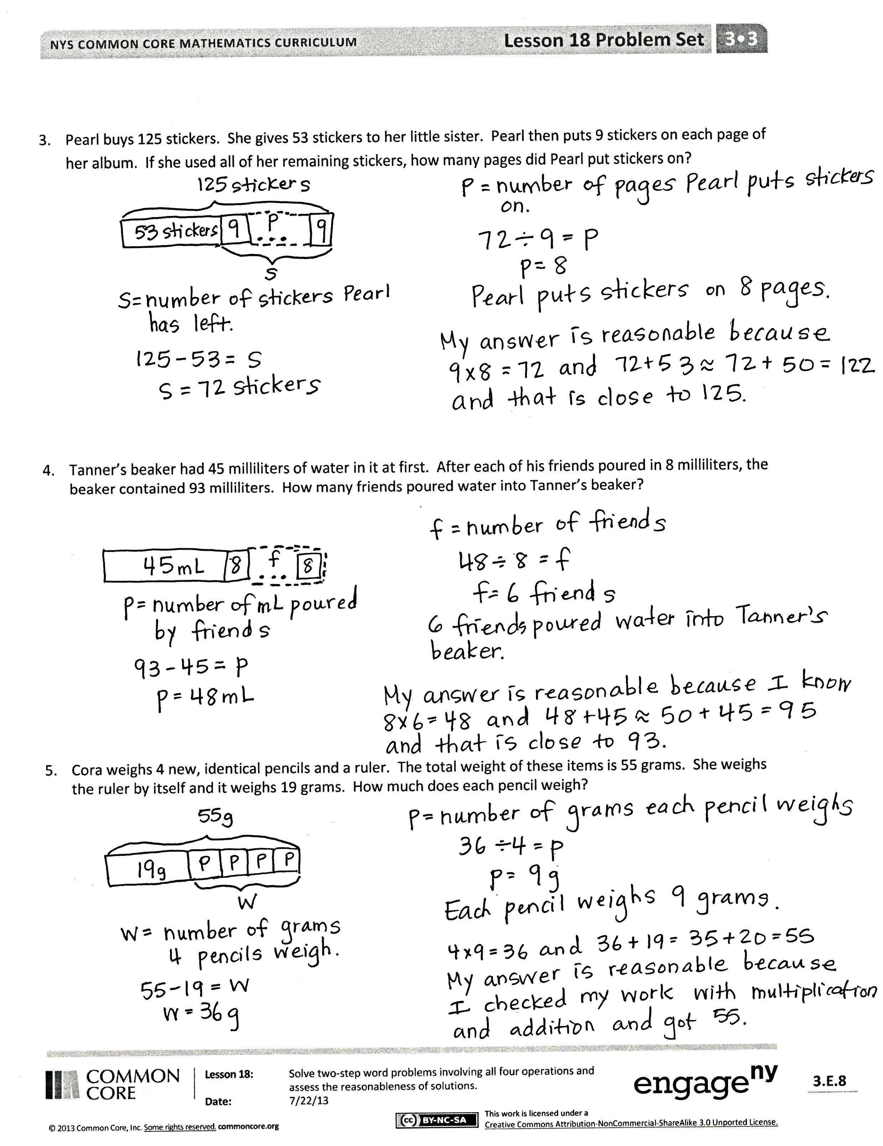
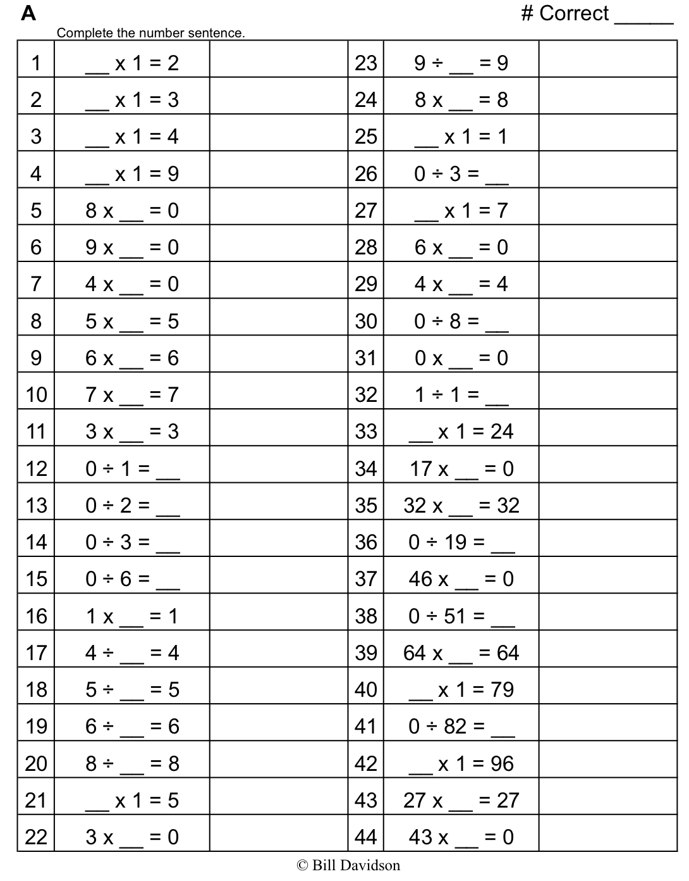

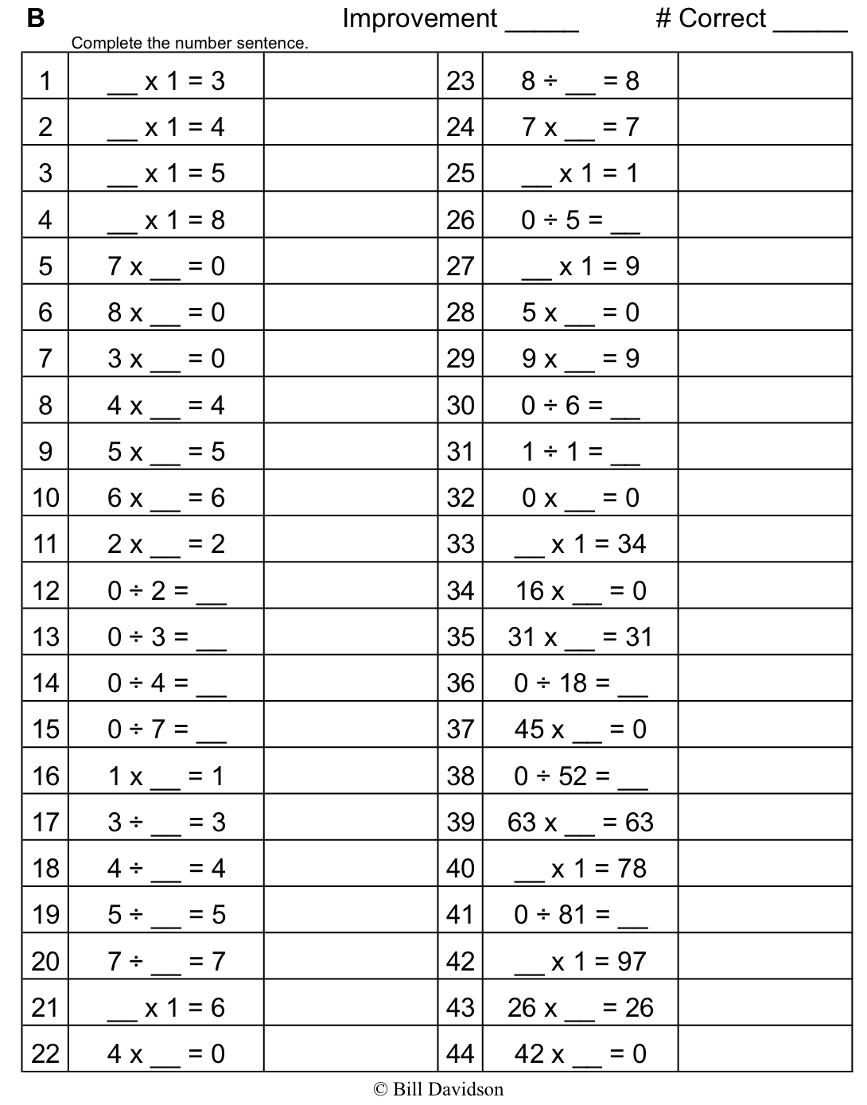

Name Date
Use the RDW process for each problem. Explain why your answer is reasonable.
- Rose has 6 pieces of yarn that are each 9 centimeters long. Sasha gives Rose a piece of yarn. Now, Rose has a total of 81 centimeters of yarn. What is the length of the yarn that Sasha gives Rose?

- Julio spends 29 minutes doing his spelling homework. He then completes each math problem in 4 minutes. There are 7 math problems. How many minutes does Julio spend on his homework in all?
- Pearl buys 125 stickers. She gives 53 stickers to her little sister. Pearl then puts 9 stickers on each page of her album. If she uses all of her remaining stickers, how many pages does Pearl put stickers on?

- Tanner’s beaker had 45 milliliters of water in it at first. After each of his friends poured in 8 milliliters, the beaker contained 93 milliliters. How many friends poured water into Tanner’s beaker?

- Cora weighs 4 new, identical pencils and a ruler. The total weight of these items is 55 grams. She weighs the ruler by itself and it weighs 19 grams. How much does each pencil weigh?

Name Date
Use the RDW process to solve. Explain why your answer is reasonable.
On Saturday, Warren swims laps in the pool for 45 minutes. On Sunday, he runs 8 miles. It takes him 9 minutes to run each mile. How long does Warren spend exercising over the weekend?

Name Date
Use the RDW process for each problem. Explain why your answer is reasonable.
- Mrs. Portillo’s cat weighs 6 kilograms. Her dog weighs 22 kilograms more than her cat. What is the total weight of her cat and dog?

- Darren spends 39 minutes studying for his science test. He then does 6 chores. Each chore takes him 3 minutes. How many minutes does Darren spend studying and doing chores?

- Mr. Abbot buys 8 boxes of granola bars for a party. Each box has 9 granola bars. After the party, there are 39 bars left. How many bars were eaten during the party?

- Leslie weighs her marbles in a jar, and the scale reads 474 grams. The empty jar weighs 439 grams. Each marble weighs 5 grams. How many marbles are in the jar?

- Sharon uses 72 centimeters of ribbon to wrap gifts. She uses 24 centimeters of her total ribbon to wrap a big gift. She uses the remaining ribbon for 6 small gifts. How much ribbon will she use for each small gift if she uses the same amount on each?

- Six friends equally share the cost of a gift. They pay $90 and receive $42 in change. How much does each friend pay?

