Lesson 17
Objective: Identify patterns in multiplication and division facts using the multiplication table.

Suggested Lesson Structure
 Fluency Practice (11 minutes)
 Application Problem (5 minutes)
 Concept Development (34 minutes)
 Student Debrief (10 minutes)
Total Time (60 minutes)
Fluency Practice (11 minutes)
- Multiply By 10 3.NBT.3 (3 minutes)
- Multiply or Divide 3.OA.7 (4 minutes)
- Complete the Number Sentence 3.OA.5 (4 minutes)
Multiply by 10 (3 minutes)
Note: This fluency activity anticipates Lesson 19, which involves multiplying by multiples of 10 using the place value chart.
T: I’ll say a fact. You say the whole equation. 10 × 1.
S: 10 × 1 = 10.
Continue with the following possible sequence: 10 × 2, 10 × 3, 10 × 8, and 10 × 5.
T: I’ll say a product that is a multiple of 10. You say the multiplication fact starting with 10. 20.
S: 10 × 2 = 20.
Continue with the following possible sequence: 30, 40, 90, 50, and 10.
Multiply or Divide (4 minutes)
Materials: (S) Personal white board
Note: This fluency activity reviews multiplication and division facts within 100.
T: (Write 6 × 1 = ___.) Say the multiplication sentence.
S: 6 × 1 = 6.
Continue with the following possible sequence: 6 × 2 and 6 × 3.
T: On your personal white board, show the answer to 6 × 7. If you need to, skip-count.
S: (Write 42.)
Continue with the following possible sequence, asking students to write answers to the harder problems on their personal white boards, while asking them to orally answer the easier problems:
30 ÷ 6, 24 ÷ 6, 60 ÷ 6, 54 ÷ 6, 7 × 1, 7 × 2, 7 × 3, 7 × 8, 35 ÷ 7, 28 ÷ 7, 70 ÷ 7, 63 ÷ 7, 49 ÷ 7, 8 × 1, 8 × 2, 8 × 3, 8 × 9, 40 ÷ 8, 48 ÷ 8, 32 ÷ 8, 80 ÷ 8, 64 ÷ 8, 9 × 1, 9 × 2, 9 × 3, 9 × 8, 45 ÷ 9, 36 ÷ 9, 54 ÷ 9, 90 ÷ 9, 81 ÷ 9, and 63 ÷ 9.
Complete the Number Sentence (4 minutes)
Materials: (S) Personal white board
Note: This fluency activity reviews multiplication and division using units of 0 and 1.
T: (Write ___ × 1 = 6.) On your personal white board, complete the equation.
S: (Write 6 × 1 = 6.)
Continue with the following possible sequence: __ × 1 = 7, 9 × __ = 9, 8 × __ = 8, 7 ÷ __ = 7, 9 ÷ __ = 9, 7 ÷ __ = 1, 9 ÷ __ = 1, 8 × __ = 0, 6 × __ = 0, 0 ÷ 7 = __, 0 ÷ 9 = __, __ ÷ 8 = 0, __ ÷ 6 = 0, __ × 1 = 8, 7 × __ = 7, 6 ÷ __ = 6,
9 × __ = 0, 6 ÷ __ = 1, 0 ÷ 6 = __, __ ÷ 9 = 0, and 9 ÷ __ = 1.
Application Problem (5 minutes)
Henry’s garden has 9 rows of squash plants. Each row has 8 squash plants. There is also 1 row with
8 watermelon plants. How many squash and watermelon plants does Henry have in all?
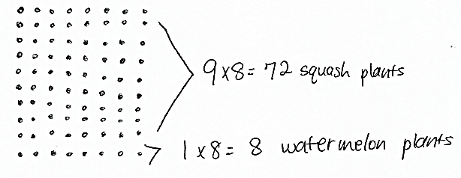
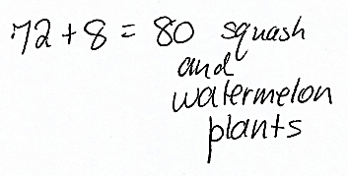
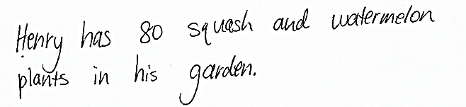

Note: This problem reviews multiplying by units of 9 and 1. Depending on how students choose to solve the problem, it can be used to review multiplying with units of 10, e.g., 10 × 8. Be sure to discuss the various strategies that can be used to solve this problem.

Concept Development (34 minutes)
Materials: (S) Personal white board, Problem Set, orange crayon
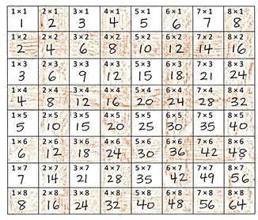
Problems 1(a) and 1(b)
Completed table from Problem 1:
T: Write the products to complete the table in Problem 1. Then, color all the squares that have even products orange.
T: Let’s look at the first orange square in the table. Write the multiplication equation on your board for the product in this square. (Students write.) Are the factors 2 and 1 odd or even?
S: 2 is even and 1 is odd.
T: Look at the orange square below this one. Write the multiplication equation on your board for the product in this square. (Students write.) Are the factors 2 and 2 odd or even?

NOTES ON
MULTIPLE MEANS
OF REPRESENTATION:
If possible and necessary, transcribe the rapid oral responses of learners who may otherwise work at a slower pace. Use color to outline rows and columns to help learners better discern the content. If you choose to highlight the column of threes facts, for example, ask students to circle even products (instead of coloring them orange).

S: They’re both even!
T: Work with a partner to continue to look at the orange squares, and tell if the factors are odd or even.
(Students finish working.) What did you notice about the factors of even products?
S: The factors are either both even or one is odd and one is even.
T: (Write the following.) Even times even equals even. Odd times even equals even.
T: Work with a partner to find out what kinds of factors are required to produce an odd product.
(Students finish working.) What did you notice?
S: Odd times odd equals odd!
T: Answer Problems 1(a) and 1(b) on the Problem Set.
Problems 1(c) and 1(d)
T: Compare the shaded columns and shaded rows. Which factors do they have in common?
S: 2, 4, 6, 8.
T: What is 5 × 4?
S: 20!
T: What is 2 × 4?
S: 8!

T: How do these 2 facts help you find 7 × 4? Talk to your partner and answer Problem 1(c) on the Problem Set.
S: 20 and 8 is 28. 2 fours + 5 fours is 7 fours. 2 plus 5 is 7, so the products of these 2 facts can be added together to get the product of 7 × 4. (Answer Problem 1(c) on the Problem Set.)
T: Is the product of 7 and 16 on this table?
S: No!
T: Talk to a partner. How can we use this table and what we know to solve 7 $×$ 16?
S: 10 sevens and 6 sevens is 16 sevens, 70 + 42. Doubling 8 sevens equals 56 + 56. 9 sevens and 7 sevens, 63 + 49. We can think of 16 as 8 + 8 and then the problem is (7 × 8) + (7 × 8). We could also add 4 sevens four times! 28 + 28 + 28 + 28!
T: Answer Problem 1(d).
Problem 2
T: Complete the chart in Problem 2 by writing the products for each equation. (Students finish working.) Read the products to me.
S: 1, 4, 9, 16, 25, 36.
T: If this chart continued, what would the next equation be?
S: 7 × 7 = 49.
T: And the next equation?
S: 8 × 8 = 64.
T: Draw arrays to match each of these equations in Problem 2. (Students finish working.) Now, record the change in the number of squares from one array to the next.
T: (Allow students time to finish.) Discuss with a partner. What is the pattern in the number of squares being added?
S: It’s 1, 3, 5, 7, like that! The increase in squares is the same as counting by the odd numbers, 1, 3, 5, 7, 9, 11, 13, 15.
T: Answer Problem 2(b).
T: What are the first 2 odd numbers when you start counting at 0?
MP.7
S: 1 and 3.
T: What is their sum?
S: 4!
T: Look at Problem 2. Four is the product of what?
S: 2 × 2.
T: The sum of the first 2 odd numbers is the same as the product of 2 × 2.
T: What is the sum of the first 3 odd numbers?
S: 9!
T: Look at Problem 2. Nine is the product of what?
S: 3 × 3.
T: Use the table in Problem 2: What do you think is the sum of the first 5 odd numbers?
S: 25!
T: Check your work: What is 1 + 3 + 5 + 7 + 9?
MP.7
S: 25!
T: Answer Problems 2(c) and 2(d).
Problem Set (10 minutes)
Students should do their personal best to complete the Problem Set within the allotted 10 minutes. For some classes, it may be appropriate to modify the assignment by specifying which problems they work on first. Some problems do not specify a method for solving. Students solve these problems using the RDW approach used for Application Problems.
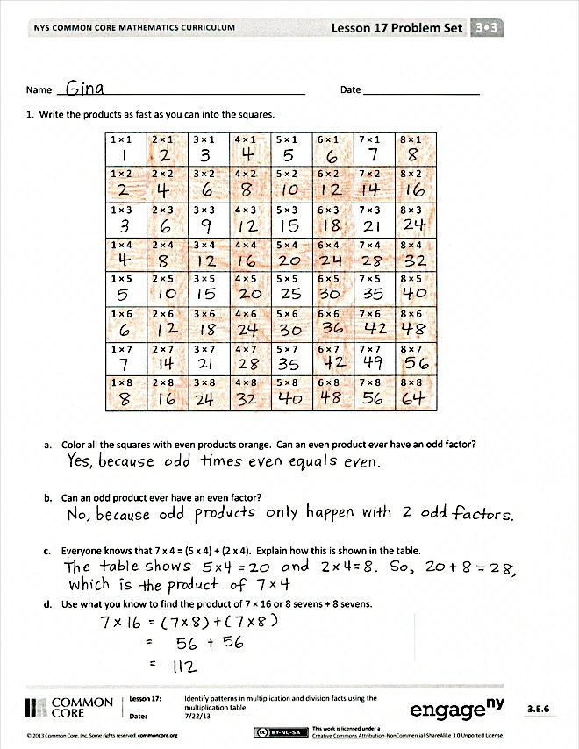
Student Debrief (10 minutes)
Lesson Objective: Identify patterns in multiplication and division facts using the multiplication table.
The Student Debrief is intended to invite reflection and active processing of the total lesson experience.
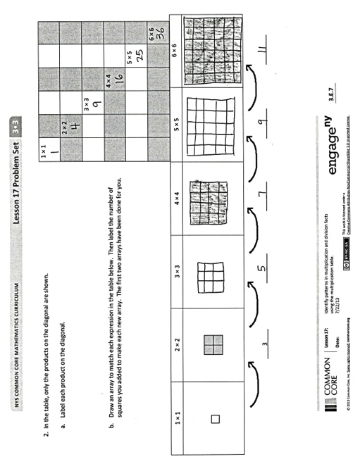
Invite students to review their solutions for the Problem Set. They should check work by comparing answers with a partner before going over answers as a class. Look for misconceptions or misunderstandings that can be addressed in the Debrief. Guide students in a conversation to debrief the Problem Set and process the lesson.
You may choose to use any combination of the questions below to lead the discussion.
- Talk to a partner: How do the patterns you discovered in Problem 1 for odd and even products help you when multiplying?
- What is the name of the strategy that you used to solve Problem 1(c)? Explain to a partner how this strategy could be used to solve another fact that isn’t on the chart, like 6 × 18.
- Look at the arrays you drew for Problem 2. If you drew an array for 7 × 7, how many little squares would you add to the array that you drew for 6 × 6? How do you know?

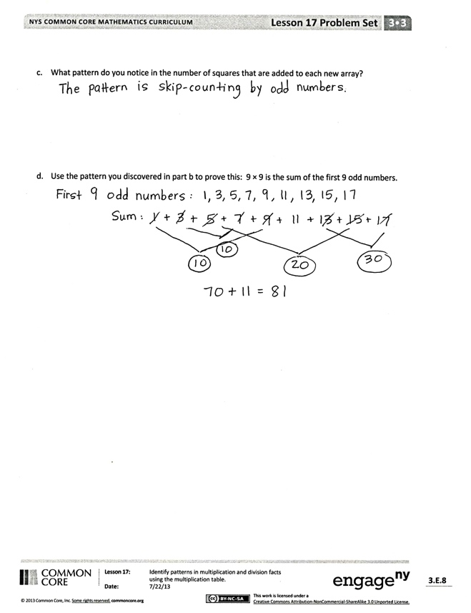
- In Problem 2(c), you proved that 9 × 9 is the sum of the first 9 odd numbers. Is 10 × 10 the sum of the first 10 odd numbers? Where can you see the odd numbers on the two-colored multiplication table? Can you state a rule that this pattern shows using n to represent a number? (Guide students to see that n × n is the sum of the first n odd numbers. These types of problems are included in the homework.)
Exit Ticket (3 minutes)
After the Student Debrief, instruct students to complete the Exit Ticket. A review of their work will help you assess the students’ understanding of the concepts that were presented in the lesson today and plan more effectively for future lessons. You may read the questions aloud.

Name Date
1. Write the products into the squares as fast as you can.
1 × 1 | 2 × 1 | 3 × 1 | 4 × 1 | 5 × 1 | 6 × 1 | 7 × 1 | 8 × 1
1 × 2 | 2 × 2 | 3 × 2 | 4 × 2 | 5 × 2 | 6 × 2 | 7 × 2 | 8 × 2
1 × 3 | 2 × 3 | 3 × 3 | 4 × 3 | 5 × 3 | 6 × 3 | 7 × 3 | 8 × 3
1 × 4 | 2 × 4 | 3 × 4 | 4 × 4 | 5 × 4 | 6 × 4 | 7 × 4 | 8 × 4
1 × 5 | 2 × 5 | 3 × 5 | 4 × 5 | 5 × 5 | 6 × 5 | 7 × 5 | 8 × 5
1 × 6 | 2 × 6 | 3 × 6 | 4 × 6 | 5 × 6 | 6 × 6 | 7 × 6 | 8 × 6
1 × 7 | 2 × 7 | 3 × 7 | 4 × 7 | 5 × 7 | 6 × 7 | 7 × 7 | 8 × 7
1 × 8 | 2 × 8 | 3 × 8 | 4 × 8 | 5 × 8 | 6 × 8 | 7 × 8 | 8 × 8

- Color all the squares with even products orange. Can an even product ever have an odd factor?

- Can an odd product ever have an even factor?

- Everyone knows that 7 × 4 = (5 × 4) + (2 × 4). Explain how this is shown in the table.

- Use what you know to find the product of 7 × 16 or 8 sevens + 8 sevens.

1 × 1
2 × 2
3 × 3
4 × 4
5 × 5
- × 6
- In the table, only the products on the diagonal are shown.
- Label each product on the diagonal.

- Draw an array to match each expression in the table below. Then, label the number of squares you added to make each new array. The first two arrays have been done for you.

1 × 1 | 2 × 2 | 3 × 3 | 4 × 4 | 5 × 5 | 6 × 6
3

- What pattern do you notice in the number of squares that are added to each new array?

- Use the pattern you discovered in Part (b) to prove this: 9 × 9 is the sum of the first 9 odd numbers.
Name Date
1. Use what you know to find the product of 8 × 12 or 6 eights + 6 eights.

2. Luis says 3 × 233 = 626. Use what you learned about odd times odd to explain why Luis is wrong.

Name Date
- a. Write the products into the chart as fast as you can.
× | 1 | 2 | 3 | 4 | 5 | 6 | 7 | 8
1
2
3
4
5
6
7
8

- Color the rows and columns with even factors yellow.

- What do you notice about the factors and products that are left unshaded?

- Complete the chart below by filling in each blank and writing an example for each rule.
Rule | Example
odd times odd equals __________

even times even equals __________

even times odd equals __________

- Explain how 7 × 6 = (5 × 6) + (2 × 6) is shown in the table.

- Use what you know to find the product of 4 × 16 or 8 fours + 8 fours.

2. Today in class, we found that n × n is the sum of the first n odd numbers. Use this pattern to find the value of n for each equation below. The first is done for you.
- 1 + 3 + 5 = n × n

9 = 3 × 3

- 1 + 3 + 5 + 7 = n × n

- 1 + 3 + 5 + 7 + 9 + 11 = n × n

- 1 + 3 + 5 + 7 + 9 + 11 + 13 + 15 = n × n

- 1 + 3 + 5 + 7 + 9 + 11 + 13 + 15 + 17 + 19 = n × n

