Lesson 16
Objective: Reason about and explain arithmetic patterns using units
of 0 and 1 as they relate to multiplication and division.

Suggested Lesson Structure
 Fluency Practice (9 minutes)
 Concept Development (41 minutes)
 Student Debrief (10 minutes)
Total Time (60 minutes)

A NOTE ON
STANDARDS ALIGNMENT:
The last six problems on the Sprint extend beyond Grade 3 multiplication and division standards because students who have mastered their times tables are likely to otherwise go unchallenged during this activity. By extending to products above 90 and quotients above 10, strong students are provided the stimulus to stretch their conceptual understanding, which may keep them engaged and invigorated to improve on Sprint B.

Fluency Practice (9 minutes)
- Sprint: Divide By 9 3.OA.7 (9 minutes)

Sprint: Divide by 9 (9 minutes)
Materials: (S) Divide By 9 Sprint
Note: This Sprint reviews Lessons 12–15, focusing on the relationship between multiplication and division using units of 9.
Concept Development (41 minutes)
Materials: (S) Personal white board

NOTES ON
MULTIPLE MEANS
OF ACTION AND EXPRESSION:
One group is often challenging for students to represent because they tend to interpret it as the number in the set. The opening activity starts with 3 groups and works back to 1 group to avoid this misconception. Stay alert to it as you circulate, and support students with their work in Problem 1.

Problem 1: Multiply and divide using units of 1.
T: Draw three large circles on your personal white board. Draw an equal number of dots in each circle. You can draw between 2 and 10 dots in each circle. You choose! How many groups are there?
S: 3!
T: Write a multiplication equation to represent your picture. Read your equation to a partner.
T: Erase one of the circles. How many groups now?
S: 2!
T: Write a multiplication equation to represent your picture. Read your equation to a partner.
T: Erase one of the circles. How many groups now?

NOTES ON
MULTIPLE MEANS
OF REPRESENTATION:
English language learners and others may benefit from a scaffolded review of unknowns represented as letters. Start with a frame using blanks (___ × 1 = ___), then question marks (? × 1 = ?), then a number × 1 = a number, and finally, n × 1 = n.

S: 1!
T: Write a multiplication equation to represent your picture. Read your equation to me. (Call on students to read equations and record.)
T: Rewrite your equation. Let n equal the number of dots in each group. What is 1 times n dots?
S: It’s n because the number of dots in each group is the same as the total number of dots.
T: What is 1 times a number equal to?
S: That number!
T: Write the related division fact for your multiplication equation. Read it at my signal. (Signal.)
S: n ÷ 1 = n.
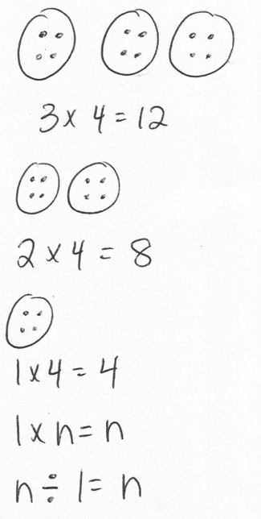
T: Use your picture to discuss with a partner. Why is our division equation true?
S: It shows the total number of dots, n, divided into 1 group. That equals n counters in each group.
T: What is a number divided by 1?
S: That number!
Repeat this process, drawing n circles with 3 dots in each circle. Students erase 1 dot from each circle and write multiplication equations to represent their pictures until they are left with n circles and 1 dot in each circle. This demonstrates n × 1 = n and n ÷ n = 1.
T: What patterns did we discover for multiplying and dividing by units of 1?
S: Any number times 1 equals that number, any number divided by 1 equals that number, and any number divided by itself equals 1.
Problem 2: Multiply and divide using units of 0.
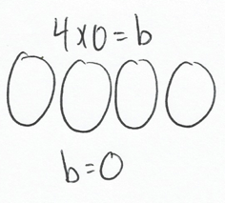
T: (Write 4 × 0 = b on the board.) What does this equation represent?
S: Four groups of 0.
T: Draw a picture of the equation using circles to show the groups and dots to show the number in each group. (Allow students time to draw.) How many dots did you draw in each group?
S: Zero!
T: There are a total of 0 dots, so 4 times 0 equals?
S: Zero!
T: What is the value of b in the equation?
S: b equals 0.
Continue with the following possible suggestions: 7 × 0, 6 × 0, and 0 × 0.
T: What pattern did you notice?
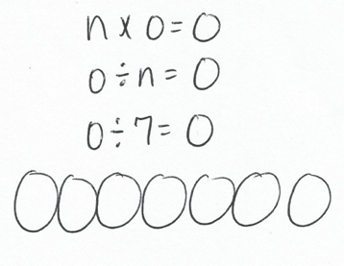
S: Any number times 0 equals 0.
T: Write that equation using n to represent a number.
S: n × 0 = 0.
T: Write the related division equation on your board.
S: 0 ÷ n = 0.
T: What does this equation represent?
S: Zero divided by a number equals 0.
T: Let’s choose a value for n and see if we get a true equation. Rewrite the equation, letting n equal 7. (After students write 0 ÷ 7 = 0.) What does this equation represent?
S: Zero things divided into 7 groups equals 0.
T: Draw a picture of the equation using circles to show the groups and dots to show the number in each group. (Allow students time to draw.) How many dots did you draw in each group?
S: Zero!
T: Zero divided by 7 equals?
S: Zero!
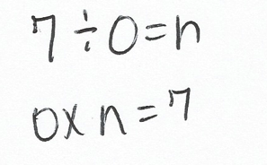
T: Rewrite the equation to show 7 things divided into 0 groups equals n.
S: (Write 7 ÷ 0 = n.)
T: What is the related multiplication fact?
MP.7
S: 0 × n = 7.
T: What does this equation represent?
S: Zero times a number equals 7!
T: Talk with your partner; is this possible?
S: No, because any number times 0 equals 0, not 7.
T: There’s no value for n that would make a true multiplication sentence, and the same is true for the division equation.
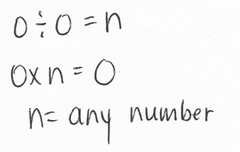
T: Let’s look at a special case of dividing by 0. Write 0 ÷ 0 = n on your board. What is the related multiplication fact?
S: 0 × n = 0.
T: What does this equation represent?
S: Zero times a number equals 0.
T: Talk with a partner; what is the value of n?
S: Any number! n can be any number because when you multiply any number times 0, it equals 0.

T: n could be 3, 2, 5, 6, or any other number. n can be any number in the multiplication equation, and the same is true for the division equation. Work with your partner to try a few different numbers in the multiplication and division equations.
MP.7
S: (Plug in a variety of values.)
T: What do you notice?
S: Lots of numbers work!
T: Right, there isn’t one single value for n in this case. Talk with a partner about what patterns you discovered for dividing by 0.

Problem Set (10 minutes)
Students should do their personal best to complete the Problem Set within the allotted 10 minutes. For some classes, it may be appropriate to modify the assignment by specifying which problems they work on first. Some problems do not specify a method for solving. Students should solve these problems using the RDW approach used for Application Problems.
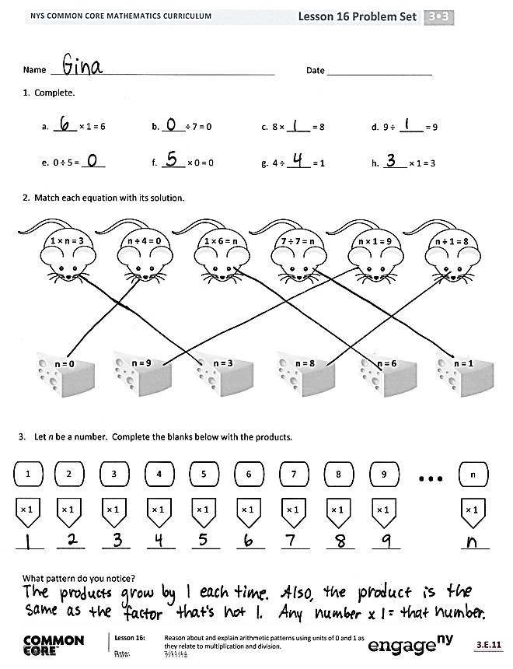
Student Debrief (10 minutes)
Lesson Objective: Reason about and explain arithmetic patterns using units of 0 and 1 as they relate to multiplication and division.
The Student Debrief is intended to invite reflection and active processing of the total lesson experience.
Invite students to review their solutions for the Problem Set. They should check work by comparing answers with a partner before going over answers as a class. Look for misconceptions or misunderstandings that can be addressed in the Debrief. Guide students in a conversation to debrief the Problem Set and process the lesson.
You may choose to use any combination of the questions below to lead the discussion.
- Discuss with a partner, what patterns for multiplying and dividing by 0 and 1 helped you solve Problem 1?
MP.7
- What pattern for multiplying by 1 does Problem 3 represent?
- Which problems show that we can’t define a single specific value when we divide by 0? Explain your answer to a partner.
- How is multiplying by 1 and multiplying units of 1 similar to adding 0 to a number?
- How can the patterns for multiplying and dividing by 1 or multiplying and dividing 0 by a number help you solve equations with larger factors, e.g., 346 × 1 = b?
MP.7
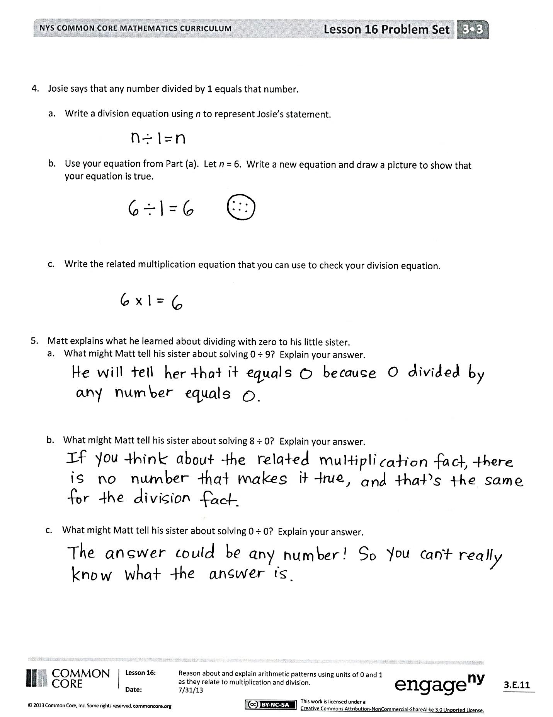
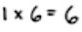
Exit Ticket (3 minutes)
After the Student Debrief, instruct students to complete the Exit Ticket. A review of their work will help you assess the students’ understanding of the concepts that were presented in the lesson today and plan more effectively for future lessons. You may read the questions aloud to the students.

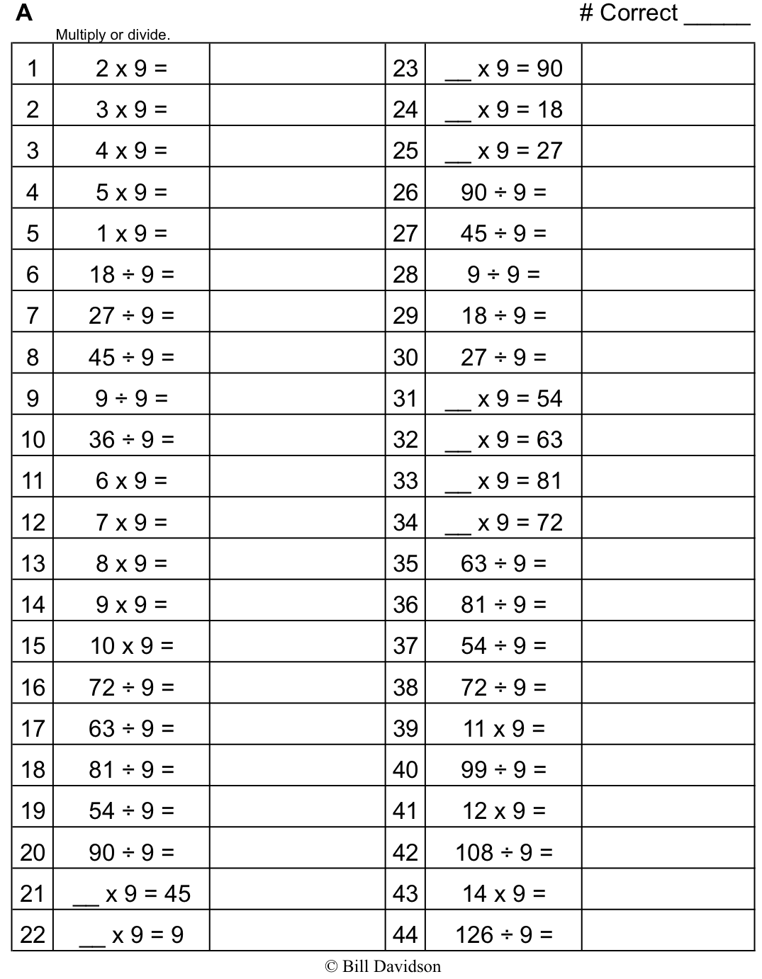
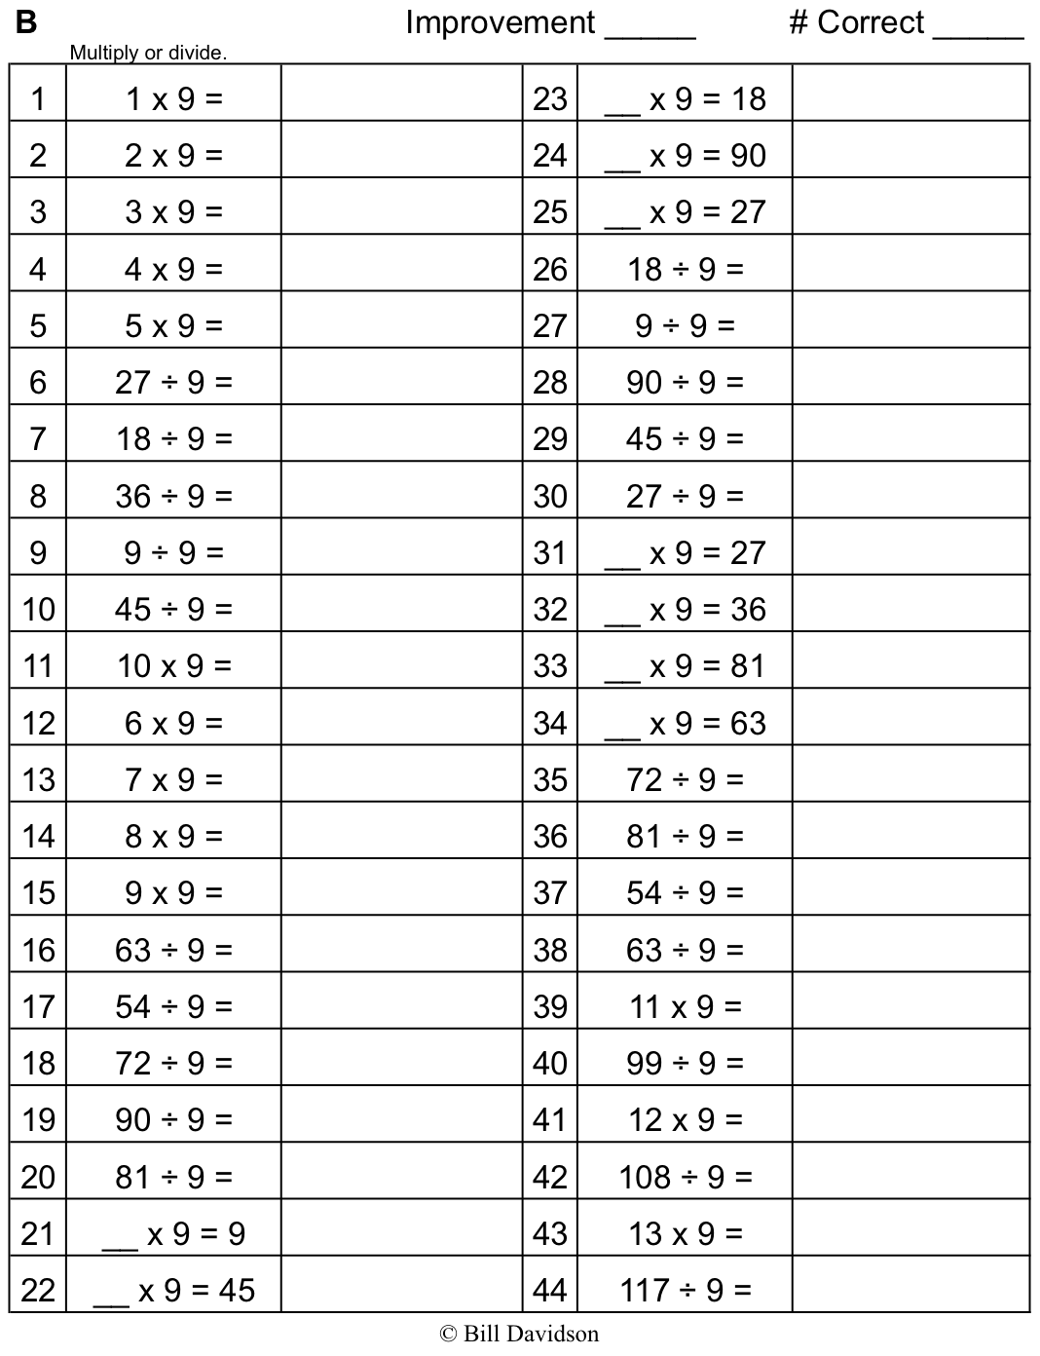
Name Date
1. Complete.

a. _____ × 1 = 6 | b. _____ ÷ 7 = 0 | c. 8 × _____ = 8 | d. 9 ÷ _____ = 9
e. 0 ÷ 5 = _____ | f. _____ × 0 = 0 | g. 4 ÷ _____ = 1 | h. _____ × 1 = 3
2. Match each equation with its solution.
1 × n = 3
n ÷ 4 = 0
1 × 6 = n
7 ÷ 7 = n
n × 1 = 9
n ÷ 1 = 8
n = 1
n = 6
n = 8
n = 3
n = 9
n = 0

3. Let n be a number. Complete the blanks below with the products.
× 1
1
______
× 1
3
______
× 1
2
______
× 1
4
______
× 1
5
______
× 1
6
______
× 1
7
______
× 1
8
______
× 1
9
______
× 1
n
______
…
What pattern do you notice?

- Josie says that any number divided by 1 equals that number.
- Write a division equation using n to represent Josie’s statement.
- Use your equation from Part (a). Let n = 6. Write a new equation, and draw a picture to show that your equation is true.

- Write the related multiplication equation that you can use to check your division equation.

- Matt explains what he learned about dividing with zero to his little sister.
- What might Matt tell his sister about solving 0 ÷ 9? Explain your answer.

- What might Matt tell his sister about solving 8 ÷ 0? Explain your answer.

- What might Matt tell his sister about solving 0 ÷ 0? Explain your answer.

Name Date
  - Complete.

- _____ × 1 = 5 b. 6 × _____ = 6 c. _____÷ 7 = 0

d. 5 × _____ = 0 e. 1 = 9 ÷ _____ f. 8 = 1 × _____

  - Luis divides 8 by 0 and says it equals 0. Is he correct? Explain why or why not.

Name Date
  - Complete.
a. 4 × 1 = ______ | b. 4 × 0 = _____ | c. _____ × 1 = 5 | d. _____ ÷ 5 = 0
e. 6 × _____ = 6 | f. _____ ÷ 6 = 0 | g. 0 ÷ 7 = _____ | h. 7 × _____ = 0
i. 8 ÷ _____ = 8 | j. _____ × 8 = 8 | k. 9 × _____ = 9 | l. 9 ÷ _____ = 1

- Match each equation with its solution.
9 × 1 = w
w × 1 = 6
7 ÷ w = 1
w ÷ 8 = 0 w
1 × w = 8
9 ÷ 9 = w
w = 6
w = 7
w = 8
w = 9
w = 1
w = 0

- Let c = 8. Determine whether the equations are true or false. The first one has been done for you.
- c × 0 = 8 | False
- 0 × c = 0
- c × 1 = 8
- 1 × c = 8
- 0 ÷ c = 8
- 8 ÷ c = 1
- 0 ÷ c = 0
- c ÷ 0 = 8

- Rajan says that any number multiplied by 1 equals that number.
- Write a multiplication equation using n to represent Rajan’s statement.

- Using your equation from Part (a), let n = 5, and draw a picture to show that the new equation is true.

