Lesson 15
Objective: Interpret the unknown in multiplication and division to model and solve problems.

Suggested Lesson Structure
 Fluency Practice (15 minutes)
 Concept Development (35 minutes)
 Student Debrief (10 minutes)
Total Time (60 minutes)
Fluency Practice (15 minutes)
- Multiply By 9 3.OA.7 (7 minutes)
- Group Counting 3.OA.1 (4 minutes)
- Divide by 9 3.OA.7 (4 minutes)
Multiply By 9 (7 minutes)
Materials: (S) Multiply By 9 (6–10) (Pattern Sheet)
Note: This activity builds fluency with respect to multiplication facts using units of 9. It supports students knowing from memory all products of two one-digit numbers. See Lesson 5 for the directions regarding administering a Multiply By Pattern Sheet.
T: (Write 6 × 9 = ____.) Let’s skip-count up by nine to solve. (Count with fingers to 6 as students count.)
S: 9, 18, 27, 36, 45, 54.
T: Let’s skip-count down to find the answer, too. Start at 90. (Starting with 10 fingers, count down as students count.)
S: 90, 81, 72, 63, 54.
T: Let’s skip-count up again to find the answer, but this time start at 45. (Starting with 5 fingers, count up as students count.)
S: 45, 54.
Continue with the following possible suggestions: 8 × 9, 7 × 9, and 9 × 9.
T: (Distribute the Multiply By 9 Pattern Sheet.) Let’s practice multiplying by 9. Be sure to work left to right across the page.
Group Counting (4 minutes)
Note: Group counting reviews interpreting multiplication as repeated addition. Counting by sixes, sevens, and eights reviews multiplication taught previously in the module. Direct students to count forward and backward, occasionally changing the direction of the count.
- Sixes to 60
- Sevens to 70
- Eights to 80

Divide by 9 (4 minutes)
Materials: (S) Personal white board
Note: This fluency activity reviews using a letter to represent the unknown, which was first taught in
Lesson 3.
T: (Write a × 9 = 18.) On your personal white board, write the value of a.
S: (Write a = 2.)
T: (Write 18 ÷ 9 = ___.) Say the division sentence.
S: 18 ÷ 9 = 2.
Continue with the following possible sequence: b × 9 = 45, c × 9 = 36, d × 9 = 54, e × 9 = 27, f × 9 = 90,
g × 9 = 81, and h × 9 = 72.
Concept Development (35 minutes)
Materials: (S) Personal white board
Problem 1: Interpret the unknown in multiplication.
Write or project the following problem: Ada buys 9 packs of highlighters with 4 in each pack. After giving 1 highlighter to each classmate, she has 17 left. How many highlighters does Ada give away?

NOTES ON
MULTIPLE MEANS
OF ENGAGEMENT:
Students working above grade level and others may not identify a strategy for solving 9 × 4 = 36, instead saying, “It’s easy! I just knew it.” Challenge students to articulate strategies that work so well they seem automatic. Ask, “Did you count by fours? Did you switch the factors and calculate 4 × 9 instead? Did you use a pattern to solve? If so, what pattern?”

T: Model the problem. Then, tell your partner the steps you’ll follow to solve it.
S: (Model.) First, you have to find out how many highlighters Ada has. After that, subtract 17 from the total to see how many she gives away.
T: Write and solve an equation to find the total number of highlighters. Use h to represent the unknown. (Allow students time to finish their work.)
T: What equation did you use?
S: 9 × 4 = h.
T: Talk to your partner. What strategy for solving nines facts did you use?
S: (Discuss.)
T: What is the value of h?
S: The value of h is 36.
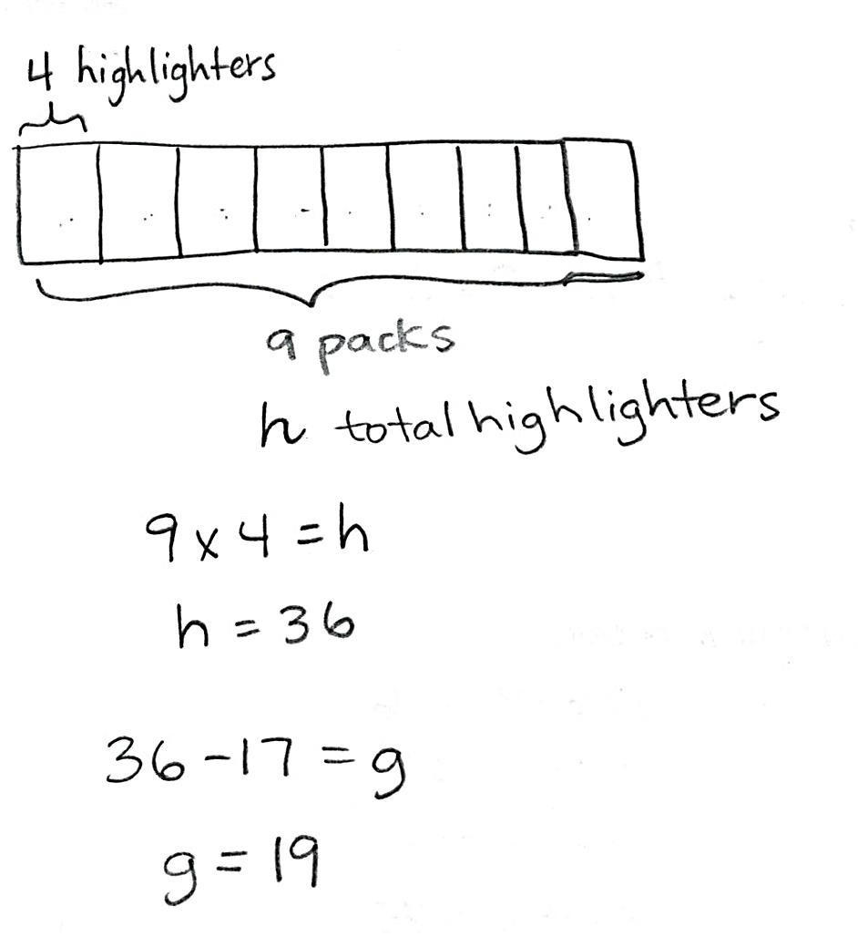
T: How many highlighters does Ada have at the start?
S: 36 highlighters.
T: Is the problem complete yet?
S: No, we have to find how many highlighters Ada gives away.
T: Solve the second step of the problem using the letter g to represent the unknown.
S: (Write 36 – 17 = g and solve.)
T: What is the value of g?
S: The value of g is 19.
T: How many highlighters does Ada give away?
S: Ada gives away 19 highlighters.
T: Can we tell how many classmates Ada has? How do you know?
S: Ada has 19 classmates! I know because she gave 1 highlighter to each classmate, and she gave away 19 highlighters.
Problem 2: Interpret the unknown in division.

NOTES ON
MULTIPLE MEANS
OF ACTION AND EXPRESSION:
Some students may mistakenly interpret the divisor to be 8 rather than 9. Use this example to highlight the advantages of carefully reading word problems and drawing a picture to solve. Guide students to underline Eliza and each of her friends in the final question before attempting an equation.

Write the following problem: Eliza finds a bag of 72 marbles and runs to share them with 8 of her friends. She’s so excited that she drops the bag and loses 18 marbles. How many marbles will Eliza and each of her friends get?
T: What should we do first, subtract or divide? Why?
S: We should subtract. Subtract because we need to find out how many marbles Eliza has left after she loses some.
T: Write an equation to solve for the first unknown. Use m to represent the number of marbles Eliza has.
S: (Solve 72 – 18 = m.)
T: What is the value of m?
S: 54!
T: So, how many marbles does Eliza have to give away?
S: 54 marbles!
T: Is our work on this problem finished?
S: No! Now we have to find out how many marbles each friend gets!
T: Draw a model that represents how many marbles each friend gets.
T: (After finishing.) How many units are in your model?
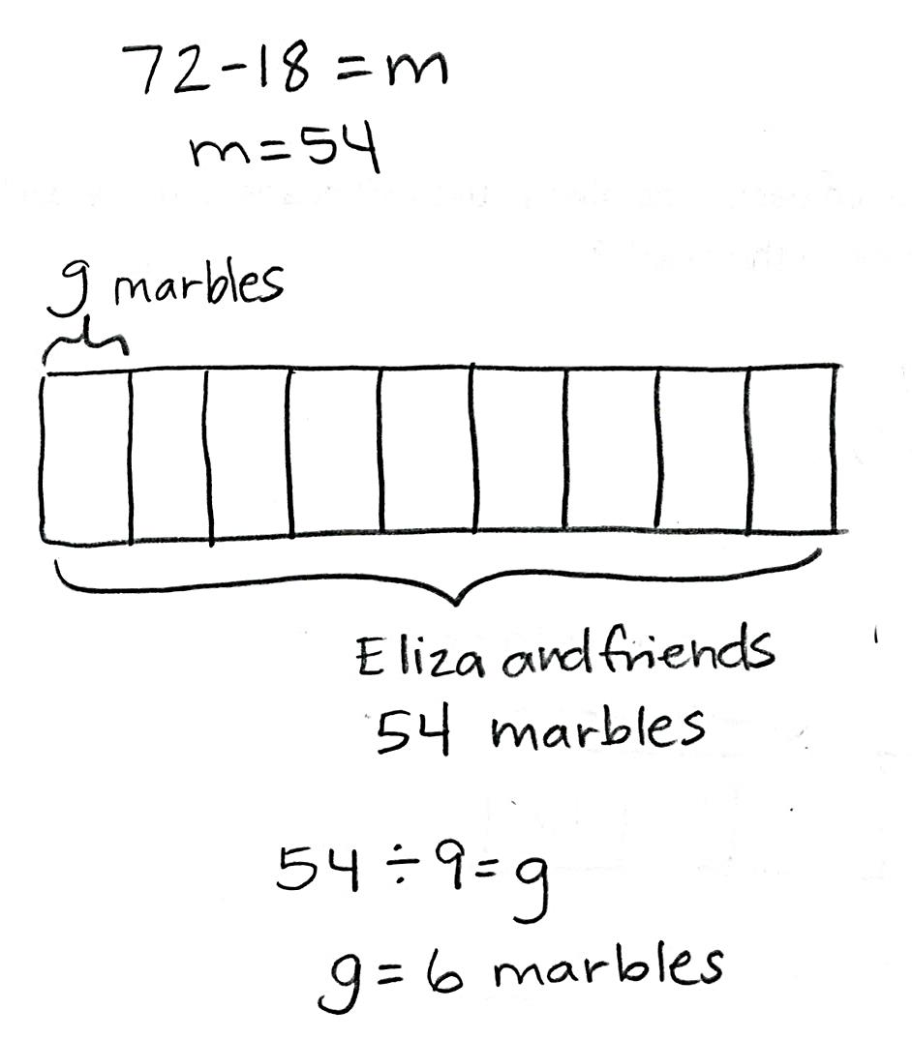
S: 9 units.
T: What part of the problem tells you that your model needs 9 units?
S: Where it says, “Eliza and each of her friends.” She has 8 friends, and 8 + 1 = 9.
T: Write an equation to solve for the second unknown. Use g to represent the number of marbles each friend gets.
S: (Solve 54 ÷ 9 = g.)
T: How many marbles does each friend get? How do you know?
S: Each friend gets 6 marbles. 6 marbles because the value of
g is 6, and g represents the number of marbles each friend gets.
Problem Set (10 minutes)
Students should do their personal best to complete the Problem Set within the allotted 10 minutes. For some classes, it may be appropriate to modify the assignment by specifying which problems they work on first. Some problems do not specify a method for solving. Students should solve these problems using the RDW approach used for Application Problems.
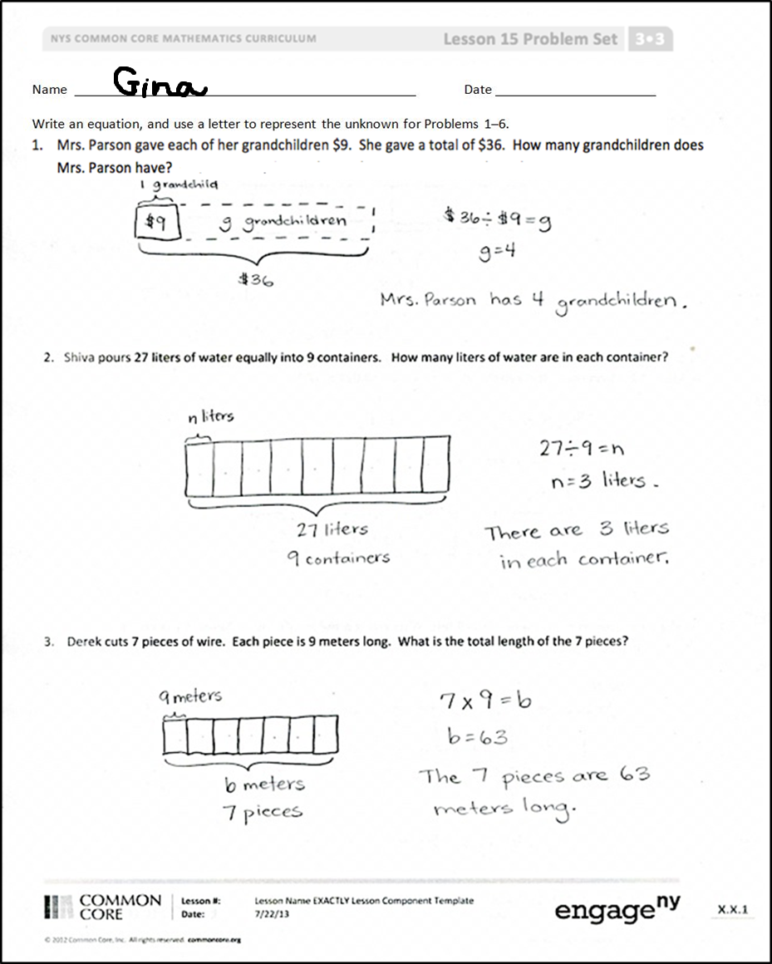
Student Debrief (10 minutes)
Lesson Objective: Interpret the unknown in multiplication and division to model and solve problems.
The Student Debrief is intended to invite reflection and active processing of the total lesson experience.
Invite students to review their solutions for the Problem Set. They should check work by comparing answers with a partner before going over answers as a class. Look for misconceptions or misunderstandings that can be addressed in the Debrief. Guide students in a conversation to debrief the Problem Set and process the lesson.
You may choose to use any combination of the questions below to lead the discussion.
- In your model for Problem 1, is the unknown the number of units or the size of each unit?
- In Problem 3, how did you show what letter you used to represent the unknown and what it stood for?
- How did you solve the large division fact in Problem 4?
- What longer equation, including parentheses, can be used to solve Problem 6?
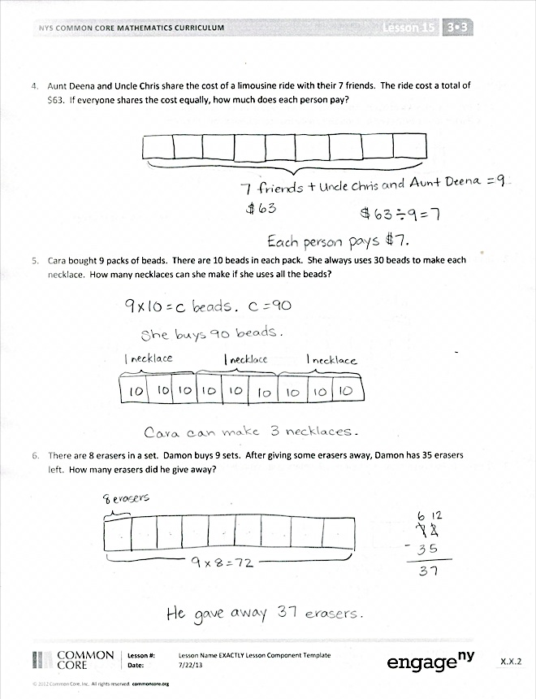
Exit Ticket (3 minutes)
After the Student Debrief, instruct students to complete the Exit Ticket. A review of their work will help you assess the students’ understanding of the concepts that were presented in the lesson today and plan more effectively for future lessons. You may read the questions aloud to the students.

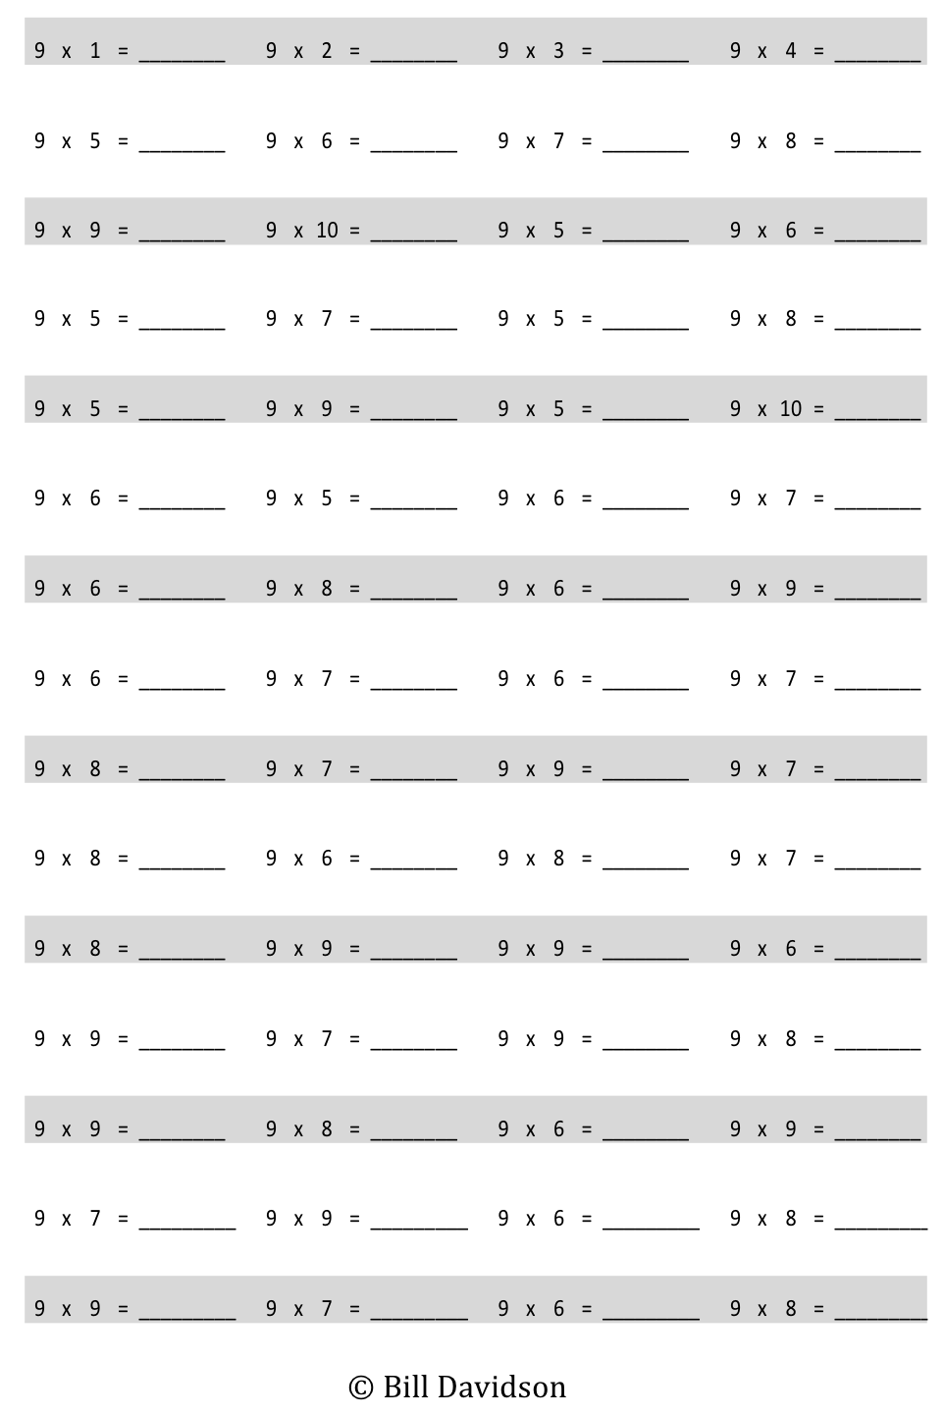
Multiply.
Name Date
Write an equation, and use a letter to represent the unknown for Problems 1–6.
- Mrs. Parson gave each of her grandchildren $9. She gave a total of $36. How many grandchildren does Mrs. Parson have?

- Shiva pours 27 liters of water equally into 9 containers. How many liters of water are in each container?

- Derek cuts 7 pieces of wire. Each piece is 9 meters long. What is the total length of the 7 pieces?

- Aunt Deena and Uncle Chris share the cost of a limousine ride with their 7 friends. The ride cost a total of $63. If everyone shares the cost equally, how much does each person pay?

- Cara bought 9 packs of beads. There are 10 beads in each pack. She always uses 30 beads to make each necklace. How many necklaces can she make if she uses all the beads?

- There are 8 erasers in a set. Damon buys 9 sets. After giving some erasers away, Damon has 35 erasers left. How many erasers did he give away?

Name Date
Use a letter to represent the unknown.
- Mrs. Aquino pours 36 liters of water equally into 9 containers. How much water is in each container?

- Marlon buys 9 packs of hot dogs. There are 6 hot dogs in each pack. After the barbeque, 35 hot dogs are left over. How many hot dogs were eaten?

Name Date
- The store clerk equally divides 36 apples between 9 baskets. Draw a tape diagram, and label the number of apples in each basket as a. Write an equation, and solve for a.

- Elijah gives each of his friends a pack of 9 almonds. He gives away a total of 45 almonds. How many packs of almonds did he give away? Model using a letter to represent the unknown, and then solve.

- Denice buys 7 movies. Each movie costs $9. What is the total cost of 7 movies? Use a letter to represent the unknown. Solve.

- Mr. Doyle shares 1 roll of bulletin board paper equally with 8 teachers. The total length of the roll is 72 meters. How much bulletin board paper does each teacher get?

- There are 9 pens in a pack. Ms. Ochoa buys 9 packs. After giving her students some pens, she has 27 pens left. How many pens did she give away?

- Allen buys 9 packs of trading cards. There are 10 cards in each pack. He can trade 30 cards for a comic book. How many comic books can he get if he trades all of his cards?

multiply by 9 (6–10)

