Lesson 14
Objective: Identify and use arithmetic patterns to multiply.

Suggested Lesson Structure
 Fluency Practice (7 minutes)
 Concept Development (43 minutes)
 Student Debrief (10 minutes)
Total Time (60 minutes)
Fluency Practice (7 minutes)
- Multiply By 9 3.OA.7 (7 minutes)

Multiply By 9 (7 minutes)
Materials: (S) Multiply By 9 (1–5) (Pattern Sheet)
Note: This activity builds fluency with respect to multiplication facts using units of 9. It supports students knowing from memory all products of two one-digit numbers. See Lesson 5 for the directions regarding administering a Multiply By Pattern Sheet.
T: (Write 5 × 9 = ____.) Let’s skip-count by nines to find the answer. (Count with fingers to 5 as students count and record the count-by sequence on the board.)
S: 9, 18, 27, 36, 45.
T: (Circle 45 and write 5 × 9 = 45 above it. Write 3 × 9 = ____.) Let’s skip-count up by nines again. (Count with fingers to 3 as students count.)
S: 9, 18, 27.
T: (Circle 27 and write 3 × 9 = 27 above it.) Let’s see how we can skip-count down to find the answer, too. Start at 45 with 5 fingers, 1 for each nine. (Count down with your fingers as students say numbers.)
S: 45 (5 fingers), 36 (4 fingers), 27 (3 fingers).
Repeat the process for 4 × 9.
T: (Distribute the Multiply By 9 Pattern Sheet.) Let’s practice multiplying by 9. Be sure to work left to right across the page.

Concept Development (43 minutes)
Materials: (S) Personal white board
Part 1: Extend the 9 = 10 – 1 strategy of multiplying with units of 9.
T: How is the 9 = 10 – 1 strategy, or add ten, subtract 1, from the last lesson used to solve 2 × 9?
S: You can do 1 × 9 = 9, then add ten and subtract one like this: (9 + 10) – 1 = 18.
T: Let’s use this strategy to find 2 × 9 another way. (Draw a 2 × 10 array.) When we start with 2 × 10, how many tens do we have?
S: 2 tens.
T: In unit form, what is the fact we are finding?
S: 2 nines.
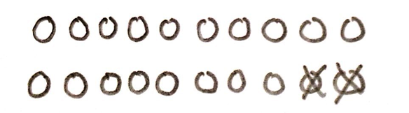
T: To get 1 nine, we subtract 1 from a ten. In our problem, there are 2 nines, so we need to subtract 2 from our
2 tens. (Cross off 2 from the array, as shown at right.) When we subtract 2, how many tens are left?
S: 1 ten.
T: What happened to the other ten?
S: We subtracted 2, so now there are 8 left, not 10. It’s not a full ten anymore after we took off
2 ones. There is just 1 ten and 8 ones.
T: 2 × 9 = 18. Tell your partner how we used the 9 = 10 – 1 strategy with 2 × 10 to find 2 × 9.
S: (Explain.)
T: Let’s use the 9 = 10 – 1 strategy to solve 3 × 9. Draw an array for 3 × 10. (Allow time for students to draw.) To solve, how many should we subtract?
S: 3!
T: Tell your partner why 3.
S: Because we are trying to find 3 nines. The teacher made 3 tens, and you have to take 1 away from each ten to make it 3 nines. So, you subtract 3.
T: Cross off 3, and then talk to your partner: How many tens and ones are left in the array?
S: (Cross off 3.) There are still 2 complete tens, but only 7 ones in the third row.
T: What does our array show is the product of 3 × 9?
S: 27!
T: How is the array related to the strategy of using the number of groups, 3, to help you solve 3 × 9?
S: There are only 2 tens in 27, and 3 – 1 = 2. There are 7 ones in 27, and 10 – 3 = 7.
T: You can use your fingers to quickly solve a nines fact using this strategy. Put your hands out in front of you with all 10 fingers up, like this. (Model, palms facing away.)
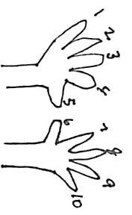
T: Imagine your fingers are numbered 1 through 10 with your pinky on the left being number 1 and your pinky on the right being number 10. Let’s count from 1 to 10 together, lowering the finger that matches each number. (Count from 1 to 10 with the class.)

NOTES ON
MULTIPLE MEANS
OF ENGAGEMENT:
Display a picture of 10 fingers (numbered) on two hands for English language learners and others. Present a demonstration of the finger strategy yourself, or make an animated video. Make it fun for students with rhythm or a song, which you or students compose.

T: To solve a nines fact, lower the finger that matches the number of nines. Let’s try together with 3 × 9.
Hands out, fingers up!
T: For 3 × 9, which finger matches the number of nines?
S: My third finger from the left!
T: Lower that finger. (Model.) How many fingers are to the left of the lowered finger?
S: 2 fingers!
T: 2 is the digit in the tens place. How many fingers are to the right of the lowered finger?
S: 7 fingers!
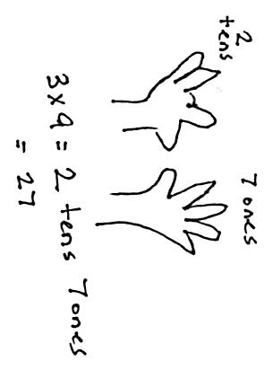
T: 7 is the digit in the ones place.
T: What is the product of 3 × 9 shown by our fingers?
S: 27!
T: Does it match the product we found using our array?
S: Yes!
Continue with the following possible sequence: 7 × 9, 10 × 9, and 11 × 9. Use the previous example to discuss with students that the finger strategy is limited to facts where the number of groups is between 1 and 10.
T: Discuss with your partner. How is the finger strategy we just learned related to the strategy of using the number of groups to help solve a nines fact?
S: (Discuss.)
Part 2: Apply strategies for solving nines facts and reason about their effectiveness.
Part 2 is intended to be a station-based activity where small groups of students rotate through five stations. At each station, they use a different strategy to solve nines facts. The suggestions below indicate which recently learned strategy students might use to solve nines facts at each station.
Station 1: Use the add 10, subtract 1 strategy to list facts from 1 × 9 to 10 × 9.
Station 2: Use 9 × n = (10 × n) – (1 × n), a distributive strategy, to solve facts from 1 × 9 to 10 × 9.
Station 3: Use the finger strategy to solve facts from 1 × 9 to 10 × 9.
Station 4: Use the number of groups to find the digits in the tens and ones places of the product to solve facts from 6 × 9 to 9 × 9.
Station 5: Use 9 × n = (5 × n) + (4 × n), a distributive strategy, to solve facts from 6 × 9 to 9 × 9.

After finishing, discuss the effectiveness of the strategies used to solve nines facts. Use the following suggested discussion questions:

NOTES ON
MULTIPLE MEANS
OF ENGAGEMENT:
If appropriate for your class, consider having students complete station work in math journals or reflecting in writing so that they have their work as a reference.

MP.5
- Is there a strategy that is easiest for you? What makes it easier than the others?
- What strategy helps you solve a nines fact with a large number of groups, such as 12 × 9 = n, the quickest? Which strategies would not work for such a large fact?
- Which strategies could easily be used to solve a division fact?
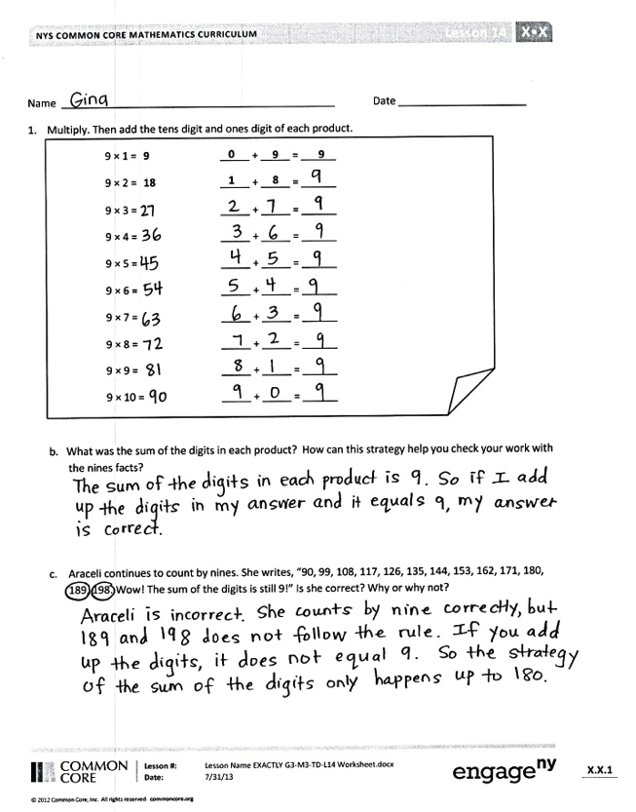
Problem Set (10 minutes)
Students should do their personal best to complete the Problem Set within the allotted 10 minutes. For some classes, it may be appropriate to modify the assignment by specifying which problems they work on first. Some problems do not specify a method for solving. Students should solve these problems using the RDW approach used for Application Problems.
Student Debrief (10 minutes)
Lesson Objective: Identify and use arithmetic patterns to multiply.
The Student Debrief is intended to invite reflection and active processing of the total lesson experience.
Invite students to review their solutions for the Problem Set. They should check work by comparing answers with a partner before going over answers as a class. Look for misconceptions or misunderstandings that can be addressed in the Debrief. Guide students in a conversation to debrief the Problem Set and process the lesson.
You may choose to use any combination of the questions below to lead the discussion.
- Invite students to explain the strategy used in each problem.
- Encourage students to explain a different strategy that could be used to solve Problem 3.
- Why is it important to know several strategies for solving larger multiplication facts? Which strategies for solving nines facts can be modified to apply to a different set of facts (sixes, sevens, eights, etc.)?

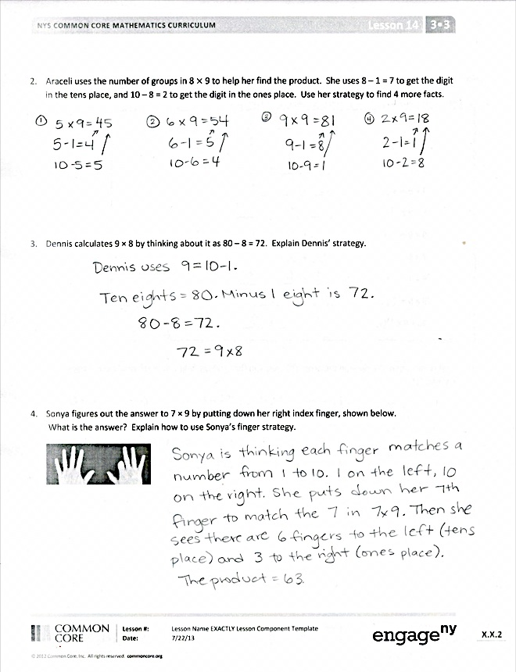
Exit Ticket (3 minutes)
After the Student Debrief, instruct students to complete the Exit Ticket. A review of their work will help you assess the students’ understanding of the concepts that were presented in the lesson today and plan more effectively for future lessons. You may read the questions aloud to the students.

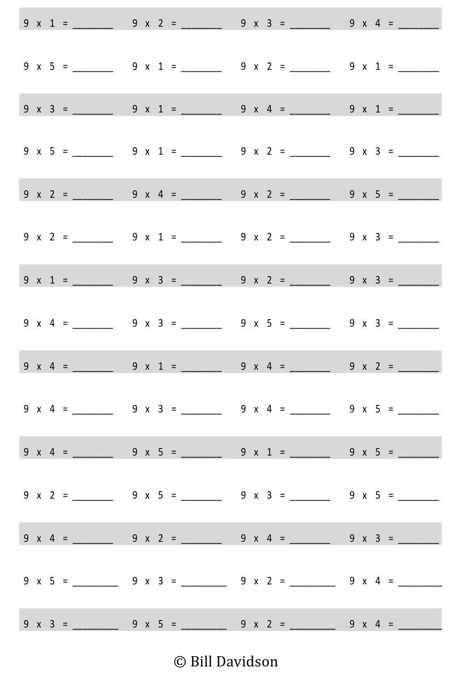
Multiply.

Name Date
- a. Multiply. Then, add the tens digit and ones digit of each product.
0
9
1
8
9
1 × 9 = 9 _____ + _____ = ______
2 × 9 = 18 _____ + _____ = ______
3 × 9 = _____ + _____ = ______
4 × 9 = _____ + _____ = ______
5 × 9 = _____ + _____ = ______
6 × 9 = _____ + _____ = ______
7 × 9 = _____ + _____ = ______
8 × 9 = _____ + _____ = ______
9 × 9 = _____ + _____ = ______
10 × 9 = _____ + _____ = ______

b. What is the sum of the digits in each product? How can this strategy help you check your work with the nines facts?

c. Araceli continues to count by nines. She writes, “90, 99, 108, 117, 126, 135, 144, 153, 162, 171, 180, 189, 198. Wow! The sum of the digits is still 9!” Is she correct? Why or why not?

2. Araceli uses the number of groups in 8 × 9 to help her find the product. She uses 8 – 1 = 7 to get the digit in the tens place and 10 – 8 = 2 to get the digit in the ones place. Use her strategy to find 4 more facts.

- Dennis calculates 9 × 8 by thinking about it as 80 – 8 = 72. Explain Dennis’ strategy.

- Sonya figures out the answer to 7 × 9 by putting down her right index finger, shown below.
What is the answer? Explain how to use Sonya’s finger strategy.
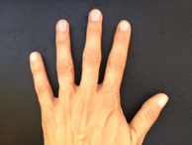
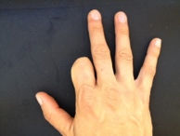

Name Date
Donald writes 6 × 9 = 54. Explain two strategies you could use to check his work.

Name Date
- a. Multiply. Then, add the digits in each product.
10 × 9 = 90 | 9 + 0 = 9
9 × 9 = 81 | 8 + 1 = 9
8 × 9 = | _____ + _____ = ______
7 × 9 = | _____ + _____ = ______
6 × 9 = | _____ + _____ = ______
5 × 9 = | _____ + _____ = ______
4 × 9 = | _____ + _____ = ______
3 × 9 = | _____ + _____ = ______
2 × 9 = | _____ + _____ = ______
1 × 9 = | _____ + _____ = ______

b. What pattern did you notice in Problem 1(a)? How can this strategy help you check your work with nines facts?

- Thomas calculates 9 × 7 by thinking about it as 70 – 7 = 63. Explain Thomas’ strategy.

- Alexia figures out the answer to 6 × 9 by lowering the thumb on her right hand, shown below. What is the answer? Explain Alexia’s strategy.
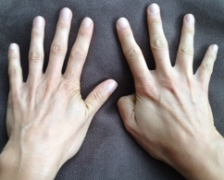

- Travis writes 72 = 9 × 8. Is he correct? Explain at least 2 strategies Travis can use to help him check his work.

multiply by 9 (1–5)

