Lesson 13
Objective: Identify and use arithmetic patterns to multiply.

Suggested Lesson Structure

NOTES ON
LESSON STRUCTURE:
The Problem Set follows immediately after the Application Problem in this lesson. The 10 minutes for the Problem Set are included in the time allotted for the Application Problem rather than the Concept Development.

 Fluency Practice (15 minutes)
 Concept Development (20 minutes)
 Application Problem (15 minutes)
 Student Debrief (10 minutes)
Total Time (60 minutes)
Fluency Practice (15 minutes)

A NOTE ON
STANDARDS ALIGNMENT:
Some problems in the Sprint and Part 2 of the Concept Development extend beyond Grade 3 multiplication and division standards.
By extending to products above 90 and quotients above 10 in the Sprint, students working above grade level are provided the stimulus to stretch their conceptual understanding, which may keep them engaged and invigorated to improve on Sprint B. Students who have mastered their times tables are likely to otherwise go unchallenged.

- Sprint: Divide By 8 3.OA.7 (8 minutes)
- Group Counting 3.OA.1 (4 minutes)
- Decompose Multiples of 9 3.OA.5 (3 minutes)

Sprint: Divide By 8 (8 minutes)
Materials: (S) Divide By 8 Sprint
Note: This Sprint reviews Lessons 10 and 11, focusing on the relationship between multiplying and dividing using units of 8.
Group Counting (4 minutes)
Note: Group counting reviews interpreting multiplication as repeated addition. Counting by sixes, sevens, and eights reviews multiplication taught previously in the module. Group counting nines prepares students for multiplication in this lesson. Direct students to count forward and backward, occasionally changing the direction of the count:
- Sixes to 60
- Sevens to 70
- Eights to 80
- Nines to 90

Decompose Multiples of 9 (3 minutes)
Materials: (S) Personal white board
Note: This activity prepares students to use the distributive property using units of 9.
T: (Project a number bond with a whole of 45 and 18 as a part.) On your personal white board, complete the unknown part in the number bond.
S: (Write 27.)
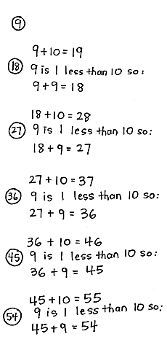
Continue with the following possible sequence: whole of 90 and 27 as a part, whole of 54 and 36 as a part, whole of 72 and 27 as a part, and whole of 63 and 18 as a part.
Concept Development (20 minutes)
Materials: (S) Personal white board, Problem Set
Part 1: Identify patterns in multiples of 9.
T: During the fluency activity, we group counted nines to say the multiples of 9. When we skip-count by nines, what are we adding each time?
S: 9!
T: Adding nines can be tricky. What’s a simplifying strategy for adding 9?
S: I can break apart 9 to make the next ten, and then add what’s left of the 9 to it. I can add 10, and then subtract 1.
T: (Lead students through applying the add 10, subtract 1 strategy in Problem 2 on the Problem Set. Model the first example. Students can then work in pairs to find the rest. Allow time for students to finish their work.)
MP.7
T: Compare the digits in the ones and tens places of the multiples. What pattern do you notice?

NOTES ON
MULTIPLE MEANS
OF REPRESENTATION:
Simplify and clarify “sum of the digits” for English language learners and others. Distinguish some from sum. Perhaps express the request in another manner, such as, “Look at the product. (Point.) Add the digit in the ones place (point) to the digit in the tens place (point). What’s the sum? Now, look at the next product… ”

S: The digit in the tens place increases by 1. The digit in the ones place decreases by 1.
T: Now, with your partner, analyze the sum of the digits for each multiple of 9. What pattern do you notice?
S: The sum of the digits in every multiple of 9 is equal to 9!
T: How does knowing the sum of the digits in every multiple of 9 is equal to 9 help you with nines facts?
S: To check my answer, I can add up the digits. If the sum isn’t equal to 9, I made a mistake.
Part 2: Apply strategies to solve nines facts.
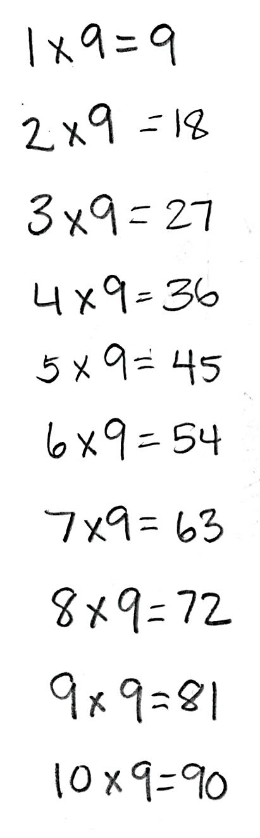
Have students write and solve all facts from 1 × 9 to 10 × 9 in a column on their personal white boards.
T: Let’s examine 1 × 9 = 9. Here, what is 9 multiplied by?
S: 9 is multiplied by 1.
T: What number is in the tens place of the product for 1 × 9?
S: Zero.
T: How is the number in the tens place related to 1?
S: It is 1 less. Zero is one less than 1.
T: Say the product of 2 × 9 at my signal. (Signal.)
S: 18.
T: Which digit is in the tens place of the product?
S: 1.
T: How is the digit in the tens place related to the 2?
S: It’s one less again. 1 is one less than 2!
Repeat the process with 3 × 9 and 4 × 9.
T: What pattern do you notice with the digit in the tens place for each of those products?
S: The number in the tens place is 1 less than the number of groups.
T: With your partner, see if that pattern fits for the rest of the nines facts to ten.
S: It does! The pattern keeps going!
T: Let’s see if we can find a pattern involving the ones place. We know that 2 × 9 equals 18. The 2 and 8 are related in some way. We also know that 3 × 9 equals 27. The 3 and 7 are related in the same way. Discuss with your partner how they are related.

A NOTE ON
STANDARDS ALIGNMENT:
The fact 11 × 9 extends beyond the Grade 3 multiplication standards. Its use here allows students to construct boundaries for the pattern that they discovered with the nines facts (the number in the tens place in the product is one less than the number of groups, and the number in the ones place in the product is 10 minus the number of groups). By examining the product of 11 × 9, students learn that the pattern only applies to 1 × 9 through 10 × 9.

S: 2 + 8 = 10 and 3 + 7 = 10! 10 – 2 = 8 and 10 – 3 = 7!
T: When you take the number of groups and subtract it from 10, what do you get?
S: The ones place in the product!
T: With your partner, see if that pattern fits for the rest of the nines facts. (Allow students time to finish their work.)
T: Did the pattern work for every fact, 1 × 9 through 10 × 9?
S: Yes!
T: Let’s try 11 × 9. What is the product?
S: 99!
T: What is the number of groups?
S: 11!
T: Talk to your partner: Does the pattern work for 11 × 9? Why or why not?
S: No, the pattern doesn’t make sense. You can’t have 10 in the tens place, and we don’t know how to solve 10 – 11 to find what digit is in the ones place.
T: The pattern can give you the answer to any nines fact from 1 × 9 to 10 × 9, but it doesn’t work for nines facts bigger than 10 × 9.
Application Problem (15 minutes)
Michaela and Gilda read the same book. It takes Michaela about 8 minutes to read a chapter and Gilda about 10 minutes. There are 9 chapters in the book. How many fewer minutes does Michaela spend reading than Gilda?
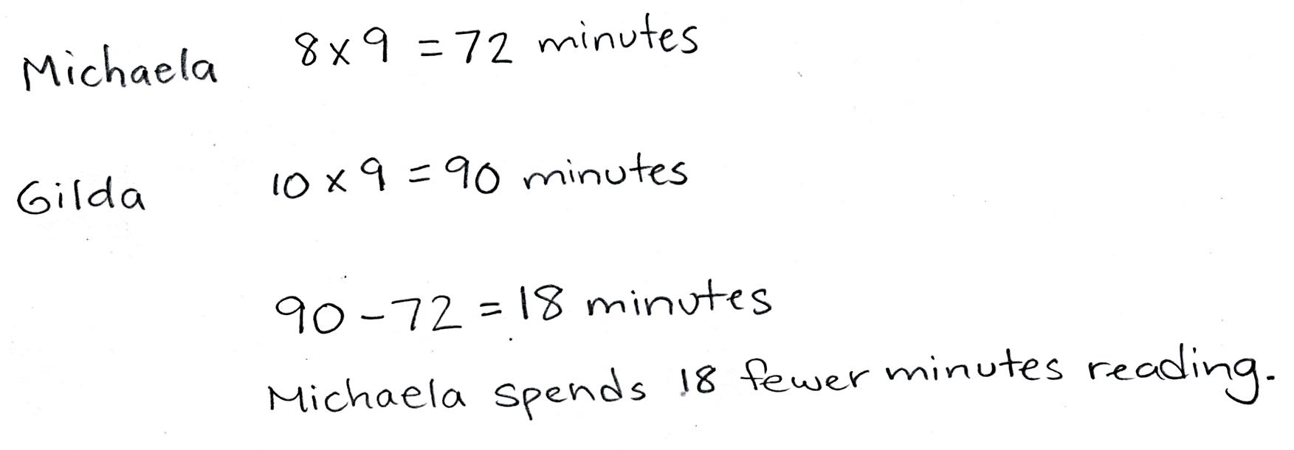

Note: This problem comes after the Concept Development, so students have the opportunity to apply some of the strategies they learned in the context of problem solving. Encourage them to check their answers to the nines facts using new learning.
Problem Set (10 minutes)

NOTES ON
MULTIPLE MEANS
OF REPRESENTATION:
Consider adjusting the Problem Set to assist learners with perceptual disabilities. Provide a table for students to record the nine skip-count, and/or highlight the tens or ones.
As students solve Problem 2, it may be helpful to write the nines fact for each given product (e.g., in Problem 2(f), have students write 5 × 9 above 45).

Students should do their personal best to complete the Problem Set within the allotted 10 minutes. For some classes, it may be appropriate to modify the assignment by specifying which problems they work on first. Some problems do not specify a method for solving. Students should solve these problems using the RDW approach used for Application Problems.
Student Debrief (10 minutes)
Lesson Objective: Identify and use arithmetic patterns to multiply.
The Student Debrief is intended to invite reflection and active processing of the total lesson experience.
Invite students to review their solutions for the Problem Set. They should check work by comparing answers with a partner before going over answers as a class. Look for misconceptions or misunderstandings that can be addressed in the Debrief. Guide students in a conversation to debrief the Problem Set and process the lesson.
You may choose to use any combination of the questions below to lead the discussion.
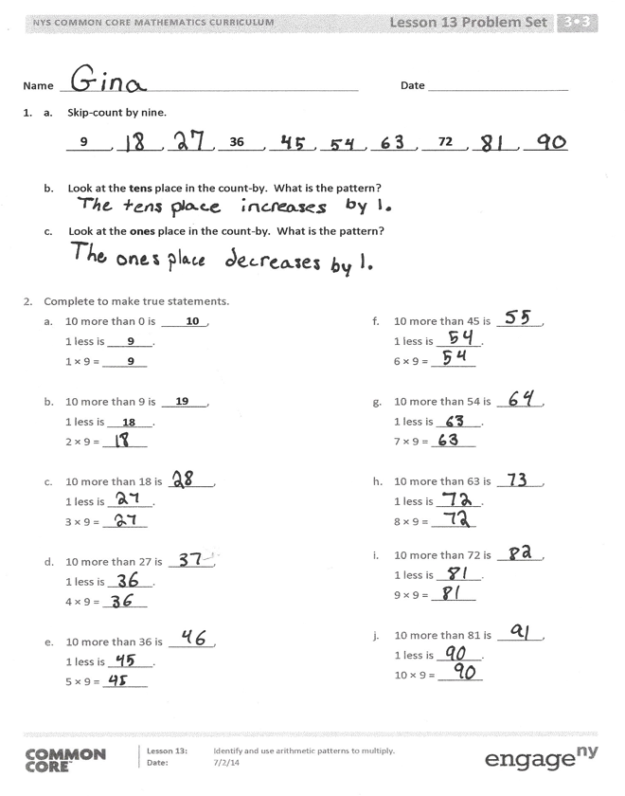
- What patterns did you use to solve Problem 1?
- The add 10, subtract 1 strategy can be used to quickly find multiples of 9. How could you change it to quickly find multiples of 8?
- How is the add 10, subtract 1 strategy related to the 9 = 10 – 1 break apart and distribute strategy we learned recently?
- In Problem 3(d) how did you figure out where Kent’s strategy stops working? Why doesn’t this strategy work past 10 × 9?
- How can the number of groups in a nines fact help you find the product?
- How did group counting during the fluency activity help prepare us for today’s lesson?
Exit Ticket (3 minutes)
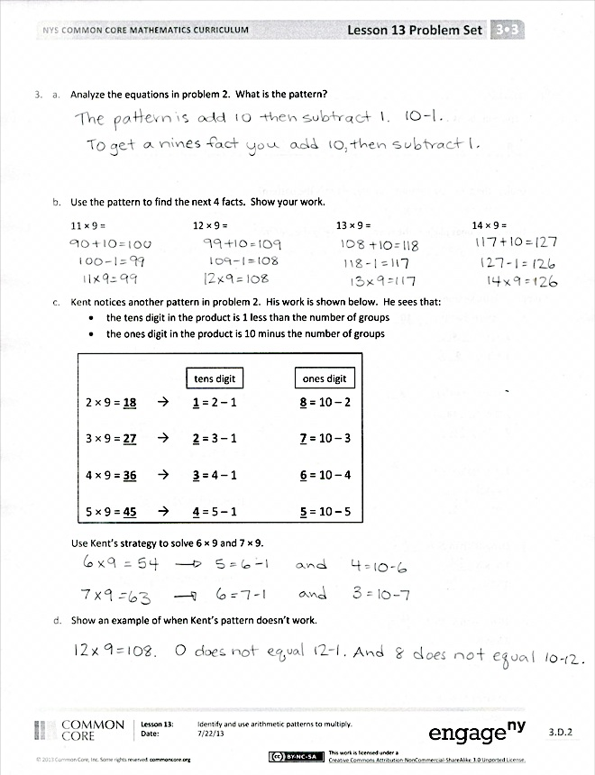
After the Student Debrief, instruct students to complete the Exit Ticket. A review of their work will help you assess the students’ understanding of the concepts that were presented in the lesson today and plan more effectively for future lessons. You may read the questions aloud to the students.
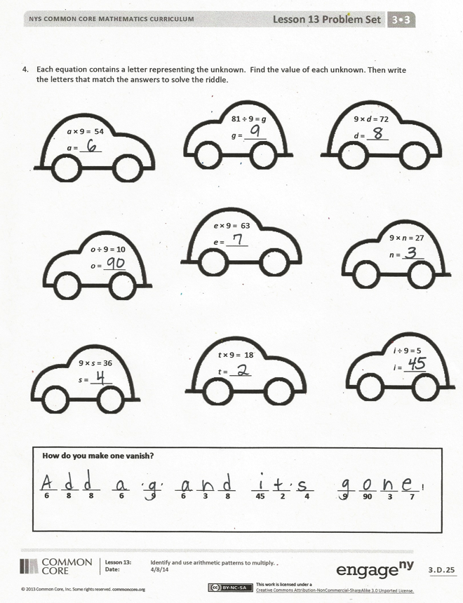

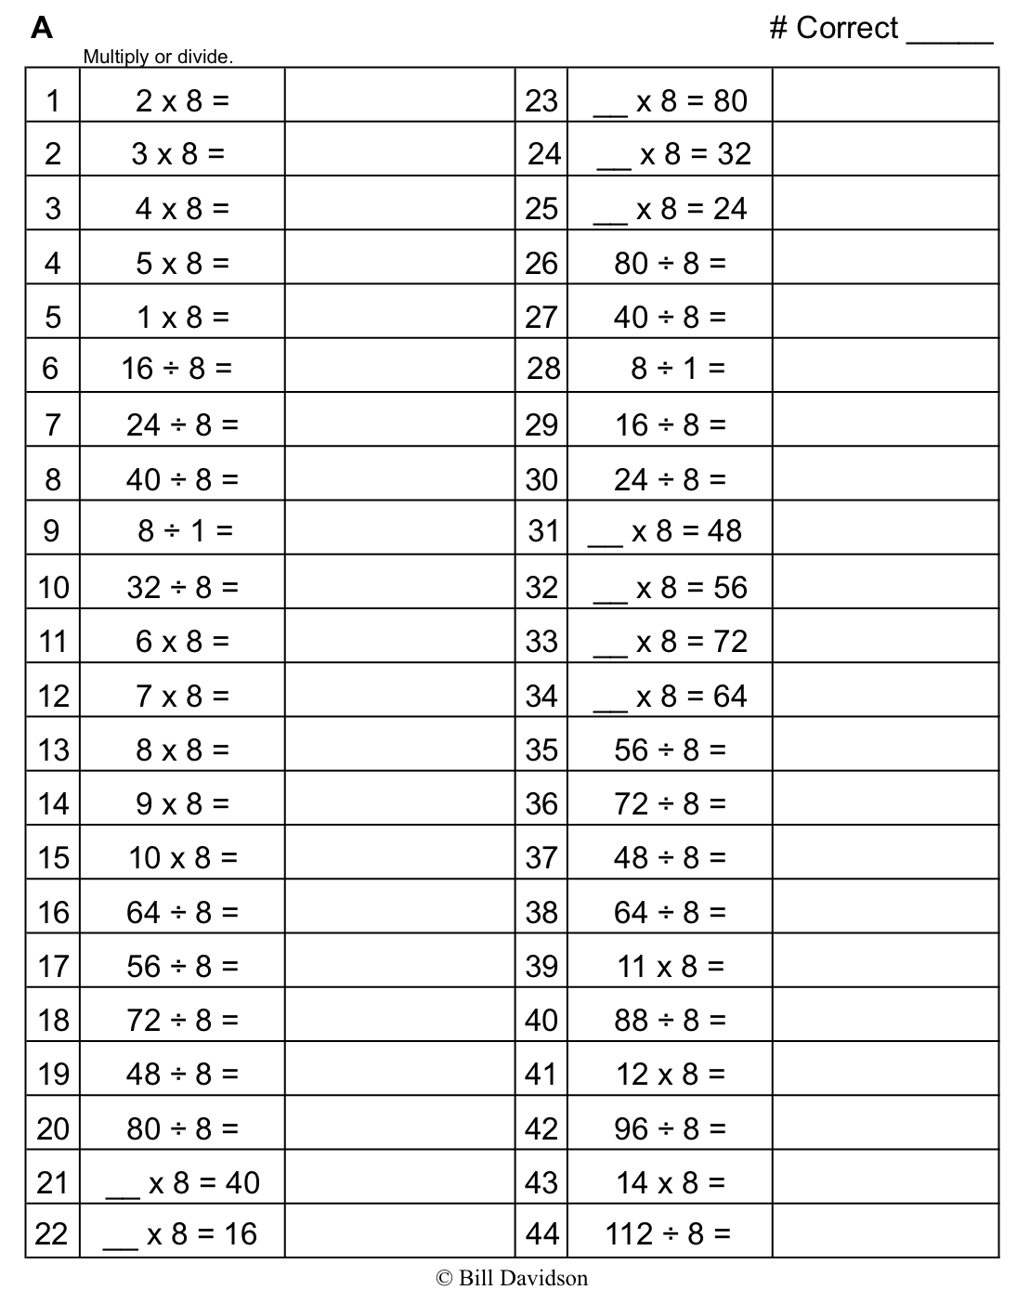
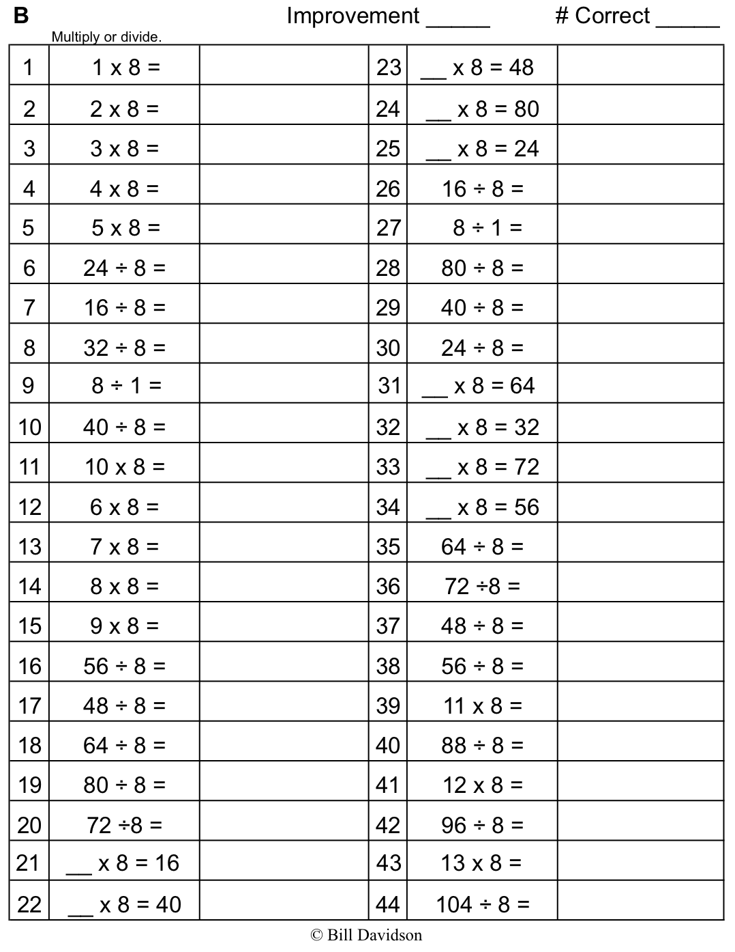
Name Date
- a. Skip-count by nine.
9
36
72
_______, _______, _______, _______, _______, _______, _______, _______, _______, _______

- Look at the tens place in the count-by. What is the pattern?

- Look at the ones place in the count-by. What is the pattern?

- Complete to make true statements.

- 10 more than 0 is _______,
10
1 less is _______.
9
1 × 9 = _______
9

- 10 more than 9 is _______,
19
1 less is _______.
18
2 × 9 = _______

- 10 more than 18 is _______,
1 less is _______.
3 × 9 = _______

- 10 more than 27 is _______,
1 less is _______.
4 × 9 = _______

- 10 more than 36 is _______,
1 less is _______.
5 × 9 = _______

- 10 more than 45 is _______,
1 less is _______.
6 × 9 = _______

- 10 more than 54 is _______,
1 less is _______.
7 × 9 = _______

- 10 more than 63 is _______,
1 less is _______.
8 × 9 = _______

- 10 more than 72 is _______,
1 less is _______.
9 × 9 = _______

- 10 more than 81 is _______,
1 less is _______.
10 × 9 = _______
- a. Analyze the equations in Problem 2. What is the pattern?

- Use the pattern to find the next 4 facts. Show your work.
11 × 9 = 12 × 9 = 13 × 9 = 14 × 9 =

- Kent notices another pattern in Problem 2. His work is shown below. He sees the following:
- The tens digit in the product is 1 less than the number of groups.
- The ones digit in the product is 10 minus the number of groups.
Ones digit
Tens digit

2 × 9 = 18 1 = 2 – 1 8 = 10 – 2

3 × 9 = 27 2 = 3 – 1 7 = 10 – 3

4 × 9 = 36 3 = 4 – 1 6 = 10 – 4

5 × 9 = 45 4 = 5 – 1 5 = 10 – 5

Use Kent’s strategy to solve 6 × 9 and 7 × 9.

- Show an example of when Kent’s pattern doesn’t work.

- Each equation contains a letter representing the unknown. Find the value of each unknown. Then, write the letters that match the answers to solve the riddle.
9 × d = 72
d = _____
81 ÷ 9 = g
g = _____
e × 9 = 63
e = _____
a × 9 = 54
a = _____

9 × n = 27
n = _____
o ÷ 9 = 10
o = _____

i ÷ 9 = 5
i = _____
t × 9 = 18
t = _____
9 × s = 36
s = _____

____ ____ ____ ____ ‘____’ ____ ____ ____ ____ ____’ ____ ____ ____ ____ ____ !
6 8 8 6 9 6 3 8 45 2 4 9 90 3 7

How do you make one vanish?

Name Date
1. 6 × 9 = 54 8 × 9 = 72
What is 10 more than 54? _______ What is 10 more than 72? _______
What is 1 less? _______ What is 1 less? _______
7 × 9 = _______ 9 × 9 = _______

- Explain the pattern used in Problem 1.

Name Date
- a. Skip-count by nines down from 90.
90
72
36
_______, _______, _______, _______, _______, _______, _______, _______, _______, _______
- Look at the tens place in the count-by. What is the pattern?

- Look at the ones place in the count-by. What is the pattern?

- Each equation contains a letter representing the unknown. Find the value of each unknown.
a × 9 = 18
a = _____
m ÷ 9 = 3
m = _____
f ÷ 9 = 4
f = _____
9 × d = 81
d = _____
e × 9 = 45
e = _____
w ÷ 9 = 6
w = _____
9 × s = 90
s = _____
k ÷ 9 = 8
k = _____
- Solve.
a. What is 10 more than 0? _____
What is 1 less? _____
1 × 9 = _____

b. What is 10 more than 9? _____
What is 1 less? _____
2 × 9 = _____

c. What is 10 more than 18? _____
What is 1 less? _____
3 × 9 = _____

d. What is 10 more than 27? _____
What is 1 less? _____
4 × 9 = _____

e. What is 10 more than 36? _____
What is 1 less? _____
5 × 9 = _____

f. What is 10 more than 45? _____
What is 1 less? _____
6 × 9 = _____

9
g. What is 10 more than 54? _____
What is 1 less? _____
7 × 9 = _____

h. What is 10 more than 63? _____
What is 1 less? _____
8 × 9 = _____

i. What is 10 more than 72? _____
What is 1 less? _____
9 × 9 = _____

j. What is 10 more than 81? _____
What is 1 less? _____
10 × 9 = _____

- Explain the pattern in Problem 3, and use the pattern to solve the next 3 facts.

11 × 9 = _____ 12 × 9 = _____ 13 × 9 = _____

