Lesson 12

Objective: Apply the distributive property and the fact 9 = 10 – 1 as a strategy to multiply.

**Suggested Lesson Structure**

 Fluency Practice (11 minutes)

 Application Problem (6 minutes)

 Concept Development (33 minutes)

 Student Debrief (10 minutes)

**Total Time (60 minutes)**

Fluency Practice (11 minutes)

* Multiply By 8  **3.OA.7** (7 minutes)
* Take from the Ten **3.OA.5** (4 minutes)

Multiply by 8 (7 minutes)

Materials: (S) Multiply By 8 (6–10) (Pattern Sheet)

Note: This activity builds fluency with respect to multiplication facts using units of 8. It supports students knowing from memory all products of two one-digit numbers. See Lesson 5 for the directions regarding administration of a Multiply By Pattern Sheet.

T: (Write 6 × 8 = ____.) Let’s skip-count up by eights to solve. (Count with fingers to 6 as students count.)

S: 8, 16, 24, 32, 40, 48.

T: Let’s skip-count down to find the answer, too. Start at 80. (Count down from 10 fingers as students count.)

S: 80, 72, 64, 56, 48.

T: Let’s skip-count up again to find the answer, but this time start at 40. (Count up from 5 fingers as students count.)

S: 40, 48.

Continue with the following possible sequence: 8 × 8, 7 × 8, and 9 × 8.

T: (Distribute the Multiply By 8 Pattern Sheet.) Let’s practice multiplying by 8. Be sure to work left to right across the page.

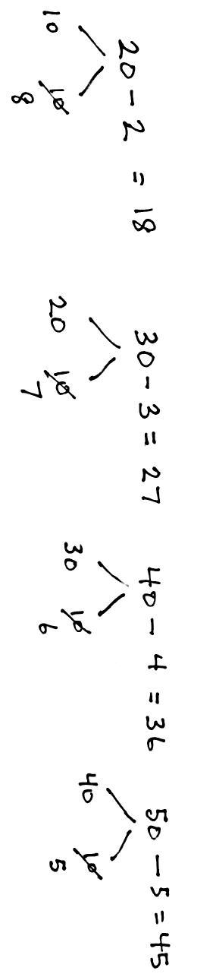Take from the Ten (4 minutes)

Materials: (S) Personal white board

Note: This fluency activity prepares students for today’s Concept Development.

T: (Write 20 – 2 = ____.) Say the subtraction sentence in unit form.

S: 2 tens – 2 ones.

T: (Point at the 20.) Let’s break apart the 20, taking out 10 ones. How many tens are left?

S: 1 ten.

T: What’s 10 ones – 2 ones?

S: 8 ones.

T: (Write 8.)

T: What’s 20 – 2?

S: 18.

T: (Write 20 – 2 = 18.)

T: (Write 30 – 3 = ____.) After writing the equation, break apart the 30, taking out 10 ones.

S: (Break apart the 30 into 20 and 10.)

T: Take 3 ones from 10 ones and complete the equation.

S: (Take 3 from 10 to get 7, 30 – 3 = 27.)

Continue with the following possible sequence: 40 – 4, 50 – 5, 60 – 6, 70 – 7, 80 – 8, and 90 – 9.

Application Problem (6 minutes)

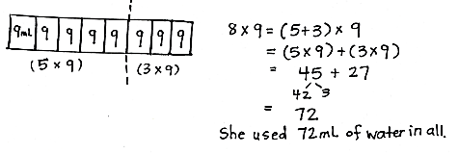A scientist fills 5 test tubes with 9 milliliters of fresh water in each. She fills another 3 test tubes with 9 milliliters of salt water in each. How many milliliters of water does she use in all? Use the break apart and distribute strategy to solve.

Note: The Application Problem is meant to reinforce the 5 + *n* break apart and distribute strategy to support Problem 1 in the Problem Set and also provide a point of comparison between the 5 + *n* strategy and   
9 = 10 – 1 strategy for multiplying with a factor of 9. Notice that, to add 45 and 27, the student has taken 3 from 45 to make 30 from 27.

Concept Development (33 minutes)

*Template*

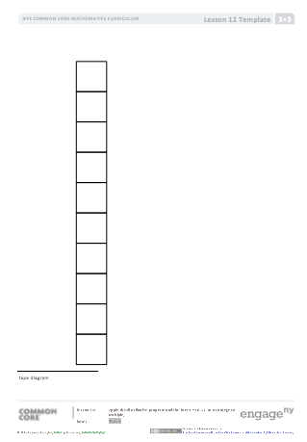

Materials: (S) Personal white board, tape diagram (Template)

Use the 9 = 10 – 1 strategy to solve 9 × *n* facts.

Have students insert templates into their personal white boards.

T: We solved 8 × 9 in the Application Problem.   
Does 8 × 9 show 8 units of 9 or 9 units of 8?

S: 8 units of 9.

T: What multiplication fact represents 9 units of 8?

S: 9 × 8.

T: How can our work solving 8 × 9 help us solve 9 × 8?

S: We can use the commutative property to know that, if 8 × 9 = 72, then so does 9 × 8.

|  |  |
| --- | --- |
|  | NOTES ON  MULTIPLE MEANS  OF ACTION AND EXPRESSION: |
| Adjust your rate of speech for English language learners and others as students write equations in response to your oral prompts. Label the equations. For example, write  “9 eights” under “9 × 8.” | |

T: Sometimes we can’t use the commutative property because we don’t know the product of either fact. Let’s look at how we can use a tens fact to help solve a nines fact when that happens. What’s easier to solve,   
9 × 8 or 10 × 8?

S: 10 × 8 because we already know tens facts.

T: How many eights are in 10 × 8?

S: 10 eights!

T: Label them on your tape diagram.

T: How many eights in 9 × 8?

S: 9 eights!

T: Change your tape diagram so it shows 9 eights. (Allow students time to finish their work.)

T: What change did you make?

S: I crossed off an eight. 🡪 I took away 1 eight. 🡪 I subtracted one unit.

T: 9 eights (point to the tape diagram) equals 10 eights minus…

S: 1 eight!

T: Work with your partner to write a number sentence showing that.

S: (Write 9 × 8 = (10 × 8) – (1 × 8).)

T: Rewrite your equation using the products of 10 × 8 and 1 × 8.

S: (Write 9 × 8 = 80 – 8.)

T: What is 80 – 8?

S: 72!

T: Tell your partner how we used a tens fact to solve a nines fact.

S: We just took the product of 10 × 8 and subtracted 1 eight. 🡪 That made the math simple.   
I can do 80 – 8 in my head!

T: (Write 9 × 8 = (5 + 4) × 8.) One way we’ve learned to solve 9 × 8 is by breaking 9 eights up into 5 eights plus 4 eights. Why did it work well to subtract this time instead?

**MP.3**

S: Because we only had to subtract 1 eight. 🡪 Yeah, 9 is really close to 10, and tens are easy to use. We already know 10 × 8, and besides, it’s easy to subtract from a tens fact.

|  |  |
| --- | --- |
|  | NOTES ON  MULTIPLE MEANS  OF ENGAGEMENT: |
| As students solve the Problem Set, some learners may solve Problem 1 more efficiently using the 9 = 10 – 1 strategy.  Students working above grade level can be encouraged to write equations using parentheses for Problem 2. Challenge students to offer multiple equations. Ask, “How many equations can you write for Problem 2(a)?” | |

T: Work with your partner to change the equation I just wrote for 9 × 8. Make sure it shows how we used subtraction to solve.

S: (Change the equation to 9 × 8 = (10 – 1) × 8.)

T: What part of the equation did you change?

S: We changed 5 + 4 to 10 – 1.

T: Why?

S: Because we didn’t add; we subtracted. We started with 10 eights and then took away 1 eight.

Continue with the following suggested sequence: 9 × 7 and 9 × 6.

Problem Set (10 minutes)

Students should do their personal best to complete the Problem Set within the allotted 10 minutes. For some classes, it may be appropriate to modify the assignment by specifying which problems they work on first. Some problems do not specify a method for solving. Students should solve these problems using the RDW approach used for Application Problems.

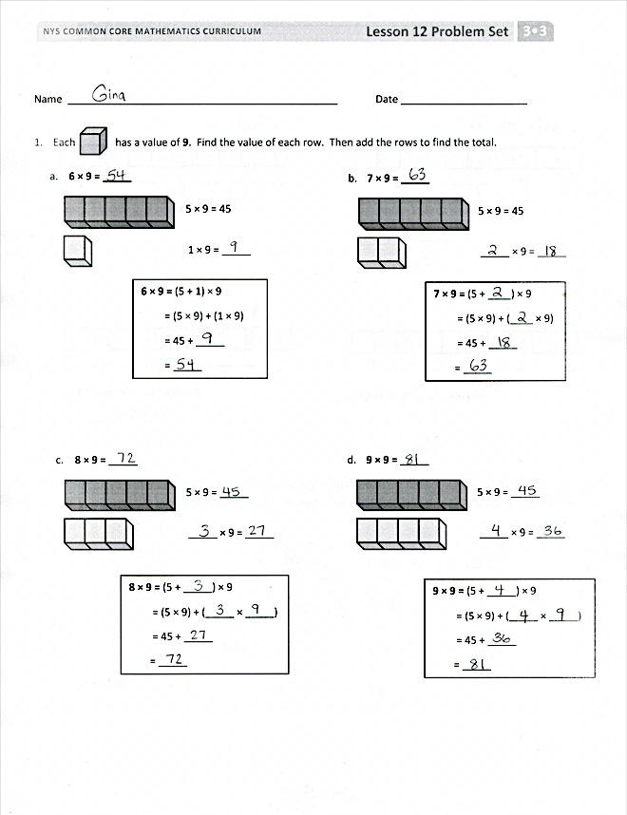

Student Debrief (10 minutes)

**Lesson Objective:** Apply the distributive property and the fact 9 = 10 – 1 as a strategy to multiply.

The Student Debrief is intended to invite reflection and active processing of the total lesson experience.

Invite students to review their solutions for the Problem Set. They should check work by comparing answers with a partner before going over answers as a class. Look for misconceptions or misunderstandings that can be addressed in the Debrief. Guide students in a conversation to debrief the Problem Set and process the lesson.

You may choose to use any combination of the questions below to lead the discussion.

* What does the nine represent in Problem 1?   
  (It represents the value of each unit.)   
  What does the nine represent in Problem 2?   
  (It represents the number of units.)

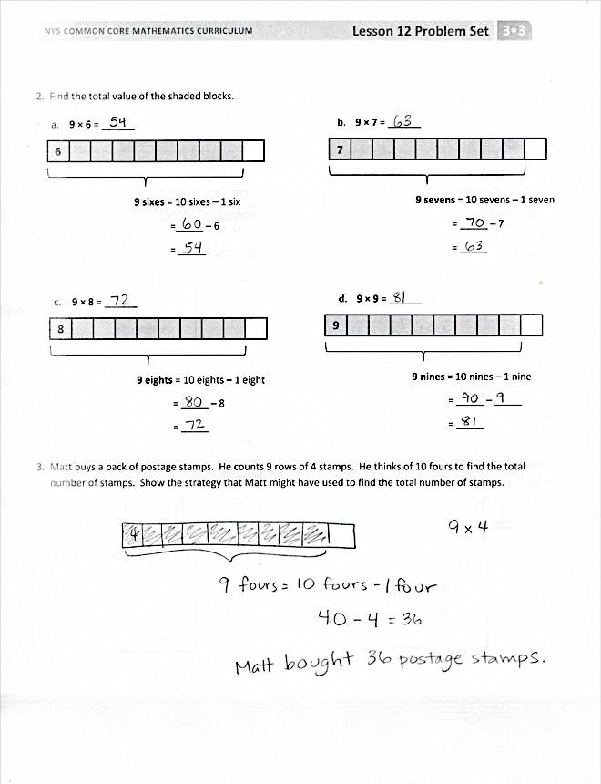

* How can multiplication be used to solve the division facts in Problem 4?
* Think about the strategy used to solve Problem 2(a). How could a similar strategy be used to solve   
  8 × 6 instead of 9 × 6?
* Today, we solved 9 × 8 in different ways. How are the strategies we used in the Application Problem and Concept Development similar? How are they different?

Exit Ticket (3 minutes)

After the Student Debrief, instruct students to complete the Exit Ticket. A review of their work will help you assess the students’ understanding of the concepts that were presented in the lesson today and plan more effectively for future lessons. You may read the questions aloud to the students.

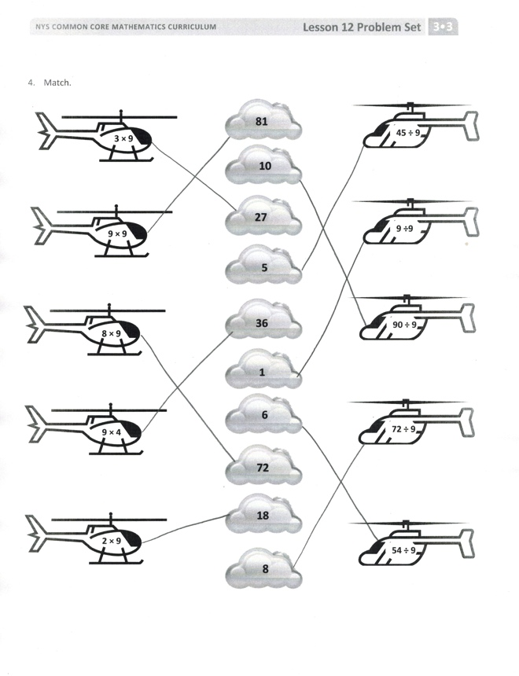

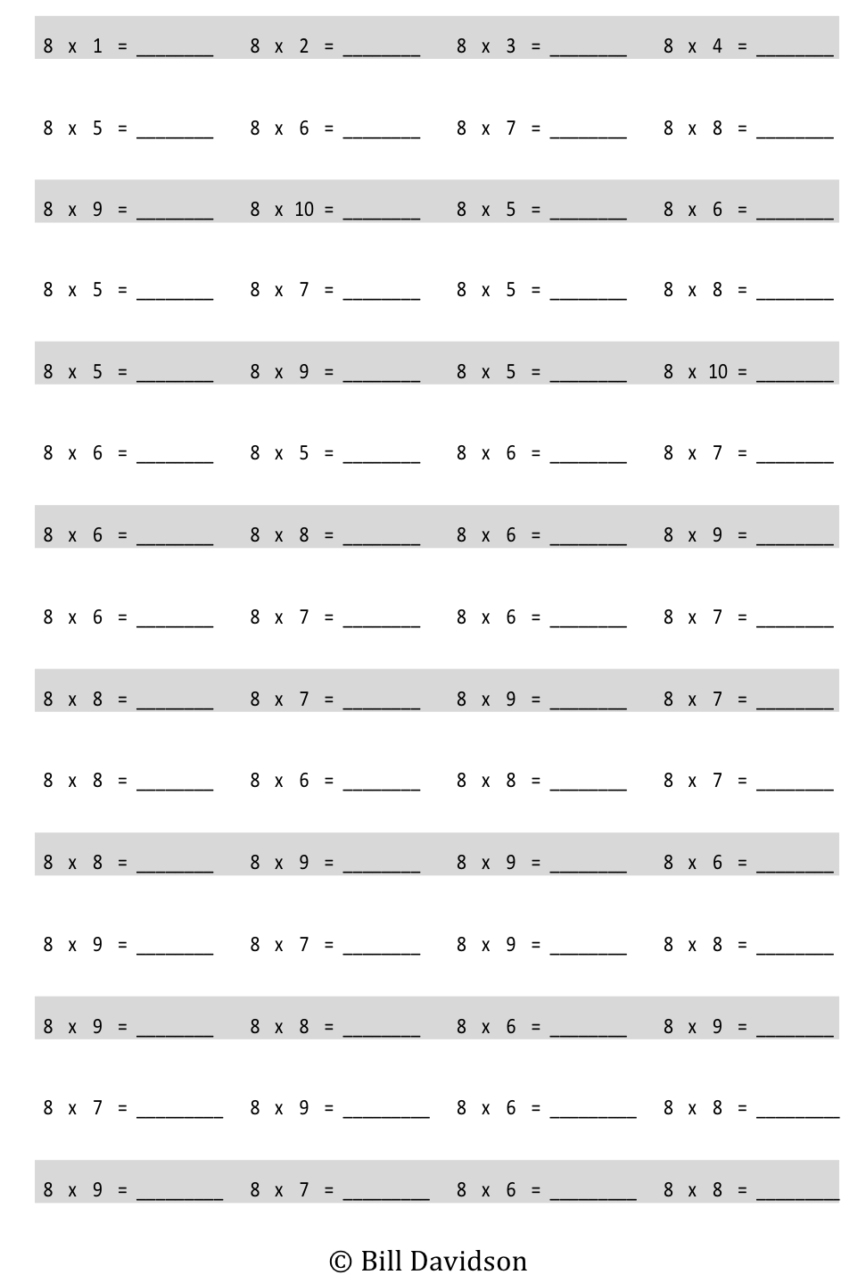

Multiply.

[1]

Name Date

1. Each has a value of **9**. Find the value of each row. Then, add the rows to find the total.

**9 × 9 =** (5 + _____) × 9

= (5 × 9) + (_____ × _____)

= 45 + _____

= _____

1. **9 × 9 = _____**

5 × 9 = _____

_____ × 9 = _____

**7 × 9 =** (5 + ____) × 9

= (5 × 9) + (____ × 9)

= 45 + _____

= _____

1. **7 × 9 = _____**

5 × 9 = 45

_____ × 9 = _____

**6 × 9 =** (5 + 1) × 9

= (5 × 9) + (1 × 9)

= 45 + _____

= _____

1. **6 × 9 = _____**

5 × 9 = 45

1 × 9 = _____

**8 × 9 =** (5 + _____) × 9

= (5 × 9) + (_____ × _____)

= 45 + _____

= _____

1. **8 × 9 = _____**

5 × 9 = _____

_____ × 9 = _____

2. Find the total value of the shaded blocks.

**9 sixes** = 10 sixes – 1 six

=_____ – 6

= _____

**6**

1. **9 × 6** = ______

**9 sevens** = 10 sevens – 1 seven

= _____ – 7

= _____

**7**

1. **9 × 7** = ______

**9 eights** = 10 eights – 1 eight

= _____ – 8

= _____

**8**

1. **9 × 8** = ______

**9 nines** = 10 nines – 1 nine

= _____ – _____

= _____

**9**

1. **9 × 9** = ______

3. Matt buys a pack of postage stamps. He counts 9 rows of 4 stamps. He thinks of 10 fours to find the total number of stamps. Show the strategy that Matt might have used to find the total number of stamps.

1. Match.



**81**

**36**

**5**

**27**

**10**

**1**

**6**

**18**

**72**

**8**



**45 ÷ 9**



**9 ÷ 9**



**90 ÷ 9**



**72 ÷ 9**



**54 ÷ 9**



**3 × 9**



**9 × 9**



**8 × 9**



**9 × 4**



**2 × 9**

Name Date

1. Each has a value of **9**. Complete the equations to find the total value of the tower of blocks.

**_____ × 9 =** (5 + ____) × 9

= (5 × _____) + (_____ × _____)

= 45 + _____

= _____

2. Hector solves 9 × 8 by subtracting 1 eight from 10 eights. Draw a model, and explain Hector’s strategy.

Name Date

1. Find the value of each row. Then, add the rows to find the total.
2. Each has a value of 6.

**9 × 6 =** (5 + 4) × 6

= (5 × 6) + (4 × 6)

= 30 + _____

= _____

**9 × 6 = _____**

5 × 6 = 30

4 × 6 = _____

b. Each has a value of 7.

**9 × 7 =** (5 + _____) × 7

= (5 × 7) + (_____ × 7)

= 35 + _____

= _____

**9 × 7 = _____**

5 × 7 = _____

_____ × 7 = _____

c.Each has a value of 8.

**9 × 8 =** (5 + _____) × 8

= (5 × 8) + (_____ × _____)

= 40 + _____

= _____

**9 × 8 = _____**

5 × 8 = _____

_____ × 8 = _____

d. Each has a value of 9.

**9 × 9 =** (5 + _____) × 9

= (5 × 9) + (_____ × _____)

= 45 + _____

= _____

**9 × 9 = _____**

5 × 9 = _____

_____ × 9 = _____

1. Match.

**9 × 7**

**9 × 8**

**9 × 4**

**9 × 6**

**9 × 9**

**9 × 5**

**45**

**54**

**81**

**72**

**36**

**63**

a. **9 fives** = 10 fives – 1 five

= 50 – 5

b. **9 sixes** = 10 sixes – 1 six

=_____ – 6

c. **9 sevens** = 10 sevens – 1 seven

= _____ – 7

d. **9 eights** = 10 eights – 1 eight

= _____ – 8

e. **9 nines** = 10 nines – 1 nine

= _____ – _____

f. **9 fours** = 10 fours – 1 four

= _____ – _____

[2]

1. multiply by 8 (6–10)
2. tape diagram