Lesson 11

Objective: Interpret the unknown in multiplication and division to model and solve problems.

Suggested Lesson Structure

 Fluency Practice (15 minutes)

 Concept Development (35 minutes)

 Student Debrief (10 minutes)

**Total Time (60 minutes)**

Fluency Practice (15 minutes)

* Multiply By 8  **3.OA.7** (7 minutes)
* Group Counting  **3.OA.1** (4 minutes)
* Decompose the Multiplication Sentence **3.OA.5** (4 minutes)

Multiply By 8 (7 minutes)

Materials: (S) Multiply By 8 (1–5) (Pattern Sheet)

Note: This activity builds fluency with multiplication facts using units of 8. It supports students knowing from memory all products of two one-digit numbers. See Lesson 5 for the directions for administering a Multiply By Pattern Sheet.

T: (Write 5 × 8 = ____.) Let’s skip-count by eights to find the answer. I’ll raise a finger for each eight. (Count with fingers to 5 as students count and record the count-by sequence on the board.)

S: 8, 16, 24, 32, 40.

T: (Circle 40 and write 5 × 8 = 40 above it. Write 3 × 8 = ____.) Let’s skip-count up by eights again. (Count with fingers to 3 as students count.)

S: 8, 16, 24.

T: Let’s see how we can skip-count down to find the answer, too. Start at 40 with 5 fingers, 1 for each eight. (Count down with your fingers as students say numbers.)

S: 40 (5 fingers), 32 (4 fingers), 24 (3 fingers).

Repeat the process for 4 × 8.

T: (Distribute the Multiply By 8 Pattern Sheet.) Let’s practice multiplying by 8. Be sure to work left to right across the page.

Group Counting (4 minutes)

Note: Group counting reviews interpreting multiplication as repeated addition. Counting by sixes and sevens reviews multiplication using those units in Topic B. Group counting nines anticipates multiplication in the next topic. Direct students to count forward and backward, occasionally changing the direction of the count:

* Sixes to 60
* Sevens to 70
* Nines to 90

Decompose the Multiplication Sentence (4 minutes)

Materials: (S) Personal white board

Note: This activity reviews multiplying using the distributive property from Lesson 10.

T: (Write 8 × 8 = (5 + __) × 8.) On your personal white board, copy and fill in the equation.

S: (Write 8 × 8 = (5 + 3) × 8.)

T: (Write = (__ × 8) + (__ × 8).) Copy and fill in the equation.

**8 × 8** = (5 + 3) x 8

= (5 × 8) + (3 × 8)

= 40 + 24

= 64

S: (Write (5 × 8) + (3 × 8).)

T: Find the products and write an addition sentence. Below it, write your answer.

S: (Write 40 + 24 and 64 below it.)

Continue with the following suggested sequence: 7 × 8, 6 × 8, and 9 × 8.

Concept Development (35 minutes)

Materials: (S) Personal white board

Problem 1: Interpret the unknown in multiplication.

Write the following problem: Asmir buys 8 boxes of 9 candles for his dad’s birthday. After putting some candles on the cake, there are 28 candles left. How many candles does Asmir use?

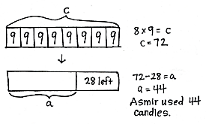T: Model the problem. Then, tell your partner the steps you’ll need to take to solve.

S: (Model.) First, you have to find out how many candles Asmir has. After that, you could subtract 28 from the total to see how many he used.

T: Write an equation to find the total number of candles. Instead of using a question mark, use the letter *c* to represent the unknown.

T: Read your equation out loud.

S: 8 times 9 equals *c*.

T: What does *c* represent?

S: The product. 🡪 The total number of candles.

T: Choose a strategy, and find the value of *c*. (Possible strategies: known from memory, skip-count, distributive property, associative property.)

T: Use a complete sentence to tell what *c* equals.

S: He bought 72 candles, so *c* equals 72.

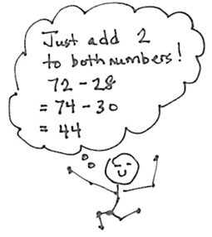T: Did we solve the problem?

S: No, we have to find how many candles Asmir uses.

T: Write an equation to represent the second step of the problem; this time, use the letter *a* to represent the unknown.

S: (Write 72 – 28 = *a*.)

T: Find the value of *a*. This is a good opportunity to practice your mental math strategies. (Allow time for solving.) What is the value of *a*?

S: 44 candles.

T: Answer the question in a complete sentence.

S: Asmir uses 44 candles.

Problem 2: Interpret the unknown in division.

Write the following problem: The fabric store sells one meter of cloth for $8. Maria buys some cloth that costs a total of $56. She then uses 3 meters to sew a dress. How many meters of cloth does she have left?

T: Draw a model to represent the problem. Choose letters to represent the unknowns.

T: What is unknown in this problem?

S: The total meters of cloth Maria buys. 🡪 There’s something else, too. We don’t know how many meters of cloth Maria has left.

|  |  |
| --- | --- |
|  | NOTES ON  MULTIPLE MEANS  OF ACTION AND EXPRESSION: |
| Many learners will benefit from this step-by-step guidance from planning a strategy to finding a solution.  Students above grade level and others may be motivated by more choice and autonomy. In addition, welcome various strategies, plans for solving, and modeling. | |

T: Tell your partner why you need to know how many meters of cloth Maria buys.

S: First, you have to find out how many meters of cloth Maria buys. After that, you could subtract 3 meters from the total to see how many meters she has left.

T: What will be your first step to solving this problem?

S: Finding the total meters of cloth Maria buys.

T: Whisper to your partner how you’ll do that, and then write an equation using a letter for the unknown.

S: I’m going to do the total cost divided by the cost of one meter of fabric. So, $56 $8 = *t*.

T: Tell your partner why you picked the letter you used to represent the unknown. How does it relate to the problem?

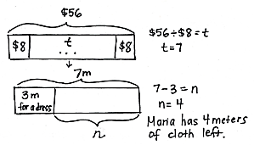S: (Possible response: I chose letter *t* to stand for the *total* meters of cloth Maria buys.)

T: Whisper what the unknown in your equation equals.

S: (Possible response: *t* equals 7 meters.)

T: Tell your partner your next step for solving. Then, write an equation using a letter for the unknown.

S: Now that I know that Maria bought a total of   
7 meters, I’ll do 7 3 = *n*. Letter *n* stands for the *number* of meters she has left.

T: Is your letter the same as the one you used for the first step? Why or why not?

|  |  |
| --- | --- |
|  | NOTES ON  MULTIPLE MEANS  OF ENGAGEMENT: |
| Students working above grade level and others may want to omit the tape diagram as they mentally solve the first few problems of the Problem Set. Redirect their focus to the accurate labeling of the unknown. After accurately labeling their tape diagrams, ask students to erase the values and experiment with numbers they choose. | |

S: It’s different because it represents something different. 🡪 Oh yeah! I need to change mine.

T: Finish solving, and then answer the question using words.

S: (Solve to find *n* is 4 meters. Write Maria has 4 meters of cloth left.)

T: Does Maria have enough cloth to sew another dress? Why or why not?

S: Yes, she has 4 meters left, and she only needs   
3 meters. 🡪 So, even after making a second dress, she will still have 1 meter of cloth left.

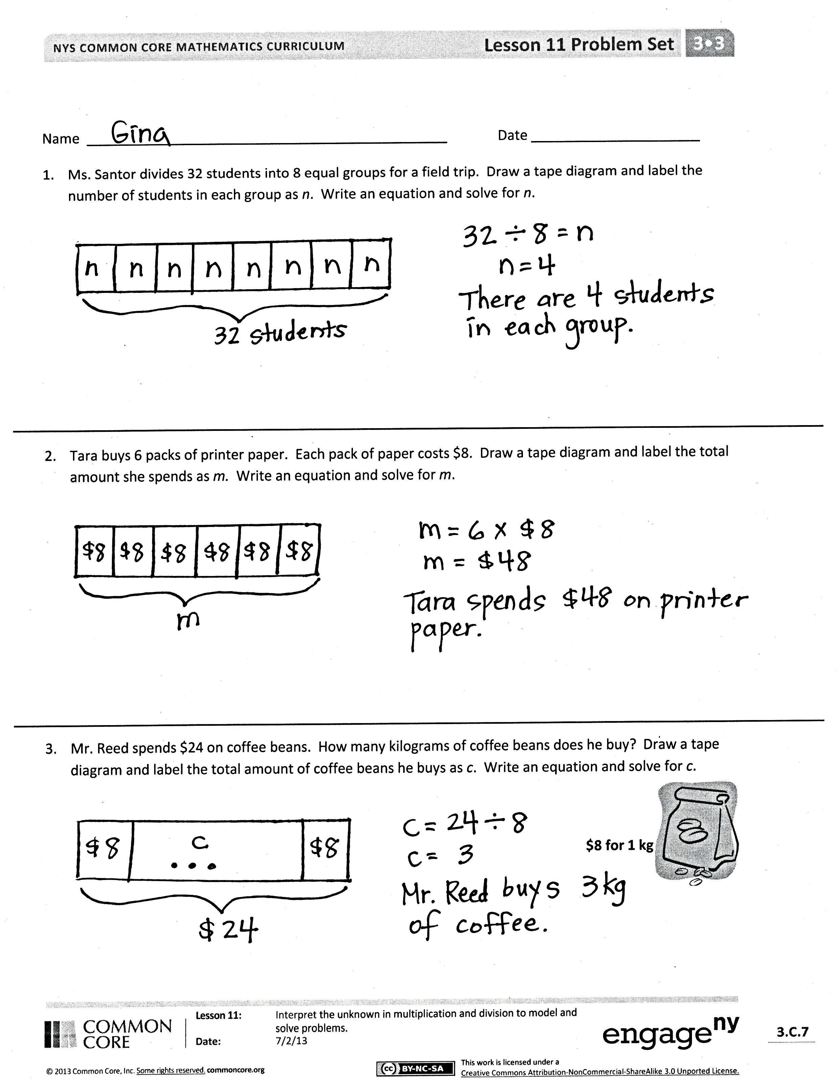Problem Set (10 minutes)

Students should do their personal best to complete the Problem Set within the allotted 10 minutes. For some classes, it may be appropriate to modify the assignment by specifying which problems they work on first. Some problems do not specify a method for solving. Students should solve these problems using the RDW approach used for Application Problems.

Student Debrief (10 minutes)

**Lesson Objective:** Interpret the unknown in multiplication and division to model and solve problems.

The Student Debrief is intended to invite reflection and active processing of the total lesson experience.

Invite students to review their solutions for the Problem Set. They should check work by comparing answers with a partner before going over answers as a class. Look for misconceptions or misunderstandings that can be addressed in the Debrief. Guide students in a 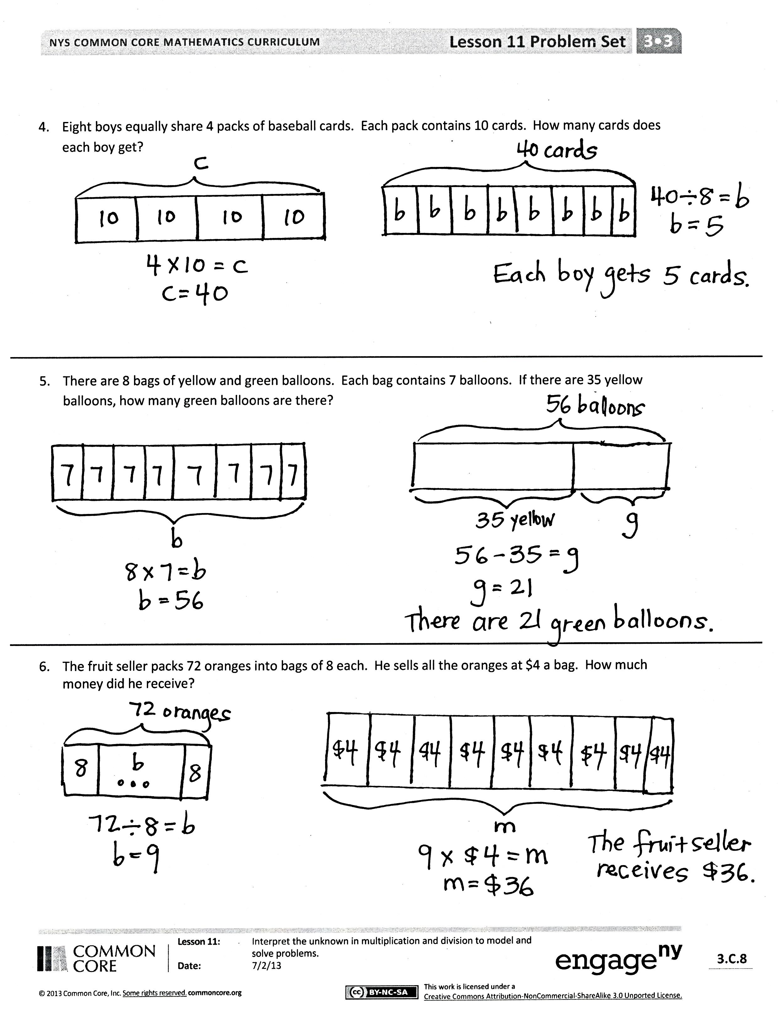conversation to debrief the Problem Set and process the lesson.

You may choose to use any combination of the questions below to lead the discussion.

* In Problem 1, did you solve to find the number of groups or the number of items in each group?
* What equations can be used to solve Problem 1?
* In Problem 4, how many parts did each pack need to be split into in order for each boy to get 1 part? (Two equal parts.) Could we use that fact to solve the problem without first finding the total number of cards? Why or why not?
* Problems 4–6 are multiple-step problems. Why is it useful to use different letters to represent two unknowns in the same problem?

Exit Ticket (3 minutes)

After the Student Debrief, instruct students to complete the Exit Ticket. A review of their work will help you assess the students’ understanding of the concepts that were presented in the lesson today and plan more effectively for future lessons. You may read the questions aloud to the students.

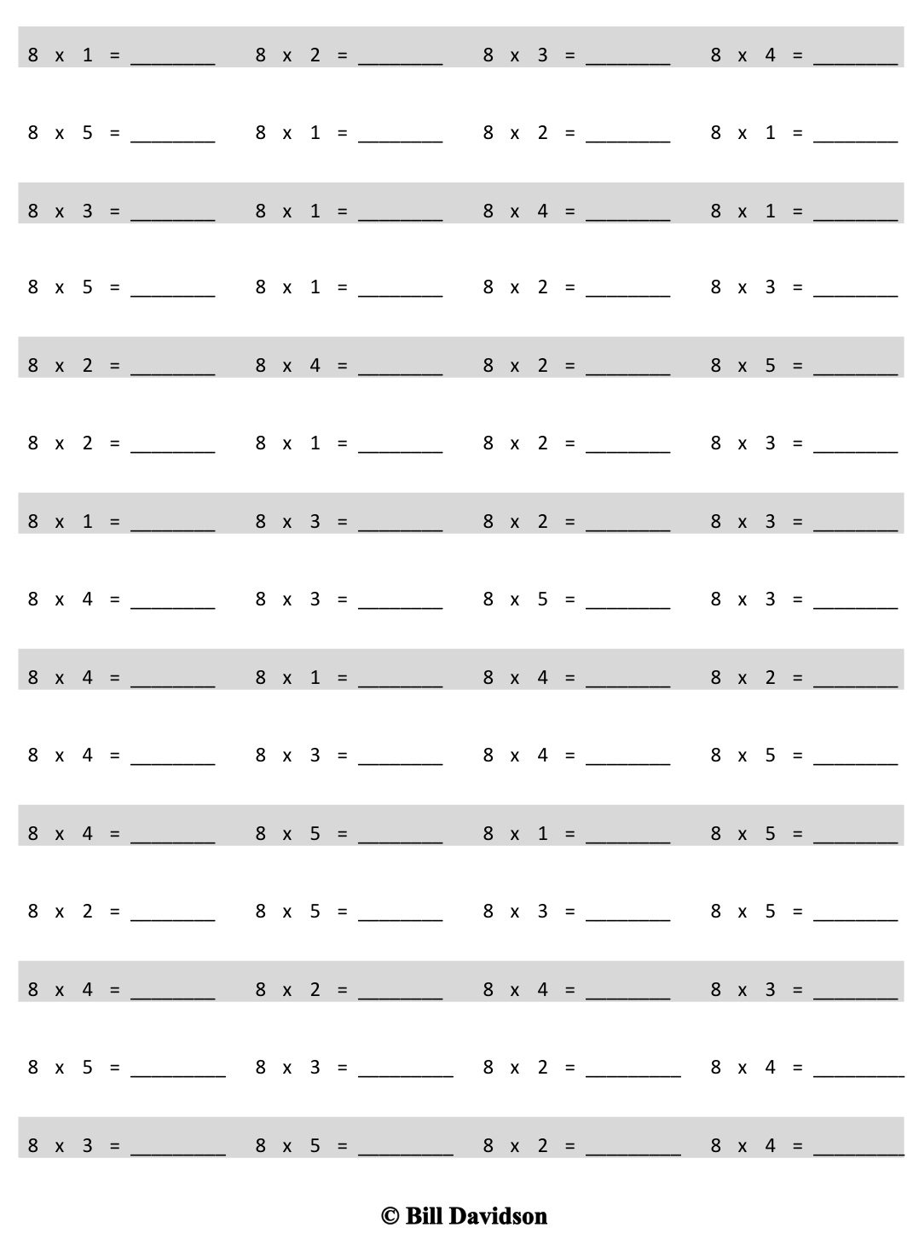[1]

Multiply.

Name Date

1. Ms. Santor divides 32 students into 8 equal groups for a field trip. Draw a tape diagram, and label the number of students in each group as *n*. Write an equation, and solve for *n*.
2. Tara buys 6 packs of printer paper. Each pack of paper costs $8. Draw a tape diagram, and label the total amount she spends as *m.* Write an equation, and solve for *m*.
3. Mr. Reed spends $24 on coffee beans. How many kilograms of coffee beans does he buy? Draw a tape diagram, and label the total amount of coffee beans he buys as *c*. Write an equation, and solve for *c*.

**$8 for 1 kg**



1. Eight boys equally share 4 packs of baseball cards. Each pack contains 10 cards. How many cards does each boy get?
2. There are 8 bags of yellow and green balloons. Each bag contains 7 balloons. If there are 35 yellow balloons, how many green balloons are there?
3. The fruit seller packs 72 oranges into bags of 8 each. He sells all the oranges at $4 a bag. How much money did he receive?

Name Date

Erica buys some packs of rubber bracelets. There are 8 bracelets in each pack.

a. How many packs of rubber bracelets does she buy if she has a total of 56 bracelets? Draw a tape diagram, and label the total number of packages as *p*. Write an equation, and solve for *p*.

b. After giving some bracelets away, Erica has 18 left. How many bracelets did she give away?

Name Date

1. Jenny bakes 10 cookies. She puts 7 chocolate chips on each cookie. Draw a tape diagram, and label the total amount of chocolate chips as *c*. Write an equation, and solve for *c*.
2. Mr. Lopez arranges 48 dry erase markers into 8 equal groups for his math stations. Draw a tape diagram, and label the number of dry erase markers in each group as *v*. Write an equation, and solve for *v*.
3. There are 35 computers in the lab. Five students each turn off an equal number of computers. How many computers does each student turn off? Label the unknown as *m*, and then solve.
4. There are 9 bins of books. Each bin has 6 comic books. How many comic books are there altogether?
5. There are 8 trail mix bags in one box. Clarissa buys 5 boxes. She gives an equal number of bags of trail mix to 4 friends. How many bags of trail mix does each friend receive?
6. Leo earns $8 each week for doing chores. After 7 weeks, he buys a gift and has $38 left. How much money does he spend on the gift?

1. multiply by 8 (1–5)