Lesson 10

Objective: Use the distributive property as a strategy to multiply and divide.

Suggested Lesson Structure

 Fluency Practice (7 minutes)

 Application Problem (5 minutes)

 Concept Development (38 minutes)

 Student Debrief (10 minutes)

**Total Time (60 minutes)**

Fluency Practice (7 minutes)

* Group Counting  **3.OA.1** (4 minutes)
* Decompose Multiples of 8 **3.OA.5** (3 minutes)

Group Counting (4 minutes)

Note: Group counting reviews interpreting multiplication as repeated addition. Counting by sixes and sevens reviews multiplication using those units in Topic B. Group counting by eights prepares students for multiplication in this topic. Group counting nines anticipates multiplication using units of nine later in the module.

Direct students to count forward and backward, occasionally changing the direction of the count:

* Sixes to 60
* Sevens to 70

|  |  |
| --- | --- |
|  | NOTES ON  MULTIPLE MEANS  OF ENGAGEMENT: |
| Students working below grade level may benefit from clear directions as to how to find the unknown part of the number bond. Model and instruct students to subtract to find the unknown part. Begin with smaller numbers as applicable to student needs. | |

* Eights to 80
* Nines to 90

Decompose Multiples of 8 (3 minutes)

Materials: (S) Personal white board

Note: This activity prepares students to use the distributive property in today’s lesson.

T: (Project a number bond with a whole of 48 and 16 as a part.) On your personal white board, fill in the unknown part in the number bond.

Continue with the following suggested sequence: whole of 56 and 24 as a part, whole of 64 and 40 as a part, whole of 40 and 16 as a part, and whole of 72 and 24 as a part.

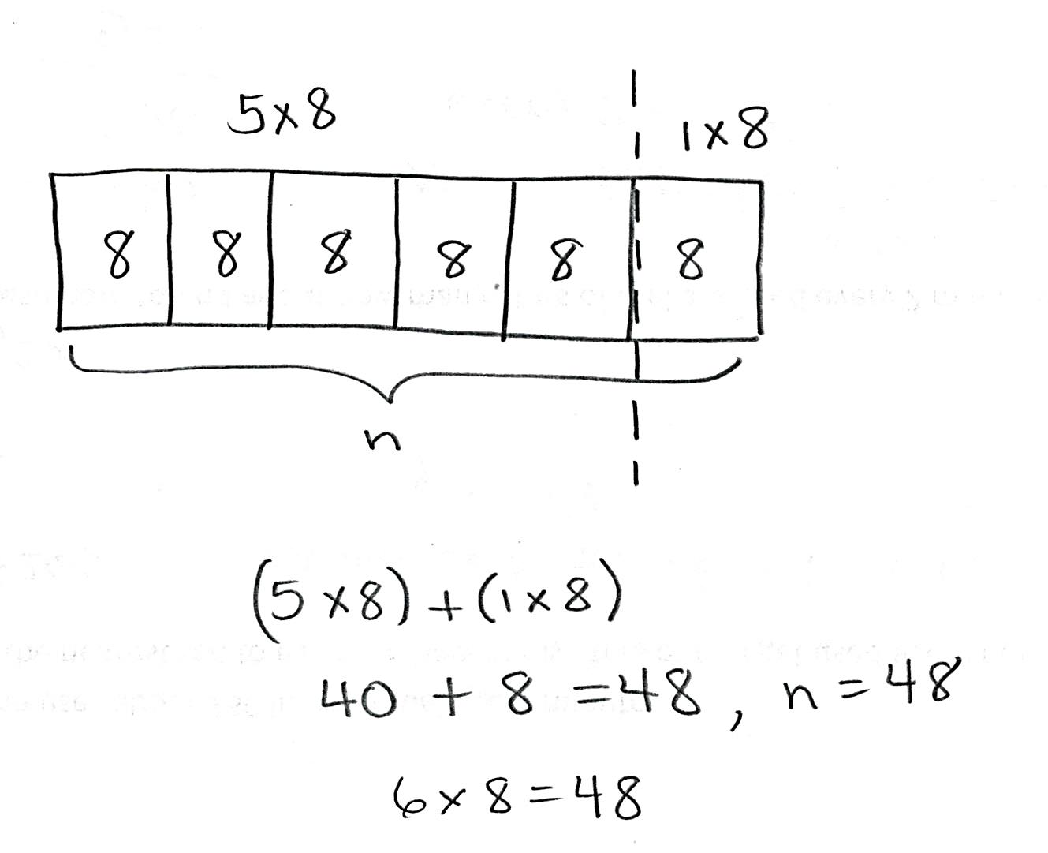Application Problem (5 minutes)

Use the 5 plus something break apart and distribute strategy to solve 6 × 8. Model with a tape diagram.

Note: This problem reviews modeling the break apart and distribute strategy using a tape diagram from Lesson 6. Up until today’s lesson, students learned to break apart the first factor and distribute the second factor. Today’s Concept Development reverses the order using the fact in this Application Problem.

Concept Development (38 minutes)

|  |  |
| --- | --- |
|  | NOTES ON  MULTIPLE MEANS  OF ACTION AND EXPRESSION: |
| Support English language learners as they engage in today’s discussion. Offer extra time for them to formulate their thoughts and discuss with their partners. If appropriate, preview words such as *factor.* Conduct subtle and frequent checks for understanding. Elaborate, expand, or paraphrase the dialogue as needed. | |

Materials: (S) Personal white board

Problem 1: Multiply.

T: When we use the break apart and distribute strategy, which factor do we break apart?

S: We break apart the number of groups.

T: Do you think our strategy would work if we broke apart the size of the groups and distributed the factor representing the number of groups instead? Think about the commutative property. Talk to your partner.

S: I’m not sure. I don’t think so. 🡪 The commutative property says that you can switch factors around in multiplication, so maybe it would work.

**MP.7**

*6 × (5 + 3)*

T: Let’s try using the break apart and distribute strategy that way to solve 6 × 8. Then, we can compare what happens with our work on the Application Problem.

T: Take a look at my array. (Project 6 by 8 array, shown at right.) Which factor will we break apart?

S: The 8! 🡪 The size of the groups.

T: Breaking it into 5 plus something helps us make two smaller facts. We can break 8 into 5 and what?

S: 5 and 3.

T: (Write 6 × (5 + 3) under the array.) Is 8 represented by the number of columns or the number of rows in the array?

S: The columns.

T: How should I draw my line to show that we broke apart the columns?

S: Maybe an up and down line? 🡪 You could make a vertical line after 5 columns. Then, one part would show 5 columns, and the other would show 3.

**MP.7**

*6 × (5 + 3)*

T: (Draw a dotted line after the fifth column.) On your personal white board, write the multiplication facts you would use to label each part of the array.

S: (Write 6 × 5 and 6 × 3.)

T: What did we break our 6 eights into?

S: 6 fives and 6 threes.

T: Talk to your partner about how 6 × (5 + 3) shows 6 fives and 6 threes. Use the array to help you explain.

T: Solve the problem.

S: (May use 6 × (5 + 3) or (6 × 5) + (6 × 3) to solve.)

T: What does it equal?

S: 48.

T: Look back at your work on the Application Problem. Compare it with this way of solving. Notice what is the same or different. Talk to your partner about what you see.

S: We switched around the factors that we broke apart and distributed. 🡪 In the Application Problem, the units never changed. They were always eights. The one we just did had two different units, fives and threes, but what stayed the same was the number of fives and the number of threes.

T: Does the break apart and distribute strategy work both ways?

S: Yes!

Continue with the following suggested problem: 7 × 8.

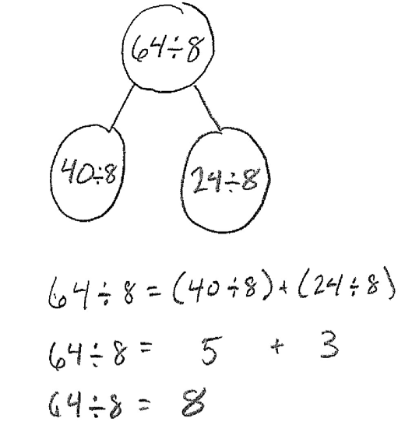Problem 2: Divide.

T: Let’s use the break apart and distribute strategy to solve   
64 ÷ 8. Draw a number bond with 64 ÷ 8 as the whole. Leave the parts empty. (Allow time for students to draw.)

T: Let’s think about how to break apart 64 into two numbers that are easier for us to divide. Make a list with your partner. Remember that when we break apart 64, both numbers need to be divisible by 8 because we originally distributed the 8 in our Application Problem.

S: How about 60 and 4? 🡪 No, you can’t divide those by 8!   
🡪 Maybe 32 and 32. 🡪 Or 40 and 24.

T: Using 32 and 32 works nicely because it’s a double. Forty and 24 also work well; 40 ÷ 8 makes 5. Five is easy to add to, so let’s try 40 and 24. Write 40 ÷ 8 as one of the parts on your number bond.

T: What division fact goes inside the other part?

S: 24 ÷ 8.

T: How do you know?

S: 40 plus 24 equals 64. 🡪 We started with 64, used 40, and need 24 more.

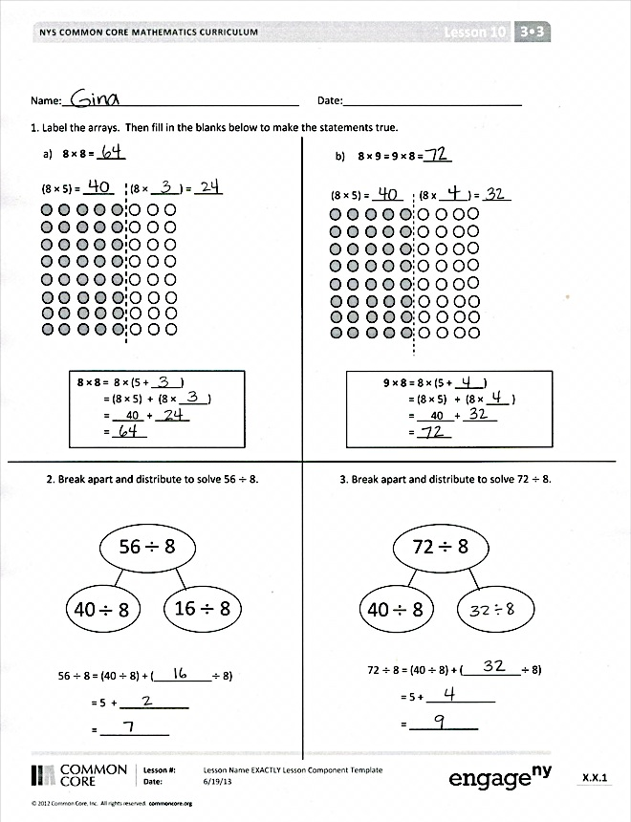

T: Write that division fact as the other part. Our number bond shows us that 64 ÷ 8 has the same value as combining 40 ÷ 8 and 24 ÷ 8. Work with your partner to write that as an addition sentence on your board.

S: (Write 64 ÷ 8 = (40 ÷ 8) + (24 ÷ 8).)

T: Work with your partner to solve.

S: (Write 5 + 3 = 8.)

T: What is 64 ÷ 8?

S: 8!

Continue with the following suggested sequence:

* 96 ÷ 8
* 54 ÷ 6

Problem Set (10 minutes)

Students should do their personal best to complete the Problem Set within the allotted 10 minutes. For some classes, it may be appropriate to modify the assignment by specifying which problems they work on first. Some problems do not specify a method for solving. Students should solve these problems using the RDW approach used for Application Problems.

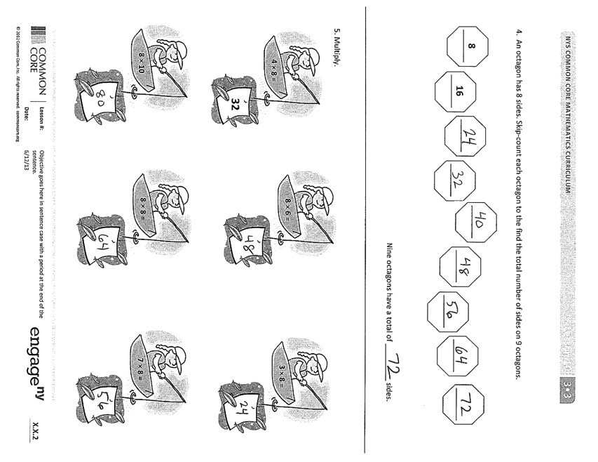

Student Debrief (10 minutes)

**Lesson Objective:** Use the distributive property as a strategy to multiply and divide.

The Student Debrief is intended to invite reflection and active processing of the total lesson experience.

Invite students to review their solutions for the Problem Set. They should check work by comparing answers with a partner before going over answers as a class. Look for misconceptions or misunderstandings that can be addressed in the Debrief. Guide students in a conversation to debrief the Problem Set and process the lesson.

You may choose to use any combination of the questions below to lead the discussion.

* Describe the steps you took to solve for the unknown numbers in Problem 1(a).

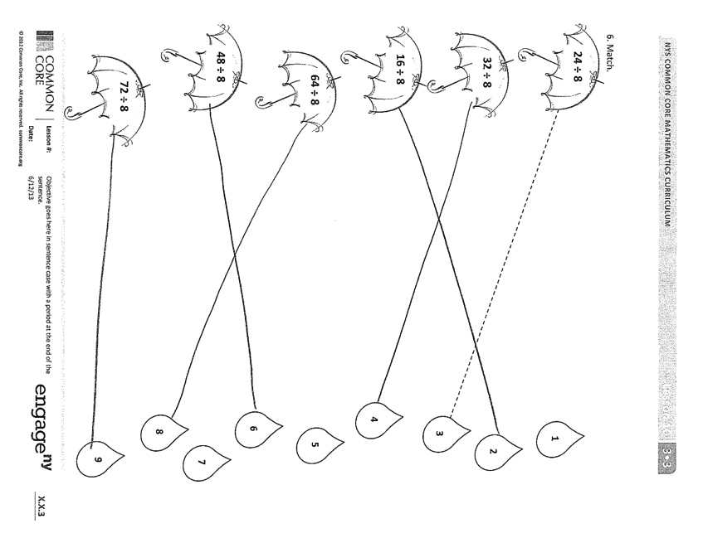

* How did you know what division fact to write for the unknown part in Problem 3?
* What multiplication sentence is used to solve Problem 4? How do you know?
* Invite students to share how to apply the break apart strategy to any of the expressions in Problem 5.
* In what ways does the break apart and distribute strategy remind you of the simplifying strategy we learned yesterday?
* How did our math work today help make multiplication and division with larger numbers simpler?

Exit Ticket (3 minutes)

After the Student Debrief, instruct students to complete the Exit Ticket. A review of their work will help you assess the students’ understanding of the concepts that were presented in the lesson today and plan more effectively for future lessons. You may read the questions aloud to the students.

Name Date

1. Label the arrays. Then, fill in the blanks below to make the statements true.

(8 × 5) = _ ____ (8 × _____) = _____

**8 × 8** = 8 × (5 + _____)

= (8 × 5) + (8 × _____)

= 40 + ______

= ______

(1 × 4) = _ _____

a. **8 × 8 = _____**

b. **8 × 9 = 9 × 8 =_____**

(8 × 5) = _ ____ (8 × _____) = _____

**9 × 8** = 8 × (5 + _____)

= (8 × 5) + (8 × ____ )

= 40 + ______

= ______

(1 × 4) = _ _____

2. Break apart and distribute to solve 56 ÷ 8.

56

40

8

56 ÷ 8 = (40 ÷ 8) + (__________÷ 8)

= 5 + ____________

= ____________

16

8

8

3. Break apart and distribute to solve 72 ÷ 8.

72

40

8

72 ÷ 8 = (40 ÷ 8) + (__________÷ 8)

= 5 + ____________

= ____________

8

8

4. An octagon has 8 sides. Skip-count to find the total number of sides on 9 octagons.

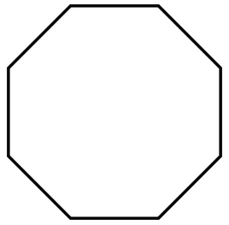

**8**



**16**



Nine octagons have a total of _________ sides.

5. Multiply.



**8 × 6 =**



**3 × 8 =**



**32**

**4 × 8 =**



**8 × 8 =**



**7 × 8 =**



**8 × 10 =**

6. Match.

**2**

**4**

**6**

**8**

**5**

**1**

**7**

**9**



**32 ÷ 8**



**16 ÷ 8**



**48 ÷ 8**



**64 ÷ 8**



**72 ÷ 8**



**24 ÷ 8**

**3**

Name Date

Use the break apart and distribute strategy to solve the following problem. You may choose whether or not to draw an array.

**7 × 8 =_____**

Name Date

1. Label the array. Then, fill in the blanks to make the statements true.

(7 × 5) = (7 × _____) = _____

**8 × 7 = 7 × 8 =_____**

**8 × 7** = 7 × (5 + _____)

= (7 × 5) + (7 × ____)

= 35 + ______

= ______

(1 × 4) = _ _____

2. Break apart and distribute to solve 72 ÷ 8.

72

40

8

72 ÷ 8 = (40 ÷ 8) + (__________÷ 8)

= 5 + ____________

= ____________

32

8

8

1. Count by 8. Then, match each multiplication problem with its value.

8 , _______, _______, _______, _______, _______, _______, _______, _______, _______

**7 × 8**

**9 × 8**

**5 × 8**

**8 × 8**

**6 × 8**

1. Divide.

**16 ÷ 8 = ______**

**48 ÷ 8 = ______**

**40 ÷ 8 = ______**

**72 ÷ 8 = ______**

**56 ÷ 8 = ______**

**32 ÷ 8 = ______**