Lesson 9
Objective: Model the associative property as a strategy to multiply.

Suggested Lesson Structure
 Fluency Practice (11 minutes)
 Application Problems (15 minutes)
 Concept Development (24 minutes)
 Student Debrief (10 minutes)
Total Time (60 minutes)
Fluency Practice (11 minutes)
- Divide by 6 and 7 3.OA.7 (3 minutes)
- Group Counting 3.OA.1 (4 minutes)
- Write In the Parentheses 3.OA.7 (4 minutes)

Divide by 6 and 7 (3 minutes)
Materials: (S) Personal white board
Note: This fluency activity reviews using a letter to represent the unknown taught in Lesson 3.
T: (Write a × 6 = 12.) On your personal white board, write the value of a.
S: (Write a = 2.)
T: (Write 12 ÷ 6 = a.) Say the division sentence.
S: 12 ÷ 6 = 2.
Continue with the following suggested sequence: a × 6 = 30, b × 6 = 24, c × 6 = 36, d × 6 = 60, e × 6 = 54,
f × 7 = 35, g × 7 = 28, h × 7 = 42, j × 7 = 70, and k × 7 = 56.
Group Counting (4 minutes)
Note: Group counting reviews interpreting multiplication as repeated addition. Group counting by eights prepares students for multiplication in this topic. Group counting nines anticipates multiplication using units of nine later in the module.
Direct students to count forward and backward, occasionally changing the direction of the count:
- Eights to 80
- Nines to 90

Write In the Parentheses (4 minutes)
Materials: (S) Personal white board
Note: This fluency activity reviews the use of parentheses taught in Lesson 8.
T: (Write 10 – 5 + 3 = 8.) On your board, copy the equation. Then, insert parentheses to make the statement true.
S: (Write (10 – 5) + 3 = 8.)
Continue with the following suggested sequence: 10 – 5 + 3 = 2, 10 = 20 – 7 + 3, 16 = 20 – 7 + 3,
8 + 2 × 4 = 40, 8 + 2 × 4 = 40, 12 = 12 ÷ 2 × 2, 3 = 12 ÷ 2 × 2, 10 = 35 – 5 × 5, and 20 – 10 ÷ 5 = 2.
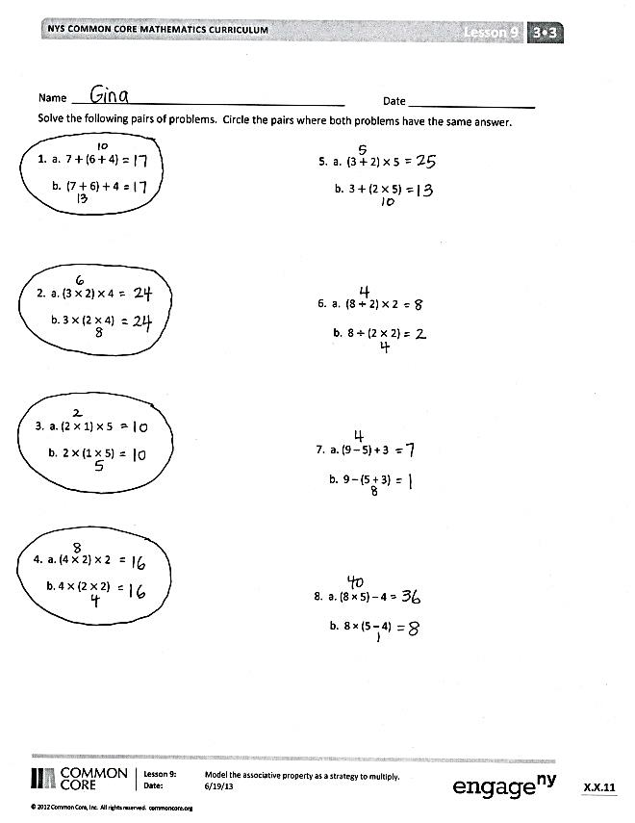
Application Problems (15 minutes)
Materials: (S) Application Problems Sheet
Note: These problems give students practice solving equations with parentheses. This sequence of problems is specifically designed so that students recognize that the position of the parentheses does not change the answer in multiplication problems with more than two factors. (The same is true for addition. Problem 1 hints at this.) Debrief the Application Problems so that this is clear to students with respect to multiplication. This understanding is critical for the Concept Development. You may choose to begin the discussion by having them analyze the difference between the problems they circled and those they did not.
Concept Development (24 minutes)
Materials: (S) Personal white board
T: (Write 16 × 3.) This is a difficult problem for a third grader to solve. Let’s simplify it. Work with your partner to list factors that have a product of 16. Write them on your personal white board.

A NOTE ON
MULTIPLE MEANS
OF ACTION AND EXPRESSION:
One way to scaffold listing factors of 16 is to give students 16 beans they can put into equal groups.

S: 4 times 4 makes 16! 8 and 2 also works.
T: 4, 8, and 2 are much friendlier factors than 16. Let’s rewrite 16 as 8 × 2. (Write (8 × 2) × 3.) Why do you think I put 8 × 2 in parentheses?
S: The parentheses show that when you group those numbers together and multiply, you get 16.
T: Even with the 16 rewritten, this problem isn’t too friendly because I still have to multiply 16 × 3 in the last step. Suppose I move the parentheses to change the way the numbers are grouped. Will it completely change my answer?
S: No, we saw that it’s okay to move the parentheses when it’s all multiplication in our Application Problems.
T: Write the equation on your board. Use the parentheses to group the numbers differently. Check your work with your partner’s.
S: (Write 8 × (2 × 3) and check work with a partner.)
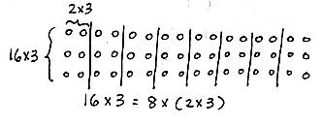
T: (Draw array.) My array shows how I regrouped the numbers to show 8 groups of (2 × 3).
Is this problem friendlier than 16 × 3?
S: Oh, it’s just 8 × 6! That’s the same as 48!
That was easy!
T: So, what is the answer to 16 × 3?
S: 48!
T: Tell your partner the steps we took to simplify the problem and solve.
S: First, we rewrote 16 as a multiplication problem with two easier factors. Then, we grouped the numbers with parentheses to make a multiplication problem that was easy to solve.
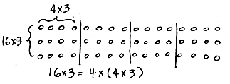
T: (Do not erase the 16 × 3 = 8 × (2 × 3) array.) When we brainstormed factors with a product of 16, some of you thought of 4 × 4. Let’s see if rewriting the 16 that way helps us simplify. Rewrite 16 × 3 using 4 × 4.
S: (Write (4 × 4) × 3.)
T: Is it easy to solve yet?
S: No!
T: Try and simplify by using the parentheses to group the numbers differently.
S: (Write 4 × (4 × 3).)
T: (Draw array.) Here is the array that shows our 4 groups of (4 × 3). Did the problem get easier?
S: Not really. It’s still 4 × 12, and that’s hard.
T: Let’s compare the two arrays. What do you notice?
S: They show 16 × 3 in different ways. The first array shows 8 groups of 6, and the second array shows 4 groups of 12. The second array has fewer groups but multiplies a larger number.
So, both arrays still show a total of 48, but the first array breaks it up into easier numbers.
T: True. If we use repeated addition to find the answer to 4 × 12, we’ll find the answer is still 48. We didn’t do anything wrong, but rewriting the 16 as 4 × 4 and moving the parentheses didn’t do what we wanted it to. It didn’t help us simplify. With your partner, compare the two arrays. What happened when we rewrote 16 as 4 × 4 and 8 × 2? What does the comparison tell you about this strategy?
S: It doesn’t always work. It means you have to be careful about which numbers you choose.
Yeah, some are helpful and some aren’t. Sometimes you might have to try more than one pair of numbers before you find the pair that helps you simplify.
Continue with 15 × 3. You may want to point out that the order in which 15 is rewritten can make a difference. For example, ask students to notice which is easier:
- (3 × 5) × 3 b. (5 × 3) × 3
3 × (5 × 3) 5 × (3 × 3)
3 × 15 5 × 9
Problem Set (10 minutes)

NOTES ON
MULTIPLE MEANS
OF ACTION AND EXPRESSION:
Learners who have not memorized sixes and sevens facts may not benefit from using the associative property to solve 14 × 3 on the Problem Set. Adjust the numbers, or encourage students to use a more personally efficient strategy, such as the distributive property.

Students should do their personal best to complete the Problem Set within the allotted 10 minutes. For some classes, it may be appropriate to modify the assignment by specifying which problems they work on first. Some problems do not specify a method for solving. Students should solve these problems using the RDW approach used for Application Problems.
Student Debrief (10 minutes)
Lesson Objective: Model the associative property as a strategy to multiply.
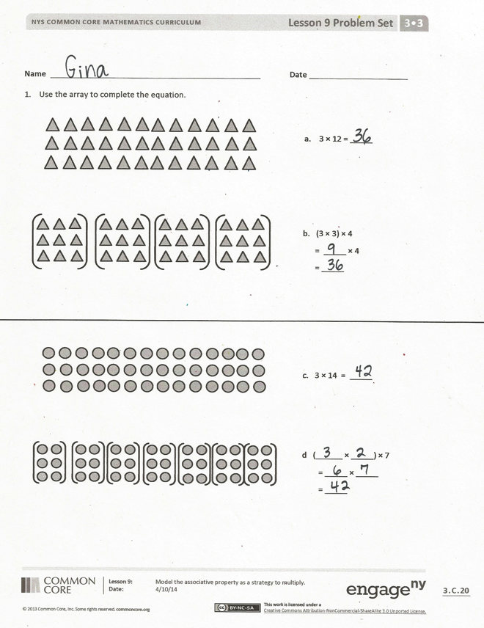
The Student Debrief is intended to invite reflection and active processing of the total lesson experience. Invite students to review their solutions for the Problem Set. They should check work by comparing answers with a partner before going over answers as a class. Look for misconceptions or misunderstandings that can be addressed in the Debrief. Guide students in a conversation to debrief the Problem Set and process the lesson.
You may choose to use any combination of the questions below to lead the discussion.
- In Problem 1, how do the problems on the bottom simplify the problems on the top?
- Invite students to share how they knew where to draw parentheses for the equations in Problem 2.
- In Problem 3, how did Charlotte simplify?
- How are the commutative property and this new strategy helpful for finding unknown, larger facts?
- How did the Application Problems relate to the lesson today?

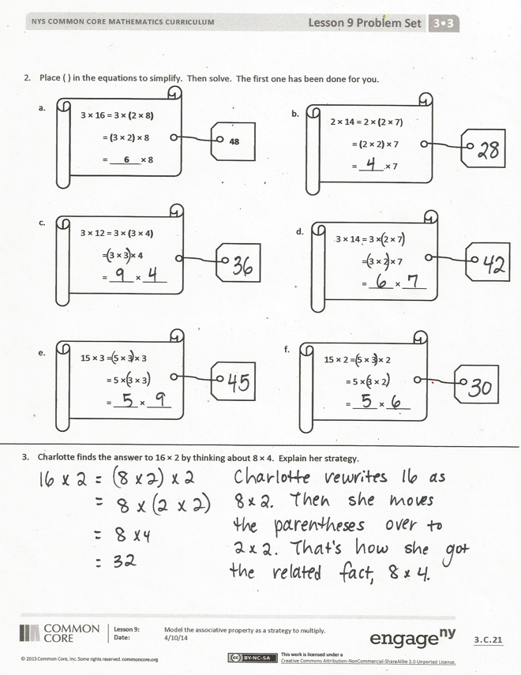
- In the Application Problems, we noticed that it is okay to move the parentheses when every operation is multiplication. Is that true for the other operations too? (Provide subtraction and division examples, where it is not okay to move parentheses and obtain the same answer. Provide addition examples that students can use in conjunction with Application Problem 1 to generalize that it is also true for addition.)
Exit Ticket (3 minutes)
After the Student Debrief, instruct students to complete the Exit Ticket. A review of their work will help you assess the students’ understanding of the concepts that were presented in the lesson today and plan more effectively for future lessons. You may read the questions aloud to the students.

Name Date
Solve the following pairs of problems. Circle the pairs where both problems have the same answer.

1. a. 7 + (6 + 4)
b. (7 + 6) + 4

2. a. (3 × 2) × 4
b. 3 × (2 × 4)

3. a. (2 × 1) × 5
b. 2 × (1 × 5)

4. a. (4 × 2) × 2
b. 4 × (2 × 2)

5. a. (3 + 2) × 5
b. 3 + (2 × 5)

6. a. (8 ÷ 2) × 2
b. 8 ÷ (2 × 2)

7. a. (9 – 5) + 3
b. 9 – (5 + 3)

8. a. (8 × 5) – 4
b. 8 × (5 – 4)

Name Date
- Use the array to complete the equation.
c. 3 × 14 = _____
d (______ × _____) × 7
= _____ × _____
= _____
- 3 × 12 = _____
b. (3 × 3) × 4
= _____ × 4
= _____
- Place parentheses in the equations to simplify. Then, solve. The first one has been done for you.
3 × 12 = 3 × (3 × 4)
= 3 × 3 × 4
= _____ × _____

c.
2 × 14 = 2 × (2 × 7)
= (2 × 2) × 7
= _____ × 7

b.
3 × 16 = 3 × (2 × 8)
= (3 × 2) × 8
= ___6__ × 8

48
a.
15 × 2 = 5 × 3 × 2
= 5 × 3 × 2
= _____ × _____
f.
15 × 3 = 5 × 3 × 3
= 5 × 3 × 3
= _____ × _____
e.

3 × 14 = 3 × 2 × 7
= 3 × 2 × 7
= _____ × _____
d.

- Charlotte finds the answer to 16 × 2 by thinking about 8 × 4. Explain her strategy.

Name Date
Simplify to find the answer to 18 × 3. Show your work and explain your strategy.

Name Date
- Use the array to complete the equation.

- 3 × 16 = _____
b. (3 × ____) × 8
= _____ × _____
= _____
c. 4 × 18 = _____
d. (4 × ____) × 9
= _____ × _____
= _____

- Place parentheses in the equations to simplify and solve.
a.
3 × 14 = 3 × (2 × 7)
= 3 × 2 × 7
= ____ × 7

= _____
12 × 4 = (6 × 2) × 4
= 6 × (2 × 4)
= 6 × _8_

= ___48__

b.
3 × 12 = 3 × (3 × 4)
= 3 × 3 × 4
= ____× 4

= _____

- Solve. Then, match the related facts.
- 20 × 2 = __40__ =

- 30 × 2 = ______ =

- 35 × 2 = ______ =

- 40 × 2 = ______ =

6 × (5 × 2)
8 × (5 × 2)
4 × (5 × 2)
7 × (5 × 2)

