Lesson 8
Objective: Understand the function of parentheses and apply to solving problems.

Suggested Lesson Structure
 Fluency Practice (15 minutes)
 Application Problem (5 minutes)
 Concept Development (30 minutes)
 Student Debrief (10 minutes)
Total Time (60 minutes)
Fluency Practice (15 minutes)
- Multiply By 7 3.OA.7 (6 minutes)
- Group Counting 3.OA.1 (4 minutes)
- Add 6 and 7 Mentally 2.NBT.5 (5 minutes)

Multiply By 7 (6 minutes)
Materials: (S) Multiply By 7 (6–10) (Pattern Sheet)

NOTES ON
MULTIPLE MEANS
OF ENGAGEMENT:
Multiply By 7 is carefully scaffolded to support student success. Adjust the activity to suit students’ diverse needs. For example, focus on one skill, such as skip-counting down to solve. Or, have students review and solidify their memorization of skip-counting up by seven by doing the Group Counting first.
Note: This activity builds fluency with multiplication facts using units of seven. It supports students knowing from memory all products of two one-digit numbers. See Lesson 5 for the directions for administering a Multiply By Pattern Sheet.
T: (Write 6 × 7 = ____.) Let’s skip-count up by sevens to solve. I’ll raise a finger for each seven. (Count with fingers to 6 as students count.)
S: 7, 14, 21, 28, 35, 42.
T: Let’s skip-count down to find the answer, too. Start at 70. (Count down with fingers as students count.)
S: 70, 63, 56, 49, 42.
Continue with the following suggested sequence: 8 × 7, 7 × 7, and 9 × 7.
T: (Distribute the Multiply By 7 Pattern Sheet.) Let’s practice multiplying by 7. Be sure to work left to right across the page.

Group Counting (4 minutes)
Note: Group counting reviews interpreting multiplication as repeated addition. Counting by sixes reviews multiplication using units of six from Topic B. Group counting eights prepares students for multiplication in this topic. Group counting nines anticipates multiplication using units of nine later in the module. Direct students to count forward and backward, occasionally changing the direction of the count:
- Sixes to 60
- Eights to 80
- Nines to 90

Add 6 and 7 Mentally (5 minutes)
Materials: (S) Personal white board
Note: This activity reviews the make ten strategy used for skip-counting by sixes and sevens in Lessons 4 and 5.
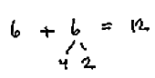
T: (Project 6 + 6 = ___.) Say the expression.
S: 6 + 6.
T: 6 and what make ten?
S: 4.
T: (Draw a number bond beneath the second 6.) On your personal white board, break apart the second 6, taking out the 4.
S: (Write the number bond.)
T: Say the addition sentence.
S: 6 + 6 = 12.
Continue with the following possible sequence: 12 + 6, 18 + 6, 24 + 6, 30 + 6, 36 + 6, 42 + 6, 48 + 6, 54 + 6,
7 + 7, 14 + 7, 21 + 7, 28 + 7, 35 + 7, 42 + 7, 49 + 7, 56 + 7, and 63 + 7.
Application Problem (5 minutes)
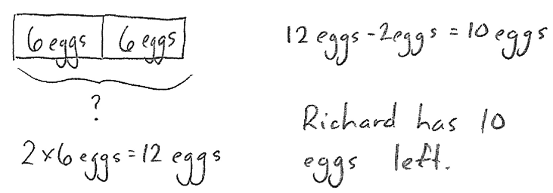
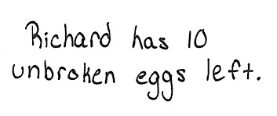
Richard has 2 cartons with 6 eggs in each. As he opens the cartons, he drops 2 eggs. How many unbroken eggs does Richard have left?

Note: This problem provides a context for solving equations involving multiple operations which is central to the Concept Development.
Concept Development (30 minutes)
Materials: (S) Personal white board
Part 1: Solve equations containing parentheses.



T: The two equations used to solve the Application Problem are
2 × 6 = 12 and 12 – 2 = 10. (Show picture to the right.) This picture shows both. Talk to your partner: How could we include all of this information in one equation?
S: We can rewrite them as one equation. Maybe 2 × 6 – 2 = 10?
T: Let’s check to make sure the new equation equals 10. Should we multiply first or subtract first? Does it matter?
S: I don’t think it matters. Before we multiplied first, so let’s do that again.
T: Let’s find out. Solve the equation twice. The first time you solve it, multiply first. The second time you solve, subtract first. (Allow time for students to calculate.)
S: When I multiplied first, I still got 10, but when I subtracted first, I got 8!
T: For this problem, the order does matter. We can use parentheses in our equation to show what to do first. Remind me, which part of the equation do we need to do first and why?
S: 2 × 6. We have to find the total number of eggs Richard has in 2 cartons first.
T: Watch how I use parentheses to show that. (Write (2 × 6) – 2 = 10.)
T: What is the product of 2 × 6?

NOTES ON
MULTIPLE MEANS
OF ENGAGEMENT:
Alternatively, challenge students working above grade level to write equations in which multiple operations are used on both sides of the equation. For example, a student might extend
(2 × 6) – 2 = 10, as (2 × 6) −2 = (7 – 2)
× 2.

S: 12!
T: Rewrite 2 × 6 as 12. What expression is left?
S: 12 – 2!
T: What does 12 – 2 equal?
S: 10!
T: In a complete sentence, how many eggs does Richard have left?
S: Richard has 10 eggs left.
Continue with the following suggested sequence:
- 4 + 2 = 6 and 6 × 6 = 36 (4 + 2) × 6 = 36
- 12 ÷ 3 = 4 and 15 – 4 = 11 15 – (12 ÷ 3) = 11
Note: Have students refer back to the original problem, as the situation dictates the placement of the parentheses.

Part 2: Explore how moving the parentheses can change the answer in an equation.
Write or project the following equation and the picture on the following page: (25 – 10) ÷ 5 = 3.
T: Check my work. Is it correct?
S: Yes, because 25 – 10 equals 15, and 15 ÷ 5 equals 3.
T: Let’s divide 10 by 5 first. What should we do with the parentheses to show that?
S: Move them over! Make them go around 10 ÷ 5.
T: Now the equation looks like this. (Write 25 – (10 ÷ 5) = n.) Write the equation on your personal white board. Why is there a letter where the
3 was before?
S: We should write 3 because the numbers didn’t change. We don’t know if it equals 3 anymore.
T: Really? Why not? The numbers are the same as before.
S: The parentheses moved.
T: Solve the problem with your partner. Does this equation still have an answer of 3?
S: (Work and discuss.) No, the answer is 23!
T: Why is the answer different?
S: We divided first. One way, we divided 15 by 5. The other way, we subtracted 2 from 25.
We divided and then subtracted. Before, we subtracted, and then divided.
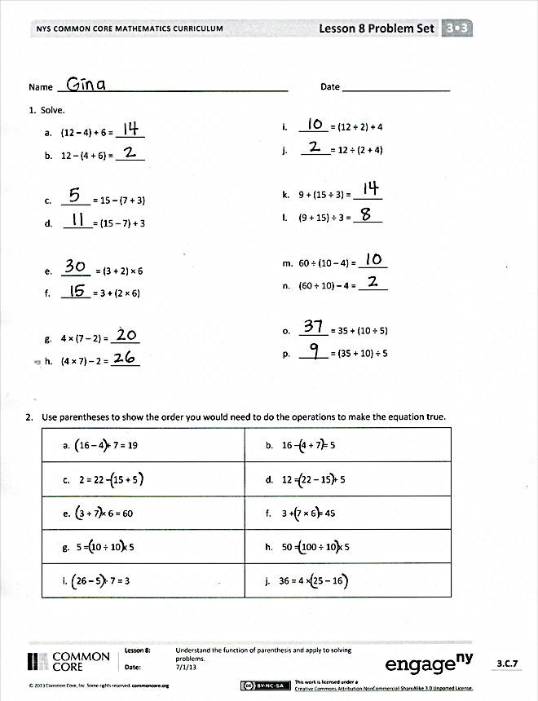
T: What does this tell you about the way we use parentheses to group the math in equations? Is it important? Why or why not?
S: The parentheses tell us what math gets done first. Yes, it’s important because moving the parentheses can change the answer.
Continue with the following suggested sequence:
- (2 + 3) × 7 and 2 + (3 × 7)
- (3 × 4) ÷ 2 and 3 × (4 ÷ 2)

Problem Set (10 minutes)
Students should do their personal best to complete the Problem Set within the allotted 10 minutes. For some classes, it may be appropriate to modify the assignment by specifying which problems they work on first. Some problems do not specify a method for solving. Students should solve these problems using the RDW approach used for Application Problems.

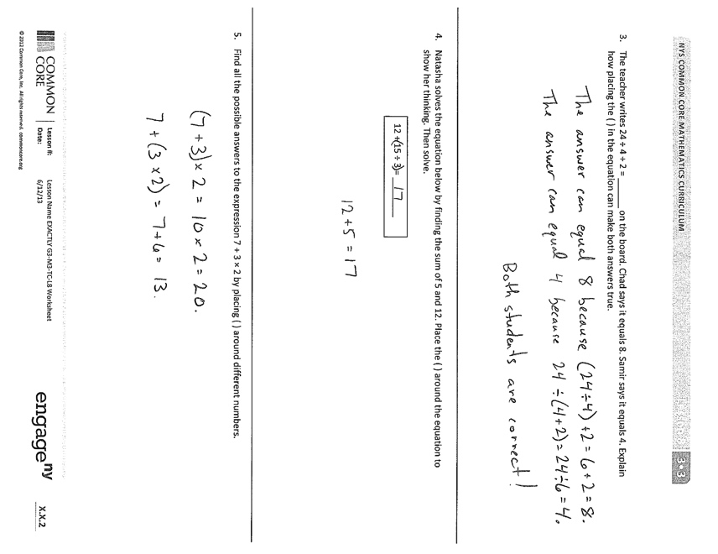
Student Debrief (10 minutes)
Lesson Objective: Understand the function of parentheses and apply to solving problems.
The Student Debrief is intended to invite reflection and active processing of the total lesson experience.
Invite students to review their solutions for the Problem Set. They should check work by comparing answers with a partner before going over answers as a class. Look for misconceptions or misunderstandings that can be addressed in the Debrief. Guide students in a conversation to debrief the Problem Set and process the lesson.
You may choose to use any combination of the questions below to lead the discussion.
- Look at Problem 1(j). Would the answer be the same if I solved (12 ÷ 2) + (12 ÷ 4)? Why not? (Lead students to understand that they cannot distribute in this problem.)
- Look at Problem 1(l). Would the answer be the same if I solved (9 ÷ 3) + (15 ÷ 3)? Why?
- How did you discover where the parentheses belonged in Problem 2?
- Why does moving the parentheses in an equation only change the answer sometimes?

Exit Ticket (3 minutes)
After the Student Debrief, instruct students to complete the Exit Ticket. A review of their work will help you assess the students’ understanding of the concepts that were presented in the lesson today and plan more effectively for future lessons. You may read the questions aloud to the students.
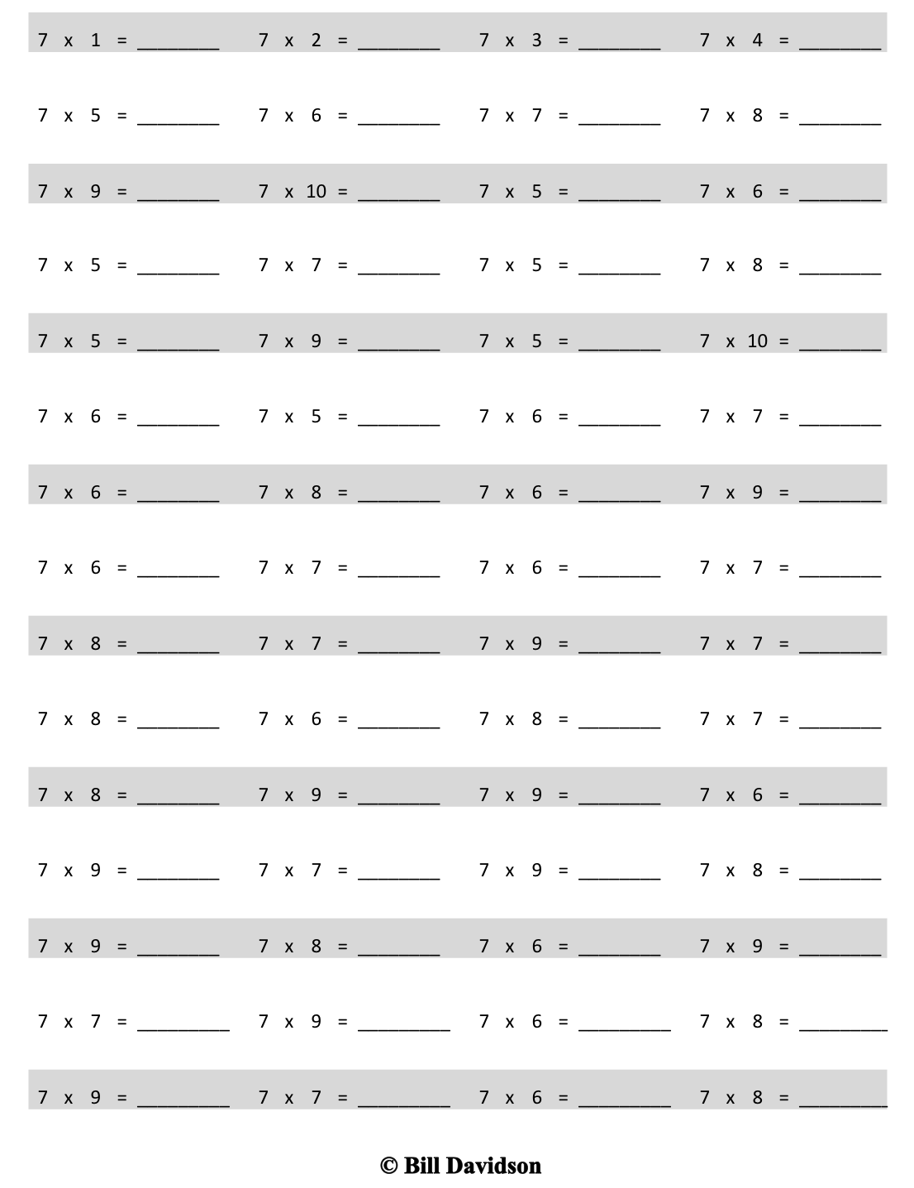
Multiply.
Name Date
- Solve.

- (12 – 4) + 6 = ______ i. ______ = (12 ÷ 2) + 4
- 12 – (4 + 6) = ______ j. ______ = 12 ÷ (2 + 4)

- ______ = 15 – (7 + 3) k. 9 + (15 ÷ 3) = ______
- ______ = (15 – 7) + 3 l. (9 + 15) ÷ 3 = ______

- ______ = (3 + 2) × 6 m. 60 ÷ (10 – 4) = ______
- ______ = 3 + (2 × 6) n. (60 ÷ 10) – 4 = ______

- 4 × (7 – 2) = ______ o. ______ = 35 + (10 ÷ 5)
- (4 × 7) – 2 = ______ p. ______ = (35 + 10) ÷ 5
- Use parentheses to make the equations true.
- 16 – 4 + 7 = 19 | - 16 – 4 + 7 = 5
- 2 = 22 – 15 + 5 | - 12 = 22 – 15 + 5
- 3 + 7 × 6 = 60 | - 3 + 7 × 6 = 45
g. 5 = 10 ÷ 10 × 5 | h. 50 = 100 ÷ 10 × 5
i. 26 – 5 ÷ 7 = 3 | j. 36 = 4 × 25 – 16

- The teacher writes 24 ÷ 4 + 2 = ______ on the board. Chad says it equals 8. Samir says it equals 4. Explain how placing the parentheses in the equation can make both answers true.

- Natasha solves the equation below by finding the sum of 5 and 12. Place the parentheses in the equation to show her thinking. Then, solve.
12 + 15 ÷ 3 = ________

- Find two possible answers to the expression 7 + 3 × 2 by placing the parentheses in different places.

Name Date
- Use parentheses to make the equations true.

a. 24 = 32 – 14 + 6 b. 12 = 32 – 14 + 6
c. 2 + 8 × 7 = 70 d. 2 + 8 × 7 = 58

- Marcos solves 24 ÷ 6 + 2 = ______. He says it equals 6. Iris says it equals 3. Show how the position of parentheses in the equation can make both answers true.

Name Date
- Solve.
- 9 $–$ (6 + 3) = ______ b. (9 $–$ 6) + 3 = ______

c. ______= 14 – (4 + 2) d. ______ = (14 – 4) + 2

e. ______ = (4 + 3) × 6 f. ______ = 4 + (3 × 6)

g. (18 ÷ 3) + 6 = ______ h. 18 ÷ (3 + 6) = ______

- Use parentheses to make the equations true.

- 12 = 18 ÷ 3 × 2

- 3 = 18 ÷ 3 × 2

- 14 – 8 + 2 = 4

- 14 – 8 + 2 = 8

- 2 + 4 × 7 = 30

- 2 + 4 × 7 = 42

- 5 = 50 ÷ 5 × 2

- 20 = 50 ÷ 5 × 2

- Determine if the equation is true or false.
- (15 – 3) ÷ 2 = 6 | Example: True
- (10 – 7) × 6 = 18
- (35 – 7) ÷ 4 = 8
- 28 = 4 × (20 – 13)
- 35 = (22 - 8) ÷ 5

- Jerome finds that (3 × 6) ÷ 2 and 18 ÷ 2 are equal. Explain why this is true.

- Place parentheses in the equation below so that you solve by finding the difference between 28 and 3. Write the answer.

4 × 7 – 3 =

- Johnny says that the answer to 2 × 6 ÷ 3 is 4 no matter where he puts the parentheses. Do you agree?
Place parentheses around different numbers to help you explain his thinking.

multiply by 7 (6–10)

