Lesson 6
Objective: Use the distributive property as a strategy to multiply and divide using units of 6 and 7.

Suggested Lesson Structure
 Fluency Practice (15 minutes)
 Application Problem (5 minutes)
 Concept Development (30 minutes)
 Student Debrief (10 minutes)
Total Time (60 minutes)
Fluency Practice (15 minutes)

NOTES ON
MULTIPLE MEANS
OF ENGAGEMENT:
Multiply By 6 is carefully scaffolded to support student success. However, you may adjust the activity to suit your students’ diverse needs. For example, focus on one skill, such as skip-counting down to solve. Or, have students choose and solve the three hardest facts using three different strategies.
- Multiply By 6 3.OA.7 (8 minutes)
- Group Counting 3.OA.1 (4 minutes)
- Decompose Multiples of 6 and 7 3.OA.5 (3 minutes)

Multiply By 6 (8 minutes)
Materials: (S) Multiply by 6 (6–10) (Pattern Sheet)
Note: This activity builds fluency with multiplication facts using units of six. It supports students knowing from memory all products of two one-digit numbers. See Lesson 5 for the directions for administering a Multiply By Pattern Sheet.
T: (Write 7 × 6 = ____.) Let’s skip-count up by sixes. I’ll raise a finger for each six. (Count with fingers to 7 as students count.)
S: 6, 12, 18, 24, 30, 36, 42.
T: Let’s skip-count by sixes starting at 30. Why is 30 a good place to start?
S: It’s a fact we already know, so we can use it to figure out a fact we don’t know.
T: Let’s see how we can skip-count down to find the answer, too. Start at 60 with 10 fingers, 1 for each six. (Count down with your fingers as students say numbers.)
S: 60 (10 fingers), 54 (9 fingers), 48 (8 fingers), 42 (7 fingers).
Continue with the following suggested sequence: 9 × 6, 6 × 6, and 8 × 6.
T: (Distribute Multiply by 6 Pattern Sheet.) Let’s practice multiplying by 6. Be sure to work left to right across the page.
Group Counting (4 minutes)
Note: Group counting reviews interpreting multiplication as repeated addition. Counting by sevens prepares students for multiplication using units of seven in this lesson. Group counting by eights and nines anticipates multiplication using those units later in the module.
Direct students to count forward and backward, occasionally changing the direction of the count.
- Sevens to 70
- Eights to 80
- Nines to 90

Decompose Multiples of 6 and 7 (3 minutes)
Materials: (S) Personal white board
Note: This activity prepares students to use the distributive property with number bonds in today’s lesson.
T: (Project a number bond with a whole of 48 and 12 as a part.) On your personal white board, fill in the unknown part in the addition number bond.
Continue with the following suggested sequence: a whole of 54 and 24 as a part, a whole of 49 and 14 as a part, and a whole of 63 and 21 as a part.
Application Problem (5 minutes)
Mabel cuts 9 pieces of ribbon for an art project. Each piece of ribbon is 7 centimeters long. What is the total length of the pieces of ribbon that Mabel cuts?
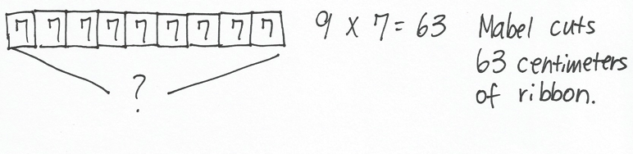

Note: This problem reviews multiplication using units of seven. It is the same problem that is used in the first example in the Concept Development. Here it is given a context, while in the Concept Development it is not because the focus shifts to using the distributive property.

Concept Development (30 minutes)
Materials: (S) Personal white board
Part 1: Apply the distributive property to multiply using units of 6 and 7.
T: We used 9 × 7 to solve the Application Problem. Say 9 × 7 in unit form.
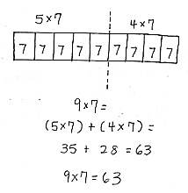
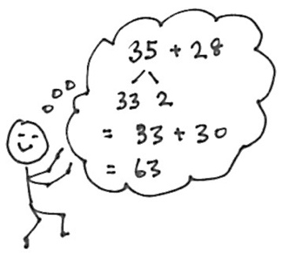
S: 9 sevens.
T: Model 9 × 7 using a tape diagram. Then, write the fact under the diagram. (Allow students time to work.)
T: Recently, we used the break apart and distribute strategy to help solve larger multiplication facts. Discuss with your partner. How did we do that?
S: We broke apart a bigger fact into two smaller facts. That made it easier to solve because we just added the products of the two smaller facts.
T: Breaking the bigger fact into 5 plus something helped us make those two smaller facts.
9 sevens can be broken into 5 sevens plus how many sevens?
S: 5 sevens plus 4 sevens.
T: Draw a dotted line separating the 5 sevens from 4 sevens on your tape diagram. Label the 5 sevens and 4 sevens on your tape diagram with multiplication facts.
S: (Draw line, label 5 × 7 and 4 × 7.)
T: Let’s use those facts to rewrite 5 sevens plus 4 sevens like this. (Write: (5 × 7) + (4 × 7).) Remind your partner why this expression is the same as 9 × 7.
S: It’s the same because the 5 and the 4 together make 9. And the 7 just got distributed to the 2 parts.
T: Now, solve. Check your work with your partner’s. (Allow students time to work.)

A NOTE ON
MULTIPLE MEANS
OF ENGAGEMENT:
Alternatively, challenge students working above grade level to use, compare, and present three different multiplication strategies to solve 8 × 6, including the 5 plus something (5 + n) strategy.
T: What is 9 × 7?
S: 63.
Continue with the following suggested sequence:
- 8 × 6
- 8 × 7

Part 2: Use addition number bonds to apply the distributive property to divide using units of 6 and 7.
T: We also used the break apart and distribute strategy earlier this year with arrays and division. Instead of using arrays today, let’s use number bonds.
T: Write 48 ÷ 6 on your board and circle it.
T: We need to break apart 48 ÷ 6 into two smaller division expressions. Why would 30 make a good breaking point?
S: 30 ÷ 6 is an easy fives fact.

NOTES ON
MULTIPLE MEANS
OF ENGAGEMENT:
Clarify that the two smaller division expressions must be divided by 6 expressions. Emphasize the value of this strategy as a way to solve sixes facts by using familiar fives, fours, threes, or twos facts.
Alternatively, challenge students to present, compare, and justify the use of a different number bond for 48 ÷ 6.
T: Write and circle 30 ÷ 6 as a part on your number bond.
S: (Write and circle 30 ÷ 6 as a part on the number bond.)
T: We have 30 ÷ 6 as one of our parts. What division expression do we need to write for the other part?
S: 18 ÷ 6.
T: How do you know?
S: 30 plus 18 equals 48. I know because we used 30 and we need 18 more to get to 48.
T: Write and circle 18 ÷ 6 as the other part.
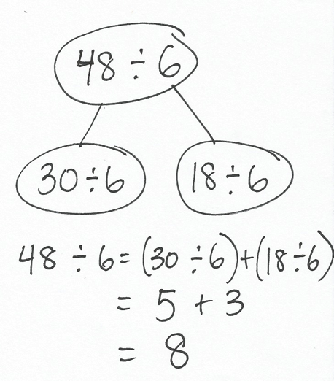
T: Let’s show that work with an equation. Write
48 ÷ 6 = (30 ÷ 6) + (18 ÷ 6). Put parentheses around the two expressions to show that we solve these two division facts first.
Sample teacher board:
T: How can we use the quotients of these two division expressions to find the quotient of 48 ÷ 6?
S: Add the quotient of 30 ÷ 6 and the quotient of 18 ÷ 6.
T: (Write addition sign as shown.) Add the two quotients to solve for 48 ÷ 6.
S: (Write 5 + 3 = 8.)
T: 48 ÷ 6 is…?
S: 8!
T: Write the answer below your equation. This is a great problem to solve this way since adding to 30 is so easy. What is another 5 fact that results in an easy number?
S: 5 times 8 is 40. 5 times 4 is 20. The even numbers!
T: What fact would you like to try next?
S: Let’s do a big number divided by 8. 56 divided by 8!
Repeat the process with 56 ÷ 8.

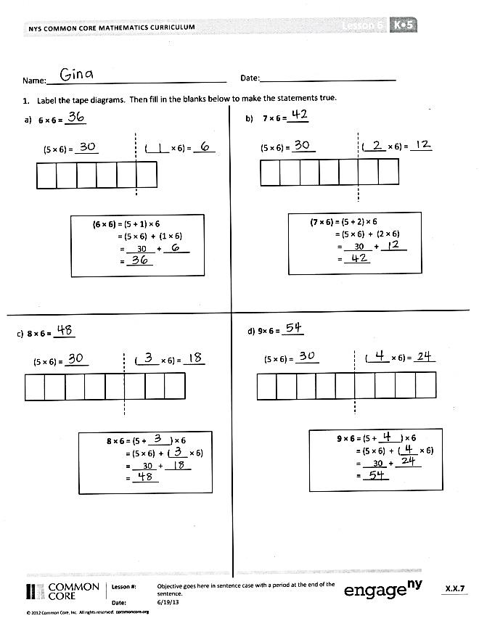
Problem Set (10 minutes)
6
6
6
6
Students should do their personal best to complete the Problem Set within the allotted 10 minutes. For some classes, it may be appropriate to modify the assignment by specifying which problems they work on first. Some problems do not specify a method for solving. Students should solve these problems using the RDW approach used for Application Problems.
Student Debrief (10 minutes)
Lesson Objective: Use the distributive property as a strategy to multiply and divide using units of 6 and 7.
The Student Debrief is intended to invite reflection and active processing of the total lesson experience.
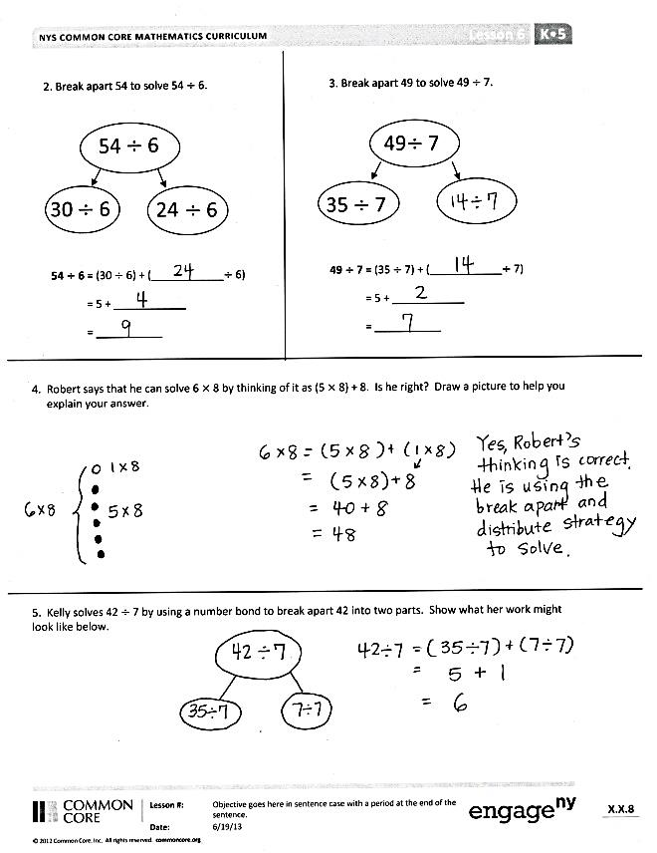
Invite students to review their solutions for the Problem Set. They should check work by comparing answers with a partner before going over answers as a class. Look for misconceptions or misunderstandings that can be addressed in the Debrief. Guide students in a conversation to debrief the Problem Set and process the lesson.
You may choose to use any combination of the questions below to lead the discussion.
- What pattern did you notice in Problems 1(a) through 1(d)? What multiplication fact is used in all of these problems? How does this fact help you solve these problems?
- What division fact did you use to complete the number bond in Problem 3? Why?
- Show a partner your picture for Problem 4. How does your picture show the break apart and distribute strategy?
- What number bond did you use to solve Problem 5? Explain your choice. Explain why Kelly could not break apart 42 ÷ 7 into 30 ÷ 7 and 12 ÷ 7.
- How does using the break apart and distribute strategy help you multiply and divide using known facts to find the answers to larger, unknown facts?

Exit Ticket (3 minutes)
After the Student Debrief, instruct students to complete the Exit Ticket. A review of their work will help you assess the students’ understanding of the concepts that were presented in the lesson today and plan more effectively for future lessons. You may read the questions aloud to the students.

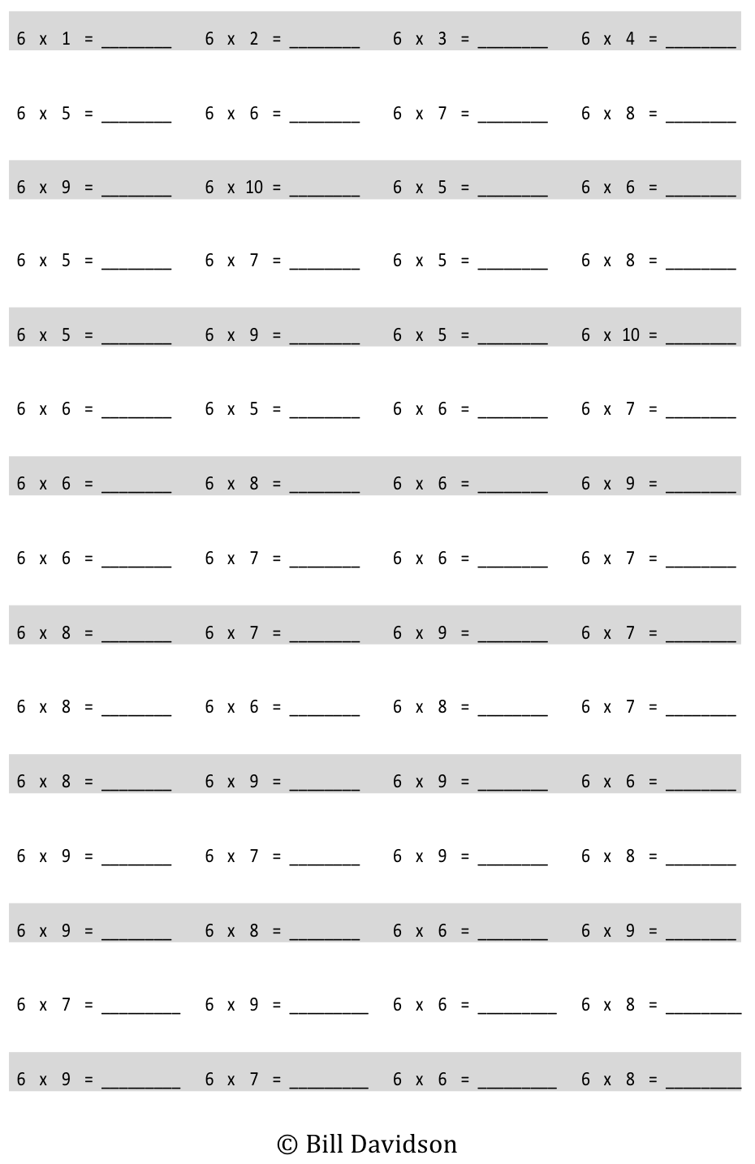
Multiply.
Name _________________________________________ Date _______________________________
- Label the tape diagrams. Then, fill in the blanks below to make the statements true.

(5 × 6) = _____ (_____× 6) = ____

6 × 6 = _____

(5 × 6) = _____ (____ × 6) = ____

b. 7 × 6 = _____
(6 × 6) = (5 + 1) × 6
= (5 × 6) + (1 × 6)
= 30 + ______
= ______

(1 × 4) = _ _____

(7 × 6) = (5 + 2) × 6
= (5 × 6) + (2 × 6)
= 30 + ______
= ______

(1 × 4) = _ _____

(5 × 6) = _____ (_____× 6) = ____

8 × 6 = (5 + _____) × 6
= (5 × 6) + (____ × 6)
= 30 + ______
= ______

(1 × 4) = _ _____

8 × 6 = _____
c.

(5 × 6) = _____ (____ × 6) = ____

9 × 6 = (5 + _____) × 6
= (5 × 6) + (____ × 6)
= 30 + ______
= ______

(1 × 4) = _ _____

9 × 6 = _____
d.

6
6
6
6
a.

2. Break apart 54 to solve 54 ÷ 6.

54

30$÷$ 6
$÷$ 6

54 ÷ 6 = (30 ÷ 6) + (____________÷ 6)
= 5 + ____________
= ___________

3. Break apart 49 to solve 49 ÷ 7.

49

35 $÷$ 7

$÷$ 7

24
$÷$ 6

49 ÷ 7 = (35 ÷ 7) + (____________÷ 7)
= 5 + ____________
= ___________

4. Robert says that he can solve 6 × 8 by thinking of it as (5 × 8) + 8. Is he right? Draw a picture to help explain your answer.

5. Kelly solves 42 ÷ 7 by using a number bond to break apart 42 into two parts. Show what her work might look like below.
Name Date
- A parking lot has space for 48 cars. Six cars can park in 1 row. Break apart 48 to find how many rows there are in the parking lot.

- Malia solves 6 × 7 using (5 × 7) + 7. Leonidas solves 6 × 7 using (6 × 5) + (6 × 2). Who is correct? Draw a picture to help explain your answer.
Name Date
- Label the tape diagrams. Then, fill in the blanks below to make the statements true.

a.
6 × 7 = _____

(5 × 7) = ____ (____ × 7) = ____

b. 7 × 7 =_____
(6 × 7) = (5 + 1) × 7
= (5 × 7) + (1 × 7)
= 35 + ______
= ______

(1 × 4) = _ _____

(7 × 7) = (5 + 2) × 7
= (5 × 7) + (2 × 7)
= 35 + ______
= ______

(1 × 4) = _ _____

7
7

(5 × 7) = ____ (____ × 7) = ____

(5 × 7) = ____ (____ × 7) = ____

9 × 7 = (5 + _____) × 7
= (5 × 7) + (____ × 7)
= 35 + ______
= ______

(1 × 4) = _ _____

9 × 7 = _____
d.

(5 × 7) = ____ (____ × 7) = ____

8 × 7 = (5 + _____) × 7
= (5 × 7) + (____ × 7)
= 35 + ______
= ______

(1 × 4) = _ _____

8 × 7 = _____
c.

7

7

56 ÷ 7 = (_____ ÷ _____) + (_____ ÷ _____)
= 5 + ________
= __________

3. Break apart 56 to solve 56 ÷ 7.

56

35
$÷$ 7

$÷$ 7

2. Break apart 54 to solve 54 ÷ 6.

54

30
$÷$ 6

54 ÷ 6 = (30 ÷ 6) + (____________÷ 6)
= 5 + ____________
= ___________

$÷$ 6

$÷$ 6

$÷$ 7

$÷$ 6

4. Forty-two third grade students sit in 6 equal rows in the auditorium. How many students sit in each row? Show your thinking.

5. Ronaldo solves 7 × 6 by thinking of it as (5 × 7) + 7. Is he correct? Explain Ronaldo’s strategy.

multiply by 6 (6–10)

