Lesson 5
Objective: Count by units of 7 to multiply and divide using number bonds to decompose.

Suggested Lesson Structure
 Fluency Practice (15 minutes)
 Application Problem (5 minutes)
 Concept Development (30 minutes)
 Student Debrief (10 minutes)
Total Time (60 minutes)
Fluency Practice (15 minutes)
- Multiply By 6 3.OA.7 (7 minutes)
- Group Counting 3.OA.1 (4 minutes)
- Make Seven Game 3.OA.5 (4 minutes)

Multiply By 6 (7 minutes)
Materials: (S) Multiply by 6 (1–5) (Pattern Sheet)
Note: This activity builds fluency with multiplication facts using units of six. It supports students knowing from memory all products of two one-digit numbers.
T: (Write 5 × 6 = ____.) Let’s skip-count by sixes to find the answer. I’ll raise a finger for each six. (Count with fingers to 5 as students count, and record the count-by sequence on the board.)
S: 6, 12, 18, 24, 30.
T: (Circle 30, and write 5 × 6 = 30 above it. Write 3 × 6 = ____.) Let’s skip-count up by sixes again. (Count with fingers to 3 as students count.)
S: 6, 12, 18.
T: Let’s see how we can skip-count down to find the answer, too. Start at 30 with 5 fingers, 1 for each six. (Count down with your fingers as students say numbers.)
S: 30 (5 fingers), 24 (4 fingers), 18 (3 fingers).
Repeat the process for 4 × 6.
T: (Distribute the Multiply by 6 Pattern Sheet.) Let’s practice multiplying by 6. Be sure to work left to right across the page.

Directions for administration of Multiply By Pattern Sheets:
- Distribute Multiply By Pattern Sheets.
- Allow a maximum of two minutes for students to complete as many problems as possible.
- Direct students to work left to right across the page.
- Encourage skip-counting strategies to solve unknown facts.
Group Counting (4 minutes)
Note: Group counting reviews interpreting multiplication as repeated addition. Counting by sevens prepares students for multiplication using units of seven in this lesson. Group counting by eights and nines anticipates multiplication using those units later in the module. Direct students to count forward and backward, occasionally changing the direction of the count:
- Sevens to 70
- Eights to 80
- Nines to 90
Make Seven Game (4 minutes)
Materials: (S) Set of playing cards numbered 1─6
Note: This activity prepares students for the skip-counting strategy used to multiply units of seven in today’s lesson.
Students play in pairs. Each pair has a set of six cards, each with a number 1–6.
T: (Write ___ + ___ = 7.) Spread the cards out in front of you.
T: Put your hands behind your back. I’ll write a number in the first blank. When you know the number that belongs in the second blank, touch the card that shows the number. The first person to touch the card keeps it. Whoever has the most cards at the end wins. (Write 5 + __ = 7.)
S: (Touch the 2 card. The first to touch it keeps the card.)
Continue with the following suggested sequence: 1, 4, 2, 3, and 6.
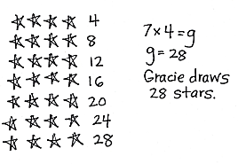
Application Problem (5 minutes)
Gracie draws 7 rows of stars. In each row, she draws 4 stars. How many stars does Gracie draw in all? Use a letter to represent the unknown and solve.
Note: This problem reviews the G3–Module 1 concept of multiplying using units of four. It will be used in the Concept Development to lead into skip-counting by sevens. Be sure to circulate and find a student’s answer to use as an example in the Concept Development (find a student who counted by four 7 times to solve the problem).
Concept Development (30 minutes)

NOTES ON
MULTIPLE MEANS
OF REPRESENTATION:
For English language learners, pre-teach and/or clarify unfamiliar math terms such as sequence, row, factors, product, number bond, count by, and skip-count.
Depending on your learners’ needs, give explicit prompts for every step of the make ten strategy to count by seven 4 times. Alternatively, you may scaffold with a checklist or template.

Materials: (S) Personal white board
Part 1: Use number bonds to decompose and make ten as a strategy for skip-counting units of 7.
T: I noticed that Student A solved the Application Problem by skip-counting by four 7 times. Is there another count-by strategy that could be used to solve this problem?
S: Skip-count by seven 4 times.
T: Let’s show that work on our boards. Write 7 on your board.
T: How do we get the next number in our count?
S: Add 7!
Count by seven 4 times:
Remaining count by seven:
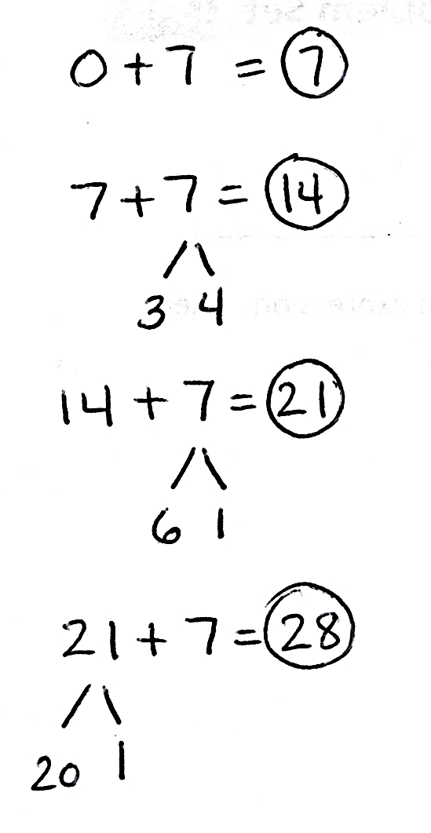
T: Can we use a number bond to add 7 by making ten like we did with sixes?
S: Yes, we can break apart 7 into 3 and 4, and then use the 3 to make ten with the first 7.
T: Work with a partner to use number bonds to show how you make ten to count by seven 4 times.
T: Check your work with mine. (Project work as shown.)
T: What is the last number in the sequence when you count by seven 4 times?
S: 28!
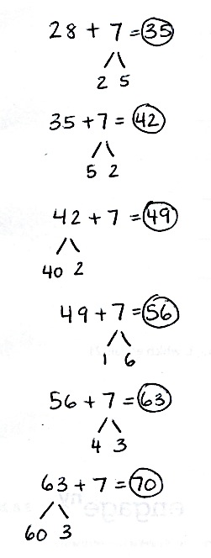
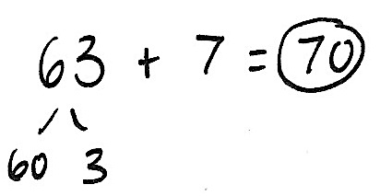
T: Is the answer the same even though Student A counted by four 7 times?
S: Yes, it’s the same because we just switched the order of the factors. The product is the same, but the order of the factors is different. It’s the commutative property.
T: Work with a partner to complete your sequence by counting by seven 10 times. Use number bonds to make ten. (Circulate and check student work.)
T: Everyone, at my signal, read your count by seven sequence.
S: 7, 14, 21, 28, 35, 42, 49, 56, 63, 70.

Part 2: Skip-count by seven to solve multiplication and division problems.
T: Let’s use our sequence to solve multiplication and division problems with seven. I am going to say a multiplication or division problem. Write the problem on your personal white board and use your sequence to find the answer. At my signal, show your board.

NOTES ON
MULTIPLE MEANS
OF ENGAGEMENT:
Some learners may prefer to use the distributive or commutative property to solve 7 times 6. Encourage their personal choices of efficient strategies. Challenge learners to present a multiplication fact they would solve using skip-counting. Ask, “How do you choose your strategy to solve?”
T: Let’s do a practice one together. Turn and talk to a partner. How can you use your skip-counting sequence to solve 42 divided by 7?
S: I can count 6 sevens in the sequence, which takes me to 42. So, 42 divided by 7 equals 6.
T: Write the equation on your board.
S: (Write 42 ÷ 7 = 6.)
T: At my signal, show me your board. (Signal.)
S: (Show board.)
T: Okay, here we go, next problem! 49 divided by 7 equals…? (After students work, signal.)
Continue with the following suggested sequence:
- 7 × 6
- 7 × e = 56
- f ÷ 7 equals 9
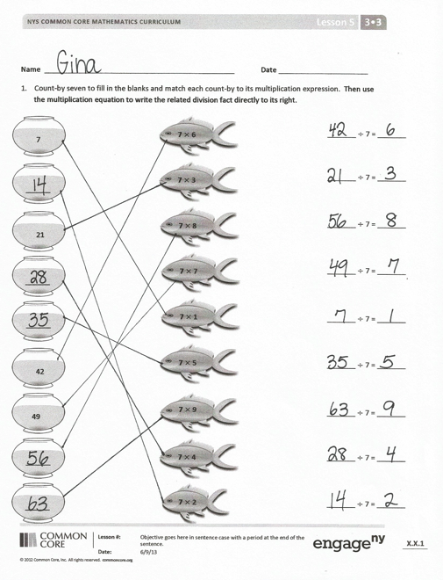
Problem Set (10 minutes)
Students should do their personal best to complete the Problem Set within the allotted 10 minutes. For some classes, it may be appropriate to modify the assignment by specifying which problems they work on first. Some problems do not specify a method for solving. Students should solve these problems using the RDW approach used for Application Problems.

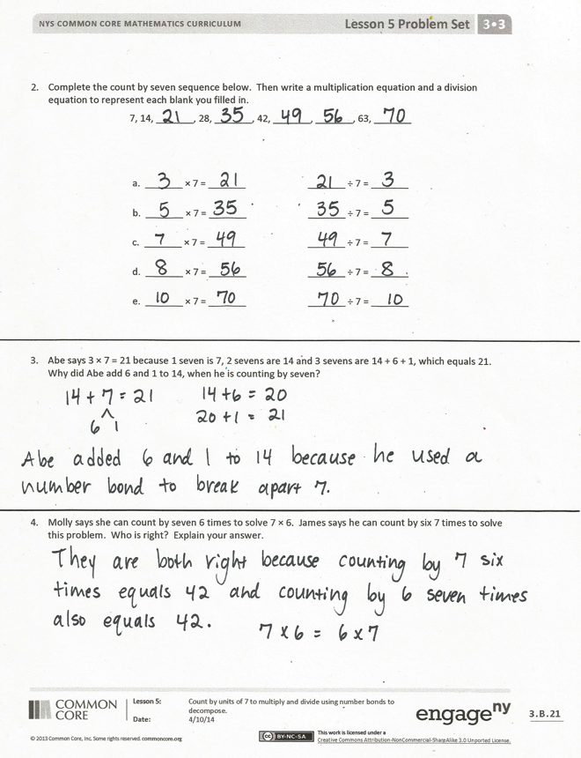
Student Debrief (10 minutes)
Lesson Objective: Count by units of 7 to multiply and divide using number bonds to decompose.
The Student Debrief is intended to invite reflection and active processing of the total lesson experience.
Invite students to review their solutions for the Problem Set. They should check work by comparing answers with a partner before going over answers as a class. Look for misconceptions or misunderstandings that can be addressed in the Debrief. Guide students in a conversation to debrief the Problem Set and process the lesson.
You may choose to use any combination of the questions below to lead the discussion.
- Take turns with a partner reading the multiplication facts in Problem 1 and the related division facts.
- How can you use number bonds to help you solve Problem 2?
- What are some different strategies that can help you solve multiplication facts using units of seven? How do you choose your strategy to solve?
MP.5
- In Problem 3, would it make sense for Abe to use number bonds to find the next number after 21 in the count by seven sequence? Why or why not?
- How does counting by seven help you solve multiplication and division problems with seven?
- How does Problem 4 demonstrate the commutative property?
- How does today’s lesson relate to our previous work of adding 1 unit to 5 units?
Exit Ticket (3 minutes)
After the Student Debrief, instruct students to complete the Exit Ticket. A review of their work will help you assess the students’ understanding of the concepts that were presented in the lesson today and plan more effectively for future lessons. You may read the questions aloud to the students.
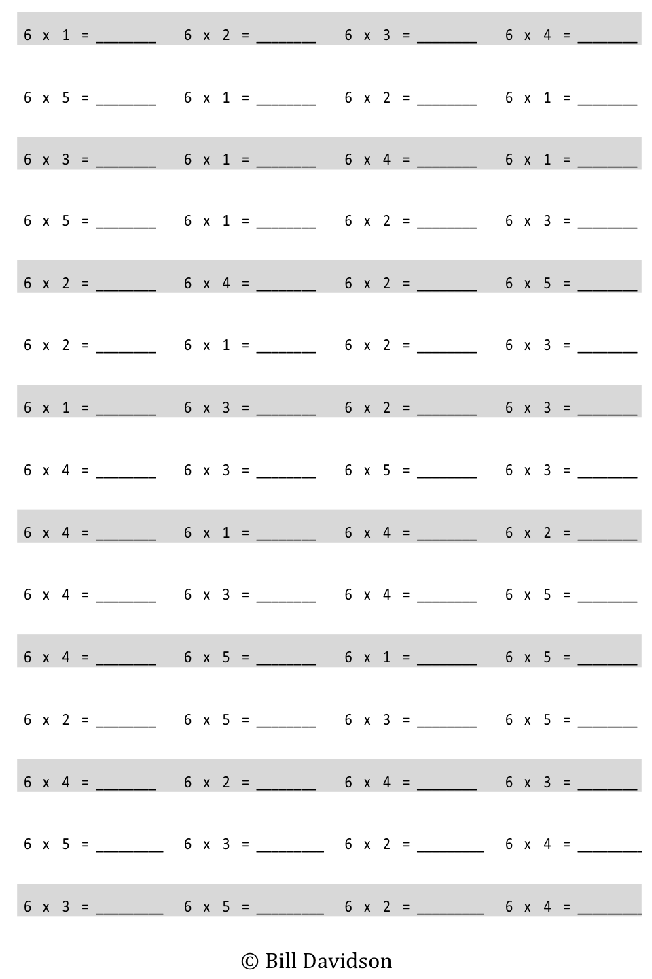
Multiply.

Name Date
- Skip-count by seven to fill in the blanks in the fish bowls. Match each count-by to its multiplication expression. Then, use the multiplication equation to write the related division fact directly to the right.
7

______

21

______

______

42

49

______

______

7 $×$ 2

7 $×$ 3

7 $×$ 6

7 $×$ 7

7 $×$ 1

7 $×$ 5

7 $×$ 8

7 $×$ 9

7 $×$ 4

_______ ÷ 7 = _______
_______ ÷ 7 = _______
_______ ÷ 7 = _______
_______ ÷ 7 = _______
_______ ÷ 7 = _______
_______ ÷ 7 = _______
_______ ÷ 7 = _______
_______ ÷ 7 = _______
_______ ÷ 7 = _______

- Complete the count-by seven sequence below. Then, write a multiplication equation and a division equation to represent each blank you filled in.
7, 14, _______, 28, _______, 42, _______, _______, 63, _______

a. _______ × 7 = _______ _______ ÷ 7 = _______
b. _______ × 7 = _______ _______ ÷ 7 = _______
c. _______ × 7 = _______ _______ ÷ 7 = _______
d. _______ × 7 = _______ _______ ÷ 7 = _______
e. _______ × 7 = _______ _______ ÷ 7 = _______

- Abe says 3 × 7 = 21 because 1 seven is 7, 2 sevens are 14, and 3 sevens are 14 + 6 + 1, which equals 21. Why did Abe add 6 and 1 to 14 when he is counting by seven?

- Molly says she can count by seven 6 times to solve 7 × 6. James says he can count by six 7 times to solve this problem. Who is right? Explain your answer.
Name Date
Complete the count-by seven sequence below. Then, write a multiplication equation and a division equation to represent each number in the sequence.
7, 14, _______, 28, _______, 42, _______, _______, 63, _______

- _______ × 7 = _______ _______ ÷ 7 = _______
- _______ × 7 = _______ _______ ÷ 7 = _______
- _______ × 7 = _______ _______ ÷ 7 = _______
- _______ × 7 = _______ _______ ÷ 7 = _______
- _______ × 7 = _______ _______ ÷ 7 = _______
- _______ × 7 = _______ _______ ÷ 7 = _______
- _______ × 7 = _______ _______ ÷ 7 = _______
h. _______ × 7 = _______ _______ ÷ 7 = _______
i. _______ × 7 = _______ _______ ÷ 7 = _______ j. _______ × 7 = _______ _______ ÷ 7 = _______
Name Date
- Use number bonds to help you skip-count by seven by making ten or adding to the ones.
4
10
- 7 + 7 = ______ + ______ = _______
4
3

- 14 + 7 = ______ + ______ = _______
1
6

- 21 + 7 = ______ + ______ = _______
1
20

- 28 + 7 = ______ + ______ = _______
5
2

- 35 + 7 = ______ + ______ = _______
2
5

- 42 + 7 = ______ + ______ = _______

- 49 + 7 = ______ + ______ = _______

- 56 + 7 = ______ + ______ = _______

- Skip-count by seven to fill in the blanks. Then, fill in the multiplication equation and use it to write the related division fact directly to the right.
_______ ÷ 7 = _______

_______ ÷ 7 = _______

_______ ÷ 7 = _______

_______ ÷ 7 = _______

_______ ÷ 7 = _______

7 × 10 = _____
7 × 9 = _____
_____

_____

_____

49

_____

_____

28

_____

_____

7

_______ ÷ 7 = _______

_______ ÷ 7 = _______

_______ ÷ 7 = _______

_______ ÷ 7 = _______

_______ ÷ 7 = _______

7 × 1 = _____
7 × 2 = _____
7 × 3 = _____
7 × 4 = _____
7 × 5 = _____
7 × 6 = _____
7 × 7 = _____
7 × 8 = _____

multiply by 6 (1–5)

