Lesson 4
Objective: Count by units of 6 to multiply and divide using number bonds to decompose.

Suggested Lesson Structure
 Fluency Practice (15 minutes)
 Application Problem (5 minutes)
 Concept Development (30 minutes)
 Student Debrief (10 minutes)
Total Time (60 minutes)
Fluency Practice (15 minutes)
- Group Counting 3.OA.1 (4 minutes)
- Familiar Facts 3.OA.4 (4 minutes)
- Multiply Using the Distributive Property 3.OA.5 (4 minutes)
- Make Ten Game 3.OA.5 (3 minutes)
Group Counting (4 minutes)
Note: Group counting reviews interpreting multiplication as repeated addition. Counting by sixes and sevens prepares students for multiplication using those units in this topic. Group counting by eights and nines anticipates multiplication using those units later in the module. Direct students to count forward and backward, occasionally changing the direction of the count:
- Sixes to 60
- Sevens to 70
- Eights to 80
- Nines to 90
Familiar Facts (4 minutes)
Materials: (S) Personal white board
Note: This fluency activity reviews the relationship between multiplication and division from Module 1 and uses a letter to represent the unknown from Lesson 3 in this module, G3-M3.
T: (Write 6 × 2 = a.) On your personal white board, write the value of a.
S: (Write a = 12.)
T: (Write 6 × 2 = 12. To the right, write 12 ÷ 6 = b.) On your board, write the value of b.
S: (Write b = 2.)
Repeat the process for: 7 × 3= c, 21 ÷ 7 = d, e × 4 = 24, 24 ÷ 4 = f, g × 2= 18, 18 ÷ 2 = h, 16 = i × 2, 16 ÷ 8 = j,
45 = 5 × k, and 45 ÷ 9 = m.
Multiply Using the Distributive Property (4 minutes)
Materials: (S) Personal white board
Note: This fluency activity reviews the n + 1 strategy from Lesson 2.
T: (Project a 6 × 6 array, covering the sixth row of 6.) How many groups of 6 are there?
S: 5.
T: Let’s find how many are in the array counting by fives. (Point as students count.)
S: 5, 10, 15, 20, 25, 30.
T: Let’s find how many are in the array counting by sixes. (Point as students count.)
S: 6, 12, 18, 24, 30.
T: Write two multiplication sentences for this array.
S: (Write 6 × 5 = 30 and 5 × 6 = 30.)
T: (Reveal the sixth row of 6.) How many groups of 6 are there now?
S: 6.
T: Add 1 more group of 6 to 30. (Write 30 + 6 = .) On your board, write the addition sentence.
S: (Write 30 + 6 = 36.)
T: On your board, write a multiplication sentence for this array.
S: (Write 6 × 6 = 36.)
Continue with the following suggested sequence: 5 × 8 → 6 × 8, 5 × 7 → 6 × 7, and 5 × 9 → 6 × 9.
Make Ten Game (3 minutes)
Materials: (S) Set of playing cards numbered 1─9
Note: This fluency activity prepares students for today’s Concept Development.
Students play in pairs. Each pair has a set of 9 cards, each with a number 1–9.
T: (Write + = 10.) Spread the cards out in front of you.
T: Put your hands behind your back. I’ll write a number in the first blank. When you know the number that belongs in the second blank, touch the card that shows the number. The first person to touch the card keeps it. Whoever has the most cards at the end wins. (Write 8 + = 10.)
S: (Touch the 2 card. The first to touch it keeps the card.)
Continue with the following suggested sequence: 5, 2, 7, 1, 4, 3, and 6; students replace cards: 1, 5, 3, 2, 4, 7, and 6; students replace cards: 4, 7, 3, 9, and 6.
Application Problem (5 minutes)
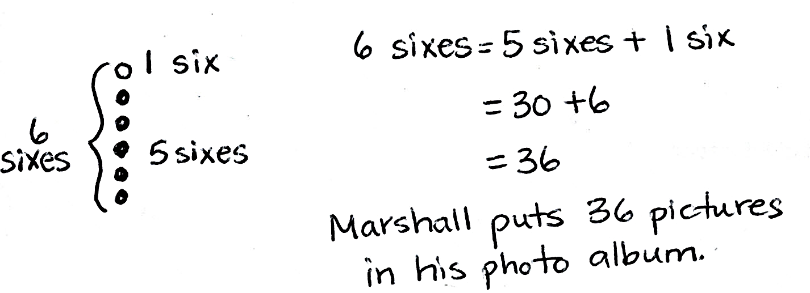
Marshall puts 6 pictures on each of the 6 pages in his photo album. How many pictures does he put in the photo album in all?

NOTES ON
MULTIPLE MEANS
OF ENGAGEMENT:
In order to encourage students to apply the distributive property, adjust the numbers in the Application Problem. For example, a student above grade level may mentally solve 6 times 6, yet choose to use the distributive property to multiply 6 times 13.

Note: This problem is designed to review the Lesson 2 concept of applying the distributive property to relate multiplication by n + 1 to multiplication by n.
Concept Development (30 minutes)
Materials: (S) Personal white board
Part 1: Use number bonds to decompose and skip-count using units of 6.
T: Some of you may have skip-counted by six to get the answer to Marshall’s problem. When we’re skip-counting by six, how do we get the next number in our sequence?
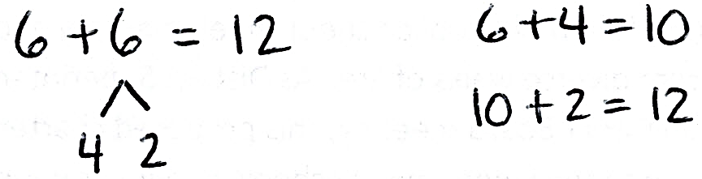
S: Add 6!
T: Like this? (Write 6 + 6 = 12.)
T: Think back to our Fluency Practice today.
What number should I add to 6 to make 10?
S: 4!
T: Write my equation on your board. Then, draw a number bond to break apart the second six, showing how to solve using a make ten strategy. (Draw number bond as shown.)

NOTES ON
MULTIPLE MEANS
OF REPRESENTATION:
Learners differ in their ability to process information. Help students organize board notes to support their understanding. For example, you may choose to label, write out, illustrate, or put to music the steps of the make ten strategy.
T: 6 plus 4 equals?
S: 10!
T: Write it next to 6 + 6. (Write equation as shown.)
T: 10 plus 2 equals…?
S: 12!
T: Write that under 6 + 4 = 10. (Write equation as shown.)
T: So, what is 6 plus 6?
S: 12!
Have students repeat the process for the next two minutes to see how high they can count by six:
12 + 6 = 18, 18 + 6 = 24, 24 + 6 = 30, 30 + 6 = 36, 36 + 6 = 42, 42 + 6 = 48, 48 + 6 = 54, and 54 + 6 = 60.
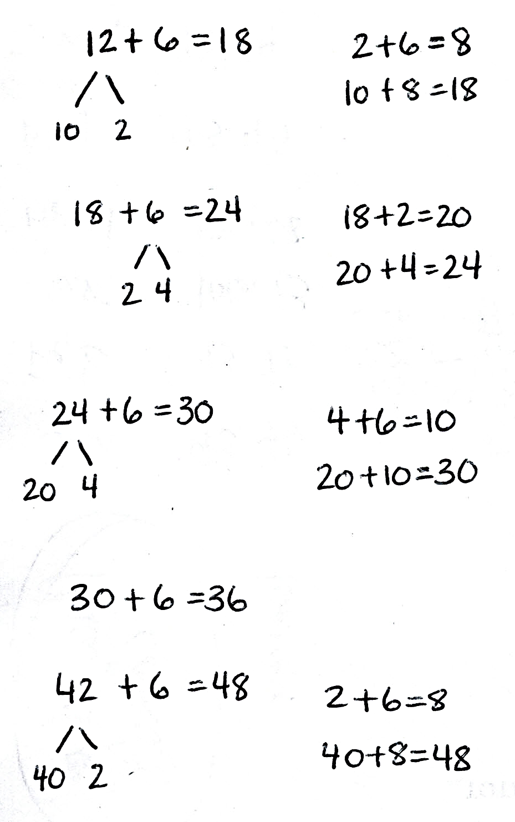
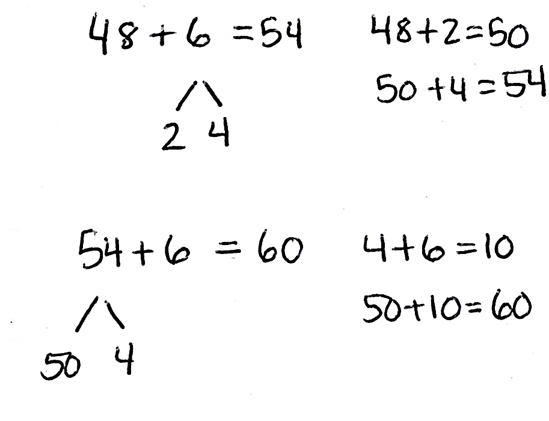
T: What patterns did you notice counting by six?
MP.5
S: Sometimes we broke apart the six to complete the ten, as in 18 + 6. Other times, we broke apart the two-digit number to complete the ten, as in 12 + 6.
T: How did adding 6 and 6 help you add 36 and 6?
S: You add it the same way by breaking the six into 4 and 2 to complete the ten. You can also think of 36 + 6 as 3 tens more than 6 + 6.
T: How did adding 18 and 6 help you add 48 and 6?
S: We broke apart the six into 2 and 4 to complete the ten. 48 + 6 is also just 3 tens more than
18 + 6.
T: Why is a make ten strategy with number bonds helpful for counting by sixes?
S: Adding sixes is harder than adding with tens.
T: What other count-bys is it helpful for? Is it helpful for the fives?
S: No, because adding by fives is easy to do mentally.
T: Is it helpful for sevens?
S: I think so. Sevens are hard to skip-count by, too.
T: Now that we have discussed how the make ten strategy makes skip-counting sixes more efficient, let’s try it out to solve multiplication and division problems.
Part 2: Use skip-counting by sixes to solve multiplication and division problems.
T: Skip-count by six 10 times. Write the count-by sequence on your board. You can also record your addition on your board.
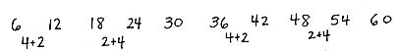
Sample student board of count-by:

T: What is the last number in the sequence?
S: 60!
T: 60 is the same as how many sixes?
S: 10 sixes.
T: Tell a partner what multiplication problem we just solved, and then write it on your board.
S: 6 times 10 equals 60. (Write 6 × 10 = 60.)
T: We just used our count by six sequence to help us find that 6 times 10 equals 60.
T: We can also use skip-counting to solve division problems. Write the last number in the sequence on your board, followed by a division symbol.
T: What did we count by to get to 60?
S: Sixes!
T: Write 6 after the division symbol, followed by an equal sign.
T: How many times did we count by six to get to 60?
S: 10 times!
T: Write 10 as the answer to this division problem. Read your equation to a partner.
T: Turn and talk to a partner. What do you notice about the multiplication and division problems we solved?
S: They use the same numbers. The division fact uses the same numbers as the multiplication fact, just in a different order. 60 divided by 6 equals 10 is the related division fact for 6 times 10 equals 60.
T: That’s right. They are related facts. Now, you have learned another strategy to solve multiplication and division facts with sixes!
Continue with the following suggested sequence to help develop strategies for and learn the following facts. You may want to refer students to the times table chart in Lesson 1 to focus their attention on the 16 new facts:
- 6 × 6
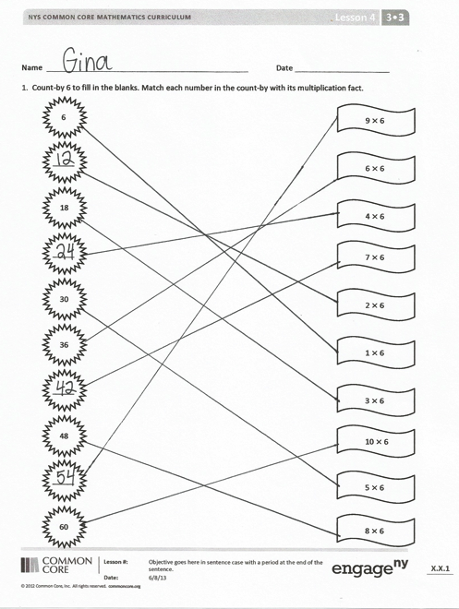
- 6 × 7
- 6 × 8
- 6 × 9
Problem Set (10 minutes)
Students should do their personal best to complete the Problem Set within the allotted 10 minutes. For some classes, it may be appropriate to modify the assignment by specifying which problems they work on first. Some problems do not specify a method for solving. Students should solve these problems using the RDW approach used for Application Problems.

Student Debrief (10 minutes)
Lesson Objective: Count by units of 6 to multiply and divide using number bonds to decompose.
The Student Debrief is intended to invite reflection and active processing of the total lesson experience.
Invite students to review their solutions for the Problem Set. They should check work by comparing answers with a partner before going over answers as a class. Look for misconceptions or misunderstandings that can be addressed in the Debrief. Guide students in a conversation to debrief the Problem Set and process the lesson.
You may choose to use any combination of the questions below to lead the discussion.
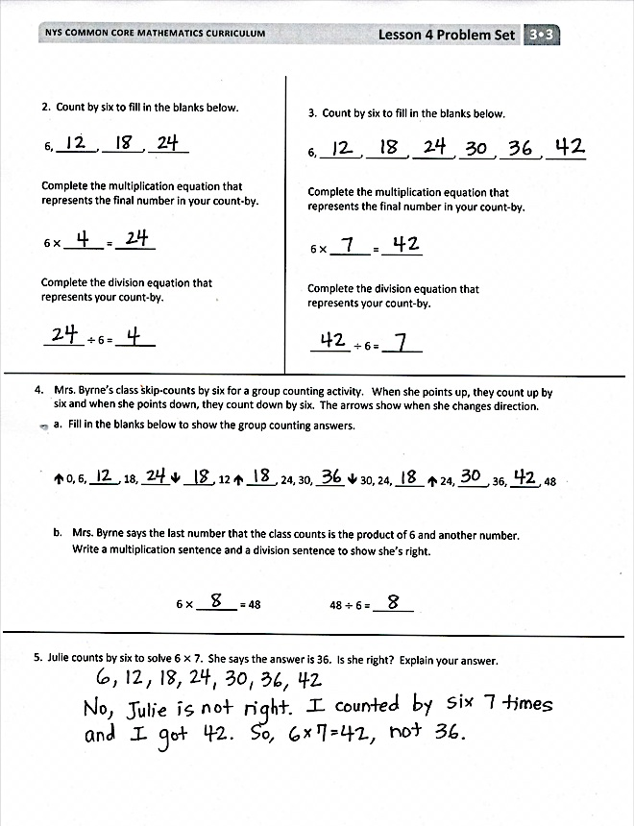
- With a partner, list the related division facts for each number in the skip-counting sequence in Problem 1.
- What other multiplication and division problems can you solve with the sequence you already have in Problem 2?
- How was using the skip-counting strategy in Problem 4 different from the other problems?
- How does your method of adding 18 and 6 help you add 18 tens and 6 tens, and $480 and $60?
- How did the Application Problem connect to today’s lesson?
- How did the Fluency Practice help prepare you for the lesson?
Exit Ticket (3 minutes)
After the Student Debrief, instruct students to complete the Exit Ticket. A review of their work will help you assess the students’ understanding of the concepts that were presented in the lesson today and plan more effectively for future lessons. You may read the questions aloud to the students.

Name Date
- Skip-count by six to fill in the blanks. Match each number in the count-by with its multiplication fact.
6
_____
18
_____
30
_____
36
48
_____
60
2 × 6
9 × 6
4 × 6
7 × 6
1 × 6
3 × 6
10 × 6
5 × 6
8 × 6
6 × 6
3. Count by six to fill in the blanks below.
6, ______, ______, ______, ______, _____, _____
Complete the multiplication equation that
represents the final number in your count-by.

6 × _______ = _______
Complete the division equation that represents your count-by.

_______ ÷ 6 = _______

2. Count by six to fill in the blanks below.
6, _______, _______, _______
Complete the multiplication equation that represents the final number in your count-by.

6 × _______ = _______

Complete the division equation that
represents your count-by.

_______ ÷ 6 = _______

4. Mrs. Byrne’s class skip-counts by six for a group counting activity. When she points up, they count up by six, and when she points down, they count down by six. The arrows show when she changes direction.
- Fill in the blanks below to show the group counting answers.

⬆ 0, 6, _____, 18, _____⬇ _____, 12 ⬆ _____, 24, 30, _____ ⬇ 30, 24, _____ ⬆ 24, _____, 36, _____, 48

- Mrs. Byrne says the last number that the class counts is the product of 6 and another number.
Write a multiplication sentence and a division sentence to show she’s right.

6 × _______ = 48 48 ÷ 6 = _______

5. Julie counts by six to solve 6 $×$ 7. She says the answer is 36. Is she right? Explain your answer.

Name Date
- Sylvia solves 6 × 9 by adding 48 + 6. Show how Sylvia breaks apart and bonds her numbers to complete the ten. Then, solve.

- Skip-count by six to solve the following:

- 8 × 6 = ______ b. 54 ÷ 6 = ______

Name Date
- Use number bonds to help you skip-count by six by either making a ten or adding to the ones.
10
2
- 6 + 6 = ______ + ______ = _______
2
4

10
8
- 12 + 6 = ______ + ______ = _______
2
10

- 18 + 6 = ______ + ______ = _______
4
2

- 24 + 6 = ______ + ______ = _______
4
20

- 30 + 6 = _______

- 36 + 6 = ______ + ______ = _______
2
4

- 42 + 6 = ______ + ______ = _______

- 48 + 6 = ______ + ______ = _______

- 54 + 6 = ______ + ______ = _______

3. Count by six to fill in the blanks below.
6, _______, _______, _______, ______, ______
Complete the multiplication equation that represents the final number in your count-by.

6 × _______ = _______
Complete the division equation that
represents your count-by.

_______ ÷ 6 = _______

2. Count by six to fill in the blanks below.
6, _______, _______, _______, _______
Complete the multiplication equation that represents the final number in your count-by.

6 × _______ = _______
Complete the division equation that
represents your count-by.

_______ ÷ 6 = _______

4. Count by six to solve 48 ÷ 6. Show your work below.

