Lesson 3
Objective: Multiply and divide with familiar facts using a letter to represent the unknown.

Suggested Lesson Structure
 Fluency Practice (12 minutes)
 Application Problem (8 minutes)
 Concept Development (30 minutes)
 Student Debrief (10 minutes)
Total Time (60 minutes)
Fluency Practice (12 minutes)
- Familiar Facts 3.OA.4 (5 minutes)
- Multiply Using the Distributive Property 3.OA.5 (5 minutes)
- Make Ten 3.OA.5 (2 minutes)
Familiar Facts (5 minutes)
Materials: (S) Personal white board
Note: This fluency activity reviews the relationship between multiplication and division from G3─Module 1 in anticipation of today’s lesson.
T: (Write 5 × 3 = .) Say the multiplication sentence.
S: 5 × 3 = 15.
T: (Write 5 × 3 = 15. To the right, write 15 ÷ 3 = .) On your personal white board, write the division sentence.
S: (Write 15 ÷ 3 = 5.)
Repeat process for 4 × 3 and 7 × 2.
T: (Write × 2 = 10.) Say the unknown factor.
S: 5.
T: (Write 10 ÷ 2 = .) On your board, write the division sentence.
S: (Write 10 ÷ 2 = 5.)
Repeat process for × 3 = 6 and × 2 = 16.
T: (Write 20 = × 10.) Say the unknown factor.
S: 2.
T: (Write 20 ÷ 10 = .) On your board, write the division sentence.
S: (Write 20 ÷ 10 = 2.)
Repeat process for 18 = × 3 and 45 = × 5.
Multiply Using the Distributive Property (5 minutes)

NOTES ON
MULTIPLE MEANS
OF REPRESENTATION:
Use color to customize the presentation of the Multiply Using the Distributive Property fluency activity. Using a different color for each row of 9 may help students count groups of 9. The various colors can additionally help students interpret each column of the array as fives.

Materials: (S) Personal white board
Note: This fluency activity reviews the n + 1 strategy from Lesson 2.
T: (Project a 6 × 9 array, covering the sixth row of 9.)
How many groups of 9 are there?
S: 5.
T: Let’s find how many are in the array counting by fives. (Point as students count.)
S: 5, 10, 15, 20, 25, 30, 35, 40, 45.
T: Let’s find how many are in the array counting by nines.
(Point as students count.)
S: 9, 18, 27, 36, 45.
T: Write two multiplication sentences for this array.
S: (Write 9 × 5 = 45 and 5 × 9 = 45.)
T: (Reveal the sixth row of 9.) How many groups of 9 are there now?
S: 6.
T: Add 1 more group of 9 to 45. (Write 45 + 9 = .) On your board, write the addition sentence.
S: (Write 45 + 9 = 54.)
T: On your board, write two multiplication sentences for this array.
S: (Write 9 × 6 = 54 and 6 × 9 = 54.)
Continue with the following suggested sequence: 5 × 8 → 6 × 8, 5 × 7 → 6 × 7, and 5 × 6 → 6 × 6.
Make Ten (2 minutes)
Note: This fluency activity prepares students for the skip-counting strategies used to multiply units of 6 and 7 in Lessons 4 and 5.
T: I’ll say a number between 0 and 10. You say the number that you add to it to make a ten. 9.
S: 1.
Continue with the following suggested sequence: 8, 7, 6, 5, 9, 1, 8, 2, 7, 3, 6, 4, 8, 4, 7, 3, 6, 1, 2, 5, and 9.

Application Problem (8 minutes)

NOTES ON
MULTIPLE MEANS
OF REPRESENTATION:
Challenge above grade level learners by adding complexity to the Application Problem.
For example: Twenty-eight people lined up for canoes. Three people are assigned to each canoe. Create at least two solutions to make it possible for those people who don’t make a threesome to go canoeing.

Twenty-four people line up to use the canoes at the park. Three people are assigned to each canoe. How many canoes are used?
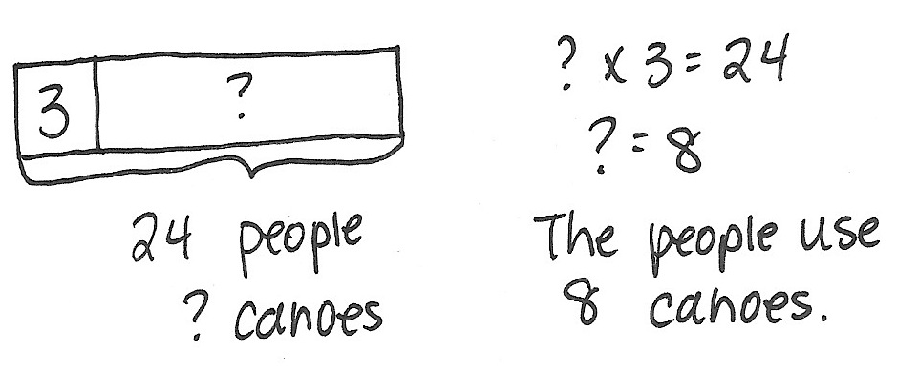
Note: Students may choose to model either as division or as multiplication. In the Concept Development, this problem provides a context for using a letter to represent the unknown.
Concept Development (30 minutes)

NOTES ON
MULTIPLE MEANS
OF REPRESENTATION:
Clarify unknowns for English language learners and others by pre-teaching using a few simple equations with letters, such as 2 + 2 = h; h = 4, or use the Familiar Facts fluency in Lesson 4.
Materials: (S) Personal white board
Problem 1: Use a letter to represent the unknown in multiplication.
T: (Show a student’s tape diagram and equation for the Application Problem, or use the example work above.) This is Student A’s work on the Application Problem.
What do the question marks in her work represent?
S: The unknown. The number of canoes that are used.
T: We can use a letter to represent the unknown value instead of a question mark. For this problem, we might choose letter c to help us express that the unknown stands for how many canoes are used in the problem. How will using a letter to express the unknown value change the way we model and solve?
MP.4
S: There will be c’s where the question marks were on the tape diagram and in the equation.
I don’t think it changes the way you solve though.
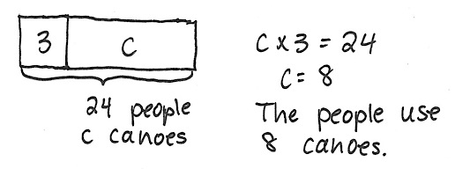
T: Let’s confirm your thinking. On your personal white board, solve the Application Problem using the letter c to express the unknown on your model and in your equation. Solve, and then compare with your work on the Application Problem.
S: (Solve and compare; possible work to the right.)
T: In a complete sentence, what is the value of c?
S: The value of c is 8 canoes.

Problem 2: Use a letter to represent the unknown in division.
Project or show the following problem: Twenty-one students are grouped in threes to go on a field trip. How many groups of students are there?
T: Read the problem with your partner. Then, whisper what the unknown represents.

NOTES ON
CHOOSING
VARIABLES:
Point out that some letters may potentially be confused with other symbols. Letters s, o, l, x, and t, respectively, resemble 5, 0, 1, the multiplication symbol (×), and the addition symbol (+). Encourage students to use other letters if possible.
S: (Read problem.) The unknown represents the number of groups.
T: Before we solve, talk with your partner about which letter you might choose to express the unknown on your model and in your equation.
S: We could use s for students. I think n will remind me that we are looking for the number of groups.
g is best because it stands for groups.
T: Model the problem and write an equation to solve. Let’s use the letter g to express the unknown.
S: (Model and write 21 ÷ 3 = g.)
T: In a complete sentence, tell the value of g.

NOTES ON
NUMBER CHOICES:
This lesson intentionally uses known facts from Module 1. Ideally, students are fairly automatic with these facts so that the focus stays on naming the unknown, represented by the letter, rather than on performing the calculation.
S: The value of g is 7 groups.
Continue with the following suggested sequence to show unknowns in various positions:
- 24 = 4 × r
- 5 = 50 ÷ m
- 27 ÷ b = 3
- d ÷ 6 = 3
Call attention to the way that you write the value of the unknown, e.g., n = 14. Students should emulate this in their work.
Depending on time, extend the lesson by assigning each student (or pair of students) a letter of the alphabet. Task them with writing a simple word problem in which their assigned letter represents the unknown. They first solve their own problem, and then exchange with another student to solve a new one.
Problem Set (10 minutes)
Students should do their personal best to complete the Problem Set within the allotted 10 minutes.
For some classes, it may be appropriate to modify the assignment by specifying which problems they work on first. Some problems do not specify a method for solving. Students should solve these problems using the RDW approach used for Application Problems.
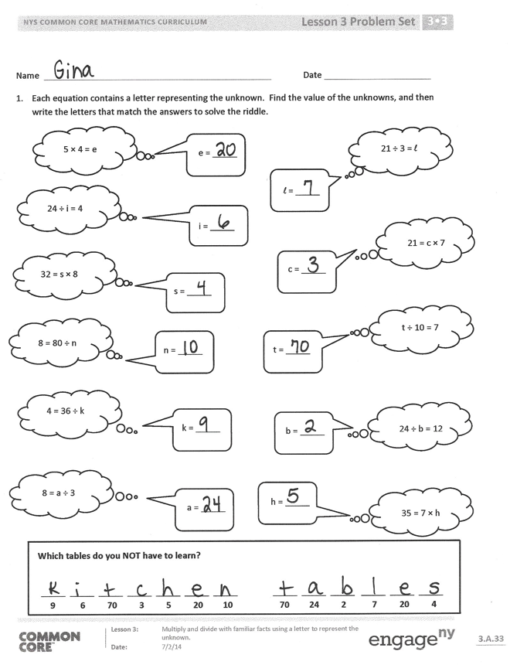
Student Debrief (10 minutes)
Lesson Objective: Multiply and divide with familiar facts using a letter to represent the unknown.
The Student Debrief is intended to invite reflection and active processing of the total lesson experience.
Invite students to review their solutions for the Problem Set. They should check work by comparing answers with a partner before going over answers as a class. Look for misconceptions or misunderstandings that can be addressed in the Debrief. Guide students in a conversation to debrief the Problem Set and process the lesson.
You may choose to use any combination of the questions below to lead the discussion.
- Explain to your partner how you solved Problem 3. (Review division as both an unknown factor and an equal groups problem.)
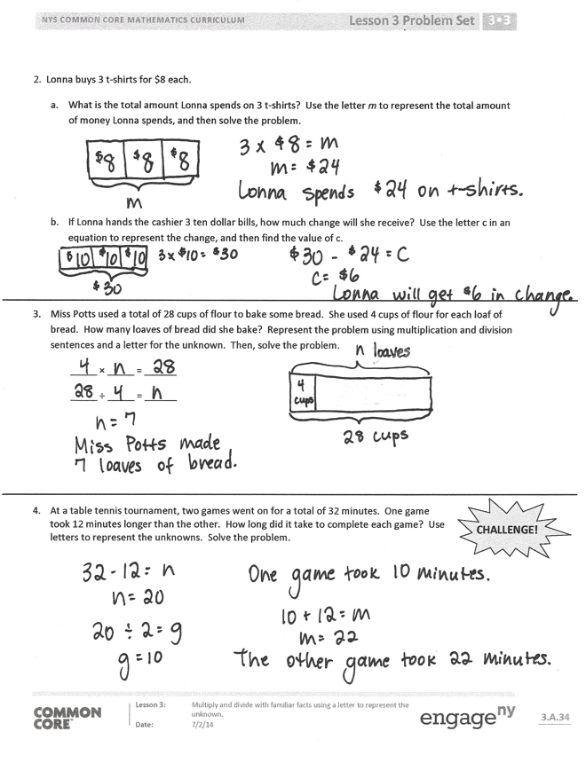
- Tell your partner the steps you took to model and solve Problem 4. (This problem likely posed the greatest challenge.) Why is using a letter to represent the unknown more helpful than using a question mark?
Exit Ticket (3 minutes)
After the Student Debrief, instruct students to complete the Exit Ticket. A review of their work will help you assess the students’ understanding of the concepts that were presented in the lesson today and plan more effectively for future lessons. You may read the questions aloud to the students.

Name Date
- Each equation contains a letter representing the unknown. Find the value of the unknowns, and then write the letters that match the answers to solve the riddle.

e = _____

n = _____

21 ÷ 3 = l
l = _____

4 = 36 ÷ k
k = _____

21 = c × 7
c = _____

8 = a ÷ 3
a = _____

t = _____
t ÷ 10 = 7

24 ÷ b = 12
b = _____
i = _____
5 × 4 = e
24 ÷ i = 4
8 = 80 ÷ n

35 = 7 × h
h = _____
_____ _____ _____ _____ _____ _____ _____ _____ _____ _____ _____ _____ _____
9 6 70 3 5 20 10 70 24 2 7 20 4

Which tables do you NOT have to learn?

32 = s × 8

s = _____

2. Lonna buys 3 t-shirts for $8 each.
- What is the total amount Lonna spends on 3 t-shirts? Use the letter m to represent the total amount of money Lonna spends, and then solve the problem.

- If Lonna hands the cashier 3 ten dollar bills, how much change will she receive? Use the letter c in an equation to represent the change, and then find the value of c.

- Miss Potts used a total of 28 cups of flour to bake some bread. She used 4 cups of flour for each loaf of bread. How many loaves of bread did she bake? Represent the problem using multiplication and division sentences and a letter for the unknown. Then, solve the problem.
_____ × _____ = ______
_____ ÷ _____ = ______

CHALLENGE!
- At a table tennis tournament, two games went on for a total of 32 minutes. One game took 12 minutes longer than the other. How long did it take to complete each game? Use letters to represent the unknowns. Solve the problem.

Name Date
Find the value of the unknown in Problems 1–4.

- z = 5 × 9
z = ______

- 30 ÷ 6 = v
v = ______

- 8 × w = 24
w = ______

- y ÷ 4 = 7
y = ______

- Mr. Strand waters his rose bushes for a total of 15 minutes. He waters each rose bush for 3 minutes. How many rose bushes does Mr. Strand water? Represent the problem using multiplication and division sentences and a letter for the unknown. Then, solve the problem.
_____ × _____= _____
_____ ÷ _____ = _____

Name Date
- a. Complete the pattern.
30

60

90

- Find the value of the unknown.

10 × 2= d d =__20_ 10 × 6 = w w =_____
3 × 10 = e e =_____ 10 × 7 = n n =_____
f = 4 × 10 f =_____ g = 8 × 10 g =_____
p = 5 × 10 p =_____

- Each equation contains a letter representing the unknown. Find the value of the unknown.
8 ÷ 2 = n | n = _____
3 × a = 12 | a = _____
p × 8 = 40 | p = _____
18 ÷ 6 = c | c = _____
d × 4= 24 | d = _____
h ÷ 7 = 5 | h = _____
6 × 3 = f | f = _____
32 ÷ y = 4 | y = _____

- Pedro buys 4 books at the fair for $7 each.
- What is the total amount Pedro spends on 4 books? Use the letter b to represent the total amount Pedro spends, and then solve the problem.

- Pedro hands the cashier 3 ten dollar bills. How much change will he receive? Write an equation to solve. Use the letter c to represent the unknown.

- On field day, the first-grade dash is 25 meters long. The third-grade dash is twice the distance of the first-grade dash. How long is the third-grade dash? Use a letter to represent the unknown and solve.

