Lesson 2
Objective: Apply the distributive and commutative properties to relate multiplication facts 5 × n + n to 6 × n and n × 6 where n is the size of the unit.

Suggested Lesson Structure
 Fluency Practice (15 minutes)
 Application Problem (5 minutes)
 Concept Development (30 minutes)
 Student Debrief (10 minutes)
Total Time (60 minutes)
Fluency Practice (15 minutes)
- Sprint: Commutative Property of Multiplication 3.OA.5 (9 minutes)
- Group Counting 3.OA.1 (4 minutes)
- Make Ten 3.OA.5 (2 minutes)
Sprint: Commutative Property of Multiplication (9 minutes)
Materials: (S) Commutative Property of Multiplication Sprint
Note: This Sprint reviews G3─M3─Lesson 1.
Group Counting (4 minutes)
Note: Group counting reviews interpreting multiplication as repeated addition. Counting by sixes, sevens, eights, and nines in this activity anticipates multiplication using those units later in the module. Focusing on the mentioned transitions bolsters student understanding of the distributive property of multiplication.
Direct students to count forward and backward, occasionally changing the direction of the count:
- Sixes to 60, emphasizing the 30 to 36 transition
- Sevens to 70, emphasizing the 35 to 42 transition
- Eights to 80, emphasizing the 40 to 48 transition
- Nines to 90, emphasizing the 45 to 54 transition

Make Ten (2 minutes)
Note: This fluency activity prepares students for the skip-counting strategies used to multiply units of 6 and 7 in Lessons 4 and 5.
T: (Write 9 + __ = 10.) Say the unknown addend.
S: 1.
Continue with the following suggested sequence: 1 + __ = 10, 5 + __ = 10, 8 + __ = 10, 2 + __ = 10,
6 + __ = 10, 7 + __ = 10, 4 + __ = 10, and 3 + __ = 10.
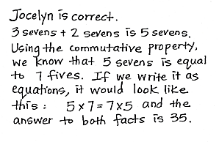
Application Problem (5 minutes)
Jocelyn says 7 fives has the same answer as 3 sevens + 2 sevens.
Is she correct? Explain why or why not.
Note: This problem reviews the commutative property from Lesson 1 and also previews the first fact used in the Concept Development to ensure all students’ automaticity with the answer.
Concept Development (30 minutes)

NOTES ON
MULTIPLE MEANS
OF ACTION AND EXPRESSION:
This lesson moves from pictorial representations in the vignette to abstract in the examples suggested for continued guided practice. Depending on the needs of your class, start out concretely. Have students manipulate cubes rather than draw or look at dots. As they become comfortable with the material, transition to pictorial circles, and, if appropriate, eventually to an abstract example.

Materials: (S) Personal white board
T: (Draw 1 circle with a 7 inside.) This circle represents 1 unit of 7. As I draw circles, count the sevens with me. (Draw circles one on top of the other until you make one column of 5 circles.)
MP.7
7
7
7
7
7
7
7
7
7
7
7
7
7
7
7

S: 1 seven, 2 sevens, 3 sevens, 4 sevens, 5 sevens.
T: Whisper the multiplication fact for 5 sevens.
S: 5 × 7.
T: Use commutativity to name a related fact.
S: 7 × 5.
T: What are 5 sevens, 5 × 7, and 7 × 5 all equal to?
S: 35.
MP.7
T: Let’s use our familiar fives facts to find facts we haven’t learned yet. (Draw a dot above the first 5 dots in another color, shown right.) What is 5 sevens + 1 seven?
7
7
7
7
7
7
S: 6 sevens.
T: (Write 35 + 7.) Tell your partner how this expression shows the total of 6 sevens.
S: 35 is the total of 5 sevens, and 7 is the total of 1 seven.
35 + 7 shows 5 sevens + 1 seven in number form. It’s the break apart and distribute strategy we learned before! The dots show 6 sevens broken into 5 sevens and 1 seven because we know those facts, and they’re easy!
T: What is the total of 6 sevens?
S: 42!

NOTES ON
MULTIPLE MEANS
OF REPRESENTATION:
Problem 1 of the Problem Set reviews
6 × 7 used in the vignette using blocks. Although the blocks were not used in the lesson, it is familiar enough to feel friendly for students and provides an opportunity to discuss the difference in models during the Debrief.

T: On your personal white board, use commutativity to write the two multiplication facts we just solved.
S: (Write 6 × 7 and 7 × 6.)
T: Compare 5 × 7 and 6 × 7. What is the difference between them?
S: 6 × 7 has one more group of 7 than 5 × 7. That’s what the teacher showed with the dots, 5 sevens and
6 sevens.
T: By noticing that 6 × 7 is only 1 more group of 7 than
5 × 7, we used the total of 5 × 7 to help us make an easy addition problem to find 6 × 7.
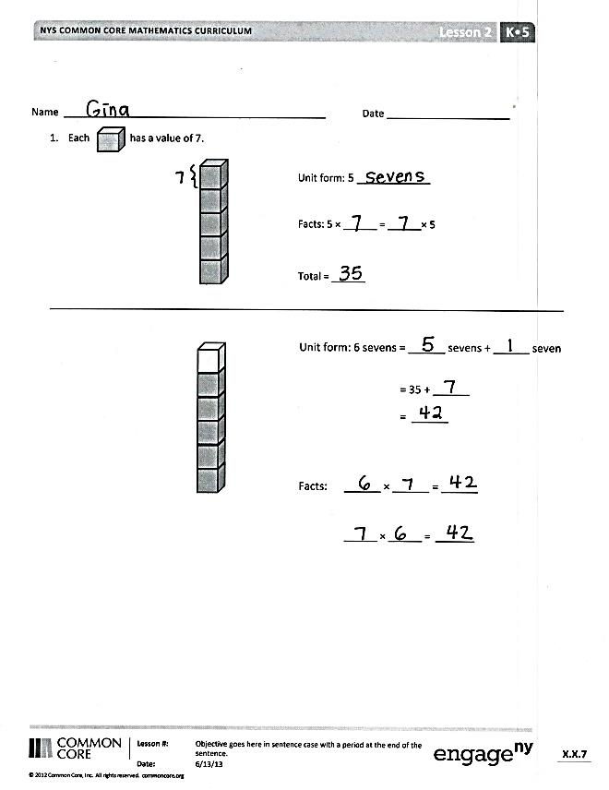
Continue with the following suggested sequence. Use the model of the dots as necessary, changing the value of
1 dot to match the problem.
- 5 × 9 to find 6 × 9 and 9 × 6
- 5 × 6 to find 6 × 6
Problem Set (10 minutes)
Students should do their personal best to complete the Problem Set within the allotted 10 minutes. For some classes, it may be appropriate to modify the assignment by specifying which problems they work on first. Some problems do not specify a method for solving. Students should solve these problems using the RDW approach used for Application Problems.

Student Debrief (10 minutes)
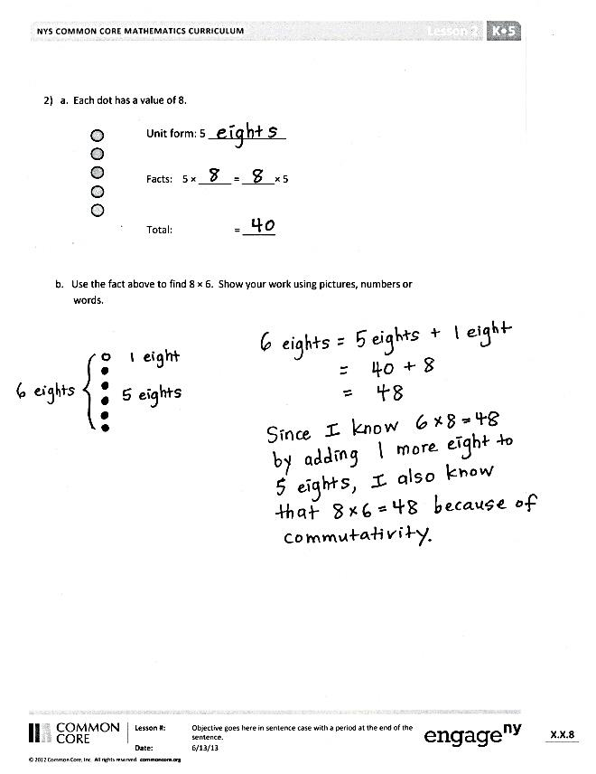
Lesson Objective: Apply the distributive and commutative properties to relate multiplication facts 5 x n + n to 6 x n and n x 6 where n is the size of the unit.
The Student Debrief is intended to invite reflection and active processing of the total lesson experience.
Invite students to review their solutions for the Problem Set. They should check work by comparing answers with a partner before going over answers as a class. Look for misconceptions or misunderstandings that can be addressed in the Debrief. Guide students in a conversation to debrief the Problem Set and process the lesson.
You may choose to use any combination of the questions below to lead the discussion.
- What pattern did you notice between
Problems 1 and 2?
- Explain to your partner how one fact can help you solve two new facts.
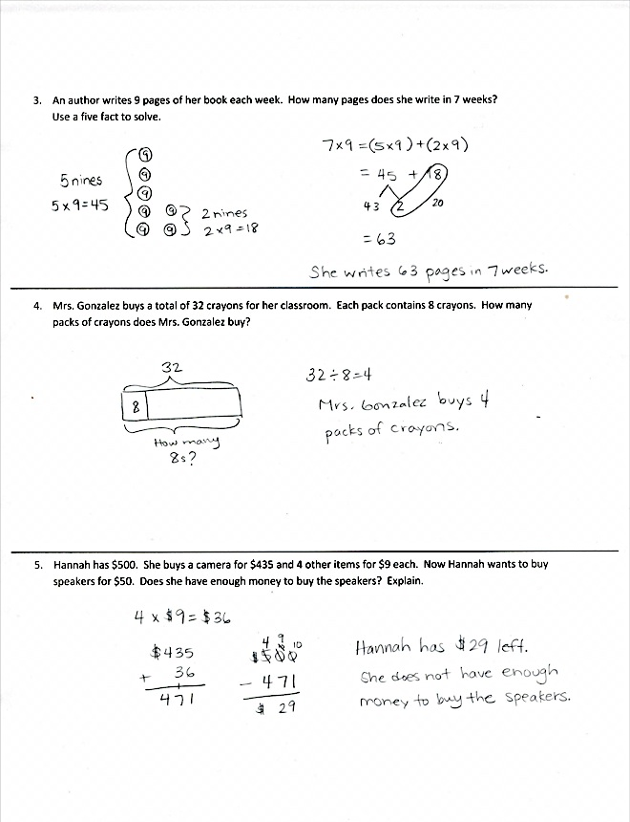
- Explain why you used multiplication or division to solve Problem 4. How does a division sentence in this problem relate to a multiplication sentence?
- How does the strategy we learned today relate to the break apart and distribute strategy we studied in Module 1?
- How might you use the strategy we practiced today to solve other problems? For example, how might you use 5 × 7 to help you solve 7 × 7?
Exit Ticket (3 minutes)
After the Student Debrief, instruct students to complete the Exit Ticket. A review of their work will help you assess the students’ understanding of the concepts that were presented in the lesson today and plan more effectively for future lessons. You may read the questions aloud to the students.

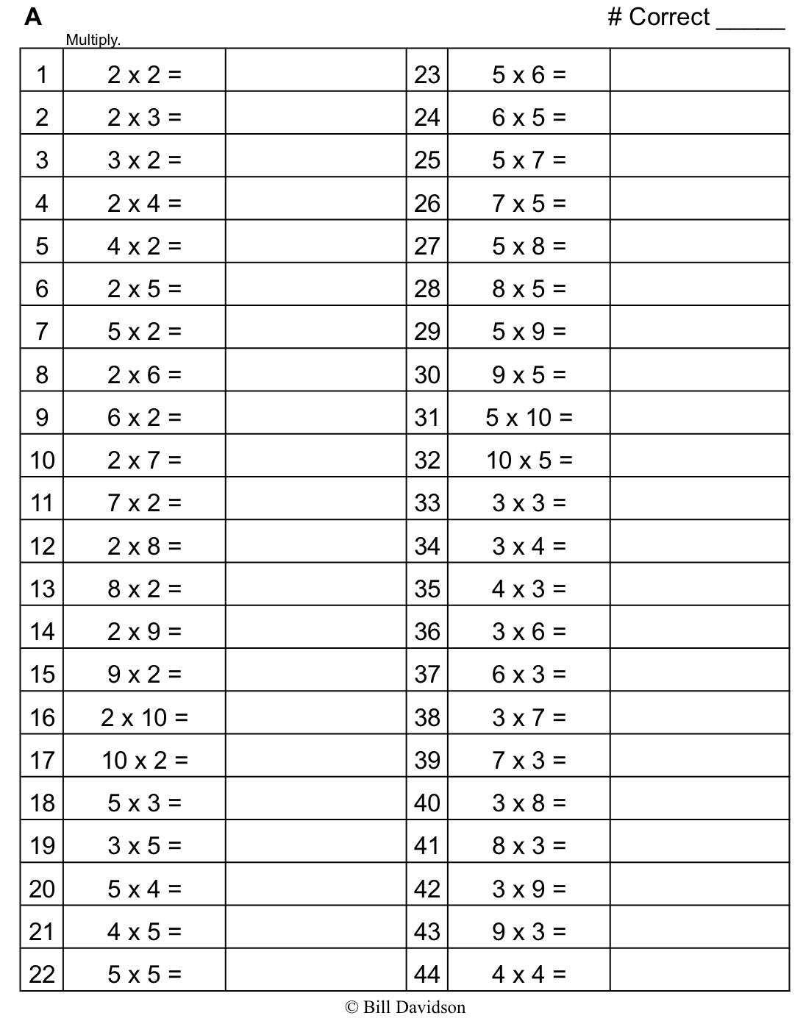
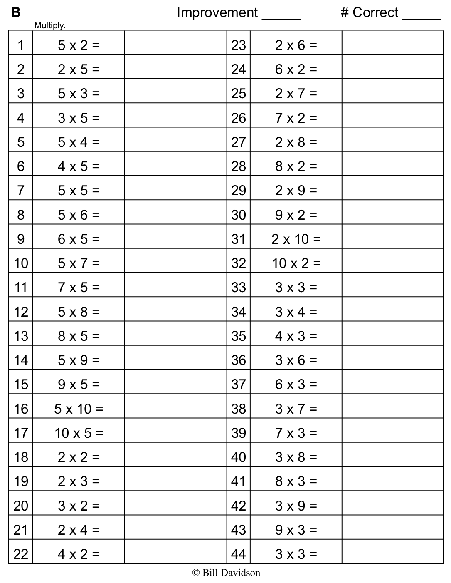

Name Date
- Each has a value of 7.
Unit form: 5 ____________

Facts: 5 × ______ = ______ × 5

Total = ______

Unit form: 6 sevens = ______ sevens + ______ seven

= 35 + ______
= ______

Facts: ______ × ______ = ______

______ × ______ = _______

b. Use the fact above to find 8 × 6. Show your work using pictures, numbers, or words.

2. a. Each dot has a value of 8.
Unit form: 5 _____________

Facts: 5 × ______ = ______× 5

Total: = ______

An author writes 9 pages of her book each week. How many pages does she write in 7 weeks?
Use a fives fact to solve.

Mrs. Gonzalez buys a total of 32 crayons for her classroom. Each pack contains 8 crayons. How many packs of crayons does Mrs. Gonzalez buy?

Hannah has $500. She buys a camera for $435 and 4 other items for $9 each. Now Hannah wants to buy speakers for $50. Does she have enough money to buy the speakers? Explain.

Name Date
Use a fives fact to help you solve 7 × 6. Show your work using pictures, numbers, or words.

Name Date
- Each has a value of 9.
Unit form: ____________________

Facts: 5 × ______ = ______ × 5

Total = ______

Unit form: 6 nines = ______ nines + ______ nine

= 45 + ______
= ______

Facts: ______ × ______ = ______

______ × ______ = _______

- There are 6 blades on each windmill. How many total blades are on 7 windmills? Use a fives fact to solve.

- Juanita organizes her magazines into 3 equal piles. She has a total of 18 magazines. How many magazines are in each pile?

- Markuo spends $27 on some plants. Each plant costs $9. How many plants does he buy?

