Lesson 1
Objective: Study commutativity to find known facts of 6, 7, 8, and 9.

Suggested Lesson Structure
 Fluency Practice (15 minutes)
 Application Problem (5 minutes)
 Concept Development (30 minutes)
 Student Debrief (10 minutes)
Total Time (60 minutes)
Fluency Practice (15 minutes)
- Sprint: Mixed Multiplication 3.OA.7 (9 minutes)
- Group Counting 3.OA.1 (3 minutes)
- Commutative Property of Multiplication 3.OA.5 (3 minutes)
Sprint: Mixed Multiplication (9 minutes)
Materials: (S) Mixed Multiplication Sprint
Note: This Sprint reviews familiar multiplication facts from Module 1 and prepares students for today’s lesson on using commutativity with known facts to find unknown facts.
Group Counting (3 minutes)

NOTES ON
MULTIPLE MEANS
OF ENGAGEMENT:
Group Counting in Module 3 no longer explicitly includes twos, threes, fours, and fives. However, you may want to include those units if your class has not yet mastered those facts.
Whisper/talking, hum/talking, or think/talking by threes and fours can also work as a scaffold to build fluency with sixes and eights.

Note: Group counting reviews interpreting multiplication as repeated addition. Counting by sixes, sevens, eights, and nines in this activity anticipates multiplication using those units later in the module.
Direct students to count forward and backward, occasionally changing the direction of the count:
- Sixes to 60
- Sevens to 70
- Eights to 80
- Nines to 90
Commutative Property of Multiplication (3 minutes)
Materials: (S) Personal white board
Note: This activity reviews the commutative property from Module 1 and anticipates its use in today’s lesson.
T: (Project array with 3 groups of 2 circles.) Write two multiplication sentences and two division sentences for this array.
S: (Write 3 × 2 = 6, 2 × 3 = 6, 6 ÷ 2 = 3, and 6 ÷ 3 = 2.)
Continue with the following suggested sequence: 2 groups of 9, 3 groups of 7, and 5 groups of 8.
Application Problem (5 minutes)

NOTES ON
MULTIPLE MEANS
OF ENGAGEMENT:
Extend for students working above grade level with a related word problem with larger factors.
For example, “Kelly drinks 3 liters of water each day. How many liters of water does she drink in a week?”

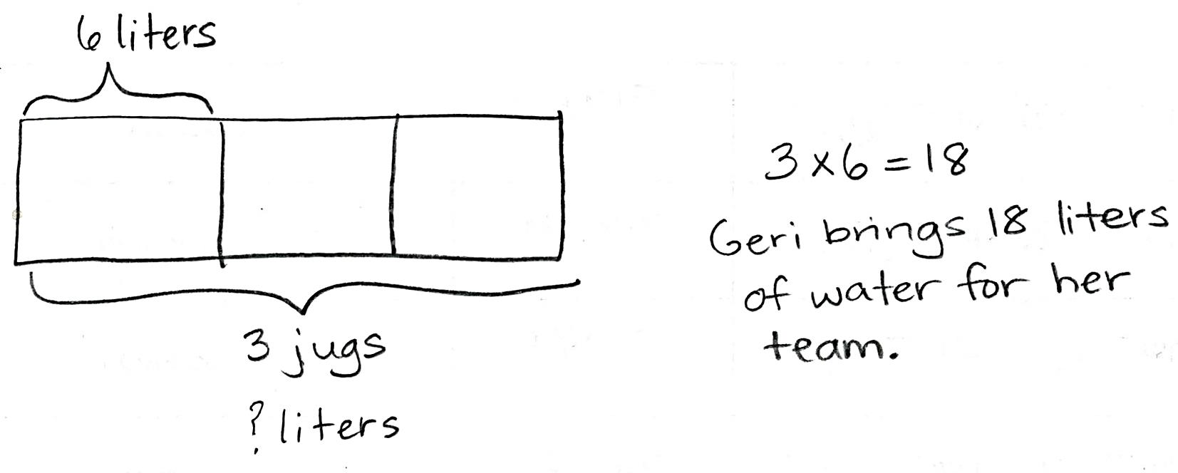
Geri brings 3 water jugs to her soccer game to share with teammates. Each jug contains 6 liters of water. How many liters of water does Geri bring?
Note: This problem reviews multiplication using units of three. It leads into the discussion of commutativity in the Concept Development.
Concept Development (30 minutes)
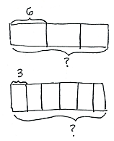
Materials: (S) Personal white board, Problem Set
Part 1: Explore commutativity as it relates to multiplication.
Draw or project the tape diagrams shown at right.
T: Talk to your partner. Which tape diagram represents the Application Problem? How do you know? (Allow time for discussion.)
T: Draw both tape diagrams on your personal white board. Write a multiplication sentence for each. (Allow time for students to work and finish.)
T: How are the multiplication sentences related?
S: They use the same numbers. Both have a product of 18. They use the same factors, but in a different order. The product is the same.
T: This is an example of the commutative property that we studied in Module 1. What does this property tell us about the product and its factors?

NOTES ON
MULTIPLE MEANS
OF ENGAGEMENT:
Review the commutative property by exploring arrays—concrete or pictorial. Review 3 twos is 2 threes, for example, by 6 students standing in 2 rows of 3, and then 3 rows of 2.
When drawing the array, use color to differentiate 6 threes from 3 sixes.

MP.7
S: Even if the order of the factors changes, the product stays the same!
T: Earlier in the year, we learned our threes, including
3 × 6. If we know 3 × 6, what other fact do we know?
S: 6 × 3!
T: What is the product of both 3 × 6 and 6 × 3?
S: 18!
T: To show that 3 × 6 and 6 × 3 equal the same amount, we can write 3 × 6 = 6 × 3. (Model.)
T: Using commutativity as a strategy, we know many more facts than just the ones we’ve practiced!
Continue with the following suggested sequence:
- 2 × 7 = 7 × 2
- 5 eights = 8 fives
- 4 nines = 9 fours
Part 2: Use the multiplication chart to find known facts through commutativity.
T: Problem 1(a) on your Problem Set shows a multiplication chart. The shaded numbers along the left column and the top are factors. The numbers inside the chart are products. Each un-shaded box represents the product of one multiplication fact. Find the total number of facts on your multiplication chart. (Allow time for students to count.) How many facts are on the chart?
S: 100 facts.
T: Let’s use the chart to locate the product of 3 and 6. Put your finger on the row labeled 3 and slide it to the right until it’s also in the column labeled 6. The number in the square where the row and column meet is the product, which has been done for you. Using the chart, what is the product of 3 and 6?
S: 18.
T: Let’s now locate the product of 6 and 3. Find the square where the row for 6 and the column for 3 meet. Use commutativity to write the product of 6 and 3 in that square on your chart.
S: (Write 18.)
T: We can use commutativity to solve many new facts and fill in the products on the chart. On the chart, write the products for all the facts that we’ve already studied. Then, fill in those you can solve using commutativity. (Allow time for students to work.)
T: Shade in the facts you completed. (Allow time for students to work.) How many are left to learn?
S: 16!
T: Look carefully at those 16 facts. Are there any that you will be able to solve using the commutative property once you know one?
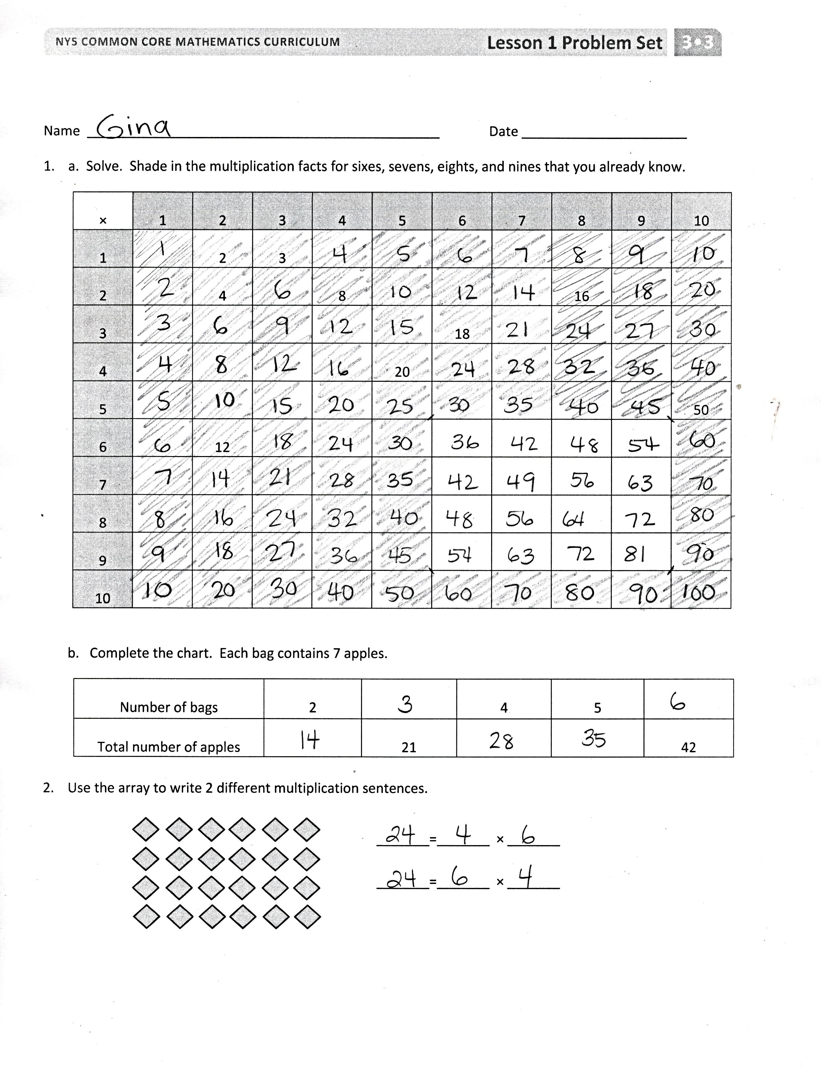
S: Yes! There are 12 facts that we can use the commutative property to solve. That means we only need to know 6 of them.
T: Really, there are only 10 new facts to learn before you know all the facts up to 10 × 10!
Problem Set (10 minutes)
Students should do their personal best to complete the Problem Set within the allotted 10 minutes. Some problems do not specify a method for solving. This is an intentional reduction of scaffolding that invokes MP.5, Use Appropriate Tools Strategically. Students should solve these problems using the RDW approach used for Application Problems.
For some classes, it may be appropriate to modify the assignment by specifying which problems students should work on first. With this option, let the purposeful sequencing of the Problem Set guide your selections so that problems continue to be scaffolded. Balance word problems with other problem types to ensure a range of practice. Consider assigning incomplete problems for homework or at another time during the day.
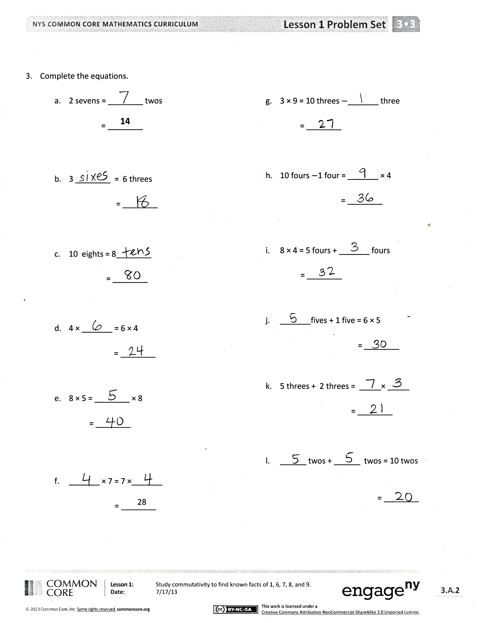
Student Debrief (10 minutes)
Lesson Objective: Study commutativity to find known facts of 6, 7, 8, and 9.
The Student Debrief is intended to invite reflection and active processing of the total lesson experience.
Invite students to review their solutions for the Problem Set. They should check work by comparing answers with a partner before going over answers as a class. Look for misconceptions or misunderstandings that can be addressed in the Debrief. Guide students in a conversation to debrief the Problem Set and process the lesson.
You may choose to use any combination of the questions below to lead the discussion.
- How did commutativity help you solve more facts than you thought you knew in Problem 1(a)?
- Invite students to share their processes for finding the multiplication facts for the array in Problem 2.
- In Problems 3(a), 3(b), and 3(c), what do you notice about the words and numbers on each side of the equal sign? How are they related?

NOTES ON
MULTIPLE MEANS
OF ACTION AND EXPRESSION:
English language learners and others benefit from reviewing commutative property and commutativity during the Debrief. Allow students to explain the property to a partner in their first language, and/or record the term with an example in a personal math dictionary.

- How did you know to subtract 1 three in Problem 3(g)? What would that problem look like rewritten as an equation?
Exit Ticket (3 minutes)
After the Student Debrief, instruct students to complete the Exit Ticket. A review of their work will help you assess the students’ understanding of the concepts that were presented in the lesson today and plan more effectively for future lessons. You may read the questions aloud to the students.

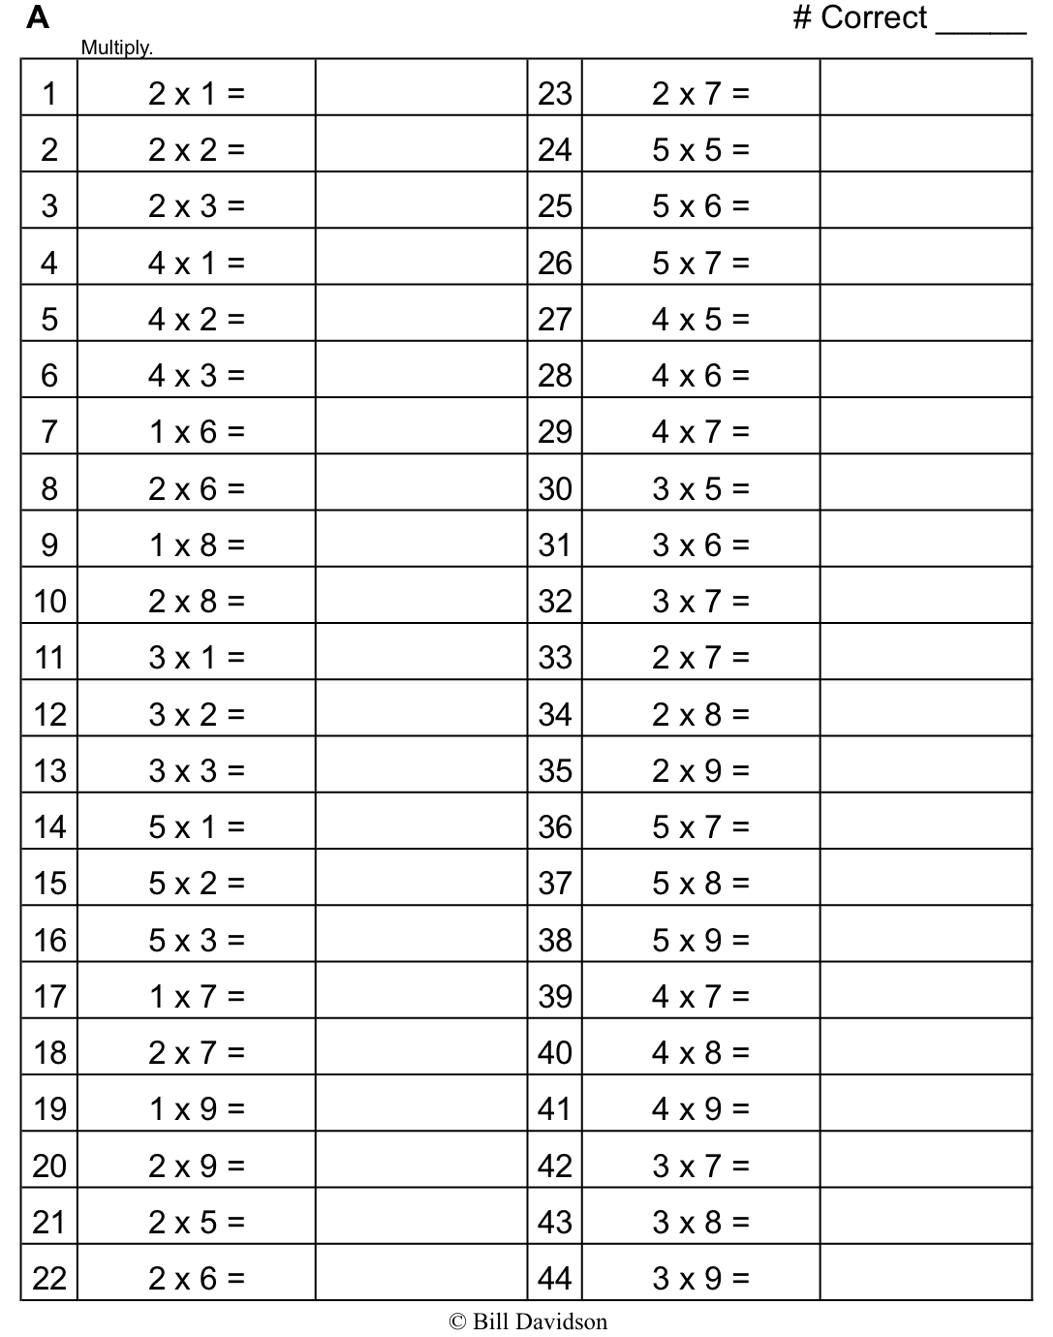
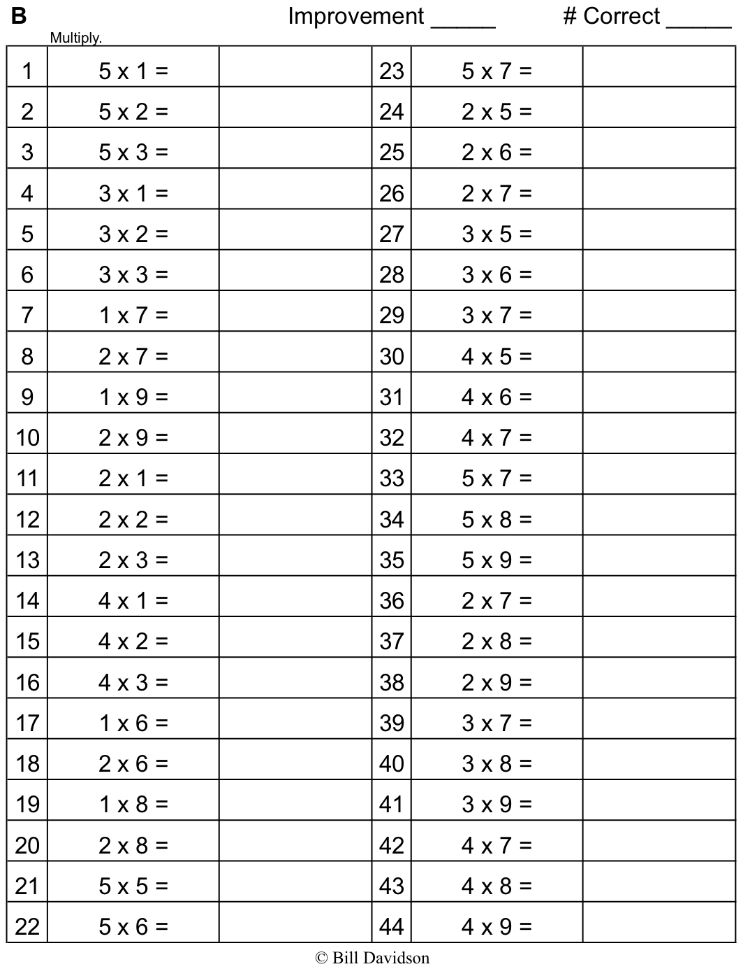
Name Date
- a. Solve. Shade in the multiplication facts that you already know. Then, shade in the facts for sixes,
sevens, eights, and nines that you can solve using the commutative property.
× | 1 | 2 | 3 | 4 | 5 | 6 | 7 | 8 | 9 | 10
1 |  | 2 | 3
2 |  | 4 |  | 8 |  |  |  | 16
3 |  |  |  |  |  | 18
4 |  |  |  |  | 20
5 |  |  |  |  |  |  |  |  |  | 50
6 |  | 12
7
8
9
10

b. Complete the chart. Each bag contains 7 apples.
Number of Bags | 2 |  | 4 | 5
Total Number of Apples |  | 21 |  |  | 42

- Use the array to write two different multiplication sentences.
_______ = _______ × _______
_______ = _______ × _______

- Complete the equations.

a. 2 sevens = ________ twos g. 3 × 9 = 10 threes – _______ three
14
= ________ = _______

b. 3 ________ = 6 threes h. 10 fours – 1 four = _______ × 4

= ________ = ________

c. 10 eights = 8 ________ i. 8 × 4 = 5 fours + _______ fours

= ________ = ________

d. 4 × _______ = 6 × 4 j. _______ fives + 1 five = 6 × 5

= ________ = ________

e. 8 × 5 = ________ × 8 k. 5 threes + 2 threes = _____ × _____

= ________ = ________

f. _______ × 7 = 7 × _______ l. ______ twos + ______ twos = 10 twos
28
= ________ = ________

Name Date

- Use the array to write two different multiplication facts.

_______ = _______ × _______
_______ = _______ × _______

- Karen says, “If I know 3 × 8 = 24, then I know the answer to 8 × 3!” Explain why this is true.

Name Date
- Complete the charts below.

- A tricycle has 3 wheels.
Number of Tricycles | 3 |  | 5 |  | 7
Total Number of Wheels |  | 12 |  | 18

- A tiger has 4 legs.
Number of Tigers |  |  | 7 | 8 | 9
Total Number of Legs | 20 | 24

- A package has 5 erasers.
Number of Packages | 6 |  |  |  | 10
Total Number of Erasers |  | 35 | 40 | 45

- Write two multiplication facts for each array.

_______ = _______ × _______
_______ = _______ × _______

_______ = _______ × _______
_______ = _______ × _______

- Match the expressions.
3 × 6 7 threes

3 sevens 2 × 10

2 eights 9 × 5

5 × 9 8 × 2

10 twos 6 × 3

- Complete the equations.

- 2 sixes = ______ twos d. 4 × _____ = _____ × 4
28
12
= _______ = ________

- _____ × 6 = 6 threes e. 5 twos + 2 twos = _____ × _____

= _______ = _______

- 4 × 8 = _____ × 4 f. _____ fives + 1 five = 6 × 5

= _______ = _____

