Lesson 21
Objective: Estimate sums and differences of measurements by rounding, and then solve mixed word problems.

Suggested Lesson Structure
 Fluency Practice (13 minutes)
 Application Problem (5 minutes)
 Concept Development (32 minutes)
 Student Debrief (10 minutes)
Total Time (60 minutes)
Fluency Practice (13 minutes)
- Group Counting 3.OA.1 (4 minutes)
- Use Algorithms with Different Units 3.MD.2 (5 minutes)
- Estimate and Subtract 3.NBT.2 (4 minutes)
Group Counting (4 minutes)
Note: Group counting reviews interpreting multiplication as repeated addition. It reviews foundational strategies for multiplication from Module 1 and anticipates Module 3.
Direct students to count forward and backward, occasionally changing the direction of the count.
- Threes to 30
- Fours to 40
- Sixes to 60
- Sevens to 70
- Eights to 80
- Nines to 90
As students’ fluency with skip-counting improves, help them make a connection to multiplication by tracking the number of groups they count using their fingers.
Use Algorithms with Different Units (5 minutes)
Materials: (S) Personal white board
Note: This activity reviews addition and subtraction using the standard algorithm.
T: (Write 495 L + 126 L = ___.) On your personal white board, solve using the standard algorithm.
Repeat the process, using the following suggested sequence: 368 cm + 132 cm, 479 cm + 221 cm,
532 cm + 368 cm, 870 L – 39 L, 870 L – 439 L, 807 g – 45 g, and 807 g – 445 g.
Estimate and Subtract (4 minutes)
Materials: (S) Personal white board
Note: This activity reviews rounding to estimate differences from Lesson 20.
T: (Write 71 – 23 ≈ ___.) Say the subtraction sentence.

NOTES ON
MULTIPLE MEANS
OF ACTION AND EXPRESSION:
Some learners may be more successful estimating and subtracting if allowed support (without stigma), such as base ten blocks, a place value chart, or a calculator. Maintain high expectations of student achievement, and set realistic personalized goals that you steadily guide them to attain.
S: 71 – 23.
T: Say the subtraction sentence, rounding each number to the nearest ten.
S: 70 – 20.
T: (Write 71 – 23 ≈ 70 – 20.) What’s 70 – 20?
S: 50.
T: So, 71 – 23 should be close to?
S: 50.
T: On your boards, answer 71 – 23.
S: (Solve.)
Continue with the following suggested sequence:
47 – 18, 574 – 182, and 704 – 187.
Application Problem (5 minutes)

NOTES ON
APPLICATION PROBLEM:
Have students complete the problem in partners so that Partner 1 rounds to the nearest ten and Partner 2 rounds to the nearest hundred—it’s a time-efficient way of having both estimates to compare with the actual answer.

Gloria fills water balloons with 238 mL of water. How many milliliters of water are in two water balloons? Estimate to the nearest 10 mL and 100 mL. Which gives a closer estimate?
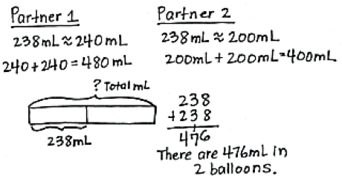
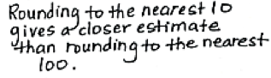
Note: This problem reviews Lesson 17 by having students round to estimate sums and then calculate the actual answer. It reviews addition because this lesson includes mixed practice with addition and subtraction.
Concept Development (32 minutes)

NOTES ON
MULTIPLE MEANS
OF ACTION AND EXPRESSIONS:
English language learners and others benefit from a demonstration of the procedure, as well as a review of behavior norms. For example, how will turns be recognized? What can you say to request the use of a tool? What is each tool called?
Working in pairs may be to the advantage of English language learners because it provides an opportunity to speak about math in English.

Materials: See complete description below.
Problems 1–3 of the Problem Set:
Each group has the premeasured items and measurement tools listed below. Students work together to measure weight, length, and capacity.
Next, they round to estimate sums and differences, then use the standard algorithm to solve. Determine whether students work in pairs, groups, or individually based on ability. Students should use their estimates to assess the reasonableness of actual answers.
Student Directions: Follow the Problem Set directions to complete Problems 1–3 with your group. Once you have finished those problems, complete Problem 4 on your own.
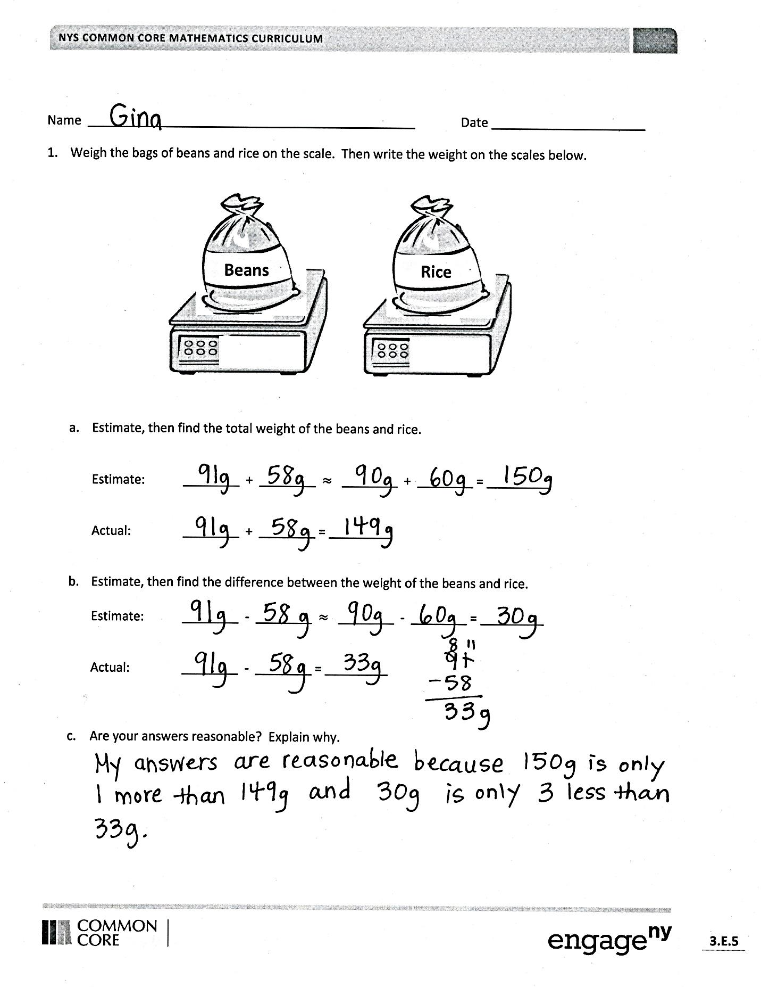
Materials Description (per group):
Problem 1: 1 digital scale, 1 bag of rice pre-measured at 58 grams, 1 bag of beans premeasured at 91 grams
Problem 2: 1 meter stick, labeled Yarn A, B, and C (Yarn A pre-measured at 64 cm, Yarn B pre-measured at 88 cm, Yarn C pre-measured at 38 cm)
Problem 3: 1 400 mL beaker, Container D with liquid pre-measured at 212 mL, Container E with liquid pre-measured at 238 mL, Container F with liquid pre-measured at 195 mL
Problem 4: No additional materials
Student Debrief (10 minutes)
Lesson Objective: Estimate sums and differences of measurements by rounding, and then solve mixed word problems.
The Student Debrief is intended to invite reflection and active processing of the total lesson experience.
Invite students to review their solutions for the Problem Set. They should check work by comparing answers with a partner before going over answers as a class.
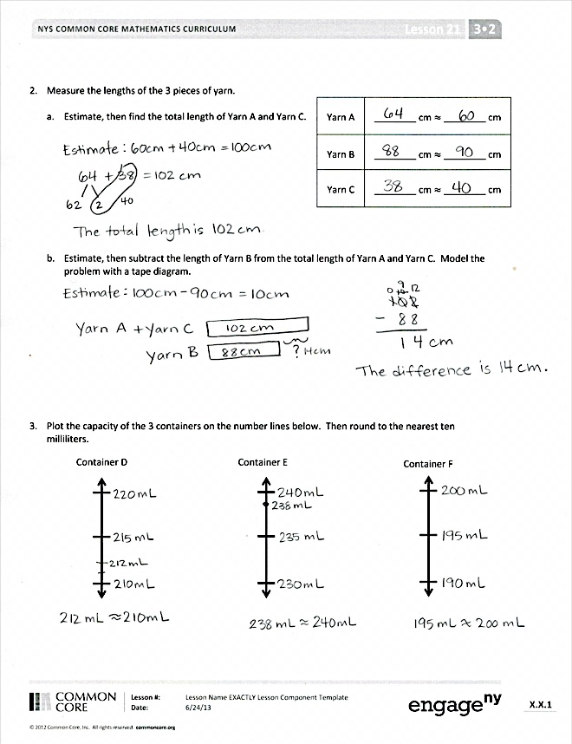
Look for misconceptions or misunderstandings that can be addressed in the Debrief. Guide students in a conversation to debrief the Problem Set and process the lesson.
You may choose to use any combination of the questions below to lead the discussion.
- How can you use measurement as a tool for checking whether or not your answers are reasonable?
- How did you use mental math in today’s lesson?
- How did the Application Problem prepare you for today’s Problem Set?
- How did the Fluency Practice relate to your work today?
Exit Ticket (3 minutes)
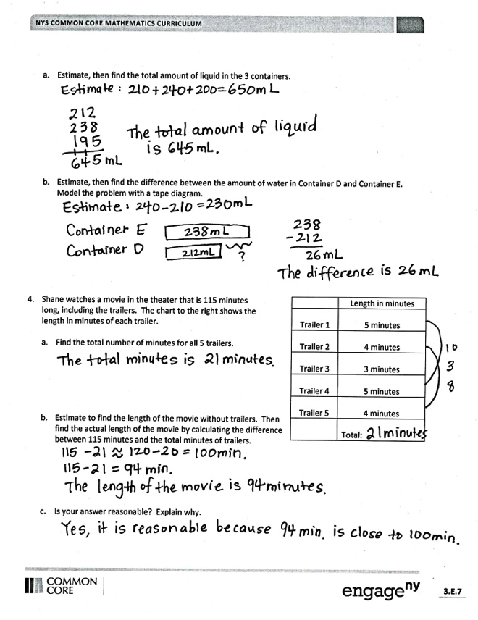
After the Student Debrief, instruct students to complete the Exit Ticket. A review of their work will help you assess the students’ understanding of the concepts that were presented in the lesson today and plan more effectively for future lessons. You may read the questions aloud to the students.

Name Date
- Weigh the bags of beans and rice on the scale. Then, write the weight on the scales below.

Rice
Beans

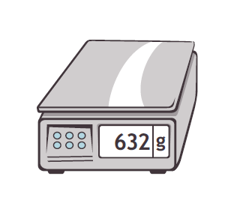

- Estimate, and then find the total weight of the beans and rice.

Estimate: ________ + ________ $≈$ ________ + ________ = _________

Actual: ________ + ________ = _________

- Estimate, and then find the difference between the weight of the beans and rice.

Estimate: ________ – ________ $≈$ ________ – ________ = _________

Actual: ________ – ________ = _________

- Are your answers reasonable? Explain why.

Yarn A | ________ cm $≈$________ cm
Yarn B | ________ cm $≈$________ cm
Yarn C | ________ cm $≈$________ cm
- Measure the lengths of the three pieces of yarn.

  - Estimate, and then find the total length of Yarn A and Yarn C.

  - Estimate, and then subtract the length of Yarn B from the total length of Yarn A and Yarn C. Model the problem with a tape diagram.

- Plot the amount of liquid in the three containers on the number lines below. Then, round to the nearest 10 milliliters.
Container D
Container E
Container F

  - Estimate, and then find the total amount of liquid in the three containers.

  - Estimate, and then find the difference between the amount of water in Container D and Container E. Model the problem with a tape diagram.

Trailer | Length in minutes
1 | 5 minutes
2 | 4 minutes
3 | 3 minutes
4 | 5 minutes
5 | 4 minutes
Total

- Shane watches a movie in the theater that is 115 minutes long, including the trailers. The chart to the right shows the length in minutes of each trailer.

- Find the total number of minutes for all 5 trailers.

- Estimate to find the length of the movie without trailers. Then, find the actual length of the movie by calculating the difference between 115 minutes and the total minutes of trailers.

- Is your answer reasonable? Explain why.

Name Date
Rogelio drinks water at every meal. At breakfast, he drinks 237 milliliters. At lunch, he drinks 300 milliliters. At dinner, he drinks 177 milliliters.

  - Estimate the total amount of water Rogelio drinks. Then, find the actual amount of water he drinks at all three meals.

  - Estimate how much more water Rogelio drinks at lunch than at dinner. Then, find how much more water Rogelio actually drinks at lunch than at dinner.

Name Date
      - There are 153 milliliters of juice in 1 carton. A three-pack of juice boxes contains a total of 459 milliliters.
- Estimate, and then find the actual total amount of juice in 1 carton and in a three-pack of juice boxes.

- mL + 459 mL ≈ ______ + ______ =______

- mL + 459 mL = ______

- Estimate, and then find the actual difference between the amount in 1 carton and in a three-pack of juice boxes.

- mL − 153 mL ≈ ______ − ______ = ______

- mL − 153 mL = ______

- Are your answers reasonable? Why?

- Mr. Williams owns a gas station. He sells 367 liters of gas in the morning, 300 liters of gas in the afternoon, and 219 liters of gas in the evening.

- Estimate, and then find the actual total amount of gas he sells in one day.

- Estimate, and then find the actual difference between the amount of gas Mr. Williams sells in the morning and the amount he sells in the evening.

Blue Team | Time in Minutes
Jen | 5 minutes
Kristin | 7 minutes
Lester | 6 minutes
Evy | 8 minutes
Total
- The Blue Team runs a relay. The chart shows the time, in minutes, that each team member spends running.

- How many minutes does it take the Blue Team to run the relay?

- It takes the Red Team 37 minutes to run the relay. Estimate, and then find the actual difference in time between the two teams.

Banner A | 437 cm
Banner B | 457 cm
Banner C | 332 cm

- The lengths of three banners are shown to the right.
- Estimate, and then find the actual total length of Banner A and Banner C.

- Estimate, and then find the actual difference in length between Banner B and the combined length of Banner A and Banner C. Model the problem with a tape diagram.

