Lesson 20

Objective: Estimate differences by rounding and apply to solve measurement word problems.

Suggested Lesson Structure

 Fluency Practice (12 minutes)

 Concept Development (23 minutes)

 Application Problem (15 minutes)

 Student Debrief (10 minutes)

**Total Time (60 minutes)**

Fluency Practice (12 minutes)

* Sprint: Round to the Nearest Hundred **3.NBT.1** (9 minutes)
* Use Subtraction Algorithm with Measurements **3.MD.2** (3 minutes)

Sprint: Round to the Nearest Hundred (9 minutes)

Materials: (S) Round to the Nearest Hundred Sprint

Note: This activity builds automaticity with rounding to the nearest hundred from Lesson 14.

Use Subtraction Algorithm with Measurements (3 minutes)

Materials: (S) Personal white board

Note: This activity reviews the standard algorithm, taught in Module 2.

T: (Write 50 L – 28 L = ___.) On your personal white board, solve using the standard algorithm.

Repeat the process outlined in Lesson 19 using the following suggested sequence: 50 L – 28 L,   
450 L – 28 L, 450 L – 228 L, 604 g – 32 g, and 604 g – 132 g.

Concept Development (23 minutes)

Materials: (S) Personal white board

Problem 1: Estimate 362 – 189 by rounding.

T: What is 362 rounded to the nearest hundred?

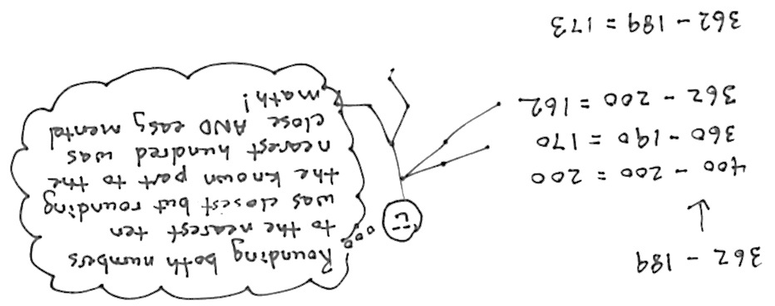S: 400.

T: Let’s write it directly below 362. (Allow students time to write 400 below 362.) What is 189 rounded to the nearest hundred?

S: 200.

T: Let’s write it directly below 189. (Allow students time to write 200 below 189.) What is 400 – 200?

S: 200!

T: We estimated the difference by rounding both numbers to the nearest hundred and got 200. Let’s now find the difference by rounding to the nearest ten.

Repeat the process. Students find that the difference rounded to the nearest ten is 360 – 190 or 36 tens – 19 tens, which is 170 or 17 tens.

|  |  |
| --- | --- |
|  | NOTES ON  MULTIPLE MEANS  OF ACTION AND EXPRESSION: |

Learners differ in their internal organization and working memory. Facilitate students’ use of the standard algorithm as a desktop checklist. You might include the following:

1. Whisper read the problem.

2 Say the larger number in unit form.

3. Scan. Are you ready to subtract?

4. Record bundling and unbundling.

5. Check your answer with your estimate, place value disks, or partner.

6. Correct any mistake.

T: We rounded to the nearest ten and hundred. Is there another easy way we could round these numbers so it is easy to subtract?

S: Since we’re subtracting, 362 is the whole and 189 is a part. Let’s just round the part. 362 – 200 is 162. That is really easy mental math.

T: So, round only 189 because it is already so close to 200?

S: Yeah. The answer is closer than if we round the whole because 362 isn’t very close to 400. 🡪 How about   
380 – 180 = 200?

T: What are our rounded answers?

S: 200, 170, and 162.

T: Let’s see which is closest. Solve the problem and discuss which rounded solution is closest. (Solve and discuss.) Rounding to the nearest ten was the closest answer. Which was the easiest mental math?

S: Rounding to the hundred. 🡪 Yes, but the answer was much closer when we rounded the known part, like we did with 362 – 200, and it was still easy.

T: Rounding the known part we are subtracting from the whole is easy, and in this case, gave us a pretty good estimate. How does comparing your actual answer with your estimation help you check your calculation?

S: We saw that our answer was not crazy. 🡪 If the estimate is really different than the real answer, we can see that we might’ve made a mistake.

T: Rounding to estimate is a tool that helps us simplify calculations to help us make sure our actual answers are reasonable. Rounding can also be useful when we don’t need an exact answer. I know it isn’t as precise as an actual calculation, but sometimes an idea of an amount is all the information I need.

Problem 2: Analyze the estimated differences of four expressions with subtrahends close to the halfway point: (A) 349 – 154, (B) 349 – 149, (C) 351 – 154, and (D) 351 – 149.

T: (Write the four expressions above on the board.) Take 90 seconds to find the value of these expressions.

|  |  |
| --- | --- |
|  | NOTES ON  ROUNDING PROBLEM 2 EXPRESSIONS: |

1. 349 – 154  
   (Whole rounds down. Part rounds up.)
2. 349 – 149  
   (Whole rounds down. Part rounds down.)
3. 351 – 154   
   (Whole rounds up. Part rounds up.)
4. 351 – 149   
   (Whole rounds up. Part rounds down.)

S: (Work and check answers.)

T: What do you notice about the differences:   
195, 200, 197, and 202?

S: They are really close to each other. 🡪 They are all between 195 and 202. 🡪 The difference between the smallest and greatest is 7.

T: Analyze why the differences were so close by looking at the totals and the parts being subtracted. What do you notice?

S: Two of them are exactly the same. 🡪 The totals are all really close to 350. 🡪 The part being subtracted is really close to 150.

T: Let’s round to the nearest hundred as we did earlier. (Lead the students through rounding each number to the nearest hundred and finding the differences.)

**MP.6**

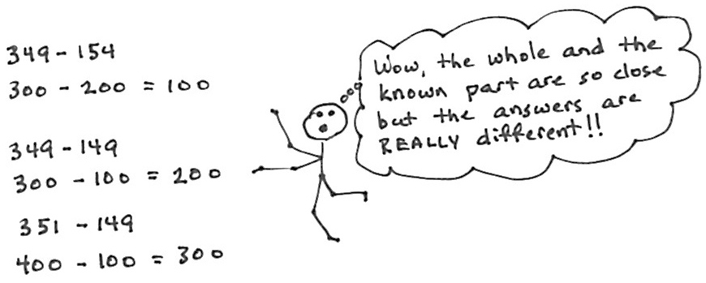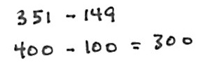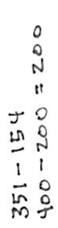

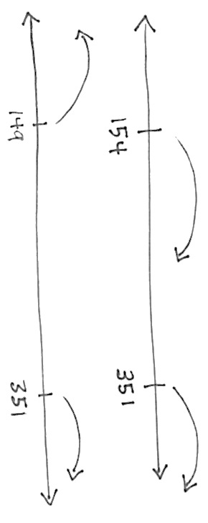S: The answers came out really different!

**MP.6**

T: Analyze the rounding with your partner. Did we round up or down?

S: In A, the total rounded down and the part rounded up. 🡪 In B, they both rounded down. 🡪 In C, they both rounded up. 🡪 In D, the total rounded up and the part rounded down.

T: Which estimates are closest to the real answers?

S: B and C are closest. 🡪 That’s funny, because in B both the numbers rounded down. 🡪 And, in C, both numbers rounded up. 🡪 So, it’s different for subtraction than for addition. If we round them the same way, the difference is closer. 🡪 With addition the answer was closer when one number rounded down and one rounded up.

T: Let’s use a number line to see why that is true. Here are 154 and 351 on the number line. The difference is the distance between them. (Move your finger along the line.) When they round the same way, the distance between them is staying about the same. When we round in opposite directions, the distance gets either much longer or much shorter.

|  |  |
| --- | --- |
|  | NOTES ON  MULTIPLE MEANS  OF  ENGAGEMENT: |
| Challenge students to transform what they have learned about rounding and reasonable estimates. Upon evaluating the usefulness of rounding to the nearest ten or hundred, invite students to propose a better method of rounding to check the reasonableness of answers. For example, students may conclude that rounding to the nearest fifty or nearest twenty-five proves more useful. | |

S: That reminds me of my mental math strategy for subtraction. Let’s say I’m subtracting 198 from 532, I can just add 2 to both numbers so I have 534 – 200 and the answer is exactly right, 334.

T: Yes. When we add the same number to both the total and the part when we subtract, the difference is still exactly the same.

T: Turn and talk to your partner about what the number line is showing us about estimates when subtracting. Think about what happens on the number line when we add estimates, too. (Allow time for discussion.)

|  |  |
| --- | --- |
|  | NOTES ON  MULTIPLE MEANS  OF ENGAGEMENT: |
| This discussion challenges students to identify rules and principles for making best estimates, an activity ideal for students working above grade level. Give students an opportunity to experiment with making best estimates. Guide students to gather their reflections and conclusions in a graphic organizer, such as a flow chart or table, or perhaps as a song, rap, or poem. | |

T: Why do we want our estimated differences to be about right? (Allow time for discussion.)

T: Would all four of these estimates help you to check if your exact answer is reasonable?

S: If we used B or C, our exact answer is really close. A is way too small. D is way too big.

T: Just like when we add, we need a good estimate to see if our actual difference is reasonable.

Problem 3: Round to estimate the difference of 496 – 209. Analyze how rounding to the nearest hundred is nearly the same as rounding to the nearest ten when both addends are close to 1 hundred.

T: (Write the problem above on the board.) With your partner, think about how to round to get the most precise estimate.

Have students analyze the rounded total and part before calculating to determine which is best for a precise answer. Then, have students calculate the estimated difference by rounding to different units. Have them compare estimated answers and then compare with the actual answer.

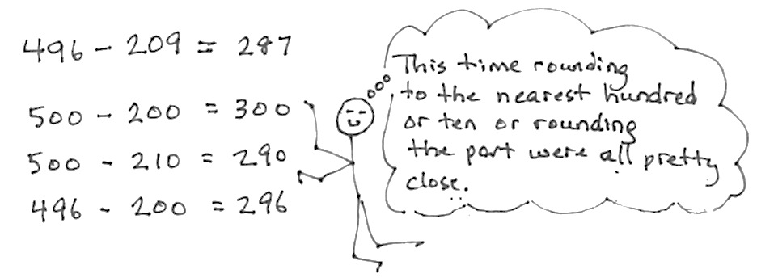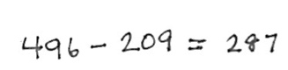

Application Problem (15 minutes)

|  |  |
| --- | --- |
|  | NOTE ON  TIMING: |

The Problem Set in this lesson is allotted 10 minutes. It directly follows the Application Problem, and so the 10 minutes are included within the 15 minutes allotted for the Application Problem.

Millie’s fish tank holds 403 liters of water. She empties out 185 liters of water to clean the tank. How many liters of water are left in the tank?

1. Estimate how many liters are left in the tank by rounding.
2. Estimate how many liters are left in the tank by rounding in a different way.
3. How many liters of water are actually left in the tank?
4. 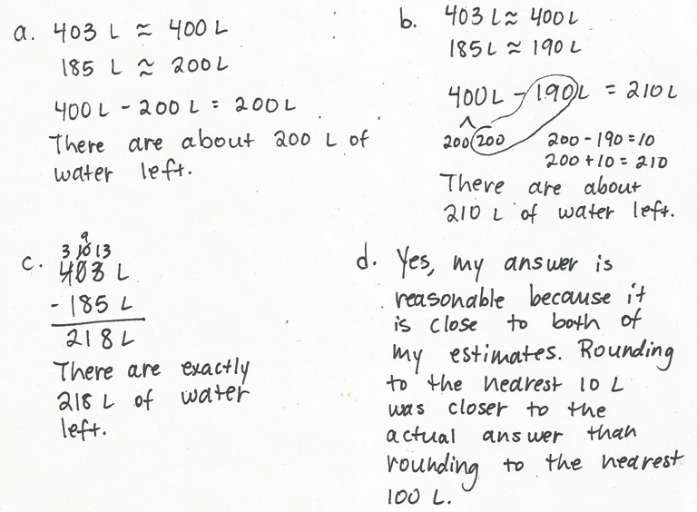Is your answer reasonable? Which estimate was closer to the exact answer?

T: To solve Part (a), first determine how you are going to round your numbers.

S: (Work and possibly share with a partner.)

T: (Invite a few students to share with the class how they rounded.)

Note: This problem reviews estimating differences to solve word problems, which the students learned in today’s Concept Development.

Problem Set (10 minutes)

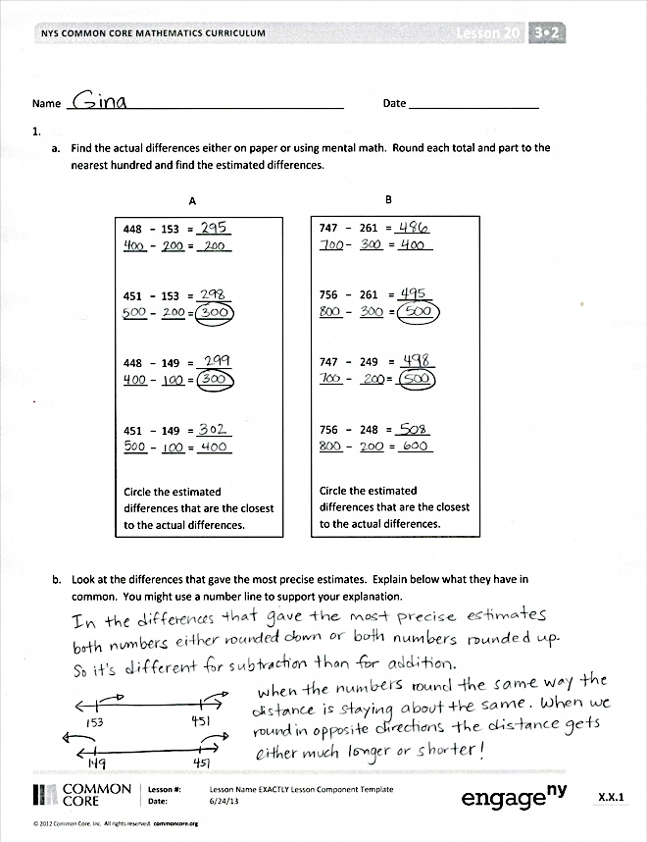

Students should do their personal best to complete the Problem Set within the allotted 10 minutes. For some classes, it may be appropriate to modify the assignment by specifying which problems they work on first. Some problems do not specify a method for solving. Students should solve these problems using the RDW approach used for Application Problems.

Student Debrief (10 minutes)

**Lesson Objective:** Estimate differences by rounding and apply to solve measurement word problems.

The Student Debrief is intended to invite reflection and active processing of the total lesson experience.

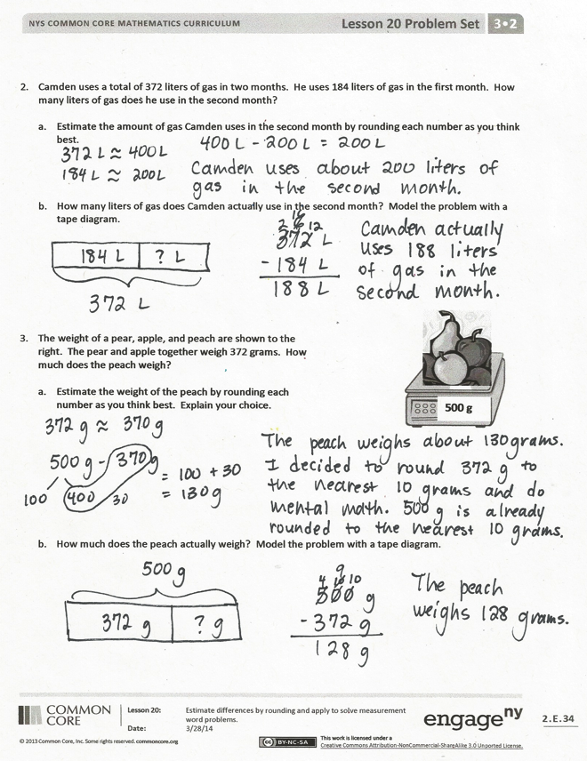Invite students to review their solutions for the Problem Set. They should check work by comparing answers with a partner before going over answers as a class. Look for misconceptions or misunderstandings that can be addressed in the Debrief. Guide students in a conversation to debrief the Problem Set and process the lesson.

You may choose to use any combination of the questions below to lead the discussion.

* Share your observations from Problem (1b). What did you find out? How is this different than rounding when you add?
* With your partner, compare your methods of estimation in Problems 2(a) and 3(a). Which was a more precise estimate? If you rounded in the same way, think of another way to estimate. Compare both estimates to the actual answer, and explain why one is more precise than the other.
* When do you need to round so that mental math is easy and fast? When do you need to round more precisely?

Exit Ticket (3 minutes)

After the Student Debrief, instruct students to complete the Exit Ticket. A review of their work will help you assess the students’ understanding of the concepts that were presented in the lesson today and plan more effectively for future lessons. You may read the questions aloud to the students.

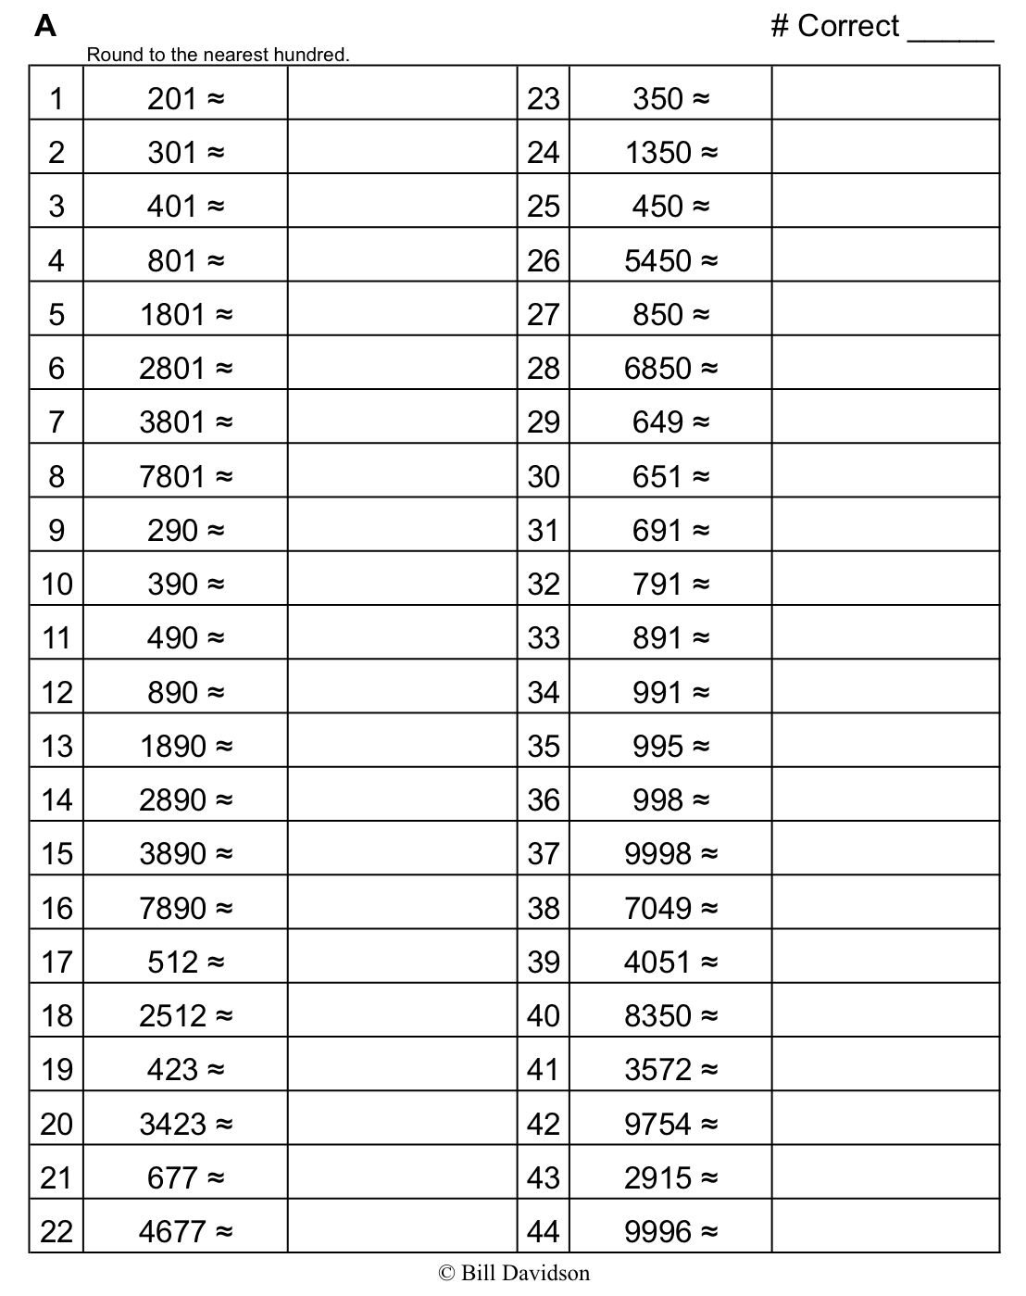

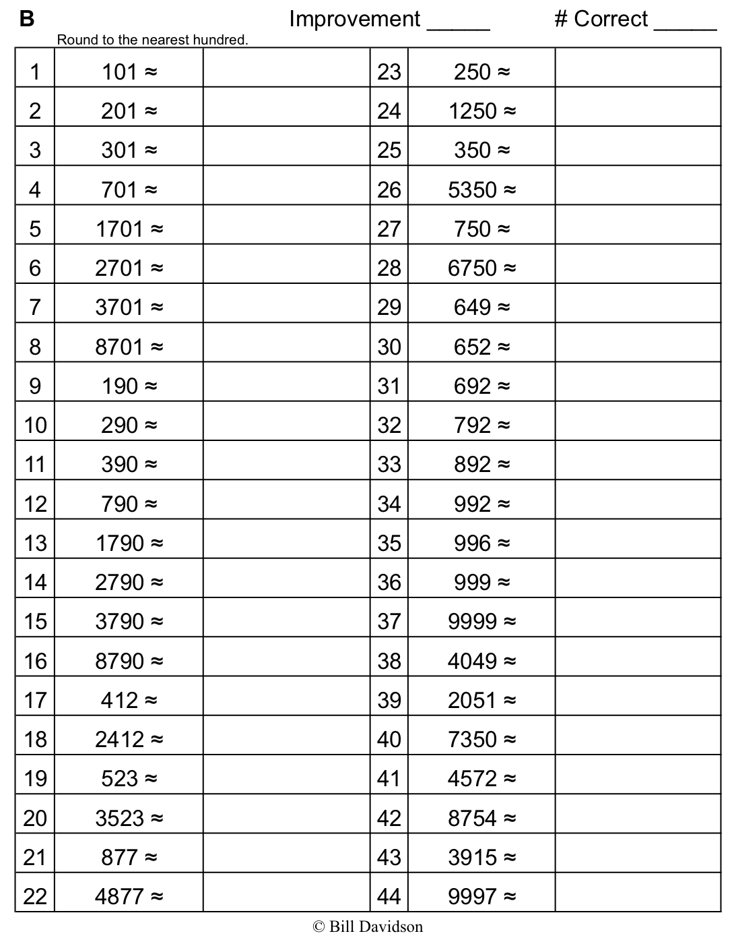

Name Date

* 1. Find the actual differences either on paper or using mental math. Round each total and part to the nearest hundred and find the estimated differences.

448 − 153 = ______

____ − ____ = ______

451 − 153 = ______

____ − ____ = ______

448 − 149 = ______

____ − ____ = ______

451 − 149 = ______

____ − ____ = ______

Circle the estimated differences that are the closest to the actual differences.

747 − 261 = ______

____ − ____ = ______

756 − 261 = ______

____ − ____ = ______

747 − 249 = ______

____ − ____ = ______

756 − 248 = ______

____ − ____ = ______

Circle the estimated differences that are the closest to the actual differences.

**A**

**B**

b. Look at the differences that gave the most precise estimates. Explain below what they have in common. You might use a number line to support your explanation.

2. Camden uses a total of 372 liters of gas in two months. He uses 184 liters of gas in the first month. How many liters of gas does he use in the second month?

* 1. Estimate the amount of gas Camden uses in the second month by rounding each number as you think best.

* 1. How many liters of gas does Camden actually use in the second month? Model the problem with a tape diagram.

3. The weight of a pear, apple, and peach are shown to the right. The pear and apple together weigh 372 grams. How much does the peach weigh?

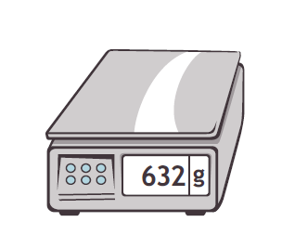

**500 g**

* 1. Estimate the weight of the peach by rounding each number as you think best. Explain your choice.
  2. How much does the peach actually weigh? Model the problem with a tape diagram.

Name Date

Kathy buys a total of 416 grams of frozen yogurt for herself and a friend. She buys 1 large cup and 1 small cup.



**416 g**



|  |  |
| --- | --- |
| **Large Cup** | 363 grams |
| **Small Cup** | ? grams |

1. Estimate how many grams are in the small cup of yogurt by rounding.
2. Estimate how many grams are in the small cup of yogurt by rounding in a different way.
3. How many grams are actually in the small cup of yogurt?
4. Is your answer reasonable? Which estimate was closer to the exact weight? Explain why.

Name Date

Estimate, and then solve each problem.

1. Melissa and her mom go on a road trip. They drive 87 kilometers before lunch. They drive 59 kilometers after lunch.
2. Estimate how many more kilometers they drive before lunch than after lunch by rounding to the nearest 10 kilometers.

1. Precisely how much farther do they drive before lunch than after lunch?
2. Compare your estimate from (a) to your answer from (b). Is your answer reasonable? Write a sentence to explain your thinking.
3. Amy measures ribbon. She measures a total of 393 centimeters of ribbon and cuts it into two pieces. The first piece is 184 centimeters long. How long is the second piece of ribbon?
   1. Estimate the length of the second piece of ribbon by rounding in two different ways.

* 1. Precisely how long is the second piece of ribbon? Explain why one estimate was closer.

1. MC900441854[1]The weight of a chicken leg, steak, and ham are shown to the right. The chicken and the steak together weigh 341 grams. How much does the ham weigh?

989 grams

* 1. Estimate the weight of the ham by rounding.
  2. How much does the ham actually weigh?

1. Kate uses 506 liters of water each week to water plants. She uses 252 liters to water the plants in the greenhouse. How much water does she use for the other plants?
2. Estimate how much water Kate uses for the other plants by rounding.
3. Estimate how much water Kate uses for the other plants by rounding a different way.
4. How much water does Kate actually use for the other plants? Which estimate was closer? Explain why.