Lesson 19
Objective: Decompose twice to subtract measurements including three-digit minuends with zeros in the tens and ones places.

Suggested Lesson Structure
 Fluency Practice (12 minutes)
 Application Problem (5 minutes)
 Concept Development (33 minutes)
 Student Debrief (10 minutes)
Total Time (60 minutes)
Fluency Practice (12 minutes)
- Subtract Mentally 3.NBT.2 (4 minutes)
- Use Subtraction Algorithm with Measurements 3.MD.2 (4 minutes)
- Round Three- and Four-Digit Numbers 3.NBT.1 (4 minutes)
Subtract Mentally (4 minutes)
Note: This activity emphasizes the role of place value in the subtraction algorithm.
T: (Write 10 – 5 = ___.) Say the number sentence in units of one.
S: 10 ones – 5 ones = 5 ones.
Repeat the process outlined in Lesson 18. Use the following suggested sequence: 12 ones – 5 ones,
42 ones – 5 ones, 10 tens – 5 tens, 12 tens – 5 tens, and 42 tens – 5 tens.
Use Subtraction Algorithm with Measurements (4 minutes)
Materials: (S) Personal white board
Note: This activity reviews the role of place value in the subtraction algorithm from Lesson 18.
T: (Write 80 L – 26 L = ___.) On your personal white board, solve using the standard algorithm.
Continue with the following possible sequence: 380 L – 26 L, 380 L – 126 L, 908 g – 25 g, and 908 g – 425 g.

Round Three- and Four-Digit Numbers (4 minutes)
Materials: (S) Personal white board
Note: This activity reviews rounding to the nearest hundred from Lesson 14.
T: (Write 253 ≈ ___.) What is 253 rounded to the nearest hundred?
S: 300.
Repeat the process outlined in Lesson 15, rounding numbers only to the nearest hundred. Use the following possible suggestions: 253; 1,253; 735; 1,735; 850; 1,850; 952; 1,371; and 1,450.
Application Problem (5 minutes)
Jolene brings an apple and an orange with her to school. The weight of both pieces of fruit together is 417 grams. The apple weighs 223 grams. What is the weight of Jolene’s orange?
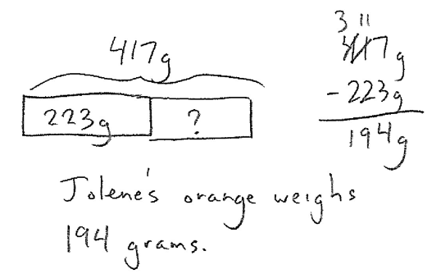

Note: This problem reviews unbundling once to subtract. It also provides a context leading into the Concept Development.
Concept Development (33 minutes)
Materials: (S) Personal white board
Part 1: Decompose twice using the standard algorithm for subtraction.
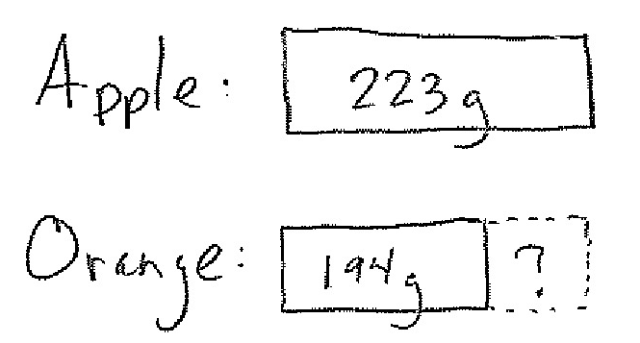
T: In the Application Problem, Jolene’s apple weighs 223 grams and her orange weighs 194 grams. (Draw or project the tape diagrams shown at right.) What does the question mark in these tape diagrams represent?
S: How much heavier the apple is than the orange.
How much more the apple weighs, in grams.
T: Tell a partner what expression you can use to find out how much heavier the apple is than the orange. Write the problem vertically on your personal white board.
S: (Write problem vertically.)
T: Before we subtract, what needs to be done?
S: We need to make sure we can subtract each place. We have to see if any tens or hundreds need to be unbundled.

NOTES ON
MULTIPLE MEANS
OF REPRESENTATION:
Use color to customize the presentation of the tape diagram. Displaying a green bar for the apple and an orange bar for the orange may enhance learners’ perception of the information.
Students may value a vertical tape diagram, alternatively, if it gives them a better sense of heavier and less heavy.

T: Do we have enough ones to subtract?
S: No. We need to change a ten for 10 ones.
T: How about in the tens place?
S: No. We also need to change a hundred for 10 tens. Then, we can solve.
T: Unbundle or change the ten. How many tens and ones do we have now?
S: 1 ten and 13 ones.
T: Now, unbundle or change the hundred. How many hundreds and tens do we have now?
S: 1 hundred and 11 tens.
T: Are we ready to subtract?
S: Yes!
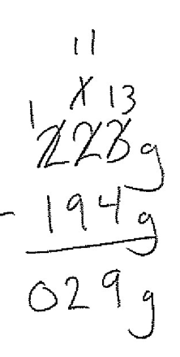
T: Solve the problem on your board.
Subtraction Complete
S: (Solve as shown at right.)
T: How much heavier is the apple than the orange?
S: The apple is 29 grams heavier than the orange!
Continue with the following suggested sequence. Students should prepare their problems for subtraction by unbundling all necessary digits before performing the operation.
- 342 cm – 55 cm
- 764 g – 485 g
- 573 mL – 375 mL
T: How are the subtraction problems we’ve solved so far different from those we solved yesterday?
S: Yesterday, we only had to unbundle once. Today, we had to unbundle twice.
Part 2: Use the standard algorithm to subtract three-digit numbers with zeros in various positions.
Write or project the following problem:
Kerrin has 703 milliliters of water in a pitcher. She pours some water out. Now, 124 milliliters are left in the pitcher. How much water did Kerrin pour out?
T: Let’s solve this problem using the algorithm. What needs to be done first?
S: We need to unbundle a ten.
T: What digit is in the tens place on top?
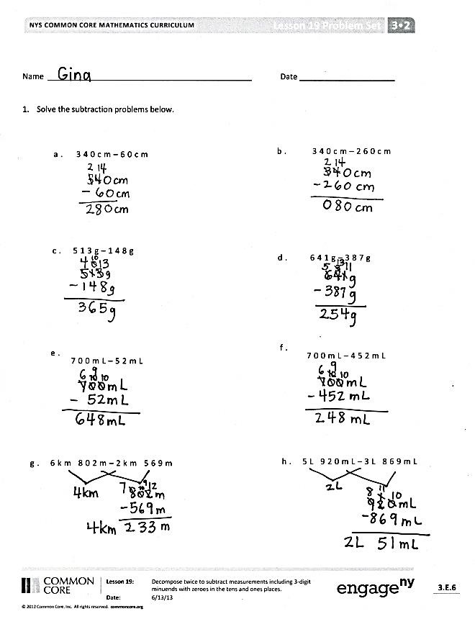
S: Zero.
T: Can we unbundle 0 tens?
S: No!
T: Where can we get tens?
S: We can change 1 hundred into 10 tens!
T: Change the hundred into tens on your board. (Model.) How many hundreds and tens does the top number have now?
S: 6 hundreds and 10 tens.
T: Why aren’t we ready to subtract yet?
S: We still have to change 1 ten for 10 ones.
T: Finish unbundling on your board and complete the subtraction. (Model.) How many milliliters of water did Kerrin pour out?
S: She poured out 579 milliliters of water!
Continue with the following suggested sequence. Students should prepare their problems for subtraction by unbundling all necessary digits before performing the operation.
- 703 cm – 37 cm
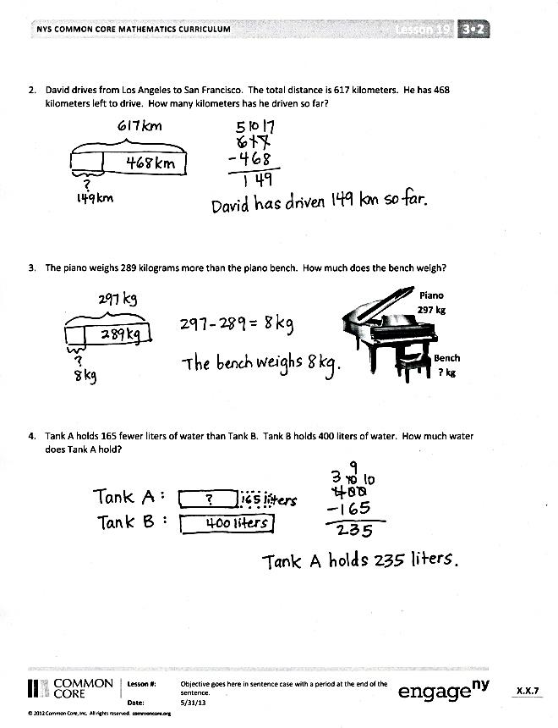
- 700 mL – 356 mL
- 500 g – 467 g
Problem Set (10 minutes)
Students should do their personal best to complete the Problem Set within the allotted 10 minutes. For some classes, it may be appropriate to modify the assignment by specifying which problems they work on first. Some problems do not specify a method for solving. Students should solve these problems using the RDW approach used for Application Problems.

Student Debrief (10 minutes)
Lesson Objective: Decompose twice to subtract measurements including three-digit minuends with zeros in the tens and ones places.
The Student Debrief is intended to invite reflection and active processing of the total lesson experience.
Invite students to review their solutions for the Problem Set. They should check work by comparing answers with a partner before going over answers as a class. Look for misconceptions or misunderstandings that can be addressed in the Debrief. Guide students in a conversation to debrief the Problem Set and process the lesson.

NOTES ON
MULTIPLE MEANS
OF REPRESENTATION:
Support English language learners and others as they articulate their steps to solve Problem 4. Give students the choice of explaining in their first language. Making this a partner-share activity may relieve students of anxiety in front of a large group. Some students may benefit from sentence starters, such as, “First, I read ____. Then, I drew ____. Next, I labeled ____. Then, I wrote my equation: _______. Last, I wrote my answer statement, which was ________.”

You may choose to use any combination of the questions below to lead the discussion.
- Which strategy did you use to solve Problem 1(a)? Why? (Students may want to talk about subtracting
6 tens from 34 tens rather than decomposing.)
- Invite students to articulate the steps they followed to solve Problem 4.
- Why is it important to unbundle or change all of your units before subtracting?
Exit Ticket (3 minutes)
After the Student Debrief, instruct students to complete the Exit Ticket. A review of their work will help you assess the students’ understanding of the concepts that were presented in the lesson today and plan more effectively for future lessons. You may read the questions aloud to the students.

Name Date
- Solve the subtraction problems below.
- 340 cm – 60 cm | - 340 cm – 260 cm
- 513 g – 148 g | - 641 g – 387 g
- 700 mL – 52 mL | - 700 mL – 452 mL
- 6 km 802 m – 2 km 569 m | - 5 L 920 mL – 3 L 869 mL

- David is driving from Los Angeles to San Francisco. The total distance is 617 kilometers. He has 468 kilometers left to drive. How many kilometers has he driven so far?

- The piano weighs 289 kilograms more than the piano bench. How much does the bench weigh?
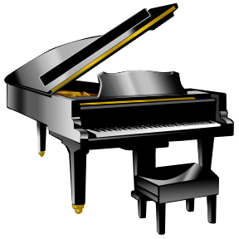
Piano
297 kg
Bench
? kg

- Tank A holds 165 fewer liters of water than Tank B. Tank B holds 400 liters of water. How much water does Tank A hold?

Name Date
- Solve the subtraction problems below.

- 346 m − 187 m b. 700 kg − 592 kg

- The farmer’s sheep weighs 647 kilograms less than the farmer’s cow. The cow weighs 725 kilograms. How much does the sheep weigh?

Name Date
- Solve the subtraction problems below.
- 280 g − 90 g | - 450 g − 284 g
- 423 cm − 136 cm | - 567 cm − 246 cm
- 900 g − 58 g | - 900 g − 358 g
- 4 L 710 mL − 2 L 690 mL | - 8 L 830 mL − 4 L 378 mL

- The total weight of a giraffe and her calf is 904 kilograms. How much does the calf weigh? Use a tape diagram to model your thinking.

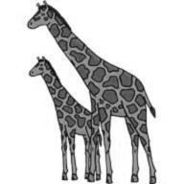
Giraffe
829 kg

Calf
? kg

- The Erie Canal runs 584 kilometers from Albany to Buffalo. Salvador travels on the canal from Albany. He must travel 396 kilometers more before he reaches Buffalo. How many kilometers has he traveled so far?

- Mr. Nguyen fills two inflatable pools. The kiddie pool holds 185 liters of water. The larger pool holds 600 liters of water. How much more water does the larger pool hold than the kiddie pool?

