Lesson 18

Objective: Decompose once to subtract measurements including three-digit minuends with zeros in the tens or ones place.

Suggested Lesson Structure

 Fluency Practice (11 minutes)

 Application Problem (5 minutes)

 Concept Development (34 minutes)

 Student Debrief (10 minutes)

**Total Time (60 minutes)**

Fluency Practice (11 minutes)

* Group Counting **3.OA.1** (3 minutes)
* Subtract Mentally **3.NBT.2** (4 minutes)
* Estimate and Add **3.NBT.2** (4 minutes)

Group Counting (3 minutes)

Note: Group counting reviews interpreting multiplication as repeated addition. It reviews foundational strategies for multiplication from Module 1 and anticipates Module 3.

Direct students to count forward and backward, occasionally changing the direction of the count.

* Threes to 30
* Fours to 40
* Sixes to 60
* Sevens to 70
* Eights to 80
* Nines to 90

As students’ fluency with skip-counting improves, help them make a connection to multiplication by tracking the number of groups they count using their fingers.

Subtract Mentally (4 minutes)

Note: This activity anticipates the role of place value in the subtraction algorithm.

T: (Write 10 – 3 = ___.) Say the number sentence in units of one.

S: 10 ones – 3 ones = 7 ones.

Continue with the following sequence: 11 – 3 and 61 – 3 (as pictured below at right).

T: (Write 100 – 30 = ___.) Now, say the number sentences in units of ten.

10 – 3 = 7 11 – 3 = 8 61 – 3 = 58

100 – 30 = 70 110 – 30 = 80 610 – 30 = 580

T: 10 tens – 3 tens = 7 tens.

Continue with the following sequence: 110 – 30 and 610 – 30.

Repeat with the following possible sequences:

* 10 – 5, 12 – 5, and 73 – 5
* 100 – 50, 120 – 50, and 730 – 50

Estimate and Add (4 minutes)

Materials: (S) Personal white board

|  |  |
| --- | --- |
|  | NOTES ON  MULTIPLE MEANS  OF ACTION AND EXPRESSION: |
| Fluency activities are fun, fast-paced math games, but don’t leave English language learners behind. At the start of each activity, speak more slowly, pause more frequently, give an example, couple language with visual aids or gestures, check for understanding, explain in students’ first language, and/or increase response time. | |

Note: This activity reviews rounding to estimate sums from Lesson 17.

T: (Write 38 + 23 ≈ ___.) Say the addition problem.

S: 38 + 23.

T: Give me the new addition problem if we round each number to the nearest ten.

S: 40 + 20.

T: (Write 38 + 23 ≈ 40 + 20.) What’s 40 + 20?

S: 60.

T: So, 38 + 23 should be close to…?

S: 60.

T: On your personal white board, solve 38 + 23.

S: (Solve.)

Continue with the following possible sequence: 24 + 59, 173 + 49, and 519 + 185.

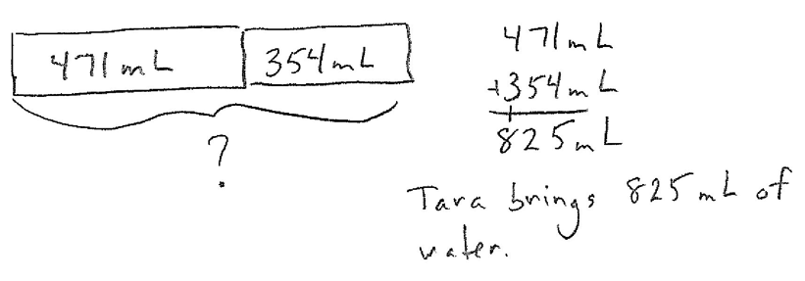Application Problem (5 minutes)

Tara brings 2 bottles of water on her hike. The first bottle has 471 milliliters of water, and the second bottle has 354 milliliters of water. How many milliliters of water does Tara bring on her hike?

Note: This problem reviews composing units once to add. It will be used to reintroduce the place value chart during Part 1 of the Concept Development.

Concept Development (34 minutes)

Materials: (T) Unlabeled place value chart (Lesson 14 Template) (S) Personal white board, unlabeled place value chart (Lesson 14 Template)

Part 1: Use the place value chart to model decomposing once to subtract with three-digit minuends.

Students start with the unlabeled place value chart template in their personal white boards.

*Lesson 14 Template*

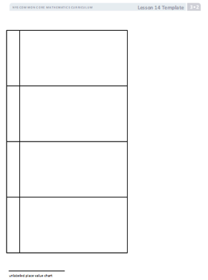

T: Tara has 132 milliliters of water left after hiking. How can we find out how many milliliters of water Tara drinks while she is hiking?

S: We can subtract. 🡪 We can subtract 132 milliliters from 825 milliliters. 🡪 She drank 825 milliliters – 132 milliliters.

T: Let’s write that vertically in the workspace below the place value chart on our personal white board, and then model the problem on our place value charts. (Model writing 825 – 132 as a vertical problem.) On your place value chart, draw place value disks to represent the amount of water Tara starts with.

S: (Draw place value disks.)

T: Let’s get ready to subtract. Look at your vertical subtraction problem. How many ones do we need to subtract from the 5 ones that are there now?

S: 2 ones.

T: Can we subtract 2 ones from 5 ones?

S: Yes!

T: How many tens are we subtracting from 2 tens?

S: 3 tens.

T: Can we subtract 3 tens from 2 tens?

S: No!

T: Why not?

S: There aren’t enough tens to subtract from. 🡪 3 tens is more than 2 tens.

T: To get more tens so that we can subtract, we have to unbundle 1 hundred into tens. How many tens in 1 hundred?

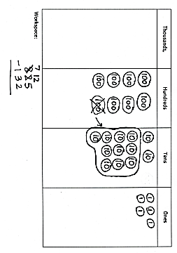

S: 10 tens!

T: (Model the process of unbundling 1 hundred into 10 tens, as shown at right. Have students work along with you.) To start off, we had 8 hundreds and 2 tens. Now, how many hundreds and tens do we have?

S: 7 hundreds and 12 tens!

T: Now, that we have 12 tens, can we take 3 tens away?

S: Yes!

|  |  |
| --- | --- |
|  | NOTES ON  MULTIPLE MEANS  OF REPRESENTATION: |
| Use color to customize the presentation of decomposing to subtract. Enhance learners’ perception of the information by consistently displaying hundreds in one color (e.g., red), while displaying tens in a different color (e.g., green). Consider varying the colors for each place value unit when teaching the standard algorithm from day to day so that students continue to look for a value, rather than for a color, to determine a unit’s value. | |

T: Now, let’s move to the hundreds place. Can we subtract 1 hundred from 7 hundreds?

S: Yes!

T: We’re ready to subtract. Cross off the ones, tens, and hundreds that are being subtracted. (Model as students work along with you.)

T: So, what’s the result?

S: 693.

T: So, that’s it. Our answer is 693?

**MP.2**

S: No! We were looking for the amount of water, not just a number. It’s 693 milliliters!

T: Answer the question with a full statement.

S: Tara drank 693 milliliters of water on her hike.

Continue with the following suggested sequence:

* 785 cm – 36 cm
* 440 g – 223 g
* 508 mL – 225 mL

Part 2: Subtract using the standard algorithm.

Write or project the following problem:

Nooran buys 507 grams of grapes at the market on Tuesday. On Thursday, he buys 345 grams of grapes. How many more grams of grapes did Nooran buy on Tuesday than on Thursday?

T: Let’s model this problem with a tape diagram to figure out what we need to do to solve. Draw with me on your board. (Model.) How should we solve this problem?

S: We can subtract, 507 grams – 345 grams. 🡪 We’re looking for the part that’s different so we subtract. 🡪 To find a missing part, subtract.

T: Write the equation, and then talk to your partner. Is this problem easily solved using mental math? Why or why not?

S: Not really. 🡪 It’s easy to subtract 300 from 500, but the 7 and the 45 aren’t very friendly.

T: Like with addition problems that aren’t easily solved with simplifying strategies, we can use the standard algorithmto solve subtraction problems that aren’t easily solved. Rewrite the problem vertically on your board if you need to.

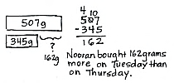S: (Rewrite problem vertically.)

T: Before we subtract, let’s see if any unbundling needs to be done. Are there enough ones to subtract 5 ones?

S: Yes.

T: Are there enough tens to subtract 4 tens?

S: No, 0 tens is less than 4 tens.

T: How can we get some more tens?

S: We can go to the hundreds place. 🡪 We can unbundle 1 hundred to make 10 tens.

T: How many hundreds are in the number on top?

S: 5 hundreds.

T: When we unbundle 1 hundred to make 10 tens, how many hundreds and tens will the top number have?

S: 4 hundreds and 10 tens.

T: (Model.) Do we have enough hundreds to subtract 3 hundreds?

S: Yes.

T: We are ready to subtract! Solve the problem on your board.

T: (Model as shown on the previous page.) How many more grams of grapes did Nooran buy on Tuesday?

S: 162 more grams of grapes!

T: Label the unknown on your tape diagram with the answer.

Continue with the following suggested sequence. Students should unbundle all necessary digits before performing the operation.

* 513 cm – 241 cm
* 760 g – 546 g

|  |  |
| --- | --- |
|  | NOTES ON  THE PROBLEM SET: |
| The problems on the Problem Set are written horizontally so that students do not assume that they need to use the standard algorithm to solve. Mental math may be a more efficient strategy in some cases. Invite students to use the algorithm as a strategic tool, purposefully choosing it rather than defaulting to it. | |

* 506 mL – 435 mL

Problem Set (10 minutes)

Students should do their personal best to complete the Problem Set within the allotted 10 minutes. For some classes, it may be appropriate to modify the assignment by specifying which problems they work on first. Some problems do not specify a method for solving. Students should solve these problems using the RDW approach used for Application Problems.

Student Debrief (10 minutes)

**Lesson Objective:** Decompose once to subtract measurements including three-digit minuends with zeros in the tens or ones place.

The Student Debrief is intended to invite reflection and active processing of the total lesson experience.

Invite students to review their solutions for the Problem Set. They should check work by comparing answers with a partner before going over answers as a class. Look for misconceptions or misunderstandings that can be addressed in the Debrief. Guide students in a conversation to debrief the Problem Set and process the lesson.

You may choose to use any combination of the questions below to lead the discussion.

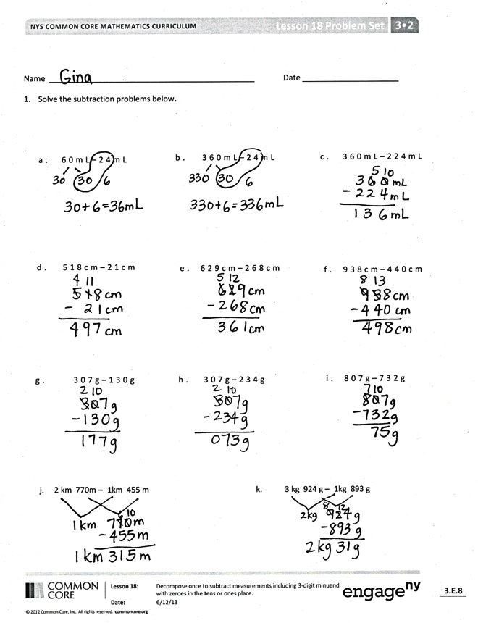

* What is the relationship between Problems 1(a), 1(b), and 1(c)?
* How are Problems 1(j) and 1(k) different from the problems that come before them?
* Invite students to share the tape diagram used to solve Problem 2.
* Compare Problems 2 and 4. What extra step was needed to solve Problem 4? What models could be used to solve this problem?
* Describe the steps of the standard algorithm for subtraction.

Exit Ticket (3 minutes)

After the Student Debrief, instruct students to complete the Exit Ticket. A review of their work will help you assess the students’ understanding of the concepts that were presented in the lesson today and plan more effectively for future lessons. You may read the questions aloud to the students.

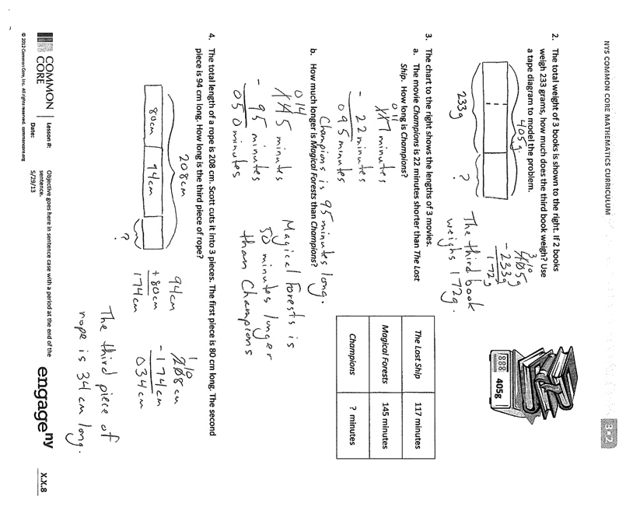

Name Date

1. Solve the subtraction problems below**.**

|  |  |  |  |
| --- | --- | --- | --- |
| 1. 60 mL – 24 mL | 1. 360 mL – 24 mL | | 1. 360 mL – 224 mL |
| 1. 518 cm – 21 cm | 1. 629 cm – 268 cm | | 1. 938 cm – 440 cm |
| 1. 307 g – 130 g | 1. 307 g – 234 g | | 1. 807 g – 732 g |
| 1. 2 km 770 m – 1km 455 m | | 1. 3 kg 924 g – 1 kg 893 g | |

1. The total weight of 3 books is shown to the right. If 2 books weigh 233 grams, how much does the third book weigh? Use a tape diagram to model the problem.

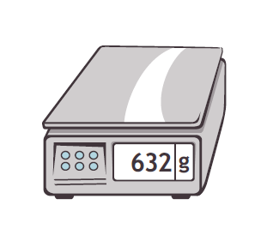

**405g**

|  |  |
| --- | --- |
| *The Lost Ship* | 117 minutes |
| *Magical Forests* | 145 minutes |
| *Champions* | ? minutes |

1. The chart to the right shows the lengths of three movies.
   1. The movie *Champions* is 22 minutes shorter than *The Lost Ship*. How long is *Champions*?
   2. How much longer is *Magical Forests* than *Champions*?
2. The total length of a rope is 208 centimeters. Scott cuts it into 3 pieces. The first piece is 80 centimeters long. The second piece is 94 centimeters long. How long is the third piece of rope?

Name Date

1. Solve the subtraction problems below.

a. 381 mL − 146 mL b. 730 m − 426 m c. 509 kg − 384 kg

1. The total length of a banner is 408 centimeters. Carly paints it in 3 sections. The first 2 sections she paints are 187 centimeters long altogether. How long is the third section?

Name Date

1. Solve the subtraction problems below.

|  |  |  |  |
| --- | --- | --- | --- |
| 1. 70 L − 46 L | 1. 370 L – 46 L | | 1. 370 L – 146 L |
| 1. 607 cm − 32 cm | 1. 592 cm − 258 cm | | 1. 918 cm − 553 cm |
| 1. 763 g − 82 g | 1. 803 g − 542 g | | 1. 572 km − 266 km |
| 1. 837 km − 645 km | |  | |

1. The magazine weighs 280 grams less than the newspaper. The weight of the newspaper is shown below. How much does the magazine weigh? Use a tape diagram to model your thinking.



**454 g**

|  |  |
| --- | --- |
| Lucas’  Baseball Game | 180 minutes |
| Joey’s  Football Game | 139 minutes |
| Francesca’s  Basketball Game | ? minutes |

3. The chart to the right shows how long it takes to play 3 games.

* 1. Francesca’s basketball game is 22 minutes shorter than Lucas’ baseball game. How long is Francesca’s basketball game?
  2. How much longer is Francesca’s basketball game than Joey’s football game?