Lesson 17
Objective: Estimate sums by rounding and apply to solve measurement word problems.

Suggested Lesson Structure

A NOTE ON
STANDARDS ALIGNMENT:
In this lesson, students round to the nearest ten, hundred, and fifty, and then analyze the precision of each estimate. When estimating sums, students intentionally make choices that lead to reasonably accurate answers and simple arithmetic. Rounding to the nearest fifty is not part of Grade 3 standards. Its inclusion here combats rigidity in thinking, encouraging students to consider the purpose of their estimates and the degree of accuracy needed rather than simply following procedure. Rounding to the nearest fifty bridges to 4.NBT.3, and is not assessed in Grade 3.

 Fluency Practice (12 minutes)
 Concept Development (23 minutes)
 Application Problem (15 minutes)
 Student Debrief (10 minutes)
Total Time (60 minutes)
Fluency Practice (12 minutes)
- Group Counting 3.OA.1 (3 minutes)
- Sprint: Round to the Nearest Ten 3.NBT.1 (9 minutes)
Group Counting (3 minutes)
Note: Group counting reviews interpreting multiplication as repeated addition. It reviews foundational strategies for multiplication from Module 1 and anticipates Module 3.
Direct students to count forward and backward, occasionally changing the direction of the count.
- Threes to 30
- Fours to 40
- Sixes to 60
- Sevens to 70
- Eights to 80
- Nines to 90
As students’ fluency with skip-counting improves, help them make a connection to multiplication by tracking the number of groups they count using their fingers.
Sprint: Round to the Nearest Ten (9 minutes)
Materials: (S) Round to the Nearest Ten Sprint
Note: This Sprint builds automaticity with rounding skills learned in Lesson 13.
Concept Development (23 minutes)
Materials: (S) Personal white board
Problem 1: Estimate the sum of 362 + 159 by rounding.

A NOTE ON
STANDARDS ALIGNMENT:
This problem asks students to round to the nearest fifty, which is part of the Grade 4 standard (4.NBT.3).

T: What is 362 rounded to the nearest hundred?
S: 400.
T: Let’s write it directly below 362.
T: What is 159 rounded to the nearest hundred?
S: 200.
T: Let’s write it directly below 159.
T: What is 400 + 200?
S: 600!
T: We estimated the sum by rounding to the nearest hundred and got 600.
T: Let’s now round to the nearest ten. (Repeat the process.)
S: (Find that the sum rounded to the nearest ten is 520.)
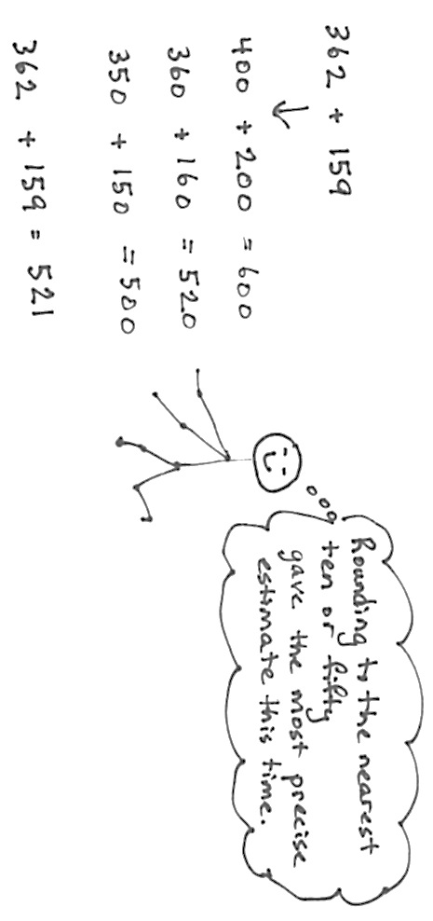
T: We’ve learned to round to the nearest ten and hundred before. Let’s think if there is another way we could round these numbers that would make them easy to add.
S: They are both really close to a fifty, and those are easy for me to add. Yeah, 50 + 50 is 100. You can’t round to a fifty! Why not? Who said so? Makes sense to me. (If no student offers the idea of rounding to the nearest 50, suggest it.)
T: Okay, let’s try it. What is 363 rounded to the nearest fifty?
S: 350.
T: 159?
S: 150.
T: 350 + 150 is…?
S: 500.
T: We have three different estimated sums. Talk to your partner. Without finding the actual sum, which estimate do you think will be closest?
S: I think rounding to the nearest hundred will be way off. Me, too. The numbers are pretty far away from the hundred. Both numbers are close to the halfway point between the hundreds.
Rounding to the nearest ten will be really close because 159 is just 1 away and 362 is just 2 away from our rounded numbers. Rounding to the fifty will be pretty close, too, but not as close as to the ten because there was a difference of 9 and 12 for both numbers. And both the numbers were bigger than the 50, too.
T: Let’s calculate the actual sum.
S: (Calculate.) It’s 521! Wow, rounding to the ten was super close! Rounding to the fifty was a lot closer than rounding to the hundred. And, it was easier mental math than rounding to the nearest ten.
T: How did you predict which way of estimating would be closer?
S: We looked at the rounded numbers and thought about how close they were to the actual numbers.
T: We think about how to round in each situation to make our estimates as precise as we need them to be.
Problem 2: Analyze the rounded sums of three expressions with addends close to the halfway point: (A) 349 + 145, (B) 352 + 145, and (C) 352 + 151.

NOTES ON
ROUNDING
PROBLEM 2 EXPRESSIONS:
- 349 + 145
(Numbers round down.)
- 352 + 145
(One number rounds up, one rounds down.)
- 352 + 151
(Numbers round up.)

T: (Write the three expressions above on the board.) Take 90 seconds to find the value of these expressions.
S: (Work and check answers.)
T: What do you notice about the sums 494, 497, and 503?
S: They are really close to each other. They are all between 490 and 510. The difference between the smallest and greatest is 9.
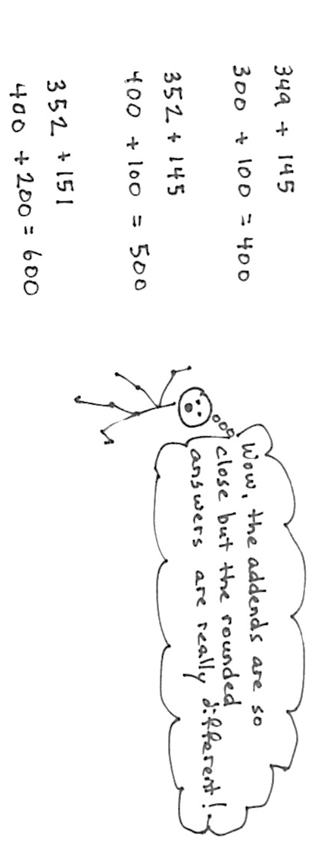
T: Analyze why the sums were so close by looking at the parts being added. What do you notice?
S: Two of them are exactly the same. Every problem has a part really close to 350.
T: Let’s round each number to the nearest hundred as we did earlier. (Lead the students through rounding each addend as pictured below.) Talk to your partner about what you notice.
S: The answers are really different. The sums were only 9 apart but the estimates are 200 apart!

T: Why do you think that happened?
S: It’s because of how we rounded. Now I see it. All the numbers we added are really close to the halfway point. 349 rounded down to 300, but 352 rounded up to 400! A’s numbers both rounded down. For B’s numbers, one rounded up and one rounded down. C’s numbers both rounded up. So, in A and C when the numbers rounded the same way, the sums were further away from the actual answer. B was the closest to the real answer because one went up and one went down.
T: I hear important analysis going on. A very small difference in the numbers can make a difference in the way we round and also make a big difference in the result. How might you get a better estimate when you see that the addends are close to halfway between your rounding units?
S: It’s like the first problem. We could round to the nearest ten or fifty.
T: That would give us a more precise estimate in cases like these where the numbers are so close to the halfway point.
T: Think about why 352 + 145 had the estimate closest to the precise answer. Share with your partner.
S: It’s because one number rounded up and one rounded down. Yeah, in A and C, either both numbers went down or both went up! In B, they balanced each other out.
T: Why do we want our estimated sum to be about right?
S: We want to see if our exact answer makes sense. It also helps with planning, like maybe planning how much to spend at the market. My mom says how much money she has, and we help her make sure we don’t spend more.
T: Would all three estimates help you to check if your exact answer is reasonable, if it makes sense?
S: No. Only B. If we used A or C, our exact answer could be way off and we wouldn’t know it.
T: So, we need a close estimate to see if our actual sum is reasonable.
Continue with the following possible problem: 253 + 544. Have students estimate by rounding to the nearest ten and fifty to determine which is best for checking whether or not the actual answer is reasonable. To save time, consider dividing the class into two groups; one group rounds to the nearest ten, and the other rounds to the nearest fifty.
Problem 3: Round the sum of 296 + 609. Analyze how rounding to the nearest hundred is nearly the same as rounding to the nearest ten when both addends are close to a hundred.
T: Here is another problem. With your partner, first think about how to round to get the closest answer.
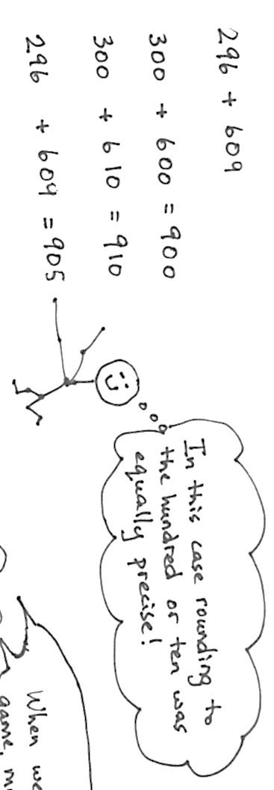
As in Problems 1 and 2, have students analyze the rounded addends before calculating to determine which is best for a precise answer. Then, have the students calculate the estimated sums, rounding to different units, and compare. Close this problem with an analysis of why this occurred. (Both numbers are very close to the hundreds unit.)

Application Problem (15 minutes)

NOTES ON
MULTIPLE MEANS
OF ENGAGEMENT:
Challenge students to transform what they have learned about rounding and reasonable estimates. Upon evaluating the usefulness of rounding to the nearest ten or hundred, invite students to propose a better method of rounding to check the reasonableness of answers. In this example, rounding one addend to the nearest hundred is a useful strategy.

The doctor prescribed 175 milliliters of medicine on Monday and 256 milliliters of medicine on Tuesday.
- Estimate how much medicine he prescribed in both days.
- Precisely how much medicine did he prescribe in both days?
T: To solve Part (a), first determine how you are going to round your numbers.
T: (Allow students time to work the entire problem and possibly to share with a partner. Invite a few students to share with the class how they rounded.)
T: Rounding to the nearest 100 wasn’t very precise this time.
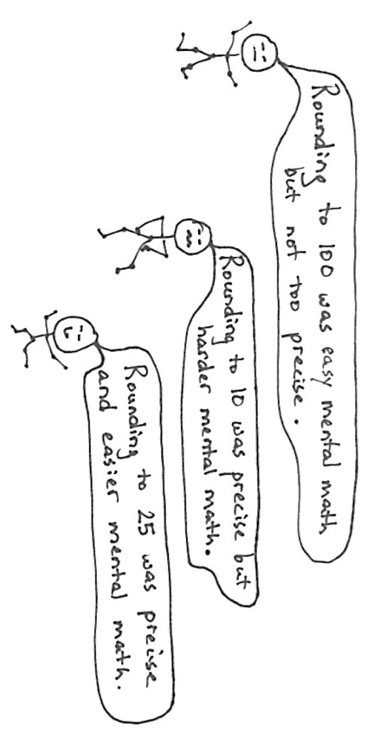
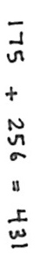
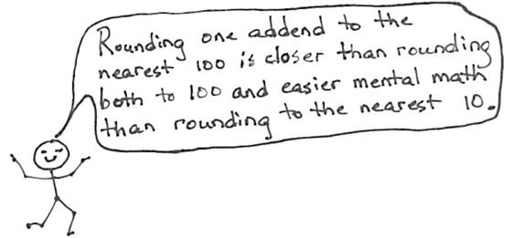
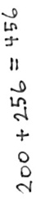
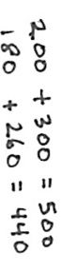

Note: This problem reviews estimating sums to solve word problems, which the students learned in today’s Concept Development.
Problem Set (10 minutes)

NOTE ON
TIMING:
The Problem Set in this lesson is allotted 10 minutes. It directly follows the Application Problem, and so the 10 minutes are included within the 15 minutes allotted for the Application Problem.
Students should do their personal best to complete the Problem Set within the allotted 10 minutes. For some classes, it may be appropriate to modify the assignment by specifying which problems they work on first. Some problems do not specify a method for solving. Students should solve these problems using the RDW approach used for Application Problems.
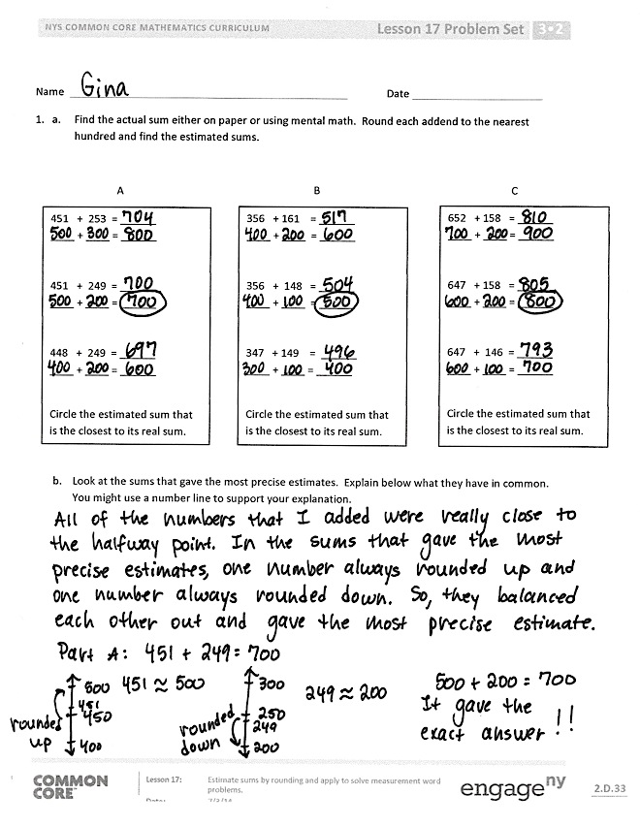
Student Debrief (10 minutes)
Lesson Objective: Estimate sums by rounding and apply to solve measurement word problems.
The Student Debrief is intended to invite reflection and active processing of the total lesson experience.
Invite students to review their solutions for the Problem Set. They should check work by comparing answers with a partner before going over answers as a class. Look for misconceptions or misunderstandings that can be addressed in the Debrief. Guide students in a conversation to debrief the Problem Set and process the lesson.
You may choose to use any combination of the questions below to lead the discussion.
- What were some of your observations about Problem 1(a)? What did the closest estimates have in common?
- Talk to a partner: Which way of rounding in Problem 2 gave an estimate closer to the actual sum?
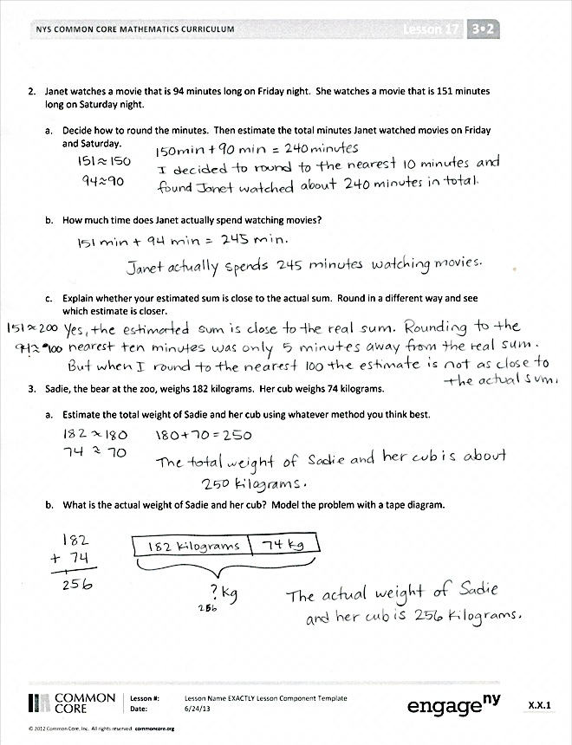
- How does estimating help you check if your answer is reasonable?
- Why might noticing how close the addends are to the halfway point change the way you choose to round?
- In Problem 3(a) how did you round? Compare your method with your partner’s. Which was closer to the actual answer? Why?
- How did the Application Problem connect to today’s lesson?
Exit Ticket (3 minutes)
After the Student Debrief, instruct students to complete the Exit Ticket. A review of their work will help you assess the students’ understanding of the concepts that were presented in the lesson today and plan more effectively for future lessons. You may read the questions aloud to the students.
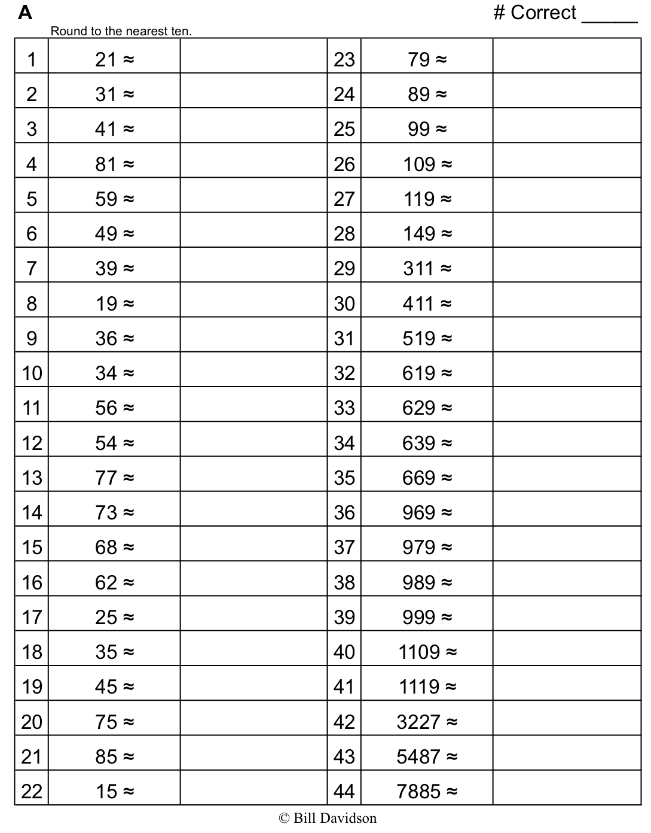
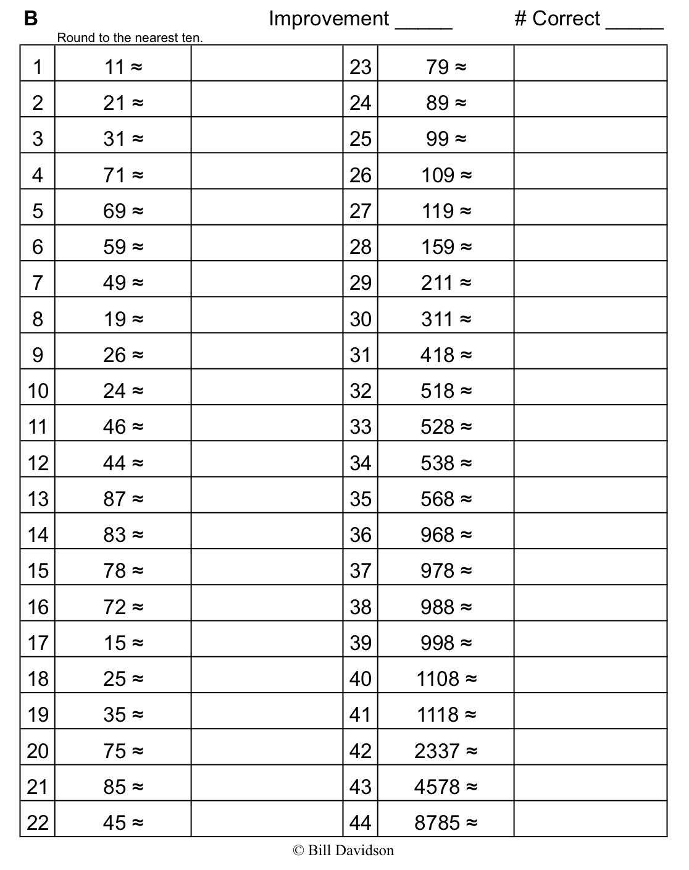

Name Date
- Find the actual sum either on paper or using mental math. Round each addend to the nearest hundred and find the estimated sums.
451 + 253 = ______
____ + ____ = ______

451 + 249 = ______
____ + ____ = ______

448 + 249 = ______
____ + ____ = ______

Circle the estimated sum that is the closest to its real sum.
356 + 161 = ______
____ + ____ = ______

356 + 148 = ______
____ + ____ = ______

347 + 149 = ______
____ + ____ = ______

Circle the estimated sum that is the closest to its real sum.

652 + 158 = ______
____ + ____ = ______

647 + 158 = ______
____ + ____ = ______

647 + 146 = ______
____ + ____ = ______

Circle the estimated sum that is the closest to its real sum.

A
C
B

- Look at the sums that gave the most precise estimates. Explain below what they have in common. You might use a number line to support your explanation.

2. Janet watched a movie that is 94 minutes long on Friday night. She watched a movie that is 151 minutes long on Saturday night.

- Decide how to round the minutes. Then, estimate the total minutes Janet watched movies on Friday and Saturday.

- How much time did Janet actually spend watching movies?

- Explain whether or not your estimated sum is close to the actual sum. Round in a different way and see which estimate is closer.

3. Sadie, a bear at the zoo, weighs 182 kilograms. Her cub weighs 74 kilograms.

  - Estimate the total weight of Sadie and her cub using whatever method you think best.

  - What is the actual weight of Sadie and her cub? Model the problem with a tape diagram.

Name Date
Jesse practices the trumpet for a total of 165 minutes during the first week of school. He practices for 245 minutes during the second week.
  - Estimate the total amount of time Jesse practices by rounding to the nearest 10 minutes.

  - Estimate the total amount of time Jesse practices by rounding to the nearest 100 minutes.

  - Explain why the estimates are so close to each other.

Name Date
    - Cathy collects the following information about her dogs, Stella and Oliver.
Stella
Time Spent Getting a Bath | Weight
36 minutes | 32 kg
Oliver
Time Spent Getting a Bath | Weight
25 minutes | 7 kg

Use the information in the charts to answer the questions below.
- Estimate the total weight of Stella and Oliver.

- What is the actual total weight of Stella and Oliver?

- Estimate the total amount of time Cathy spends giving her dogs a bath.

- What is the actual total time Cathy spends giving her dogs a bath?

- Explain how estimating helps you check the reasonableness of your answers.

    - Dena reads for 361 minutes during Week 1 of her school’s two-week long Read-A-Thon. She reads for 212 minutes during Week 2 of the Read-A-Thon.

- Estimate the total amount of time Dena reads during the Read-A-Thon by rounding.

- Estimate the total amount of time Dena reads during the Read-A-Thon by rounding in a different way.

- Calculate the actual number of minutes that Dena reads during the Read-A-Thon. Which method of rounding was more precise? Why?

