Lesson 16

Objective: Add measurements using the standard algorithm to compose larger units twice.

Suggested Lesson Structure

 Fluency Practice (12 minutes)

 Application Problem (5 minutes)

 Concept Development (33 minutes)

 Student Debrief (10 minutes)

**Total Time (60 minutes)**

Fluency Practice (12 minutes)

* Part–Whole with Measurement Units **3.MD.2** (3 minutes)
* Round Three- and Four-Digit Numbers **3.NBT.1** (5 minutes)
* Group Counting **3.OA.1** (4 minutes)

Part–Whole with Measurement Units (3 minutes)

Materials: (S) Personal white board

Note: This activity reviews part–whole thinking using measurement units.

T: There are 100 centimeters in 1 meter. How many centimeters are in 4 meters?

S: 400 centimeters.

T: 5 meters?

S: 500 centimeters.

T: 7 meters?

S: 700 centimeters.

T: (Write 30 minutes + ____ minutes = 1 hour.) There are 60 minutes in 1 hour. On your personal white board, fill in the equation.

S: (Write 30 minutes + 30 minutes = 1 hour.)

Continue with the following suggested sequence: 40 minutes and 25 minutes.

T: (Write 300 mL + ____ mL = 1 L.) There are 1,000 milliliters in 1 liter. On your board, fill in the equation.

S: (Write 300 mL + 700 mL = 1 liter.)

Continue with the following suggested sequence: 200 mL, 600 mL, and 550 mL.

Round Three- and Four-Digit Numbers (5 minutes)

Materials: (S) Personal white board

Note: This activity reviews rounding from Lessons 13 and 14.

T: (Write 73 ≈ ___.) What is 73 rounded to the nearest ten?

S: 70.

Repeat the process, varying the numbers.

Group Counting (4 minutes)

Note: Group counting reviews interpreting multiplication as repeated addition. It reviews foundational strategies for multiplication from Module 1 and anticipates Module 3.

Direct students to count forward and backward, occasionally changing the direction of the count.

* Threes to 30
* Fours to 40
* Sixes to 60
* Sevens to 70
* Eights to 80
* Nines to 90

As students’ fluency with skip-counting improves, help them make a connection to multiplication by tracking the number of groups they count using their fingers.

Application Problem (5 minutes)

Josh’s apple weighs 93 grams. His pear weighs 152 grams. What is the total weight of the apple and the pear?

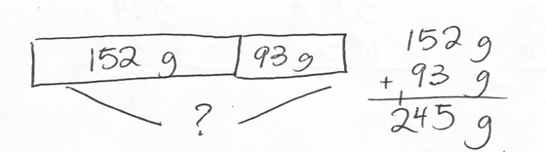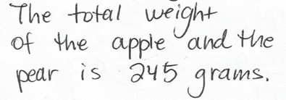

Note: This problem reviews the use of the standard algorithm to compose larger units once.

Concept Development (33 minutes)

Materials: (T) Bag A of beans (266 grams), Bag B of beans (158 grams), scale that weighs in grams   
(S) Personal white board, unlabeled place value chart (Lesson 14 Template), place value disks

Problem 1: Use place value charts, disks, and the standard algorithm to add measurements, composing larger units twice.

Students start with the unlabeled place value chart template in their personal white boards.

*Lesson 14 Template*

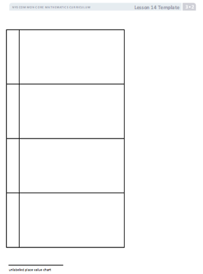

T: (Show Bags A and B.) Bag A has 266 grams of beans, and Bag B has 158 grams of beans. Let’s use our place value charts and place value disks to figure out how many grams of beans we have altogether.

T: Use disks to represent the weight of the beans in Bag B.

S: (Put 8 ones disks in the ones column, 5 tens disks in the tens column, and 1 hundreds disk in the hundreds column.)

T: Record 158 grams in the workspace on your board below the place value chart.

|  |  |
| --- | --- |
|  | NOTES ON  MULTIPLE MEANS  OF ENGAGEMENT: |
| Students working above grade level may be eager to find the sum quickly without using place value disks. Keep these learners engaged by optimizing their choice and autonomy. Request from them an alternative model, such as a tape diagram. They may enjoy offering two more examples of their own in which they use the standard algorithm to compose larger units twice. | |

T: Leave the disks on your chart. Use more disks to represent the weight of the beans in Bag A. Place them below your model of 158.

S: (Place 6 ones disks, 6 tens disks, and 2 hundreds disks in respective columns.)

T: In the workspace on your board, use an addition sign to show that you added 266 grams to 158 grams.

T: (Point to the place value disks in the ones column.)   
8 ones plus 6 ones equals?

S: 14 ones.

T: We can change 10 ones for 1 ten. Take 10 ones disks and change them for 1 tens disk. Where do we put the tens disk on the place value chart?

S: In the tens column.

T: How many ones do we have now?

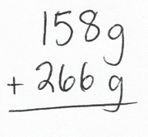S: 4 ones!

T: Let’s use the standard algorithm to show our work on the place value chart. Use the problem you wrote in the workspace on your board. (Write the problem vertically, as shown.) Be sure your problem is written vertically, like mine.

T: (Point to the ones in the problem.) 8 ones plus 6 ones equals?

S: 14 ones.

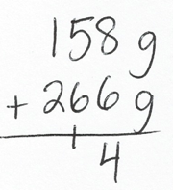T: Let’s rename some ones as tens. How many tens and ones in 14?

S: 1 ten and 4 ones.

T: Just like we practiced yesterday, show that on your problem.

S: (Write the 1 so that it crosses the line under the tens in the tens place and the 4 below the line in the ones column.)

T: (Point to the place value disks in the tens column.) Five tens plus 6 tens plus 1 ten equals?

S: 12 tens!

T: We can change 10 tens for 1 hundred. Take 10 tens disks and change them for 1 hundreds disk. Where do we put the hundreds disk on the place value chart?

S: In the hundreds column.

T: How many tens do we have now?

S: 2 tens!

T: Let’s show that in our problem. (Point to the tens in the problem.) Five tens plus 6 tens plus 1 ten equals?

S: 12 tens.

T: Let’s rename some tens as hundreds. How many hundreds and tens in 12 tens?

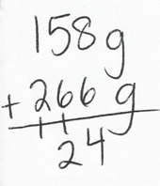S: 1 hundred and 2 tens.

T: We show our new hundred just like we showed our new ten before, but this time we put it in the hundreds column because it’s a hundred, not a ten. (Write the 1 so that it crosses the line under the hundreds in the hundreds place and the 2 below the line in the tens column.)

T: (Point to the place value disks in the hundreds column.) One hundred plus 2 hundreds plus 1 hundred equals?

S: 4 hundreds!

T: Four hundreds 2 tens 4 ones makes how many total grams of beans in Bag A and Bag B?

S: 424 grams.

T: Let’s show that in our problem. (Point to the hundreds in the problem.) One hundred plus 2 hundreds plus 1 hundred equals?

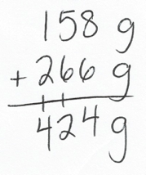S: 4 hundreds!

T: Record 4 hundreds in the hundreds column below the line.

T: What unit do we need to include in our answer?

S: Grams!

T: Read the problem with me. (Point and read.) 158 grams plus 266 grams equals 424 grams.

T: How can I check our work using a scale?

S: Put Bag A and Bag B on the scale and read the measurement.

T: (Put Bags A and B on the scale.) The total weight of the beans is 424 grams!

Continue with the following suggested problems:

* *Add to with start unknown:* Jamal had a piece of rope. His brother cut off 47 centimeters and took it! Now, Jamal only has 68 centimeters left. How long was Jamal’s rope before his brother cut it?
* *Compare with bigger unknown:* The goldfish aquarium at Sal’s Pet Store has 189 liters of water. The guppy aquarium has 94 more liters of water than the goldfish aquarium. How many liters of water are in both aquariums?

Problem 2: Use the partner–coach strategy and the standard algorithm to add measurements, composing larger units twice.

Materials: (S) Problem Set

Students work with a partner and use the partner–coach strategy to complete page 1 of the Problem Set.

Prepare students:

* Explain how to use the partner–coach strategy. (One partner coaches, verbalizing the steps needed to solve the problem, while the other partner writes the solution. Then, partners switch roles.)
* Generate a class list of important words that should be included in the coaching conversations (e.g., *ones*, *tens*, *hundreds*, *change*, *standard algorithm*, *mental math, rename*). Keep this list posted for students to refer to as they coach each other.

**MP.6**

Circulate as students work, addressing misconceptions or incorrect work.

Problem Set (5 minutes)

|  |  |
| --- | --- |
|  | NOTES ON  MULTIPLE MEANS  OF ACTION AND EXPRESSION: |

Help students prepare for successful participation in the Student Debrief. Some may need your guidance and support to discover the patterns of Problem 1. Encourage students to read aloud the number sentences in each row and to search for the numbers that repeat.

Students should do their personal best to complete page 2 of the Problem Set within the allotted 5 minutes. For some classes, it may be appropriate to modify the assignment by specifying which problems they work on first. Some problems do not specify a method for solving. Students should solve these problems using the RDW approach used for Application Problems.

Student Debrief (10 minutes)

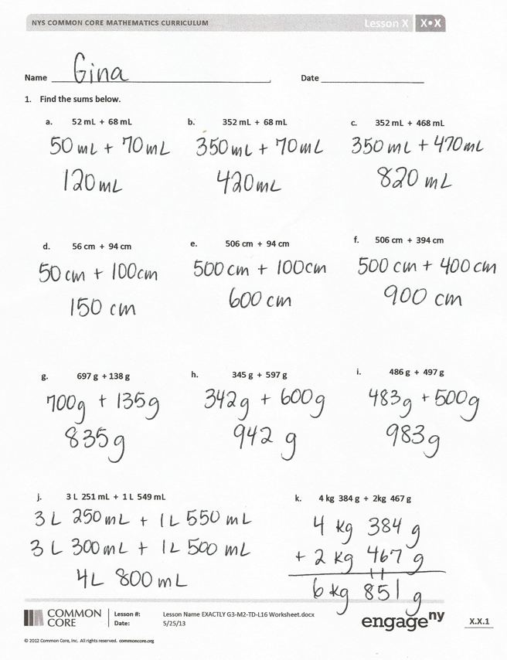

**Lesson Objective:** Add measurements using the standard algorithm to compose larger units twice.

The Student Debrief is intended to invite reflection and active processing of the total lesson experience.

Invite students to review their solutions for the Problem Set. They should check work by comparing answers with a partner before going over answers as a class. Look for misconceptions or misunderstandings that can be addressed in the Debrief. Guide students in a conversation to debrief the Problem Set and process the lesson.

You may choose to use any combination of the questions below to lead the discussion.

* What pattern did you notice between Problems 1(a), 1(b), and 1(c)? How did the pattern help you solve these problems?
* Did you or your partner use mental math? For which problems? Why?
* Look at your work for Problem 2. Did you rename ones? Tens? Hundreds? How can you tell?

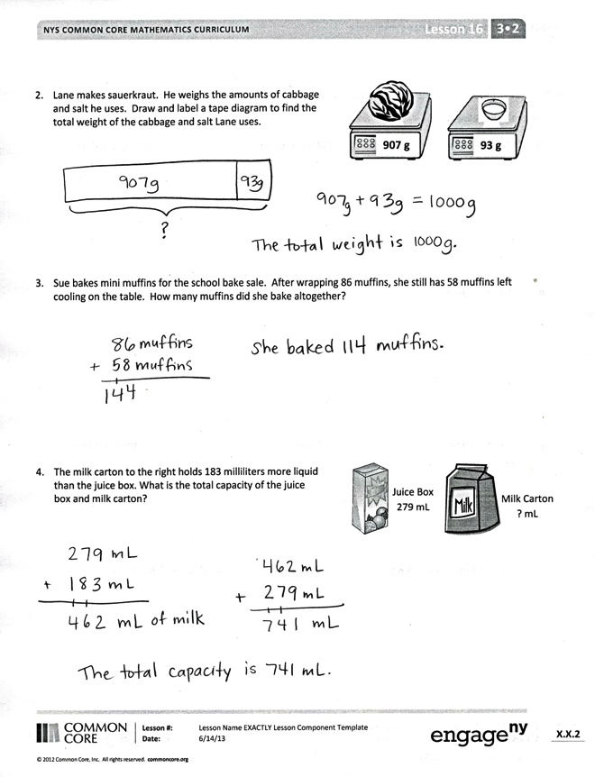

* Explain to a partner how Problem 4 is different than the other problems. What steps did you use to solve this problem?

Exit Ticket (3 minutes)

After the Student Debrief, instruct students to complete the Exit Ticket. A review of their work will help you assess the students’ understanding of the concepts that were presented in the lesson today and plan more effectively for future lessons. You may read the questions aloud to the students.

Name Date

1. Find the sums below.

|  |  |
| --- | --- |
| c. | 352 mL + 468 mL |
|  |  |
|  |  |

|  |  |
| --- | --- |
| a. | 52 mL + 68 mL |
|  |  |
|  |  |

|  |  |
| --- | --- |
| b. | 352 mL + 68 mL |
|  |  |
|  |  |

|  |  |
| --- | --- |
| e. | 506 cm + 94 cm |
|  |  |
|  |  |

|  |  |
| --- | --- |
| d. | 56 cm + 94 cm |
|  |  |
|  |  |

|  |  |
| --- | --- |
| f. | 506 cm + 394 cm |
|  |  |
|  |  |

|  |  |
| --- | --- |
| g. | 697 g + 138 g |
|  |  |
|  |  |

|  |  |
| --- | --- |
| h. | 345 g + 597 g |
|  |  |
|  |  |

|  |  |
| --- | --- |
| i. | 486 g + 497 g |
|  |  |

|  |  |
| --- | --- |
| j. | 3 L 251 mL + 1 L 549 mL |

|  |  |
| --- | --- |
| k. | 4 kg 384 g + 2 kg 467 g |

1. Lane makes sauerkraut. He weighs the amounts of cabbage and salt he uses. Draw and label a tape diagram to find the total weight of the cabbage and salt Lane uses.

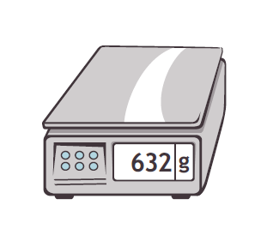

**93 g**



**907 g**



1. Sue bakes mini-muffins for the school bake sale. After wrapping 86 muffins, she still has 58 muffins left cooling on the table. How many muffins did she bake altogether?



*Juice Box*

279 mL



*Milk Carton*

? mL

1. The milk carton to the right holds 183 milliliters more liquid than the juice box. What is the total capacity of the juice box and milk carton?

Name Date

1. Find the sums.
2. 78 g + 29 g b. 328 kg + 289 kg c. 509 L + 293 L
3. The third-grade class sells lemonade to raise funds. After selling 58 liters of lemonade in 1 week, they still have 46 liters of lemonade left. How many liters of lemonade did they have at the beginning?

Name Date

1. Find the sums below.
2. 47 m + 8 m b. 47 m + 38 m c. 147 m + 383 m
3. 63 mL + 9 mL e. 463 mL + 79 mL f. 463 mL + 179 mL
4. 368 kg + 263 kg h. 508 kg + 293 kg i. 103 kg + 799 kg
5. 4 L 342 mL + 2 L 214 mL k. 3 kg 296 g + 5 kg 326 g
6. Mrs. Haley roasts a turkey for 55 minutes. She checks it and decides to roast it for an additional 46 minutes. Use a tape diagram to find the total minutes Mrs. Haley roasts the turkey.

|  |  |
| --- | --- |
| **Types of Horses** | **Weight in kg** |
| Shetland pony | _____ kg |
| American Saddlebred | 478 kg |
| Clydesdale horse | _____ kg |
| Miniature horse | 56 kg |

1. A miniature horse weighs 268 fewer kilograms than a Shetland pony. Use the table to find the weight of a Shetland pony.

1. A Clydesdale horse weighs as much as a Shetland pony and an American Saddlebred horse combined. How much does a Clydesdale horse weigh?