Lesson 15

Objective: Add measurements using the standard algorithm to compose larger units once.

Suggested Lesson Structure

 Fluency Practice (8 minutes)

 Application Problem (8 minutes)

 Concept Development (34 minutes)

 Student Debrief (10 minutes)

**Total Time (60 minutes)**

Fluency Practice (8 minutes)

* Part–Whole with Measurement Units **3.MD.2** (3 minutes)
* Round Three- and Four-Digit Numbers **3.NBT.1** (5 minutes)

Part–Whole with Measurement Units (3 minutes)

Materials: (S) Personal white board

Note: This activity reviews part–whole thinking using measurement units.

T: There are 100 centimeters in 1 meter. How many centimeters are in 2 meters?

S: 200 centimeters.

T: 3 meters?

S: 300 centimeters.

T: 8 meters?

S: 800 centimeters.

T: (Write 50 minutes + ____ minutes = 1 hour.) There are 60 minutes in 1 hour. On your personal white board, fill in the equation.

S: (Write 50 minutes + 10 minutes = 1 hour.)

Continue with the following suggested sequence: 30 minutes and 45 minutes.

T: (Write 800 mL + ____ mL = 1 L.) There are 1,000 milliliters in 1 liter. On your board, fill in the equation.

S: (Write 800 mL + 200 mL = 1 liter.)

Continue with the following suggested sequence: 500 mL, 700 mL, and 250 mL.

T: (Write 1 kg – 500 g = _____ g.) There are 1,000 grams in 1 kilogram. On your board, fill in the equation.

S: (Write 1 kg – 500 g = 500 g.)

Continue with the following suggested sequence: Subtract 300 g, 700 g, and 650 g from 1 kg.

Round Three- and Four-Digit Numbers (5 minutes)

Materials: (S) Personal white board

Note: This activity reviews rounding from Lessons 13 and 14.

T: (Write 87 ≈ ___.) What is 87 rounded to the nearest ten?

S: 90.

Continue with the following possible sequence: 387, 43, 643, 35, and 865.

T: (Write 237 ≈ ___.) 237 is between which 2 hundreds?

S: 200 and 300.

T: On your board, draw a vertical number line. Mark 200 and 300 as your endpoints and label the halfway point.

S: (Label 200 and 300 as endpoints and 250 as the halfway point.)

T: Show where 237 falls on the number line, and then round to the nearest hundred.

S: (Plot 237 between 200 and 250 and write 237 ≈ 200.)

Continue with the following suggested sequence: 1,237; 678; 1,678; 850; 1,850; and 2,361.

Application Problem (8 minutes)

Use mental math to solve these problems. Record your strategy for solving each problem.

a. 46 mL + 5 mL b. 39 cm + 8 cm c. 125 g + 7 g d. 108 L + 4 L

Possible strategies:

1. 46 mL + 4 mL + 1 mL = 50 mL + 1 mL = 51 mL
2. 39 cm + 1 cm + 7 cm = 40 cm + 7 cm = 47 cm
3. 125 g + 5 g + 2 g = 130 g + 2 g = 132 g
4. 108 L + 2 L + 2 L = 110 L + 2 L = 112 L

Note: This problem is designed to show that mental math can be an efficient strategy even when renaming is required. It also sets up the conversation in the Debrief about when and why the standard algorithm is used. Be sure to give the students an opportunity to discuss and show how they solved these problems.

Concept Development (34 minutes)

Materials: (T) 2 beakers, water (S) Unlabeled place value chart (Lesson 14 Template), place value disks, personal white board

*Lesson 14 Template*

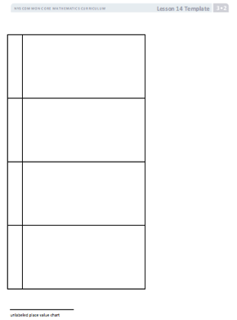

Students start with the unlabeled place value chart template in their personal white boards.

T: (Show Beaker A with 56 milliliters of water and Beaker B with 27 milliliters of water.) Beaker A has   
56 milliliters of water and Beaker B has 27 milliliters of water. Let’s use place value charts and place value disks to find the total milliliters of water in both beakers.

T: Use place value disks to represent the amount of water from Beaker A on your chart. (Allow time for students to work.)

|  |  |
| --- | --- |
|  | NOTES ON  MULTIPLE MEANS  OF ACTION AND EXPRESSION: |
| English language learners and others will benefit from the real world context, the varied methods for response (personal white boards, models, numbers, etc.), and the introduction to academic math language (*standard algorithm*) at the end of the lesson. | |

T: Record 56 milliliters in the workspace on your personal white board below the place value chart.

T: Leave the disks for 56 on your chart. Use more disks to represent the amount of water from Beaker B. Place them below your model of 56. (Allow time for students to work.)

T: In the workspace on your board, use an addition sign to show that you added 27 milliliters to 56 milliliters.

T: (Point to the place value disks in the ones column.)   
Six ones plus 7 ones equals?

S: 13 ones.

T: We can change 10 ones for 1 ten. Take 10 ones disks and change them for 1 tens disk. Where do we put the tens disk on the place value chart?

S: In the tens column.

T: How many ones do we have now?

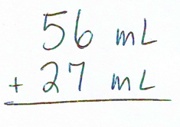S: 3 ones!

T: Let’s show that same work in the problem we wrote in our workspace on our boards. If you wrote your problem horizontally, rewrite it vertically so that it looks like mine.

T: (Point to the ones.) 6 ones plus 7 ones equals?

S: 13 ones.

T: Let’s **rename** some ones as tens. How many tens and ones in 13 ones?

S: 1 ten and 3 ones.

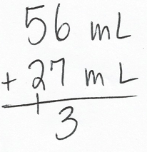T: This is how we show how we rename using the **standard algorithm**. (Write the 1 so that it crosses the line under the tens in the tens place and the 3 below the line in the ones column. This way you write 13 rather than 3 and 1 as separate numbers. Refer to the vertical addition shown to the right.) Show this work on your board.

T: Talk to a partner. How is this work similar to the work we did with the place value disks?

S: (Discuss.)

T: That’s right. Renaming in the algorithm is the same as changing with our place value disks.

T: (Point to the place value disks in the tens column.) 5 tens plus 2 tens plus 1 ten equals?

S: 8 tens!

T: 8 tens 3 ones makes how many milliliters of water in the bowl?

S: 83 milliliters.

T: Let’s show that in our problem. (Point to the tens.) 5 tens plus 2 tens plus 1 ten equals?

S: 8 tens.

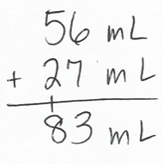T: Record 8 tens below the line in the tens column.

T: What unit do we need to include in our answer?

S: Milliliters!

T: Read the problem with me. (Point and read.) 56 milliliters plus 27 milliliters equals 83 milliliters. We just used the standard algorithm as a tool for solving this problem.

T: How can I check our work using the beaker?

S: Pour the water from one beaker into the other beaker and read the measurement.

T: (Pour.) The amount of water in the beaker is 83 milliliters!

Continue with the following suggested problems:

* *Add to with start unknown:* Lisa draws a line on the board. Marcus shortens the length of the line by erasing 32 centimeters. The total length of the line is now 187 centimeters. How long is the line that Lisa drew?
* *Compare with bigger unknown (start unknown):* John reads for 74 minutes on Wednesday. On Thursday, he reads for 17 more minutes than he read on Wednesday. How many total minutes does John read on Wednesday and Thursday?

|  |  |
| --- | --- |
|  | NOTES ON  THE PROBLEM SET: |
| The problems in the Problem Set are written horizontally so that students do not assume that they need to use the standard algorithm to solve. Mental math may be a more efficient strategy in some cases. Invite students to use the algorithm as a strategic tool, purposefully choosing it rather than defaulting to it. | |

Problem Set (10 minutes)

Students should do their personal best to complete the Problem Set within the allotted 10 minutes. For some classes, it may be appropriate to modify the assignment by specifying which problems they work on first. Some problems do not specify a method for solving. Students should solve these problems using the RDW approach used for Application Problems.

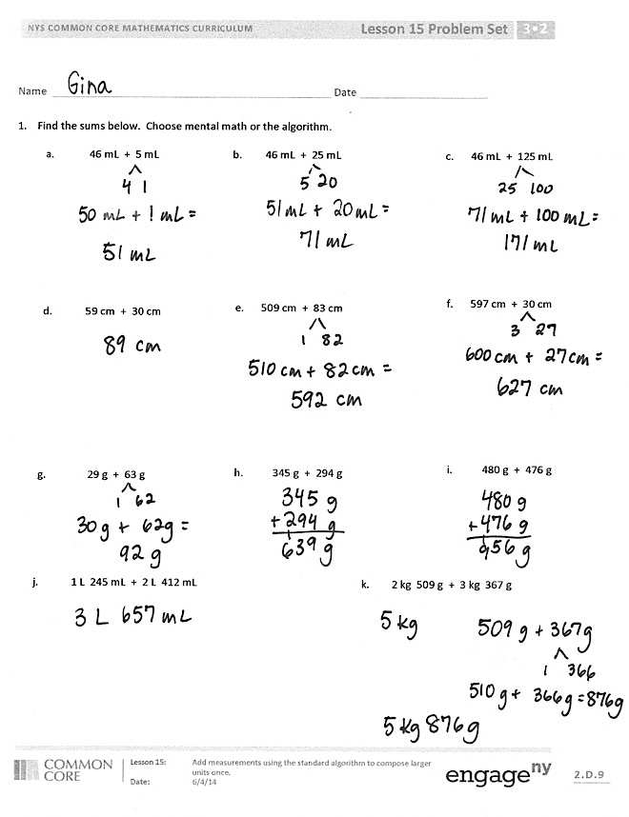 Student Debrief (10 minutes)

**Lesson Objective:** Add measurements using the standard algorithm to compose larger units once.

The Student Debrief is intended to invite reflection and active processing of the total lesson experience.

Invite students to review their solutions for the Problem Set. They should check work by comparing answers with a partner before going over answers as a class. Look for misconceptions or misunderstandings that can be addressed in the Debrief. Guide students in a conversation to debrief the Problem Set and process the lesson.

You may choose to use any combination of the questions below to lead the discussion.

* Notice the units in Problems 1(j) and 1(k). Both problems use both kilograms and grams. Did having two units in the problem change anything about the way you solved?
* 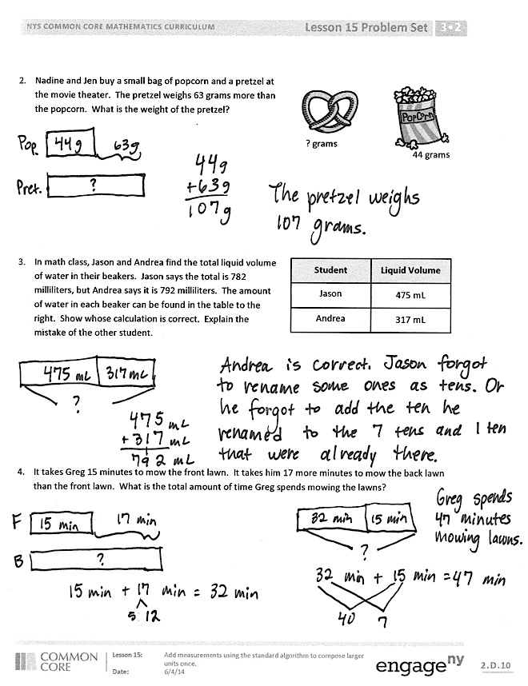What pattern did you notice between Problems 1(a), 1(b), and 1(c)? How did this pattern help you solve the problems?

**MP.7**

* Did you rewrite any of the horizontal problems vertically? Why?
* Which problems did you solve using mental math? The **standard algorithm**? Why did you use the standard algorithm for some problems and mental math for other problems? Think about the strategies you used to solve today’s Application Problem to help you answer this question.
* Explain to your partner how you used the standard algorithmto solve Problem 3. Did you **rename** the ones? Tens? Hundreds?
* Explain to your partner what your tape diagram looked like for Problem 4.
* How are Problems 2 and 4 similar? How are they different from the other problems?

Exit Ticket (3 minutes)

After the Student Debrief, instruct students to complete the Exit Ticket. A review of their work will help you assess the students’ understanding of the concepts that were presented in the lesson today and plan more effectively for future lessons. You may read the questions aloud to the students.

Name Date

1. Find the sums below. Choose mental math or the algorithm.

|  |  |
| --- | --- |
| c. | 46 mL + 125 mL |
|  |  |
|  |  |

|  |  |
| --- | --- |
| a. | 46 mL + 5 mL |
|  |  |
|  |  |

|  |  |
| --- | --- |
| b. | 46 mL + 25 mL |
|  |  |
|  |  |

|  |  |
| --- | --- |
| e. | 509 cm + 83 cm |
|  |  |
|  |  |

|  |  |
| --- | --- |
| d. | 59 cm + 30 cm |
|  |  |
|  |  |

|  |  |
| --- | --- |
| f. | 597 cm + 30 cm |
|  |  |
|  |  |

|  |  |
| --- | --- |
| g. | 29 g + 63 g |
|  |  |
|  |  |

|  |  |
| --- | --- |
| h. | 345 g + 294 g |
|  |  |
|  |  |

|  |  |
| --- | --- |
| i. | 480 g + 476 g |
|  |  |

|  |  |
| --- | --- |
| j. | 1 L 245 mL + 2 L 412 mL |

|  |  |
| --- | --- |
| k. | 2 kg 509 g + 3 kg 367 g |

1. Nadine and Jen buy a small bag of popcorn and a pretzel at the movie theater. The pretzel weighs 63 grams more than the popcorn. What is the weight of the pretzel?



*44 grams*



*? grams*

1. In math class, Jason and Andrea find the total liquid volume of water in their beakers. Jason says the total is 782 milliliters, but Andrea says it is 792 milliliters. The amount of water in each beaker can be found in the table to the right. Show whose calculation is correct. Explain the mistake of the other student.

**Liquid Volume**

**Student**

475 mL

Jason

317 mL

Andrea

1. It takes Greg 15 minutes to mow the front lawn. It takes him 17 more minutes to mow the back lawn than the front lawn. What is the total amount of time Greg spends mowing the lawns?

Name Date

1. Find the sums below. Choose mental math or the algorithm.

1. 24 cm + 36 cm b. 562 m + 180 m c. 345 km + 239 km
2. Brianna jogs 15 minutes more on Sunday than Saturday. She jogged 26 minutes on Saturday.
3. How many minutes does she jog on Sunday?
4. How many minutes does she jog in total?

Name Date

* + - 1. Find the sums below. Choose mental math or the algorithm.

a. 75 cm + 7 cm

b. 39 kg + 56 kg

c. 362 mL + 229 mL

e. 451 mL + 339 mL

d. 283 g + 92 g

f. 149 L + 331 L

* + - 1. The liquid volume of five drinks is shown below.

1. Jen drinks the apple juice and the water. How many milliliters does she drink in all?

Jen drinks ________ mL.

1. Kevin drinks the milk and the fruit punch. How many milliliters does he drink in all?

Kevin drinks ________ mL.

|  |  |
| --- | --- |
| **Drink** | **Liquid Volume** |
| Apple juice | 125 mL |
| Milk | 236 mL |
| Water | 248 mL |
| Orange juice | 174 mL |
| Fruit punch | 208 mL |

* + - 1. There are 75 students in Grade 3. There are 44 more students in Grade 4 than in Grade 3. How many students are in Grade 4?
      2. Mr. Green’s sunflower grew 29 centimeters in one week. The next week it grew 5 centimeters more than the previous week. What is the total number of centimeters the sunflower grew in 2 weeks?
      3. Kylie records the weights of 3 objects as shown below. Which 2 objects can she put on a pan balance to equal the weight of a 460 gram bag? Show how you know.

**Paperback Book**

343 grams

**Banana**

108 grams

**Bar of Soap**

117 grams