Lesson 14

Objective: Round to the nearest hundred on the vertical number line.

Suggested Lesson Structure

 Fluency Practice (11 minutes)

 Application Problem (9 minutes)

 Concept Development (30 minutes)

 Student Debrief (10 minutes)

**Total Time (60 minutes)**

Fluency Practice (11 minutes)

* Sprint: Find the Halfway Point **3.NBT.1** (9 minutes)
* Rename the Tens **3.NBT.3** (2 minutes)

Sprint: Find the Halfway Point (9 minutes)

Materials: (S) Find the Halfway Point on the Number Line Sprint

Note: This activity directly supports students’ work with rounding by providing practice with finding the halfway point between two numbers.

Rename the Tens (2 minutes)

Note: This activity prepares students for rounding in today’s lesson.

T: (Write 11 tens = ____.) Say the number.

S: 110.

Continue with the following possible sequence: 11 tens, 19 tens, 20 tens, 28 tens, 30 tens, and 40 tens.

Application Problem (9 minutes)

Materials: (S) Unlabeled place value chart (Template), place value disks (13 hundreds, 10 tens, 8 ones)

Students model the following on the place value chart:

* 10 tens
* 10 hundreds
* 13 tens.
* 13 hundreds

*Drawn representation of place value chart and disks showing 13 hundreds 8 tens 7 ones:*

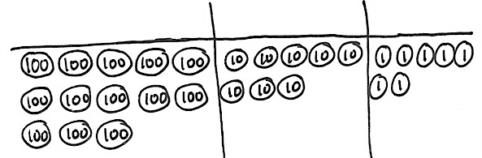

* 13 tens and 8 ones
* 13 hundreds 8 tens 7 ones

Note: This problem prepares students for the place value knowledge necessary for Problem 2 in this lesson. They need to understand that there are 13 hundreds in 1387. Through discussion, help students explain the difference between the total number of hundreds in 1387 and the digit in the hundreds place. Use the place value cards to reinforce this discussion if necessary (shown below to the right).

**MP.6**

Concept Development (30 minutes)

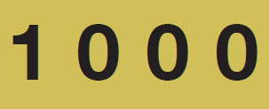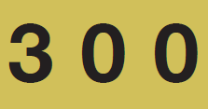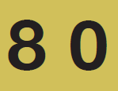

Materials: (T) Place value cards (S) Personal white board

Problem 1: Round three-digit numbers to the nearest hundred.

T: We’ve practiced rounding numbers to the nearest ten. Today, let’s find 132 grams rounded to the nearest hundred.

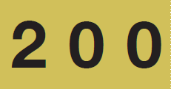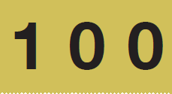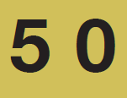

T: How many hundreds are in 132 grams? (Show place value cards for 132.)

S: 1 hundred! (Pull apart the cards to show the hundred as 100.)

T: Draw a number line on your personal white board. (Allow students to draw number line.) Draw a tick mark near the bottom of the number line. To the right, label it 100 = 1 hundred.

S: (Draw and label 100 = 1 hundred.)

T: What is 1 more hundred?

S: 2 hundreds! (Show the place value card for 200 or   
2 hundreds.)

T: Draw a tick mark near the top of the number line. To the right, label 200 = 2 hundreds.

S: (Draw and label 200 = 2 hundreds.)

T: What number is halfway between 100 and 200?

S: 150!

T: In unit form, what number is halfway between 1 hundred and 2 hundreds?

S: 1 hundred 5 tens. (Show with the place value cards.)

T: Estimate to draw a tick mark halfway between 100 and 200. Label it 150 = 1 hundred 5 tens.

S: (Draw and label as 150 = 1 hundred 5 tens.)

T: Estimate to mark and label the location of 132.

S: (Mark and label 132.)

T: When you look at your vertical number line, is 132 more than halfway or less than halfway between 100 and 200? Turn and talk to a partner.

S: 132 is less than halfway between 1 hundred and 2 hundreds. 🡪 I know because 132 is less than 150, and 150 is halfway. 🡪 I know because 5 tens is halfway, and 3 tens is less than 5 tens.

T: 132 grams rounded to the nearest hundred grams is…?

S: 100 grams.

T: Tell me in unit form.

S: 1 hundred 3 tens 2 ones rounded to the nearest hundred is 1 hundred.

Continue with rounding 250 grams and 387 milliliters to the nearest hundred. (Leave the number line for   
387 milliliters on the board. It will be used in Problem 2.)

Problem 2: Round four-digit numbers to the nearest hundred.

|  |  |
| --- | --- |
|  | NOTES ON  MULTIPLE MEANS OF ENGAGEMENT: |

Support students as they locate points on the number line by allowing them to count by tens and mark all points between 1,300 and 1,400.

Alternatively, challenge students to offer three other numbers similar to 2,146 that would be rounded to 2,100.

T: To round 387 milliliters to the nearest hundred, we drew a number line with endpoints 3 hundreds and   
4 hundreds. Suppose we round 1,387 milliliters to the nearest hundred. How many hundreds are in 1,387?

S: 13 hundreds.

T: What is 1 more hundred?

S: 14 hundreds.

T: (Draw a vertical number line with endpoints labeled   
13 hundreds and 14 hundreds next to the number line for 387.) Draw my number line on your board. Then, work with your partner to estimate, mark, and label the halfway point, as well as the location of 1,387.

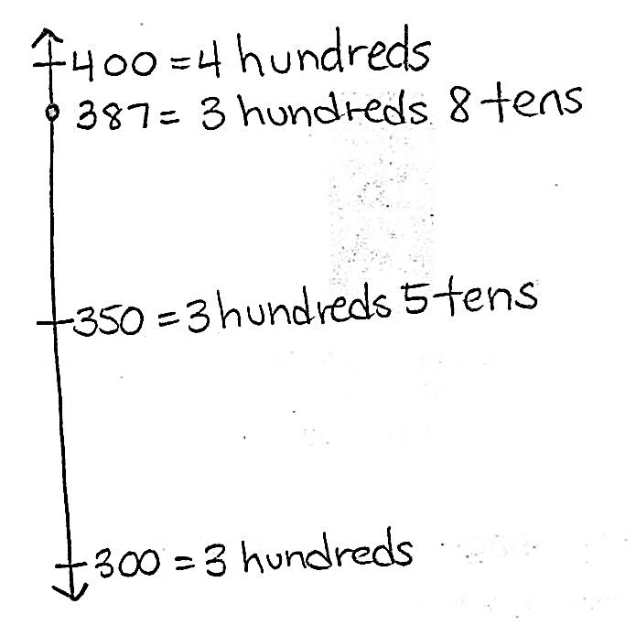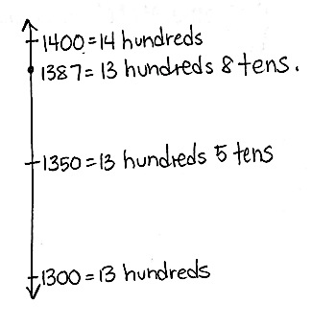

S: (Mark and label 13 hundreds 5 tens, and 1,387.)

T: Is 1,387 more than halfway or less than halfway between 13 hundreds and 14 hundreds?

S: It’s more than halfway.

T: Then, what is 1,387 milliliters rounded to the nearest hundred milliliters?

S: 14 hundred milliliters.

Continue using the following possible sequence: 1,582; 2,146; and 3,245.

Problem Set (10 minutes)

Students should do their personal best to complete the Problem Set within the allotted 10 minutes. For some classes, it may be appropriate to modify the assignment by specifying which problems they work on first. Some problems do not specify a method for solving. Students should solve these problems using the RDW approach used for Application Problems.

Student Debrief (10 minutes)

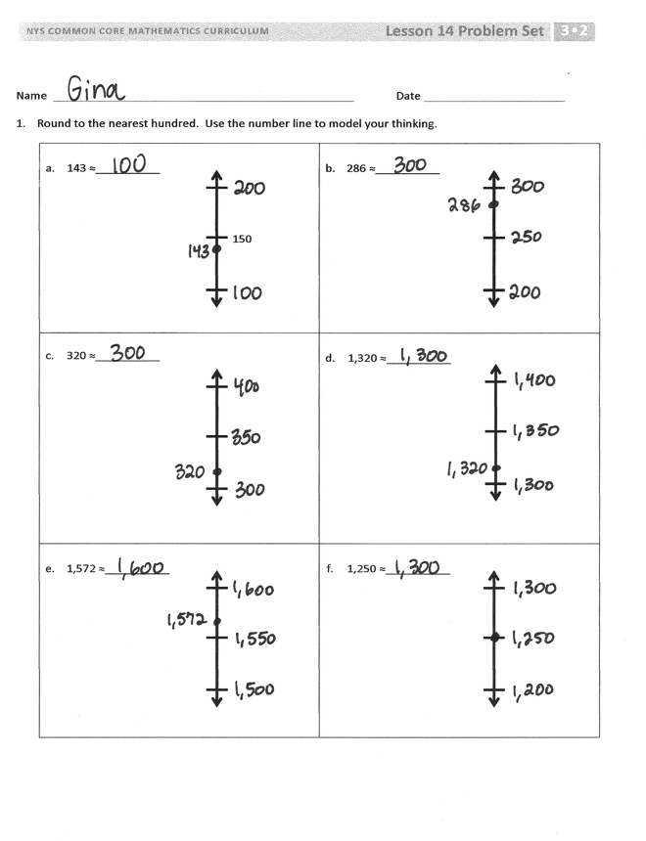

**Lesson Objective:** Round to the nearest hundred on the vertical number line.

The Student Debrief is intended to invite reflection and active processing of the total lesson experience.

Invite students to review their solutions for the Problem Set. They should check work by comparing answers with a partner before going over answers as a class. Look for misconceptions or misunderstandings that can be addressed in the Debrief. Guide students in a conversation to debrief the Problem Set and process the lesson.

You may choose to use any combination of the questions below to lead the discussion.

* Have students share their explanations for Problem 4, particularly if there is disagreement.
* What strategies did you use to solve Problem 3?
* How is the procedure for rounding to the nearest hundred the same or different for three-digit and four-digit numbers?

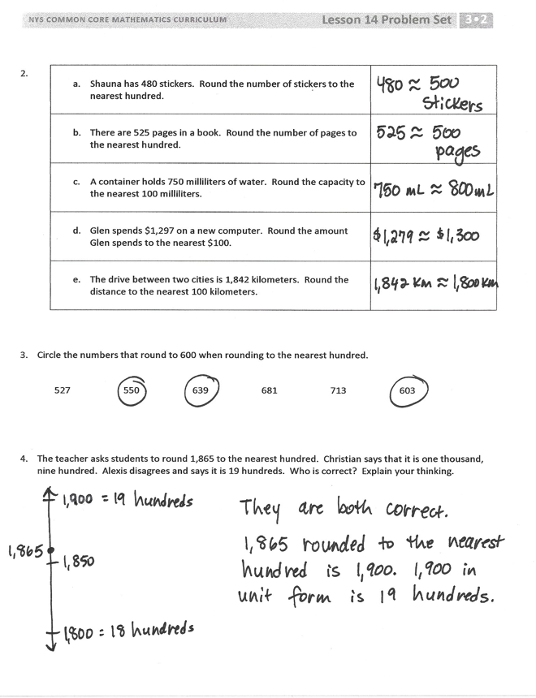

* How is rounding to the nearest hundred different from rounding to the nearest ten?

Exit Ticket (3 minutes)

After the Student Debrief, instruct students to complete the Exit Ticket. A review of their work will help you assess the students’ understanding of the concepts that were presented in the lesson today and plan more effectively for future lessons. You may read the questions aloud to the students.



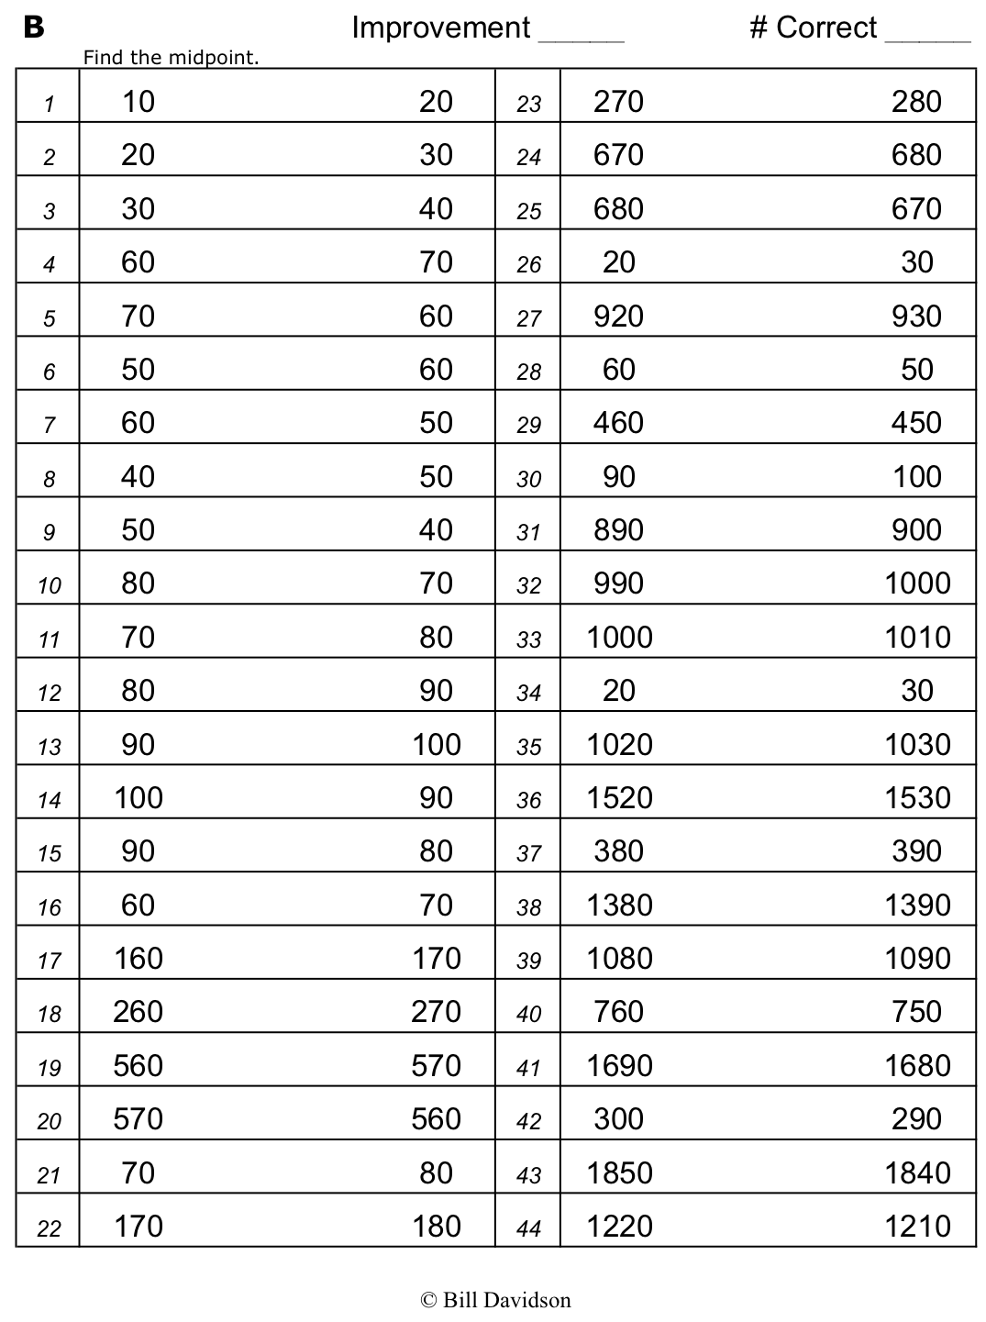

Write the number that is halfway between the two numbers.

Name Date

1. Round to the nearest hundred. Use the number line to model your thinking.

|  |  |
| --- | --- |
| 1. 143 ≈ __________   150 | 1. 286 ≈ __________ |
| 1. 320 ≈ __________ | 1. 1,320 ≈ __________ |
| 1. 1,572 ≈ __________ | 1. 1,250 ≈ __________ |

|  |  |
| --- | --- |
| 1. Shauna has 480 stickers. Round the number of stickers to the nearest hundred. |  |
| 1. There are 525 pages in a book. Round the number of pages to the nearest hundred. |  |
| 1. A container holds 750 milliliters of water. Round the capacity to the nearest 100 milliliters. |  |
| 1. Glen spends $1,297 on a new computer. Round the amount Glen spends to the nearest $100. |  |
| 1. The drive between two cities is 1,842 kilometers. Round the distance to the nearest 100 kilometers. |  |

2.

1. Circle the numbers that round to 600 when rounding to the nearest hundred.
2. 550 639 681 713 603
3. The teacher asks students to round 1,865 to the nearest hundred. Christian says that it is one thousand, nine hundred. Alexis disagrees and says it is 19 hundreds. Who is correct? Explain your thinking.

Name Date

1. Round to the nearest hundred. Use the number line to model your thinking.

|  |  |
| --- | --- |
| * 1. 137 ≈ __________ | * 1. 1,761 ≈ _________ |

1. There are 685 people at the basketball game. Draw a vertical number line to round the number of people to the nearest hundred people.

Name Date

1. Round to the nearest hundred. Use the number line to model your thinking.

|  |  |
| --- | --- |
| 1. 156 ≈ __________   150 | b. 342 ≈ __________ |
| c. 260 ≈ ___________ | d. 1,260 ≈ _________ |
| e. 1,685 ≈ __________ | f. 1,804 ≈ __________ |

|  |  |
| --- | --- |
| 1. Luis has 217 baseball cards. Round the number of cards Luis has to the nearest hundred. |  |
| 1. There were 462 people sitting in the audience. Round the number of people to the nearest hundred. |  |
| 1. A bottle of juice holds 386 milliliters. Round the capacity to the nearest 100 milliliters. |  |
| 1. A book weighs 727 grams. Round the weight to the nearest 100 grams. |  |
| 1. Joanie’s parents spent $1,260 on two plane tickets. Round the total to the nearest $100. |  |

1. Complete the chart.
2. Circle the numbers that round to 400 when rounding to the nearest hundred.

368 342 420 492 449 464

1. There are 1,525 pages in a book. Julia and Kim round the number of pages to the nearest hundred. Julia says it is one thousand, five hundred. Kim says it is 15 hundreds. Who is correct? Explain your thinking.

|  |  |
| --- | --- |
|  |  |
|  |  |
|  |  |
|  |  |

[1]

1. unlabeled place value chart