Lesson 13

Objective: Round two- and three-digit numbers to the nearest ten on the vertical number line.

Suggested Lesson Structure

 Fluency Practice (13 minutes)

 Application Problem (7 minutes)

 Concept Development (30 minutes)

 Student Debrief (10 minutes)

**Total Time (60 minutes)**

Fluency Practice (13 minutes)

* Group Counting **3.OA.1** (4 minutes)
* Rename the Tens **3.NBT.3** (4 minutes)
* Halfway on the Number Line **3.NBT.1** (5 minutes)

Group Counting (4 minutes)

Note: Group counting reviews interpreting multiplication as repeated addition. It reviews foundational strategies for multiplication from Module 1 and anticipates Module 3.

Direct students to count forward and backward, occasionally changing the direction of the count.

* Threes to 30
* Fours to 40
* Sixes to 60
* Sevens to 70
* Eights to 80
* Nines to 90

As students’ fluency with skip-counting improves, help them make a connection to multiplication by tracking the number of groups they count using their fingers.

Rename the Tens (4 minutes)

Materials: (S) Personal white board

Note: This activity prepares students for rounding in this lesson and anticipates the work in Lesson 14 where students round numbers to the nearest hundred on the number line.

T: (Write 9 tens = ____.) Say the number.

S: 90.

Continue with the following possible sequence: 10 tens, 20 tens, 80 tens, 63 tens, and 52 tens.

Halfway on the Number Line (5 minutes)

Materials: (S) Personal white board

Note: This activity reviews rounding using a vertical number line from Lesson 12.

T: (Project a vertical line with endpoints labeled 30 and 40.) What number is halfway between 3 tens and 4 tens?

S: 35.

T: (Write 35 halfway between 30 and 40.)

Continue with the following possible sequence: 130 and 140, 830 and 840, and 560 and 570.

Application Problem (7 minutes)

The school ballet recital begins at 12:17 p.m. and ends at   
12:45 p.m. How many minutes long is the ballet recital?

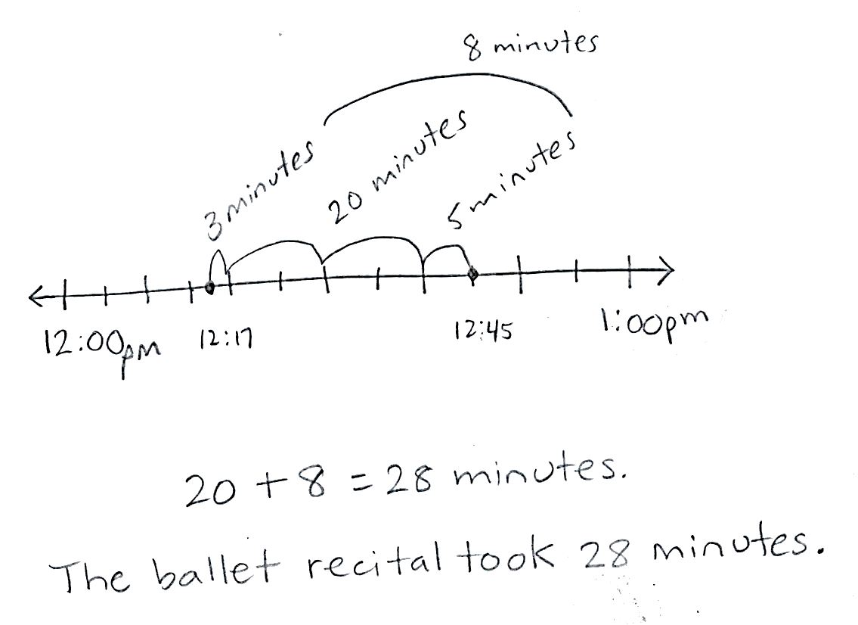

Note: This problem reviews finding intervals of minutes from Topic A and leads directly into rounding intervals of minutes to the nearest ten in this lesson. Encourage students to share and discuss simplifying strategies they may have used to solve. Possible strategies:

* Count by ones from 12:17 to 12:20, then by fives to 12:45.
* Count by tens and ones, 12:27, 12:37, plus 8 minutes.
* Subtract 17 minutes from 45 minutes.

Concept Development (30 minutes)

Materials: (T) Place value cards (S) Personal white board

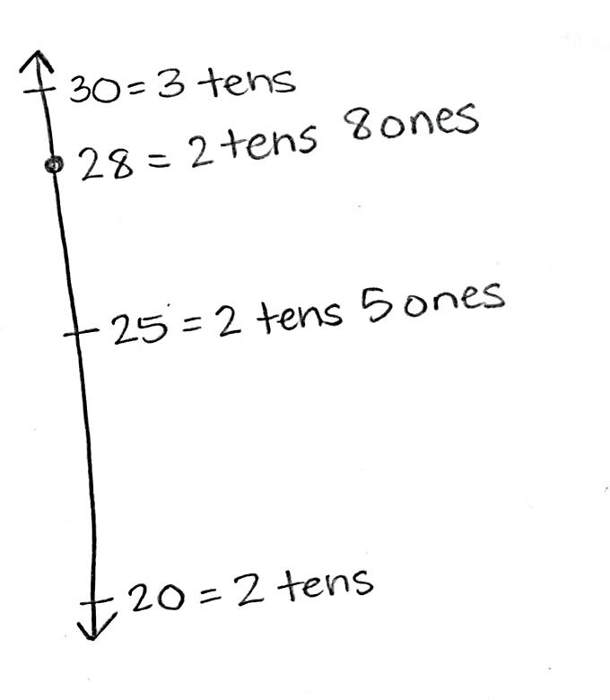Problem 1: Round two-digit measurements to the nearest ten.

T: Let’s round 28 minutes to the nearest 10 minutes.

T: How many tens are in 28? (Show place value cards for 28.)

S: 2 tens! (Pull apart the cards to show the 2 tens as 20. Perhaps cover the zero in the ones to clarify the interpretation of 20 as 2 tens.)

T: Draw a tick mark near the bottom of the number line. To the right, label it 20 = 2 tens.

S: (Draw and label 20 = 2 tens.)

T: What is 1 more ten than 2 tens?

S: 3 tens! (Show the place value card for 30 or 3 tens. Again, cover the zero to help clarify.)

T: Draw a tick mark near the top of the number line. To the right, label it 30 = 3 tens.

S: (Draw and label 30 = 3 tens.)

T: What number is halfway between 20 and 30?

S: 25!

T: In unit form, what number is halfway between 2 tens and 3 tens?

S: 2 tens 5 ones.

T: (Show 2 tens 5 ones with the place value cards). Estimate to draw a tick mark halfway between 20 and 30. Label it 25 = 2 tens 5 ones.

S: (Draw and label 25 = 2 tens 5 ones.)

T: When you look at your vertical number line, is 28 more than halfway or less than halfway between 20 and 30? Turn and talk to a partner about how you know. Then, plot it on the number line.

|  |  |
| --- | --- |
|  | NOTES ON  MULTIPLE MEANS  OF ENGAGEMENT: |
| Alternatively, challenge students who round with automaticity to quickly round 28 minutes to the nearest 10 minutes (without the number line). Students can then write their own word problem for rounding 17 milliliters or 17 minutes. | |

S: 28 is more than halfway between 2 tens and 3 tens. 🡪 I know because 28 is more than 25, and 25 is halfway. 🡪 I know because 5 ones is halfway, and 8 is more than 5.

T: What is 28 rounded to the nearest ten?

S: 30.

T: Tell me in unit form.

S: 2 tens 8 ones rounded to the nearest ten is 3 tens.

T: Let’s go back to our Application Problem. How would you round to answer the question, “About how long was the ballet recital?” Discuss with a partner.

S: The ballet recital took about 30 minutes. 🡪 Rounded to the nearest ten, the ballet recital took 30 minutes.

Continue with rounding 17 milliliters to the nearest ten. (Leave the number line used for this on the board. It will be used in Problem 2.)

Problem 2: Round three-digit measurements of milliliters to the nearest ten.

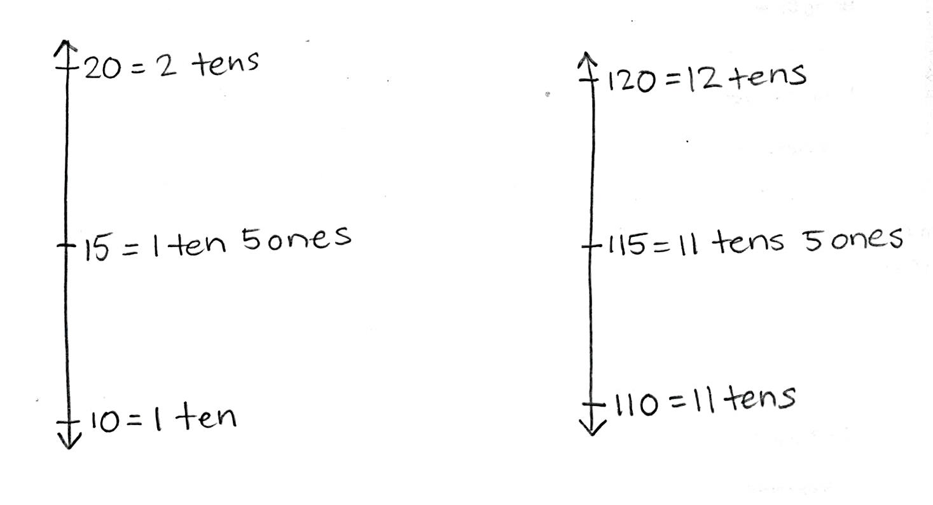T: To round 17 milliliters to the nearest ten we drew a number line with **endpoints** 1 ten and 2 tens. How will our endpoints change to round 1 *hundred* 17 to the nearest ten? Turn and talk.

**MP.6**

S: Each endpoint has to grow by 1 hundred.

T: How many tens are in 1 hundred (show the place value card of 100)?

S: 10 tens.

T: When I cover the ones we see the 10 tens. (Put your hand over the zero in the ones place.)

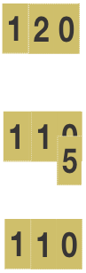T: What is 1 more ten than 10 tens?

S: 11 tens.

T: (Show the place value cards for 10 tens and then 11 tens, i.e., 100 and 110.)

T: (Show 117 with the place value cards.)

T: How many tens are in 117? Turn and talk about how you know.

S: (Track on fingers) 10, 20, 30, 40, 50, …110. Eleven tens. 🡪 17 has 1 ten so 117 has 10 plus 1 tens, 11 tens. 🡪 110 has 11 tens. 🡪 100 has 10 tens and one more ten is 11 tens.

T: What is 1 more ten than 11 tens?

S: 12 tens.

T: What is the value of 12 tens?

S: 120.

T: What will we label our bottom endpoint on the number line when we round 117 to the nearest ten?

S: 110 = 11 tens.

T: The top endpoint?

S: 120 = 12 tens.

T: (Draw and label endpoints on the vertical number line.)

T: How should we label our halfway point?

S: 115 = 11 tens 5 ones.

T: (Show 11 tens 5 ones with the place value cards.) On your number line, mark and label the halfway point.

S: (Mark and label the halfway point.)

T: Is 117 more or less than halfway between 110 and 120? Tell your partner how you know.

|  |  |
| --- | --- |
|  | NOTES ON  MULTIPLE MEANS  OF ACTION AND EXPRESSION: |
| Reduce the small motor demands of plotting points on a number line by enlarging the number line and offering alternatives to marking with a pencil, such as placing stickers or blocks. Additionally, connect back to yesterday’s lesson by using beakers or scales with water or rice. | |

S: It’s closer to 120. 17 is only 3 away from 20, but 7 away from 10. 🡪 It’s more than halfway between 110 and 120, above 115.

T: Label 117 on your number line now. (Allow time for students to label 117.) What is 117 rounded to the nearest ten? Use a complete sentence.

S: 117 rounded to the nearest ten is 120.

T: Tell me in unit form with tens and ones.

S: 11 tens 7 ones rounded to the nearest ten is 12 tens.

T: What is 17 rounded to the nearest ten?

S: 20.

T: Again, what is 117 rounded to the nearest ten?

S: 120!

T: Remember from telling time that a number line is continuous. The models we drew to round 17 milliliters and 117 milliliters were the same, even though they showed different portions of the number line; corresponding points are 1 hundred milliliters apart. Discuss the similarities and differences between rounding within those two intervals with your partner.

S: All the numbers went in the same place, we just wrote a 1 in front of them all to show they were 1 hundred more. 🡪 We still just paid attention to the number of tens. We thought about if 17 was more or less than halfway between 10 and 20.

Continue with rounding the following possible measurements to the nearest ten: 75 mL and 175 mL, 212 g, 315 mL, and 103 kg.

Problem Set (10 minutes)

|  |  |
| --- | --- |
|  | NOTES ON  SYMBOLS: |
| This symbol is used to show that the answer is approximate: ≈. Before students start work on the Problem Set, call their attention to it and point out the difference between ≈ and =. | |

Students should do their personal best to complete the Problem Set within the allotted 10 minutes. Depending on your class, it may be appropriate to modify the assignment by specifying which problems they work on first. Some problems do not specify a method for solving. Students should solve these problems using the RDW approach used for Application Problems.

Student Debrief (10 minutes)

**Lesson Objective:** Round two- and three-digit numbers to the nearest ten on the vertical number line.

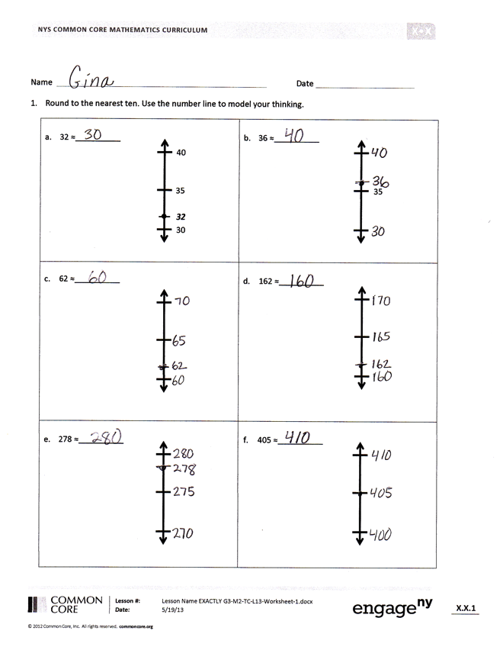

The Student Debrief is intended to invite reflection and active processing of the total lesson experience.

Invite students to review their solutions for the Problem Set. They should check work by comparing answers with a partner before going over answers as a class. Look for misconceptions or misunderstandings that can be addressed in the Debrief. Guide students in a conversation to debrief the Problem Set and process the lesson.

You may choose to use any combination of the ideas below to lead the discussion.

* What is the same and different about Problems 1(c) and 1(d)? Did you solve the problems differently? Why or why not?
* Look at Problem 1(f). Did the zero in 405 make the problem challenging? Why?
* 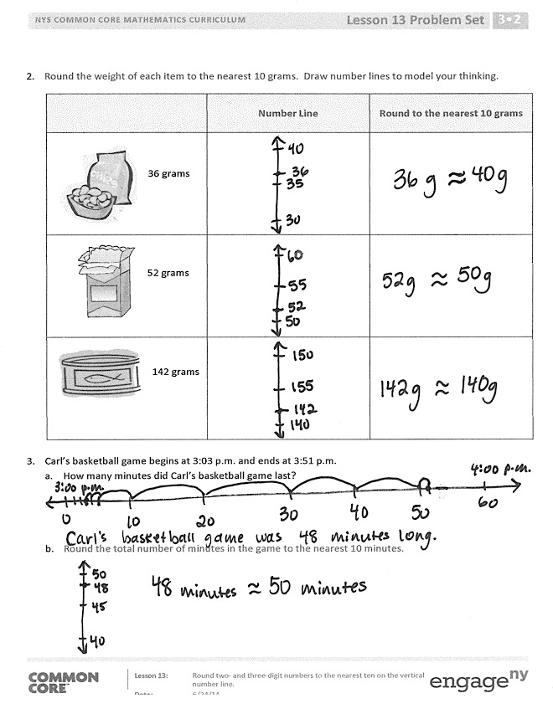How did our fluency activities Rename the Ten and Halfway on the Number Line help with our rounding work today?
* Think back to yesterday’s activity where we measured and then rounded at stations. How did that work help you envision the units we worked with today on the number line?

Exit Ticket (3 minutes)

After the Student Debrief, instruct students to complete the Exit Ticket. A review of their work will help you assess the students’ understanding of the concepts that were presented in the lesson today and plan more effectively for future lessons. You may read the questions aloud to the students.

Name Date

1. Round to the nearest ten. Use the number line to model your thinking.

|  |  |
| --- | --- |
| 1. 32 ≈ __________   30  40  ***32***  35 | 1. 36 ≈ __________   35 |
| 1. 62 ≈ __________ | 1. 162 ≈ __________ |
| 1. 278 ≈ __________ | 1. 405 ≈ __________ |

1. Round the weight of each item to the nearest 10 grams. Draw number lines to model your thinking.

|  |  |  |
| --- | --- | --- |
| **Item** | **Number Line** | **Round to the nearest 10 grams** |
| 36 grams |  |  |
| 52 grams |  |  |
| 142 grams |  |  |

1. Carl’s basketball game begins at 3:03 p.m. and ends at 3:51 p.m.
2. How many minutes did Carl’s basketball game last?
3. Round the total number of minutes in the game to the nearest 10 minutes.

Name Date

1. Round to the nearest ten. Use the number line to model your thinking.

|  |  |
| --- | --- |
| a. 26 ≈ _________ | b. 276 ≈ __________ |

1. Bobby rounds 603 to the nearest ten. He says it is 610. Is he correct? Why or why not? Use a number line and words to explain your answer.

Name Date

1. Round to the nearest ten. Use the number line to model your thinking.

|  |  |
| --- | --- |
| 1. 43 ≈ ________   45  50  40  ***43*** | 1. 48 ≈ ________ |
| 1. 73 ≈ ________ | 1. 173 ≈ ________ |
| 1. 189 ≈ ________ | 1. 194 ≈ ________ |

1. Round the weight of each item to the nearest 10 grams. Draw number lines to model your thinking.

|  |  |  |
| --- | --- | --- |
| **Item** | **Number Line** | **Round to the nearest 10 grams** |
| candies,bars,chocolates,food,snacks,sweets,treats    **Cereal bar: 45 grams** |  |  |
| breads,food,groceries,grocery items,loaves,loaves of bread  **Loaf of bread: 673 grams** |  |  |

1. The Garden Club plants rows of carrots in the garden. One seed packet weighs 28 grams. Round the total weight of 2 seed packets to the nearest 10 grams. Model your thinking using a number line.