Lesson 12

Objective: Round two-digit measurements to the nearest ten on the vertical number line.

Suggested Lesson Structure

|  |  |
| --- | --- |
|  | NOTES ON  LESSON STRUCTURE: |

This lesson does not include an Application Problem, but rather uses an extended amount of time for the Problem Set. The Problem Set provides an opportunity for students to apply their newly acquired rounding skills to measurement.

 Fluency Practice (9 minutes)

 Concept Development (41 minutes)

 Student Debrief (10 minutes)

**Total Time (60 minutes)**

Fluency Practice (9 minutes)

* Rename the Tens **3.NBT.3** (4 minutes)
* Halfway on the Number Line **3.NBT.1** (5 minutes)

Rename the Tens (4 minutes)

Materials: (S) Personal white board

Note: This activity anticipates rounding in Lessons 13 and 14 by reviewing unit form.

T: (Write 9 tens = ____.) Say the number.

S: 90.

Continue with the following possible sequence: 10 tens, 12 tens, 17 tens, 27 tens, 37 tens, 87 tens, 84 tens, 79 tens.

Halfway on the Number Line (5 minutes)

Materials: (S) Personal white board

Note: This activity prepares students to round to the nearest ten in this lesson.

T: (Project a vertical line with endpoints labeled 10 and 20.) What number is halfway between 1 ten and 2 tens?

S: 15.

T: (Write 15, halfway between 10 and 20.)

Repeat process with endpoints labeled 30 and 40.

T: Draw a vertical number line on your personal white board and make tick marks at each end.

T: (Write 2 tens and 3 tens.) Label the tick marks at each end and at the halfway point.

S: (Label 20 as the bottom point, 30 as the top point, and 25 as the halfway point.)

Continue with 90 and 100.

Concept Development (41 minutes)

Materials: (T) 100 mL beaker, water (S) Personal white board

|  |  |
| --- | --- |
|  | NOTES ON  MULTIPLE MEANS  OF REPRESENTATION: |

Scaffold the drawing and use of the number line. First, round water amounts in a beaker. Then, round using a picture of a beaker. Last, guide students to see and draw the number line in isolation. If helpful, students can shade the water amount on the number line until plotting points is easy.

T: (Show a beaker holding 73 milliliters of water.) This beaker has 73 milliliters of water in it. Show the amount on a vertical number line. Draw a vertical number line, like in today’s Fluency Practice. (Model a vertical number line with tick marks for endpoints and a halfway point.)

S: (Draw.)

T: How many tens are in 73?

S: 7 tens!

T: Follow along with me on your board. (To the right of the lowest tick mark, write 70 = 7 tens.)

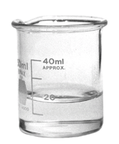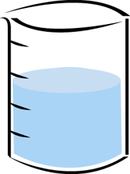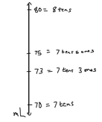

T: What is 1 more ten than 7 tens?

S: 8 tens!

T: (Write 80 = 8 tens to the right of the top tick mark.)

S: (Label.)

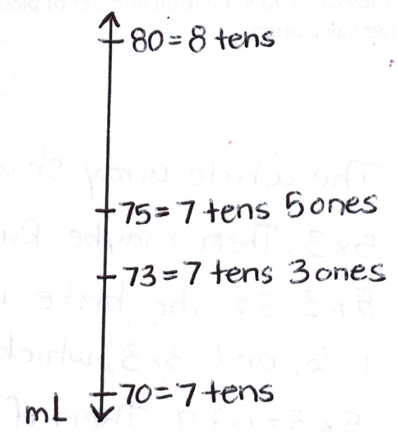T: What number is halfway between 7 tens and 8 tens?

S: 7 tens and 5 ones, or 75.

T: (Write 75 = 7 tens 5 ones to the right of the halfway point.) Label the halfway point.

S: (Label.)

T: Let’s plot 73 on the number line. Remind me, what unit are we plotting on the number line?

S: Milliliters!

T: Say “Stop!” when my finger points to where 73 milliliters should be. (Move finger up the number line from 70 toward 75.)

**MP.6**

S: Stop!

T: (Plot and label 73 = 7 tens 3 ones.) Now that we know where 73 milliliters is, we can **round** the measurement to the nearest 10 milliliters. Look at your vertical number line. Is 73 milliliters more than halfway or less than halfway between 70 milliliters and 80 milliliters? Tell your partner how you know.

S: 73 milliliters is less than halfway between 70 and 80 milliliters. I know because 3 is less than 5, and 5 marks is halfway. 🡪 73 is 7 away from 80 but only 3 away from 70.

**MP.6**

|  |  |
| --- | --- |
|  | NOTES ON  MULTIPLE MEANS  OF REPRESENTATION: |

For those students who have trouble conceptualizing *halfway*, demonstrate it using students as models. Two students represent the tens. A third student represents the number that is halfway. A fourth student represents the number being rounded. Discuss: Where does the student being rounded belong? When is the student more than halfway? Less than halfway? To which number would they round?

T: 73 milliliters rounded to the nearest ten is 70 milliliters. Another way to say it is that 73 milliliters is **about** 70 milliliters. *About* means that 70 milliliters is not the exact amount.

Continue with the following possible sequence: 61 centimeters, 38 minutes, and 25 grams. For each example, show how the vertical number line can be used even though the units have changed. Be sure to have a discussion about the convention of rounding numbers that end in 5 up to the next ten.

Problem Set (21 minutes)

Materials: (S) Problem Set, 4 bags of rice (pre-measured at four different weights within 100 g), 4 containers of water (pre-measured with four different liquid volumes within 100 mL), ruler, meter stick, blank paper, new pencil, digital scale measuring grams, 100 mL beaker, demonstration clock, classroom wall clock

|  |  |
| --- | --- |
|  | NOTES ON  MATERIALS: |

Adjust the number of measurement materials at each station (ruler, meter stick, digital scale, beaker, demonstration clock) depending both on what is available and on the number of students working at each station at a given time.

Description: Students move through different stations to measure using centimeters, grams, milliliters, and minutes as units. Then, they apply learning from the Concept Development to round each measurement to the nearest ten. Students use a ruler, a clock, a beaker, or a drawn vertical number line as tools for rounding to the nearest ten.

Directions: Work with a partner and move through the following stations to complete the Problem Set. Measure, and then round each measurement to the nearest ten.

* Station 1: Measure and round metric length using centimeters. (Provide the four objects listed in Problem Set, rulers, and meter sticks.)
* Station 2: Measure and round weight using grams. (Provide four bags of rice labeled at various weights below 100 grams and digital scales that measure in grams.)
* Station 3: Measure and round liquid volume using milliliters. (Provide four containers of various liquid volumes below 100 milliliters and 100 milliliter beakers for measuring.)
* Station 4: (Ongoing, students update the data for this station at Stations 1–3.) Record the exact time you start working at the first station, then the time you finish working at Stations 1, 2, and 3. Then, round each time to the nearest 10 minutes. (Provide demonstration clocks or have students draw vertical number lines to round.)

Prepare students:

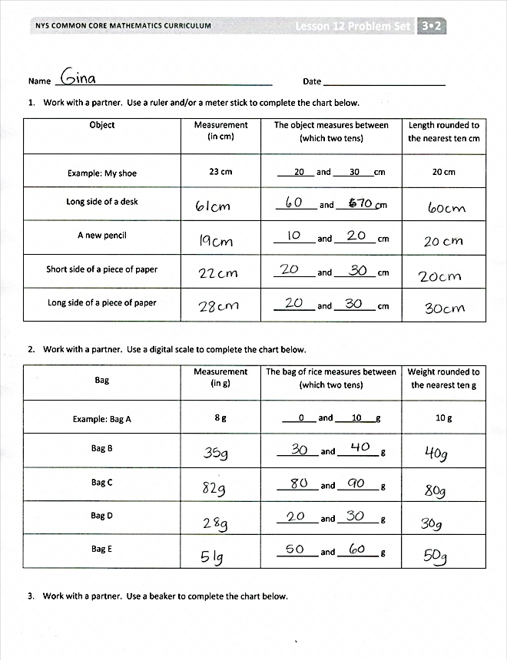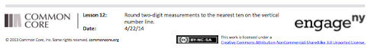

[Type a quote from the document or the summary of an interesting point. You can position the text box anywhere in the document. Use the Drawing Tools tab to change the formatting of the pull quote text box.]

* Explain how to complete the problems using the examples provided in the Problem Set.
* Discuss how to perform the measurements at each station.
* Establish which tools you would like students to use for rounding at each station (or differentiate for individual pairs of students.)
* Clarify that students should ignore the numbers after the decimal point if scales measure more accurately than to the nearest gram because students are rounding whole numbers.

Note: Making an immediate connection between the actual measurement and the rounded measurement helps students see the value of rounding. This activity concretizes the relationship between a given number and its relationship to the tens on either side of it. Students also see that when embedded within specific, real, and varied measurement contexts, 73 milliliters and 73 centimeters (rounded or not) have quite different meanings despite appearing nearly synonymous on the number line. Provide students with the language and guidance to engage in discussions that allow these ideas to surface.

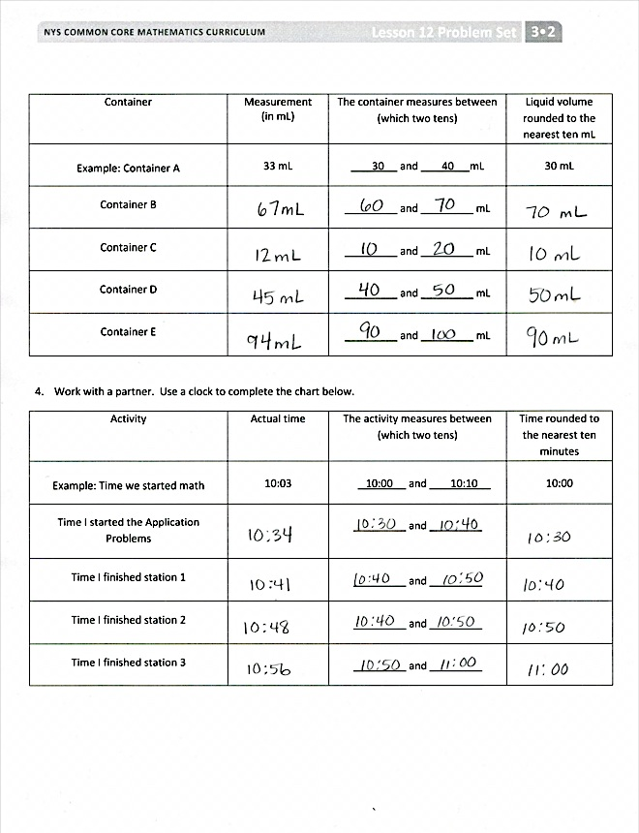

Student Debrief (10 minutes)

**Lesson Objective:** Round two-digit measurements to the nearest ten on the vertical number line.

The Student Debrief is intended to invite reflection and active processing of the total lesson experience.

Invite students to review their work in the Problem Set. They should compare answers with a partner before going over answers as a class. Look for misconceptions that can be addressed in the Debrief. Guide students in a conversation to debrief the Problem Set and process the lesson.

You may choose to use any combination of the ideas below to lead the discussion.

* Discuss new vocabulary from today’s lesson: **round** and **about**.
* Why is a vertical number line a good tool to use for rounding?
* How does labeling the halfway point help you to round?
* How did you round numbers that were the same as the halfway point?
* What are some real world situations where it would be useful to round and estimate?

Exit Ticket (3 minutes)

After the Student Debrief, instruct students to complete the Exit Ticket. A review of their work will help you assess the students’ understanding of the concepts that were presented in the lesson today and plan more effectively for future lessons. You may read the questions aloud to the students.

Name Date

1. Work with a partner. Use a ruler or a meter stick to complete the chart below.

|  |  |  |  |
| --- | --- | --- | --- |
| **Object** | **Measurement**  **(in cm)** | **The object measures between (which two tens)…** | **Length rounded to the nearest 10 cm** |
| *Example:* My shoe | 23 cm | 20 and 30 cm | 20 cm |
| Long side of a desk |  | _________ and _________ cm |  |
| A new pencil |  | _________ and _________ cm |  |
| Short side of a piece of paper |  | _________ and _________ cm |  |
| Long side of a piece of paper |  | _________ and _________ cm |  |

1. Work with a partner. Use a digital scale to complete the chart below.

|  |  |  |  |
| --- | --- | --- | --- |
| **Bag** | **Measurement**  **(in g)** | **The bag of rice measures between (which two tens)…** | **Weight rounded to the nearest 10 g** |
| *Example:* Bag A | 8 g | 0 and 10 g | 10 g |
| Bag B |  | _________ and _________ g |  |
| Bag C |  | _________ and _________ g |  |
| Bag D |  | _________ and _________ g |  |
| Bag E |  | _________ and _________ g |  |

1. Work with a partner. Use a beaker to complete the chart below.

|  |  |  |  |
| --- | --- | --- | --- |
| **Container** | **Measurement**  **(in mL)** | **The container measures between (which two tens)…** | **Liquid volume rounded to the nearest 10 mL** |
| *Example:* Container A | 33 mL | 30 and 40 mL | 30 mL |
| Container B |  | _________ and _________ mL |  |
| Container C |  | _________ and _________ mL |  |
| Container D |  | _________ and _________ mL |  |
| Container E |  | _________ and _________ mL |  |

1. Work with a partner. Use a clock to complete the chart below.

|  |  |  |  |
| --- | --- | --- | --- |
| **Activity** | **Actual time** | **The activity measures between (which two tens)…** | **Time rounded to the nearest  10 minutes** |
| *Example:* Time we started math | 10:03 | 10:00 and 10:10 | 10:00 |
| Time I started the Problem Set |  | _________ and _________ |  |
| Time I finished Station 1 |  | _________ and _________ |  |
| Time I finished Station 2 |  | _________ and _________ |  |
| Time I finished Station 3 |  | _________ and _________ |  |

Name Date

The weight of a golf ball is shown below.

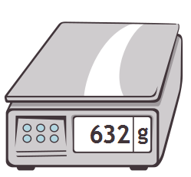

**46**

1. The golf ball weighs _________________.
2. Round the weight of the golf ball to the nearest ten grams. Model your thinking on the number line.
3. The golf ball weighs about _________________.
4. Explain how you used the halfway point on the number line to round to the nearest ten grams.

Name Date

1. Complete the chart. Choose objects and use a ruler or meter stick to complete the last two on your own.

|  |  |  |  |
| --- | --- | --- | --- |
| **Object** | **Measurement**  **(in cm)** | **The object measures between (which two tens)…** | **Length rounded to the nearest  10 cm** |
| Length of desk | 66 cm | _________ and _________ cm |  |
| Width of desk | 48 cm | _________ and _________ cm |  |
| Width of door | 81 cm | _________ and _________ cm |  |
|  |  | _________ and _________ cm |  |
|  |  | _________ and _________ cm |  |

|  |  |
| --- | --- |
| 1. Gym class ends at 10:27 a.m. Round the time to the nearest 10 minutes.       Gym class ends at about ______ a.m. | 1. Measure the liquid in the beaker to the nearest 10 milliliters.   40 mL  10 mL  20 mL  30 mL  60 mL  50 mL    There are about _________ milliliters in the beaker. |

1. Mrs. Santos’ weight is shown on the scale. Round her weight to the nearest 10 kilograms.

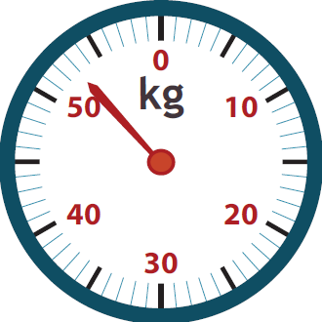

Mrs. Santos’ weight is _________ kilograms.

Mrs. Santos weighs about _________ kilograms.

1. 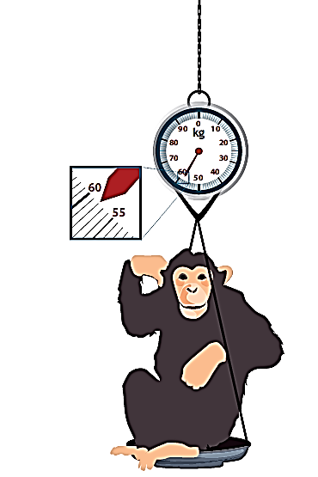A zookeeper weighs a chimp. Round the chimp’s weight to the nearest 10 kilograms.

The chimp’s weight is ________ kilograms.

The chimp weighs about __________ kilograms.