Lesson 11

Objective: Solve mixed word problems involving all four operations with grams, kilograms, liters, and milliliters given in the same units.

Suggested Lesson Structure

 Fluency Practice (11 minutes)

 Concept Development (39 minutes)

 Student Debrief (10 minutes)

**Total Time (60 minutes)**

Fluency Practice (11 minutes)

* Rename Tens **3.NBT.3** (3 minutes)
* Halfway on the Number Line **3.NBT.1** (4 minutes)
* Read a Beaker **3.MD.1** (4 minutes)

Rename Tens (3 minutes)

Materials: (T) Place value cards (S) Personal white board

Note: This activity anticipates rounding in the next topic. You may want to use place value cards to quickly review place value with students, if necessary.

T: (Write 7 tens = ____.) Say the number.

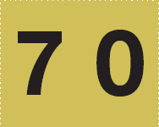

*Place value cards*



S: 70.

Continue with the following possible sequence: 8 tens, 9 tens, and 10 tens.

T: (Write 11 tens = ____.) On your personal white board, fill in the number sentence.

S: (Write 11 tens = 110.)

Continue with the following possible sequence: 12 tens, 16 tens, 19 tens, and   
15 tens.

Halfway on the Number Line (4 minutes)

Materials: (S) Personal white board

Note: This activity anticipates rounding in the next topic. Practicing this skill in isolation lays a foundation for conceptually understanding rounding on a vertical number line.

T: (Project a vertical line with endpoints labeled 0 and 10.) What’s halfway between 0 tens and 1 ten?

S: 5.

T: (Write 5 halfway between 0 and 10.)

Repeat process with endpoints labeled 10 and 20.

T: Draw a vertical number line on your board and make tick marks at each end and one for the halfway point.

S: (Draw number line.)

T: (Write 3 tens and 4 tens.) Label the tick marks at each end and at the halfway point.

S: (Label 30 as the bottom point, 40 as the top point, and 35 as the halfway point.)

Continue with the following possible sequence: 60 and 70, 80 and 90, 40 and 50, and 50 and 60.

Read a Beaker (4 minutes)

Materials: (T) Beaker images (S) Personal white boards

Note: This activity reviews Lesson 10.

T: (Show image of a beaker with a capacity of 4 liters.) Start at the bottom of the beaker and count by 1 liter. (Move finger from the bottom to each tick mark as students count.)

S: 1 liter, 2 liters, 3 liters, 4 liters.

T: I’ll shade in the beaker to show how much water it holds. Write the capacity on your board.   
(Shade in 1 liter.)

S: (Write 1 liter.)

Repeat the process, varying the liquid height.

Repeat the process with a beaker partitioned into 10 equal parts, filling in increments of 100 milliliters.

Repeat the process with a beaker partitioned into 2 equal parts, filling in increments of 500 milliliters.

Concept Development (39 minutes)

|  |  |
| --- | --- |
|  | NOTES ON  MULTIPLE MEANS  OF ENGAGEMENT: |

This lesson includes an abundance of word problems given in all four operations. It is unlikely that you will have time for them all. As you make decisions about pacing, select problems involving operations with which your class most needs practice and intentionally vary the problem types.

Materials: (T) Scale (S) Spring scales, digital scales, beakers (mL), personal white board

Problem 1: Solve word problems involving addition and subtraction.

T: (Project.) A pet mouse weighs 34 grams. A pet hamster weighs 126 grams more than the mouse. How much does the pet hamster weigh? Model the problem on your board.

S: (Model.)

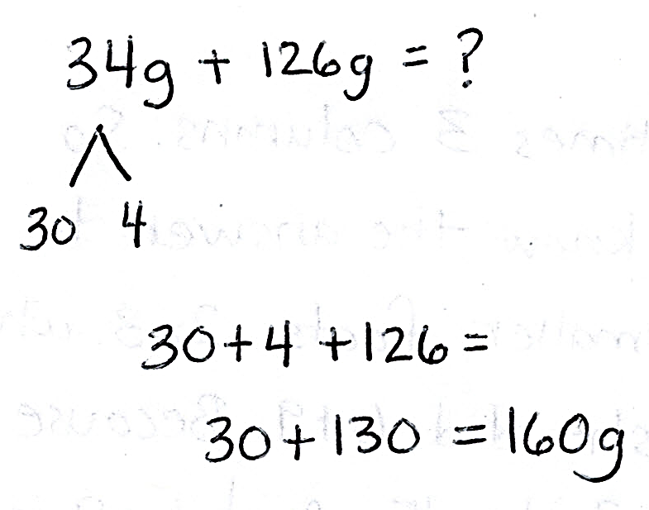T: Talk with your partner: Is there a simplifying strategy you might use to find how much the hamster weighs?

S: 126 grams is almost 130 grams. We can use the 4 from 34 to complete the ten in 126 and make 130. Then it’s just 30 + 130. That’s easy!

T: How might this strategy help us solve similar problems using mental math?

S: We can look for other problems with 6 in the ones place and see if getting 4 makes a simpler problem.   
🡪 We can look for ways to make a ten.

|  |  |
| --- | --- |
|  | NOTES ON  MULTIPLE MEANS  OF ENGAGEMENT: |

Students may come up with a variety of strategies. Strategically choose students to share their work, highlighting for the rest of the class particularly efficient methods. Use what students share to build a bank of strategies, and encourage students to try a friend’s strategy to solve subsequent problems.

As time allows, repeat the process.

* *Add to with result unknown:* Judith squeezes 140 milliliters of lemon juice to make 1 liter of lemonade. How many milliliters of lemon juice are in 2 liters of lemonade?
* *Take from with change unknown:* Robert’s crate of tools weighs 12 kilograms. He takes his power tools out. Now the crate weighs 4 kilograms. How many kilograms do the power tools weigh?

Problem 2: Solve word problems involving multiplication.

T: (Project.) A pitcher of shaved ice needs 5 milliliters of food coloring to turn red. How many milliliters of food coloring are needed to make 9 pitchers of shaved ice red? Explain to your partner how you would model and solve this problem. (Pause.)

|  |  |
| --- | --- |
|  | NOTES ON  MULTIPLE MEANS  OF ACTION AND EXPRESSION: |

Develop students’ sense of liquid volume by having them estimate to model 140 mL and then 280 mL after solving the *add to with change unknown* problem using measuring bottles from Lesson 10.

T: Go ahead and solve.

S: (Solve problem.)

T: (Pick two students who used different strategies to share.)

S: (Share.)

As time allows, repeat the process.

* *Equal groups with unknown product*: Alyssa drinks 3 liters of water every day. How many liters will she drink in 8 days?
* *Equal groups with unknown product*:There are 4 grams of almonds in each bag of mixed nuts. How many grams of almonds are in 7 bags?

Problem 3: Solve word problems involving division.

T: Let’s work in groups to solve the following problem. (Group students.)

T: (Project.) At the pet shop there are 36 liters of water in a tank. Each fish bowl holds 4 liters.   
How many fish bowls can the shopkeeper fill using the water in the tank?

T: Go ahead and solve.

S: (Solve problem.)

T: (Pick groups that used different strategies to share.)

S: (Share.)

As time allows, repeat the process:

* *Equal groups with number of groups unknown*: Every day the school garden gets watered with 7 liters of water. How many days pass until the garden has been watered with 49 liters?
* *Equal groups with group size unknown*:A bin at the grocery store holds 9 kilograms of walnuts.   
  The total value of 9 kilograms of walnuts is $36. How much does 1 kilogram of walnuts cost?

As time allows, have students work in pairs to solve one-step word problems using all four operations.

* *Take apart with addend unknown*:Together an orange and a mango weigh 637 grams. The orange weighs 385 grams. What is the weight of the mango?
* *Compare with difference unknown*: A rabbit weighs 892 grams. A guinea pig weighs 736 grams. How much more does the rabbit weigh than the guinea pig?
* *Equal groups with group size unknown*: Twenty-four kilograms of pineapple are needed to make 4 identical fruit platters. How many kilograms of pineapple are required to make 1 fruit platter?
* 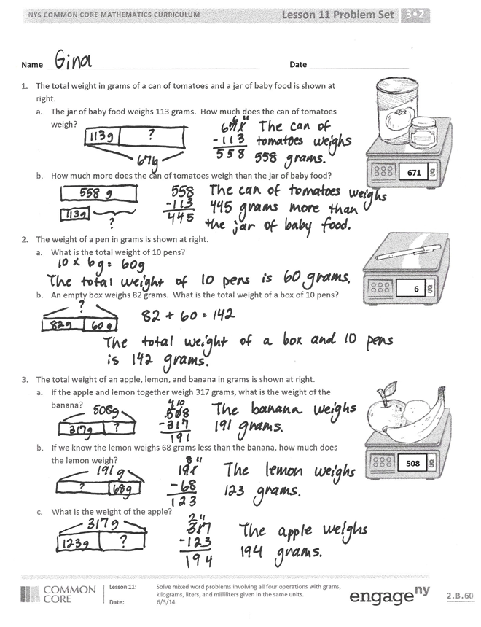*Equal groups with unknown product:* The capacity of a pitcher is 3 liters. What is the capacity of 9 pitchers?
* *Add to with result unknown:* Jack uses a beaker to measure 250 milliliters of water. Angie measures double that amount. How many milliliters of water does Angie measure?

Problem Set (10 minutes)

Students should do their personal best to complete the problem set within the allotted 10 minutes. For some classes, it may be appropriate to modify the assignment by specifying which problems they work on first. Some problems do not specify a method for solving. Students should solve these problems using the RDW approach used for Application Problems.

Student Debrief (10 minutes)

**Lesson Objective:** Solve mixed word problems involving all four operations with grams, kilograms, liters, and milliliters given in the same units.

The Student Debrief is intended to invite reflection and active processing of the total lesson experience.

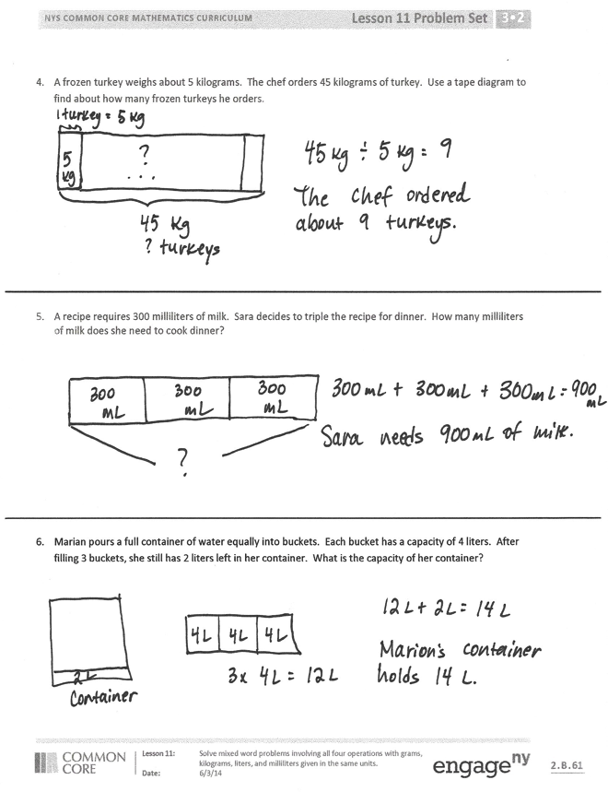Invite students to review their solutions for the Problem Set. They should check work by comparing answers with a partner before going over answers as a class. Look for misconceptions or misunderstandings that can be addressed in the Debrief. Guide students in a conversation to debrief the Problem Set and process the lesson.

You may choose to use any combination of the questions below to lead the discussion.

* What models did you use to solve the word problems?
* Explain the process you used for solving Problem 1. Did you use a special strategy? What was it?
* What pattern did you notice between Problems 4, 5, and 6? How did that pattern help you solve the problems?

**MP.7**

* Explain why Problem 6 was more challenging to solve than Problems 4 and 5.
* Look at Problem 6. Why is it important to measure the capacity of an object before dividing into equal amounts?

Exit Ticket (3 minutes)

After the Student Debrief, instruct students to complete the Exit Ticket. A review of their work will help you assess the students’ understanding of the concepts that were presented in the lesson today and plan more effectively for future lessons. You may read the questions aloud to the students.

Name Date

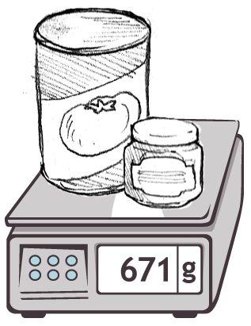

**671**

1. The total weight in grams of a can of tomatoes and a jar of baby food is shown at right.
2. The jar of baby food weighs 113 grams. How much does the can of tomatoes weigh?
3. How much more does the can of tomatoes weigh than the jar of baby food?

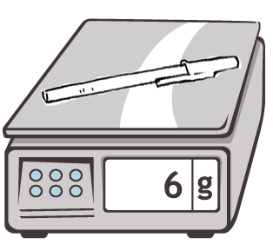

**6**

1. The weight of a pen in grams is shown at right.
2. What is the total weight of 10 pens?
3. An empty box weighs 82 grams. What is the total weight of a box of 10 pens?
4. The total weight of an apple, lemon, and banana in grams is shown at right.

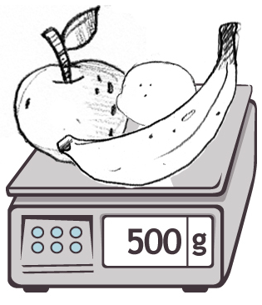

**508**

1. If the apple and lemon together weigh 317 grams, what is the weight of the banana?
2. If we know the lemon weighs 68 grams less than the banana, how much does the lemon weigh?
3. What is the weight of the apple?
4. A frozen turkey weighs about 5 kilograms. The chef orders 45 kilograms of turkey. Use a tape diagram to find about how many frozen turkeys he orders.
5. A recipe requires 300 milliliters of milk. Sara decides to triple the recipe for dinner. How many milliliters of milk does she need to cook dinner?
6. Marian pours a full container of water equally into buckets. Each bucket has a capacity of 4 liters. After filling 3 buckets, she still has 2 liters left in her container. What is the capacity of her container?

Name Date

The capacities of three cups are shown below.



*Cup A*

160 mL

*Cup B*

280 mL

*Cup C*

237 mL

1. Find the total capacity of the three cups.
2. Bill drinks exactly half of Cup B. How many milliliters are left in Cup B?
3. Anna drinks 3 cups of tea from Cup A. How much tea does she drink in total?

Name Date

1. Karina goes on a hike. She brings a notebook, a pencil, and a camera. The weight of each item is shown in the chart. What is the total weight of all three items?

**Item**

**Weight**

Notebook

312 g

Pencil

10 g

Camera

365 g

The total weight is __________ grams.

1. Together a horse and its rider weigh 729 kilograms. The horse weighs 625 kilograms. How much does the rider weigh?

The rider weighs __________ kilograms.

1. Theresa’s soccer team fills up 6 water coolers before the game. Each water cooler holds 9 liters of water. How many liters of water do they fill?
2. Dwight purchased 48 kilograms of fertilizer for his vegetable garden. He needs 6 kilograms of fertilizer for each bed of vegetables. How many beds of vegetables can he fertilize?
3. Nancy bakes 7 cakes for the school bake sale. Each cake requires 5 milliliters of oil. How many milliliters of oil does she use?