Lesson 10
Objective: Estimate and measure liquid volume in liters and milliliters using the vertical number line.

Suggested Lesson Structure
 Fluency Practice (10 minutes)
 Application Problem (5 minutes)
 Concept Development (35 minutes)
 Student Debrief (10 minutes)
Total Time (60 minutes)
Fluency Practice (10 minutes)
- Milliliter Counting 3.MD.2 (2 minutes)
- Decompose 1 Liter 3.MD.2 (4 minutes)
- Group Counting 3.OA.1 (4 minutes)
Milliliter Counting (2 minutes)
Note: This activity reviews Lesson 9 and lays the foundation for eventually composing compound units of liters and milliliters in Grade 4.
T: There are 1,000 milliliters in 1 liter. Count by 100 milliliters to 1 liter.
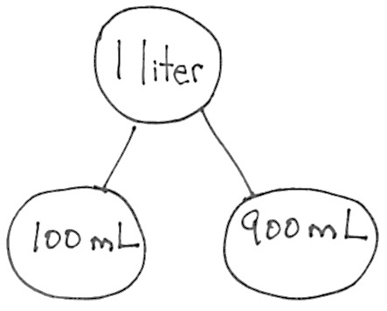
S: 100 milliliters, 200 milliliters, 300 milliliters, 400 milliliters, 500 milliliters, 600 milliliters,
700 milliliters, 800 milliliters, 900 milliliters, 1 liter.
Decompose 1 Liter (4 minutes)
Materials: (S) Personal white board
Note: Decomposing 1 liter using a number bond helps students relate part–whole thinking to measurement concepts.
T: (Project a number bond with 1 liter written as the whole.) There are 1,000 milliliters in 1 liter.
T: (Write 900 mL as one of the parts.) On your personal white board, write a number bond by filling in the unknown part.
S: (Draw number bond with 100 mL, completing the unknown part.)
Continue with possible sequence of 500 mL, 700 mL, 400 mL, 600 mL, 300 mL, 750 mL, 650 mL, 350 mL,
250 mL, 850 mL, and 150 mL.
Group Counting (4 minutes)
Note: Group counting reviews interpreting multiplication as repeated addition. It reviews foundational strategies for multiplication from Module 1 and anticipates Module 3.
Direct students to count forward and backward, occasionally changing the direction of the count:
- Threes to 30
- Fours to 40
- Sixes to 60
- Sevens to 70
- Eights to 80
- Nines to 90
As students’ fluency with skip-counting increases, have them track the number of groups counted with their fingers in order to make the connection to multiplication.
Application Problem (5 minutes)
Subha drinks 4 large glasses of water each day. How many large glasses of water does she drink in 7 days?
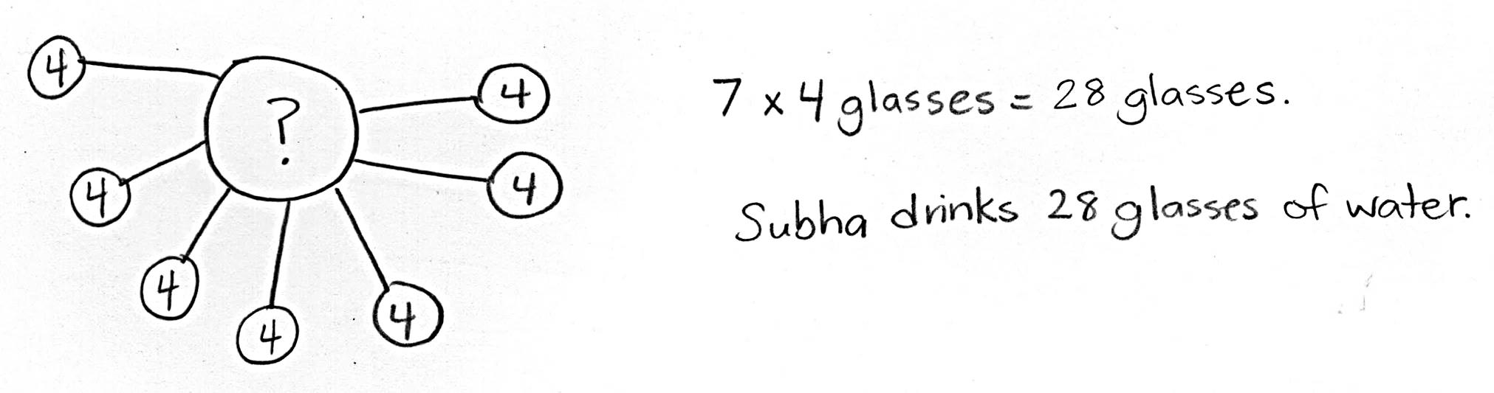

Note: This problem activates prior knowledge about solving multiplication word problems using units of 4. It is designed to lead into a discussion about liquid volume in the Concept Development.

NOTES ON
MATERIALS:
The bottles used in this exploration should be as close to the shape of a cylinder as possible. This will create a more precise vertical number line with tick marks that are equidistant from one another. Many soda bottles have grooves on the bottom and a thinner waistline which will skew the tick marks and create uneven intervals on the number line.
In this lesson, the 1 liter beaker is used to validate the ones students construct. If you don’t have access to a 1 liter beaker, you might choose to show a photo instead.

Concept Development (35 minutes)
Materials: (T) 1-liter beaker (S) Pitcher of water (1 per group), empty 2-liter bottle with top cut off (1 per group),
1 plastic cup pre-measured and labeled at 100 mL,
1 permanent marker, Problem Set
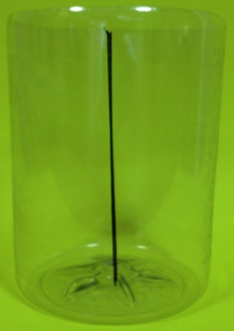
Part 1: Create a vertical number line marked at 100 mL intervals.
Empty bottle with number line
T: (Make groups of three students.) Each group will measure liquid volume to make a measuring bottle that contains 1 liter of water, similar to the one we used yesterday. Each group member has a job. One person will be the measurer, one will be the pourer, and the other will be the marker. Take 30 seconds to decide on jobs.
S: (Decide.)
T: The marker should draw a straight, vertical line from top to bottom (pictured right). These are the rest of the directions:
- The measurer measures 100 milliliters of water by pouring from the pitcher into the plastic cup.
- The pourer holds the plastic cup in place and helps the measurer know when to stop.
Then the pourer pours the water from the cup into the bottle.
- The marker makes horizontal lines to show each new water level on the side of the bottle.
Each horizontal line should cross the vertical line. The horizontal lines should be about the same size, and one should be right above the other.
T: There are 1,000 milliliters in 1 liter of water. You are measuring 100 milliliters each time. Think back to yesterday. How many times will you need to measure and mark 100 milliliters of water to make
1 liter?
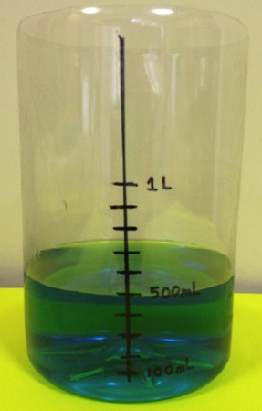
S: 10 times.
Labels at 100 mL, 500 mL, 1 L
T: Go ahead and get started.
S: (Measure, pour, and mark until there are 10 horizontal lines on the bottle and 1 liter of water inside.)
T: What do the tick marks and line remind you of?
S: They look like the number line! It’s going up and down instead of sideways.
T: Another way to say up-and-down is vertical. It’s a vertical number line. Point to the tick mark that shows the most liquid volume.
MP.6
S: (Point to the top-most horizontal mark.)
T: Use the word milliliters or liters to tell your group the capacity indicated by that mark.
S: 1,000 milliliters. 1 liter.
T: To the right of the mark, label 1 L.
Repeat the process for the mark that shows the least liquid volume and label 100 mL.
T: With your group, use the vertical number line to find the mark that shows about halfway to 1 liter. Discuss the value of the mark in milliliters. Make sure you all agree.
S: (Find the mark; agree that the value is 500 mL.)
T: Label the halfway mark.
S: (Label 500 mL.)

T: You’ve made a tool that scientists and mathematicians use to measure liquid volume. It’s called a beaker. (Show a beaker.) Work with your group to answer all three parts of Problem 1 on your Problem Set.
Part 2: Use the vertical number line to estimate and precisely measure liquid volume.
S: (Groups pour the liter of water from measuring bottle into pitcher.)

NOTES ON
MULTIPLE MEANS
OF ENGAGEMENT:
Encourage students to use precise strategies rather than estimating half by sight. For example, they might skip-count or divide 10 marks by 2.

T: A small water bottle has about 200 milliliters of water inside. Let’s see what 200 milliliters looks like. Pour from your pitcher to the measuring bottle to see the capacity of a small water bottle.
S: (Pour and measure 200 mL.)
T: How did your group use the vertical number line to measure?
S: Each tick mark represents 100 milliliters. We knew the water level was at 200 milliliters when it reached the second tick mark.
T: Is the water level in your bottle less than halfway, more than halfway, or about halfway to a liter?

NOTES ON
MULTIPLE MEANS
OF ENGAGEMENT:
If appropriate, increase the level of difficulty by asking students to estimate less than halfway between tick marks and more than halfway using the following examples:
- 225 mL, 510 mL (less than)
- 675 mL, 790 mL (more than)

S: Less than halfway.
T: A larger water bottle has about 500 milliliters of water inside. How many milliliters should you add to your measuring bottle so that the liquid volume is the same as that of a larger water bottle?
S: 300 milliliters.
T: How many tick marks higher should the water level rise if you are adding 300 milliliters?
S: Three tick marks higher.
T: Add 300 milliliters of water to your measuring bottle.
S: (Pour and measure 300 milliliters.)
T: Is the water level in your bottle less than halfway, more than halfway, or about halfway to a liter?
S: About halfway.
Repeat the process with the following sequence:
- 700 mL, 900 mL, 1,000 mL
- 250 mL, 450 mL
(These will be estimates. This is an opportunity to discuss halfway between two tick marks.)

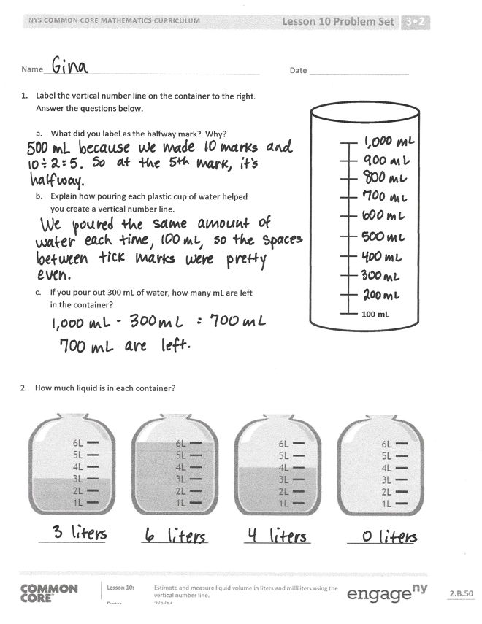
Problem Set (10 minutes)
Students should do their best to complete Problems 2–4 within the allotted 10 minutes. For some classes, it may be appropriate to modify the assignment by specifying which problems they work on first.
Student Debrief (10 minutes)
Lesson Objective: Estimate and measure liquid volume in liters and milliliters using the vertical number line.
The Student Debrief is intended to invite reflection and active processing of the total lesson experience.
Invite students to review their solutions for the Problem Set. They should check work by comparing answers with a partner before going over answers as a class. Look for misconceptions or misunderstandings that can be addressed in the Debrief. Guide students in a conversation to debrief the Problem Set and process the lesson.
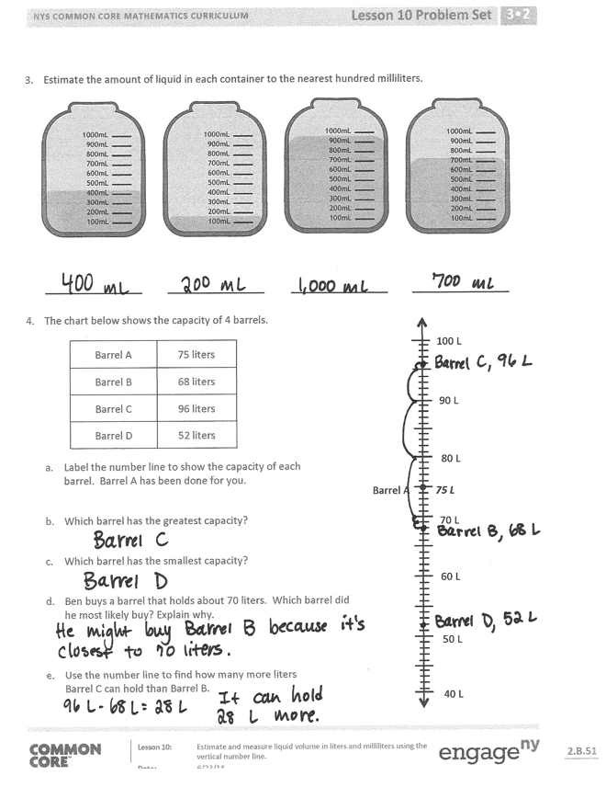
You may choose to use any combination of the questions below to lead the discussion.
- In Problem 4, describe how the position of the points plotted in Part (a) helped you solve Parts (b) and (c).
- Students may have different answers for Problem 4 (d). (Barrel B is closest to 70, but Barrel A has enough capacity to hold 70 liters, plus a little extra.) Invite students with both answers a chance to explain their thinking.
- Compare the beaker with your measuring bottle.
- How would we have labeled our vertical number lines differently if we had measured 10 mL instead of 100 mL cups to make our measuring bottles?
- If we had measured 10 mL instead of 100 mL cups to make our measuring bottles, would our halfway mark have been the same or different?
How do you know?
- Would our estimates change if our bottles had marks at every 10 mL instead of every 100 mL?

Exit Ticket (3 minutes)
After the Student Debrief, instruct students to complete the Exit Ticket. A review of their work will help you assess the students’ understanding of the concepts that were presented in the lesson today and plan more effectively for future lessons. You may read the questions aloud to the students.
Name Date
- Label the vertical number line on the container to the right. Answer the questions below.
100 mL

- What did you label as the halfway mark? Why?

- Explain how pouring each plastic cup of water helped you create a vertical number line.

- If you pour out 300 mL of water, how many mL are left in the container?

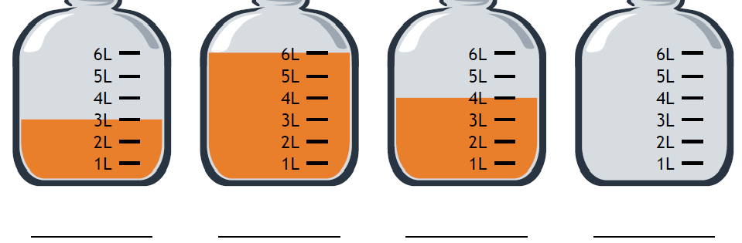
- How much liquid is in each container?
- Estimate the amount of liquid in each container to the nearest hundred milliliters.
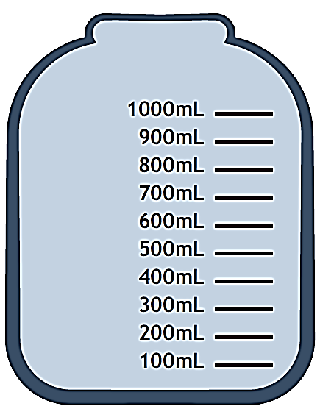

- The chart below shows the capacity of 4 barrels.
40 L
50 L
60 L
70 L
80 L
90 L
100 L
Barrel A
75 L
Barrel A | 75 liters
Barrel B | 68 liters
Barrel C | 96 liters
Barrel D | 52 liters

- Label the number line to show the capacity of each barrel. Barrel A has been done for you.

- Which barrel has the greatest capacity?

- Which barrel has the smallest capacity?

- Ben buys a barrel that holds about 70 liters. Which barrel did he most likely buy? Explain why.

- Use the number line to find how many more liters Barrel C can hold than Barrel B.

Name Date
- Use the number line to record the capacity of the containers.
10 L
20 L
30 L
40 L
50 L
60 L
70 L
Container A

Container | Capacity in Liters  Container B
A
B
C

- What is the difference between the capacity of Container A and Container C?
Container C

Name Date
- How much liquid is in each container?
Container 4
Container 3
Container 2
Container 1
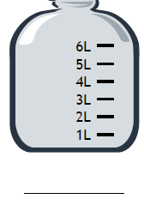

- Jon pours the contents of Container 1 and Container 3 above into an empty bucket. How much liquid is in the bucket after he pours the liquid?

- Estimate the amount of liquid in each container to the nearest liter.

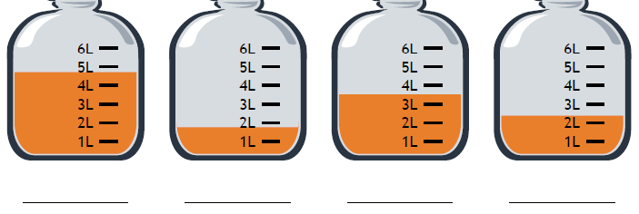

- Kristen is comparing the capacity of gas tanks in different size cars. Use the chart below to answer the questions.
20 L
30 L
40 L
50 L
60 L
70 L
80 L

Size of Car | Capacity in Liters
Large | 74
Medium | Medium  57
Small | 42

- Label the number line to show the capacity of each gas tank. The medium car has been done for you.

- Which car’s gas tank has the greatest capacity?

- Which car’s gas tank has the smallest capacity?

- Kristen’s car has a gas tank capacity of about 60 liters. Which car from the chart has about the same capacity as Kristen’s car?

- Use the number line to find how many more liters the large car’s tank holds than the small car’s tank.

