Lesson 9
Objective: Decompose a liter to reason about the size of 1 liter,
100 milliliters, 10 milliliters, and 1 milliliter.

Suggested Lesson Structure

A NOTE ON
STANDARDS ALIGNMENT:
In this lesson, students decompose 1 liter into milliliters following the same procedure used to decompose 1 kilogram into grams used in Lesson 6.
They make connections between metric units and the base ten place value system. The opportunity to make these connections comes from introducing milliliters, which the standards do not include until Grade 4 (4.MD.1). Although milliliters are used in Module 2, they are not assessed.

 Fluency Practice (4 minutes)
 Concept Development (46 minutes)
 Student Debrief (10 minutes)
Total Time (60 minutes)
Fluency Practice (4 minutes)
- Decompose 1 Kilogram 3.MD.2 (4 minutes)
Decompose 1 Kilogram (4 minutes)
Materials: (S) Personal white board
Note: Decomposing 1 kilogram using a number bond helps students relate part–whole thinking to measurement concepts.
T: (Project a number bond with 1 kg written as the whole.) There are 1,000 grams in 1 kilogram.
T: (Write 900 g as one of the parts.) On your personal white board, write a number bond by filling in the unknown part.
S: (Students draw number bond with 100 g, completing the unknown part.)
Continue with the following possible sequence: 500 g, 700 g, 400 g, 600 g, 300 g, 750 g, 650 g, 350 g, 250 g, 850 g, and 150 g.

NOTES ON
MATERIALS:
Maximize Part 1 by choosing odd-shaped containers, or ones that appear to hold less, for the quart and gallon comparisons. This will challenge students’ sense of conservation; they will likely predict that the shorter, wider container holds less than the bottle. Take the opportunity for discussion. How might a shampoo bottle fool you into thinking you are getting more for your money?

Concept Development (46 minutes)
Materials: (T) Beaker, 2-liter bottle (empty, top cut off, without label), ten-frame, 12 clear plastic cups (labeled A–L), dropper, one each of the following sizes of containers: cup, pint, quart, gallon (labeled 1, 2, 3, and 4, respectively) (S) Problem Set

Part 1: Compare the capacities of containers with different shapes and sizes.
T: (Measure 1 liter of water using a beaker. Pour it into the 2-liter bottle. Use a marker to draw a line at the water level in the bottle and label it 1 L. Have containers 1–4 ready.)
T: Which holds more water, a swimming pool or a glass?
S: A swimming pool!
T: Which holds more water, a swimming pool or a bathtub?
S: A swimming pool!
T: Which holds the least amount of water, a swimming pool, a bathtub, or a glass?
S: A glass holds the least amount of water.
T: The amount of liquid a container holds is called its capacity. The glass has the smallest capacity because it holds the least amount of water. (Show bottle.) Is this container filled to capacity?
S: No!
T: The amount of water inside measures 1 liter. A liter is a unit we use to measure amounts of liquid. To abbreviate the word liter, use a capital L. (Show the side of the bottle.) Use your finger to write the abbreviation in the air.
T: Let’s compare the capacities of different containers by pouring 1 liter into them to see how it fits. (Show Container 1 and the bottle side by side.) Talk to your partner. Predict whether Container 1 holds more than, less than, or about the same as 1 liter. Circle your prediction on Part 1, Problem A of your Problem Set.
S: (Discuss and circle predictions.)
T: I’ll pour water from the bottle into Container A to confirm our predictions. (Pour.) Is the capacity of Container 1 more than or less than 1 liter?
S: Less than 1 liter!
T: Does that match your prediction? What surprised you? Why?
S: (Discuss.)
T: Next to the word actual on Problem A, write less.
Repeat the process with Containers 2–4. (Container 2 holds less than 1 liter, Container 3 holds about the same as 1 liter, and Container 4 holds more than 1 liter.) Then have students complete Problem B.
Part 2: Decompose 1 liter.
T: (Arrange empty cups A–J on the ten-frame, shown on the next page. Measure and label the water level on Cup K at 100 milliliters and on Cup L at 10 milliliters.)
T: We just compared capacities using a liquid volume of 1 liter. We call an amount of liquid liquid volume. Whisper the words liquid volume.
S: Liquid volume.
T: Now, we’re going to decompose 1 liter into smaller units called milliliters. Say the word milliliter.
S: (Say the word.)
T: To abbreviate milliliter we write mL. (Model.) Write the abbreviation in the air.

NOTES ON
MULTIPLE MEANS
OF REPRESENTATION:
Support students in differentiating between the meanings of capacity and liquid volume. Capacity refers to a container and how much the container holds. Liquid volume refers to the amount of liquid itself.

T: We’ll decompose our liter into 10 equal parts. Each square of our ten-frame shows 1 part. (Show Cup K.) This cup is marked at 100 milliliters. We’ll use it to measure the liquid volume that goes into each cup on the ten-frame.
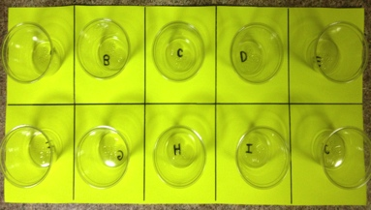
Labeled Cups A–J on a ten-frame.

A NOTE ON
STANDARDS ALIGNMENT:
The standards do not introduce milliliters until Grade 4 (4.MD.1).

T: (Use water from the bottle marked 1 L to fill Cup K to the 100 mL mark. Empty Cup K into Cup A.) How much water is in Cup A?
S: 100 milliliters!
T: (Repeat with Cups B–J.) How many cups are filled with 100 milliliters?
S: 10 cups!

NOTES ON
MULTIPLE MEANS
OF ENGAGEMENT:
As you decompose, pause to ask students to estimate whether you’ve poured more than half, half, or less than half of the liter. Encourage them to reason about estimations using the number of cups on the ten-frame.

T: Is there any water left in the bottle?
S: No!
T: We partitioned 1 liter of water into 10 parts, each with a liquid volume of about 100 milliliters. Skip-count hundreds to find the total milliliters on the ten-frame. (Point to each cup as students count.)
S: 100, 200, 300, 400, 500, 600, 700, 800, 900, 1,000.
T: How many milliliters of water are in 1 liter?
S: 1,000 milliliters!
T: Talk to your partner about how this equation describes our work. (Write: 1,000 mL ÷ 10 = 100 mL.)
S: (Discuss.)
T: Answer Problem C on your Problem Set. Include the equation written on the board.
S: (Students skip-count as 9 cups are emptied back into the bottle. Empty the final cup into Cup K.)
T: Let’s decompose again. This time we’ll pour the 100 milliliters in Cup K into 10 equal parts. (Show Cup L.) This cup is marked at 10 milliliters. We'll use it to measure the liquid volume that goes into each cup on the ten-frame. How many milliliters will be in each of the 10 cups?
S: 10 milliliters. 10 groups of 10 make100.
T: Cup L is marked at 10 milliliters. (Show Cups K and L side by side.) How do the marks on each cup compare?
S: The mark on Cup L is closer to the bottom.
T: Why is Cup L’s mark lower than Cup K’s?
S: Cup L shows 10 milliliters. That is less than 100 milliliters. Cup L shows a smaller liquid volume.
T: (Repeat the process of decomposing outlined above.)
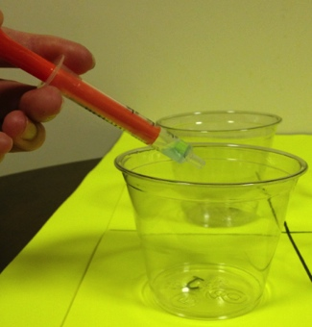
T: What number sentence represents dividing 100 milliliters into 10 parts?
Measure 1 mL with dropper.
S: 100 ÷ 10 = 10. 100 mL ÷ 10 = 10 mL.
T: (Write equation using units.) Complete Problem D on your Problem Set. Include the equation.
S: (Skip-count as 9 cups are emptied back into the bottle. Empty the final cup into Cup L. Repeat the process used for decomposing 100 milliliters into 10 milliliters, using a dropper to decompose 10 milliliters into cups of 1 milliliter.)
T: How many droppers full of water would it take to fill an entire liter of water?
S: 1,000 droppers full!
T: Answer Problem E. Include the equation.
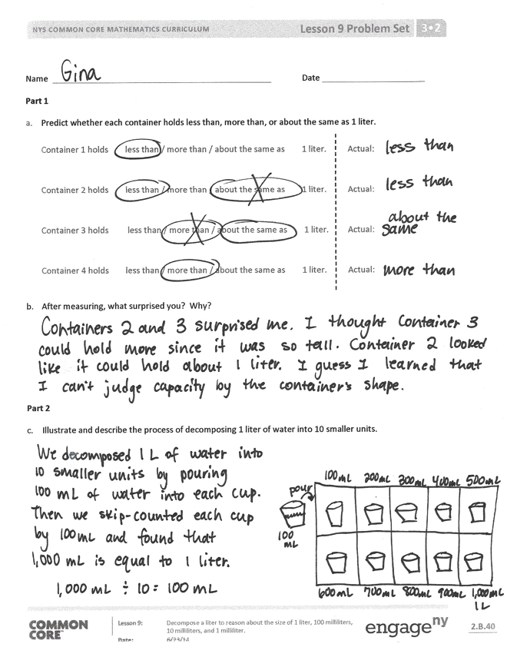
Problem Set (10 minutes)
Students should only need to complete Problems F and G. You may choose to work through these problems as a class, have students work in pairs, or have students work individually. Students should do their personal best to complete the remaining problems within the allotted 10 minutes.
Student Debrief (10 minutes)
Lesson Objective: Decompose a liter to reason about the size of 1 liter, 100 milliliters, 10 milliliters, and 1 milliliter.
The Student Debrief is intended to invite reflection and active processing of the total lesson experience.
Invite students to review their solutions for the problem set. They should check work by comparing answers with a partner before going over answers as a class. Look for misconceptions or misunderstandings that can be addressed in the Debrief. Guide students in a conversation to debrief the Problem Set and process the lesson.

You may choose to use any combination of the questions below to lead the discussion.
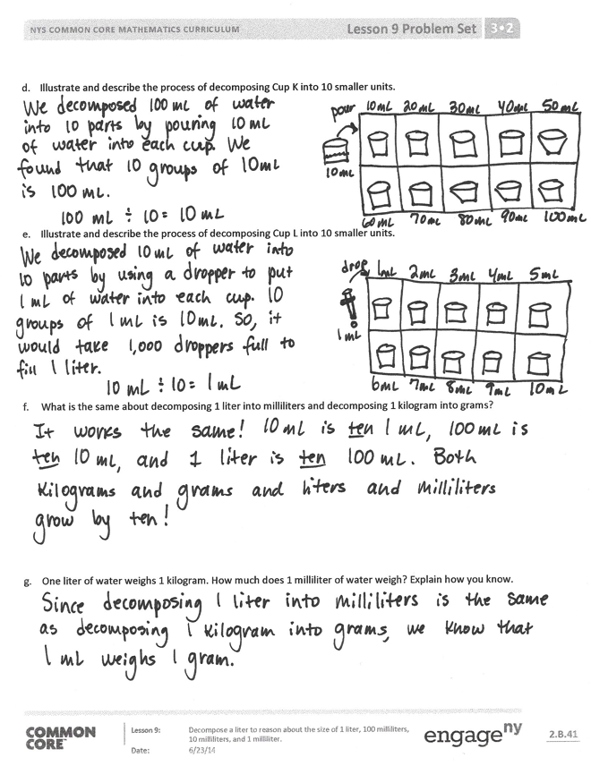
- Revisit predictions from Part 1. Lead a discussion about why students may have thought taller containers had larger capacities. Guide students to articulate understanding about conservation and capacity.
- Review the difference between capacity and liquid volume.
- In the equations for Part 2, why are the first number and quotient in each followed by the word milliliters? Why not the 10?
- How is decomposing 1 liter similar to decomposing 1 kilogram?
- How do our decompositions of 1 liter and 1 kilogram remind you of the place value chart?
Exit Ticket (3 minutes)
After the Student Debrief, instruct students to complete the Exit Ticket. A review of their work will help you assess the students’ understanding of the concepts that were presented in the lesson today and plan more effectively for future lessons. You may read the questions aloud to the students.

Name Date
Part 1
- Predict whether each container holds less than, more than, or about the same as 1 liter.

Container 1 holds less than / more than / about the same as 1 liter. Actual:

Container 2 holds less than / more than / about the same as 1 liter. Actual:

Container 3 holds less than / more than / about the same as 1 liter. Actual:

Container 4 holds less than / more than / about the same as 1 liter. Actual:

- After measuring, what surprised you? Why?

Part 2
- Illustrate and describe the process of decomposing 1 liter of water into 10 smaller units.

- Illustrate and describe the process of decomposing Cup K into 10 smaller units.

- Illustrate and describe the process of decomposing Cup L into 10 smaller units.

- What is the same about decomposing 1 liter into milliliters and decomposing 1 kilogram into grams?

- One liter of water weighs 1 kilogram. How much does 1 milliliter of water weigh? Explain how you know.

Name Date
- Morgan fills a 1-liter jar with water from the pond. She uses a 100-milliliter cup to scoop water out of the pond and pour it into the jar. How many times will Morgan scoop water from the pond to fill the jar?

- How many groups of 10 milliliters are in 1 liter? Explain.

There are _____________ groups of 10 mL in 1 liter.

Name Date
- Find containers at home that have a capacity of about 1 liter. Use the labels on containers to help you identify them.

Name of Container
Example: Carton of orange juice

- Sketch the containers. How do their sizes and shapes compare?

- The doctor prescribes Mrs. Larson 5 milliliters of medicine each day for 3 days. How many milliliters of medicine will she take altogether?

- Mrs. Goldstein pours 3 juice boxes into a bowl to make punch. Each juice box holds 236 milliliters.
How much juice does Mrs. Goldstein pour into the bowl?

- Daniel’s fish tank holds 24 liters of water. He uses a 4-liter bucket to fill the tank. How many buckets of water are needed to fill the tank?

- Sheila buys 15 liters of paint to paint her house. She pours the paint equally into 3 buckets.
How many liters of paint are in each bucket?

