Lesson 8

Objective: Solve one-step word problems involving metric weights within 100 and estimate to reason about solutions.

Suggested Lesson Structure

 Fluency Practice (8 minutes)

 Concept Development (42 minutes)

 Student Debrief (10 minutes)

**Total Time (60 minutes)**

Fluency Practice (8 minutes)

* Divide Grams and Kilograms  **3.MD.2** (2 minutes)
* Determine the Unit of Measure **3.MD.2** (2 minutes)
* Group Counting **3.OA.1** (4 minutes)

Divide Grams and Kilograms (2 minutes)

Note: This activity reviews the decomposition of 1 kg, 100 g, and 10 g from Lesson 6, as well as division skills using units of 10 from Module 1.

T: (Project 10 g ÷ 10 = ___.) Read the division sentence.

S: 10 grams ÷ 10 = 1 gram.

|  |  |
| --- | --- |
|  | NOTES ON  MULTIPLE MEANS  OF REPRESENTATION: |
| Provide a visual. Use a place value chart to model the division, making an explicit connection between metric weight measurement and the base ten system. | |

Continue with the following possible sequence: 100 g ÷ 10 and   
1,000 g ÷ 10.

Determine the Unit of Measure (2 minutes)

Note: This activity reviews the difference in size between grams and kilograms as units of measurement from Lesson 7.

T: I’ll name an object. You say if it should be measured in grams or kilograms. Apple.

S: Grams.

Continue with the following possible sequence: carrot, dog, pencil, classroom chair, car tire, and paper clip.

Group Counting (4 minutes)

Note: Group counting reviews interpreting multiplication as repeated addition. The group counting in this activity reviews foundational multiplication strategies from Module 1 and anticipates units used in Module 3.

Direct students to count forward and backward, occasionally changing the direction of the count:

* Threes to 30
* Fours to 40
* Sixes to 60
* Sevens to 70
* Eights to 80
* Nines to 90

As students become more fluent with skip-counting by a particular unit, have them track the number of groups counted on their fingers.

Concept Development (42 minutes)

Materials: (T) Spring scale, digital scale (S) Spring scales that measure grams, personal white board, 1-kg bag of rice, pinto beans (baggie of 80 beans per pair), popcorn kernels (baggie of 30 kernels per pair)

Problem 1: Solve one-step word problems using addition.

Pairs of students have spring scales and baggies of pinto beans and popcorn kernels.

T: Let’s use spring scales to weigh our beans and kernels. Should we use grams or kilograms?

S: Grams!

T: Compare the feel of 80 pinto beans and 30 popcorn kernels. Which do you think weighs more?

S: (Pick up bags and estimate.)

T: Work with your partner to weigh the beans and kernels. Record the measurements on your board.

S: (Weigh and record. Beans will weigh about 28 grams and kernels will weigh about 36 grams.)

T: Was your estimation correct? Tell your partner.

S: (Share.)

T: Let’s add to find the total weight of the beans and kernels. Solve the problem on your personal white board.

S: (Solve.)

T: I noticed someone used a simplifying strategy to add. She noticed that 28 grams is very close to   
30 grams. Thirty is an easier number to add than 28. Watch how she made a ten to add.   
(Model sequence below.)

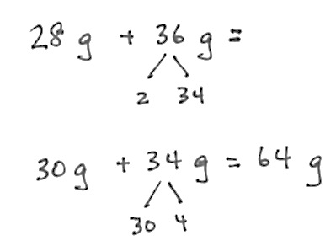

|  |  |
| --- | --- |
|  | NOTES ON  MULTIPLE MEANS  OF ACTION AND EXPRESSION: |
| Depending on timing and the variety of strategies used to solve, you may want to select a few students to share work. | |

T: How might this strategy help us solve other similar problems using mental math?

S: From 28 it was easy to make 30, so I guess when there’s a number close to a ten, like 39 or 58, we can just get 1 or 2 out of the other number to make a ten. 🡪 Yeah, it is easy to add tens like 20, 30, 40. 🡪 So, 49 + 34 becomes 49 + 1 + 33, then 50 + 33 = 88. 🡪 Oh! One just moved from 34 to 49!

T: Tell your partner how we could have used our scales to find the total weight.

S: We could have weighed the beans and kernels together!

T: Do that now to check your calculation.

Problem 2: Solve one-step word problems using subtraction.

T: (Project this *compare lesser (smaller) unknown problem with result unknown* problem.) Lindsey wants to ride the roller coaster. The minimum weight to ride is 32 kilograms. She weighs 14 kilograms less than the required weight. How many kilograms does Lindsey weigh?

T: Work with your partner to draw and write an equation to model the problem.

S: (Model.)

|  |  |
| --- | --- |
|  | NOTES ON  MULTIPLE MEANS  OF ENGAGEMENT: |
| Adjust students’ level of independence to provide an appropriate challenge. You may find it works well for some students to work on their own and for others to work in pairs.  An intermediate level of scaffolding might be for students to work in pairs, with each partner solving one of the two problems. Then partners can check each other’s work and compare strategies. *Result unknown* problems are usually easiest. Assign problems strategically. | |

T: How will you solve? Why will you do it that way?

S: (Discuss. Most will likely agree on subtraction:   
32 kg – 14 kg.)

T: Talk with your partner about how you might use tens to make a simplifying strategy for solving.

S: How about 32 – 10 – 4? 🡪 Or we could break 14 into 10 + 2 + 2. Then it’s easy to do 32 – 2 – 10 – 2.

T: Solve the problem now. (Select one to two pairs of students to demonstrate their work.)

As time allows, repeat the process.

* *Take from with result unknown*: Ms. Casallas buys a new cabinet for the classroom. It comes in a box that weighs 42 kilograms. Ms. Casallas unpacks pieces that total 16 kilograms. How much does the box weigh now?
* *Take from with change unknown*: Mr. Flores weighs 73 kilograms. After exercising every day for 6 weeks, he loses weight. Now he weighs 67 kilograms. How much weight did he lose?

Problem 3: Solve one-step word problems using multiplication.

T: Let’s use a digital scale to measure the weight of Table 1’s supply box. (Model weighing.)

T: It weighs about 2 kilograms. Talk with your partner. Is it reasonable to suppose that the supply boxes at each table weigh about 2 kilograms?

S: No, because ours has more crayons than the blue table’s. 🡪 But it’s not very many crayons and they don’t weigh very much. Besides, the teacher said *about* 2 kilograms. 🡪 It’s reasonable because they are the same box, and they all have almost the exact same things in them.

**MP.4**

T: How are we using a simplifying strategy by supposing that each of the boxes weighs about   
2 kilograms?

S: It’s simpler because we don’t have to weigh everything. 🡪 It’s simplifying because then we can just multiply the number of boxes times 2 kilograms. Multiplying by two is easier than adding a bunch of different numbers together.

T: Partner A, model and solve this problem. Explain your solution to Partner B. Partner B, check your friend’s work. Then write and solve a different multiplication sentence to show the problem. Explain to, or model for, Partner A why your multiplication sentence makes sense, too.

S: (Partner A models and writes 6 × 2. Partner B checks work and writes and explains 2 × 6.)

As time allows, repeat the process with the following suggested *equal measures with unknown product* problems.

* Jerry buys 3 bags of groceries. Each bag weighs 4 kilograms. How many kilograms do Jerry’s grocery bags weigh in all?
* A dictionary weighs 3 kilograms. How many kilograms do 9 dictionaries weigh?

Problem 4: Solve one-step word problems using division.

T: (Project this *equal measures with group size unknown* problem.) Eight chairs weigh 24 kilograms. What is the weight of 1 chair? Work with your partner to model or write an equation to represent the problem.

S: (Model and/or write 24 8 = .)

T: What will be your strategy for solving?

S: We can skip-count by eights just like we practiced in today’s Fluency!

As time allows, repeat the process.

* *Equal measures with group size unknown*:   
  Thirty-six kilograms of apples are equally distributed into 4 crates. What is the weight of each crate?
* *Equal measures with number of groups unknown*: A tricycle weighs 8 kilograms. The delivery truck is almost full but can hold 40 kilograms more. How many more tricycles can the truck hold?

Problem Set (10 minutes)

Students should do their personal best to complete the Problem Set within the allotted 10 minutes. For some classes, it may be appropriate to modify the assignment by specifying which problems they work on first. Some problems do not specify a method for solving. Students should solve these problems using the RDW approach used for Application Problems.

Student Debrief (10 minutes)

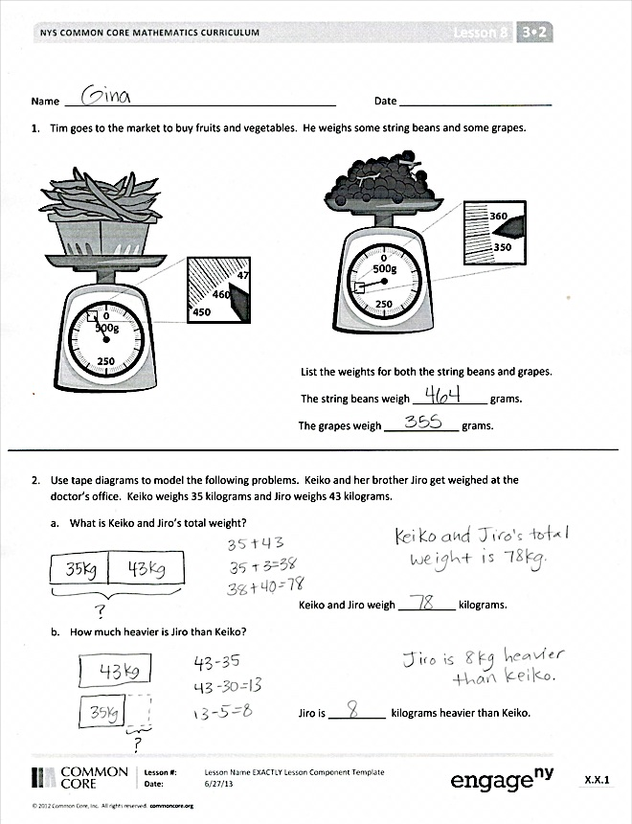





**Lesson Objective:** Solve one-step word problems involving metric weights within 100 and estimate to reason about solutions.

The Student Debrief is intended to invite reflection and active processing of the total lesson experience. Invite students to review their solutions for the Problem Set.   
  
They should check work by comparing answers with a partner before going over answers as a class. Look for misconceptions or misunderstandings that can be addressed in the Debrief. Guide students in a conversation to debrief the Problem Set and process the lesson.

You may choose to use any combination of the questions below to lead the discussion.

* How did your tape diagrams change in Problems 2(a) and 2(b)?
* Explain to your partner the relationship between Problem 2(a) and Problem 2(b).
* How did today’s Fluency Practice help you with problem solving during the Concept Development?

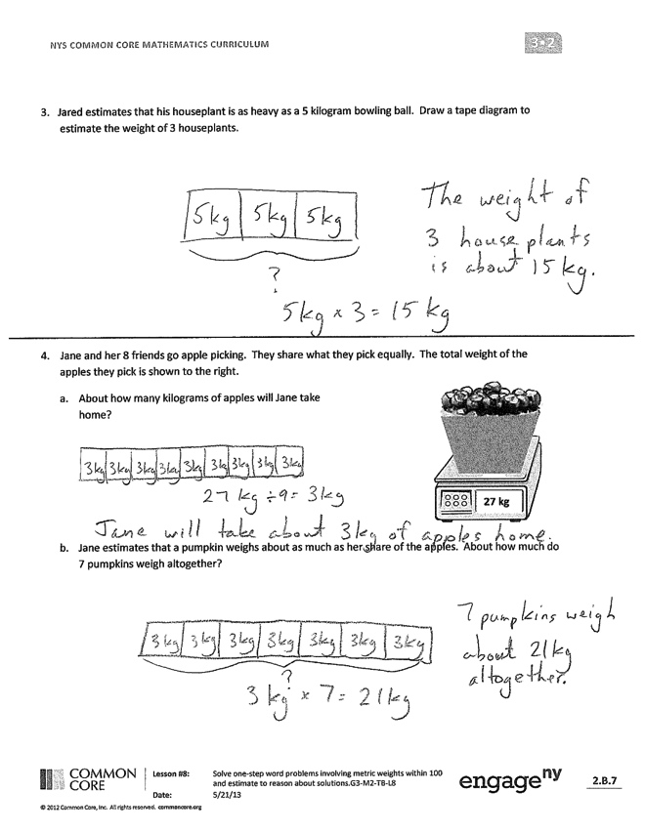







* Select students to share simplifying strategies or mental mathstrategies they used to solve problems in the Problem Set. If no one used a special strategy or mental math, brainstorm about alternative ways for solving Problem 2.

Exit Ticket (3 minutes)

After the Student Debrief, instruct students to complete the Exit Ticket. A review of their work will help you assess the students’ understanding of the concepts that were presented in the lesson today and plan more effectively for future lessons. You may read the questions aloud to the students.

Name Date

1. Tim goes to the market to buy fruits and vegetables. He weighs some string beans and some grapes.

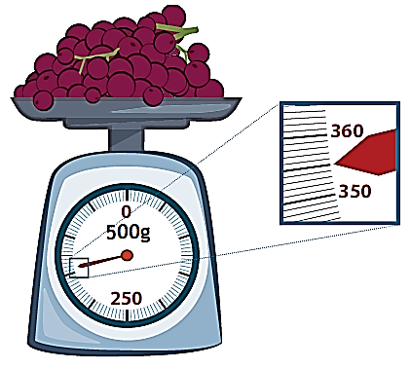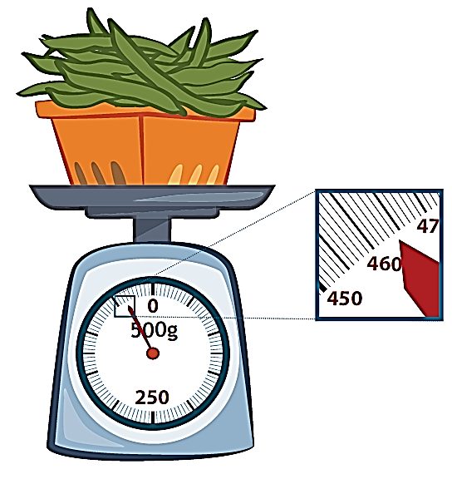

List the weights for both the string beans and grapes.

The string beans weigh _____________ grams.

The grapes weigh _____________ grams.

2. Use tape diagrams to model the following problems. Keiko and her brother Jiro get weighed at the doctor’s office. Keiko weighs 35 kilograms and Jiro weighs 43 kilograms.

a. What is Keiko and Jiro’s total weight?

Keiko and Jiro weigh __________ kilograms.

b. How much heavier is Jiro than Keiko?

Jiro is __________ kilograms heavier than Keiko.

3. Jared estimates that his houseplant is as heavy as a 5-kilogram bowling ball. Draw a tape diagram to estimate the weight of 3 houseplants.

4. Jane and her 8 friends go apple picking. They share what they pick equally. The total weight of the apples they pick is shown to the right.

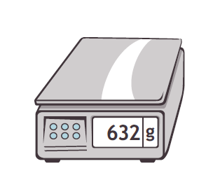

**27 kg**



1. About how many kilograms of apples will Jane take home?

1. Jane estimates that a pumpkin weighs about as much as her share of the apples. About how much do 7 pumpkins weigh altogether?

Name Date

The weights of a backpack and suitcase are shown below.



21 kg

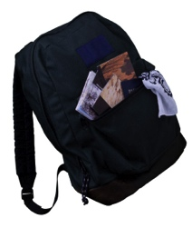

7 kg

* + - * 1. How much heavier is the suitcase than the backpack?

1. What is the total weight of 4 identical backpacks?

1. How many backpacks weigh the same as one suitcase?

Name Date

1. The weights of 3 fruit baskets are shown below.



Basket C

16kg



Basket B

8kg



Basket A

12kg

1. Basket ______ is the heaviest.
2. Basket ______ is the lightest.
3. Basket A is __________ kilograms heavier than Basket B.
4. What is the total weight of all three baskets?
5. Each journal weighs about 280 grams. What is total weight of 3 journals?
6. Ms. Rios buys 453 grams of strawberries. She has 23 grams left after making smoothies. How many grams of strawberries did she use?
7. Andrea’s dad is 57 kilograms heavier than Andrea. Andrea weighs 34 kilograms.
8. How much does Andrea’s dad weigh?

1. How much do Andrea and her dad weigh in total?



**28 kg**

1. Jennifer’s grandmother buys carrots at the farm stand. She and her 3 grandchildren equally share the carrots. The total weight of the carrots she buys is shown below.

a. How many kilograms of carrots will Jennifer get?

1. Jennifer uses 2 kilograms of carrots to bake muffins. How many kilograms of carrots does she have left?