Lesson 7
Objective: Develop estimation strategies by reasoning about the weight
in kilograms of a series of familiar objects to establish mental benchmark measures.

Suggested Lesson Structure
 Fluency Practice (10 minutes)
 Application Problem (3 minutes)
 Concept Development (37 minutes)
 Student Debrief (10 minutes)
Total Time (60 minutes)
Fluency Practice (10 minutes)
- Group Counting 3.OA.1 (4 minutes)
- Decompose 1 Kilogram 3.MD.2 (4 minutes)
- Gram Counting 3.MD.2 (2 minutes)
Group Counting (4 minutes)
Note: Group counting reviews interpreting multiplication as repeated addition. The counting by groups in this activity reviews foundational strategies for multiplication from Module 1 and anticipates Module 3.
Direct students to count forward and backward, occasionally changing the direction of the count using the following suggested sequence:
- Threes to 30
- Fours to 40
- Sixes to 60
- Sevens to 70, emphasizing the transition from 63 to 70
- Eights to 80, emphasizing the transition from 72 to 80
- Nines to 90, emphasizing the transition from 81 to 90
As students improve with skip-counting, e.g., 7, 14, 21, 28, etc., have them keep track of how many groups they have counted on their fingers. Keep asking them to say the number of groups, e.g., “24 is how many threes?” “63 is how many sevens?”

Decompose 1 Kilogram (4 minutes)
Materials: (S) Personal white board
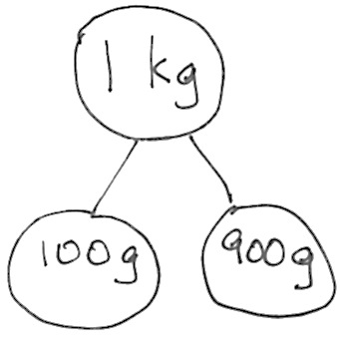
Note: Decomposing 1 kilogram using a number bond helps students relate part–whole thinking to measurement concepts. It also sets the foundation for work with fractions.
T: (Project a number bond with 1 kg written as the whole.) There are
1,000 grams in 1 kilogram.
T: (Write 900 grams as one of the parts.) On your personal white board, write a number bond filling in the unknown part.
S: (Draw number bond with 100 g, completing the unknown part.)
Continue with the following possible sequence: 500 g, 700 g, 400 g, 600 g, 300 g, 750 g, 650 g, 350 g, 250 g, 850 g, and 150 g. Do as many as possible within the four minutes allocated for this activity.
Gram Counting (2 minutes)
Note: This activity reviews Lesson 6 and lays a foundation for Grade 4 when students compose compound units of kilograms and grams.
T: There are 1,000 grams in 1 kilogram. Count by 100 grams to 1 kilogram.
S: 100 grams, 200 grams, 300 grams, 400 grams, 500 grams, 600 grams, 700 grams, 800 grams,
900 grams, 1 kilogram.
Application Problem (3 minutes)
Justin put a 1-kilogram bag of flour on one side of a pan balance. How many 100-gram bags of flour does he need to put on the other pan to balance the scale?
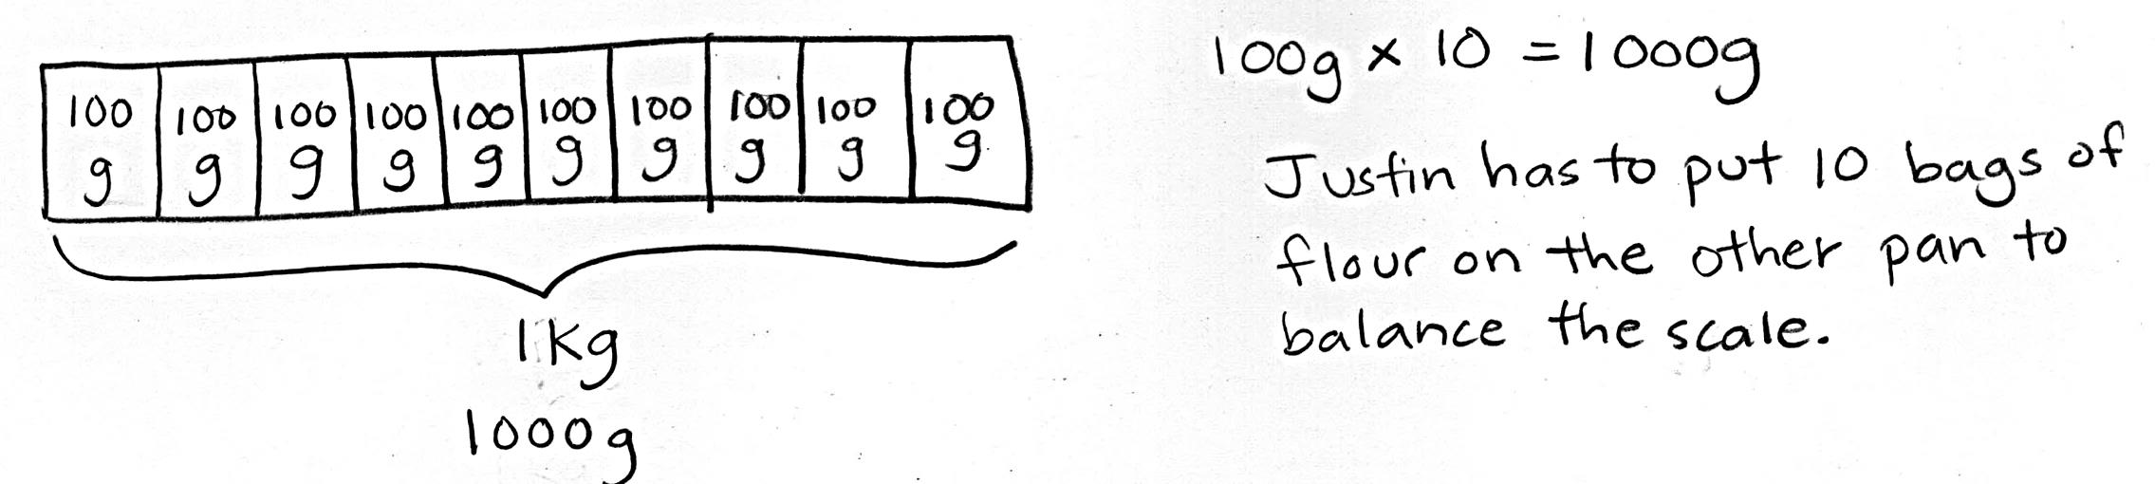

Note: This problem reviews the decomposition of 1 kilogram and the vocabulary words kilogram and gram from Lesson 6. The student work shows exemplary work. Students may also solve with repeated addition or skip-counting. Invite discussion by having students share a variety of strategies.
Concept Development (37 minutes)
Materials: (T) Digital scale in grams (S) Metric spring scale

NOTES ON
SCALES:
The scales available to you may be different from those used in the vignette. Change the directions as necessary to match the tools at your disposal.
Unlike a clock, a spring scale may be labeled in different ways. This adds the complexity that the value of the whole may change, therefore changing the value of the interval.
Part 1: Become familiar with scales.
Draw or project spring scales shown below on the board.
T: (Show spring scale. See illustration in Module Overview.) This is a spring scale. There is a g on this scale. That means it can be used to measure grams. Other spring scales measure in kilograms. I’ve drawn some on the board. (See examples below.)
T: (Point to the first drawing.) This scale shows the weight of a bowl of apples. Each interval on this scale represents 1 kilogram. How much does the bowl of apples weigh?
S: 3 kilograms.
T: Talk to your partner. Where would the arrow point if it weighed 1 kilogram? 4 kilograms?
T: Look at the next scale, weighing rice. Each interval on this scale represents 500 grams. How much does the bag of rice weigh?
S: 1,000 grams. 1 kilogram.
T: Talk to your partner about how this scale would show 3 kilograms. What about 5 kilograms?
T: On the last scale, 5 intervals represent 500 grams. How much does 1 interval represent?
S: 100 grams!
T: Let’s count grams on this scale to find 1 kilogram. (Move finger and count 100 grams, 200 grams, 300 grams, etc.)
T: Where is 1 kilogram on this scale? 200 grams?
S: (Discuss.)
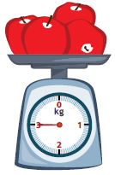
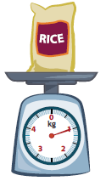
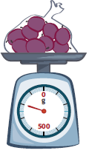

T: (Pass out spring scales that measure in grams.) This scale is labeled in intervals of 200.
Skip-count by two-hundreds to find how many grams the scale can measure.
S: (Point and skip-count.) 200, 400, 600, 800, 1,000, 1,200, 1,400, 1,600, 1,800, 2,000.
T: This scale can measure 2,000 grams. That means that each tick mark represents 20 grams.
Working with a partner, start at 0 and skip-count by twenties to find the 100-gram mark on this scale.
S: (Work with a partner and skip-count to 100.) 20, 40, 60, 80, 100.
Continue having students locate weights on this scale with the following possible sequence: 340 g, 880 g,
and 1,360 g.
T: To accurately measure objects that weigh less than 20 grams, we are going to use a digital scale. (Show digital scale.) Remember from yesterday, to measure weight on this scale, you read the number on the display screen. (Point to display screen.) There is a g next to the display screen which means that this scale measures in grams. (Model measuring.)
T: We’ll use both a spring scale and a digital scale in today’s exploration.
Part 2: Exploration Activity

NOTES ON
MULTIPLE MEANS
OF ACTION AND EXPRESSION:
Comparative language is often difficult for English language learners. Depending on your class, pre-teach the vocabulary and provide students with sentence frames.
Students begin to use estimation skills as they explore the weight of 1 kilogram. In one hand, they hold a 1-kilogram weight, and with the other, they pick up objects around the room that they think weigh about the same as 1 kilogram. Students determine whether the objects weigh less than, more than, or about the same as 1 kilogram. Encourage students to use the italicized comparative language. Next, they weigh the objects using scales and compare their estimates with precise measurements. They repeat this process using 100 gram, 10 gram, and 1 gram weights.
Demonstrate the process of using the kilogram weight. For example, pick up the 1-kilogram weight and a small paperback book. Think out loud so the students can hear you model language and thinking to estimate that the book weighs less than 1 kilogram. Repeat the process with an object that weighs more than and about the same as 1 kilogram.
Problem Set (20 minutes)

NOTES ON
MULTIPLE MEANS
OF REPRESENTATION:
Review directions with students before they begin. Use prompts to get them to stop and think before moving to the next step, e.g., “Who remembers the next step?”
Materials: (S) 1 kg, 100 g, 10 g, and 1 g weights (or
pre-measured and labeled bags of rice corresponding to each measurement), spring scale that measures up to 2,000 grams, metric digital
Side 1 of the Problem Set is used for the lesson’s exploration. Students should complete Side 2 independently or with a partner.

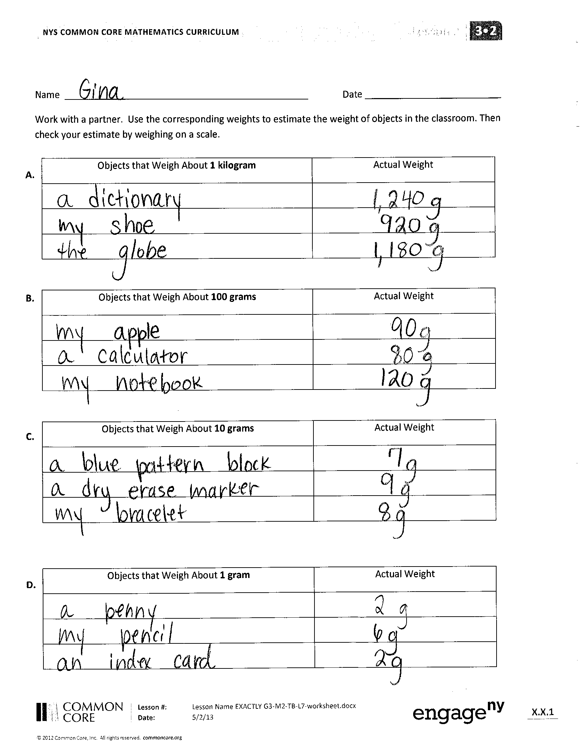
Student Debrief (10 minutes)
Lesson Objective: Develop estimation strategies by reasoning about the weight in kilograms of a series of familiar objects to establish mental benchmark measures.
The Student Debrief is intended to invite reflection and active processing of the total lesson experience.
Invite students to review their solutions for the Problem Set. They should check work by comparing answers with a partner before going over answers as a class. Look for misconceptions or misunderstandings that can be addressed in the Debrief. Guide students in a conversation to debrief the Problem Set and process the lesson.
You may choose to use any combination of the questions below to lead the discussion.
- How did you use the 1 kilogram, 100 gram,
10 gram, and 1 gram weights to help you estimate the weights of objects in the classroom?
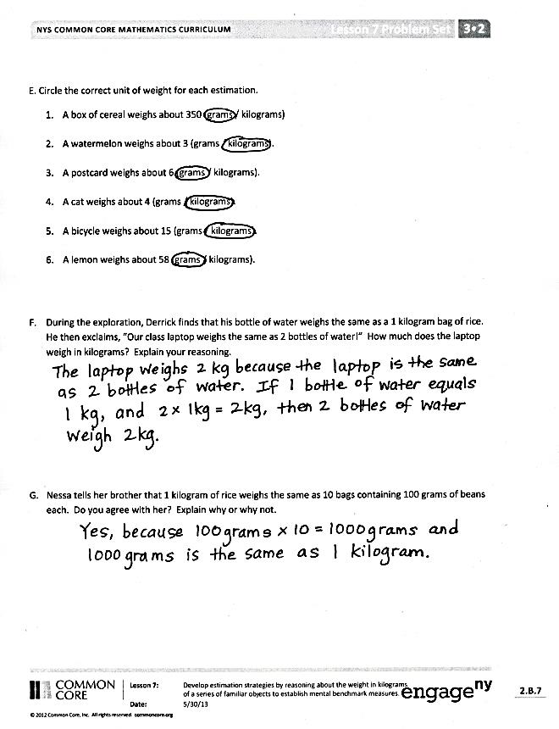
- Today you used a spring scale and a digital scale to measure objects. How are these scales used differently than the pan balance from yesterday’s lesson?

- Did anyone find an object that weighs exactly
1 kilogram? What object? (Repeat for
100 grams, 10 grams, and 1 gram.)
- Look at Problem D. List some of the actual weights you recorded (there should be a huge variation in weights for this problem).
Why do you suppose there are a small number of weights very close to 1 gram?
- Discuss Problem E with a partner. How did you determine which estimation was correct for each object?
- Discuss Problem F. (This problem anticipates the introduction of liters in Lessons 9 and 10, hinting at the weight equivalence of 1 liter of water and 1 kilogram.)
- Problem G reminds me of a riddle I know: What weighs more, 1 kilogram of bricks or 1 kilogram of feathers? Think about the relationship between the beans and rice in Problem G to help you answer this riddle.
Exit Ticket (3 minutes)
After the Student Debrief, instruct students to complete the Exit Ticket. A review of their work will help you assess the students’ understanding of the concepts that were presented in the lesson today and plan more effectively for future lessons. You may read the questions aloud to the students.

Name Date
Work with a partner. Use the corresponding weights to estimate the weight of objects in the classroom. Then, check your estimate by weighing on a scale.
A.

B.

C.

D.

Objects that Weigh About 1 Kilogram | Actual Weight

Objects that Weigh About 100 Grams | Actual Weight

Objects that Weigh About 10 Grams | Actual Weight

Objects that Weigh About 1 Gram | Actual Weight

- Circle the correct unit of weight for each estimation.
- A box of cereal weighs about 350 (grams / kilograms).

- A watermelon weighs about 3 (grams / kilograms).

- A postcard weighs about 6 (grams / kilograms).

- A cat weighs about 4 (grams / kilograms).

- A bicycle weighs about 15 (grams / kilograms).

- A lemon weighs about 58 (grams / kilograms).

- During the exploration, Derrick finds that his bottle of water weighs the same as a 1-kilogram bag of rice. He then exclaims, “Our class laptop weighs the same as 2 bottles of water!” How much does the laptop weigh in kilograms? Explain your reasoning.

- Nessa tells her brother that 1 kilogram of rice weighs the same as 10 bags containing 100 grams of beans each. Do you agree with her? Explain why or why not.

Name Date
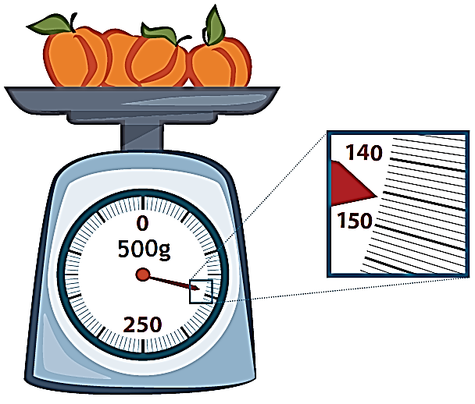
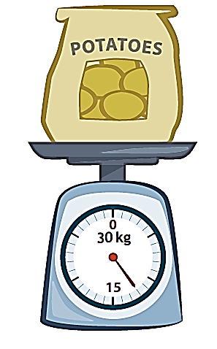
- Read and write the weights below. Write the word kilogram or gram with the measurement.

- Circle the correct unit of weight for each estimation.
- An orange weighs about 200 (grams / kilograms).

- A basketball weighs about 624 (grams / kilograms).

- A brick weighs about 2 (grams / kilograms).

- A small packet of sugar weighs about 4 (grams / kilograms).

- A tiger weighs about 190 (grams / kilograms).

Name Date
- Match each object with its approximate weight.

100 grams
10 grams
1 gram
1 kilogram

- Alicia and Jeremy weigh a cell phone on a digital scale. They write down 113 but forget to record the unit. Which unit of measurement is correct, grams or kilograms? How do you know?

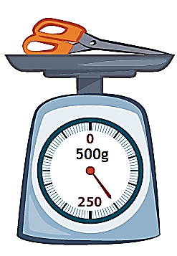
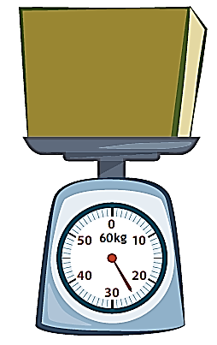
- Read and write the weights below. Write the word kilogram or gram with the measurement.

