Lesson 6

Objective: Build and decompose a kilogram to reason about the size and weight of 1 kilogram, 100 grams, 10 grams, and 1 gram.

Suggested Lesson Structure

 Fluency Practice (3 minutes)

 Concept Development (47 minutes)

 Student Debrief (10 minutes)

**Total Time (60 minutes)**

Fluency Practice (3 minutes)

* Tell Time on the Clock **3.MD.1** (3 minutes)

Tell Time on the Clock (3 minutes)

Materials: (T) Analog clock for demonstration (S) Personal white board

Note: This activity provides additional practice with the newly learned skill of telling time to the nearest minute.

T: (Show an analog demonstration clock.) Start at 12 and count by 5 minutes on the clock.   
(Move finger from 12 to 1, 2, 3, 4, etc., as students count.)

S: 5, 10, 15, 20, 25, 30, 35, 40, 45, 50, 55, 60.

T: I’ll show a time on the clock. Write the time on your personal white board. (Show 7:13.)

S: (Write 7:13.)

T: (Show 6:47.)

S: (Write 6:47.)

Repeat process, varying the hour and minute so that students read and write a variety of times to the nearest minute.

Concept Development (47 minutes)

|  |  |
| --- | --- |
|  | NOTES ON  MATERIALS: |

You may decide to make the   
1-kilogram benchmark bag of beans hold rice instead. This way students can use the beans to compose their own 1-kilogram bag rather than rice. Beans may be easier for students to pour and clean up in case of a spill. The purpose of using beans and rice is for students to see that 1 kilogram is not just made by rice.

Materials: (T) 1-kilogram weight, 1-kilogram benchmark bag of beans (S) 1-kilogram benchmark bag of beans (one per pair of students), digital metric scale, pan balance, rice,   
gallon-sized sealable bags, dry-erase marker, Problem Set

Part 1: Use a pan balance to make a bag of rice that weighs 1 kilogram.

T: Today we are going to explore a **kilogram**. It’s a unit used to measure weight. (Write the word *kilogram* on the board.) Whisper *kilogram* to a partner.

S: Kilogram.

T: (Pass out a 1-kilogram bag of beans to each pair of students.) You are holding 1 kilogram of beans. To record 1 kilogram, we abbreviate the word kilogram by writing *kg*. (Write *1 kg* on the board.) Read this weight to a partner.

|  |  |
| --- | --- |
|  | NOTES ON  MULTIPLE MEANS  OF REPRESENTATION: |

Pre-teach new vocabulary and abbreviations whenever possible, making connections to students’ prior knowledge. Highlight the similarities between *kilogram* and *kg* to aid comprehension and correct usage.

S: 1 kg. 🡪 1 kilogram.

T: (Show pan balance. See illustration in Module Overview.) This is a pan balance. Watch what happens when I put a 1-kilogram weight on one of the pans. (Turn and talk.) What will happen when I put a   
1-kilogram bag of beans on the other pan?

T: (Put the beans on the other side of the pan balance.) How do we know it’s balanced now?

S: Both sides are the same. 🡪 Both pans have the same amount on them. That makes it balanced. 🡪 Both pans have 1 kilogram on them, so they are equal which balances the scale.

|  |  |
| --- | --- |
|  | NOTES ON  MULTIPLE MEANS  OF ENGAGEMENT: |

Provide a checklist of the steps to support students in monitoring their own progess.

T: (Provide pan balances, gallon-sized sealable bags, and rice.) Work with a partner.

1. Put a 1-kilogram bag of beans on one of the pans.
2. Put the empty bag on the other side and add rice to it until the pan balance is balanced.
3. Answer Problem 1 on the Problem Set.

Part 2: Decompose 1 kilogram.

Students work in pairs.

T: Be sure your bag is sealed, then lay it flat on your desk.   
Move the rice to smooth it out until it fills the bag.

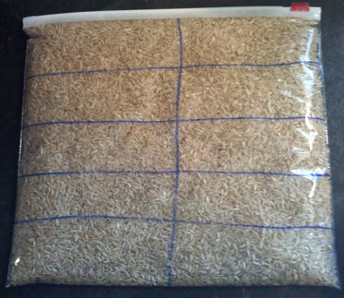

*Decompose 1 kg into 10 groups of 100 g.*

T: Using your dry erase marker, estimate to draw a ten-frame that covers the whole bag of rice. (Ten-frame drawn on the bag at right.)

T: The whole bag contains 1 kilogram of rice. We just decomposed the rice into 10 equal parts. These equal parts can be measured with a smaller unit of weight called **grams**. (Write *grams* on the board.) Whisper the word *grams* to your partner.

S: Grams.

T: Each part of the ten-frame is about 100 grams of rice. To record 100 grams, we can abbreviate using the letter *g*. (Write 100 g on the board.) Write 100 g in each part of the ten-frame.

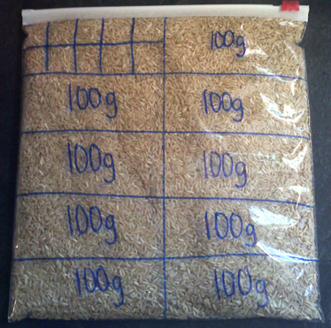

*Decompose 100 g into 10 groups of 10 g.*

T: How many hundreds are in 1 kilogram of rice?

S: 10 hundreds!

T: Let’s skip-count hundreds to find how many grams of rice are in the whole bag. Point to each part of the ten-frame as we skip-count.

S: (Point and skip-count.) 100, 200, 300, 400, 500, 600, 700, 800, 900, 1,000.

T: How many grams of rice are in the whole bag?

S: 1,000 grams!

T: One kilogram of rice is the same as 10 hundreds, or 1,000 grams, of rice.

T: A digital scale helps us measure the weight of objects. Let’s use it to measure 100 grams of rice. To measure weight on this scale, you read the number on the display screen. There is a *g* next to the display screen which means that this scale measures in grams. Put an empty cup on your digital scale. Carefully scoop rice from your bag into the cup until the scale reads 100 g.

T: How many grams are still in your bag?

S: 900 grams.

T: How many grams are in your cup?

S: 100 grams.

T: Turn and talk to a partner, will your bag of rice balance the pan balance with the 1-kilogram bag of beans? Why or why not?

T: Check your prediction by using the pan balance to see if the bag of rice balances with the bag of beans.

S: (Use pan balance to see that the bags are not balanced anymore.)

T: Carefully set the cup of rice on the same pan as the bag of rice. Is it balanced now?

S: Yes, because both sides are 1 kilogram!

T: Pour the rice from the cup back into the bag. How many grams are in the bag?

S: 1,000 grams.

T: Answer Problem 2 on your Problem Set.

Follow the same process to further decompose:

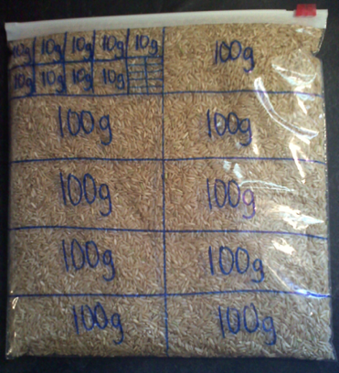

*Decompose 10 g into 10 groups of 1 g.*

* Decompose 100 grams into 10 groups of 10 grams by drawing a new ten-frame within 1 part of the first ten-frame (shown right). Use the digital scale to scoop 100 grams into a cup again and then scoop 10 grams into another cup. How many grams are left in the first cup? How many grams are in the smaller cup? Students pour the rice back into the bag and answer Problem 3.
* Decompose 10 grams into 10 groups of 1 gram by drawing a new ten-frame within 1 part of the second ten-frame (shown at right). Have a discussion about the difficulty of weighing 1 gram using the previous method. Students answer Problem 4.

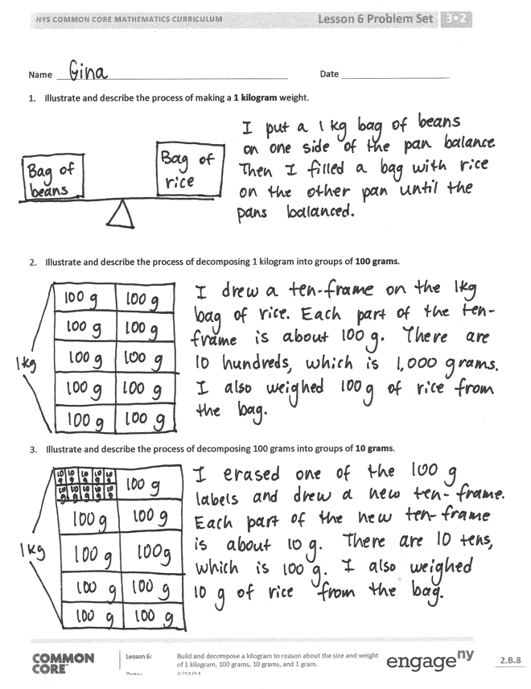Problem Set (5 minutes)

Problems 1–4 in the Problem Set are intended to be completed during the Concept Development. Students can use this time to complete Problem 5.

Student Debrief (10 minutes)

**Lesson Objective:** Build and decompose a kilogram to reason about the size and weight of 1 kilogram,   
100 grams, 10 grams, and 1 gram.

The Student Debrief is intended to invite reflection and active processing of the total lesson experience.

Invite students to review their solutions for the Problem Set. They should check work by comparing answers with a partner before going over answers as a class. Look for misconceptions or misunderstandings that can be addressed in the Debrief. Guide students in a conversation to debrief the Problem Set and process the lesson.

You may choose to use any combination of the questions below to lead the discussion.

* 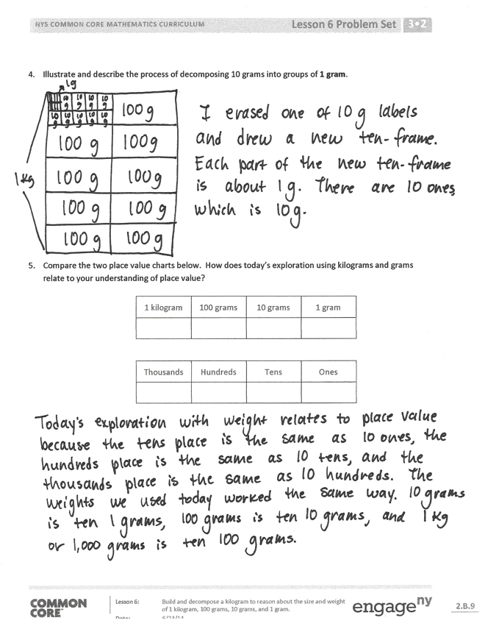How are the units **kilogram** and **gram** similar? How are they different?
* Explain to a partner how you used a pan balance to create a bag of rice that weighed   
  1 kilogram.
* Could we have used the digital scale to create a bag of rice that weighs 1 kilogram? Why or why not?
* How many equal parts were there when you decomposed 1 kilogram into groups of 100 grams? 100 grams into groups of 10 grams? 10 grams into groups of 1 gram? How does this relationship help you answer Problem 5?
* What new math vocabulary did we use today to communicate precisely about weight?

**MP.6**

* At the beginning of our lesson, we used a number bond to show an hour in two parts that together made the whole. How did we also show parts that together made a whole kilogram?

Exit Ticket (3 minutes)

After the Student Debrief, instruct students to complete the Exit Ticket. A review of their work will help you assess the students’ understanding of the concepts that were presented in the lesson today and plan more effectively for future lessons. You may read the questions aloud to the students.

Name Date

1. Illustrate and describe the process of making a 1 kilogram weight.
2. Illustrate and describe the process of decomposing 1 kilogram into groups of 100 grams.
3. Illustrate and describe the process of decomposing 100 grams into groups of 10 grams.
4. Illustrate and describe the process of decomposing 10 grams into groups of 1 gram.
5. Compare the two place value charts below. How does today’s exploration using kilograms and grams relate to your understanding of place value?

|  |  |  |  |
| --- | --- | --- | --- |
| 1 kilogram | 100 grams | 10 grams | 1 gram |
|  |  |  |  |

|  |  |  |  |
| --- | --- | --- | --- |
| Thousands | Hundreds | Tens | Ones |
|  |  |  |  |

Name Date

Ten bags of sugar weigh 1 kilogram. How many grams does each bag of sugar weigh?

Name Date

1. Use the chart to help you answer the following questions:

|  |  |  |  |
| --- | --- | --- | --- |
| 1 kilogram | 100 grams | 10 grams | 1 gram |
|  |  |  |  |

1. Isaiah puts a 10 gram weight on a pan balance. How many 1 gram weights does he need to balance the scale?

1. Next, Isaiah puts a 100 gram weight on a pan balance. How many 10 gram weights does he need to balance the scale?
2. Isaiah then puts a kilogram weight on a pan balance. How many 100 gram weights does he need to balance the scale?
3. What pattern do you notice in Parts (a–c)?
4. Read each digital scale. Write each weight using the word *kilogram* or *gram* for each measurement.

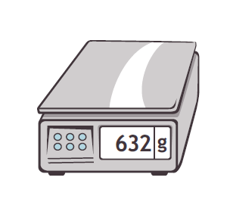

**11 kg**



**6 kg**



**450 g**



**3 kg**



**907 g**

C:\Users\Cristina\AppData\Local\Microsoft\Windows\Temporary Internet Files\Content.IE5\7RX2XT30\MC900198990[1].wmf



**1 kg**