Lesson 5
Objective: Solve word problems involving time intervals within 1 hour by adding and subtracting on the number line.

Suggested Lesson Structure
 Fluency Practice (12 minutes)
 Application Problem (5 minutes)
 Concept Development (33 minutes)
 Student Debrief (10 minutes)
Total Time (60 minutes)
Fluency Practice (12 minutes)
- Group Counting 3.OA.1 (3 minutes)
- Tell Time on the Clock 3.MD.1 (3 minutes)
- Minute Counting 3.MD.1 (6 minutes)
Group Counting (3 minutes)
Note: Group counting reviews interpreting multiplication as repeated addition. Counting by sevens, eights, and nines in this activity anticipates multiplication using those units in Module 3.
Direct students to count forward and backward, occasionally changing the direction of the count, using the following suggested sequence:
- Sevens to 56, emphasizing the transition from 49 to 56
- Eights to 64, emphasizing the transition from 56 to 64
- Nines to 72, emphasizing the transition from 63 to 72
Tell Time on the Clock (3 minutes)
Materials: (T) Analog clock for demonstration (S) Personal white board
Note: This activity provides additional practice with the newly learned skill of telling time to the nearest minute.
T: (Show an analog demonstration clock.) Start at 12 and count by 5 minutes on the clock.
(Move finger from 12 to 1, 2, 3, 4, etc., as students count.)
S: 5, 10, 15, 20, 25, 30, 35, 40, 45, 50, 55, 60.
T: I’ll show a time on the clock. Write the time on your personal white board. (Show 5:07.)
S: (Write 5:07.)
T: (Show 12:54.)
S: (Write 12:54.)
Repeat process, varying the hour and minute so that students read and write a variety of times to the nearest minute.
Minute Counting (6 minutes)
Note: This activity reviews the Grade 2 standard of telling and writing time to the nearest 5 minutes. Students practice group counting strategies for multiplication in the context of time.
Use the process outlined in Lesson 1. Direct students to count by 5 minutes to 1 hour, forward and backward, naming the quarter hour and half hour intervals as such. Repeat the process for the following suggested sequences:
- 3 minutes to 30 minutes, naming the quarter hour and half hour intervals as such
- 6 minutes to 1 hour, naming the half hour and 1 hour intervals as such
- 9 minutes to 45 minutes, naming the quarter hours and half hour intervals as such
(45 minutes is named quarter ‘til 1 hour)
- 10 minutes, using the following sequence: 10 minutes, 20 minutes, half hour, 40 minutes, 50 minutes, 1 hour
Application Problem (5 minutes)
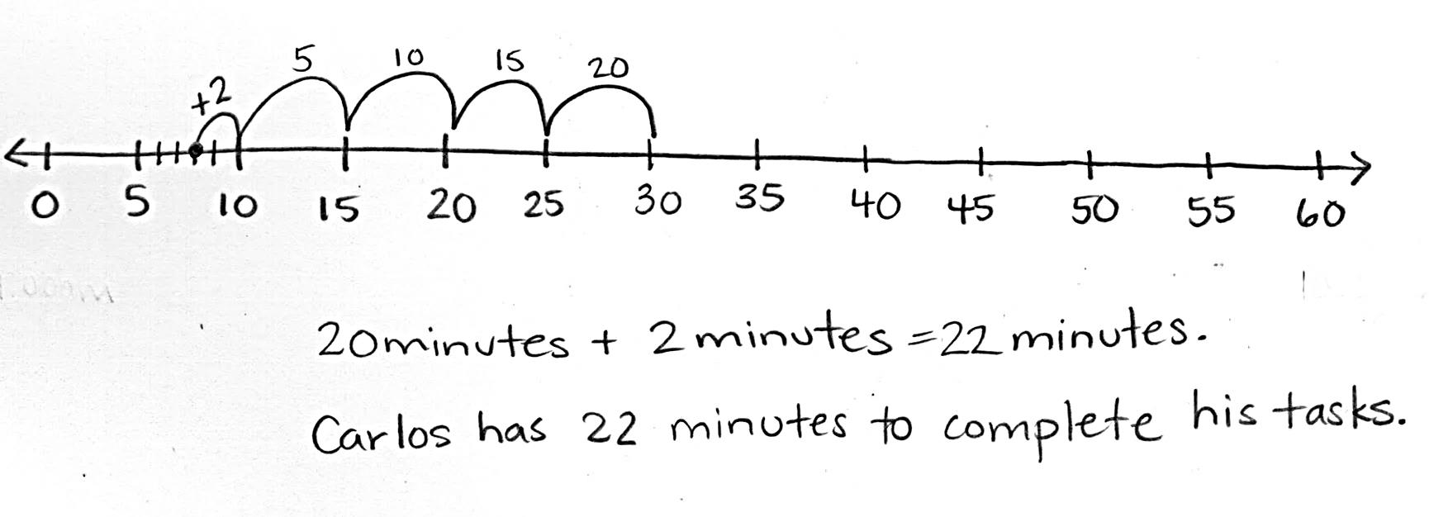
Carlos gets to class at 9:08 a.m. He has to write down homework assignments and complete morning work before math begins at 9:30 a.m. How many minutes does Carlos have to complete his tasks before math begins?

Note: This problem reviews Lesson 4 and provides a context for the problems in the Concept Development.
Encourage students to discuss how they might solve using mental math strategies, e.g., count 9:18, 9:28 + 2 minutes, 2 + 20, 30 – 8.

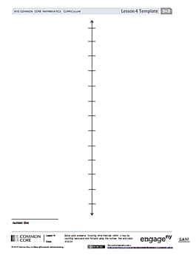
Concept Development (33 minutes)
Lesson 4 Template
Materials: (S) Personal white board, number line (Lesson 4 Template)
Part 1: Count forward and backward to add and subtract on the number line.
T: Use your number line template to label the points when Carlos arrives and when math starts.
S: (Label.)
T: Writing down homework assignments is the first thing Carlos does when he gets to class. It takes 4 minutes. Work with your partner to plot the point that shows when Carlos finishes this first task.
T: At what time did you plot the point?
S: 9:12 a.m.
T: What does the interval between 9:12 and 9:30 represent?
S: The number of minutes it takes Carlos to finish his morning work.
T: How can we find the number of minutes it takes Carlos to complete morning work?
S: Count on the number line. Count forward from 9:12 to 9:30.
T: What addition sentence represents this problem?
S: 12 minutes + ____ = 30 minutes.
T: With your partner, find the number of minutes it takes Carlos to complete morning work.
T: How many minutes did it take Carlos to finish morning work?
S: 18 minutes.
T: Talk with your partner. How could we have modeled that problem by counting backward?
S: We could have started at 9:30 and counted back until we got to 9:12.
T: What subtraction sentence represents this problem?
S: 30 minutes – 12 minutes = 18 minutes.
Repeat the process using the following suggestions:
- Lunch starts at 12:05 p.m. and finishes at 12:40 p.m. How long is lunch?
- Joyce spends 24 minutes finding everything she needs at the grocery store. It takes her 7 minutes to pay. How long does it take Joyce to find her groceries and pay?
Part 2: Solve word problems involving time intervals within 1 hour.
T: Gia, Carlos’s classmate, gets to class at 9:11. It takes her 19 minutes to write homework assignments and complete morning work. How can we figure out if Gia will be ready to start math at 9:30?
S: We have to find out what time Gia finishes.
T: What do we know?
S: We know what time Gia starts and how long it takes her to complete her tasks.
T: What is unknown?
S: The time that Gia finishes.
T: How can we find what time Gia finishes morning work?
S: We can start at 9:11 and add 19 minutes. We can add 11 minutes and 19 minutes to find out how many minutes after 9:00 she finishes.
T: (Draw the model below.) Talk with your partner about why this number line shows 11 minutes
+ 19 minutes. (Students discuss.)

NOTES ON
Multiple Means
of ENGAGEMENT:
Relate addition on the number line with part–whole thinking. Use this connection with prior knowledge to encourage students to move from counting forward and backward toward more efficient number line representations like those modeled. Allow less confident students to verify these strategies by counting forward and backward.

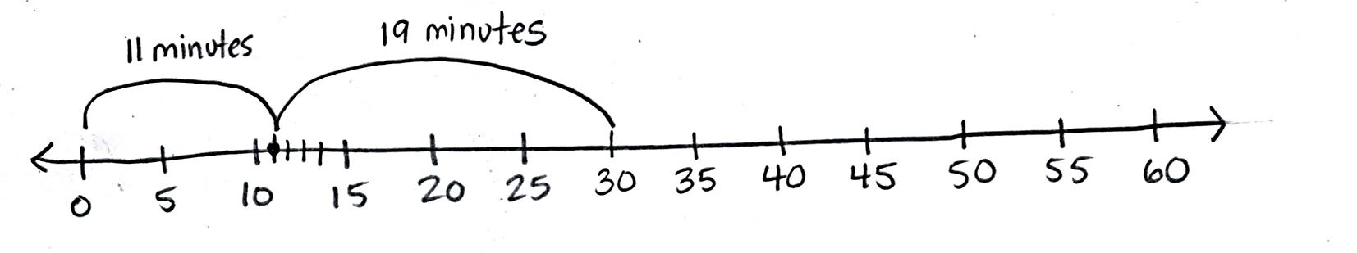

T: When we add our 2 parts, 11 minutes + 19 minutes, what is our whole?
S: 30 minutes!
T: Does Gia finish on time?
S: Yes, just barely!
T: Think back to the Application Problem where Carlos gets to class at 9:08 a.m. If he left for school at 9:00 a.m., then what do the 8 minutes from 9:00 to 9:08 represent?
S: That’s how long it takes Carlos to get to school.
T: We know the whole, 30 minutes, and 1 part. What does the unknown part represent?
S: The amount of time he takes to write homework and complete morning work.
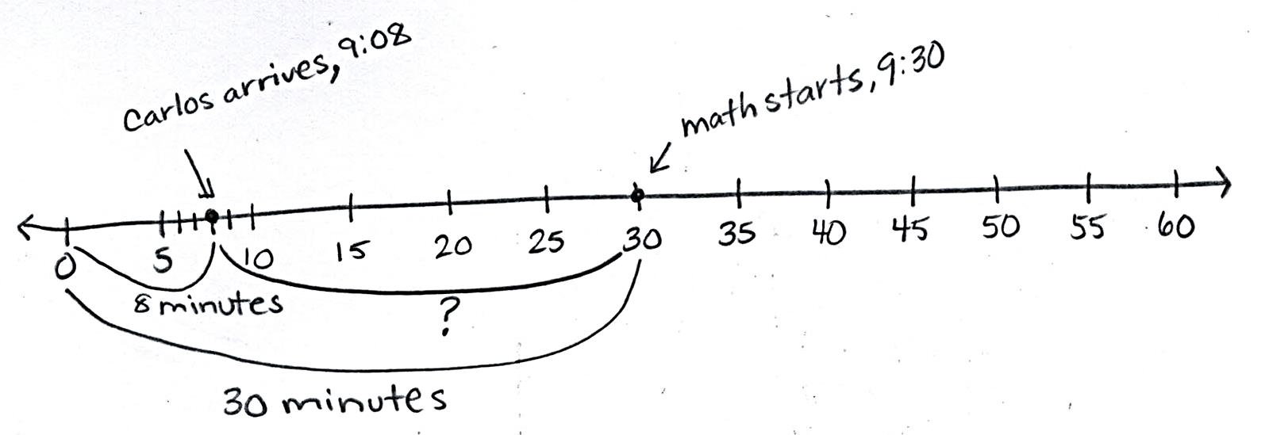
T: Work with your partner to draw a number line and label the known and unknown intervals.
S: (Draw. One possible number line shown at right.)
T: What is 30 minutes – 8 minutes?
S: 22 minutes!
Repeat the process using the following suggestions:

NOTES ON
Multiple Means
of engagement:
Students who need an additional challenge can write their own word problems using real life experiences. Encourage them to precisely time themselves during an activity and use the information to write a word problem.
- Joey gets home at 3:25 p.m. It takes him 7 minutes to unpack and 18 minutes to have a snack before starting his homework. What is the earliest time Joey can start his homework?
- Shane’s family wants to start eating dinner at 5:45 p.m. It takes him 15 minutes to set the table and 7 minutes to help put the food out. If Shane starts setting the table at 5:25 p.m., will his chores be finished by 5:45 p.m.?
- Tim gets on the bus at 8:32 a.m. and gets to school at 8:55 a.m. How long is Tim’s bus ride?
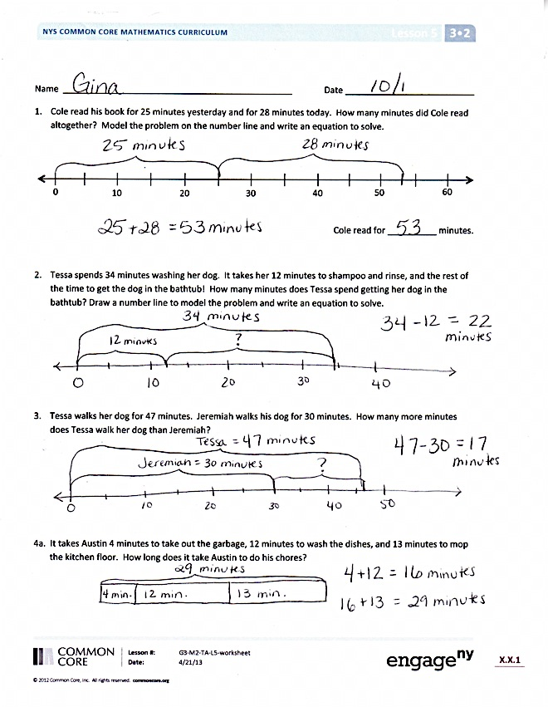
- Joanne takes the same bus as Tim, but her bus ride is 25 minutes. What time does Joanne get on the bus?
- Davis has 3 problems for math homework. He starts at 4:08 p.m. The first problem takes him 5 minutes, and the second takes him 6 minutes. If Davis finishes at 4:23 p.m., how long does it take him to solve the last problem?
Problem Set (10 minutes)
Students should do their personal best to complete the Problem Set within the allotted 10 minutes. Depending on your class, it may be appropriate to modify the assignment by specifying which problems they work on first. Some problems do not specify a method for solving. Students should solve these problems using the RDW approach used for Application Problems.
Student Debrief (10 minutes)
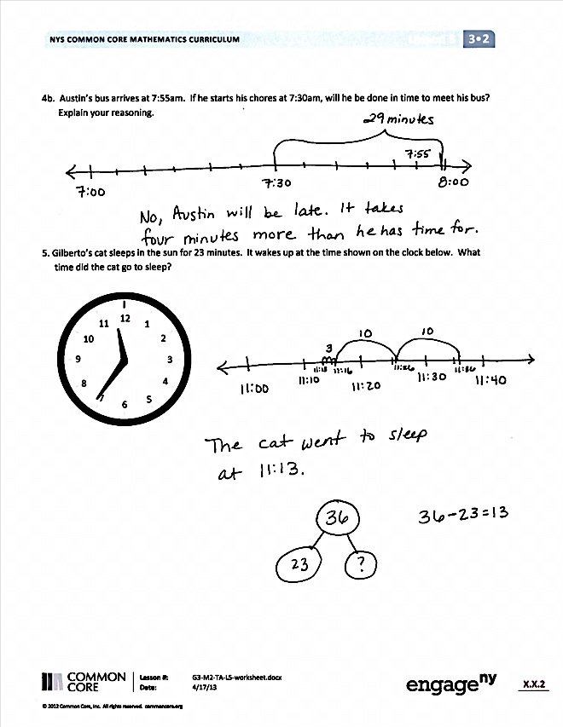
Lesson Objective: Solve word problems involving time intervals within 1 hour by adding and subtracting on a number line.
The Student Debrief is intended to invite reflection and active processing of the total lesson experience.
Invite students to review their solutions for the Problem Set. They should check work by comparing answers with a partner before going over answers as a class. Look for misconceptions or misunderstandings that can be addressed in the Debrief. Guide students in a conversation to debrief the Problem Set and process the lesson.
You may choose to use any combination of the questions below to lead the discussion.
- Describe the process of drawing the number line for Problem 2. Explain how you labeled it. (Call on students who used different ways of thinking about and labeling parts and wholes to share.)
- How did your answer to Problem 4(a) help you solve Problem 4(b)?

- In Problem 5, you had to find a start time. How is your approach to finding a start time different from your approach to finding an end time?
- Besides a number line, what other models could you use to solve Problems 2, 4, and 5?
Exit Ticket (3 minutes)
After the Student Debrief, instruct students to complete the Exit Ticket. A review of their work will help you assess the students’ understanding of the concepts that were presented in the lesson today and plan more effectively for future lessons. You may read the questions aloud to the students.

Name Date
- Cole read his book for 25 minutes yesterday and for 28 minutes today. How many minutes did Cole read altogether? Model the problem on the number line and write an equation to solve.
20
10
30
40
50
60
0

Cole read for __________ minutes.

- Tessa spends 34 minutes washing her dog. It takes her 12 minutes to shampoo and rinse and the rest of the time to get the dog in the bathtub! How many minutes does Tessa spend getting her dog in the bathtub? Draw a number line to model the problem and write an equation to solve.

- Tessa walks her dog for 47 minutes. Jeremiah walks his dog for 30 minutes. How many more minutes does Tessa walk her dog than Jeremiah?

- a. It takes Austin 4 minutes to take out the garbage, 12 minutes to wash the dishes, and 13 minutes to
mop the kitchen floor. How long does it take Austin to do his chores?

- Austin’s bus arrives at 7:55 a.m. If he starts his chores at 7:30 a.m., will he be done in time to meet his bus? Explain your reasoning.

- Gilberto’s cat sleeps in the sun for 23 minutes. It wakes up at the time shown on the clock below.
What time did the cat go to sleep?
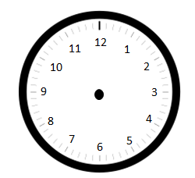

Name Date
Michael spends 19 minutes on his math homework and 17 minutes on his science homework.
How many minutes does Michael spend doing his homework?

Model the problem on the number line, and write an equation to solve.
20
10
30
40
50
60
0

Michael spends __________ minutes on his homework.

Name Date
- Abby spent 22 minutes working on her science project yesterday and 34 minutes working on it today. How many minutes did Abby spend working on her science project altogether? Model the problem on the number line, and write an equation to solve.
20
10
30
40
50
60
0

Abby spent __________ minutes working on her science project.

- Susanna spends a total of 47 minutes working on her project. How many more minutes than Susanna does Abby spend working? Draw a number line to model the problem, and write an equation to solve.

- Peter practices violin for a total of 55 minutes over the weekend. He practices 25 minutes on Saturday. How many minutes does he practice on Sunday?

- a. Marcus gardens. He pulls weeds for 18 minutes, waters for 13 minutes, and plants for 16 minutes.
How many total minutes does he spend gardening?

- Marcus wants to watch a movie that starts at 2:55 p.m. It takes 10 minutes to drive to the theater. If Marcus starts the yard work at 2:00 p.m., can he make it on time for the movie? Explain your reasoning.

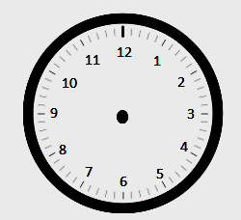
- Arelli takes a short nap after school. As she falls asleep, the clock reads 3:03 p.m. She wakes up at the time shown below. How long is Arelli’s nap?

