Lesson 4
Objective: Solve word problems involving time intervals within 1 hour by counting backward and forward using the number line and clock.

Suggested Lesson Structure
 Fluency Practice (12 minutes)
 Application Problem (5 minutes)
 Concept Development (33 minutes)
 Student Debrief (10 minutes)
Total Time (60 minutes)
Fluency Practice (12 minutes)
- Group Counting 3.OA.1 (3 minutes)
- Tell Time on the Clock 3.MD.1 (3 minutes)
- Minute Counting 3.MD.1 (6 minutes)
Group Counting (3 minutes)
Note: Group counting reviews interpreting multiplication as repeated addition. Counting by sevens, eights, and nines in this activity anticipates multiplication using those units in Module 3.
Direct students to count forward and backward, occasionally changing the direction of the count using the following suggested sequence:
- Sevens to 49, emphasizing the transition from 35 to 42
- Eights to 56, emphasizing the transition from 48 to 56
- Nines to 63, emphasizing the transition from 54 to 63
Tell Time on the Clock (3 minutes)
Materials: (T) Analog clock for demonstration (S) Personal white board
Note: This activity provides additional practice with the skill of telling time to the nearest minute, taught in Lesson 3.
T: (Show an analog demonstration clock.) Start at 12 and count by 5 minutes on the clock.
(Move finger from 12 to 1, 2, 3, 4, etc., as students count.)
S: 5, 10, 15, 20, 25, 30, 35, 40, 45, 50, 55, 60.
T: I’ll show a time on the clock. Write the time on your board. (Show 11:23.)
S: (Write 11:23.)
T: (Show 9:17.)
S: (Write 9:17.)
Repeat process, varying the hour and minute so that students read and write a variety of times to the nearest minute.
Minute Counting (6 minutes)
Note: This activity reviews the Grade 2 standard of telling and writing time to the nearest 5 minutes.
Students also practice group counting strategies for multiplication in the context of time.
Use the process outlined for this activity in Lesson 1. Direct students to count by 5 minutes to 1 hour, forward and backward, naming the quarter hour and half hour intervals as such. Repeat the process:
- 6 minutes to 1 hour, naming the half hour and 1 hour intervals as such
- 3 minutes to 30 minutes, naming the quarter hour and half hour intervals as such
- 9 minutes to quarter ’til 1 hour
- 10 minutes, using the following sequence: 10 minutes, 20 minutes, 1 half hour, 40 minutes, 50 minutes, 1 hour
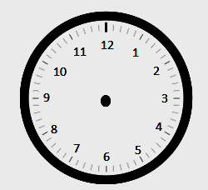
Application Problem (5 minutes)
0
5:00 p.m.
60
6:00 p.m.
Patrick
Lilly
Display a clock and number line as shown.

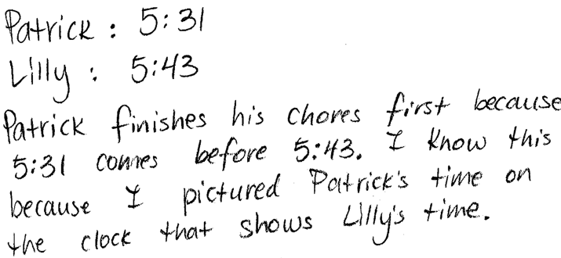
Patrick and Lilly start their chores at 5:00 p.m. The clock
and the number line show the times that Patrick and Lilly finish their chores. Who finishes first? Explain how you know. Solve the problem without drawing a number line. You might want to visualize or use your clock template, draw a tape diagram, use words, number sentences, etc.
Note: This problem reviews Lesson 3, telling time to the nearest minute. This problem is used in the first example of the Concept Development to solve word problems involving minute intervals.
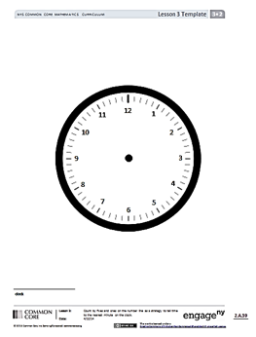
Concept Development (33 minutes)
Lesson 3 Template
Materials: (T) Demonstration analog clock (S) Personal white board, number line (Template), clock (Lesson 3 Template)
Problem 1: Count forward and backward using a number line to solve word problems involving time intervals within 1 hour.
T: Look back at your work on today’s Application Problem. We know that Lilly finished after Patrick. Let’s use a number line to figure out how many more minutes than Patrick, Lilly took to finish. Slip the number line Template into your personal white board.
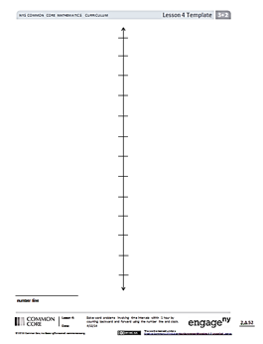
T: Label the first tick mark 0 and the last tick mark 60. Label the hours and 5-minute intervals.
Number Line Template
T: Plot the times 5:31 p.m. and 5:43 p.m.
T: We could count by ones from 5:31 to 5:43. Instead, discuss with a partner a more efficient way to find the difference between Patrick and Lilly’s times.
S: (Discuss.)
T: Work with a partner to find the difference between Patrick’s and Lilly’s times.
T: How many more minutes than Patrick did it take Lilly to finish her chores?

NOTES ON
MULTIPLE MEANS
OF ACTION AND EXPRESSION:
If appropriate for the class, discuss strategies for solving different problem types (start unknown, change unknown, result unknown). Although problem types can be solved using a range of strategies, some methods are more efficient than others depending on the unknown.

S: 12 minutes more.
MP.4
T: What strategy did you use to solve this problem?
S: (Share possible strategies, listed below.)
- Count by ones to 5:35, by fives to 5:40, by ones to 5:43.
- Subtract 31 minutes from 43 minutes.
- Count backwards from 5:43 to 5:31.
- Know 9 minutes gets to 5:40 and 3 more minutes gets to 5:43.
- Add a ten and 2 ones.

Repeat the process with other time interval word problems, varying the unknown as suggested below.

NOTES ON
PROBLEM TYPES:
Tables 1 and 2 in the Glossary of the Common Core Learning Standards for Mathematics provide a quick reference of problem types and examples.

- Result unknown: Start time and minutes elapsed known, end time unknown. (We started math at 10:15 a.m. We worked for 23 minutes. What time was it when we ended?)
- Change unknown: Start time and end time known, minutes elapsed unknown. (Leslie starts reading at 11:24 a.m. She finishes reading at 11:57 a.m. How many minutes does she read?)
- Start unknown: End time and minutes elapsed known, start time unknown. (Joe finishes his homework at 5:48 p.m. He worked for 32 minutes. What time did he start his homework?)
Problem 2: Count forward and backward using a clock to solve word problems involving time intervals within 1 hour.
T: It took me 42 minutes to cook dinner last night. I finished cooking at 5:56 p.m. What time did I start?
T: Let’s use a clock to solve this problem. Put the clock template in your board.
T: Work with your partner to draw the hands on your clock to show 5:56 p.m.
T: Talk with your partner, will you count backward or forward on the clock to solve this problem? (Allow time for discussion.)
T: Use an efficient strategy to count back 42 minutes. Write the start time on your personal white board, and as you wait for others, record your strategy.
Circulate as students work and analyze their strategies so that you can select those you would like to have shared with the whole class. Also consider the order in which strategies will be shared.
T: What time did I start making dinner?
S: 5:14 p.m.
T: I would like to ask Nina and Hakop to share their work, in that order.
Repeat the process with other time interval word problems, varying the unknown as suggested below.
- Result unknown: Start time and minutes elapsed known, end time unknown. (Henry starts riding his bike at 3:12 p.m. He rides for 36 minutes. What time does he stop riding his bike?)

NOTES ON
MULTIPLE MEANS
OF REPRESENTATION:
Students who struggle with comprehension may benefit from peers or teachers reading word problems aloud. This accommodation also provides students with the opportunity to ask clarifying questions as needed.

- Change unknown: Start time and end time known, minutes elapsed unknown. (I start exercising at 7:12 a.m. I finish exercising at 7:53 a.m. How many minutes do I exercise?)
- Start unknown: End time and minutes elapsed known, start time unknown. (Cassie works on her art project for 37 minutes. She finishes working at 1:48 p.m. What time did she start working?)
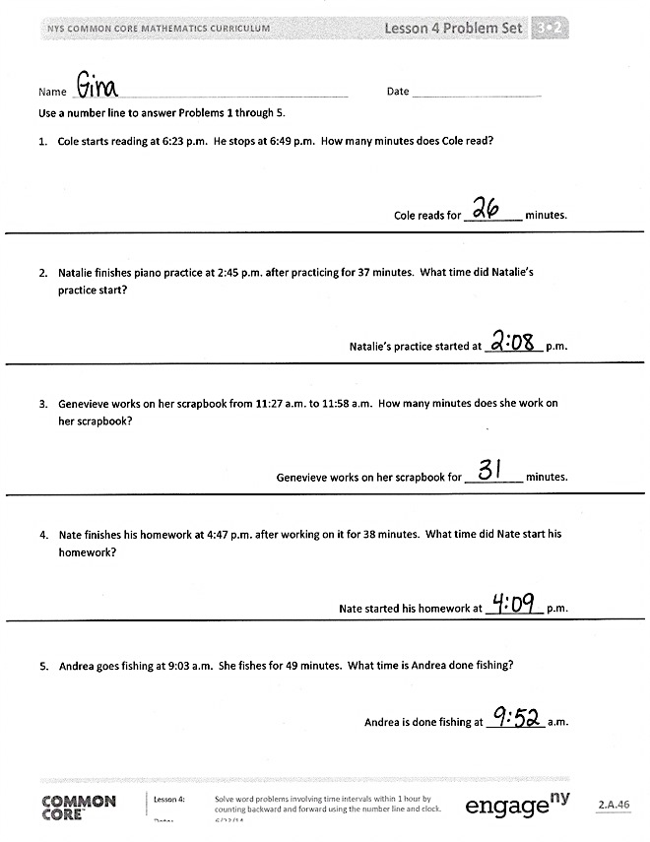
Problem Set (10 minutes)
Students should do their personal best to complete the Problem Set within the allotted 10 minutes. For some classes, it may be appropriate to modify the assignment by specifying which problems they work on first. Some problems do not specify a method for solving. Students should solve these problems using the RDW approach used for Application Problems.
Student Debrief (10 minutes)
Lesson Objective: Solve word problems involving time intervals within 1 hour by counting backward and forward using the number line and clock.
The Student Debrief is intended to invite reflection and active processing of the total lesson experience.
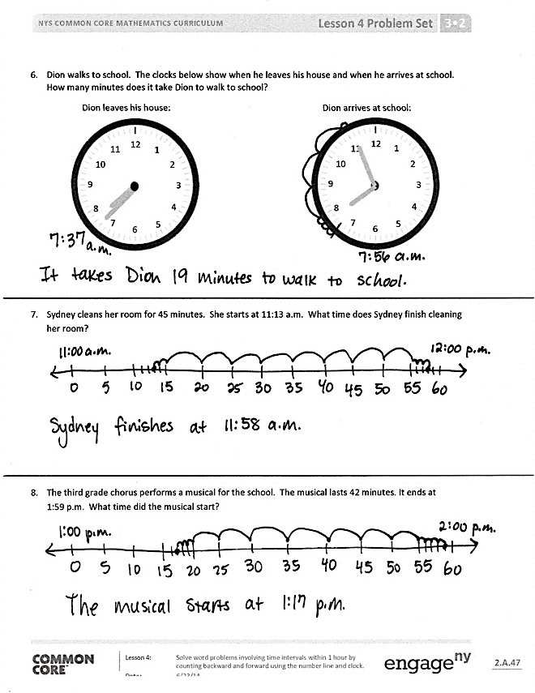
Invite students to review their solutions for the Problem Set. They should check work by comparing answers with a partner before going over answers as a class. Look for misconceptions or misunderstandings that can be addressed in the Debrief. Guide students in a conversation to debrief the Problem Set and process the lesson.
You may choose to use any combination of the questions below to lead the discussion.
- How are Problems 1 and 2 different? How did it affect the way you solved each problem?
- Did you count forward or backward to solve Problem 3? How did you decide which strategy to use?
- Discuss with a partner your strategy for solving Problem 6. What other counting strategies could you use with the clocks to get the same answer?
- Is 11:58 a.m. a reasonable answer for Problem 7? Why or why not?
- Explain to your partner how you solved Problem 8. How might you solve it without using a number line or a clock?
- How did we use counting as a strategy to problem solve today?

Exit Ticket (3 minutes)
After the Student Debrief, instruct students to complete the Exit Ticket. A review of their work will help you assess the students’ understanding of the concepts that were presented in the lesson today and plan more effectively for future lessons. You may read the questions aloud to the students.

Name Date
Use a number line to answer Problems 1 through 5.
- Cole starts reading at 6:23 p.m. He stops at 6:49 p.m. How many minutes does Cole read?

Cole reads for __________ minutes.

- Natalie finishes piano practice at 2:45 p.m. after practicing for 37 minutes. What time did Natalie’s practice start?

Natalie’s practice started at __________ p.m.

- Genevieve works on her scrapbook from 11:27 a.m. to 11:58 a.m. How many minutes does she work on her scrapbook?

Genevieve works on her scrapbook for __________ minutes.

- Nate finishes his homework at 4:47 p.m. after working on it for 38 minutes. What time did Nate start his homework?

Nate started his homework at __________ p.m.

- Andrea goes fishing at 9:03 a.m. She fishes for 49 minutes. What time is Andrea done fishing?

Andrea is done fishing at __________ a.m.
- Dion walks to school. The clocks below show when he leaves his house and when he arrives at school. How many minutes does it take Dion to walk to school?
Dion arrives at school:
Dion leaves his house:
12
1
2
3
4
5
6
7
8
9
10
11
12
1
2
3
4
5
6
7
8
9
10
11

- Sydney cleans her room for 45 minutes. She starts at 11:13 a.m. What time does Sydney finish cleaning her room?

- The third-grade chorus performs a musical for the school. The musical lasts 42 minutes. It ends at
1:59 p.m. What time did the musical start?

Name Date
Independent reading time starts at 1:34 p.m. It ends at 1:56 p.m.

- Draw the start time on the clock below. 2. Draw the end time on the clock below.

- How many minutes does independent reading time last?

Name Date
Record your homework start time on the clock in Problem 6.
Use a number line to answer Problems 1 through 4.

- Joy’s mom begins walking at 4:12 p.m. She stops at 4:43 p.m. How many minutes does she walk?

Joy’s mom walks for __________ minutes.

- Cassie finishes softball practice at 3:52 p.m. after practicing for 30 minutes. What time did Cassie’s practice start?

Cassie’s practice started at ____________ p.m.
- Jordie builds a model from 9:14 a.m. to 9:47 a.m. How many minutes does Jordie spend building his model?

Jordie builds for _____________ minutes.
- Cara finishes reading at 2:57 p.m. She reads for a total of 46 minutes. What time did Cara start reading?

Cara started reading at ____________ p.m.
- Jenna and her mom take the bus to the mall. The clocks below show when they leave their house and when they arrive at the mall. How many minutes does it take them to get to the mall?

Time when they leave home: Time when they arrive at the mall:

- Record your homework start time: Record the time when you finish Problems 1–5:

How many minutes did you work on Problems 1–5?

number line

