Lesson 3
Objective: Count by fives and ones on the number line as a strategy to tell time to the nearest minute on the clock.

Suggested Lesson Structure
 Fluency Practice (15 minutes)
 Application Problem (5 minutes)
 Concept Development (30 minutes)
 Student Debrief (10 minutes)
Total Time (60 minutes)
Fluency Practice (15 minutes)
- Tell Time on the Clock 2.MD.7 (3 minutes)
- Decompose 60 Minutes 3.MD.1 (6 minutes)
- Minute Counting 3.MD.1 (3 minutes)
- Group Counting 3.OA.1 (3 minutes)
Tell Time on the Clock (3 minutes)
Materials: (T) Analog clock for demonstration (S) Personal white board
Note: This activity reviews the Grade 2 standard of telling and writing time to the nearest 5 minutes. It reviews Lesson 2 and prepares students to count by 5 minutes and some ones in this lesson.
T: (Show an analog demonstration clock.) Start at 12 and count by 5 minutes on the clock.
(Move finger from 12 to 1, 2, 3, 4, etc., as students count.)
S: 5, 10, 15, 20, 25, 30, 35, 40, 45, 50, 55, 60.
T: I’ll show a time on the clock. Write the time on your personal white board. (Show 4:00.)
S: (Write 4:00.)
T: (Show 4:15.)
S: (Write 4:15.)
Repeat process, varying the hour and 5-minute interval so that students read and write a variety of times to the nearest 5 minutes.
Decompose 60 Minutes (6 minutes)
Materials: (S) Personal white board
Note: Decomposing 60 minutes using a number bond helps students relate part–whole thinking to telling time.
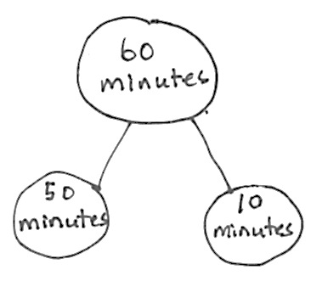
T: (Project a number bond with 60 minutes written as the whole.)
There are 60 minutes in 1 hour.
T: (Write 50 minutes as one of the parts.) On your board, draw this
number bond and complete the unknown part.
S: (Draw number bond with 10 minutes, completing the unknown part.)
Repeat the process for 30 minutes, 40 minutes, 45 minutes, and 35 minutes.
Minute Counting (3 minutes)
Note: Students practice counting strategies for multiplication in the context of time. This activity prepares students for telling time to the nearest minute and builds skills for using mental math to add and subtract minute intervals in Lesson 5.

NOTES ON
MULTIPLE MEANS
OF REPRESENTATION:
The vocabulary half-past, quarter-past and quarter ‘til might be challenging for students. Consider reviewing the phrases by writing the words on the board and having students read them chorally. As you define the phrases for students, next to each one, draw a circle with clock hands pointing to the place that corresponds to the language. Leave it on the board for students to reference during this activity.

Use the process outlined for this activity in Lesson 1. Direct students to count by 5 minutes to an hour, half hour, and quarter hours.
- 6 minutes, counting to 1 hour, and naming half hour and 1 hour intervals as such
- 3 minutes, counting to 30 minutes, and naming the quarter hour and half hour intervals as such
- 9 minutes, counting to quarter ’til 1 hour
- 10 minutes, using the following sequence: 10 minutes, 20 minutes, half hour, 40 minutes, 50 minutes,
1 hour
Group Counting (3 minutes)
Note: Group counting reviews the interpretation of multiplication as repeated addition. Counting by sevens, eights, and nines in this activity anticipates multiplication using those units in Module 3.
Direct students to count forward and backward using the following suggested sequence, occasionally changing the direction of the count:
- Sevens to 42, emphasizing the transition from 35 to 42
- Eights to 48, emphasizing the transition from 40 to 48
- Nines to 54, emphasizing the transition from 45 to 54
Application Problem (5 minutes)
There are 12 tables in the cafeteria. Five students sit at each of the first 11 tables. Three students sit at the last table. How many students are sitting at the 12 tables in the cafeteria?
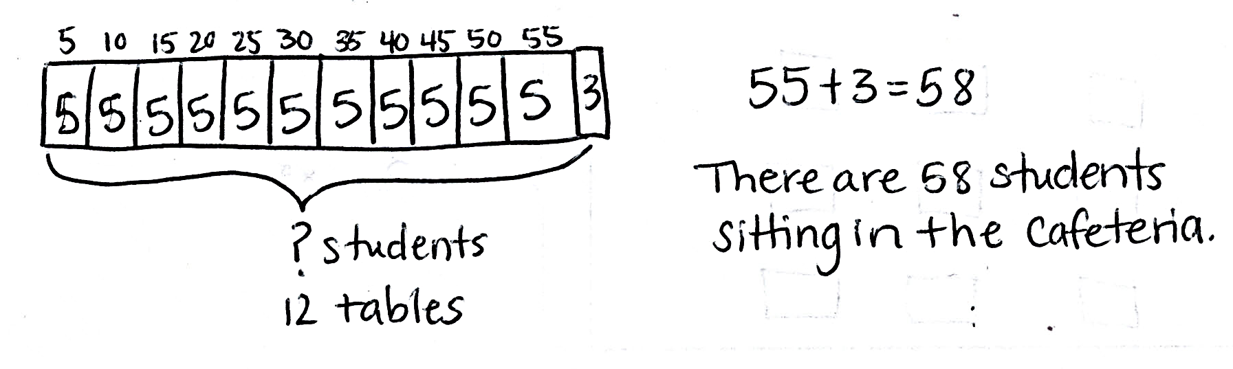

Note: This problem activates prior knowledge from Module 1 about multiplying by 5. Students relate this work from the Application Problem to modeling minutes on the number line in the Concept Development.
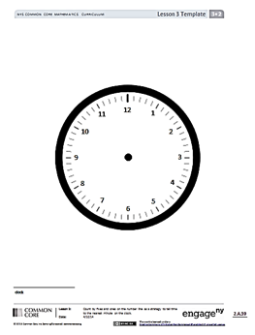
Concept Development (30 minutes)
Template
Materials: (T) Demonstration analog clock (S) Personal white board, centimeter ruler, clock (Template) (pictured right)
Problem 1: Count minutes by fives and ones on a number line.
T: Use your ruler to draw a 12 centimeter line on your personal white board. Start at the 0 mark and make a tick mark at each centimeter up to the number 12. Label the first tick mark 0 and the last tick mark 60. Then, count by fives from 0 to 60 to label each interval, like we did in the last lesson.
S: (Draw and label a number line as shown.)
0
5
10
15
20
25
30
35
40
45
50
55
60

T: Put your finger on 0. Count by ones from 0 to 5.
What numbers did you count between 0 and 5?

NOTES ON
MULTIPLE MEANS
OF ACTION AND EXPRESSION:
Use preprinted number lines for students with fine motor or perception difficulties. You can also have students actually draw all the tick marks, but be aware this may encourage counting all when the objective is to count by fives and ones.

S: 1, 2, 3, and 4.
T: We could draw tick marks, but let’s instead imagine they are there. Can you see them?
S: Yes!
T: Put your finger on 5. Count on by ones from 5 to 10.
What numbers did you count between 5 and 10?
S: 6, 7, 8, and 9.
T: Can you imagine those tick marks, too?

S: Yes!
T: Let’s find 58 minutes on the number line. Put your finger on 0. Count by five to 55.
S: (Count 11 fives.)
T: Let’s draw the tick marks from 55 to 60. Count with me as I draw the tick marks from 55 to 60. Start at 55, which is already there.
S: 55, (begin drawing) 56, 57, 58, 59 (stop drawing), 60.
T: How many ticks did I draw?
S: 4.
T: Go ahead and draw yours. (Allow students time to draw.)
T: Count on by ones to find 58 using the tick marks we made in the interval between 55 and 60.
MP.6
0
5
10
15
20
25
30
35
40
45
50
55
60

S: (Count on by ones and say numbers aloud.) 56, 57, 58.
T: How many fives did we count?
S: 11.
T: How many ones did we count?
S: 3.
T: 11 fives + 3. How can we write that as multiplication? Discuss with your partner.
S: (11 × 5) + 3.
T: Discuss with a partner how our modeling with the number line relates to the Application Problem.
S: (Discuss.)
Repeat the process with other combinations of fives and ones, such as (4 × 5) + 2 and (0 × 5) + 4.
T: Which units did we count by on the number line to solve these problems?
S: Fives and ones.
T: Whisper to your partner. What steps did we take to solve these problems on the number line?
S: (Discuss.)
Problem 2: Count by fives and ones on a number line to tell time to the nearest minute.
T: I arrived at school this morning at 7:37 a.m. Let’s find that time on our number line. Label 7:00 a.m. above the 0 mark and 8:00 a.m. above the 60 mark.
S: (Label 7:00 a.m. and 8:00 a.m.)
T: Which units should we count by to get to 7:37?
S: Count by fives to 7:35 and then by ones to 7:37.
T: How many fives?
S: 7.
T: How many ones?
S: 2 ones.
T: Let's move our fingers over 7 fives and 2 ones on the number line.
S: (Move fingers and count.)
T: Give me a number sentence.
S: (7 × 5) + 2 = 37.
T: Plot the point on your number line.
Repeat the process with other times that can be plotted on this same number line, such as 7:13 a.m.,
7:49 a.m., and 7:02 a.m.
Problem 3: Count by fives and ones on a clock to tell time to the nearest minute.
T: Insert the clock template in your personal white board. How is the clock similar to our number line?
S: There are 4 tick marks between the numbers on both. They both have intervals of 5 with 4 marks in between.
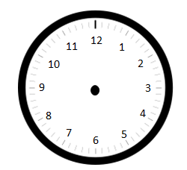
T: What do the small tick marks represent on the clock?
S: Ones. 1 minute!
T: We can use a clock just like we use a number line to tell time because a clock is a circular number line. Imagine twisting our number line into a circle. In your mind’s eye, at what number do the ends of your number line connect?
S: At the 12.
T: The 12 on the clock represents the end of one hour and the beginning of another.
T: (Project analog clock and draw hands as shown.) This clock shows what time I woke up this morning. Draw the minute hand on your clock to look like mine.
S: (Draw hand on clock template.)
T: Let’s find the minutes by counting by fives and ones. Put your finger on the 12—the zero—and count by fives with me.
S: (Move finger along clock and count by fives to 45.)
T: (Stop at 45.) How many minutes?
S: 45.
T: Let’s count on by ones until we get to the minute hand. Move your finger and count on with me.
S: 46, 47, 48. (Move finger and count on by ones.)
T: How many minutes?
S: 48.
T: Draw the hour hand. How many hours?
S: 5.
T: What is the time?
S: 5:48 a.m.
T: Write the time on your personal white boards.
S: (Write 5:48 a.m.)
Repeat the process of telling time to the nearest minute, providing a small context for each example.
Use the following suggested sequence: 12:14 a.m. and 2:28 p.m.
T: Can anyone share another strategy they used to tell the time on the clock for 2:28 p.m. other than counting by fives and ones from the 0 minute mark?
S: I started at 2:30 p.m. and counted back 2 minutes to get to 2:28 p.m.
Problem Set (10 minutes)
Students should do their personal best to complete the Problem Set within the allotted 10 minutes. For some classes, it may be appropriate to modify the assignment by specifying which problems they work on first. Some problems do not specify a method for solving. Students should solve these problems using the RDW approach used for Application Problems.
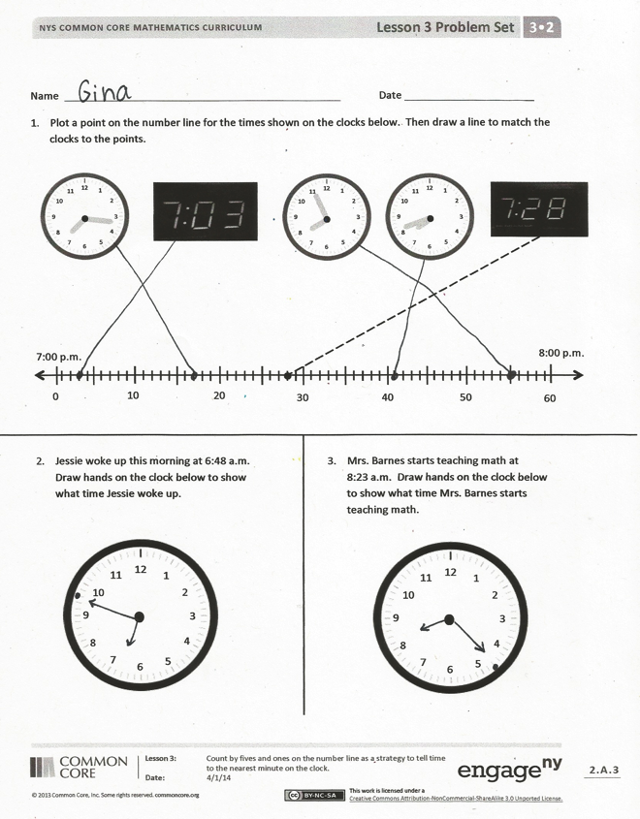
Student Debrief (10 minutes)
Lesson Objective: Count by fives and ones on the number line as a strategy to tell time to the nearest minute on the clock.
The Student Debrief is intended to invite reflection and active processing of the total lesson experience.
Invite students to review their solutions for the Problem Set. They should check work by comparing answers with a partner before going over answers as a class. Look for misconceptions or misunderstandings that can be addressed in the Debrief. Guide students in a conversation to debrief the Problem Set and process the lesson.
You may choose to use any combination of the questions below to lead the discussion.
- Look at Problem 1. Talk to a partner: How is the number line similar to the analog clock? How is it different?
- What strategy did you use to draw the hands on the clock in Problem 3?
- Look at Problem 4. How many fives did you count by? Write a multiplication equation to show that. How many ones did you count on by? Write a multiplication equation to show that. How many minutes altogether?
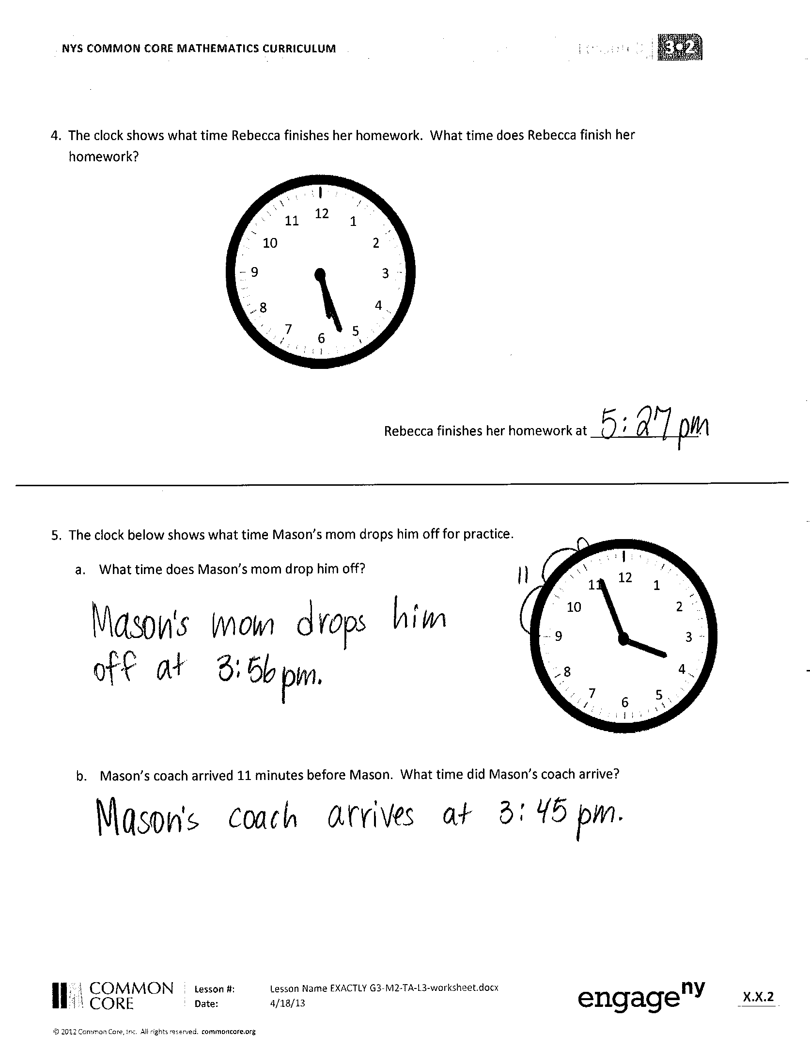
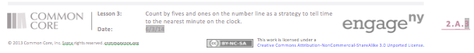
- How does the tape diagram that many of us drew to solve the Application Problem relate to the first number line we drew in the Concept Development?
- Look at Problem 5. Can you share another strategy you used to tell the time on the clock other than counting by fives and ones from the
0 minute mark?
- (In anticipation of Lesson 4, which involves solving word problems with time intervals, have students discuss Problem 5(b).) How is Problem 5(b) different from the rest of the problems? How can you solve Problem 5(b)?
Exit Ticket (3 minutes)
After the Student Debrief, instruct students to complete the Exit Ticket. A review of their work will help you assess the students’ understanding of the concepts that were presented in the lesson today and plan more effectively for future lessons. You may read the questions aloud to the students.

Name Date
1. Plot a point on the number line for the times shown on the clocks below. Then, draw a line to match the clocks to the points.
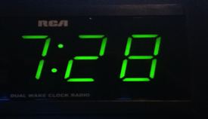
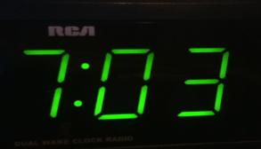
0
10
7:00 p.m.
20
30
40
50
60
8:00 p.m.
12
11
10
9
8
7
6
5
4
3
2
1
12
11
10
9
8
7
6
5
4
3
2
1
12
11
10
9
8
7
6
5
4
3
2
1

12
1
2
3
4
5
6
7
8
9
10
11
2. Jessie woke up this morning at 6:48 a.m. Draw hands on the clock below to show what time Jessie woke up.

12
1
2
3
4
5
6
7
8
9
10
11
3. Mrs. Barnes starts teaching math at
8:23 a.m. Draw hands on the clock below to show what time Mrs. Barnes starts teaching math.

- The clock shows what time Rebecca finishes her homework. What time does Rebecca finish her homework?
12
1
2
3
4
5
6
7
8
9
10
11

Rebecca finishes her homework at _______________.

- The clock below shows what time Mason’s mom drops him off for practice.
12
1
2
3
4
5
6
7
8
9
10
11
a. What time does Mason’s mom drop him off?

b. Mason’s coach arrived 11 minutes before Mason. What time did Mason’s coach arrive?

Name Date
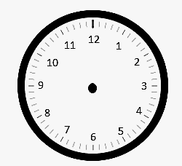
The clock shows what time Jason gets to school in the morning.
Arrival at School

- What time does Jason get to school?

First Bell Rings
- The first bell rings at 8:23 a.m. Draw hands on the clock to show when the first bell rings.

- Label the first and last tick marks 8:00 a.m. and 9:00 a.m. Plot a point to show when Jason arrives at school. Label it A. Plot a point on the line when the first bell rings and label it B.

0
10

20
30
40
50
60

Name Date
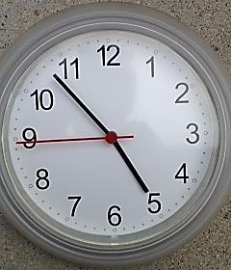
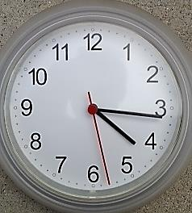
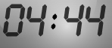
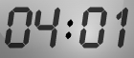
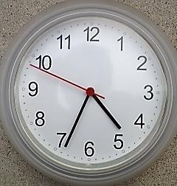
1. Plot points on the number line for each time shown on a clock below. Then, draw lines to match the clocks to the points.

0
10
4:00 p.m.
20
30
40
50
60
5:00 p.m.

12
1
2
3
4
5
6
7
8
9
10
11
2. Julie eats dinner at 6:07 p.m. Draw hands on the clock below to show what time Julie eats dinner.

12
1
2
3
4
5
6
7
8
9
10
11
3. P.E. starts at 1:32 p.m. Draw hands on the clock below to show what time
P.E. starts.

4. The clock shows what time Zachary starts playing with his action figures.
Start
Finish
- What time does he start playing with his action figures?

- He plays with his action figures for 23 minutes.
What time does he finish playing?

- Draw hands on the clock to the right to show what time Zachary finishes playing.

- Label the first and last tick marks with 2:00 p.m. and 3:00 p.m. Then, plot Zachary’s start and finish times. Label his start time with a B and his finish time with an F.

0
10

20
30
40
50
60

12
1
2
3
4
5
6
7
8
9
10
11

clock

