Lesson 2
Objective: Relate skip-counting by fives on the clock and telling time to a continuous measurement model, the number line.

Suggested Lesson Structure
 Fluency Practice (12 minutes)
 Application Problem (5 minutes)
 Concept Development (33 minutes)
 Student Debrief (10 minutes)
Total Time (60 minutes)
Fluency Practice (12 minutes)
- Group Counting 3.OA.1 (3 minutes)
- Tell Time on the Clock 2.MD.7 (3 minutes)
- Minute Counting 3.MD.1 (6 minutes)
Group Counting (3 minutes)
Note: Group counting reviews interpreting multiplication as repeated addition. Counting by sevens and eights in this activity anticipates multiplication using those units in Module 3.
Direct students to count forward and backward using the following suggested sequence, occasionally changing the direction of the count:
- Sevens to 35, emphasizing the transition from 28 to 35
- Eights to 40, emphasizing the transition from 32 to 40
Tell Time on the Clock (3 minutes)
Materials: (T) Analog clock for demonstration (S) Personal white board
Note: This activity reviews the Grade 2 standard of telling and writing time to the nearest 5 minutes.
It prepares students to use the number line and clock to tell time to the nearest 5 minutes in the Concept Development.
T: (Show an analog demonstration clock.) Start at 12 and count by 5 minutes on the clock.
(Move finger from 12 to 1, 2, 3, 4, etc., as students count.)
S: 5, 10, 15, 20, 25, 30, 35, 40, 45, 50, 55, 60.
T: I’ll show a time on the clock. Write the time on your personal white board. (Show 3:05.)
S: (Write 3:05.)
T: (Show 2:35.)
S: (Write 2:35.)
Repeat process, varying the hour and 5-minute interval so that students read and write a variety of times to the nearest 5 minutes.
Minute Counting (6 minutes)
Note: This activity reviews the Grade 2 standard of telling and writing time to the nearest 5 minutes. It prepares students to count by 5-minute intervals on the number line and clock in the Concept Development. Students also practice group counting strategies for multiplication in the context of time.
Use the process outlined for this activity in Lesson 1. Direct students to count by 5 minutes to the hour, the half hour, and the quarter hour. Repeat the process using the following suggested sequence:
- 6 minutes, counting to the half hour and hour.
- 3 minutes, counting to a quarter past the hour and half hour
- 10 minutes, counting up to 1 hour
- 9 minutes, counting to 45 and emphasizing the transition from 36 to 45
Application Problem (5 minutes)
Christine has 12 math problems for homework. It takes her 5 minutes to complete each problem. How many minutes does it take Christine to finish all 12 problems?
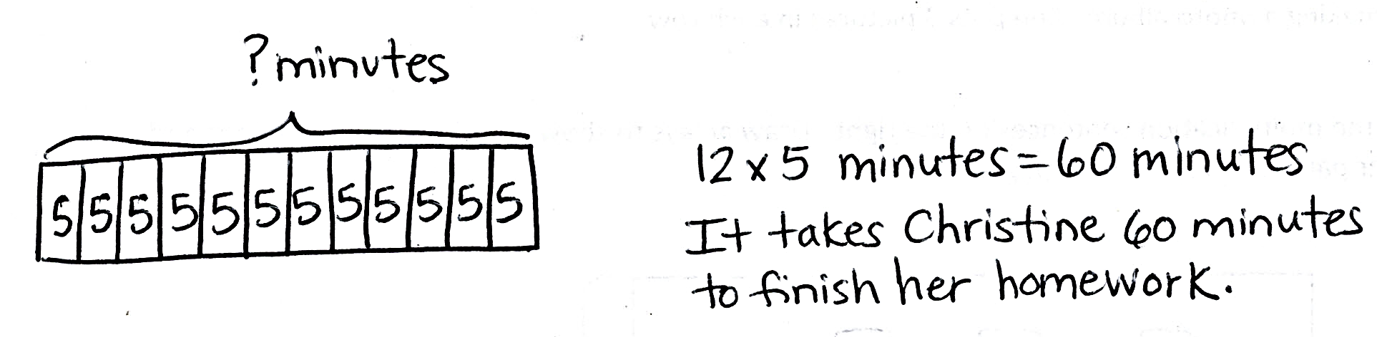
Note: This problem anticipates the Concept Development. It activates prior knowledge from Grade 2 about math with minutes. Twelve is a new factor. If students are unsure about how to multiply 12 groups of 5, encourage them to solve by skip-counting. They can also use the distributive property, 10 fives + 2 fives or 6 fives + 6 fives. Students use the solution to this problem as a springboard for modeling 12 intervals of 5 minutes on the number line in the Concept Development.
Concept Development (33 minutes)
Materials: (T) Demonstration analog clock (S) Personal white board, tape diagram (Template 1), 2 clocks (Template 2), centimeter ruler
Part 1: Draw a number line and relate skip-counting by fives to skip-counting intervals of 5 minutes.
Students place the tape diagram template in personal white boards.
Template 1
T: Model the Application Problem using the tape diagram on the template.
S: (Model.)
Guide discussion so that students articulate the following: the tape diagram is divided into 12 parts, with each part representing the time it takes Christine to do one math problem; the whole tape diagram represents a total of 60 minutes.
T: A different way to model this problem is to use a number line. Let’s use our tape diagram to help us draw a number line that represents a total of 60 minutes.
T: Draw a line a few centimeters below the tape diagram. Make it the same length as the tape diagram. Make tick marks on the number line where units are divided on the tape diagram.
(Model each step as students follow along.)
MP.4
T: What do you notice about the relationship between the tape diagram and the number line?
S: The lines are in the same place. They have the same number of parts.
T: What part of the tape diagram do the spaces between tick marks represent?
S: The units. The time it takes to do each math problem. They each represent 5 minutes.
T: We know from yesterday that time doesn’t stop. It was happening before Christine started her homework, and it keeps going after she’s finished. To show that time is continuous, we’ll extend our number line on both sides and add arrows to it. (Model.)
S: (Extend number lines and add arrows.)
T: Let’s label our number lines. The space between 2 tick marks represents a 5-minute interval.
Write 0 under the first tick mark on the left. Then, skip-count by fives. As you count, write each number under the next tick mark. Stop when you’ve labeled 60. (Model as students follow along.)
T: The space between 2 marks represents one 5-minute interval. How many minutes are in the interval from 0 to 10? From 0 to 60? From 15 to 30?
S: From 0 to 10 is 10 minutes, from 0 to 60 is 60 minutes, and from 15 to 30 is 15 minutes.
T: Let’s use the number line to find how many minutes it takes Christine to do 4 math problems. (Place finger at 0. Move to 5, 10, 15, and 20 as you count 1 problem, 2 problems, 3 problems, 4 problems.) It takes Christine 20 minutes to do 4 math problems. Use the word interval to explain to your partner how we used the number line to figure that out.
S: (Discuss.)
Use guided practice to find how long it takes Christine to solve 7, 9, and 11 problems.
Part 2: Use a number line to tell time to the nearest 5 minutes within 1 hour.
T: Use your ruler to draw a 12-centimeter number line. (Model as students follow along.)
T: How many 5-minute intervals will the number line need to represent a total of 60 minutes?
S: Twelve!
T: Marking 12 equally spaced intervals is difficult! How can the ruler help do that?
S: It has 12 centimeters. The centimeters show us where to draw tick marks.
T: Use the centimeters on your ruler to draw tick marks for the number line. (Model.)
S: (Use rulers to draw tick marks.)
T: Just like on the first number line, we’ll need to show that time is continuous. Extend each side of your number line and make arrows. Then skip-count to label each 5-minute interval starting with 0 and ending with 60. (Model while students follow along.)
0
5
10
15
20
25
30
35
40
45
50
55
60
minutes
minutes

T: How many minutes are labeled on our number line?
S: 60 minutes.
T: There are 60 minutes between 1:00 p.m. and 2:00 p.m. Let’s use the number line to model exactly when we will do the activities on our class schedule that happen between 1:00 p.m. and 2:00 p.m.

NOTES ON
MULTIPLE MEANS
OF ACTION AND EXPRESSION:
You need not use 1 p.m. to 2 p.m. as the interval; pick an hour that is relevant to today’s class. As students determine the number of 5-minute intervals on the number line, some may count tick marks instead of spaces and get an answer of 13. Watch for this misconception and guide students to make a distinction between tick marks and intervals if necessary.

T: Below the 0 tick mark, write 1:00 p.m. Below the
60 tick mark, write 2:00 p.m. (Model.)
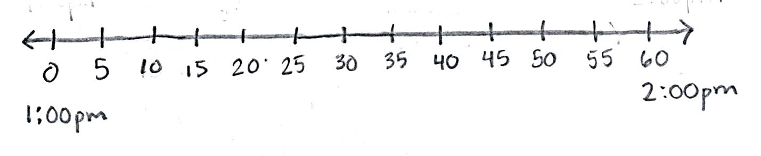
S: (Label as shown below.)
T: Now this number line shows the hour between
1:00 p.m. and 2:00 p.m.
T: We start recess at 1:10 p.m. Is that time between
1:00 p.m. and 2:00 p.m.?
S: (Agree.)
T: To find that spot on the number line, I’ll put my finger on 1:00 and move it to the right as I skip-count intervals until I reach 1:10. Remind me, what are we counting by?
S: Fives!
T: (Model, with students chorally counting along.)
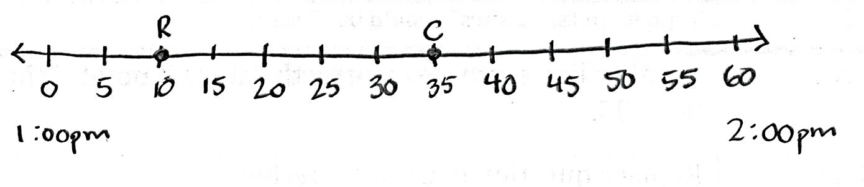
T: I’ll draw a dot on the spot where the tick mark and number line cross and label it R for recess. (Draw and label as shown right.) That dot shows the location of a point. Finding and drawing a point is called plotting a position on the number line.
T: At 1:35 p.m., we’ll start science. Is 1:35 p.m. between 1:00 p.m. and 2:00 p.m.?

NOTES ON
MULTIPLE MEANS
OF ACTION AND EXPRESSION:
Extend discussion by inviting students to discuss whether or not 12:55 p.m. and 2:15 p.m. can be plotted on this number line. Help them reason about their answer and think about where the times might be plotted, given the continuity of time.

S: (Agree.)
T: Plot 1:35 p.m. as a point on your number line. Label it C.
S: (Plot a point on the number line at 1:35.)
Continue guided practice using the following suggested sequence: 1:45 p.m. and 2:00 p.m.
T: How does the number line you’ve labeled compare to the analog clock on the wall?
S: We count the minutes by fives on both. The clock is like the number line wrapped in a circle.
Part 3: Relate the number line to the clock and tell time to the nearest 5 minutes.

NOTES ON
MULTIPLE MEANS
OF REPRESENTATION:
Activate prior knowledge about the minute hand and hour hand learned in Grade 2, Module 2. Review their difference in purpose, as well as in length.

Students have Template 2 (two clocks) ready. Display a clock face without hands.
T: We counted by fives to plot minutes on a number line, and we’ll do the same on a clock.
T: How many 5-minute intervals show 15 minutes on a clock?
S: 3 intervals.
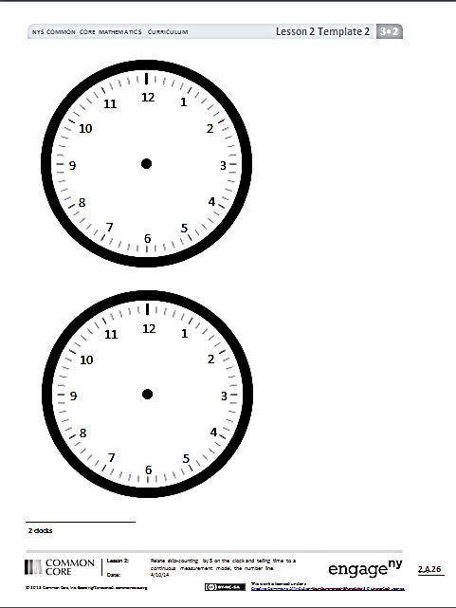
T: We started at 0 on the number line, but a clock has no 0. Where is the starting point on a clock?
Template 2
S: The 12.
T: Let’s count each 5-minute interval and plot a point on the clock to show 15 minutes. (Model.)
Options for further practice:
- Plot 30 minutes, 45 minutes, and 55 minutes using the process above.
- Write 9:15 a.m., 3:30 p.m., and 7:50 a.m. on the board as they would appear on a digital clock, or say the time rather than write it. Students copy each time, plot points, and draw hands to show that time. (Model drawing hands with 10:20 a.m.)
Problem Set (10 minutes)

NOTES ON
MULTIPLE MEANS
OF REPRESENTATION:
Problem 4 is likely to pose the biggest challenge. It requires understanding the difference between a.m. and p.m. This concept was introduced in Grade 2. One option would be to review it with students before they begin the Problem Set. Another option would be to allow them to grapple with the question and support understanding through the Debrief.

Students should do their personal best to complete the Problem Set within the allotted 10 minutes. For some classes, it may be appropriate to modify the assignment by specifying which problems they work on first. Some problems do not specify a method for solving. Students should solve these problems using the RDW approach used for Application Problems.
Student Debrief (10 minutes)
Lesson Objective: Relate skip-counting by fives on the clock and telling time to a continuous measurement model, the number line.
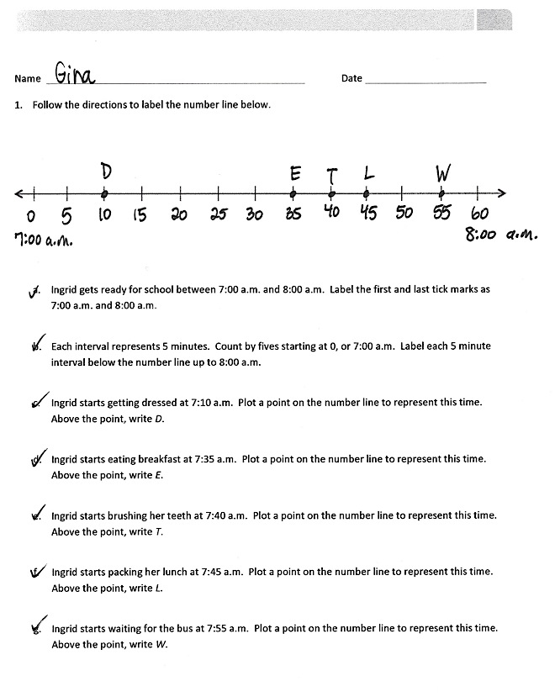
The Student Debrief is intended to invite reflection and active processing of the total lesson experience.
Invite students to review their solutions for the Problem Set. They should check work by comparing answers with a partner before going over answers as a class. Look for misconceptions or misunderstandings that can be addressed in the Debrief. Guide students in a conversation to debrief the Problem Set and process the lesson.
You may choose to use any combination of the questions below to lead the discussion.
- In Problem 2, what information was important for plotting the point on the number line that matched the time shown on each clock?
- Each interval on the analog clock is labeled with the numbers 1–12. Compare those with our labels from 0 to 60 on the number line. What do the labels represent on both tools?
- How does multiplication using units of 5 help you read or measure time?
- Students may have different answers for Problem 4
(11:25 p.m. may come before or after 11:20 a.m.). Allow students with either answer a chance to explain their thinking.
- How did our minute counting and time telling activities in today’s Fluency Practice help you with the rest of the lesson?
- Look at the number line used for Problem 2. Where do you think 5:38 would be? (This anticipates Lesson 3 by counting by fives and then ones on a number line.)
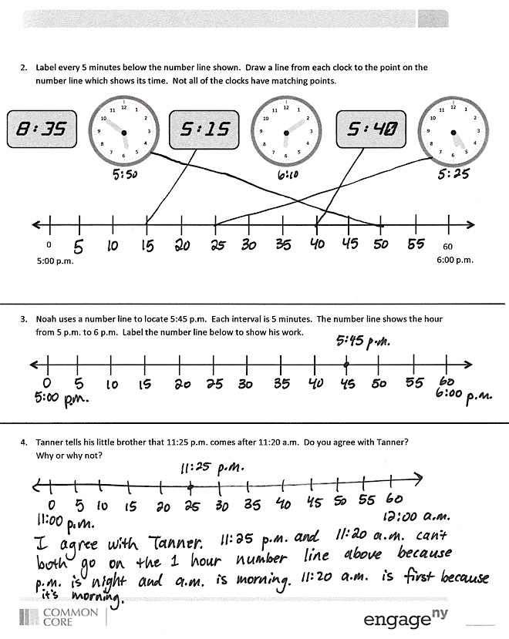
Exit Ticket (3 minutes)
After the Student Debrief, instruct students to complete the Exit Ticket. A review of their work will help you assess the students’ understanding of the concepts that were presented in the lesson today and plan more effectively for future lessons. You may read the questions aloud to the students.

Name Date
- Follow the directions to label the number line below.

- Ingrid gets ready for school between 7:00 a.m. and 8:00 a.m. Label the first and last tick marks as 7:00 a.m. and 8:00 a.m.
- Each interval represents 5 minutes. Count by fives starting at 0, or 7:00 a.m. Label each 5-minute interval below the number line up to 8:00 a.m.
- Ingrid starts getting dressed at 7:10 a.m. Plot a point on the number line to represent this time. Above the point, write D.
- Ingrid starts eating breakfast at 7:35 a.m. Plot a point on the number line to represent this time. Above the point, write E.
- Ingrid starts brushing her teeth at 7:40 a.m. Plot a point on the number line to represent this time. Above the point, write T.
- Ingrid starts packing her lunch at 7:45 a.m. Plot a point on the number line to represent this time. Above the point, write L.
- Ingrid starts waiting for the bus at 7:55 a.m. Plot a point on the number line to represent this time. Above the point, write W.
- Label every 5 minutes below the number line shown. Draw a line from each clock to the point on the number line which shows its time. Not all of the clocks have matching points.
0

5:00 p.m.

60
6:00 p.m.
8:35

5:15

5:40

12
11
10
9
8
7
6
5
4
3
2
1
12
11
10
9
8
7
6
5
4
3
2
1
12
11
10
9
8
7
6
5
4
3
2
1

- Noah uses a number line to locate 5:45 p.m. Each interval is 5 minutes. The number line shows the hour from 5 p.m. to 6 p.m. Label the number line below to show his work.

- Tanner tells his little brother that 11:25 p.m. comes after 11:20 a.m. Do you agree with Tanner?
Why or why not?

Name Date
The number line below shows a math class that begins at 10:00 a.m. and ends at 11:00 a.m. Use the number line to answer the following questions.
10:00 a.m.
11:00 a.m.

0 5 10 15 20 25 30 35 40 45 50 55 60
Sprints
Application Problem
Exit Ticket
11:00

- What time do Sprints begin?
- What time do students begin the Application Problem?
- What time do students work on the Exit Ticket?
- How long is math class?

Name Date
Follow the directions to label the number line below.

- The basketball team practices between 4:00 p.m. and 5:00 p.m. Label the first and last tick marks as 4:00 p.m. and 5:00 p.m.

- Each interval represents 5 minutes. Count by fives starting at 0, or 4:00 p.m. Label each 5-minute interval below the number line up to 5:00 p.m.
- The team warms up at 4:05 p.m. Plot a point on the number line to represent this time. Above the point, write W.
- The team shoots free throws at 4:15 p.m. Plot a point on the number line to represent this time. Above the point, write F.
- The team plays a practice game at 4:25 p.m. Plot a point on the number line to represent this time. Above the point, write G.
- The team has a water break at 4:50 p.m. Plot a point on the number line to represent this time. Above the point, write B.
- The team reviews their plays at 4:55 p.m. Plot a point on the number line to represent this time. Above the point, write P.

12
1
2
3
4
5
6
7
8
9
10
11
12
1
2
3
4
5
6
7
8
9
10
11

tape diagram
two clocks

