Lesson 1

Objective: Explore time as a continuous measurement using a stopwatch.

Suggested Lesson Structure

|  |  |
| --- | --- |
|  | A NOTE ON  STANDARDS ALIGNMENT: |
| In this lesson, students use stopwatches to measure time. To understand how to use a stopwatch and to begin to conceptualize time as a continuous measurement, students need some familiarity with seconds. This anticipates Grade 4 content (**4.MD.1**).  Seconds are used as a unit in the Application Problem and also as a unit of measure that students explore in Part 1 of the lesson as they familiarize themselves with stopwatches. | |

 Fluency Practice (12 minutes)

 Application Problem (5 minutes)

 Concept Development (33 minutes)

 Student Debrief (10 minutes)

**Total Time (60 minutes)**

Fluency Practice (12 minutes)

* Tell Time on the Clock **2.MD.7** (3 minutes)
* Minute Counting **3.MD.1** (6 minutes)
* Group Counting **3.OA.1** (3 minutes)

Tell Time on the Clock (3 minutes)

Materials: (T) Analog clock for demonstration (S) Personal white board

Note: This activity reviews the Grade 2 standard of telling and writing time to the nearest 5 minutes. It prepares students to count by 5-minute intervals on the number line and clock in Lesson 2.

T: (Show an analog demonstration clock.) Start at 12 and count by 5 minutes on the clock. (Move finger from 12 to 1, 2, 3, 4, etc., as students count.)

S: 5, 10, 15, 20, 25, 30, 35, 40, 45, 50, 55, 60.

T: I’ll show a time on the clock. Write the time on your personal white board. (Show 11:10.)

S: (Write 11:10.)

T: (Show 6:30.)

S: (Write 6:30.)

Repeat the process, varying the hour and 5-minute interval so that students read and write a variety of times to the nearest 5 minutes.

Minute Counting (6 minutes)

Note: This activity reviews the Grade 2 standard of telling and writing time to the nearest 5 minutes. It prepares students to count by 5-minute intervals on the number line and clock in Lesson 2. Students also practice group counting strategies for multiplication in the context of time.

T: There are 60 minutes in 1 hour. Count by 5 minutes to 1 hour.

S: 5 minutes, 10 minutes, 15 minutes, 20 minutes, 25 minutes, 30 minutes, 35 minutes, 40 minutes, 45 minutes, 50 minutes, 55 minutes, 60 minutes. (Underneath 60 minutes, write 1 hour.)

T: How many minutes are in a half hour?

S: 30 minutes.

T: Count by 5 minutes to 1 hour. This time, say *half hour* when you get to 30 minutes.

Repeat the process using the following suggested sequence:

* Count by 10 minutes and 6 minutes to 1 hour.
* Count by 3 minutes to a half hour.

Group Counting (3 minutes)

Note: Group counting reviews interpreting multiplication as repeated addition. Counting by sevens, eights, and nines in this activity anticipates multiplication using those units in Module 3.

Direct students to count forward and backward using the following suggested sequence, occasionally changing the direction of the count:

* Sevens to 28
* Eights to 32
* Nines to 36

Application Problem (5 minutes)

|  |  |
| --- | --- |
|  | A NOTE ON  STANDARDS ALIGNMENT: |
| Seconds exceed the standard for Grade 3, which expects students to tell time to the nearest minute. The standards introduce seconds in Grade 4 (**4.MD.1**). | |

Ms. Bower helps her kindergartners tie their shoes. It takes her 5 seconds to tie 1 shoe. How many seconds does it take Ms. Bower to tie 8 shoes?

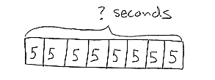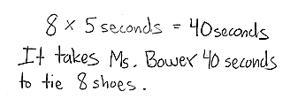

Note: This reviews multiplication from Module 1 and gets students thinking about how long it takes to complete an activity or task. It leads into the Concept Development by previewing the idea of seconds as a unit of time.

Concept Development (33 minutes)

Materials: (T) Stopwatch and classroom clock (S) Stopwatch, personal white board

Part 1: Explore seconds as a unit of time.

T: It takes Ms. Bower 5 seconds to tie one shoe. Does it take a very long time to tie a shoe?

S: No!

T: Let’s see how long a second is. (Let the stopwatch tick off a second.)

T: It’s a short amount of time! Let’s see how long 5 seconds is so we know how long it takes Ms. Bower to tie 1 shoe. (Let the stopwatch go for 5 seconds.)

|  |  |
| --- | --- |
|  | NOTES ON  MULTIPLE MEANS  OF ENGAGEMENT: |
| When introducing the stopwatch as a tool to measure time, ask students to think about where stopwatches are used in real world contexts, for example, in swim meets, races, etc. Then, discuss the purpose of the stopwatch in these contexts. | |

T: Let’s see how long 40 seconds lasts. That’s the amount of time it takes Ms. Bower to tie 8 shoes. (Let the stopwatch go for 40 seconds.) Tell the count after every 5 seconds.

S: (Watch the stopwatch.) 5! 10! 15! Etc.

T: **Seconds** are a unit of time. They’re smaller than minutes, so we can use them to measure short amounts of time.

T: What are other things we might measure using seconds?

S: (Discuss.)

T: Turn and tell your partner how many seconds you estimate it takes us to walk from the carpet to sit in our seats.

T: Let’s use the stopwatch to measure. Go!

T: It took us ___ seconds. Use mental math to compare your estimate with the real time. How close were you? (Select a few students to share.)

T: (Display stopwatch.) The tool I’m using to measure seconds is called a stopwatch**.** We can start it and stop it to measure how much time passes by. It has two buttons. The button on the right is the start button, and the one on the left is the stop and reset button.

T: When we stopped the stopwatch, did time stop, or did we just stop measuring?

S: Time didn’t stop. 🡪 We stopped measuring time by hitting the stop button. 🡪 Time keeps going. We only stopped measuring.

T: Time is **continuous**. *Continuous* means time does not stop, but is always moving forward. We just use stopwatches and clocks to measure its movement.

T: Partner 1, measure and write how long it takes Partner 2 to draw a 2 by 5 array on her personal white board.

S: (Partner 1 times, and Partner 2 draws. Partner 1 writes unit form, e.g., 8 seconds.)

Student pairs take turns using a stopwatch to measure how long it takes them to do the following:

* Skip-count by fives to 60.
* Draw a 6 by 10 array.

Part 2: Explore minutes as a unit of time.

T: I look at the clock and notice that ___ minutes have passed since we walked from our tables to the carpet.

|  |  |
| --- | --- |
|  | NOTES ON  MULTIPLE MEANS  OF ENGAGEMENT: |
| Possibly extend Part 1 discussion:  T: Who was faster?  S1: I was!  T: Whose was neater?  S2: Mine!  T: In this case, was faster better?  S: The picture was better when we went more slowly. | |

T: **Minutes** are longer than seconds. Let’s find out what the length of a minute feels like. Sit quietly and measure a minute with your stopwatch. Go!

S: (Watch the stopwatch until 1 minute passes.)

T: What does a minute feel like?

S: It is *much* longer than 1 second!

T: Now, I’ll time 1 minute. You turn and talk to your partner about your favorite game. Let’s see if the length of 1 minute feels the same. (Time students talking.)

T: Did 1 minute feel faster or slower than when you were just watching the clock?

S: It seemed so much faster! Talking was fun!

T: How long a minute feels can change depending on what we’re doing, but the measurement always stays the same. What are some other things we might use minutes to measure?

|  |  |
| --- | --- |
|  | NOTES ON  MULTIPLE MEANS  OF ACTION AND EXPRESSION: |
| When leaving the classroom for recess or lunch, consider measuring how long it takes to make a line, to go to the cafeteria, or to return to the classroom. | |

S: (Discuss.)

Student pairs take turns using a stopwatch to measure how long it takes them to do the following:

* Touch their toes and raise their hands over their heads 30 times.
* Draw 1 by 1, 2 by 2, 3 by 3, 4 by 4, and 5 by 5 arrays.

Part 3: Explore time as a continuous measurement.

T: We can use the stopwatch to start measuring how many minutes it takes to get dark outside. Will it take a long time?

S: Yes!

T: (Start stopwatch and wait impatiently.) Should I keep measuring? (Let students react.)

T: (Stop stopwatch.) Imagine that I measure how long it takes for all the students in this class to turn 10 years old. Is a stopwatch a good tool for measuring such a long amount of time?

S: No! It’s better for measuring an amount of time that is not very long.

T: Time keeps going and going, and a stopwatch just captures a few seconds or minutes of it along the way.

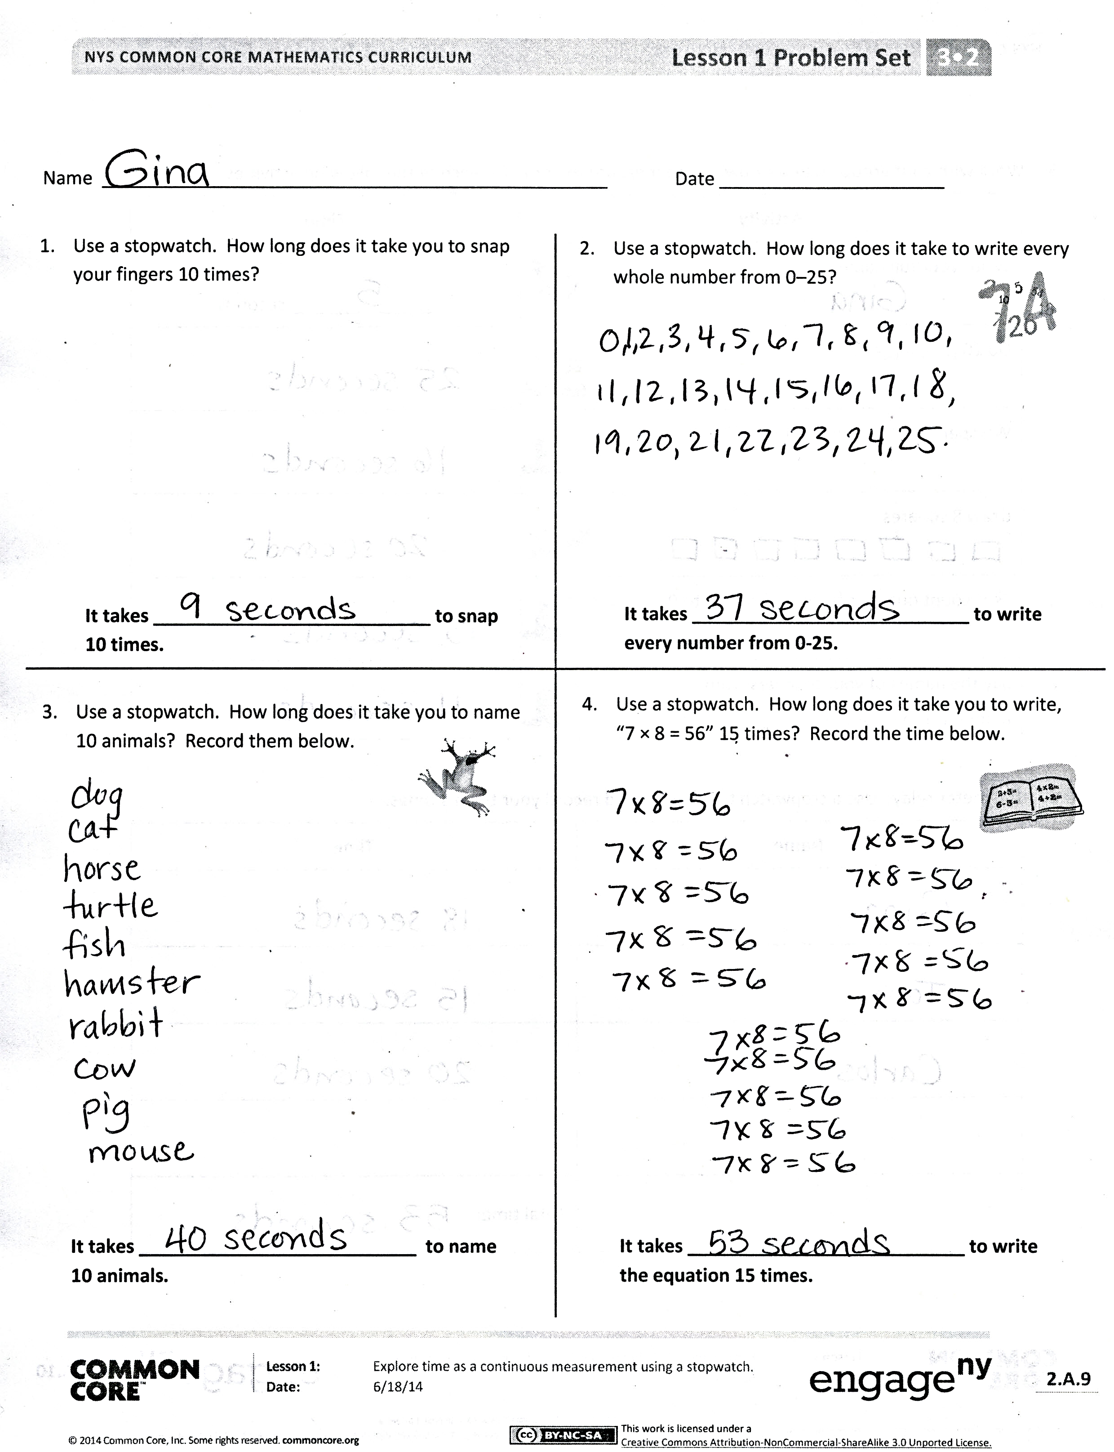Problem Set (10 minutes)

Students should do their personal best to complete the Problem Set within the allotted 10 minutes. Some problems do not specify a method for solving.  This is an intentional reduction of scaffolding that invokes MP.5, Use Appropriate Tools Strategically.  Students should solve these problems using the RDW approach used for Application Problems.

For some classes, it may be appropriate to modify the assignment by specifying which problems students should work on first. With this option, let the purposeful sequencing of the Problem Set guide your selections so that problems continue to be scaffolded.  Balance word problems with other problem types to ensure a range of practice.  Consider assigning incomplete problems for homework or at another time during the day.

Student Debrief (10 minutes)

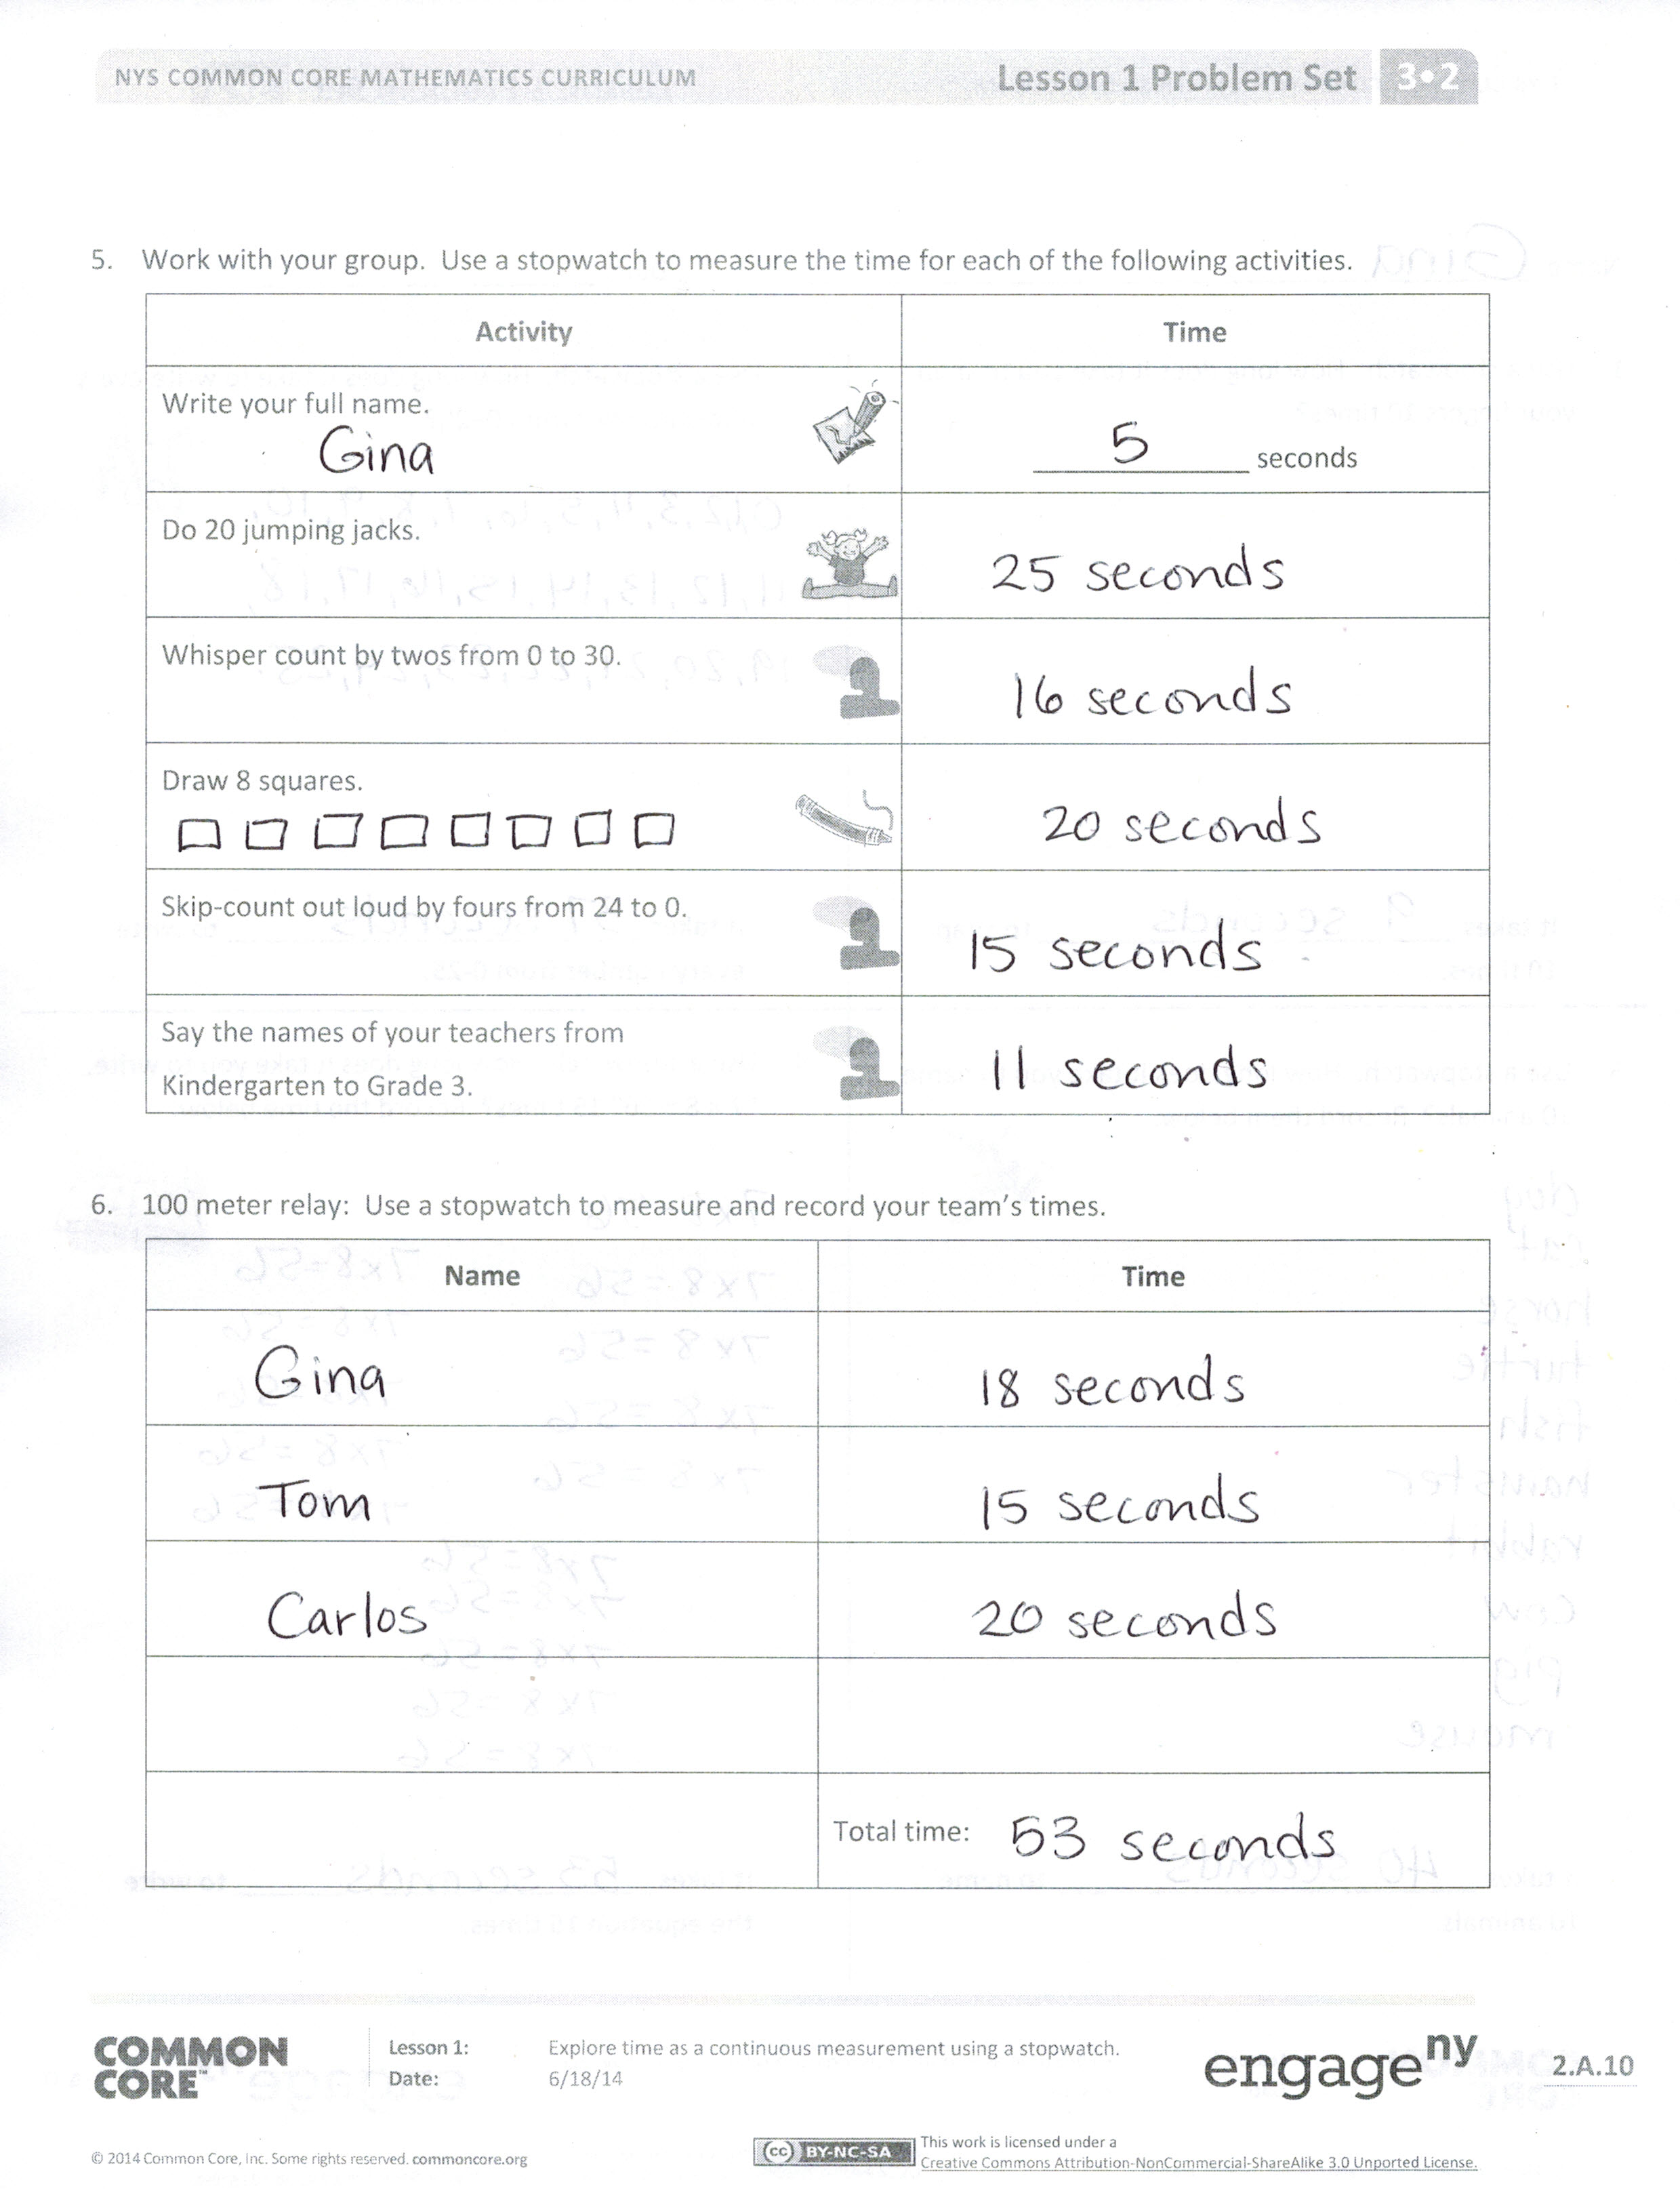**Lesson Objective:** Explore time as a continuous measurement using a stopwatch.

The Student Debrief is intended to invite reflection and active processing of the total lesson experience.

Invite students to review their solutions for the Problem Set. They should check work by comparing answers with a partner before going over answers as a class. Look for misconceptions or misunderstandings that can be addressed in the Debrief. Guide students in a conversation to debrief the Problem Set and process the lesson. You may choose to use any combination of the questions below to lead the discussion.

* What pattern did you notice in Problem 5?
* Explain to your partner why the activities in Problem 5 did not take that long to complete.
* Did it take you longer to complete Problem 1 or Problem 4? Why?
* Why do we use a stopwatch?
* **Seconds** and **minutes** are units we use to measure time. How are they different?
* Does time stop when we stop measuring time with our stopwatch? Use the word *continuous* to talk about why or why not with your partner.

Exit Ticket (3 minutes)

After the Student Debrief, instruct students to complete the Exit Ticket. A review of their work will help you assess the students’ understanding of the concepts that were presented in the lesson today and plan more effectively for future lessons. You may read the questions aloud to the students.

Name Date

1. Use a stopwatch. How long does it take you to snap your fingers 10 times?
2. Use a stopwatch. How long does it take to write every whole number from 0 to 25?

**C:\Users\Susan\AppData\Local\Microsoft\Windows\Temporary Internet Files\Content.IE5\934AWBUQ\MC900130271[1].wmf**

**It takes ___________________________ to write every number from 0 to 25.**

**It takes ___________________________ to snap**

**10 times.**

1. Use a stopwatch. How long does it take you to write 7 × 8 = 56 fifteen times? Record the time below.

C:\Users\Susan\AppData\Local\Microsoft\Windows\Temporary Internet Files\Content.IE5\OQZ7ELDY\MC900084346[1].wmf

1. Use a stopwatch. How long does it take you to name 10 animals? Record them below.

**C:\Users\Susan\AppData\Local\Microsoft\Windows\Temporary Internet Files\Content.IE5\CMU62KQ7\MC900325240[1].wmf**

**It takes ___________________________ to write   
7 × 8 = 56 fifteen times.**

**It takes ___________________________ to name 10 animals.**

1. Work with your group. Use a stopwatch to measure the time for each of the following activities.

|  |  |
| --- | --- |
| **Activity** | **Time** |
| Write your full name.  C:\Users\Susan\AppData\Local\Microsoft\Windows\Temporary Internet Files\Content.IE5\CMU62KQ7\MC900290272[1].wmf | ______________ seconds |
| Do 20 jumping jacks.  C:\Users\Susan\AppData\Local\Microsoft\Windows\Temporary Internet Files\Content.IE5\934AWBUQ\MC900232431[1].wmf |  |
| Whisper count by twos from 0 to 30.  C:\Users\Susan\AppData\Local\Microsoft\Windows\Temporary Internet Files\Content.IE5\5L60D5AD\MC900311794[1].wmf |  |
| Draw 8 squares.  C:\Users\Susan\AppData\Local\Microsoft\Windows\Temporary Internet Files\Content.IE5\OQZ7ELDY\MC900384134[1].wmf |  |
| Skip-count out loud by fours from 24 to 0.  C:\Users\Susan\AppData\Local\Microsoft\Windows\Temporary Internet Files\Content.IE5\5L60D5AD\MC900311794[1].wmf |  |
| Say the names of your teachers from  C:\Users\Susan\AppData\Local\Microsoft\Windows\Temporary Internet Files\Content.IE5\5L60D5AD\MC900311794[1].wmfKindergarten to Grade 3. |  |

1. 100 meter relay: Use a stopwatch to measure and record your team’s times.

|  |  |
| --- | --- |
| **Name** | **Time** |
|  |  |
|  |  |
|  |  |
|  |  |
|  | Total time: |

Name Date

|  |  |
| --- | --- |
| Maya | 16 seconds |
| Riley | **15 seconds** |
| Jake | **14 seconds** |
| Nicholas | **15 seconds** |
| Adeline | **17 seconds** |

The table to the right shows how much time it takes each of the 5 students to do 15 jumping jacks.

1. Who finished 15 jumping jacks the fastest?
2. Who finished their jumping jacks in the exact same amount of time?
3. How many seconds faster did Jake finish than Adeline?

Name Date

1. The table below shows how much time it takes each of the 5 students to run 100 meters.

|  |  |
| --- | --- |
| Samantha | 19 seconds |
| Melanie | **22 seconds** |
| Chester | **26 seconds** |
| Dominique | **18 seconds** |
| Louie | **24 seconds** |

1. Who is the fastest runner?
2. Who is the slowest runner?
3. How many seconds faster did Samantha run than Louie?
4. List activities at home that take about the following amounts of time to complete. If you do not have a stopwatch, you can use the strategy of counting by “1 Mississippi, 2 Mississippi, 3 Mississippi….”

|  |  |
| --- | --- |
| **Time** | **Activities at home** |
| 30 seconds | Example: Tying shoelaces |
| 45 seconds |  |
| 60 seconds |  |

1. Match the analog clock with the correct digital clock.

