Lesson 21
Objective: Solve two-step word problems involving all four operations, and assess the reasonableness of answers.

Suggested Lesson Structure
 Fluency Practice (14 minutes)
 Application Problem (5 minutes)
 Concept Development (31 minutes)
 Student Debrief (10 minutes)
Total Time (60 minutes)
Fluency Practice (14 minutes)
- Group Counting 3.OA.1 (3 minutes)
- Multiply by 5 Pattern Sheet 3.OA.7 (8 minutes)
- Commutative Multiplying 3.OA.7 (3 minutes)
Group Counting (3 minutes)
Note: Group counting reviews interpreting multiplication as repeated addition. Counting by threes, fours, and sixes in this activity reviews multiplication with units of 3 and 4 and anticipates multiplication with units of 6 in Module 3.
T: Let’s count by threes. (Direct students to count forward and backward to 30.)
T: Let’s count by fours, think/talk forward and backward. (Direct students to count forward and backward to 40. Think 1, 2, 3; say 4. Think 5, 6, 7; say 8, etc.)
T: Let’s count by sixes. (Direct students to count forward and backward to 48, emphasizing the 24 to 30 and 36 to 42 transitions.)
Multiply by 5 Pattern Sheet (8 minutes)
Materials: (S) Multiply by 5 (1–5) (Pattern Sheet)
Note: This activity builds fluency with multiplication facts using units of 5. It works toward students knowing from memory all products of two one-digit numbers. See Lesson 9 for the directions for administering a Sprint.
T: (Write 5 × 5 = ____.) Let’s skip-count up by fives to solve. (Count with fingers to 5 as students count. Record skip-count answers on the board.)
S: 5, 10, 15, 20, 25.
T: (Circle 25 and write 5 × 5 = 25 above it. Write 3 × 5 = ____.) Let’s skip-count up by fives again. (Count with fingers to 3 as students count.)
S: 5, 10, 15.
T: Let’s see how we can skip-count down to find the answer, too. Start at 25. (Count down with fingers as students say numbers.)
S: 25, 20, 15.
Repeat process for 9 × 5 and 8 × 5.
T: Let’s practice multiplying by 5. Be sure to work left to right across the page. (Distribute Multiply by 5 Pattern Sheet.)
Commutative Multiplying (3 minutes)
Note: This activity reviews the commutativity of multiplication, learned in Lessons 7, 8, and 15.
T: (Write 4 × 2 = ___.) Say the multiplication sentence.
S: 4 × 2 = 8.
T: Flip it.
S: 2 × 4 = 8.
Repeat the process for 5 × 3, 9 × 2, 4 × 3, 2 × 7, and 3 × 8.
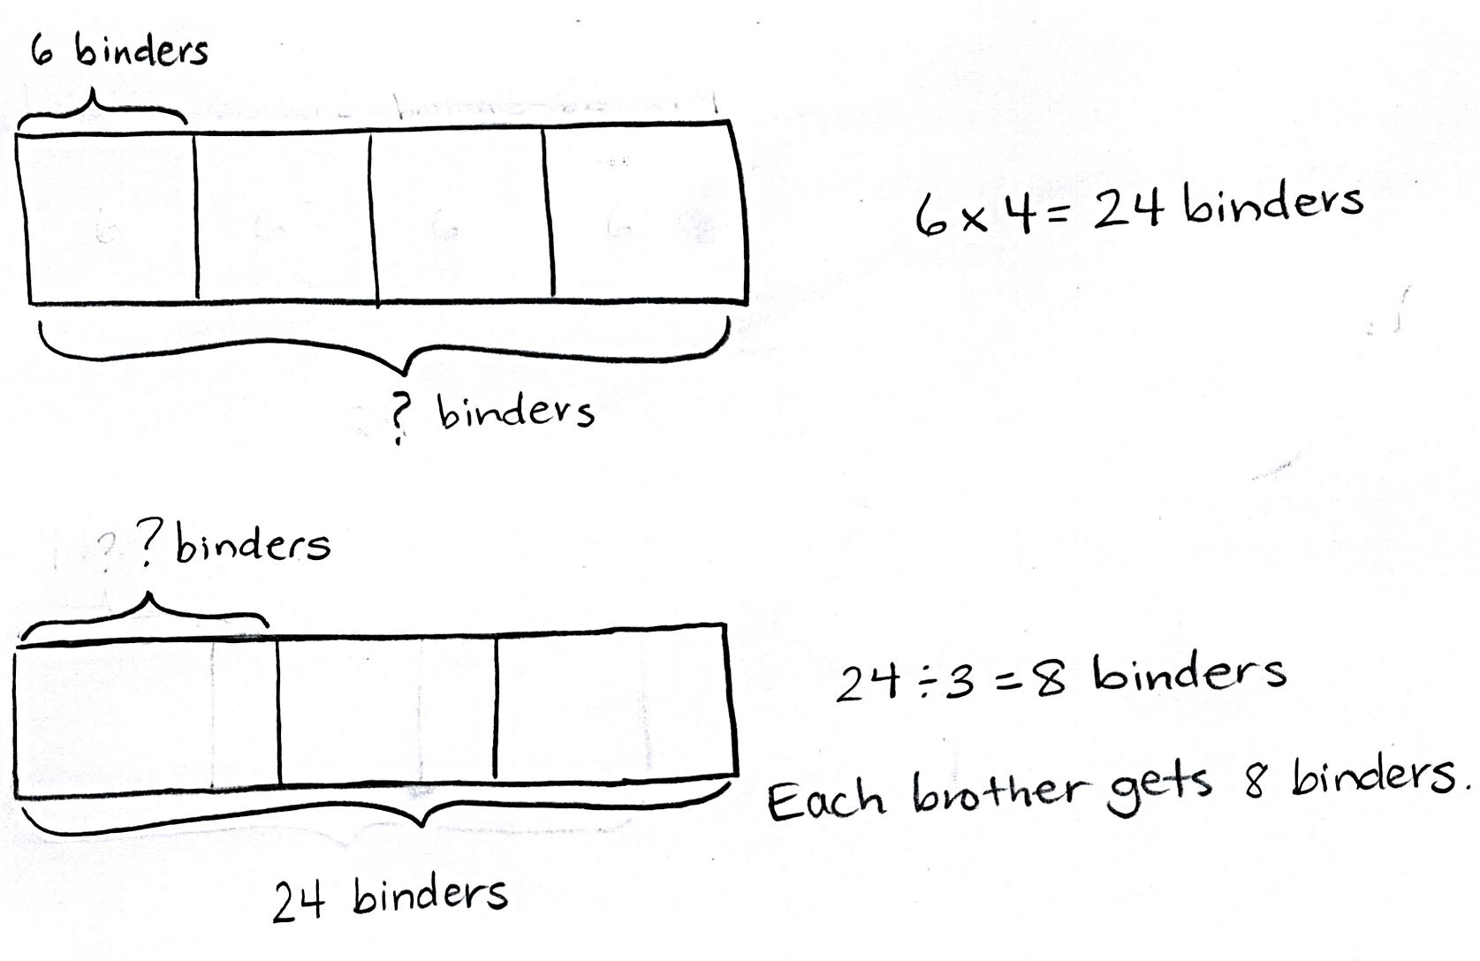
Application Problem (5 minutes)
There are 4 boxes with 6 binders in each one. Three brothers share the binders. How many binders does each brother get?
Note: This two-step problem reviews Lesson 20’s objective. To solve an Application Problem, students self-select an approach and independently solve. Practicing a two-step problem here scaffolds the difference between the structured practice in Lesson 20 and the open-ended practice in Lesson 21. Prepare students for today’s exploration by guiding them to evaluate their methods for solving and assessing the reasonableness of their answers.
Concept Development (31 minutes)
Materials: (S) Chart paper, markers, paper strips (optional for representing tape diagrams), glue
Today’s lesson is a culminating exploration that follows the following process:
- Divide the class into groups no larger than four students.
- Assign each group one word problem from the Problem Set. (Cut the Problem Set so that initially each group only receives the problem they are assigned. More than one group may work on the same problem.)
- Each group collaborates to model and solve their assigned problem.

NOTES ON
MULTIPLE MEANS
OF ACTION AND EXPRESSION:
The first two problems on the Problem Set have diagrams drawn to scaffold instructions. These diagrams may be removed for the exploration to adjust the level of support for the groups who solve them.
A visual representation of the CCLS Tables 1–2 could be used to help students determine the known and unknown information.

- Each group prepares to present their problem to the class, describing their method for solving and explaining the reasonableness of their answer.
Each group needs one set of the materials listed in the materials section.
Directions (similar to RDW process):
- Read and analyze together to determine known and unknown information.
- Discuss how to model.
- Model and label diagrams.
- Discuss and agree on the steps needed to solve.
MP.1
- Write equations and solve.
- Assess the reasonableness of the solution. (Ask, “Does our answer make sense? How do we know?”)

NOTES ON
MULTIPLE MEANS
OF REPRESENTATION:
Consider assigning roles so that group members participate and each student remains accountable for learning. This is particularly important with regard to each group’s presentation. Set the expectation that each member actively contributes.
Another option is to reconfigure the groups and partner share the process and solution, encouraging the use of precise language (e.g., equation, product, and quotient).

- Write a complete sentence to answer the question.
- Prepare a mini-presentation to explain each step of your work. Prepare to answer clarifying questions from the group.
Each group presents to the class. Audience members should be prepared to ask clarifying questions, challenge each other’s work, and offer compliments. If more than one group solves the same problem, discussion might include similarities and differences between problem-solving approaches.
Problem Set (5 minutes)
When all groups have presented, pass out the entire Problem Set and have the students solve the problems independently. The time allotment is short, as they’ve just seen and discussed every problem.

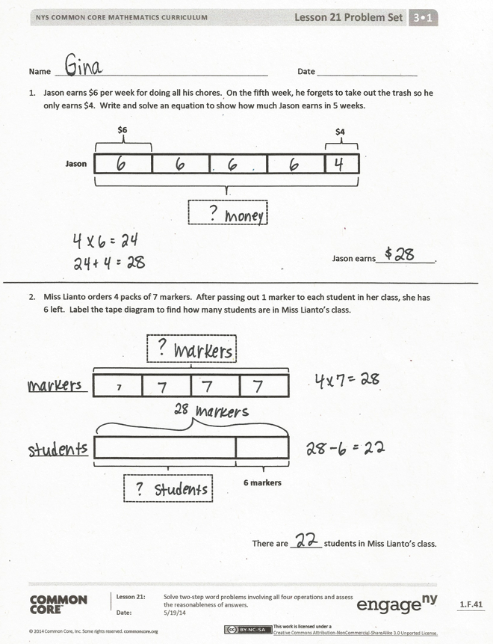
Student Debrief (10 minutes)
Lesson Objective: Solve two-step word problems involving all four operations, and assess the reasonableness of answers.
After the presentations and discussion of the Problem Set during the lesson, today’s Debrief culminates the module with a celebration. Students reflect on their progress in learning to multiply and divide using units of 2, 3, 4, 5, and 10.
Students are seated with a personal white board. Select one student to stand behind someone seated. Say an expression or give a word problem. Of the pair, the first student to solve it correctly and lift his board wins the round. That student rotates one seat to the right. The goal is for a single child to work her way back to the seat behind which she originally stood. The game is very fast-paced to build excitement. Given the time constraint, the game is unlikely to finish. The winner can be the student who moves the most spaces.
Sample expressions or word problems:
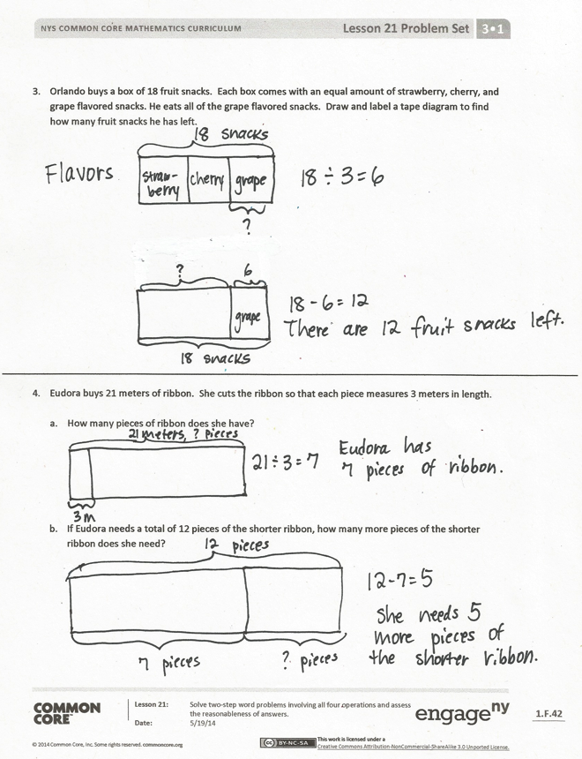
- How many legs are there on 5 dogs?
- 4 × 3
- 6 × 2
- Write a related division fact for 5 × 3.
- 18 ÷ 3
Exit Ticket (3 minutes)
After the Student Debrief, instruct students to complete the Exit Ticket. A review of their work will help you assess the students’ understanding of the concepts that were presented in the lesson today and plan more effectively for future lessons. You may read the questions aloud to the students.

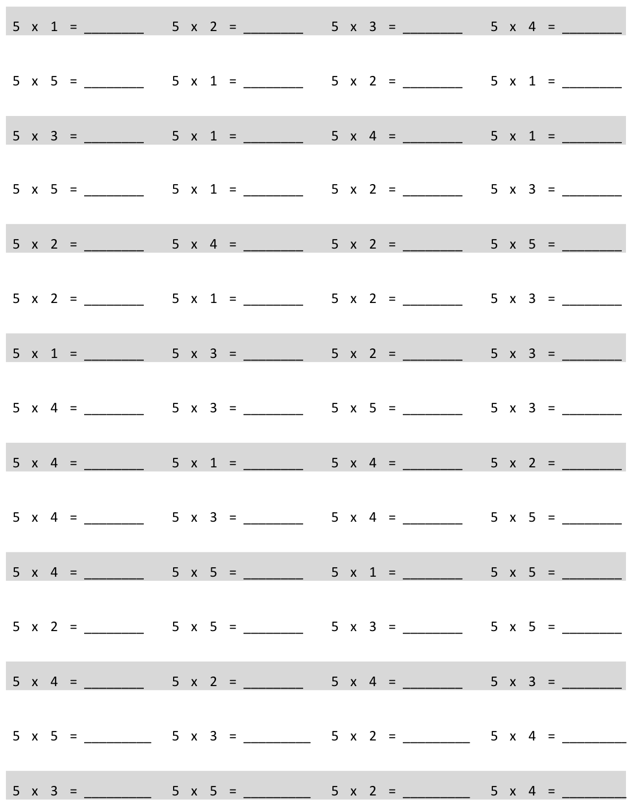
Multiply.
Name Date
- Jason earns $6 per week for doing all his chores. On the fifth week, he forgets to take out the trash, so he only earns $4. Write and solve an equation to show how much Jason earns in 5 weeks.
$6
Jason
$4

Jason earns _____________.

- Miss Lianto orders 4 packs of 7 markers. After passing out 1 marker to each student in her class, she has 6 left. Label the tape diagram to find how many students are in Miss Lianto’s class.
7
_____________

6 markers
_____________

There are _______ students in Miss Lianto’s class.
- Orlando buys a box of 18 fruit snacks. Each box comes with an equal amount of strawberry, cherry, and grape flavored snacks. He eats all of the grape flavored snacks. Draw and label a tape diagram to find how many fruit snacks he has left.

- Eudora buys 21 meters of ribbon. She cuts the ribbon so that each piece measures 3 meters in length.

- How many pieces of ribbon does she have?

- If Eudora needs a total of 12 pieces of the shorter ribbon, how many more pieces of the shorter ribbon does she need?

Name Date
Ms. Egeregor buys 27 books for her classroom library. She buys an equal number of fiction, nonfiction, and poetry books. She shelves all of the poetry books first. Draw and label a tape diagram to show how many books Ms. Egeregor has left to shelve.

Name Date
- Tina eats 8 crackers for a snack each day at school. On Friday, she drops 3 and only eats 5. Write and solve an equation to show the total number of crackers Tina eats during the week.
8 crackers
Tina
5 crackers

Tina eats __________ crackers.

- Ballio has a reading goal. He checks 3 boxes of 9 books out from the library. After finishing them, he realizes that he beat his goal by 4 books! Label the tape diagrams to find Ballio’s reading goal.

9
_________

4 books
_________

Ballio’s goal is to read _______ books.
- Mr. Nguyen plants 24 trees around the neighborhood pond. He plants equal numbers of maple, pine, spruce, and birch trees. He waters the spruce and birch trees before it gets dark. How many trees does Mr. Nguyen still need to water? Draw and label a tape diagram.

- Anna buys 24 seeds and plants 3 in each pot. She has 5 pots. How many more pots does Anna need to plant all of her seeds?

multiply by 5 (1–5)

