Lesson 20
Objective: Solve two-step word problems involving multiplication and division, and assess the reasonableness of answers.

Suggested Lesson Structure
 Fluency Practice (9 minutes)
 Application Problem (8 minutes)
 Concept Development (33 minutes)
 Student Debrief (10 minutes)
Total Time (60 minutes)
Fluency Practice (9 minutes)
- Sprint: Skip-Count by 5 2.NBT.2 (9 minutes)
Sprint: Skip-Count by 5 (9 minutes)
Materials: (S) Skip-Count by 5 Sprint
Note: This activity builds a foundation for multiplication using units of 5 through reviewing skip-counting from Grade 2. See Lesson 2 for the directions for administering a Sprint.
Between Sprints, include the following group counting in place of movement exercises:
- Count by fours to 40, hum/talk forward and backward. (Hum as you think 1, 2, 3; say 4. Hum as you think 5, 6, 7; say 8, etc.)
- Count by sixes to 42 forward and backward, emphasizing the 24 to 30 and 36 to 42 transitions.
- Count by threes to 30 forward and backward.
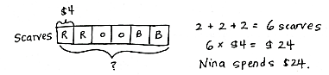
Application Problem (8 minutes)
Red, orange, and blue scarves are on sale for $4 each. Nina buys 2 scarves of each color. How much does she spend altogether?
Note: This problem reviews multiplication using units of 4. It also leads into Problem 1 of the Concept Development.

Concept Development (33 minutes)

NOTES ON
MULTIPLE MEANS
OF REPRESENTATION:
The vignette follows the I do, we do, you do process to guide students through the two-step word problems. Adjust the level of support for each problem according to the needs your students demonstrate. Consider working with a small group to solve Problem 3.

Materials: (S) Personal white board
Problem 1: Model a two-step problem with a tape diagram.
Write or project the following story: Red, orange, and blue scarves are on sale for $4 each. Nina buys 2 scarves of each color. She also buys a hat that costs $4. How much does she spend altogether?
T: Compare this new problem with the Application Problem you just solved. What is different?
S: The question is still the same, but the new problem adds the cost of a hat to the total.
T: Turn and talk to your partner: How can we use our answer from the Application Problem to help solve the new problem?
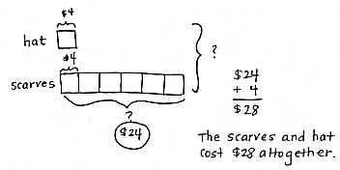
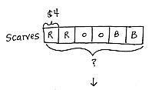
S: In our Application Problem, we found the cost of the 6 scarves. We just have to add the cost of the hat to the total.

T: (Draw tape diagram.) This tape diagram shows the Application Problem.
T: Each of these boxes is 1 unit. Tell me what 1 unit represents.
S: 1 scarf.
T: What is the value of 1 unit?
S: $4.
T: What do the 6 units represent?
S: 6 scarves.
T: How did you label the 6 units?
S: With a question mark.
T: What equation did you use to find the total of all the items?
S: 6 × $4 = $24.
T: Watch as I add to our model to represent the new problem.
T: (Draw and label diagram as shown.) Now, I add the cost of the hat, $4, to the total cost of the scarves, $24, (write $4 + $24 = ____), which is…?
S: $28.
T: How many units did we add together to find the total of both items?
S: 7 units. 1 unit + 6 units.
T: Tell your partner a multiplication sentence you could use to find the total cost of the scarves and hat without finding the value of the scarves first.
S: 7 units of $4 = $28. 7 × $4 = $28.
Problem 2: Use the tape diagram to solve a two-step problem.
Write or project the following story: Mr. Lim buys 7 plants for his garden. Each plant costs $5. The next day, he buys a rose bush that also costs $5. How much more do the 7 plants cost than the rose bush?
T: What information is known from reading the story?
S: The cost of each plant is $5. We also know the rose bush costs $5.
T: What information is unknown?
S: We don’t know the total cost of the 7 plants, so we don’t know how much more the plants cost than the rose bush.
T: Notice there are two unknowns in our problem. Let’s first draw and label a tape diagram to model the unknown as the cost of the 7 plants.
S: (Draw and label tape diagram.)
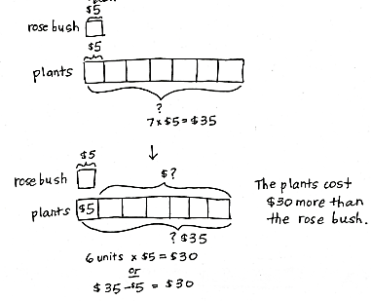
T: Tell me how to find the cost of the plants.
S: We multiply 7 × $5.
T: The plants cost…?
S: $35.
T: Have we answered the question?
S: No.
T: What is the question we are trying to answer?
S: How much more the plants cost than the rose bush.
T: (Label the second question mark.) Tell your partner what strategy you might use to answer the question.
S: I might subtract the cost of the rose bush from the total cost of the 7 plants. I might do 6 × $5 because the plants have 6 units more than the rose bush. I’ll skip-count the 6 extra fives on the plants diagram.
T: Write an equation and solve the problem on your personal white board.
S: (Possibly write: $35 – $5 = $30, 6 × $5 = $30, $5 + $5 + $5 + $5 + $5 + $5 = $30.)
T: Reread the question. Have we answered it?
S: (Reread and confirm.)
T: Is $30 a reasonable answer? Why or why not?
S: Yes, 7 plants are expensive! $5 is a lot less than $35, so $30 less makes sense. I checked with addition. $30 + $5 = $35.
T: (Erase the first diagram and the $35 that marks the total value on the second diagram.) We first drew two models because the problem has two steps. How does this model represent the whole problem on its own?
S: (Discuss).
T: We know that 1 unit is $5. How many units represent the additional cost of the plants?
S: 6 units.
T: Given what you know, is it necessary to find the total cost of the plants? Why or why not?
S: You can just do 6 × $5 without having to know about $35.
T: Explain to your partner the difference between the two ways of solving this problem.
Problem 3: Work with a partner to model and solve a two-step problem.
Write or project the following story: Ten children equally share 40 almonds. How many almonds will 3 children get?

NOTES ON
MULTIPLE MEANS
FOR ENGAGEMENT:
Scaffold Problem 3 by providing a tape diagram with no labels. This allows students to see the problem and analyze the steps they need to take to solve the problem.

T: What information is known?
S: The total amount of almonds and the number of children.
T: What is unknown?
S: How many almonds 3 children get.
T: In order to solve, what do you need to find first?
S: The amount of almonds 1 child gets.
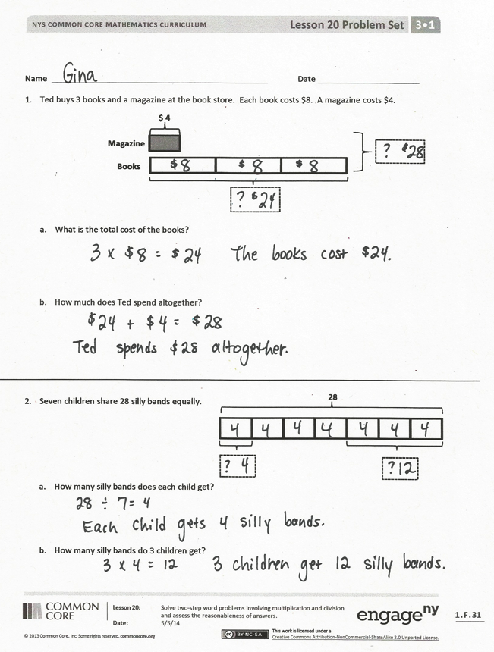
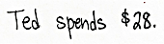
T: With a partner, model and solve the problem.
Make sure to reread the question to see if you have answered the question. Then, think about whether or not the answer makes sense. This is how we check the reasonableness of the answer.

Problem Set (10 minutes)
Students should do their personal best to complete the Problem Set within the allotted 10 minutes. For some classes, it may be appropriate to modify the assignment by specifying which problems they work on first. Some problems do not specify a method for solving. Students should solve these problems using the RDW approach used for Application Problems.

Student Debrief (10 minutes)
Lesson Objective: Solve two-step word problems involving multiplication and division and assess the reasonableness of answers.
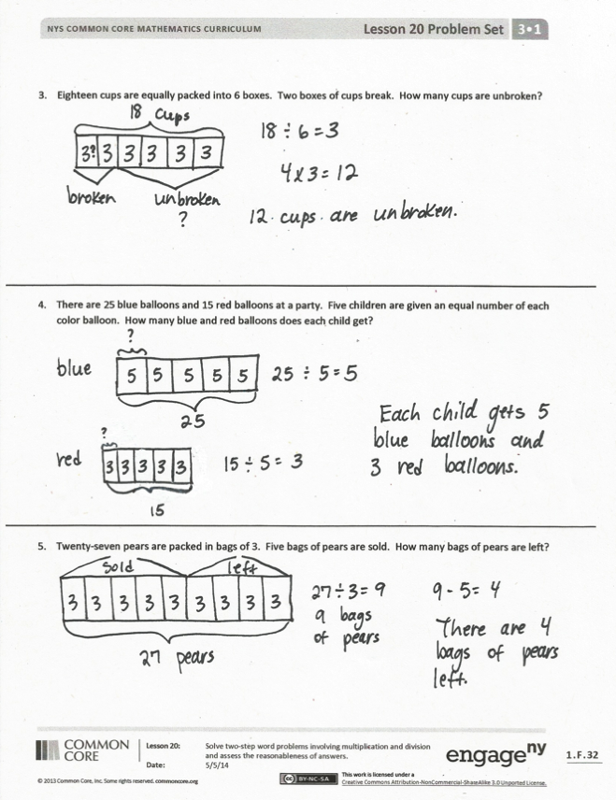
The Student Debrief is intended to invite reflection and active processing of the total lesson experience.
Invite students to review their solutions for the Problem Set. They should check work by comparing answers with a partner before going over answers as a class. Look for misconceptions or misunderstandings that can be addressed in the Debrief. Guide students in a conversation to debrief the Problem Set and process the lesson.
You may choose to use any combination of the questions below to lead the discussion.
- Compare the structure of Problems 1 and 2 to the rest of the Problem Set. Problems 1 and 2 explicitly ask two questions to scaffold the two-step word problems. Problems 3–5 still require two steps, but only ask one question.
- Compare Problems 3 and 5. What do the unknowns represent? How are these problems similar? How are they different?
- Have students share their models. In Problems 3 and 5, how did you show the boxes of broken cups and the bags of pears sold?
- How did you check the reasonableness of your answers to each problem?
Exit Ticket (3 minutes)
After the Student Debrief, instruct students to complete the Exit Ticket. A review of their work will help you assess the students’ understanding of the concepts that were presented in the lesson today and plan more effectively for future lessons. You may read the questions aloud to the students.

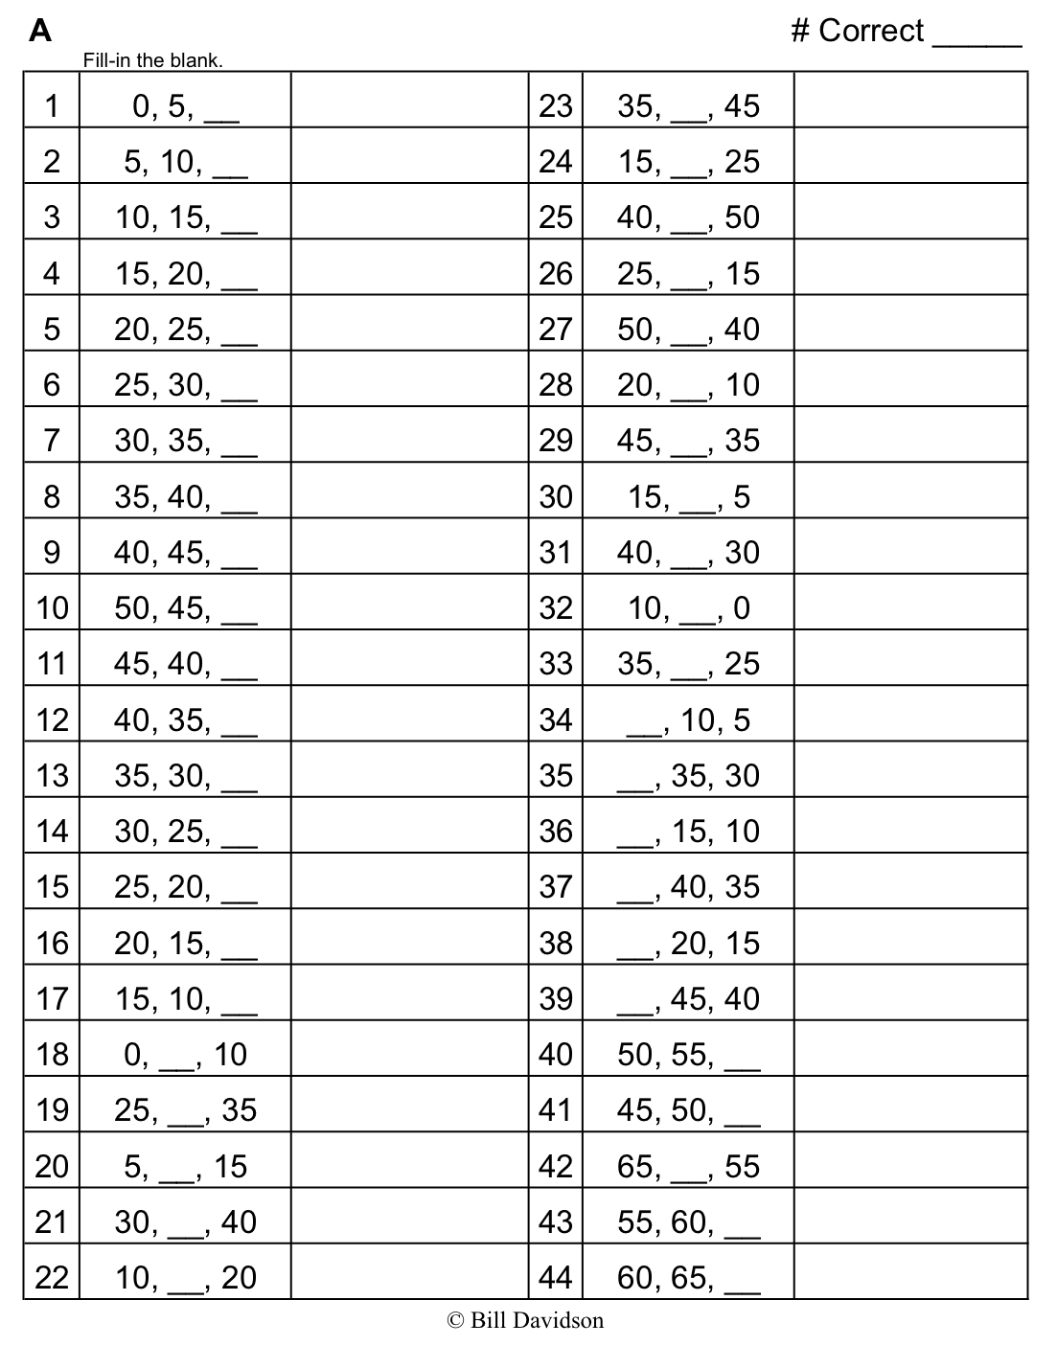
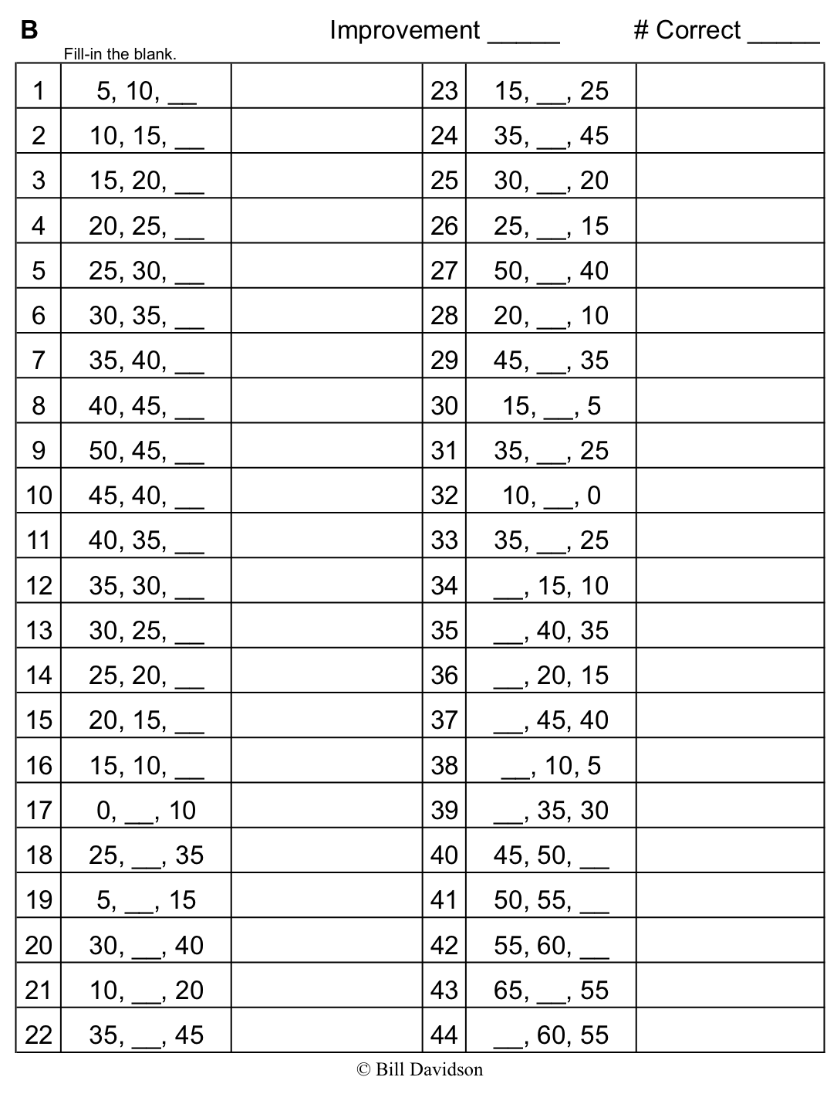
Name Date
- Ted buys 3 books and a magazine at the book store. Each book costs $8. A magazine costs $4.
Books
Magazine
$ 4

- What is the total cost of the books?

- How much does Ted spend altogether?

28 sil
- Seven children share 28 silly bands equally.

- How many silly bands does each child get?

- How many silly bands do 3 children get?

- Eighteen cups are equally packed into 6 boxes. Two boxes of cups break. How many cups are unbroken?

- There are 25 blue balloons and 15 red balloons at a party. Five children are given an equal number of each color balloon. How many blue and red balloons does each child get?

- Twenty-seven pears are packed in bags of 3. Five bags of pears are sold. How many bags of pears are left?

Name Date
- Thirty-two jellybeans are shared by 8 students.
32 jelly beans

- How many jellybeans will each student get?

- How many jellybeans will 4 students get?

- The teacher has 30 apple slices and 20 pear slices. Five children equally share all of the fruit slices. How many fruit slices does each child get?

Name Date
- Jerry buys a pack of pencils that costs $3. David buys 4 sets of markers. Each set of markers also costs $3.
Markers
Pencils
$ 3

- What is the total cost of the markers?

- How much more does David spend on 4 sets of markers than Jerry spends on a pack of pencils?

- Thirty students are eating lunch at 5 tables. Each table has the same number of students.
30 children

- How many students are sitting at each table?

- How many students are sitting at 4 tables?

- The teacher has 12 green stickers and 15 purple stickers. Three students are given an equal number of each color sticker. How many green and purple stickers does each student get?

- Three friends go apple picking. They pick 13 apples on Saturday and 14 apples on Sunday. They share the apples equally. How many apples does each person get?

- The store has 28 notebooks in packs of 4. Three packs of notebooks are sold. How many packs of notebooks are left?

