Lesson 19

Objective: Apply the distributive property to decompose units.

Suggested Lesson Structure

 Fluency Practice (14 minutes)

 Application Problem (5 minutes)

 Concept Development (31 minutes)

 Student Debrief (10 minutes)

**Total Time (60 minutes)**

Fluency Practice (14 minutes)

* Group Counting **3.OA.1** (3 minutes)
* Commutative Multiplying **3.OA.7** (3 minutes)
* Decompose and Multiply **3.OA.5** (4 minutes)
* Compose and Multiply **3.OA.5** (4 minutes)

Group Counting (3 minutes)

Note: Group counting reviews interpreting multiplication as repeated addition. Counting by threes, fours, fives, and sixes in this activity reviews multiplication with units of 3, 4, and 5 and anticipates multiplication with units of 6 in Module 3.

T: Let’s count by fives. (Direct students to count forward and backward to 50.)

T: Let’s count by fours. (Direct students to count forward and backward to 40.)

T: Let’s count by threes. (Direct students to count forward and backward to 30.)

T: Let’s count by sixes. (Direct students to count forward and backward to 36, emphasizing the 24 to 30 transition.)

Commutative Multiplying (3 minutes)

Note: This activity reviews the commutativity of multiplication, learned in Lessons 7, 8, and 15.

T: (Write 3 × 2 = ___.) Say the multiplication sentence.

S: 3 × 2 = 6.

T: Flip it.

S: 2 × 3 = 6.

Repeat process for 5 × 2, 5 × 3, 3 × 4, 2 × 8, and 3 × 7.

Decompose and Multiply (4 minutes)

Materials: (S) Personal white board

Note: This activity anticipates multiplication using units of 6, 7, 8, and 9 by decomposing larger facts into smaller known facts. It reviews the break apart and distribute strategy.

T: (Write 7 fours = ___.) Write the multiplication equation.

S: (Write 7 fours = ___.)

T: (Write (5 fours) + (____ fours) = ____ below 7 fours =*___*.) 7 fours is the same as 5 fours and how many fours?

S: 2 fours.

T: (Write (5 fours) + (2 fours) = ____. Below it, write 20 + ____ = ____.) Fill in the blanks.

S: (Write 7 fours = 28. Below it, write (5 fours) + (2 fours) = 28. Below that line, write   
20 + 8 = 28.)

Repeat for the following possible sequence: 8 × 3, 9 × 2, and 6 × 4. Change the unknowns that students need to fill in.

Compose and Multiply (4 minutes)

Materials: (S) Personal white board

Note: This activity anticipates multiplication using units of 6, 7, 8, and 9 by composing smaller known facts into larger unknown facts. It reviews the break apart and distribute strategy.

T: (Write (5 × 3) + (2 × 3) = ___.) Fill in the blank to write a true multiplication sentence on your personal white board. Below the multiplication sentence, write an addition sentence.

S: (Write (5 × 3) + (2 × 3) = 21. Below it, write 15 + 6 = 21.)

T: Write (5 × 3) + (2 × 3) as a single multiplication sentence.

S: (Write 7 × 3 = 21 above (5 × 3) + (2 × 3) = 21.)

Repeat for the following possible sequence: 8 × 2 and 9 × 4.

Application Problem (5 minutes)

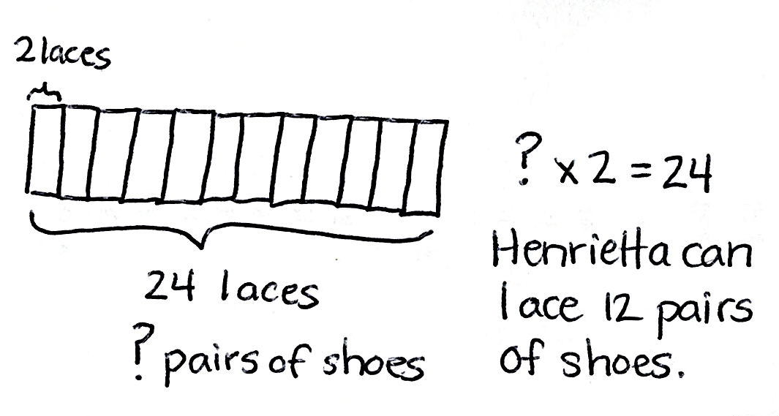Henrietta works in a shoe store. She uses 2 shoelaces to lace each pair of shoes. She has a total of 24 laces. How many pairs of shoes can Henrietta lace?

Note: This problem reviews material from Lesson 18 but intentionally previews 24 ÷ 2, which is used in the first example of the Concept Development. Students may choose to solve the Application Problem with division or as an *unknown factor* multiplication problem. Use these variations in method to spark discussion.

Concept Development (31 minutes)

Materials: (S) Personal white board

Problem 1: Model break apart and distribute using an array as a strategy for division.

Draw or project a 12 × 2 array and write 24 2 = ____ above it.

T: Let’s use the array to help us solve 24 2 = ____. There are 24 dots total. (Draw a line after the tenth row.) This shows one way to break apart the array.

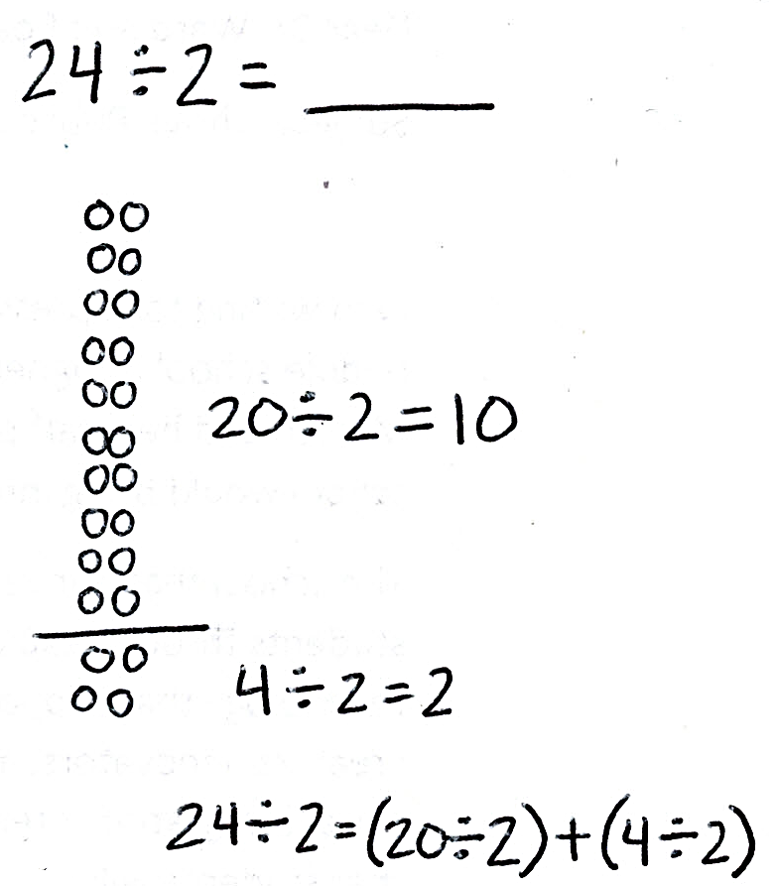T: Write division equations that represent the part of the array above the line and the part of the array below the line.

S: (Write 20 ÷ 2 = 10 and 4 ÷ 2 = 2.)

T: How many twos are above the line?

S: 10 twos.

T: How many twos are below the line?

S: 2 twos.

T: Let’s rewrite this as the addition of two quotients. Use my equations.

(____ ÷ 2) + (____ ÷ 2) = _____ ÷ 2

_____ + _____ = _____

S: (Line 1: Fill in totals. Line 2: Write 10 + 2 = 12.)

T: Explain to your partner the process we used to solve 24 2.

S: We added the quotients of two smaller facts to find the quotient of a larger one.

Repeat the process with a 13 × 2 array to show 26 2. Break it into 20 2 and 6 2.

Problem 2: Use break apart and distribute as a strategy for division.

T: (Write 27 3 = ____.) What are we focused on when we break apart to divide? Breaking up the number of groups (or rows), like in multiplication, or breaking up the total?

S: Breaking up the total.

T: Let’s break up 27 into 15 and another number. Fifteen plus what equals 27?

S: 12.

T: Work with a partner to draw an array that shows 27 3 where 3 is the number of columns.

S: (Draw a 9 × 3 array.)

T: Box the part of your array that shows a total of 15.

|  |  |
| --- | --- |
|  | NOTES ON  MULTIPLE MEANS  OF ENGAGEMENT: |

Add a challenge by asking students to think about other ways of breaking apart 27. A student will most likely choose a quotient that is not divisible by 3. This will lead to a discussion that leads students to realize that with division the strategy relies on the decomposition being such that the dividends must be divisible by the divisor.

S: (Box the first 5 rows.)

T: Write a division equation for the boxed portion to the right of the array.

S: (Write 15 ÷ 3 = 5.)

T: Box the part of your array that shows a total of 12.

S: (Box the remaining 4 rows.)

T: Now, write a division equation for that part of the array.

S: (Write 12 ÷ 3 = 4.)

T: Tell your partner how you will use the equations to help you solve the original equation, 27 3 = __.

S: I’ll add the quotients of the two smaller facts.

T: (Write the following.) Complete the following sequence to solve 27 3 with your partner.

|  |  |
| --- | --- |
|  | NOTES ON  MULTIPLE MEANS  OF REPRESENTATION: |

If appropriate, encourage the class or individual students to solve 33 ÷ 3 without using an array.

27 3 = (15 ÷ 3) + (12 ÷ 3)

= _____ + ______

= _____

Repeat the process with 33 ÷ 3. Students can break apart 33 by using the number pair 30 and 3.

Problem Set (10 minutes)

Students should do their personal best to complete the Problem Set within the allotted 10 minutes. For some classes, it may be appropriate to modify the assignment by specifying which problems they work on first. Some problems do not specify a method for solving. Students should solve these problems using the RDW approach used for Application Problems.

Student Debrief (10 minutes)

Lesson Objective: Apply the distributive property to decompose units.

The Student Debrief is intended to invite reflection and active processing of the total lesson experience.

Invite students to review their solutions for the Problem Set. They should check work by comparing answers with a partner before going over answers as a class. Look for misconceptions or misunderstandings that can be addressed in the Debrief. Guide students in a conversation to debrief the Problem Set and process the lesson.

You may choose to use any combination of the ideas below to lead the discussion.

* 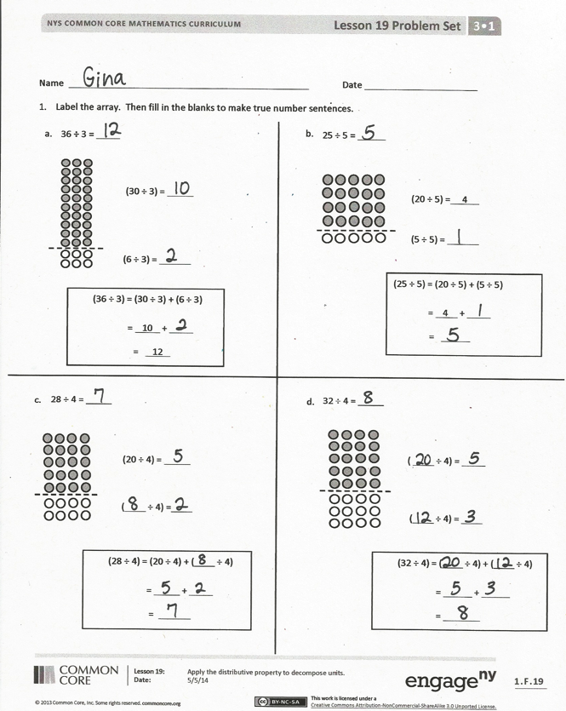Compare Nell’s strategy in Problem 3 to the strategy for solving 24 2 in the Concept Development.
* Yesterday, we used the break apart and distribute strategy with multiplication. How is the method we learned today similar?
* How is the break apart and distribute strategy different for multiplication and division? (This strategy works for division when the totals used in the decomposition are both divisible by the divisor. For example, decomposing 33 into 25 and 8 is not effective because the divisor is 3.)

Exit Ticket (3 minutes)

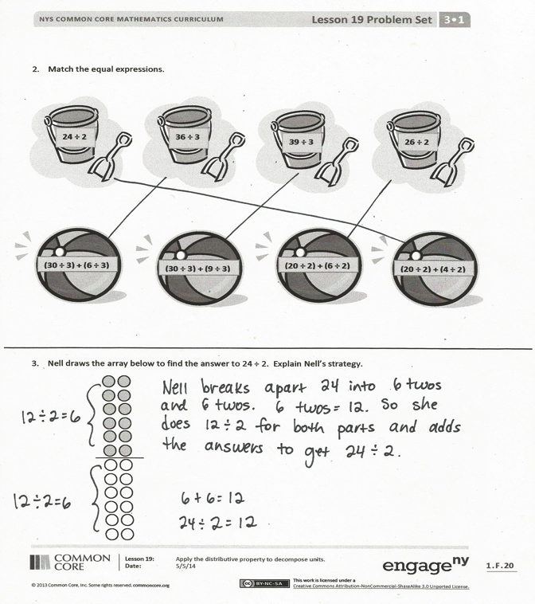After the Student Debrief, instruct students to complete the Exit Ticket. A review of their work will help you assess the students’ understanding of the concepts that were presented in the lesson today and plan more effectively for future lessons. You may read the questions aloud to the students.

Name Date

1. Label the array. Then, fill in the blanks to make true number sentences.

(30 ÷ 3) =

(6 ÷ 3) =

(36 ÷ 3) = (30 ÷ 3) + (6 ÷ 3)

= 10 +

= 12

(1 × 4) = _ _____

36 **÷** 3 **=**

25 ÷ 5 **=**

(25 ÷ 5) = (20 ÷ 5) + (5 ÷ 5)

= 4 +

=

(1 × 4) = _ _____

(20 ÷ 5) = 4

(5 ÷ 5) =

a.

b.

c.

d.

32 ÷ 4 = _____

28 ÷ 4 = _____

( ÷ 4) = ____

( ÷ 4) =

(20 ÷ 4) =

( ÷ 4) =

(32 ÷ 4) = (____ ÷ 4) + (____ ÷ 4) = +

=

(1 × 4) = _ _____

(28 ÷ 4) = (20 ÷ 4) + (____ ÷ 4) = +

=

(1 × 4) = _ _____

1. Match the equal expressions.



**36 ÷ 3**



**39 ÷ 3**



**26 ÷ 2**



**24 ÷ 2**



**(30 ÷ 3) + (6 ÷ 3)**



**(30 ÷ 3) + (9 ÷ 3)**



**(20 ÷ 2) + (6 ÷ 2)**



**(20 ÷ 2) + (4 ÷ 2)**

1. Nell draws the array below to find the answer to 24 ÷ 2. Explain Nell’s strategy.

Name Date

Complete the equations below to solve 22 ÷ 2 = _____.

(22 ÷ 2) = (20 ÷ 2) + ( ÷ 2) = +

=

(1 × 4) = _ _____

(20 ÷ 2) =

( ÷ 2) =

Name Date

1. Label the array. Then, fill in the blanks to make true number sentences.

21 ÷ 3 **= _____**

(15 ÷ 3) = 5

(6 ÷ 3) =

(21 ÷ 3) = (15 ÷ 3) + (6 ÷ 3)

= 5 + ______

=

(1 × 4) = _ _____

b.

18 **÷** 3 **= _____**

(9 ÷ 3) = 3

(9 ÷ 3) =

(18 ÷ 3) = (9 ÷ 3) + (9 ÷ 3)

= 3 + ______

= 6

(1 × 4) = _ _____

a.

(36 ÷ 4) = (___ ÷ 4) + (___ ÷ 4)

= + ______

= _____

(1 × 4) = _ _____

36 ÷ 4 **= _____**

(16 ÷ 4) =

(20 ÷ 4) =

d.

24 ÷ 4 **= _____**

(4 ÷ 4) =

(20 ÷ 4) =

(24 ÷ 4) = (20 ÷ 4) + (____ ÷ 4)

= + ______

= _____

(1 × 4) = _ _____

c.

c)

1. Match equal expressions.



**28 ÷ 2**

**26 ÷ 2**

**36 ÷ 3**

**33 ÷ 3**



**(20 ÷ 2) + (6 ÷ 2)**

**(20 ÷ 2) + (8 ÷ 2)**

**(30 ÷ 3) + (6 ÷ 3)**

**(30 ÷ 3) + (3 ÷ 3)**

1. Alex draws the array below to find the answer to 35 ÷ 5. Explain Alex’s strategy.