Lesson 18
Objective: Apply the distributive property to decompose units.

Suggested Lesson Structure
 Fluency Practice (9 minutes)
 Application Problem (5 minutes)
 Concept Development (36 minutes)
 Student Debrief (10 minutes)
Total Time (60 minutes)
Fluency Practice (9 minutes)
- Sprint: Add and Subtract by 5 2.NBT.5 (9 minutes)
Sprint: Add and Subtract by 5 (9 minutes)
Materials: (S) Add and Subtract by 5 Sprint
Note: This activity builds a foundation for multiplication using units of 5 through reviewing skip-counting from Grade 2. See Lesson 2 for the directions for administering a Sprint.
Between Sprints, include the following group counts in place of movement exercises.
- Count by threes to 30, think/talk forward and backward.
- Count by sixes to 30, forward and backward.
- Count by fours to 40, forward and backward.
Application Problem (5 minutes)
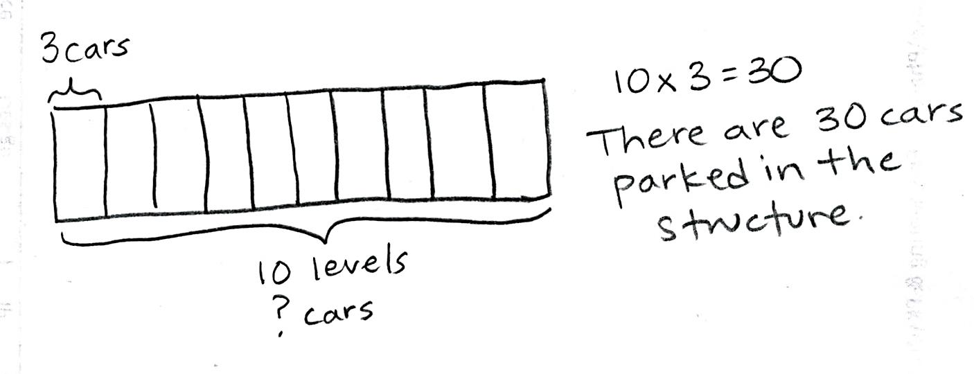
A parking structure has 10 levels. There are 3 cars parked on each level. How many cars are parked in the structure?

Note: 10 × 3 = 30 is the same problem used in Problem 2 of the Concept Development, only without the context provided here. Solving the problem ahead of time de-emphasizes the answer so that students more easily focus attention on the new concept of decomposing with number bonds.

Concept Development (36 minutes)
Materials: (S) Personal white board
Problem 1: Use number bonds to decompose numbers and apply the distributive property.
Project an array for 7 × 3 with a line drawn as shown. Write 7 × 3 next to the array.
T: How many threes?
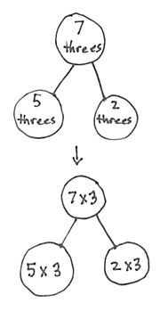
S: 7 threes.
(5 $×$ 3) + (2 $×$ 3) = _____
15 + 6 = 21
7 $×$ 3 = 21

Sample Teacher Board
7 × 3
5 threes + 2 threes = 7 threes

T: The dotted line shows a way to break apart the array. The 7 threes are broken into…?
S: 5 threes and 2 threes.
T: Let’s draw our number bonds.
S: (Draw the number bond shown to the right.)
T: Write the equation that shows how to add the two parts.
S: (Write 5 threes + 2 threes = 7 threes.)
T: Whisper to a partner the two multiplication sentences you used to help you solve 7 × 3.
S: (Whisper 5 × 3 = 15 and 2 × 3 = 6.)
T: (Draw a second number bond using the expressions
(5 × 3) and (2 × 3).) The number bond is another way to show breaking apart. This shows how we partitioned the array and wrote the number bond using our number sentences.
T: Let’s rewrite this as the addition of two products using my frame. (Point to the equation below.)
(__ × 3) + (__ × 3) = ___ × 3
______ + ______ = ______
S: (Write.)
(5 × 3) + (2 × 3) = 7 × 3
15 + 6 = 21
T: How does the number sentence show the number bond?
S: It shows the 7 broken into 5 and 2. And, the threes are shared with both parts. Yes, 5 threes and 2 threes. One part has 5 threes, and the other part has 2 threes.
Repeat the process with 9 × 4.
T: Let’s call it the break apart and distribute strategy. The number bond helps us see that we can find the total by adding two smaller parts together.

NOTES ON
MULTIPLE MEANS
OF ACTION AND EXPRESSION:
Encourage students who need extra support to draw an array before using the number bond to decompose.

Problem 2: Use number bonds and the distributive property.
T: (Write 10 × 3.) How many threes?
S: 10 threes.
T: What are some ways we can break apart 10?
S: 5 and 5. 6 and 4. 7 and 3. 8 and 2.
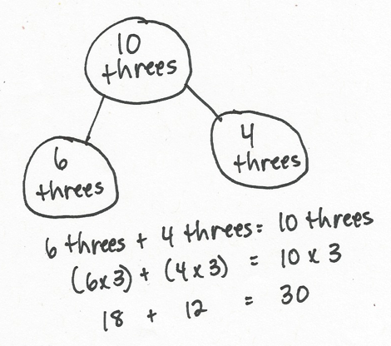
T: So, if we were counting apples, that would be 5 apples and 5 apples or 6 apples and 4 apples?
S: Yes.
T: But we aren’t counting apples. What are we counting?
S: Threes.
T: So, that would be 6 threes and…?
S: 4 threes.
T: Let’s draw our number bonds.
S: (Draw number bond shown to the right.)
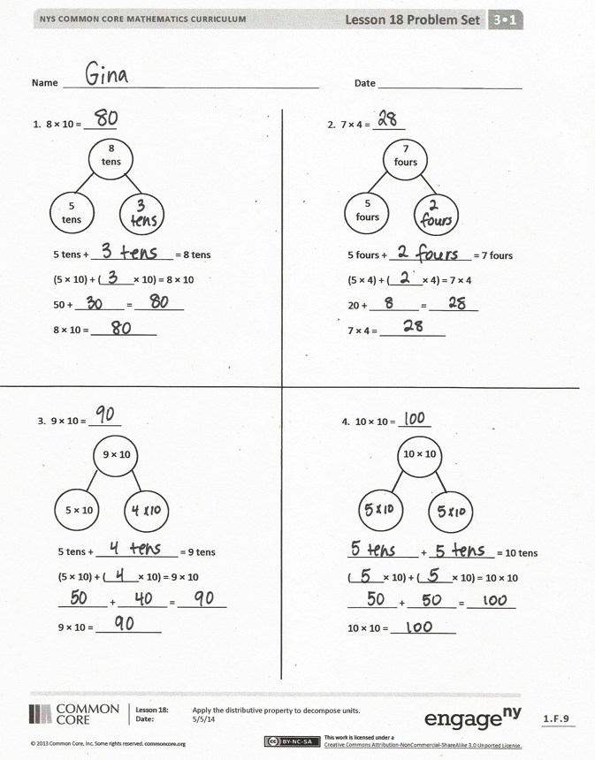
T: Write the equation that shows how to add the two parts. Start with 6 threes and 4 threes.
S: (Write 6 threes + 4 threes = 10 threes.)
T: Rewrite this as the addition of two products using my frame. (Point to the equation below.)
(__ × 3) + (__ × 3) = ___ × 3
______ + ______ = ______
S: (Write.)
(6 × 3) + (4 × 3) = 10 × 3
18 + 12 = 30
Repeat the process with 8 × 4.
Problem Set (10 minutes)
Students should do their personal best to complete the Problem Set within the allotted 10 minutes. For some classes, it may be appropriate to modify the assignment by specifying which problems they work on first. Some problems do not specify a method for solving. Students should solve these problems using the RDW approach used for Application Problems.

Student Debrief (10 minutes)
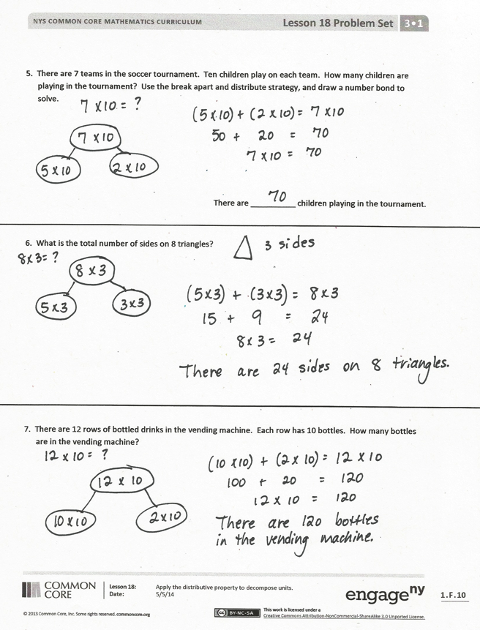
Lesson Objective: Apply the distributive property to decompose units.
The Student Debrief is intended to invite reflection and active processing of the total lesson experience.
Invite students to review their solutions for the Problem Set. They should check work by comparing answers with a partner before going over answers as a class. Look for misconceptions or misunderstandings that can be addressed in the Debrief. Guide students in a conversation to debrief the Problem Set and process the lesson.
You may choose to use any combination of the questions below to lead the discussion.
- Compare the number bond and array models for showing the break apart and distribute strategy.
- Share work for Problem 4. Compare students’ number choices.
- Why do you think we use the number bond as a method for breaking a total into two parts? How was this strategy helpful to find the answer to a larger fact in Problem 7?
- How Problem 1 in the Concept Development relate to today’s Application Problem?
- In anticipation of using the distributive property with division in Lesson 19, ask the following: Do you think the break apart and distribute strategy can be used with division? What might that look like?
Exit Ticket (3 minutes)
After the Student Debrief, instruct students to complete the Exit Ticket. A review of their work will help you assess the students’ understanding of the concepts that were presented in the lesson today and plan more effectively for future lessons. You may read the questions aloud to the students.

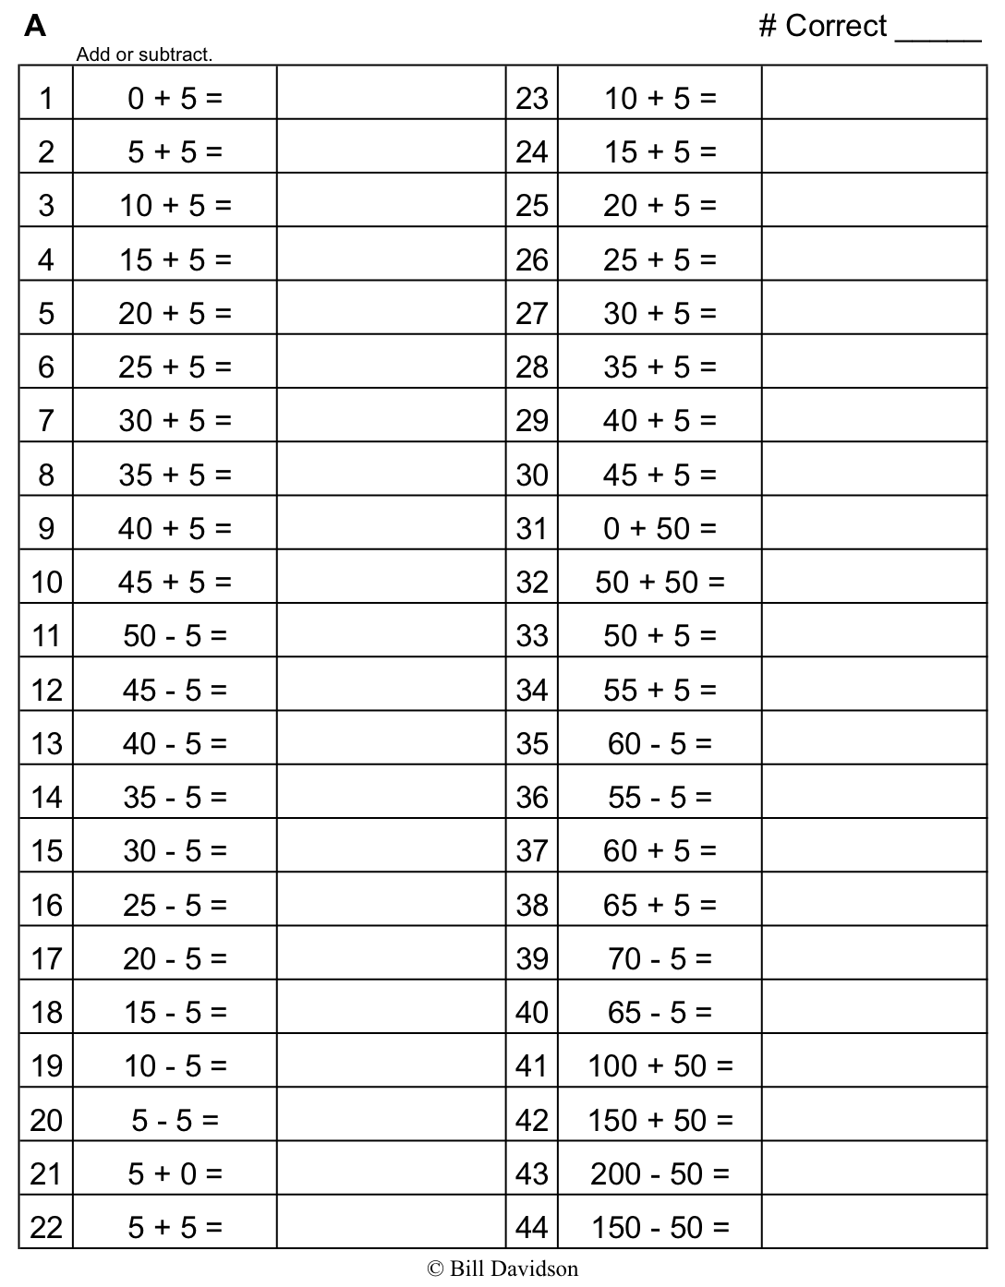
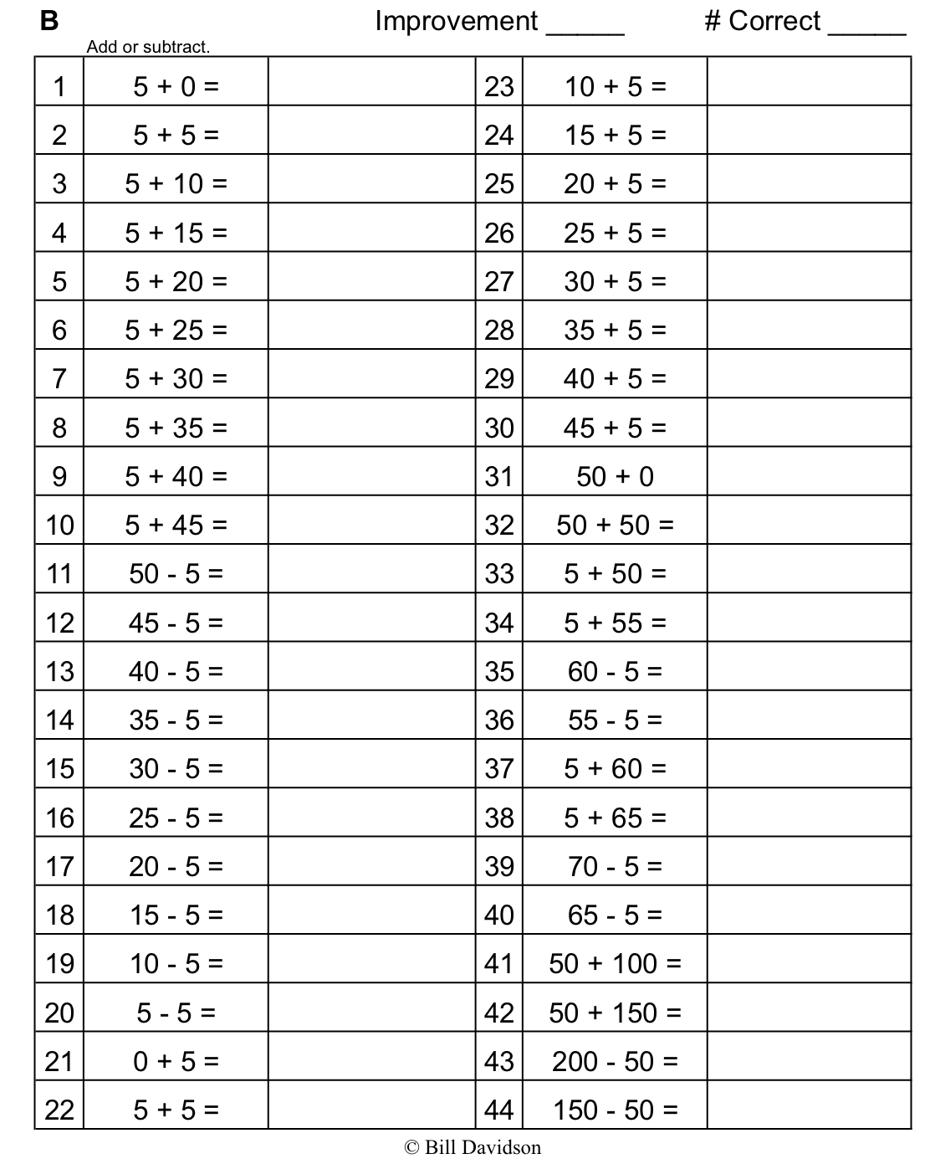
Name Date
2. 7 × 4 = ______

7
fours

5 fours + _______________ = 7 fours
(5 × 4) + (______ × 4) = 7 × 4
20 + _________ = _________
7 × 4 = ____________

5
fours
1. 8 × 10 = ______

8
tens

5 tens + _______________ = 8 tens
(5 × 10) + (______ × 10) = 8 × 10
50 + _________ = _________
8 × 10 = ____________

5
tens

4. 10 × 10 = ______

10 × 10

_____________ + ____________ = 10 tens
(______ × 10) + (______ × 10) = 10 × 10
_________ + _________ = _________
10 × 10 = ____________

3. 9 × 10 = ______

9 × 10

5 tens + _______________ = 9 tens
(5 × 10) + (______ × 10) = 9 × 10
_________ + _________ = _________
9 × 10 = ____________

5 × 10

5. There are 7 teams in the soccer tournament. Ten children play on each team. How many children are playing in the tournament? Use the break apart and distribute strategy, and draw a number bond to solve.

There are __________ children playing in the tournament.

6. What is the total number of sides on 8 triangles?

7. There are 12 rows of bottled drinks in the vending machine. Each row has 10 bottles. How many bottles are in the vending machine?

Name Date
Dylan used the break apart and distribute strategy to solve a multiplication problem. Look at his work below, write the multiplication problem Dylan solved, and complete the number bond.

5 × 4
Dylan’s work:
(5 × 4) + (1 × 4) =
20 + 4 = 24

_______ × _______ = _______

Name Date
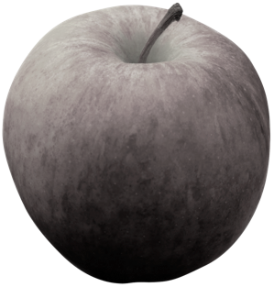
1. Match.
7 threes
5 threes
2 threes
9 tens
6 tens
3 tens tens3
8 fours
5 fours
3 fours tens3

7 tens
5 tens
2 tens tens3

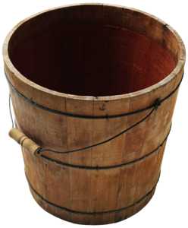
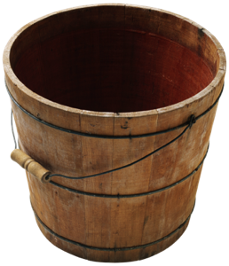
(6 × 10) + (3 $\text{×}$10) = 90

(5 × 3) + (2 × 3) = 21

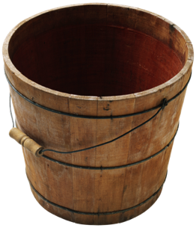
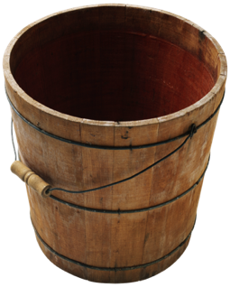
(5 × 10) + (2 × 10) = 70

(5 × 4) + (3 × 4) = 32
= 32

2. 9 × 4 =

9 × 4
(_______ × 4) + (_______ × 4) = 9 × 4
_______ + _______ = _______
9 × 4 = _______

3. Lydia makes 10 pancakes. She tops each pancake with 4 blueberries. How many blueberries does Lydia use in all? Use the break apart and distribute strategy and draw a number bond to solve.

Lydia uses _______ blueberries in all.
4. Steven solves 7 × 3 using the break apart and distribute strategy. Show an example of what Steven’s work might look like below.

5. There are 7 days in 1 week. How many days are there in 10 weeks?

