Lesson 17

Objective: Model the relationship between multiplication and division.

Suggested Lesson Structure

 Fluency Practice (9 minutes)

 Application Problem (5 minutes)

 Concept Development (36 minutes)

 Student Debrief (10 minutes)

**Total Time (60 minutes)**

Fluency Practice (9 minutes)

* Sprint: Divide by 4 **3.OA.7** (9 minutes)

Sprint: Divide by 4 (9 minutes)

Materials: (S) Divide by 4 Sprint

Note: Framing division through missing factors in multiplication sentences builds a strong foundation for understanding the relationships between multiplication and division. See Lesson 2 for directions for administering a Sprint.

Between Sprints, include the following group counts in place of movement exercises.

* Count by twos to 20 forward and backward.
* Count by threes to 30, hum/talk forward and backward. (Hum as you think 1, 2, say 3, hum 4, 5, say 6, etc.)
* Count by fives to 50 forward and backward.

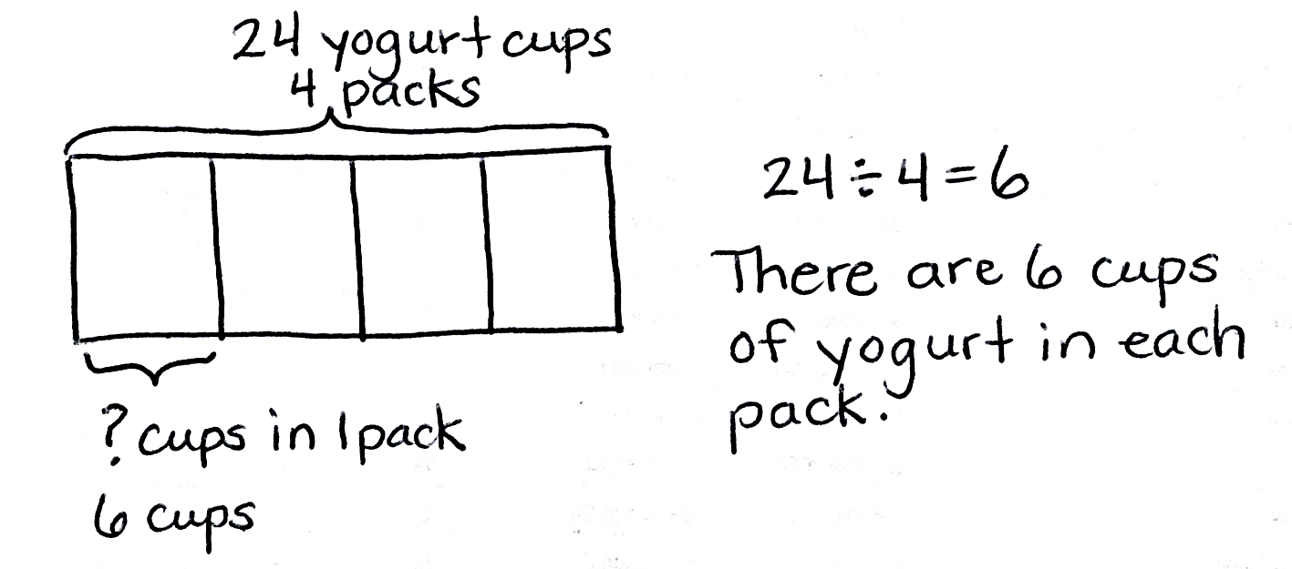Application Problem (5 minutes)

Mrs. Peacock bought 4 packs of yogurt. She had exactly enough to give each of her 24 students 1 yogurt cup. How many yogurt cups are there in 1 pack?

Note: This problem is designed to lead into the Concept Development. In Problem 1, students will analyze how a number bond represents the division expression 24 ÷ 4.

Concept Development (36 minutes)

Materials: (S) Personal white board

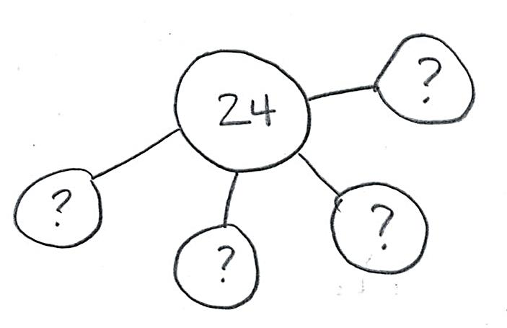Problem 1: Use the number bond to relate multiplication and division.

T: (Draw or project the number bond shown at right.) The number bond represents the division equation you wrote to solve the Application Problem. Turn and tell your partner how it shows 24 ÷ 4.

S: (Discuss.)

T: Look back at the Application Problem. Is the unknown in the number bond the same as the unknown in the division problem? What does it represent?

S: They’re the same. The unknown represents the size of the groups.

T: (Project a second number bond where the total and one part are drawn. Write __ × 4 = 24.) Skip-count by fours to find the unknown factor. Each time you say a four, I will make a new part of my number bond. (Draw the parts as students count.)

S: 4, 8, 12, 16, 20, 24.

T: How many fours make 24?

|  |  |
| --- | --- |
|  | NOTES ON  Multiple Means  of ACTION AND EXPRESSION: |
| The expression 32 ÷ 4 is also used in Problem 3 of the Problem Set. Because of the duplication, the suggested process for completing the Problem Set is to save Problem 3 until the end. However, for some classes, it may prove useful to preview the example here and have students complete it as one of the first problems they do independently on the Problem Set. This will build confidence by giving students an immediate sense of success. | |

S: 6 fours!

T: So, 24 ÷ 4 equals…?

S: 6!

T: The division equations are the same. But, how do the quotients in the two number bonds represent different things?

S: The 6 in the first number bond represents the size of the groups. The 6 in the second number bond represents the number of groups.

Repeat the process with 32 ÷ 4. (Model how the quotient can represent the number of groups or the size of the groups.)

T: How do the multiplication and division equations relate in each example?

S: I thought of the division equation like a multiplication equation with an unknown factor and skip-counted by fours until I reached the total.

Problem 2: Solve word problems to illustrate the relationship between multiplication and division.

Write or project the following problem: A classroom has tables that seat a total of 20 students. Four students are seated at each table. How many tables are in the classroom?

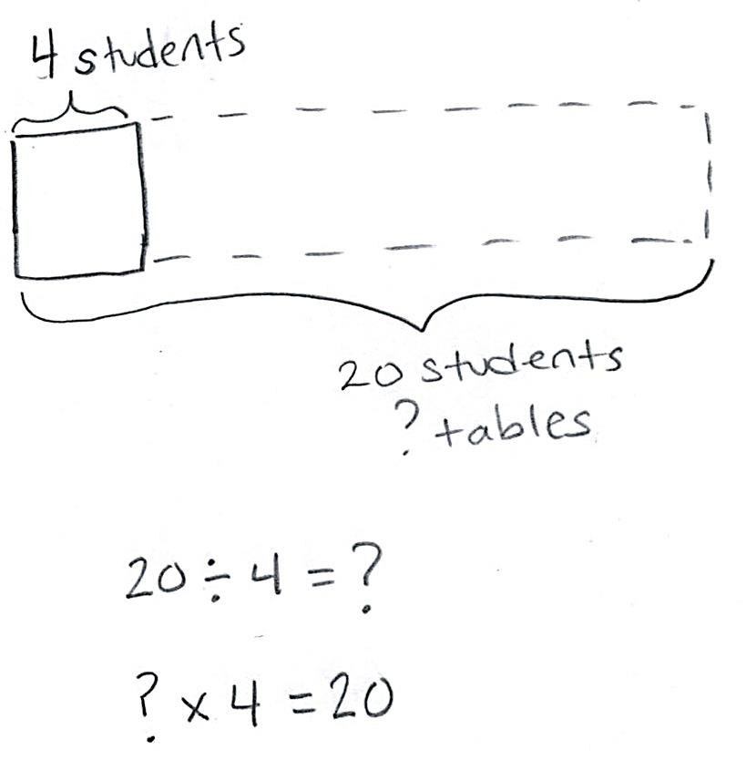T: Draw and label a tape diagram to represent the problem.

S: (Draw diagram shown at right.)

T: Without solving, write a division equation and a multiplication equation with an unknown factor to represent your drawing.

S: (Write 20 ÷ 4 = __ and __ × 4 = 20.)

**MP.2**

T: What does the unknown in both problems represent?

S: The number of groups.

T: Tell your partner your strategy for solving each equation.

S: To solve the division, I will add units of 4 to the tape diagram until I get to 20. 🡪 That is just skip-counting by fours. Skip-counting is a way to solve the multiplication too. 🡪 The strategies are the same for both equations because you can use one to solve the other.

T: Solve both equations now.

Repeat the process with 16 ÷ 4. (Problem 2 models division where the quotient represents the number of groups.)

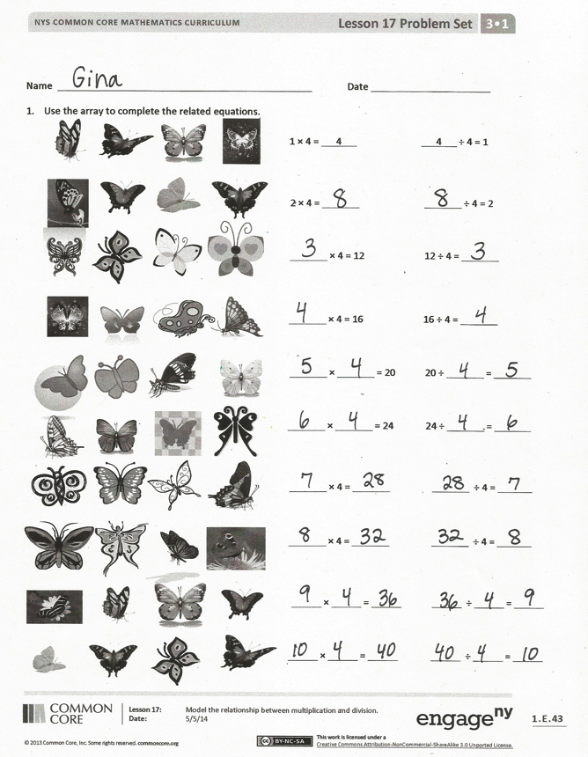Problem Set (10 minutes)

Students should do their personal best to complete the Problem Set within the allotted 10 minutes. For some classes, it may be appropriate to modify the assignment by specifying which problems they work on first. Some problems do not specify a method for solving. Students should solve these problems using the RDW approach used for Application Problems.

Student Debrief (10 minutes)

**Lesson Objective:** Model the relationship between multiplication and division.

The Student Debrief is intended to invite reflection and active processing of the total lesson experience.

Invite students to review their solutions for the Problem Set. They should check work by comparing answers with a partner before going over answers as a class. Look for misconceptions or misunderstandings that can be addressed in the Debrief. Guide students in a conversation to debrief the Problem Set and process the lesson.

You may choose to use any combination of the questions below to lead the discussion.

* 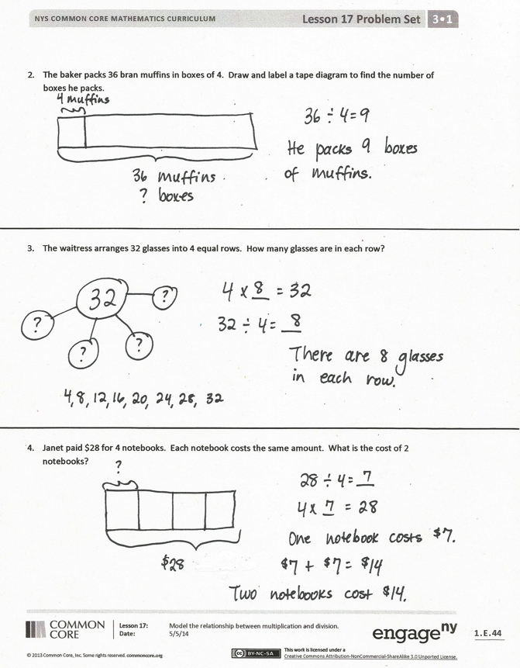In the first problem on the Problem Set, what patterns did you notice in the array?
* How did the patterns you noticed help you solve the multiplication and division sentences?
* Share student work from Problems 3 and 4. Students may have solved using number bonds or tape diagrams, multiplication, or division. Compare approaches.
* How can a number bond show both multiplication and division?
* Discuss: Division is an *unknown factor* problem.
* In Problems 3 and 4, the unknown is the size of each group. What is different about Problem 4? (It is a two-step problem.)

Exit Ticket (3 minutes)

After the Student Debrief, instruct students to complete the Exit Ticket. A review of their work will help you assess the students’ understanding of the concepts that were presented in the lesson today and plan more effectively for future lessons. You may read the questions aloud to the students.

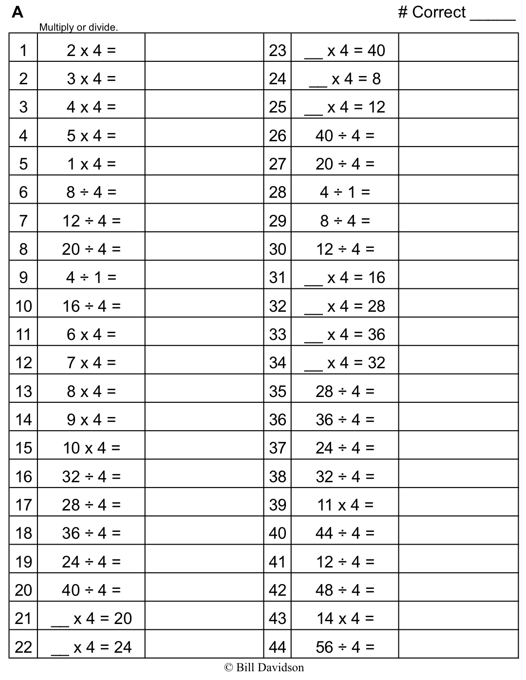

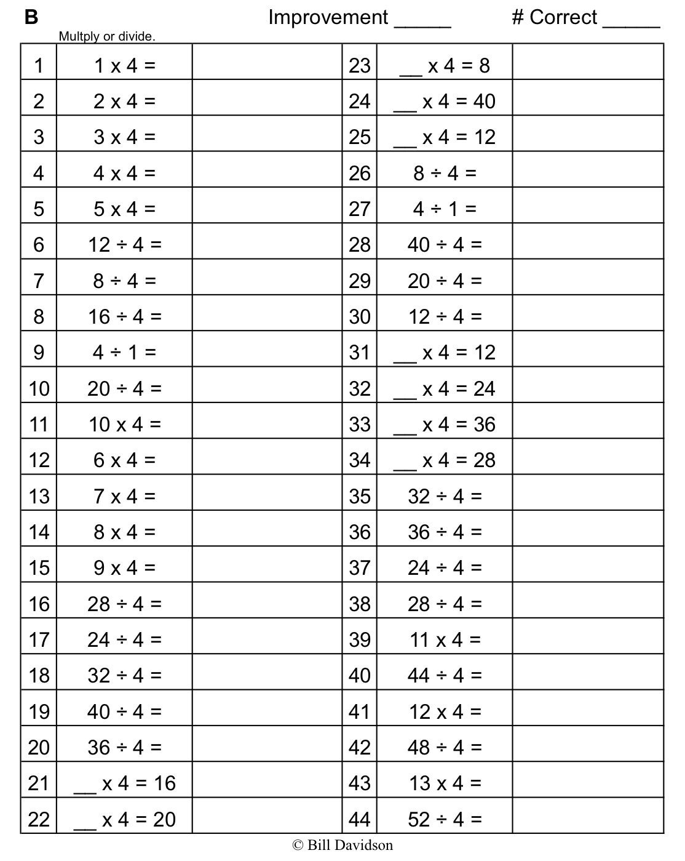

Name Date

1. Use the array to complete the related equations.

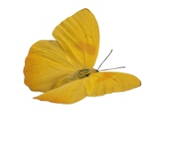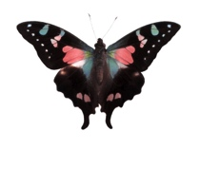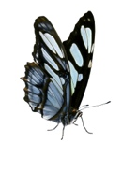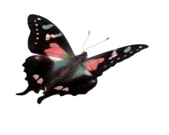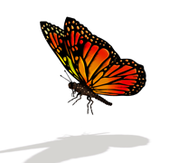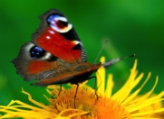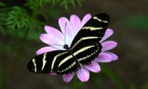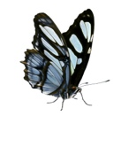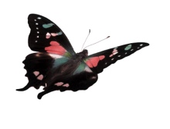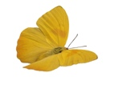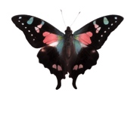

× = 24 24 ÷ =

× 4 = ÷ 4 =

× 4 = ÷ 4 =

× = ÷ =

× = ÷ =

1 × 4 = 4 4 ÷ 4 = 1

2 × 4 = ÷ 4 = 2

× 4 = 12 12 ÷ 4 =

× = 20 20 ÷ =

× 4 = 16 16 ÷ 4 =

1. The baker packs 36 bran muffins in boxes of 4. Draw and label a tape diagram to find the number of boxes he packs.
2. The waitress arranges 32 glasses into 4 equal rows. How many glasses are in each row?
3. Janet paid $28 for 4 notebooks. Each notebook costs the same amount. What is the cost of 2 notebooks?

Name Date

1. Mr. Thomas organizes 16 binders into stacks of 4. How many stacks does he make? Draw and label a number bond to solve.

1. The chef uses 28 avocados to make 4 batches of guacamole. How many avocados are in 2 batches of guacamole? Draw and label a tape diagram to solve.

Name Date

1. Use the array to complete the related equations.

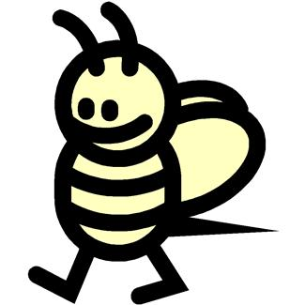 animals,cartoons,caterpillars,creatures,fantasy,insects,abstract,black and white



 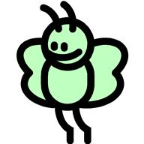 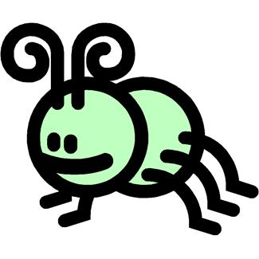

  animals,cartoons,caterpillars,creatures,fantasy,insects,abstract,black and white



 

 animals,cartoons,caterpillars,creatures,fantasy,insects,abstract,black and white



   animals,cartoons,caterpillars,creatures,fantasy,insects,abstract,black and white



     animals,cartoons,caterpillars,creatures,fantasy,insects,abstract,black and white



  

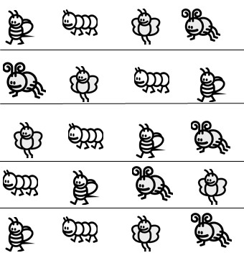

1 × 4 = ÷ 4 = 1

2 × 4 = ÷ 4 = 2

× 4 = 12 12 ÷ 4 =

× = 20 20 ÷ =

× = ÷ =

× = 24 24 ÷ =

× 4 = ÷ 4 =

× 4 = ÷ 4 =

× = ÷ =

× 4 = 16 16 ÷ 4 =

1. The teacher puts 32 students into groups of 4. How many groups does she make? Draw and label a tape diagram to solve.
2. The store clerk arranges 24 toothbrushes into 4 equal rows. How many toothbrushes are in each row?
3. An art teacher has 40 paintbrushes. She divides them equally between her 4 students. She finds 8 more brushes and divides these equally between the students, as well. How many brushes does each student receive?