Lesson 16

Objective: Use the distributive property as a strategy to find related multiplication facts.

Suggested Lesson Structure

 Fluency Practice (14 minutes)

 Application Problem (5 minutes)

 Concept Development (31 minutes)

 Student Debrief (10 minutes)

**Total Time (60 minutes)**

Fluency Practice (14 minutes)

* Multiply by 4 Pattern Sheet **3.OA.7** (8 minutes)
* Group Counting **3.OA.1** (3 minutes)
* Read Tape Diagrams **3.OA.3** (3 minutes)

Multiply by 4 Pattern Sheet (8 minutes)

Materials: (S) Multiply by 4 (6–10) (Pattern Sheet)

Note: This activity builds fluency with multiplication facts using units of 4. It works toward the goal of students knowing from memory all products of two one-digit numbers. See Lesson 9 for the directions for administering a Multiply-By Pattern Sheet.

T: (Write 7 4 = ­­­____.) Let’s skip-count up by fours to solve. (Count with fingers to 7 as students count.)

S: 4, 8, 12, 16, 20, 24, 28.

T: Let’s skip-count up by fours starting at 5 fours or 20.

S: (Show 5 fingers to represent 5 fours, or 20.) 20, 24, 28. (Count with fingers up to 7 fours as students count.)

T: Let’s skip-count down to find the answer to 7 × 4. Start at 10 fours or 40. (Count down with fingers as student say numbers.)

S: 40, 36, 32, 28.

Repeat the process of skip-counting up from 5 fours and down from 10 fours to solve 9 × 4 and 8 × 4. Distribute Multiply by 4 Pattern Sheet (6–10)*.*

Group Counting (3 minutes)

Note: Group counting reviews interpreting multiplication as repeated addition. Counting by twos and threes in this activity reviews multiplication with units of 2 and 3 from Topics C and D.

T: Let’s count by twos. (Direct students to count forward and backward to 20.)

T: Let’s count by threes. (Direct students to count forward and backward to 30. Whisper the numbers between threes and speak each three out loud. For example, whisper 1, whisper 2, say 3, whisper 4, whisper 5, say 6, and so on.)

Read Tape Diagrams (3 minutes)

Materials: (S) Personal white board

Note: Students practice reading the difference between the value of the unit (the size of the groups) and the number of units. The activity reviews using the tape diagram as a model for commutativity.

T: (Project a tape diagram partitioned into 2 equal units. Draw 8 stars in each unit, and bracket the total with a question mark.) Say the addition sentence.

S: 8 + 8 = 16.

T: Say the multiplication sentence starting with the number of groups.

S: 2 × 8 = 16.

T: Draw the tape diagram, and label units with numbers instead of stars. Label the missing total. Beneath the diagram, write a multiplication sentence.

S: (Draw a tape diagram with 8 written inside both units and 16 written as the total. Beneath the diagram, write 2 × 8 = 16.)

Repeat the process for 3 × 7 and 4 × 6.

Application Problem (5 minutes)

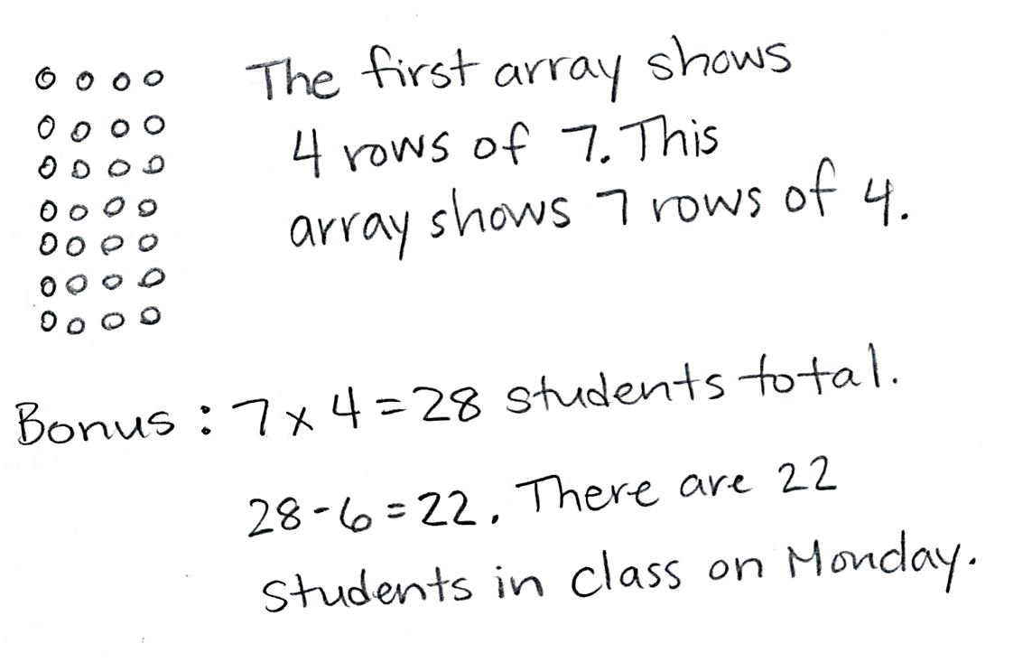

Ms. Williams draws the array below to show the class seating chart. She sees the students in 4 rows of 7 when she teaches at Board 1. Use the commutative property to show how Ms. Williams sees the class when she teaches at Board 2.

Extension: On Monday, 6 students are absent. How many students are in class on Monday?

*Board 1*

*Board 2*

Note: This problem reviews the commutative property from Lesson 15. Students may use a tape diagram to show their solution. The inclusion of the extension anticipates the two-step problem in the Lesson 17 Problem Set. If appropriate for the class, present the extension.

Concept Development (31 minutes)

Materials: (S) Personal white board, fours array (Lesson 14 Template) (pictured below)

Problem 1: Model the 5 + *n* pattern as a strategy for multiplying using units of 4.

*Fours array template*

T: Shade the part of the array that shows 5 × 4.

S: (Shade 5 rows of 4.)

T: Talk to your partner about how to box an array that shows (5 × 4) + (1 × 4), and then box it.

S: The box should have one more row than what’s shaded. (Box 6 × 4.)

T: What expression does the boxed array represent?

S: 6 × 4.

T: Label the shaded and un-shaded arrays in your box with equations.

|  |  |
| --- | --- |
|  | NOTES ON  teacher board: |

Keep track of the equations for all three examples. As students reflect, they can refer to the visual on the class board to see that 5 × 4 is the consistent expression.

S: (Write 5 × 4 = 20 and 1 × 4 = 4.)

T: How can we combine our two multiplication equations to find the total number of dots?

S: 6 × 4 = 24, or 20 + 4 = 24.

Repeat the process with the following suggested examples:

* 5 × 4 and 2 × 4 to model 7 × 4
* 5 × 4 and 4 × 4 to model 9 × 4

|  |  |
| --- | --- |
|  | NOTES ON  Multiple Means  of ACTION  AND EXPRESSION: |

Minimize instructional changes as you repeat with different numbers. Scaffolding problems using the same method allows students to generalize skills more easily.

T: What expression did we use to help us solve all three problems?

S: 5 × 4.

T: Talk to your partner. Why do you think I asked you to solve using 5 × 4 each time?

**MP.7**

S: You can just count by fives to solve it. 🡪 It equals 20. It’s easy to add other numbers to 20.

T: Compare using 5 × 4 to solve your fours with 5 × 6 to solve your sixes and 5 × 8 to solve your eights.

S: (Discuss. Identify ease of skip-counting and that the products are multiples of 10.)

T: Now that you know how to use your fives, you have a way to solve 7 sixes as 5 sixes and 2 sixes or 7 eights as 5 eights and 2 eights.

Problem 2: Apply the 5 + *n* pattern to decompose and solve larger facts.

Students work in pairs.

T: Fold the template so that only 8 of the 10 rows are showing. We’ll use the array that’s left. What multiplication expression are we finding?

|  |  |
| --- | --- |
|  | NOTES ON  Multiple Means of engagement: |
| Have students who need an additional challenge decompose the same problem using facts other than 5 × 4. They should see that other strategies work as well. Compare strategies to prove the efficiency of 5 × 4. | |

S: (Fold two rows away.) 8 × 4!

T: Use the strategy we practiced today to solve 8 × 4.

S: (Demonstrate one possible solution.) Let’s shade and label 5 × 4. 🡪 Then, we can label the un-shaded part. 🡪 That’s 3 × 4. 🡪 5 × 4 = 20 and 3 × 4 = 12. 🡪 20 + 12 = 32. 🡪 There are 32 in total.

T: (Write 8 × 4 = (5 × 4) + (3 × 4).) Talk with your partner about how you know this is true.

S: (Discuss.)

T: We can break a larger fact into two smaller facts to help us solve it. (Draw number bond shown to the right.) Here, we broke apart 8 fours into 5 fours and 3 fours to solve. So, we can write an equation, 8 fours = 5 fours + 3 fours. (Write equation on the board.)

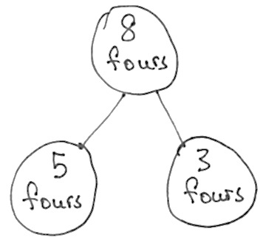

8 × 4 = (5 × 4) + (3 × 4)

= (5 + 3) × 4

8 fours = 5 fours + 3 fours

T: (5 + 3) × 4 is another way of writing (5 × 4) + (3 × 4). Talk with your partner about why these expressions are the same.

S: (Discuss.)

T: True or false? In 5 × 4 and 3 × 4, the size of the groups is the same.

S: True!

T: Four represents the size of the groups. The expression (5 × 4) + (3 × 4) shows how we **distribute** the groups of 4. Since the size of the groups is the same, we can add the 5 fours and 3 fours to make 8 fours.

Repeat the process with the following suggested example:

* 10 × 4, modeled by doubling the product of 5 × 4

Problem Set (10 minutes)

Students should do their personal best to complete the Problem Set within the allotted 10 minutes. For some classes, it may be appropriate to modify the assignment by specifying which problems they work on first. Some problems do not specify a method for solving. Students should solve these problems using the RDW approach used for Application Problems.

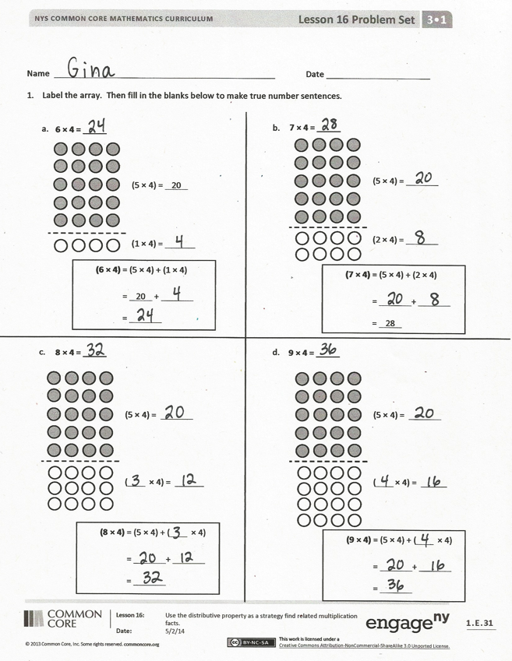Student Debrief (10 minutes)

Lesson Objective: Use the distributive property as a strategy to find related multiplication facts.

The Student Debrief is intended to invite reflection and active processing of the total lesson experience.

Invite students to review their solutions for the Problem Set. They should check work by comparing answers with a partner before going over answers as a class. Look for misconceptions or misunderstandings that can be addressed in the Debrief. Guide students in a conversation to debrief the Problem Set and process the lesson.

You may choose to use any combination of the questions below to lead the discussion.

* Review vocabulary term **distribute**.
* Explain how breaking apart or finding the products of two smaller arrays helps find the product of a larger array in Problem 1(d).
* 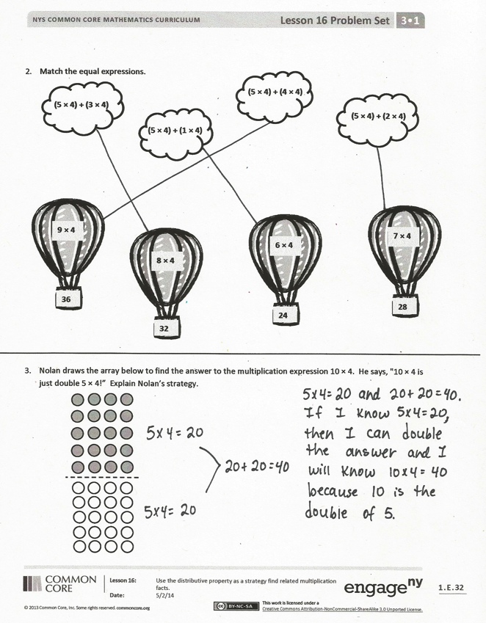Share strategies for solving Problem 2.
* Explain the following sequence:

(5 + 3) × 4 =

(5 × 4) + (3 × 4) =

5 fours + 3 fours =

8 fours =

8 × 4

* How does the sequence above show a number being distributed?
* Could the strategy we learned today change your approach to finding the total students in our Application Problem? Why or why not?
* Why would the strategy we learned today be helpful for solving an even larger fact like 15 × 4?

Exit Ticket (3 minutes)

After the Student Debrief, instruct students to complete the Exit Ticket. A review of their work will help you assess the students’ understanding of the concepts that were presented in the lesson today and plan more effectively for future lessons. You may read the questions aloud to the students.

Multiply.



[1]

Name Date

1. Label the array. Then, fill in the blanks below to make true number sentences.

**7 × 4 = _____**

b.

**6 × 4 = _____**

a.

(5 × 4) =

(2 × 4) =

(5 × 4) = 20

(1 × 4) =

**(6 × 4)** = (5 × 4) + (1 × 4) = 20 +

=

(1 × 4) = _ _____

**(7 × 4)** = (5 × 4) + (2 × 4) = +

= 28

(1 × 4) = _ _____

d.

(5 × 4) =

( × 4) =

**(9 × 4)** = (5 × 4) + ( × 4) = +

=

(1 × 4) = _ _____

**9 × 4 = _____**

c.

(5 × 4) =

( × 4) =

**(8 × 4)** = (5 × 4) + ( × 4) = +

=

(1 × 4) = _ _____

**8 × 4 = _____**

1. Match the equal expressions.



**36**

**9 × 4 =**

**(5 × 4) + (3 × 4)**

**(5 × 4) + (1 × 4)**

**=**

**(5 × 4) + (4 × 4)**

**=**

**(5 × 4) + (2 × 4)**

**=**



**32**

**8 × 4 =**



**24**

**6 × 4 =**



**28**

**7 × 4 =**

1. Nolan draws the array below to find the answer to the multiplication expression 10 × 4. He says, "10 × 4 is just double 5 × 4!” Explain Nolan’s strategy.

Name Date

Destiny says, “I can use 5 × 4 to find the answer to 7 × 4.” Use the array below to explain Destiny’s strategy using words and numbers.

**(7 × 4)** = (5 × 4) + (2 × 4) = +

=

(1 × 4) = _ _____

Name Date

1. Label the array. Then, fill in the blanks below to make true number sentences.

a.

(5 × 4) = 20

( × 4) =

**(6 × 4)** = (5 × 4) + ( × 4) = 20 +

=

(1 × 4) = _ _____

**6 × 4 = _____**

b.

(5 × 4) =

( × 4) =

**(8 × 4)** = (5 × 4) + ( × 4)

= +

=

(1 × 4) = _ _____

**8 × 4 = _____**

1. Match the multiplication expressions with their answers.

**4 × 6**

**4 × 7**

**4 × 8**

**4 × 9**

**32**

**24**

**36**

**28**

1. The array below shows one strategy for solving 9 × 4. Explain the strategy using your own words.

(5 × 4) =

(4 × 4) =

1. multiply by 4 (6–10)