Lesson 14

Objective: Skip-count objects in models to build fluency with multiplication facts using units of 4.

Suggested Lesson Structure

 Fluency Practice (12 minutes)

 Application Problem (5 minutes)

 Concept Development (33 minutes)

 Student Debrief (10 minutes)

**Total Time (60 minutes)**

Fluency Practice (12 minutes)

* Sprint: Divide by 3 **3.OA.7** (9 minutes)
* Read Tape Diagrams **3.OA.3** (3 minutes)

Sprint: Divide by 3 (9 minutes)

Materials: (S) Divide by 3 Sprint

Note: This activity builds fluency with division using units of 3. It works toward students’ ability to divide fluently within 100. See Lesson 2 for the directions for administering a Sprint.

Instead of movement exercises between Sprints, have students:

* Count by twos to 20 forward and backward.
* Count by fours to 40 forward and backward.

Read Tape Diagrams (3 minutes)

Materials: (S) Personal white board

Note: Students practice *reading* the difference between the value of the unit (the size of the groups) and the number of units. The activity anticipates using the tape diagram as a model for commutativity.

T: (Project a tape diagram partitioned into 5 equal units, drawing 2 stars in the first unit.) What is the value of each unit?

S: 2 stars.

T: How many units are there?

S: 5 units.

T: Write a multiplication sentence for this tape diagram.

S: (Write 5 × 2 = 10.)

Repeat the process, alternating between finding the number of groups and the size of the groups, for 4 × 3 = 12, 8 ÷ 4 = 2, and 15 ÷ 3 = 5.

Application Problem (5 minutes)

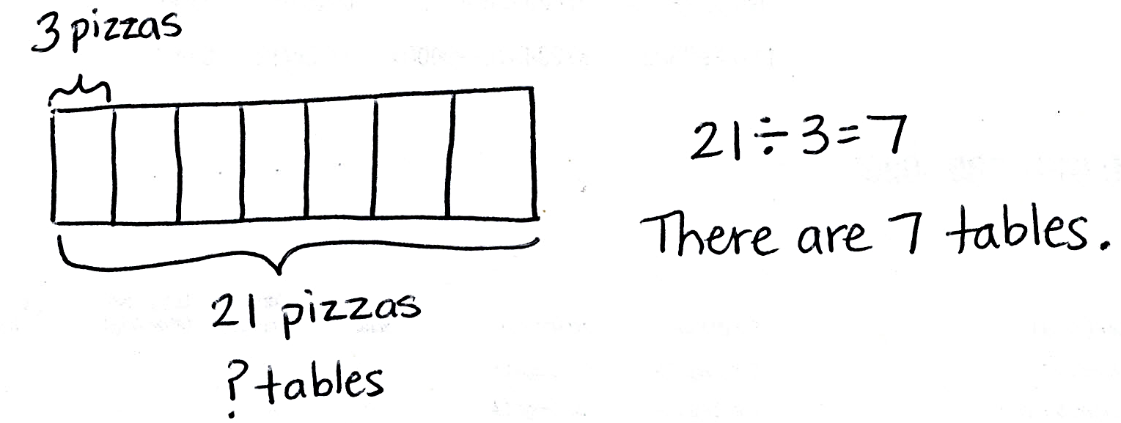Jackie buys 21 pizzas for a party. She places 3 pizzas on each table. How many tables are there?

Note: This problem reviews equal groups division from Lesson 13 where the unknown is the number of groups. In preparation for today’s lesson, students solve by skip-counting to add units until they reach the total of 21. When directions are not specified, students may use any model of their choice to solve.

Concept Development (33 minutes)

|  |  |
| --- | --- |
|  | NOTES ON  MULTIPLE MEANS  OF REPRESENTATION: |
| It may be tempting to skip the template for this problem; however, the template helps visual learners connect spoken numbers with their physical value. It illustrates the relationship between counting by fours and multiplying with units of 4. | |

Materials: (S) Personal white board, fours array (Template) (pictured below)

Problem 1: Skip-count by fours using an array to multiply.

Students start with the template inserted into their personal white board.

T: Let’s count to 40 using the array. Hum the number you count as you point to each dot. For the last dot in each row, say the number out loud and write it to the right of the row.

S: Hum, hum, hum, 4! (Write 4. Continue counting in this manner to 40.)

4

8

12

16

20

24

28

32

36

40

*Fours array template (labeled)*

T: At the signal, tell what unit we counted by. (Signal.)

S: Fours!

T: I will say a multiplication expression. You find the answer on your array. Write the expression and an equal sign next to the answer to make an equation. (Say expressions that correspond to the array out of order, for example, 4 × 4, 9 × 4, etc.)

S: (Write expressions and equal signs next to each answer.)

T: I will say the answer; you say the equation. 20.

S: 20 = 5 × 4!

Problem 2: Use a tape diagram to model and solve multiplication.

|  |  |
| --- | --- |
|  | NOTES ON MULTIPLE MEANS  OF ACTION AND EXPRESSION: |
| This is the first formal experience in Grade 3 using a tape diagram to model multiplication. Some students may have used one to solve the Application Problem in Lesson 12. If they need additional help identifying known and unknown information, prompt them to look back at the array, and then have them articulate the meaning of each factor. | |

T: Draw a tape diagram that represents the number of groups shown on the array template.

S: (Draw a rectangle partitioned into 10 units and label it as *10 groups*.)

T: Tell your partner the number of objects in each group, and then draw and label that information on your diagram.

S: There are 4 objects in each group. (Label 1 unit as *4 objects*.)

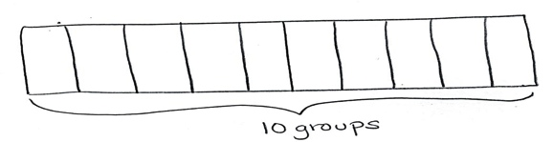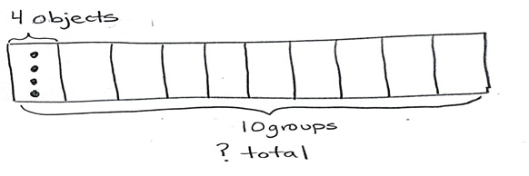

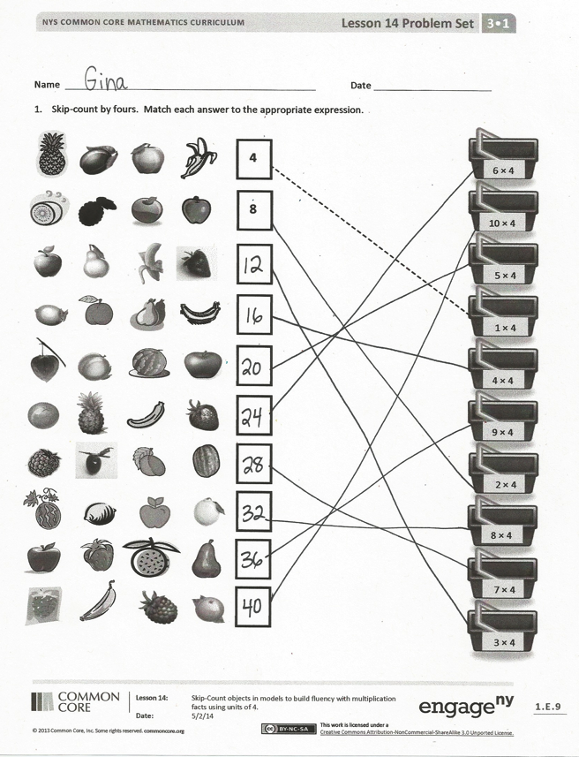

T: Label the unknown on your diagram. Check your work with your partner’s.

S: (Label the total *unknown* and check with a partner.)

T: Skip-count units to find the total value of your tape diagram.

S: 4, 8, 12, 16, 20, 24, 28, 32, 36, 40.

T: Write and solve an equation to represent the problem.

S: (Write 10 × 4 = 40.)

Repeat the process using 7 4 and 4 5. Consider asking students to draw the arrays, or vary practice by adding context to one or both of these problems.

Problem Set (10 minutes)

Students should do their personal best to complete the Problem Set within the allotted 10 minutes. For some classes, it may be appropriate to modify the assignment by specifying which problems they work on first. Some problems do not specify a method for solving. Students should solve these problems using the RDW approach used for Application Problems.

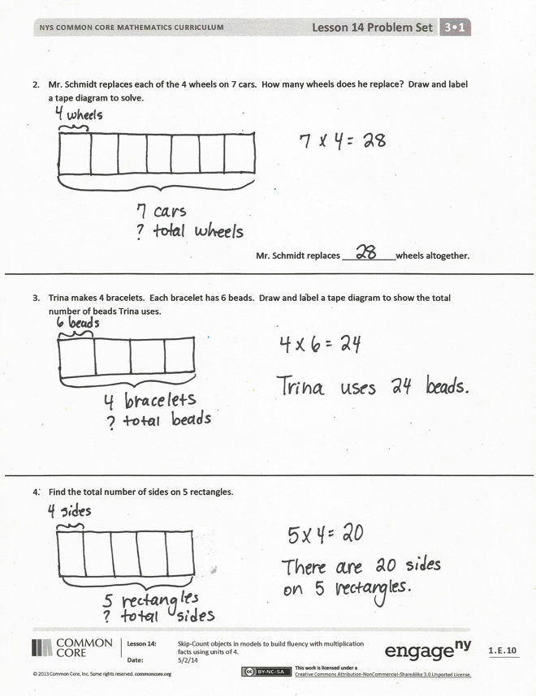

Student Debrief (10 minutes)

Lesson Objective: Skip-count objects in models to build fluency with multiplication facts using units of 4.

The Student Debrief is intended to invite reflection and active processing of the total lesson experience.

Invite students to review their solutions for the Problem Set. They should check work by comparing answers with a partner before going over answers as a class. Look for misconceptions or misunderstandings that can be addressed in the Debrief. Guide students in a conversation to debrief the Problem Set and process the lesson.

You may choose to use any combination of the questions below to lead the discussion.

* Discuss differences between the tape diagrams and unknowns in Problems 2 and 3. (In Problem 2 the value of the unit is four, and in Problem 3 the number 4 represents the number of units.)

**MP.4**

* If you were to skip-count to solve Problem 3, what would you skip-count by? How would that be different from a skip-counting strategy to solve Problem 4?
* Could you skip-count Problem 4 without drawing a model? How?
* How did the array in Problem 1 help you solve the other problems on the Problem Set?
* Lesson 15 revisits the commutative property. To review the commutative property, compare the arrays used on the Problem Set and in Problem 1 of the lesson. (It is the same array turned 90 degrees.)

Exit Ticket (3 minutes)

After the Student Debrief, instruct students to complete the Exit Ticket. A review of their work will help you assess the students’ understanding of the concepts that were presented in the lesson today and plan more effectively for future lessons. You may read the questions aloud to the students.

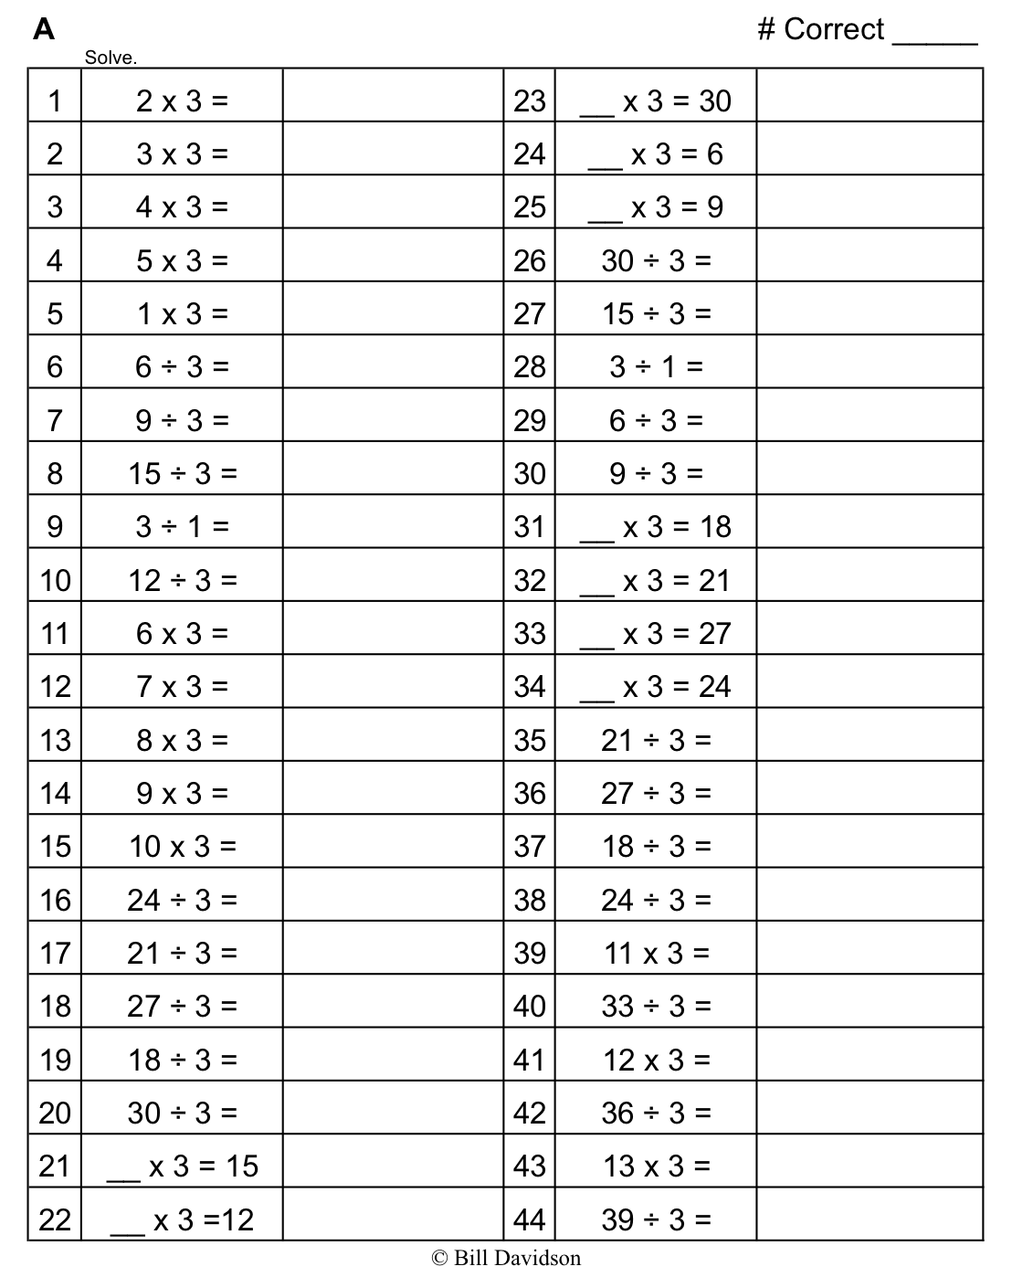

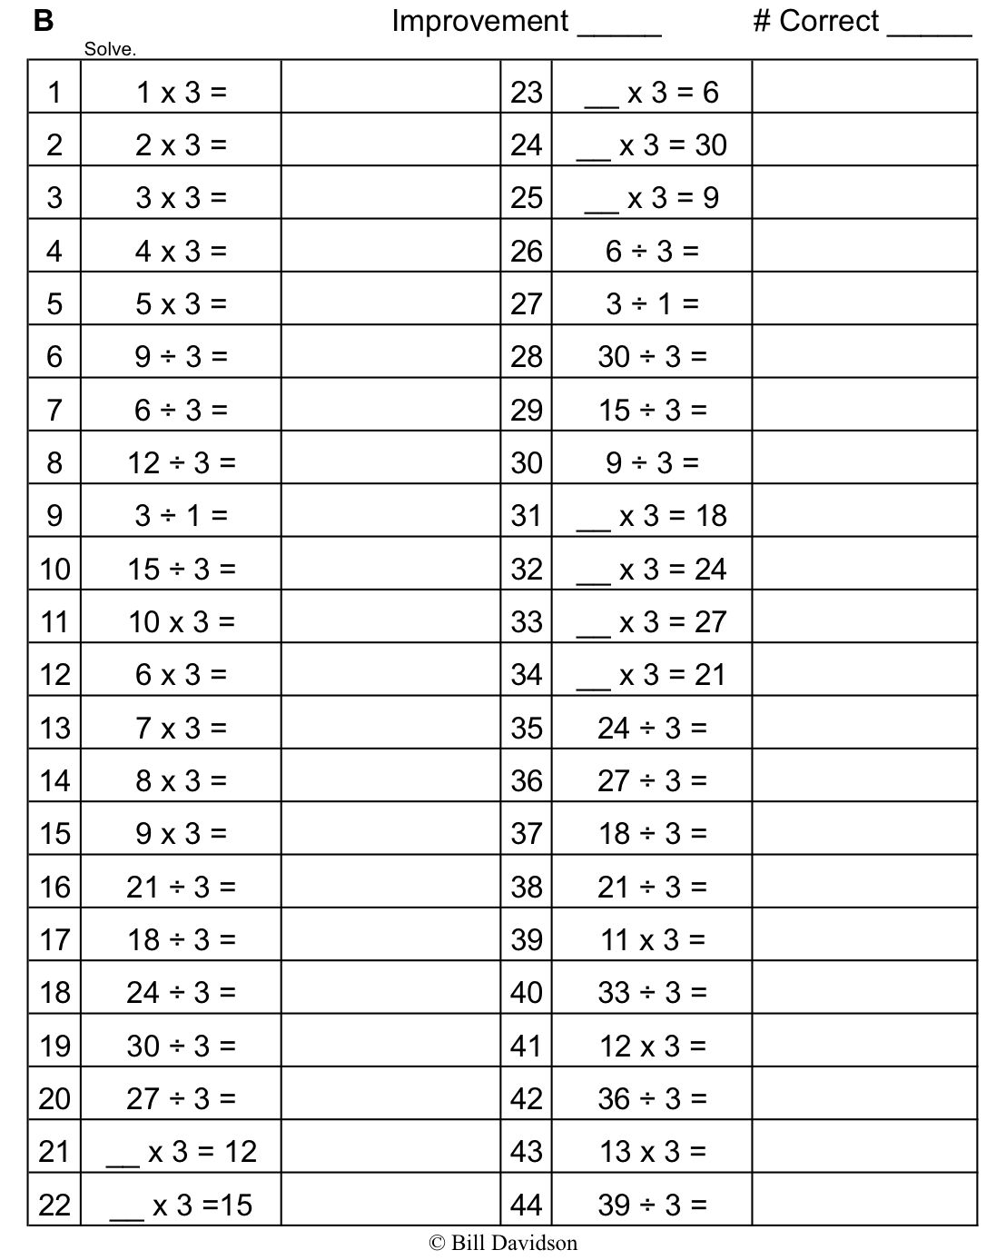

Name Date

1. Skip-count by fours. Match each answer to the appropriate expression.



6 × 4



10 × 4



5 × 4



1 × 4 ==



4 × 4

**4**

**8**



3 × 4



7 × 4



2 × 4



8 × 4



9 × 4

1. Mr. Schmidt replaces each of the 4 wheels on 7 cars. How many wheels does he replace? Draw and label a tape diagram to solve.

Mr. Schmidt replaces ___________ wheels.

1. Trina makes 4 bracelets. Each bracelet has 6 beads. Draw and label a tape diagram to show the total number of beads Trina uses.
2. Find the total number of sides on 5 rectangles.

Name Date

Arthur has 4 boxes of chocolates. Each box has 6 chocolates inside. How many chocolates does Arthur have altogether? Draw and label a tape diagram to solve.

Name Date

Skip-count by fours. Match each answer to the appropriate expression.

**4**



2 × 4



7 × 4



4 × 4



8 × 4



10 × 4



9 × 4



1 × 4



3 × 4



6 × 4



5 × 4

Lisa places 5 rows of 4 juice boxes in the refrigerator. Draw an array and skip-count to find the total number of juice boxes.

There are ___________ juice boxes in total.

Six folders are placed on each table. How many folders are there on 4 tables? Draw and label a tape diagram to solve.

Find the total number of corners on 8 squares.

[1]

1. fours array